COVID 19 – Socio-Economic Factors in the UK

Thomas Fishwick

**Abstract**—Put here a brief summary of your work: analysis task, data, approach, main findings. Length: up to 200 words.

# Problem Statement (250)

Here we will be looking at the COVID-19 statistics and comparing the spread of the virus in different areas and using the last census data to try to understand the various factors behind the spread of the virus.

To solve this problem, we have the COVID 19 case, death and Vaccine rates by UK region [2]. The ONS estimated age breakdown by region (as of August 2021). COVID 19 cases by age and region. A portion of the 2011 Census data showing the shared/unshared dwellings, number of cars, long term health and household deprivation [1]. Ideally, we would be using the 2021 census data, but it will not be released until 2023. We also have the geographic boundaries of the UK Local governments [3], so that we can plot this data onto a map.

We will look at the overall trends of the virus spread. Then look at various local risk factors and how they may interact with the spread, mortality and vaccination rates. Then look at whether we can make a predictive model for the virus spread at the Local authority level.

# State of the Art (500)

From one of SAGE’s reference papers [6], we can see that the government was interested in age group breakdowns different susceptibility to COVID 19. This was in response to the early data from China suggesting that older people were more susceptible to COVID but that younger age groups may be spreading the virus through their social contacts. From this paper we can see that different age groups spread the virus at different rates. This paper uses data from the first 4021 confirmed cases. They estimate a scaling factor for the transmissibility of COVID for each country.

In the BBC Pandemic project [7], the BBC collected contact tracing data from 40177 volunteers (who were tracked and filled in details of everyone they came in contact with. This study was conducted with the intention of being able to provide details of the average number of people that different age groups would come into contact with, so that this could be used in modelling future pandemics.

In the Office of National Statistics paper [8] the authors look at the breakdowns of the COVID 19 deaths by different ethnic groups and gender. The article links individuals’ census and NHS records (patient register and pandemic planning dataset) and looks at other health conditions the individuals might have. The authors were looking to get a risk factor for different ethnic groups for how likely they are to die of COVID 19. As we will not have access to census or medical records at the individual level, we can use their raw results or just use the ethic group data at the local authority level. They also break the model down by local authority district to account for any geographic variation. From this paper we have learnt that there are links between ethnic groups and COVID 19 mortality and we have a risk factor for these groups.

# Properties of the Data (500)

Our COVID 19 case data is at the local authority level (LTLA). The data we have from the census is at the same level, but some of the councils have been merged or split apart. Using Excel [4] we investigated the differences in councils, for the new merged councils we summed together their census data and for those splitting apart (Suffolk) we divided the data equally between them. We used Python’s Pandas library [5] to join up all of the census tables into one sheet.

# Analysis

## Approach (500)

First paragraph...

Following paragraphs...

*<500 words, 1 diagram*

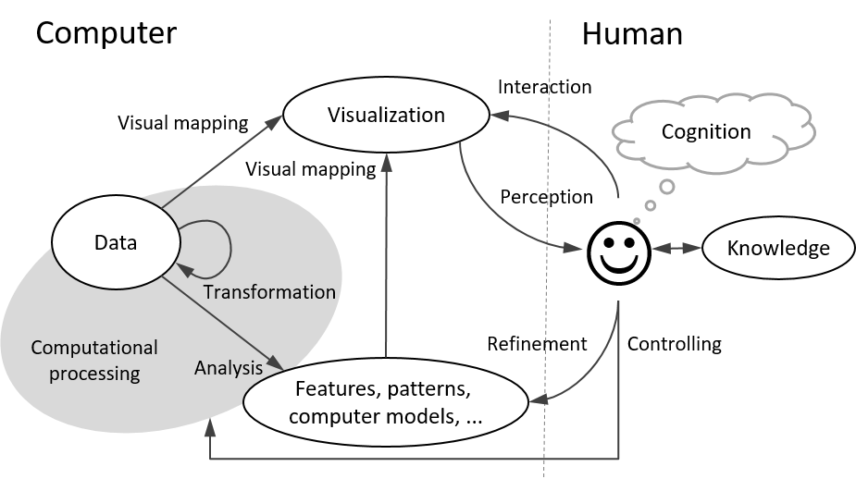

Fig. 1. An example of including a diagram in the document.

## Process (1500)

First paragraph...

Following paragraphs...

*<1500 words, <=7 images*

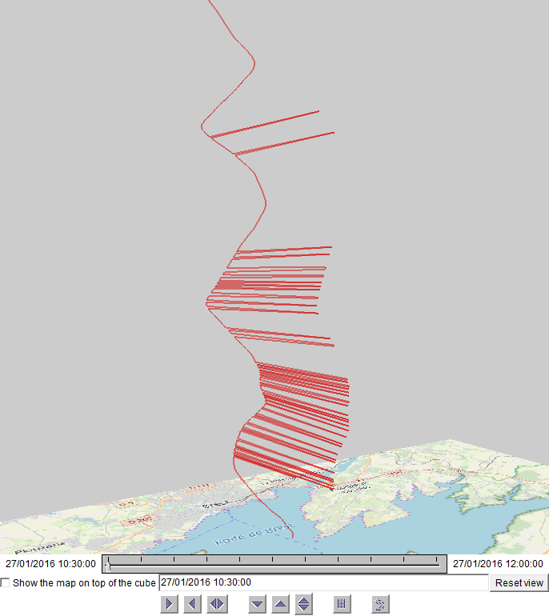

Fig. 2. An example of including a screenshot in the document.

## Results (200)

First paragraph...

Following paragraphs...

*<200 words, <=2 images*

# Critical reflection (500)

First paragraph...

Following paragraphs...

*<500 words*

Table of word counts

|  |  |
| --- | --- |
| Problem statement | 250 |
| State of the art | 500 |
| Properties of the data | 500 |
| Analysis: Approach | 500 |
| Analysis: Process | 1500 |
| Analysis: Results | 200 |
| Critical reflection | 500 |

References

The list below provides examples of formatting references.

1. Office for National Statistics; National Records of Scotland; Northern Ireland Statistics and Research Agency (2017): 2011 Census aggregate data. UK Data Service (Edition: February 2017). DOI: http://dx.doi.org/10.5257/census/aggregate-2011-2
2. Gov.UK Coronavirus. ‘Cases in the UK | Coronavirus in the UK’. HTML, 2021. <https://coronavirus.data.gov.uk/details/cases?areaType=overview&areaName=United%20Kingdom>.
3. Office for National Statistics (2011). 2011 Census: boundary data (England and Wales) [data collection]. UK Data Service. SN:5819 UKBORDERS: Digitised Boundary Data, 1840- and Postcode Directories, 1980-. <http://discover.ukdataservice.ac.uk/catalogue/?sn=5819&type=Data%20catalogue>, Retrieved from <http://census.ukdataservice.ac.uk/get-data/boundary-data.aspx>. Contains public sector information licensed under the Open Government Licence v3.
4. ‘Microsoft Excel Spreadsheet Software | Microsoft 365’. Accessed 30 December 2021. <https://www.microsoft.com/en-us/microsoft-365/excel>.
5. ‘Pandas - Python Data Analysis Library’. Accessed 30 December 2021. <https://pandas.pydata.org/>.
6. Hilton, Joe, and Matt J. Keeling. ‘Estimation of Country-Level Basic Reproductive Ratios for Novel Coronavirus (COVID-19) Using Synthetic Contact Matrices’, 27 February 2020. <https://doi.org/10.1101/2020.02.26.20028167>.
7. Klepac, Petra, Adam J. Kucharski, Andrew JK Conlan, Stephen Kissler, Maria L. Tang, Hannah Fry, and Julia R. Gog. ‘Contacts in Context: Large-Scale Setting-Specific Social Mixing Matrices from the BBC Pandemic Project’, 5 March 2020. <https://doi.org/10.1101/2020.02.16.20023754>.
8. Larsen, Tim, Matt Bosworth, and Vahé Nafilyan. ‘Updating Ethnic Contrasts in Deaths Involving the Coronavirus (COVID-19), England: 24 January 2020 to 31 March 2021’. Updating ethnic contrasts in deaths involving the coronavirus (COVID-19), England - Office of National Statistics, 2021. <https://www.ons.gov.uk/peoplepopulationandcommunity/birthsdeathsandmarriages/deaths/articles/updatingethniccontrastsindeathsinvolvingthecoronaviruscovid19englandandwales/24january2020to31march2021>.