C.V. RAMAN GLOBAL UNIVERSITY

**Bhubaneswar, Odisha, India**



**AIDS Project : Student Performance Analyzer**

**Branch – CSE**

**AI & DS Batch – 2**

**SUBMITTED BY:**

|  |  |  |
| --- | --- | --- |
| Name | College Regd No. | Cranes Regd No. |
| Lingaraj Nayak | 2201020011 | CL2025010601918718 |
| Sivarna Priyadarshini Sarangi | 2201020008 | CL20250106019407111 |
| Prabhunandan Panda | 2201020659 | CL2025010601887052 |
| Srutilochan Dash | 2201020166 | CL2025010601901977 |
| Anoksha Mohanty | 2201020173 | CL2025010601902179 |

# CONTENTS

1. Acknowledgment

2. Introduction

3. Abstract

4. Project Overview

5. Key Objectives & Features

6. Project Structure and Components

7. How the System Works

8. Implementation and Result

9. Limitations of the Current Implementation

10. Future Improvements

11. Conclusion

# ACKNOWLEDGMENT

We would like to extend our deepest and heartfelt appreciation to everyone who has supported and contributed to the successful development and completion of our **Student Performance Analyzer in AIDS** project. This journey has been both educational and rewarding, and it would not have been possible without the invaluable support, guidance, and encouragement we received along the way.

First and foremost, we express our profound gratitude to our respected instructors and mentors. Their unwavering guidance, insightful feedback, and constant motivation have been the cornerstone of this project. They have provided us with not only technical knowledge but also the inspiration to push beyond our limitations, fostering a learning environment that was both challenging and nurturing. Their dedication to our academic and personal growth has been instrumental in shaping the outcomes of this project.

We are equally thankful to our classmates and peers, whose collaborative efforts, constructive discussions, and helpful suggestions significantly enhanced the quality and scope of our project. The exchange of ideas and shared learning experiences created a vibrant and dynamic atmosphere, which enriched our understanding and broadened our perspectives on **AIDS and teamwork.**

# INTRODUCTION

The **Student Performance Analyzer** is a smart tool that uses **machine learning** to predict whether a student is likely to **pass or fail** based on their personal and academic details, such as study hours, attendance, past grades, and more. By learning patterns from historical student data, the model can identify which factors most influence performance.

This analyzer is built using **Streamlit**, a simple Python framework that lets us create interactive web apps easily. Users can input new student details directly through the app interface, and the machine learning model instantly gives a prediction. The app also allows users to explore patterns in the data and even **download the results**, making it useful for teachers, counselors, or educational planners.

Together, machine learning and Streamlit make student performance analysis **fast, interactive, and insightful**, helping educators make better decisions and support students effectively.

In today's increasingly data-driven world, educational institutions are continually seeking effective ways to better understand, monitor, and enhance student learning outcomes.

The **Student Performance Analyzer** project addresses this need by applying Machine Learning (ML) techniques to academic data, enabling the prediction of student success rates with greater accuracy and efficiency. This project emphasizes the power of data analytics in identifying patterns and trends that traditional methods might overlook.

Developed using a clean, interactive web application built with **Stream lit**, the Student Performance Analyzer provides a seamless user experience for educators. It bridges the gap between complex machine learning models and simple, actionable insights that can directly impact teaching strategies and student support initiatives. By offering intuitive visualizations and easy-to-understand results, the system empowers educators to make informed, data-backed decisions for student improvement

# ABSTRACT

This project presents the development and implementation of a Machine Learning (ML) based system designed to predict and analyze student performance using academic data. In today's education systems, early identification of students who may require additional support is crucial for enhancing learning outcomes, and this project aims to bridge that gap effectively.

By leveraging subject-wise academic scores, the model predicts the likelihood of a student passing or failing, providing educators with critical insights at an early stage. To ensure accessibility and ease of use, an intuitive web application was developed using **Stream lit**, allowing educators to input data and instantly visualize results.

The project highlights key ML processes, including data preprocessing, feature selection, model training, evaluation, and deployment in a user-friendly format. Serving as an academic prototype, the Student Performance Analyzer not only demonstrates the practical utility of ML in education but also sets the foundation for future, more comprehensive student analytics tools.

# PROJECT OVERVIEW

The Student Performance Analyzer project was designed to:  
- Apply **ML techniques** to predict student outcomes.  
- Develop a **web-based application** to present predictions interactively.  
- Provide educators with **actionable insights** for academic improvements.

Key Technologies Used:  
- **Python** (scikit-learn, pandas, NumPy)  
- **Stream lit** (for web app development)

# KEY OBJECTIVES & FEATURES

**Objectives:**  
• To build a machine learning model to analyze and predict student performance based on subject-wise marks.  
• To design an intuitive, user-friendly web application to input and display student data.  
• To enhance data-driven decision-making in educational institutions by providing insights into student performance.

**Features:**  
• **Input Collection:** Users can enter subject-wise marks for individual students through a simple form.  
• **Automatic Calculation:** The system will calculate the average score based on the entered marks.  
• **Pass/Fail Prediction:** Based on the average score, the model predicts the pass/fail status of the student.  
• **Performance Visualization:** Subject-wise performance will be presented in the form of interactive charts for easy analysis.

**Core Functionalities:**  
• **Enter Marks:** Input marks for each subject to calculate the student's average.  
• **View Results:** Display the student's pass/fail status and overall performance summary.  
• **Visualize Data:** Show subject-wise performance using graphs such as bar charts or pie charts.  
• **Prediction Model:** Machine learning algorithm to predict pass/fail status based on historical data.

**PROJECT STRUCTURE AND COMPONENTS**

1. **Dataset:**
   * The dataset includes essential student details such as Student ID, Name, and marks in five subjects: Mathematics, Physics, Chemistry, English, and Computer Science.
   * Preprocessing steps will include data cleaning (handling missing values and outliers), normalization (scaling the marks to a standard range), and formatting the data for use in machine learning algorithms. This ensures the data is in a suitable structure for model training.
2. **Machine Learning Model:**
   * **Algorithms Used:** The project will employ multiple machine learning algorithms to predict student performance. Linear Regression will be used for continuous score prediction, while a Decision Tree algorithm will assist in classifying pass/fail outcomes.
   * **Model Training:** The dataset will be split into 80% for training the model and 20% for testing its performance, ensuring that the model generalizes well to unseen data.
   * **Evaluation Metrics:** The model's effectiveness will be evaluated using several metrics such as Accuracy, Precision, Recall, and F1-Score to assess its predictive power and handle class imbalances if any.
3. **Stream lit Application:**
   * The user interface (UI) is built with Stream lit, a Python library for creating interactive web applications. The UI will allow users (such as teachers or administrators) to input student data, including marks across subjects.
   * The application will dynamically predict the student's performance outcome (pass/fail) and display the results immediately.
   * **Performance Analytics:** Visual tools, such as bar charts, will present subject-wise performance, allowing users to easily identify strengths and weaknesses in student performance.

**HOW THE SYSTEM WORKS**

1. **User Inputs:**
   * Educators begin by entering the student’s name and marks for each core subject, such as Mathematics, Physics, Chemistry, English, and Computer Science. The system ensures that the input is clean and consistent for accurate analysis.
2. **Model Processing**:
   * The machine learning model processes the input data, calculating the average score based on the marks entered for each subject. Using this average score, the model then determines if the student passes or fails, applying a predefined threshold (e.g., 40%).
3. **Display Results**:
   * The application dynamically displays the student’s average score, pass/fail status, and visualizes the student’s performance in each subject through charts, providing a clear overview of their strengths and weaknesses.
4. **Feedback Loop**:
   * The system allows educators to input data for multiple students sequentially, enabling easy analysis and comparison of performance across different students.

student-performance-analyzer

│

├── data/

│ └── student_data.csv # Dataset containing student records

│

├── models/

│ └── student_model.pkl # Trained machine learning model

│

├── notebooks/

│ └── analysis_and_training.ipynb # Jupyter notebook for training and testing

│

├── app/

│ ├── app.py # Main Streamlit web app

│ └── utils.py # Helper functions (preprocessing, prediction)

│

├── requirements.txt # Required Python libraries

├── README.md # Project overview and instructions

└── LICENSE # Optional license file

## RESULT

## 

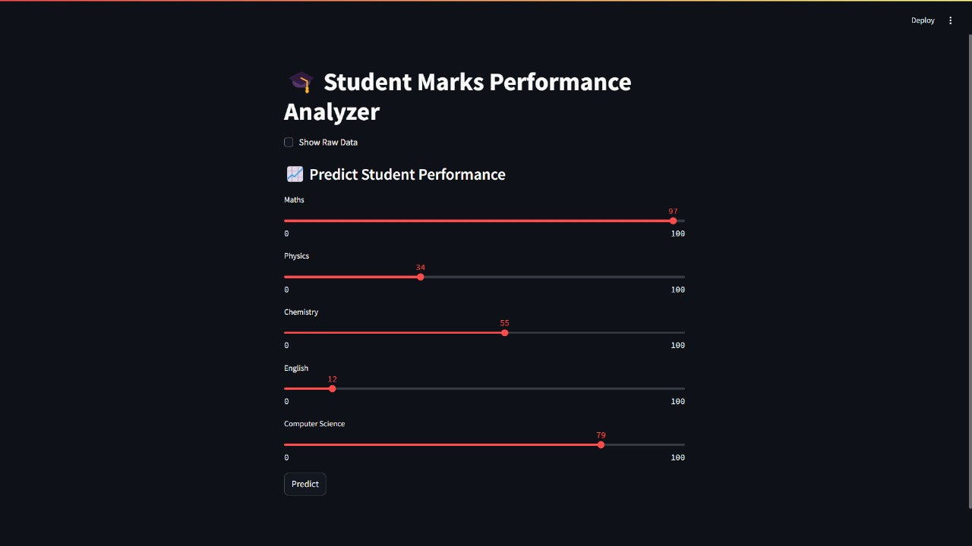

**FINAL PREDICTION (PASS/FAIL)**

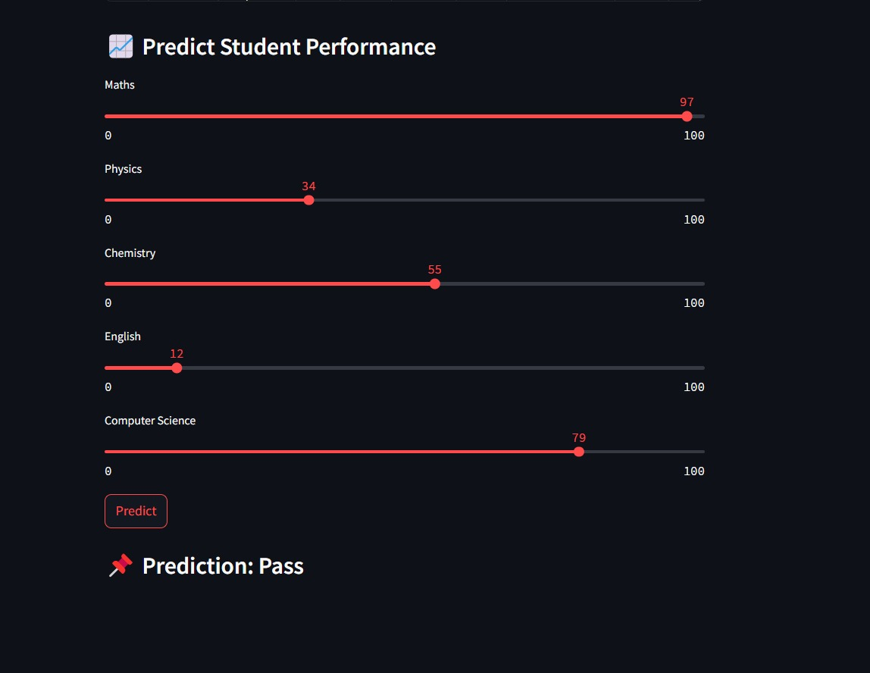

**LIMITATIONS OF THE CURRENT IMPLEMENTATION**

**Limited Data Scope**: The model only uses academic scores for prediction; demographic, behavioural, or attendance data are not considered, restricting the depth of analysis.  
**Basic ML Models Only**: The system is limited to simple machine learning models like Linear Regression and Decision Tree, without exploring advanced algorithms for better accuracy.  
**Static Pass/Fail Threshold**: The pass/fail cutoff is fixed at 40% and does not adapt automatically to different grading systems or institution-specific standards.  
**Manual Data Entry**: Users must manually input all student scores, which increases the risk of human error and limits scalability for larger datasets.  
**No Database Integration**: The web application does not connect to any external school databases, meaning student data must be re-entered each time, with no record-keeping for future reference.  
**No Automated Updates**: The system lacks real-time synchronization with academic records or automatic updates based on institutional changes.

## 

## FUTURE IMPROVEMENTS

## • Advanced Model Integration: Upgrade the system by incorporating more sophisticated machine learning models like Random Forests or Neural Networks to improve prediction accuracy and robustness. • Expanded Feature Set: Enhance the dataset by including additional factors such as attendance records, demographic information, and behavioral patterns for more comprehensive performance analysis. • Dynamic Cut-off Configuration: Implement flexible cut-off settings that allow institutions to define their own pass/fail thresholds according to their specific grading standards. • Personalized Student Recommendations: Provide students with tailored feedback and study recommendations based on their subject-wise performance to support targeted improvement. • Data Import/Export Capability: Enable seamless integration with existing school management systems, allowing for the import of student data and the export of analysis reports, thereby reducing manual data entry and improving efficiency.

**CONCLUSION**

The Student Performance Analyzer project successfully implements a machine learning-based system for predicting and analysing student outcomes, including average score calculation, pass/fail prediction, and subject-wise performance visualization. Through this project, we gained hands-on experience in:

• Structuring and preprocessing educational data for machine learning applications  
• Applying machine learning algorithms like Linear Regression and Decision Trees for predictive analysis  
• Designing an intuitive, user-friendly web application using Streamlit for real-time interaction and visualization  
• Handling manual input, processing academic data, and generating insightful performance summaries

While the project effectively demonstrates the application of machine learning in the education sector, it serves as a prototype with scope for future enhancements, such as integration with school databases, dynamic threshold settings, personalized recommendations, and the use of more advanced ML models. With further development, the system could be deployed in real educational institutions to support personalized learning and improve student success rates.

**THANK YOU!!**