FIEBRE Adult Severity Scores analysis: Figures and tables for manuscript

26 August 2024

Table of Contents

## Descriptive results tables

### Table 2

Demographic and clinical characteristics of febrile participants (aged ≥15 years) enrolled between 2018 and 2021 across four sites (Lao PDR, Malawi, Mozambique, and Zimbabwe), who had complete enrolment and follow-up data

| Variable1 | **Laos**, N = 412 | **Malawi**, N = 727 | **Mozambique**, N = 811 | **Zimbabwe**, N = 847 | **Overall**, N = 2,797 |
| --- | --- | --- | --- | --- | --- |
| Age (years) |  |  |  |  |  |
| Median (IQR) | 36.0 (25.8, 54.0) | 28.0 (22.0, 38.0) | 34.0 (25.0, 45.5) | 32.0 (23.0, 41.0) | 32.0 (24.0, 43.0) |
| Range | 15.0, 96.0 | 15.0, 87.0 | 15.0, 92.0 | 15.0, 83.0 | 15.0, 96.0 |
| Age group, n (%) |  |  |  |  |  |
| 15 - <25 | 92 (22%) | 254 (35%) | 186 (23%) | 252 (30%) | 784 (28%) |
| 25 - <35 | 100 (24%) | 215 (30%) | 221 (27%) | 246 (29%) | 782 (28%) |
| 35 - <40 | 64 (16%) | 152 (21%) | 192 (24%) | 182 (21%) | 590 (21%) |
| 45 - <55 | 56 (14%) | 59 (8.1%) | 91 (11%) | 95 (11%) | 301 (11%) |
| 55 - <65 | 49 (12%) | 30 (4.1%) | 76 (9.4%) | 42 (5.0%) | 197 (7.0%) |
| 65+ | 51 (12%) | 17 (2.3%) | 45 (5.5%) | 30 (3.5%) | 143 (5.1%) |
| Gender, n (%) |  |  |  |  |  |
| Female | 234 (57%) | 459 (63%) | 532 (66%) | 459 (54%) | 1,684 (60%) |
| Male | 178 (43%) | 268 (37%) | 279 (34%) | 388 (46%) | 1,113 (40%) |
| Patient group, n (%) |  |  |  |  |  |
| Inpatient - adult | 178 (43%) | 169 (23%) | 364 (45%) | 359 (42%) | 1,070 (38%) |
| Outpatient - adult | 234 (57%) | 558 (77%) | 447 (55%) | 488 (58%) | 1,727 (62%) |
| Length of inpatient stay (days) |  |  |  |  |  |
| Median (IQR) | 3.0 (1.0, 4.0) | 3.0 (1.8, 4.0) | 3.0 (1.0, 7.0) | 5.0 (3.0, 8.5) | 3.0 (2.0, 6.0) |
| Range | 0.0, 32.0 | 0.0, 64.0 | 0.0, 70.0 | 0.0, 65.0 | 0.0, 70.0 |
| (Missing) | 237 | 563 | 493 | 540 | 1,833 |
| Temperature (°C) |  |  |  |  |  |
| Median (IQR) | 38.0 (37.5, 38.5) | 37.8 (37.6, 38.5) | 38.0 (37.7, 38.6) | 38.0 (37.8, 38.8) | 38.0 (37.7, 38.6) |
| Range | 37.5, 40.1 | 37.5, 41.3 | 37.5, 41.0 | 37.5, 40.8 | 37.5, 41.3 |
| HIV status, n (%) |  |  |  |  |  |
| Positive | 1 (0.2%) | 102 (14%) | 413 (51%) | 169 (20%) | 685 (24%) |
| Negative | 411 (100%) | 625 (86%) | 398 (49%) | 678 (80%) | 2,112 (76%) |
| Respiratory rate (breaths/min) |  |  |  |  |  |
| Median (IQR) | 22.0 (20.0, 25.0) | 22.0 (20.0, 28.0) | 20.0 (18.0, 20.0) | 20.0 (18.0, 20.0) | 20.0 (18.0, 23.0) |
| Range | 17.0, 50.0 | 14.0, 66.0 | 14.0, 56.0 | 16.0, 85.0 | 14.0, 85.0 |
| Systolic blood pressure, mm Hg |  |  |  |  |  |
| Median (IQR) | 120.0 (110.0, 125.0) | 116.0 (106.0, 125.5) | 117.0 (105.0, 130.0) | 116.0 (105.0, 127.0) | 117.0 (106.0, 127.0) |
| Range | 60.0, 199.0 | 67.0, 191.0 | 48.0, 239.0 | 66.0, 256.0 | 48.0, 256.0 |
| Heart rate, beats/min |  |  |  |  |  |
| Median (IQR) | 89.0 (80.0, 100.0) | 95.0 (84.0, 109.0) | 103.0 (90.0, 118.0) | 106.0 (93.5, 120.0) | 99.0 (87.0, 114.0) |
| Range | 57.0, 157.0 | 48.0, 174.0 | 44.0, 181.0 | 56.0, 192.0 | 44.0, 192.0 |
| Oxygen saturation (%) |  |  |  |  |  |
| Median (IQR) | 96.0 (95.0, 97.0) | 97.0 (96.0, 98.0) | 98.0 (96.0, 99.0) | 95.0 (94.0, 97.0) | 97.0 (95.0, 98.0) |
| Range | 80.0, 99.0 | 77.0, 100.0 | 36.0, 100.0 | 75.0, 100.0 | 36.0, 100.0 |
| Modified early warning score (MEWS) |  |  |  |  |  |
| Median (IQR) | 3.0 (2.0, 4.0) | 3.0 (2.0, 4.0) | 3.0 (1.0, 4.0) | 3.0 (2.0, 5.0) | 3.0 (2.0, 4.0) |
| Range | 1.0, 9.0 | 1.0, 11.0 | 1.0, 10.0 | 1.0, 9.0 | 1.0, 11.0 |
| Modified GCS |  |  |  |  |  |
| Median (IQR) | 15.0 (15.0, 15.0) | 15.0 (15.0, 15.0) | 15.0 (15.0, 15.0) | 15.0 (15.0, 15.0) | 15.0 (15.0, 15.0) |
| Range | 8.0, 15.0 | 3.0, 15.0 | 3.0, 15.0 | 3.0, 15.0 | 3.0, 15.0 |
| qSOFA score, n (%) |  |  |  |  |  |
| 0 | 87 (21%) | 275 (38%) | 502 (62%) | 572 (68%) | 1,436 (51%) |
| 1 | 269 (65%) | 372 (51%) | 246 (30%) | 239 (28%) | 1,126 (40%) |
| 2 | 49 (12%) | 80 (11%) | 61 (7.5%) | 36 (4.3%) | 226 (8.1%) |
| 3 | 7 (1.7%) | 0 (0%) | 2 (0.2%) | 0 (0%) | 9 (0.3%) |
| UVA score |  |  |  |  |  |
| Median (IQR) | 0.0 (0.0, 0.0) | 0.0 (0.0, 1.0) | 2.0 (0.0, 2.0) | 0.0 (0.0, 2.0) | 0.0 (0.0, 2.0) |
| Range | 0.0, 7.0 | 0.0, 10.0 | 0.0, 9.0 | 0.0, 7.0 | 0.0, 10.0 |
| Altered mental status   (GCS <15), n (%) |  |  |  |  |  |
| Yes | 15 (3.6%) | 9 (1.2%) | 45 (5.5%) | 5 (0.6%) | 74 (2.6%) |
| No | 397 (96%) | 718 (99%) | 766 (94%) | 842 (99%) | 2,723 (97%) |
| 1IQR=interquartile range, bpm=beats per minute, brpm=breaths per minute, MEWS=modified early warning score, GCS=Glasgow coma scale score, qSOFA=quick sequential organ failure assessment, UVA=universal vital assessment score *Length of hospital stay reported for inpatients only | | | | | |

### Table 3

Demographic and clinical characteristics of febrile participants (aged ≥15 years) enrolled between 2018 and 2021 across four sites (Lao PDR, Malawi, Mozambique, and Zimbabwe), stratified by outcome by time of follow-up.

| Variable1 | **Alive**, N = 2,612 | **Dead**, N = 185 | **Overall**, N = 2,797 |
| --- | --- | --- | --- |
| Age (years) |  |  |  |
| N | 2,612.0 | 185.0 | 2,797.0 |
| Median (IQR) | 32.0 (23.0, 42.0) | 41.0 (33.0, 56.0) | 32.0 (24.0, 43.0) |
| Range | 15.0, 95.0 | 18.0, 96.0 | 15.0, 96.0 |
| Age group, n (%) |  |  |  |
| 15 - <25 | 769 (98%) | 15 (1.9%) | 784 (100%) |
| 25 - <35 | 740 (95%) | 42 (5.4%) | 782 (100%) |
| 35 - <40 | 545 (92%) | 45 (7.6%) | 590 (100%) |
| 45 - <55 | 269 (89%) | 32 (11%) | 301 (100%) |
| 55 - <65 | 169 (86%) | 28 (14%) | 197 (100%) |
| 65+ | 120 (84%) | 23 (16%) | 143 (100%) |
| Gender, n (%) |  |  |  |
| Female | 1,600 (95%) | 84 (5.0%) | 1,684 (100%) |
| Male | 1,012 (91%) | 101 (9.1%) | 1,113 (100%) |
| Patient group, n (%) |  |  |  |
| Inpatient - adult | 900 (84%) | 170 (16%) | 1,070 (100%) |
| Outpatient - adult | 1,712 (99%) | 15 (0.9%) | 1,727 (100%) |
| Length of inpatient stay (days) |  |  |  |
| N | 810.0 | 154.0 | 964.0 |
| Median (IQR) | 3.0 (2.0, 6.0) | 3.5 (1.0, 7.0) | 3.0 (2.0, 6.0) |
| Range | 0.0, 70.0 | 0.0, 64.0 | 0.0, 70.0 |
| (Missing) | 1,802 | 31 | 1,833 |
| country, n (%) |  |  |  |
| Laos | 389 (94%) | 23 (5.6%) | 412 (100%) |
| Malawi | 711 (98%) | 16 (2.2%) | 727 (100%) |
| Mozambique | 716 (88%) | 95 (12%) | 811 (100%) |
| Zimbabwe | 796 (94%) | 51 (6.0%) | 847 (100%) |
| Temperature (°C) |  |  |  |
| N | 2,612.0 | 185.0 | 2,797.0 |
| Median (IQR) | 38.0 (37.7, 38.6) | 38.1 (37.8, 38.8) | 38.0 (37.7, 38.6) |
| Range | 37.5, 41.3 | 37.5, 41.0 | 37.5, 41.3 |
| HIV status, n (%) |  |  |  |
| Positive | 573 (84%) | 112 (16%) | 685 (100%) |
| Negative | 2,039 (97%) | 73 (3.5%) | 2,112 (100%) |
| Respiratory rate (breaths/min) |  |  |  |
| N | 2,612.0 | 185.0 | 2,797.0 |
| Median (IQR) | 20.0 (18.0, 23.0) | 22.0 (20.0, 26.0) | 20.0 (18.0, 23.0) |
| Range | 14.0, 85.0 | 16.0, 66.0 | 14.0, 85.0 |
| Systolic blood pressure, mm Hg |  |  |  |
| N | 2,612.0 | 185.0 | 2,797.0 |
| Median (IQR) | 117.0 (106.0, 127.0) | 111.0 (98.0, 129.0) | 117.0 (106.0, 127.0) |
| Range | 48.0, 256.0 | 60.0, 228.0 | 48.0, 256.0 |
| Heart rate, beats/min |  |  |  |
| N | 2,612.0 | 185.0 | 2,797.0 |
| Median (IQR) | 99.0 (87.0, 113.0) | 110.0 (94.0, 125.0) | 99.0 (87.0, 114.0) |
| Range | 44.0, 192.0 | 60.0, 181.0 | 44.0, 192.0 |
| Oxygen saturation (%) |  |  |  |
| N | 2,612.0 | 185.0 | 2,797.0 |
| Median (IQR) | 97.0 (95.0, 98.0) | 95.0 (92.0, 97.0) | 97.0 (95.0, 98.0) |
| Range | 75.0, 100.0 | 36.0, 100.0 | 36.0, 100.0 |
| Modified early warning score (MEWS) |  |  |  |
| N | 2,612.0 | 185.0 | 2,797.0 |
| Median (IQR) | 3.0 (2.0, 4.0) | 4.0 (3.0, 6.0) | 3.0 (2.0, 4.0) |
| Range | 1.0, 10.0 | 1.0, 11.0 | 1.0, 11.0 |
| Modified GCS |  |  |  |
| N | 2,612.0 | 185.0 | 2,797.0 |
| Median (IQR) | 15.0 (15.0, 15.0) | 15.0 (15.0, 15.0) | 15.0 (15.0, 15.0) |
| Range | 6.0, 15.0 | 3.0, 15.0 | 3.0, 15.0 |
| qSOFA score, n (%) |  |  |  |
| 0 | 1,387 (97%) | 49 (3.4%) | 1,436 (100%) |
| 1 | 1,047 (93%) | 79 (7.0%) | 1,126 (100%) |
| 2 | 176 (78%) | 50 (22%) | 226 (100%) |
| 3 | 2 (22%) | 7 (78%) | 9 (100%) |
| UVA score |  |  |  |
| N | 2,612.0 | 185.0 | 2,797.0 |
| Median (IQR) | 0.0 (0.0, 2.0) | 3.0 (2.0, 4.0) | 0.0 (0.0, 2.0) |
| Range | 0.0, 9.0 | 0.0, 10.0 | 0.0, 10.0 |
| Altered mental status   (GCS <15), n (%) |  |  |  |
| Yes | 38 (51%) | 36 (49%) | 74 (100%) |
| No | 2,574 (95%) | 149 (5.5%) | 2,723 (100%) |
| Time to death (days) |  |  |  |
| Median (IQR) | NA (NA, NA) | 10.0 (3.0, 21.3) | 10.0 (3.0, 21.3) |
| (Missing) | 2,612 | 29 | 2,641 |
| In hospital outcomes, n (%) |  |  |  |
| Died | 0 (0%) | 73 (100%) | 73 (100%) |
| Discharge home | 2,458 (98%) | 61 (2.4%) | 2,519 (100%) |
| Discharged to palliative care | 12 (52%) | 11 (48%) | 23 (100%) |
| Other | 19 (90%) | 2 (9.5%) | 21 (100%) |
| Referred other | 63 (68%) | 30 (32%) | 93 (100%) |
| (Missing) | 60 | 8 | 68 |
| 1IQR=interquartile range, bpm=beats per minute, brpm=breaths per minute, MEWS=modified early warning score, GCS=Glasgow coma scale score, qSOFA=quick sequential organ failure assessment, UVA=universal vital assessment score *Length of hospital stay reported for inpatients only | | | |

Demographic and clinical characteristics of febrile participants (aged ≥15 years) enrolled between 2018 and 2021 across four sites (Lao PDR, Malawi, Mozambique, and Zimbabwe), stratified by outcome by time of follow-up.

| n | n1 | n2 | estimate1 | estimate2 | statistic | p | df | conf.low | conf.high | method | alternative | p.signif |
| --- | --- | --- | --- | --- | --- | --- | --- | --- | --- | --- | --- | --- |
| 2797 | 1070 | 1727 | 0.1588785 | 0.008685582 | 238.8553 | 6.99e-54 | 1 | 0.1270995 | 0.1732864 | Prop test | two.sided | **** |

Demographic and clinical characteristics of febrile participants (aged ≥15 years) enrolled between 2018 and 2021 across four sites (Lao PDR, Malawi, Mozambique, and Zimbabwe), stratified by outcome by time of follow-up.

| n | n1 | n2 | estimate1 | estimate2 | statistic | p | df | conf.low | conf.high | method | alternative | p.signif |
| --- | --- | --- | --- | --- | --- | --- | --- | --- | --- | --- | --- | --- |
| 2797 | 685 | 2112 | 0.1635036 | 0.03456439 | 137.1406 | 1.12e-31 | 1 | 0.09920284 | 0.1586757 | Prop test | two.sided | **** |

## Demographic and clinical characteristics of patients with incomplete data

### Table S1

Demographic and clinical characteristics of febrile participants (aged ≥15 years) enrolled between 2018 and 2021 across four sites (Lao PDR, Malawi, Mozambique, and Zimbabwe), who had incomplete enrolment and follow-up data.

| Variable1 | **Laos**, N = 800 | **Malawi**, N = 94 | **Mozambique**, N = 210 | **Zimbabwe**, N = 201 | **Overall**, N = 1,3052 |
| --- | --- | --- | --- | --- | --- |
| Age (years) |  |  |  |  |  |
| N | 800.0 | 94.0 | 210.0 | 201.0 | 1,305.0 |
| Median (IQR) | 35.0 (24.0, 54.0) | 28.0 (22.0, 39.0) | 33.0 (24.0, 47.0) | 28.0 (22.0, 38.0) | 33.0 (23.0, 50.0) |
| Range | 15.0, 96.0 | 15.0, 84.0 | 15.0, 88.0 | 15.0, 74.0 | 15.0, 96.0 |
| Age group, n (%) |  |  |  |  |  |
| 15 - <25 | 208 (26%) | 35 (37%) | 54 (26%) | 75 (37%) | 372 (29%) |
| 25 - <35 | 176 (22%) | 23 (24%) | 57 (27%) | 53 (26%) | 309 (24%) |
| 35 - <40 | 112 (14%) | 19 (20%) | 41 (20%) | 49 (24%) | 221 (17%) |
| 45 - <55 | 106 (13%) | 9 (9.6%) | 22 (10%) | 13 (6.5%) | 150 (11%) |
| 55 - <65 | 94 (12%) | 4 (4.3%) | 22 (10%) | 8 (4.0%) | 128 (9.8%) |
| 65+ | 104 (13%) | 4 (4.3%) | 14 (6.7%) | 3 (1.5%) | 125 (9.6%) |
| Gender, n (%) |  |  |  |  |  |
| Female | 412 (52%) | 51 (54%) | 128 (61%) | 101 (50%) | 692 (53%) |
| Male | 388 (49%) | 43 (46%) | 82 (39%) | 100 (50%) | 613 (47%) |
| Patient group, n (%) |  |  |  |  |  |
| Inpatient - adult | 431 (54%) | 51 (54%) | 108 (51%) | 87 (43%) | 677 (52%) |
| Outpatient - adult | 369 (46%) | 43 (46%) | 102 (49%) | 114 (57%) | 628 (48%) |
| Length of inpatient stay (days) |  |  |  |  |  |
| N | 410.0 | 41.0 | 85.0 | 71.0 | 607.0 |
| Median (IQR) | 3.0 (2.0, 4.0) | 4.0 (1.0, 6.0) | 3.0 (1.0, 6.0) | 5.0 (3.0, 8.0) | 3.0 (2.0, 5.0) |
| Range | 0.0, 47.0 | 0.0, 38.0 | 0.0, 19.0 | 0.0, 43.0 | 0.0, 47.0 |
| (Missing) | 390 | 53 | 125 | 130 | 698 |
| Temperature (°C) |  |  |  |  |  |
| N | 800.0 | 94.0 | 210.0 | 201.0 | 1,305.0 |
| Median (IQR) | 37.9 (37.5, 38.5) | 38.2 (37.7, 38.9) | 38.1 (37.7, 38.7) | 38.1 (37.9, 38.8) | 38.0 (37.5, 38.5) |
| Range | 37.5, 40.9 | 37.5, 40.1 | 37.5, 40.0 | 37.5, 40.4 | 37.5, 40.9 |
| HIV status, n (%) |  |  |  |  |  |
| Positive | 0 (0%) | 16 (19%) | 83 (42%) | 43 (25%) | 142 (29%) |
| Negative | 31 (100%) | 68 (81%) | 106 (54%) | 132 (75%) | 337 (69%) |
| Indeterminant | 0 (0%) | 0 (0%) | 9 (4.5%) | 0 (0%) | 9 (1.8%) |
| (Missing) | 769 | 10 | 12 | 26 | 817 |
| Respiratory rate (breaths/min) |  |  |  |  |  |
| N | 796.0 | 91.0 | 209.0 | 200.0 | 1,296.0 |
| Median (IQR) | 22.0 (20.0, 22.0) | 22.0 (19.0, 25.0) | 20.0 (18.0, 20.0) | 20.0 (18.0, 21.0) | 20.0 (20.0, 22.0) |
| Range | 16.0, 40.0 | 16.0, 97.0 | 10.0, 56.0 | 16.0, 99.0 | 10.0, 99.0 |
| (Missing) | 4 | 3 | 1 | 1 | 9 |
| Systolic blood pressure, mm Hg |  |  |  |  |  |
| N | 798.0 | 91.0 | 204.0 | 201.0 | 1,294.0 |
| Median (IQR) | 112.0 (100.0, 124.0) | 112.0 (103.0, 124.0) | 120.0 (106.0, 130.3) | 115.0 (102.0, 123.0) | 114.0 (101.3, 126.0) |
| Range | 50.0, 190.0 | 82.0, 162.0 | 55.0, 206.0 | 66.0, 167.0 | 50.0, 206.0 |
| (Missing) | 2 | 3 | 6 | 0 | 11 |
| Heart rate, beats/min |  |  |  |  |  |
| N | 798.0 | 94.0 | 210.0 | 201.0 | 1,303.0 |
| Median (IQR) | 90.0 (83.3, 100.0) | 101.0 (90.0, 113.5) | 99.0 (89.0, 116.0) | 106.0 (94.0, 121.0) | 96.0 (85.0, 108.0) |
| Range | 50.0, 156.0 | 62.0, 159.0 | 59.0, 185.0 | 58.0, 212.0 | 50.0, 212.0 |
| (Missing) | 2 | 0 | 0 | 0 | 2 |
| Oxygen saturation (%) |  |  |  |  |  |
| N | 798.0 | 89.0 | 203.0 | 200.0 | 1,290.0 |
| Median (IQR) | 96.0 (95.0, 98.0) | 97.0 (96.0, 98.0) | 98.0 (96.0, 99.0) | 96.0 (94.0, 97.0) | 96.0 (95.0, 98.0) |
| Range | 81.0, 100.0 | 73.0, 99.0 | 41.0, 100.0 | 80.0, 100.0 | 41.0, 100.0 |
| (Missing) | 2 | 5 | 7 | 1 | 15 |
| mews |  |  |  |  |  |
| N | 796.0 | 82.0 | 196.0 | 199.0 | 1,273.0 |
| Median (IQR) | 3.0 (2.0, 4.0) | 4.0 (3.0, 5.0) | 3.0 (1.0, 5.0) | 3.0 (2.0, 5.0) | 3.0 (2.0, 4.0) |
| Range | 1.0, 9.0 | 1.0, 8.0 | 1.0, 8.0 | 1.0, 8.0 | 1.0, 9.0 |
| (Missing) | 4 | 12 | 14 | 2 | 32 |
| CRB-65, n (%) |  |  |  |  |  |
| 0 | 477 (60%) | 50 (56%) | 127 (61%) | 108 (54%) | 762 (59%) |
| 1 | 252 (32%) | 28 (31%) | 56 (27%) | 82 (41%) | 418 (32%) |
| 2 | 57 (7.1%) | 10 (11%) | 23 (11%) | 8 (4.0%) | 98 (7.6%) |
| 3 | 9 (1.1%) | 2 (2.2%) | 3 (1.4%) | 1 (0.5%) | 15 (1.2%) |
| 4 | 3 (0.4%) | 0 (0%) | 0 (0%) | 0 (0%) | 3 (0.2%) |
| (Missing) | 2 | 4 | 1 | 2 | 9 |
| Modified GCS |  |  |  |  |  |
| N | 799.0 | 93.0 | 205.0 | 201.0 | 1,298.0 |
| Median (IQR) | 15.0 (15.0, 15.0) | 15.0 (15.0, 15.0) | 15.0 (15.0, 15.0) | 15.0 (15.0, 15.0) | 15.0 (15.0, 15.0) |
| Range | 3.0, 15.0 | 5.0, 15.0 | 3.0, 15.0 | 3.0, 15.0 | 3.0, 15.0 |
| (Missing) | 1 | 1 | 5 | 0 | 7 |
| qsofa, n (%) |  |  |  |  |  |
| 0 | 255 (32%) | 32 (36%) | 128 (63%) | 132 (66%) | 547 (43%) |
| 1 | 408 (51%) | 40 (45%) | 58 (29%) | 53 (27%) | 559 (43%) |
| 2 | 123 (15%) | 16 (18%) | 17 (8.4%) | 14 (7.0%) | 170 (13%) |
| 3 | 10 (1.3%) | 0 (0%) | 0 (0%) | 0 (0%) | 10 (0.8%) |
| (Missing) | 4 | 6 | 7 | 2 | 19 |
| uva |  |  |  |  |  |
| N | 29.0 | 73.0 | 176.0 | 173.0 | 451.0 |
| Median (IQR) | 0.0 (0.0, 0.0) | 0.0 (0.0, 2.0) | 1.0 (0.0, 2.0) | 1.0 (0.0, 2.0) | 1.0 (0.0, 2.0) |
| Range | 0.0, 0.0 | 0.0, 9.0 | 0.0, 7.0 | 0.0, 6.0 | 0.0, 9.0 |
| (Missing) | 771 | 21 | 34 | 28 | 854 |
| Altered mental status   (Glasgow Coma Scale <15), n (%) |  |  |  |  |  |
| Yes | 24 (3.0%) | 7 (7.5%) | 9 (4.4%) | 1 (0.5%) | 41 (3.2%) |
| No | 775 (97%) | 86 (92%) | 196 (96%) | 200 (100%) | 1,257 (97%) |
| (Missing) | 1 | 1 | 5 | 0 | 7 |
| In-hospital outcomes, n (%) |  |  |  |  |  |
| Died | 8 (1.0%) | 3 (3.5%) | 2 (1.0%) | 1 (0.5%) | 14 (1.1%) |
| Discharge home | 702 (88%) | 80 (93%) | 168 (85%) | 190 (99%) | 1,140 (90%) |
| Discharged to palliative care | 38 (4.8%) | 1 (1.2%) | 1 (0.5%) | 0 (0%) | 40 (3.1%) |
| Other | 5 (0.6%) | 2 (2.3%) | 7 (3.6%) | 0 (0%) | 14 (1.1%) |
| Referred other | 45 (5.6%) | 0 (0%) | 19 (9.6%) | 1 (0.5%) | 65 (5.1%) |
| (Missing) | 2 | 8 | 13 | 9 | 32 |
| Day 28 outcome, n (%) |  |  |  |  |  |
| Alive | 672 (84%) | 17 (18%) | 26 (12%) | 23 (11%) | 738 (57%) |
| Dead | 53 (6.6%) | 2 (2.1%) | 6 (2.9%) | 1 (0.5%) | 62 (4.8%) |
| lost to fup | 75 (9.4%) | 75 (80%) | 178 (85%) | 177 (88%) | 505 (39%) |
| 1IQR=interquartile range, bpm=beats per minute, brpm=breaths per minute, MEWS=modified early warning score, GCS=Glasgow coma scale score, qSOFA=quick sequential organ failure assessment, UVA=universal vital assessment score *Length of stay reported for inpatients only. | | | | | |
| 2n (%) | | | | | |

## Day 28 by outcome by site

### Table S2

Demographic characteristics of febrile participants (aged ≥15 years) enrolled between 2018 and 2021 across four sites (Lao PDR, Malawi, Mozambique, and Zimbabwe), stratified by outcome by site and time of follow-up

|  | **Laos** | | | **Malawi** | | | **Mozambique** | | | **Zimbabwe** | | |
| --- | --- | --- | --- | --- | --- | --- | --- | --- | --- | --- | --- | --- |
| Variable | **Alive**, N = 389 | **Dead**, N = 23 | **Overall**, N = 412 | **Alive**, N = 711 | **Dead**, N = 16 | **Overall**, N = 727 | **Alive**, N = 716 | **Dead**, N = 95 | **Overall**, N = 811 | **Alive**, N = 796 | **Dead**, N = 51 | **Overall**, N = 847 |
| Age group, n (%) |  |  |  |  |  |  |  |  |  |  |  |  |
| 15 - <25 | 91 (99%) | 1 (1.1%) | 92 | 253 (100%) | 1 (0.4%) | 254 | 179 (96%) | 7 (3.8%) | 186 | 246 (98%) | 6 (2.4%) | 252 |
| 25 - <35 | 99 (99%) | 1 (1.0%) | 100 | 211 (98%) | 4 (1.9%) | 215 | 199 (90%) | 22 (10.0%) | 221 | 231 (94%) | 15 (6.1%) | 246 |
| 35 - <40 | 62 (97%) | 2 (3.1%) | 64 | 147 (97%) | 5 (3.3%) | 152 | 163 (85%) | 29 (15%) | 192 | 173 (95%) | 9 (4.9%) | 182 |
| 45 - <55 | 51 (91%) | 5 (8.9%) | 56 | 56 (95%) | 3 (5.1%) | 59 | 81 (89%) | 10 (11%) | 91 | 81 (85%) | 14 (15%) | 95 |
| 55 - <65 | 43 (88%) | 6 (12%) | 49 | 29 (97%) | 1 (3.3%) | 30 | 58 (76%) | 18 (24%) | 76 | 39 (93%) | 3 (7.1%) | 42 |
| 65+ | 43 (84%) | 8 (16%) | 51 | 15 (88%) | 2 (12%) | 17 | 36 (80%) | 9 (20%) | 45 | 26 (87%) | 4 (13%) | 30 |
| Gender, n (%) |  |  |  |  |  |  |  |  |  |  |  |  |
| Female | 223 (95%) | 11 (4.7%) | 234 | 454 (99%) | 5 (1.1%) | 459 | 486 (91%) | 46 (8.6%) | 532 | 437 (95%) | 22 (4.8%) | 459 |
| Male | 166 (93%) | 12 (6.7%) | 178 | 257 (96%) | 11 (4.1%) | 268 | 230 (82%) | 49 (18%) | 279 | 359 (93%) | 29 (7.5%) | 388 |
| Patient group, n (%) |  |  |  |  |  |  |  |  |  |  |  |  |
| Inpatient - adult | 159 (89%) | 19 (11%) | 178 | 153 (91%) | 16 (9.5%) | 169 | 276 (76%) | 88 (24%) | 364 | 312 (87%) | 47 (13%) | 359 |
| Outpatient - adult | 230 (98%) | 4 (1.7%) | 234 | 558 (100%) | 0 (0%) | 558 | 440 (98%) | 7 (1.6%) | 447 | 484 (99%) | 4 (0.8%) | 488 |
| HIV status, n (%) |  |  |  |  |  |  |  |  |  |  |  |  |
| Positive | 1 (100%) | 0 (0%) | 1 | 94 (92%) | 8 (7.8%) | 102 | 349 (85%) | 64 (15%) | 413 | 129 (76%) | 40 (24%) | 169 |
| Negative | 388 (94%) | 23 (5.6%) | 411 | 617 (99%) | 8 (1.3%) | 625 | 367 (92%) | 31 (7.8%) | 398 | 667 (98%) | 11 (1.6%) | 678 |

### Table S3

Time to death (days) by time to follow-up by patient group among febrile participants (aged ≥15 years) enrolled between 2018 and 2021 across four sites (Lao PDR, Malawi, Mozambique, and Zimbabwe). IQR=interquartile range

| Variable1 | **Inpatient - adult**, N = 170 | **Outpatient - adult**, N = 15 | **Overall**, N = 185 | **p-value**2 |
| --- | --- | --- | --- | --- |
| Time to death (days) |  |  |  | 0.069 |
| Median (IQR) | 10.0 (3.0, 22.0) | 2.0 (1.0, 20.0) | 10.0 (3.0, 21.3) |  |
| Range | 0.0, 82.0 | 0.0, 51.0 | 0.0, 82.0 |  |
| (Missing) | 27 | 2 | 29 |  |
| 1IQR=interquartile range, 1 = Mann-Whitney U test | | | | |
| 2Wilcoxon rank sum test | | | | |

### Table S4

Distribution of each severity score by each country (Lao PDR, Malawi, Mozambique, and Zimbabwe) among febrile participants (aged ≥15 years) enrolled between 2018 and 2021 with complete data by time of follow-up.

|  | **Laos** | | | **Malawi** | | | **Mozambique** | | | **Zimbabwe** | | |
| --- | --- | --- | --- | --- | --- | --- | --- | --- | --- | --- | --- | --- |
| Severity score1 | **Alive**, N = 389 | **Dead**, N = 23 | **Overall**, N = 412 | **Alive**, N = 711 | **Dead**, N = 16 | **Overall**, N = 727 | **Alive**, N = 716 | **Dead**, N = 95 | **Overall**, N = 811 | **Alive**, N = 796 | **Dead**, N = 51 | **Overall**, N = 847 |
| MEWS, n (%) |  |  |  |  |  |  |  |  |  |  |  |  |
| 1 | 58 (100%) | 0 (0%) | 58 | 139 (100%) | 0 (0%) | 139 | 215 (96%) | 9 (4.0%) | 224 | 171 (96%) | 7 (3.9%) | 178 |
| 2 | 129 (97%) | 4 (3.0%) | 133 | 171 (98%) | 4 (2.3%) | 175 | 115 (90%) | 13 (10%) | 128 | 121 (96%) | 5 (4.0%) | 126 |
| 3 | 53 (91%) | 5 (8.6%) | 58 | 151 (99%) | 2 (1.3%) | 153 | 151 (94%) | 9 (5.6%) | 160 | 174 (95%) | 10 (5.4%) | 184 |
| 4 | 99 (96%) | 4 (3.9%) | 103 | 81 (99%) | 1 (1.2%) | 82 | 82 (85%) | 15 (15%) | 97 | 110 (89%) | 13 (11%) | 123 |
| 5 | 27 (87%) | 4 (13%) | 31 | 71 (100%) | 0 (0%) | 71 | 55 (75%) | 18 (25%) | 73 | 104 (93%) | 8 (7.1%) | 112 |
| 6 | 16 (89%) | 2 (11%) | 18 | 57 (98%) | 1 (1.7%) | 58 | 55 (83%) | 11 (17%) | 66 | 73 (96%) | 3 (3.9%) | 76 |
| 7 | 5 (83%) | 1 (17%) | 6 | 28 (90%) | 3 (9.7%) | 31 | 27 (68%) | 13 (33%) | 40 | 34 (87%) | 5 (13%) | 39 |
| 8 | 2 (100%) | 0 (0%) | 2 | 11 (92%) | 1 (8.3%) | 12 | 12 (71%) | 5 (29%) | 17 | 8 (100%) | 0 (0%) | 8 |
| 9 | 0 (0%) | 3 (100%) | 3 | 1 (33%) | 2 (67%) | 3 | 4 (80%) | 1 (20%) | 5 | 1 (100%) | 0 (0%) | 1 |
| 10 | 0 (NA%) | 0 (NA%) | 0 | 1 (100%) | 0 (0%) | 1 | 0 (0%) | 1 (100%) | 1 | 0 (NA%) | 0 (NA%) | 0 |
| 11 | 0 (NA%) | 0 (NA%) | 0 | 0 (0%) | 2 (100%) | 2 | 0 (NA%) | 0 (NA%) | 0 | 0 (NA%) | 0 (NA%) | 0 |
| UVA, n (%) |  |  |  |  |  |  |  |  |  |  |  |  |
| 0 | 355 (98%) | 6 (1.7%) | 361 | 406 (100%) | 2 (0.5%) | 408 | 282 (96%) | 11 (3.8%) | 293 | 445 (99%) | 4 (0.9%) | 449 |
| 1 | 25 (89%) | 3 (11%) | 28 | 176 (99%) | 1 (0.6%) | 177 | 60 (92%) | 5 (7.7%) | 65 | 144 (99%) | 2 (1.4%) | 146 |
| 2 | 4 (57%) | 3 (43%) | 7 | 81 (94%) | 5 (5.8%) | 86 | 244 (93%) | 19 (7.2%) | 263 | 123 (85%) | 22 (15%) | 145 |
| 3 | 0 (NA%) | 0 (NA%) | 0 | 28 (100%) | 0 (0%) | 28 | 69 (78%) | 19 (22%) | 88 | 45 (74%) | 16 (26%) | 61 |
| 4 | 4 (44%) | 5 (56%) | 9 | 12 (86%) | 2 (14%) | 14 | 27 (66%) | 14 (34%) | 41 | 24 (86%) | 4 (14%) | 28 |
| 5 | 1 (17%) | 5 (83%) | 6 | 5 (83%) | 1 (17%) | 6 | 10 (53%) | 9 (47%) | 19 | 12 (86%) | 2 (14%) | 14 |
| 6 | 0 (NA%) | 0 (NA%) | 0 | 2 (40%) | 3 (60%) | 5 | 15 (56%) | 12 (44%) | 27 | 2 (67%) | 1 (33%) | 3 |
| 7 | 0 (0%) | 1 (100%) | 1 | 1 (50%) | 1 (50%) | 2 | 5 (63%) | 3 (38%) | 8 | 1 (100%) | 0 (0%) | 1 |
| 8 | 0 (NA%) | 0 (NA%) | 0 | 0 (NA%) | 0 (NA%) | 0 | 2 (50%) | 2 (50%) | 4 | 0 (NA%) | 0 (NA%) | 0 |
| 9 | 0 (NA%) | 0 (NA%) | 0 | 0 (NA%) | 0 (NA%) | 0 | 2 (67%) | 1 (33%) | 3 | 0 (NA%) | 0 (NA%) | 0 |
| 10 | 0 (NA%) | 0 (NA%) | 0 | 0 (0%) | 1 (100%) | 1 | 0 (NA%) | 0 (NA%) | 0 | 0 (NA%) | 0 (NA%) | 0 |
| qSOFA, n (%) |  |  |  |  |  |  |  |  |  |  |  |  |
| 0 | 87 (100%) | 0 (0%) | 87 | 274 (100%) | 1 (0.4%) | 275 | 479 (95%) | 23 (4.6%) | 502 | 547 (96%) | 25 (4.4%) | 572 |
| 1 | 261 (97%) | 8 (3.0%) | 269 | 366 (98%) | 6 (1.6%) | 372 | 202 (82%) | 44 (18%) | 246 | 218 (91%) | 21 (8.8%) | 239 |
| 2 | 39 (80%) | 10 (20%) | 49 | 71 (89%) | 9 (11%) | 80 | 35 (57%) | 26 (43%) | 61 | 31 (86%) | 5 (14%) | 36 |
| 3 | 2 (29%) | 5 (71%) | 7 | 0 (NA%) | 0 (NA%) | 0 | 0 (0%) | 2 (100%) | 2 | 0 (NA%) | 0 (NA%) | 0 |
| 1modified early warning score (MEWS), quick Sequential (Sepsis-Related) Organ Failure Assessment (qSOFA) score and Universal Vital Assessment (UVA) | | | | | | | | | | | | |

### Table S5

Unadjusted and adjusted logistic regression results for modified early warning score (MEWS) among febrile participants (aged ≥15 years) enrolled between 2018 and 2021 with complete data by time of follow-up across four sites (Lao PDR, Malawi, Mozambique, and Zimbabwe).

| **Variable** | **Overall, N = 2,7971** | **Alive, N = 2,6122** | **Dead, N = 1852** | **Unadjusted OR (95% CI)3** | **p-value** | **Adjusted OR (95% CI)3** | **p-value** |
| --- | --- | --- | --- | --- | --- | --- | --- |
| MEWS |  |  |  |  | <0.001 |  | <0.001 |
| 1 | 599 | 583 (97%) | 16 (2.7%) | — |  | — |  |
| 2 | 562 | 536 (95%) | 26 (4.6%) | 1.77 (0.95 - 3.40) |  | 1.91 (1.00 - 3.75) |  |
| 3 | 555 | 529 (95%) | 26 (4.7%) | 1.79 (0.96 - 3.44) |  | 2.06 (1.08 - 4.03) |  |
| 4 | 405 | 372 (92%) | 33 (8.1%) | 3.23 (1.78 - 6.10) |  | 3.52 (1.90 - 6.79) |  |
| 5 | 287 | 257 (90%) | 30 (10%) | 4.25 (2.31 - 8.12) |  | 4.26 (2.25 - 8.34) |  |
| 6 | 218 | 201 (92%) | 17 (7.8%) | 3.08 (1.52 - 6.27) |  | 3.37 (1.62 - 7.06) |  |
| 7 | 116 | 94 (81%) | 22 (19%) | 8.53 (4.35 - 17.1) |  | 9.84 (4.78 - 20.7) |  |
| 8 | 39 | 33 (85%) | 6 (15%) | 6.62 (2.26 - 17.3) |  | 4.99 (1.64 - 13.7) |  |
| 9 | 16 | 7 (44%) | 9 (56%) | 46.8 (15.6 - 147) |  | 47.2 (13.8 - 169) |  |
| Age group |  |  |  |  | <0.001 |  | <0.001 |
| 15 - <25 | 784 | 769 (98%) | 15 (1.9%) | — |  | — |  |
| 25 - <35 | 782 | 740 (95%) | 42 (5.4%) | 2.91 (1.64 - 5.46) |  | 2.10 (1.14 - 4.05) |  |
| 35 - <40 | 590 | 545 (92%) | 45 (7.6%) | 4.23 (2.39 - 7.92) |  | 2.32 (1.25 - 4.50) |  |
| 45 - <55 | 301 | 269 (89%) | 32 (11%) | 6.10 (3.31 - 11.7) |  | 4.27 (2.22 - 8.53) |  |
| 55 - <65 | 197 | 169 (86%) | 28 (14%) | 8.49 (4.50 - 16.6) |  | 7.51 (3.79 - 15.4) |  |
| 65+ | 143 | 120 (84%) | 23 (16%) | 9.83 (5.03 - 19.7) |  | 10.9 (5.38 - 22.7) |  |
| Gender |  |  |  |  | <0.001 |  | <0.001 |
| Female | 1,684 | 1,600 (95%) | 84 (5.0%) | — |  | — |  |
| Male | 1,113 | 1,012 (91%) | 101 (9.1%) | 1.90 (1.41 - 2.57) |  | 1.93 (1.40 - 2.68) |  |
| HIV status |  |  |  |  | <0.001 |  | <0.001 |
| Negative | 2,112 | 2,039 (97%) | 73 (3.5%) | — |  | — |  |
| Positive | 685 | 573 (84%) | 112 (16%) | 5.46 (4.02 - 7.46) |  | 4.92 (3.49 - 6.98) |  |
| 1n | | | | | | | |
| 2n (%) | | | | | | | |
| 3OR = Odds Ratio | | | | | | | |
| OR = Odds ratio, CI = Confidence intervals, Adjusted for age and gender, MEWS scores 10 and 11 are grouped into a MEWS score of 9, reference group is a MEWS score of 1, rather than 0. | | | | | | | |

### Table S6

Unadjusted and adjusted logistic regression results for quick sequential organ failure assessment (qSOFA) among febrile participants (aged ≥15 years) enrolled between 2018 and 2021 with complete data by time of follow-up across four sites (Lao PDR, Malawi, Mozambique, and Zimbabwe).

| **Variable** | **Overall, N = 2,7971** | **Alive, N = 2,6122** | **Dead, N = 1852** | **Unadjusted OR3** | **p-value** | **Adjusted OR (95% CI)3** | **p-value** |
| --- | --- | --- | --- | --- | --- | --- | --- |
| qSOFA score |  |  |  |  | <0.001 |  | <0.001 |
| 0 | 1,436 | 1,387 (97%) | 49 (3.4%) | — |  | — |  |
| 1 | 1,126 | 1,047 (93%) | 79 (7.0%) | 2.14 (1.49 - 3.10) |  | 2.13 (1.46 - 3.13) |  |
| 2 | 226 | 176 (78%) | 50 (22%) | 8.04 (5.26 - 12.3) |  | 8.26 (5.24 - 13.1) |  |
| 3 | 9 | 2 (22%) | 7 (78%) | 99.1 (23.3 - 677) |  | 89.1 (18.5 - 658) |  |
| Age group |  |  |  |  | <0.001 |  | <0.001 |
| 15 - <25 | 784 | 769 (98%) | 15 (1.9%) | — |  | — |  |
| 25 - <35 | 782 | 740 (95%) | 42 (5.4%) | 2.91 (1.64 - 5.46) |  | 1.99 (1.08 - 3.84) |  |
| 35 - <40 | 590 | 545 (92%) | 45 (7.6%) | 4.23 (2.39 - 7.92) |  | 2.11 (1.14 - 4.10) |  |
| 45 - <55 | 301 | 269 (89%) | 32 (11%) | 6.10 (3.31 - 11.7) |  | 4.06 (2.12 - 8.11) |  |
| 55 - <65 | 197 | 169 (86%) | 28 (14%) | 8.49 (4.50 - 16.6) |  | 6.34 (3.21 - 13.0) |  |
| 65+ | 143 | 120 (84%) | 23 (16%) | 9.83 (5.03 - 19.7) |  | 8.31 (4.03 - 17.5) |  |
| Gender |  |  |  |  | <0.001 |  | <0.001 |
| Female | 1,684 | 1,600 (95%) | 84 (5.0%) | — |  | — |  |
| Male | 1,113 | 1,012 (91%) | 101 (9.1%) | 1.90 (1.41 - 2.57) |  | 2.04 (1.47 - 2.83) |  |
| HIV status |  |  |  |  | <0.001 |  | <0.001 |
| Negative | 2,112 | 2,039 (97%) | 73 (3.5%) | — |  | — |  |
| Positive | 685 | 573 (84%) | 112 (16%) | 5.46 (4.02 - 7.46) |  | 5.62 (3.98 - 7.99) |  |
| 1n | | | | | | | |
| 2n (%) | | | | | | | |
| 3OR = Odds Ratio | | | | | | | |
| OR = Odds ratio, CI = Confidence intervals, Adjusted for age and gender | | | | | | | |

### Table S7

Unadjusted and adjusted logistic regression results for universal vital assessment score (UVA) among febrile participants (aged ≥15 years) enrolled between 2018 and 2021 with complete data by time of follow-up across four sites (Lao PDR, Malawi, Mozambique, and Zimbabwe).

| **Variable** | **Overall, N = 2,7971** | **Alive, N = 2,6122** | **Dead, N = 1852** | **Unadjusted OR3** | **p-value** | **Adjusted OR (95% CI)3** | **p-value** |
| --- | --- | --- | --- | --- | --- | --- | --- |
| UVA score |  |  |  |  | <0.001 |  | <0.001 |
| 0 | 1,511 | 1,488 (98%) | 23 (1.5%) | — |  | — |  |
| 1 | 416 | 405 (97%) | 11 (2.6%) | 1.76 (0.82 - 3.55) |  | 2.13 (0.98 - 4.34) |  |
| 2 | 501 | 452 (90%) | 49 (9.8%) | 7.01 (4.28 - 11.8) |  | 6.55 (3.95 - 11.2) |  |
| 3 | 177 | 142 (80%) | 35 (20%) | 15.9 (9.23 - 28.1) |  | 17.5 (9.92 - 31.5) |  |
| 4 | 92 | 67 (73%) | 25 (27%) | 24.1 (13.0 - 45.0) |  | 24.9 (13.1 - 47.8) |  |
| 5 | 45 | 28 (62%) | 17 (38%) | 39.3 (18.8 - 81.7) |  | 37.0 (17.1 - 80.0) |  |
| 6 | 35 | 19 (54%) | 16 (46%) | 54.5 (24.9 - 120) |  | 56.6 (24.9 - 130) |  |
| 7 | 12 | 7 (58%) | 5 (42%) | 46.2 (12.9 - 156) |  | 47.8 (12.7 - 170) |  |
| 8 | 8 | 4 (50%) | 4 (50%) | 64.7 (14.5 - 289) |  | 72.4 (15.1 - 346) |  |
| Age group |  |  |  |  | <0.001 |  | <0.001 |
| 15 - <25 | 784 | 769 (98%) | 15 (1.9%) | — |  | — |  |
| 25 - <35 | 782 | 740 (95%) | 42 (5.4%) | 2.91 (1.64 - 5.46) |  | 1.95 (1.05 - 3.77) |  |
| 35 - <40 | 590 | 545 (92%) | 45 (7.6%) | 4.23 (2.39 - 7.92) |  | 1.85 (1.00 - 3.59) |  |
| 45 - <55 | 301 | 269 (89%) | 32 (11%) | 6.10 (3.31 - 11.7) |  | 3.94 (2.03 - 7.94) |  |
| 55 - <65 | 197 | 169 (86%) | 28 (14%) | 8.49 (4.50 - 16.6) |  | 6.12 (3.05 - 12.7) |  |
| 65+ | 143 | 120 (84%) | 23 (16%) | 9.83 (5.03 - 19.7) |  | 8.25 (3.95 - 17.7) |  |
| Gender |  |  |  |  | <0.001 |  | <0.001 |
| Female | 1,684 | 1,600 (95%) | 84 (5.0%) | — |  | — |  |
| Male | 1,113 | 1,012 (91%) | 101 (9.1%) | 1.90 (1.41 - 2.57) |  | 1.80 (1.29 - 2.52) |  |
| 1n | | | | | | | |
| 2n (%) | | | | | | | |
| 3OR = Odds Ratio | | | | | | | |
| OR = Odds ratio, CI = Confidence intervals, Adjusted for age and gender | | | | | | | |

### Figure 1

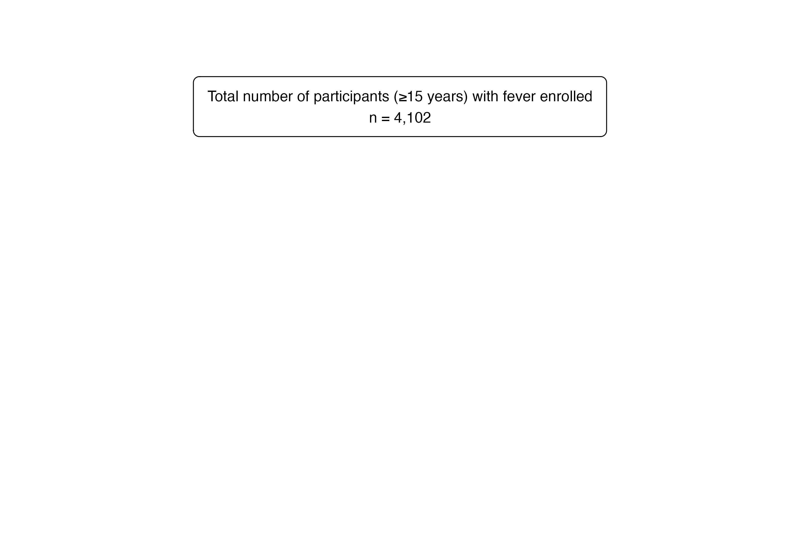

Flowchart of febrile participants (aged ≥15 years) enrolled and followed up between 2018 and 2021 at four sites (Lao PDR, Malawi, Mozambique, and Zimbabwe). MEWS=modified early warning score, qSOFA=quick sequential organ failure assessment, UVA=universal vital assessment score.

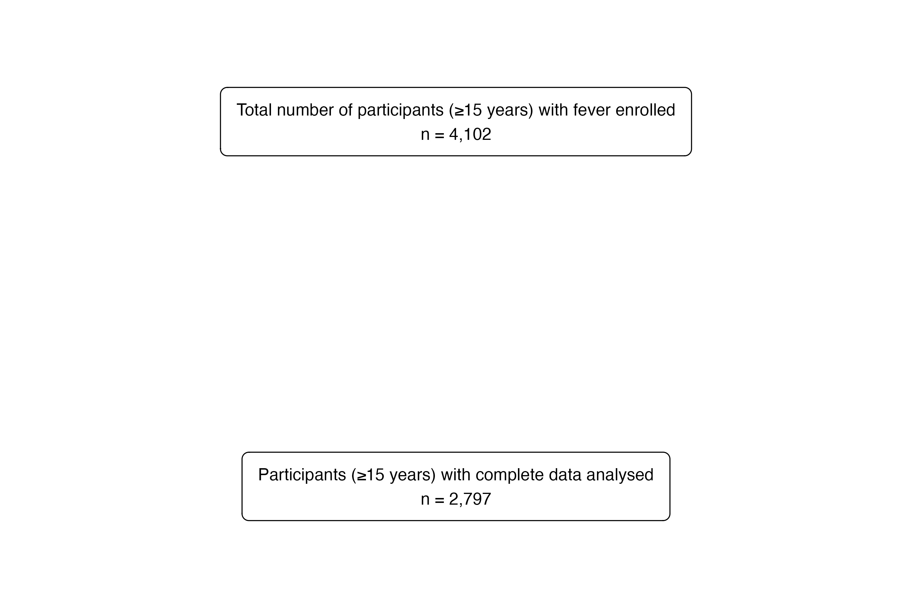

Flowchart of febrile participants (aged ≥15 years) enrolled and followed up between 2018 and 2021 at four sites (Lao PDR, Malawi, Mozambique, and Zimbabwe). MEWS=modified early warning score, qSOFA=quick sequential organ failure assessment, UVA=universal vital assessment score.

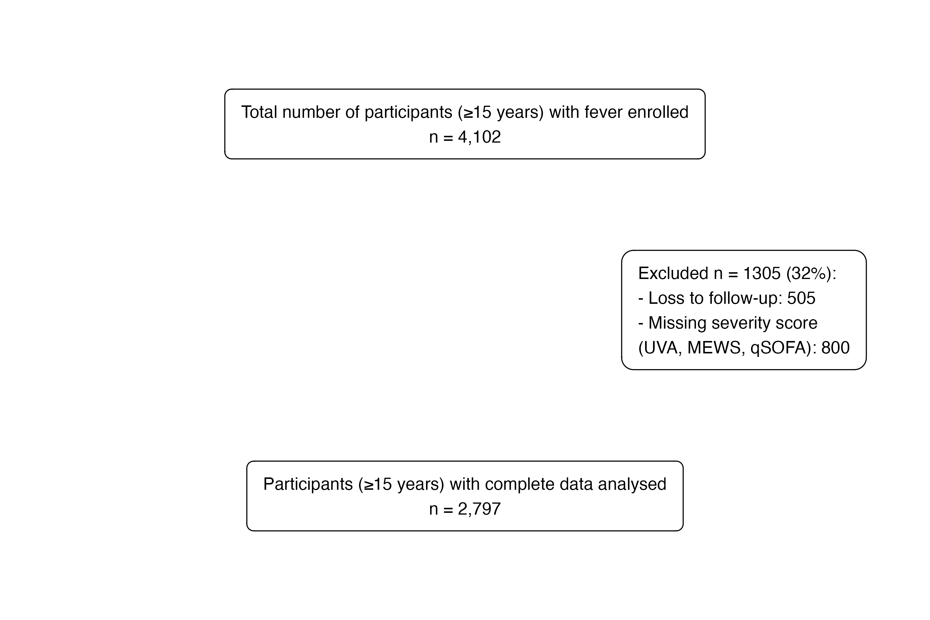

Flowchart of febrile participants (aged ≥15 years) enrolled and followed up between 2018 and 2021 at four sites (Lao PDR, Malawi, Mozambique, and Zimbabwe). MEWS=modified early warning score, qSOFA=quick sequential organ failure assessment, UVA=universal vital assessment score.

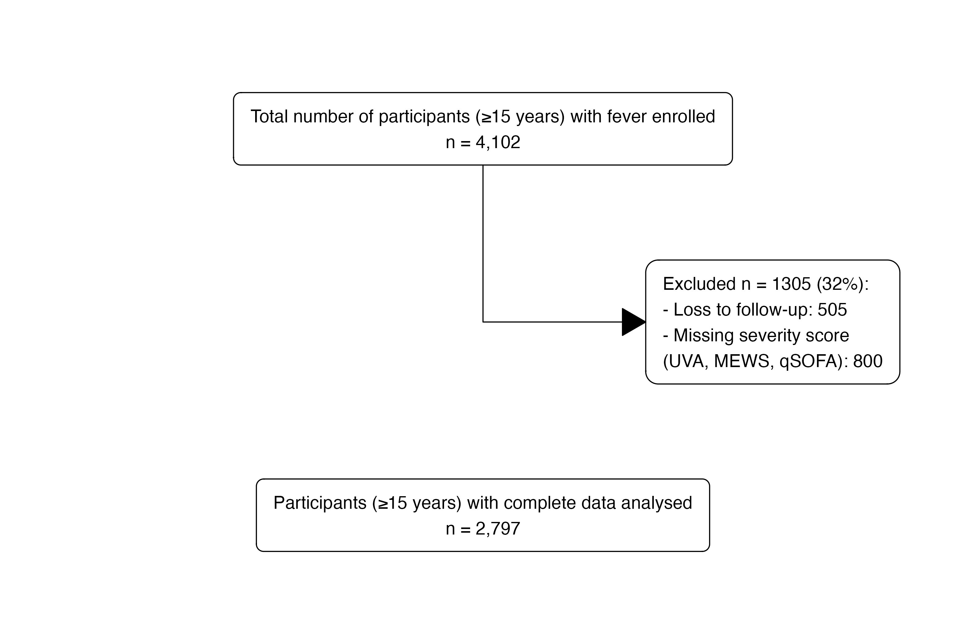

Flowchart of febrile participants (aged ≥15 years) enrolled and followed up between 2018 and 2021 at four sites (Lao PDR, Malawi, Mozambique, and Zimbabwe). MEWS=modified early warning score, qSOFA=quick sequential organ failure assessment, UVA=universal vital assessment score.

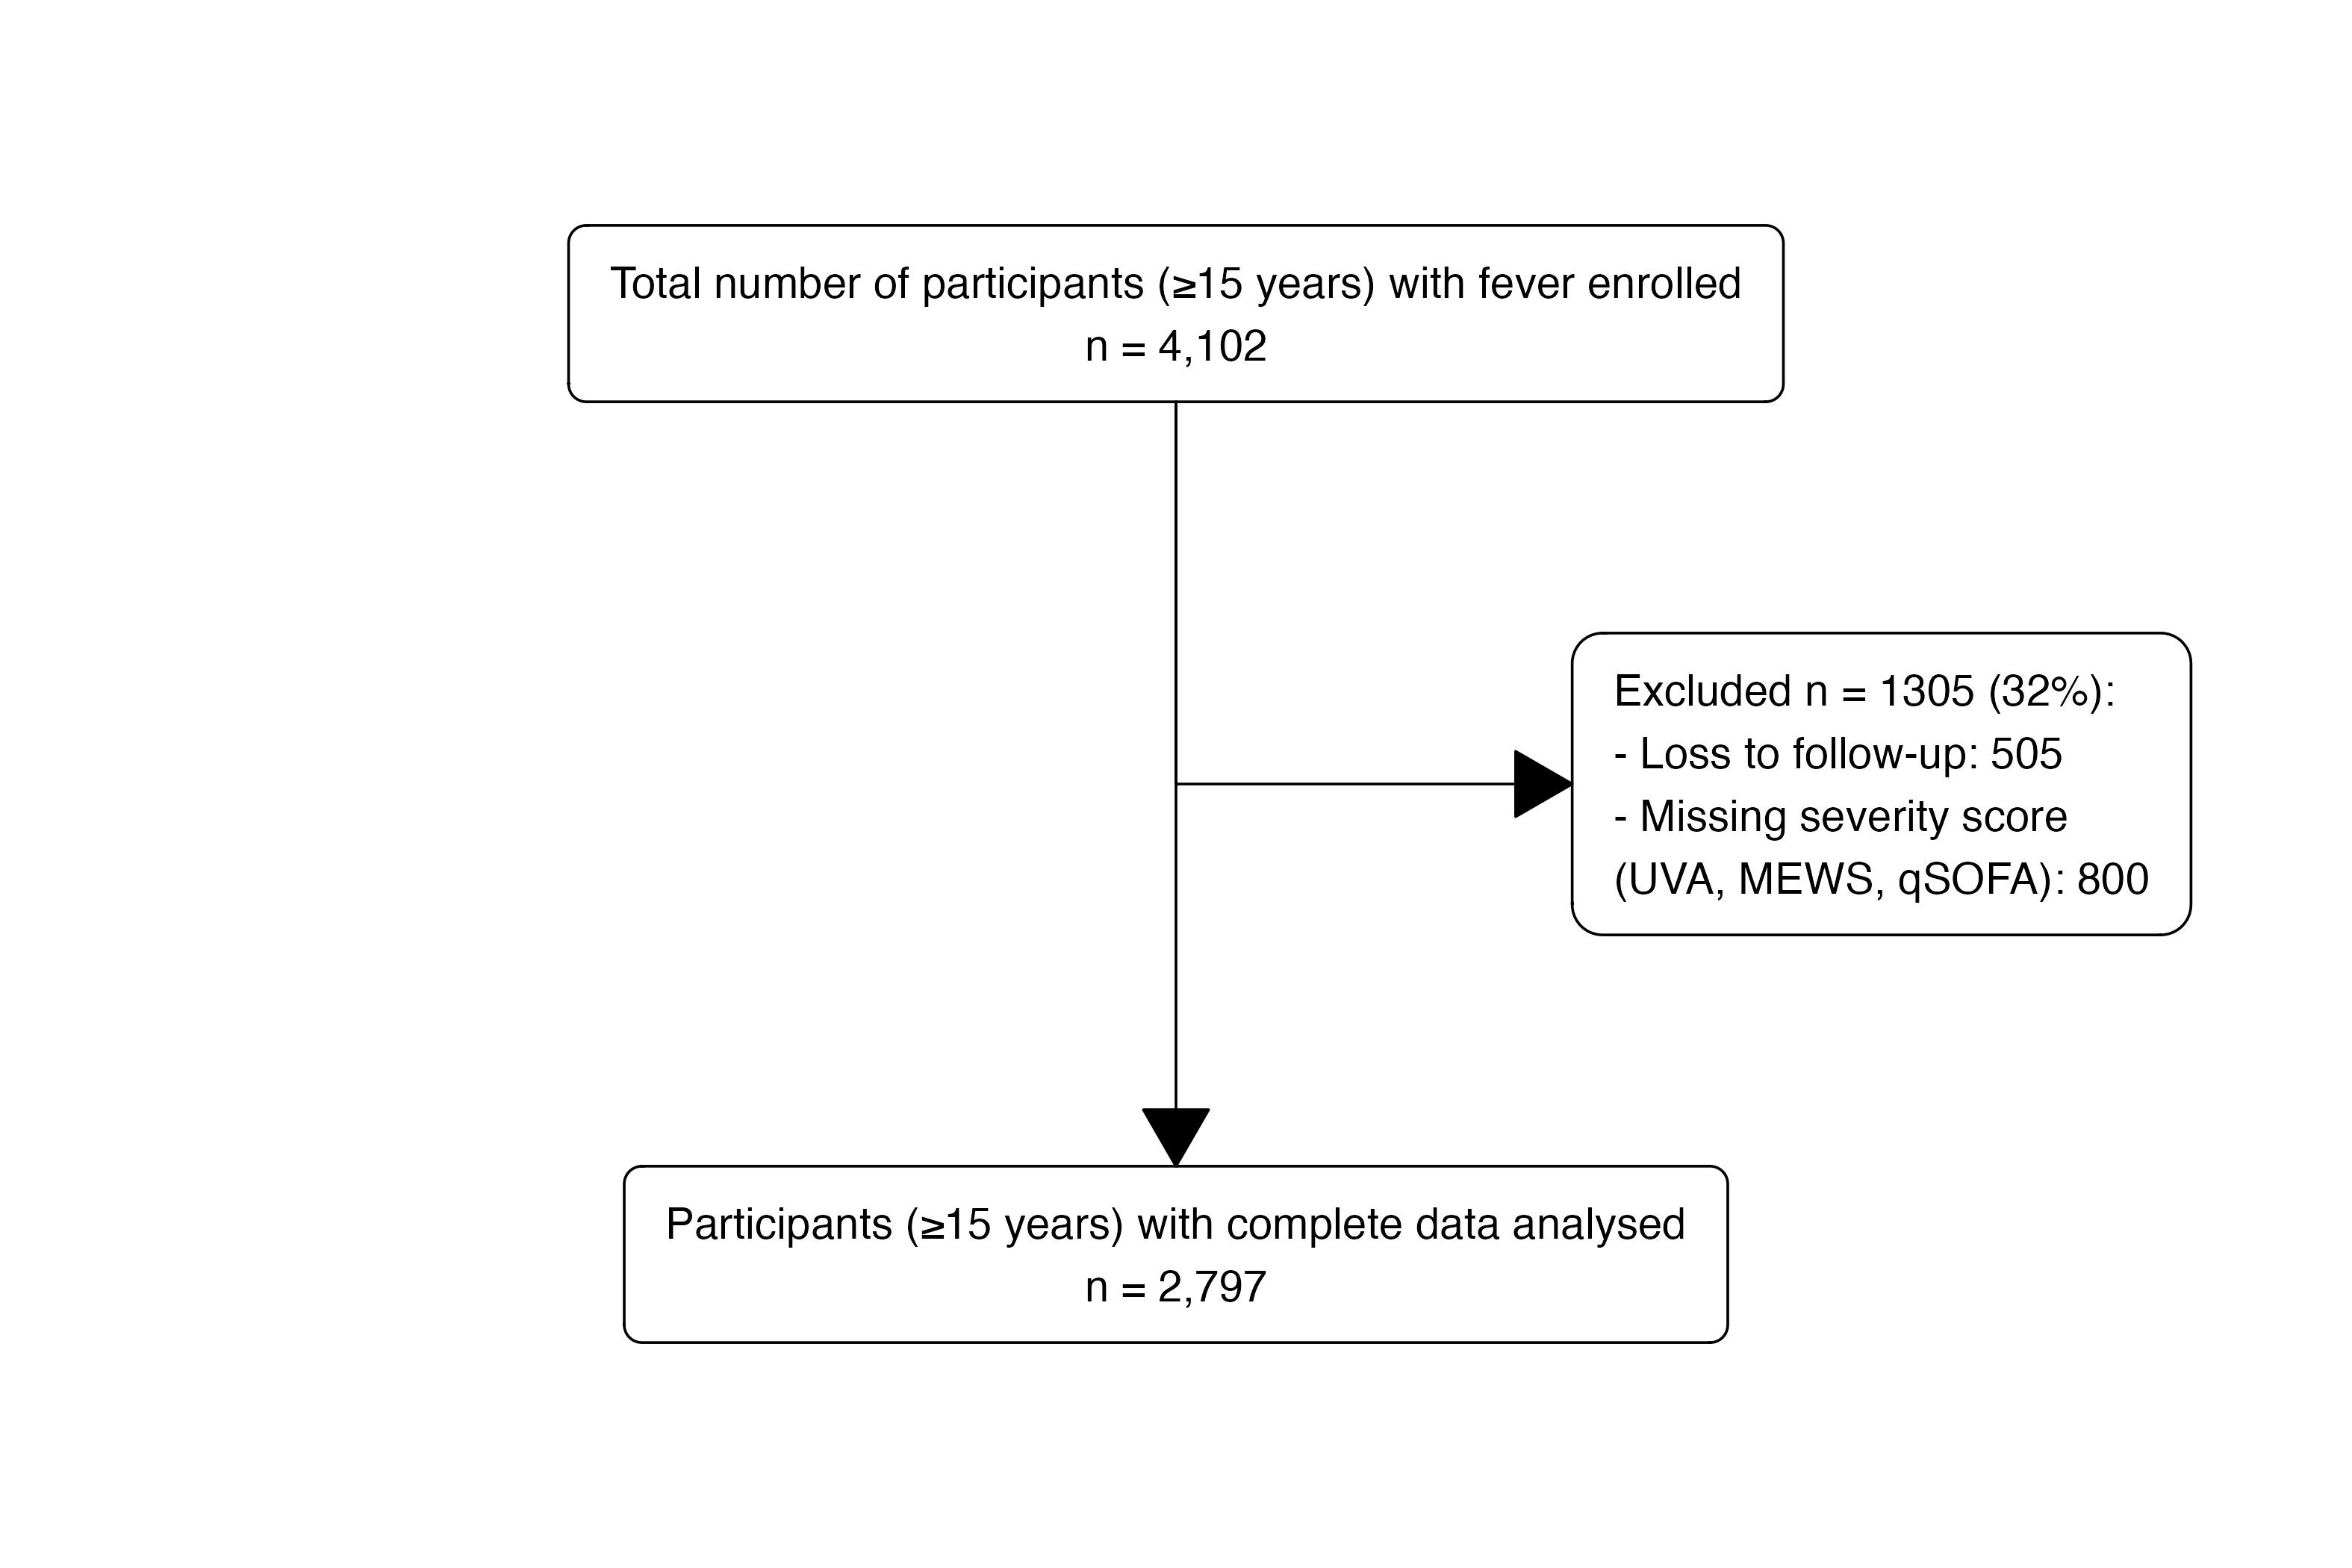

Flowchart of febrile participants (aged ≥15 years) enrolled and followed up between 2018 and 2021 at four sites (Lao PDR, Malawi, Mozambique, and Zimbabwe). MEWS=modified early warning score, qSOFA=quick sequential organ failure assessment, UVA=universal vital assessment score.

### Figure 2a

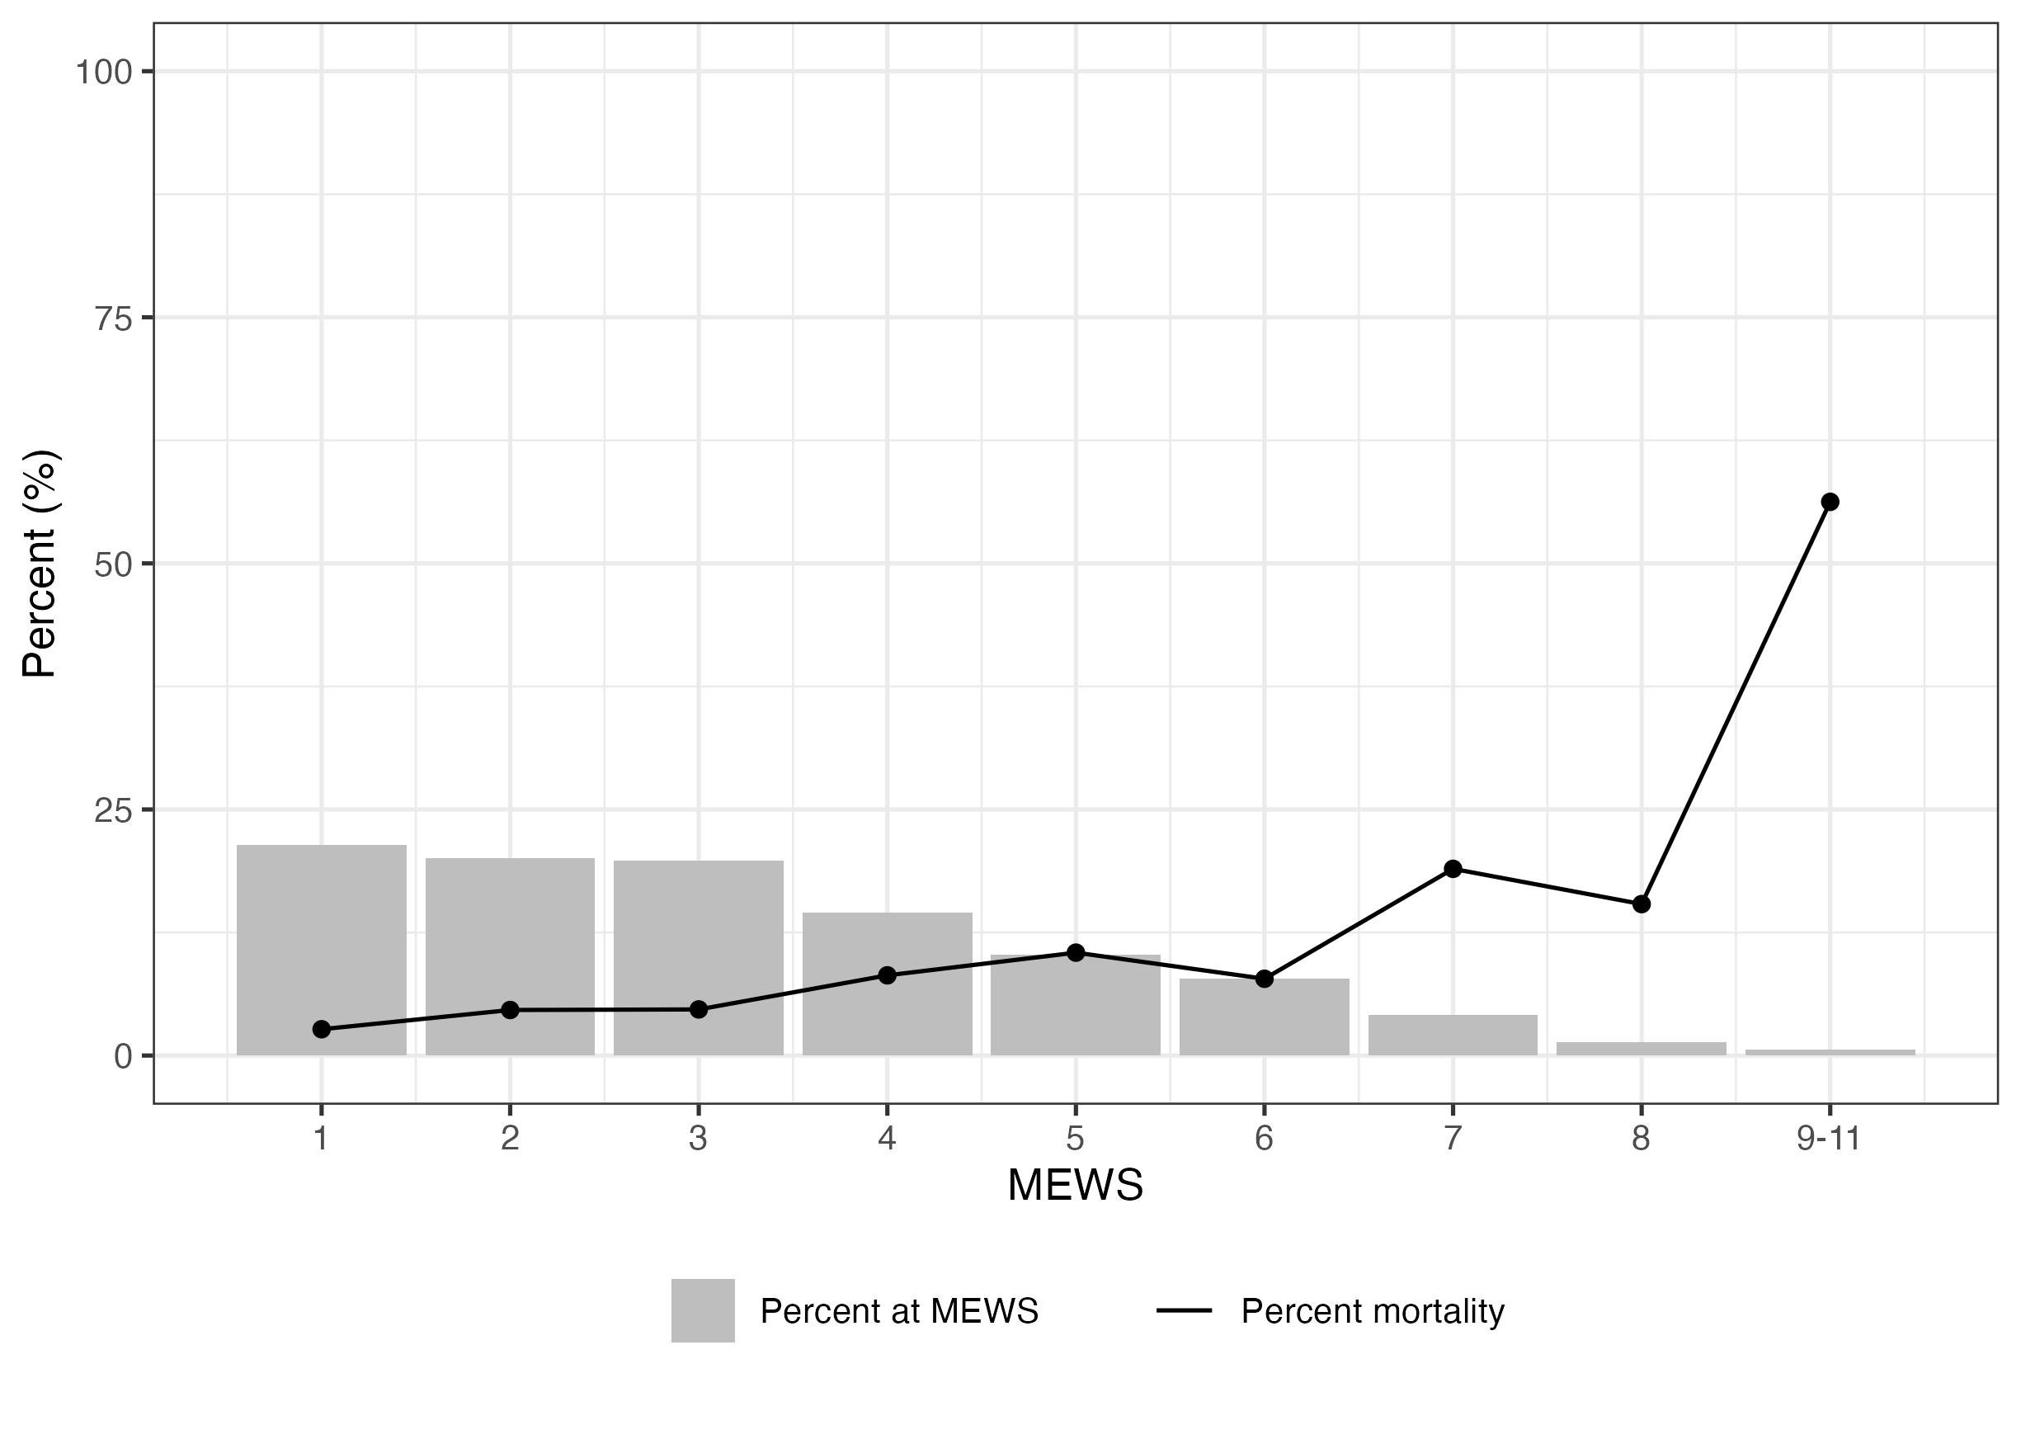

Distribution of MEWs by Day 28 outcome (grouped)

### Figure 2b

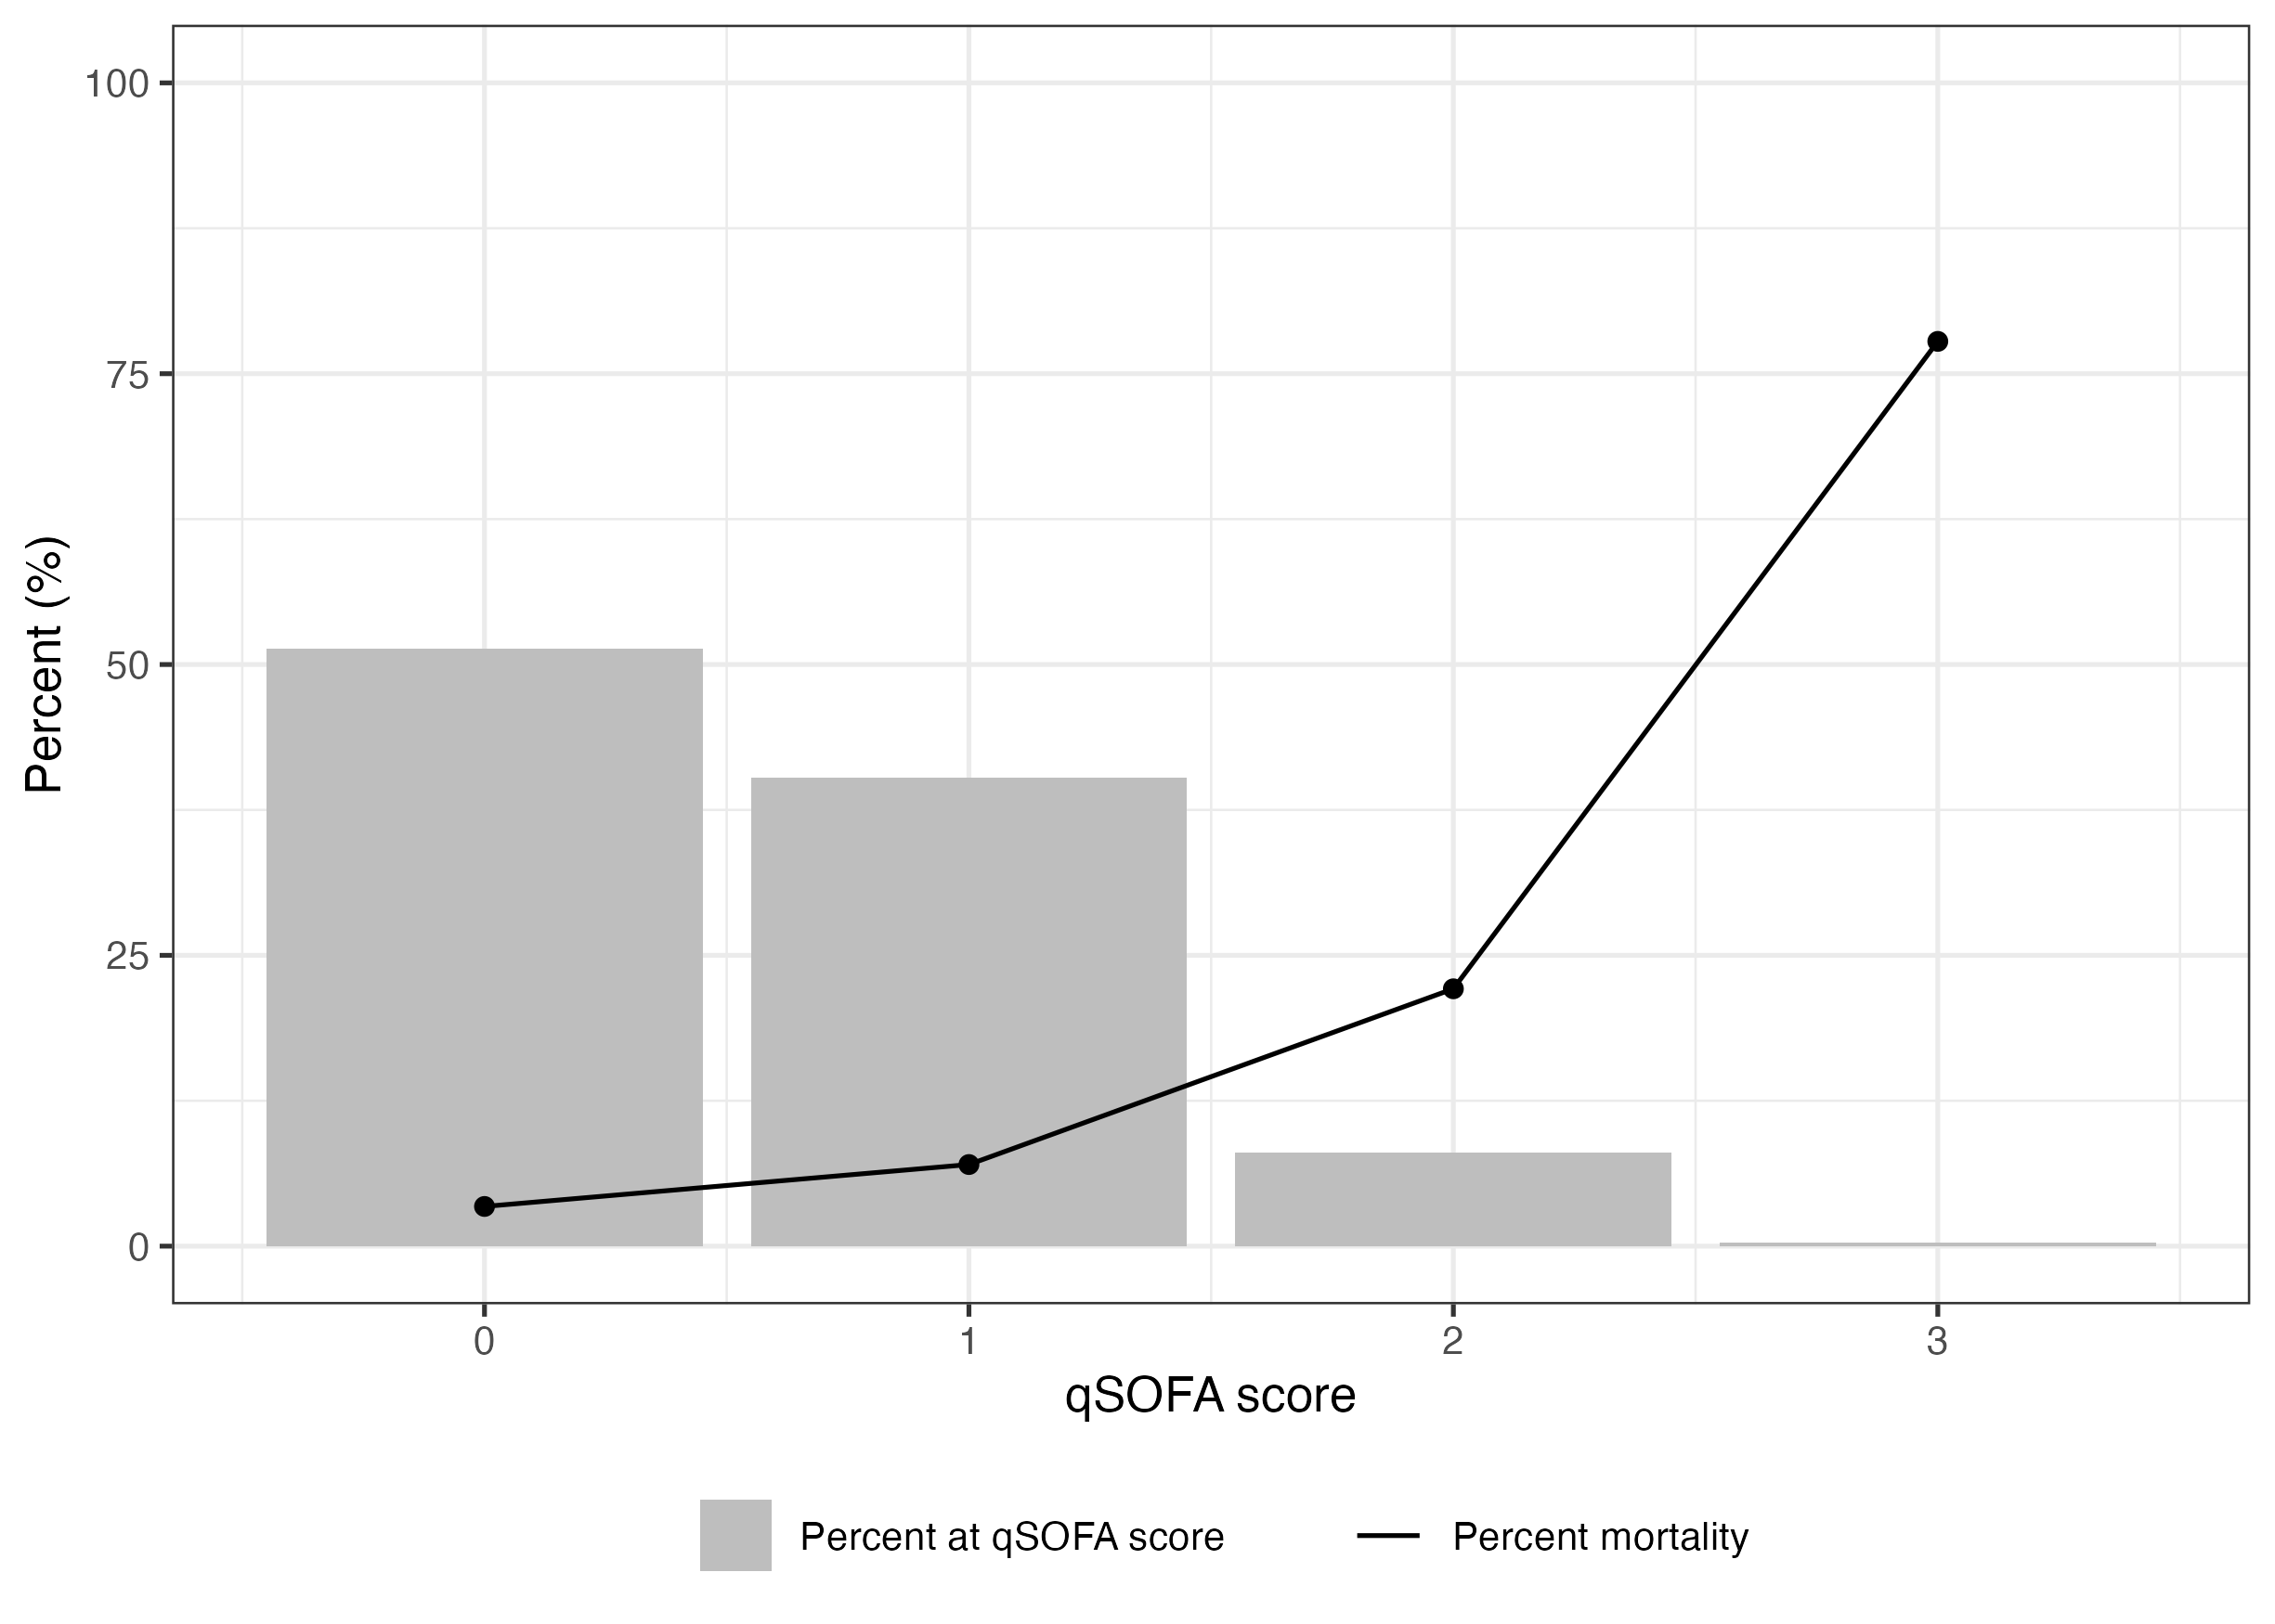

Distribution of qSOFA by Day 28 outcome

### Figure 2c

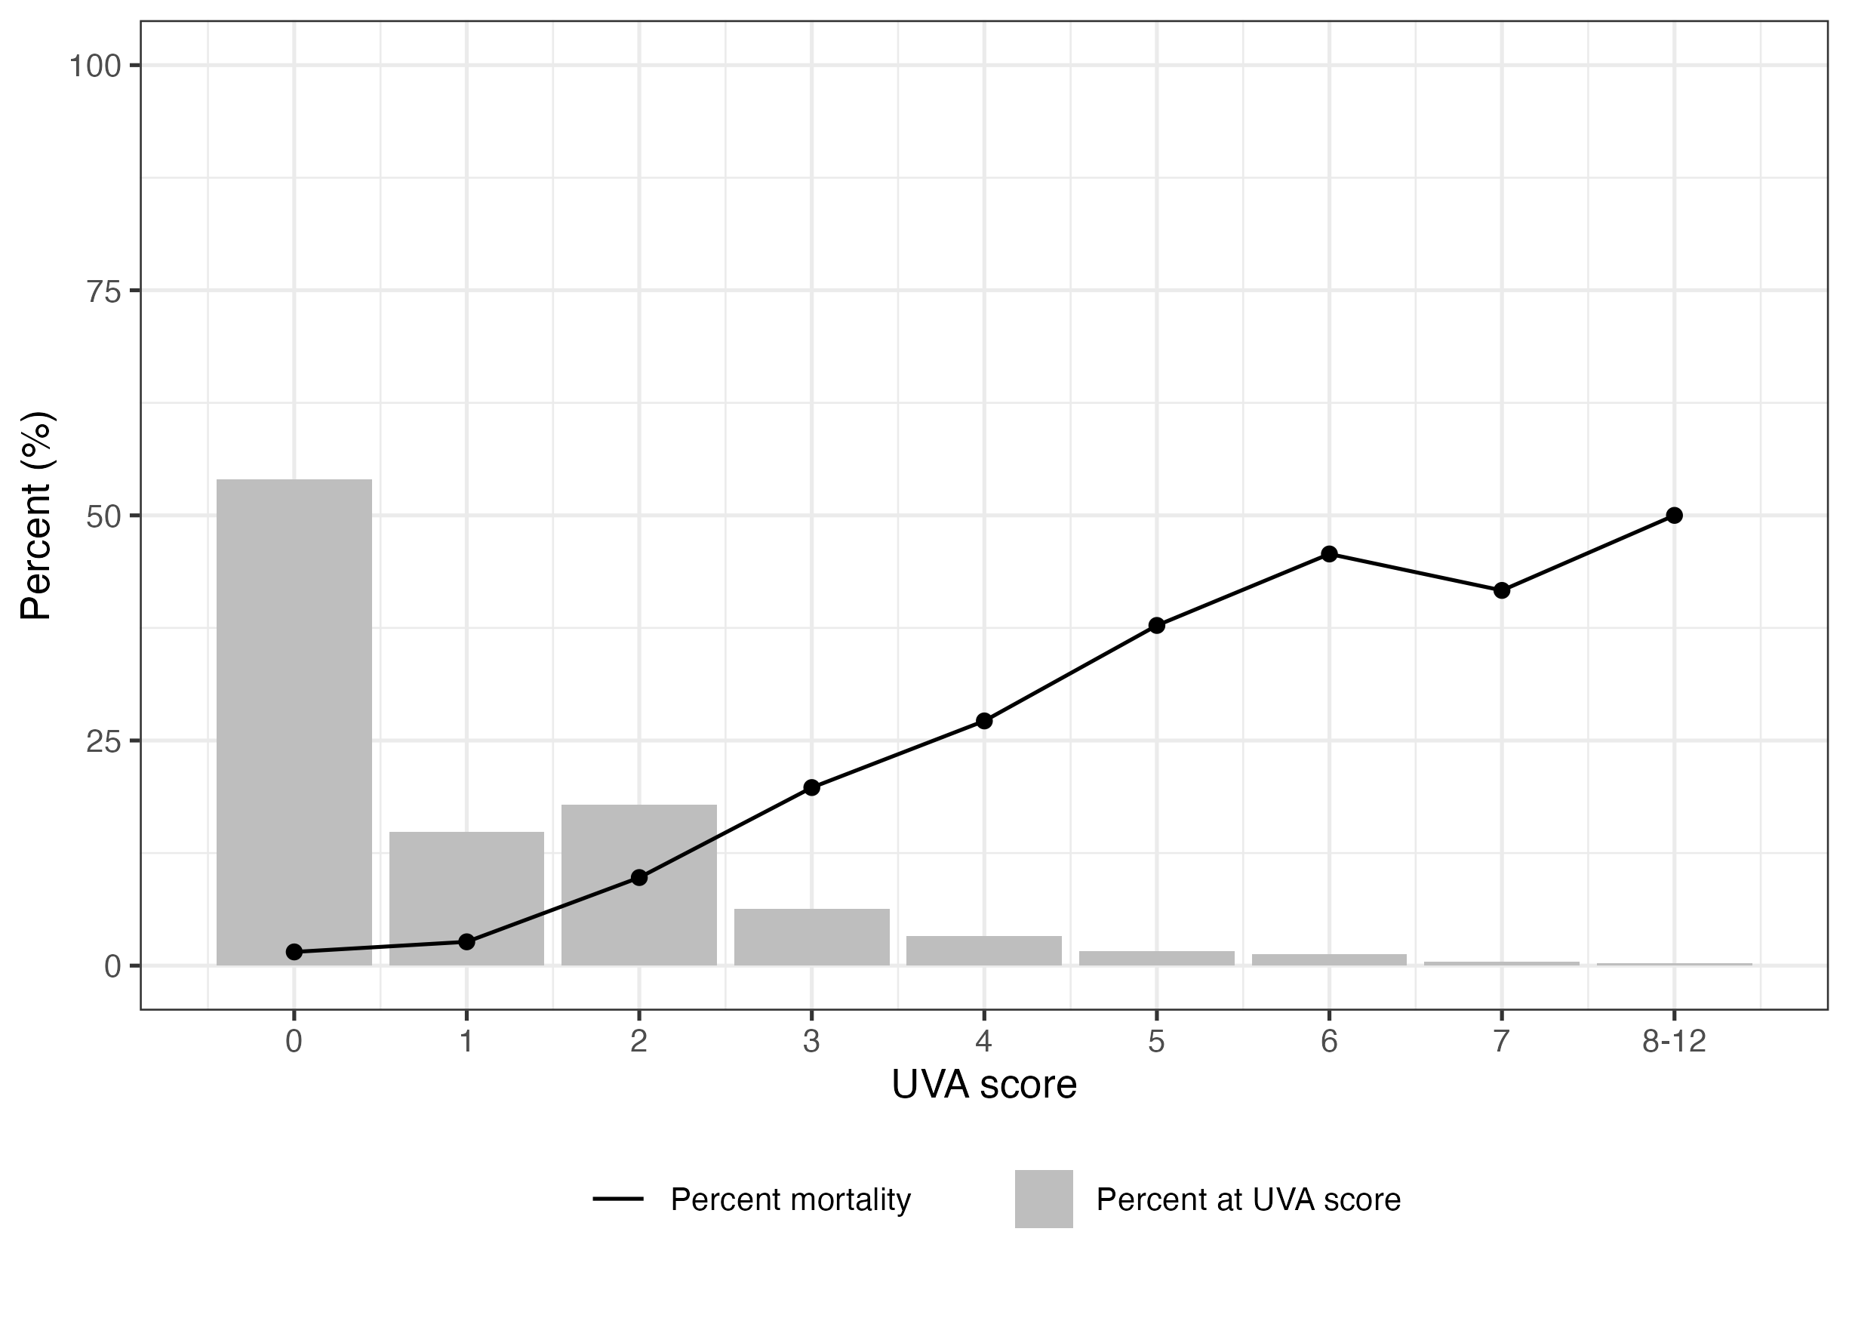

Distribution of UVA score by Day 28 outcome (grouped)

### Figure 2

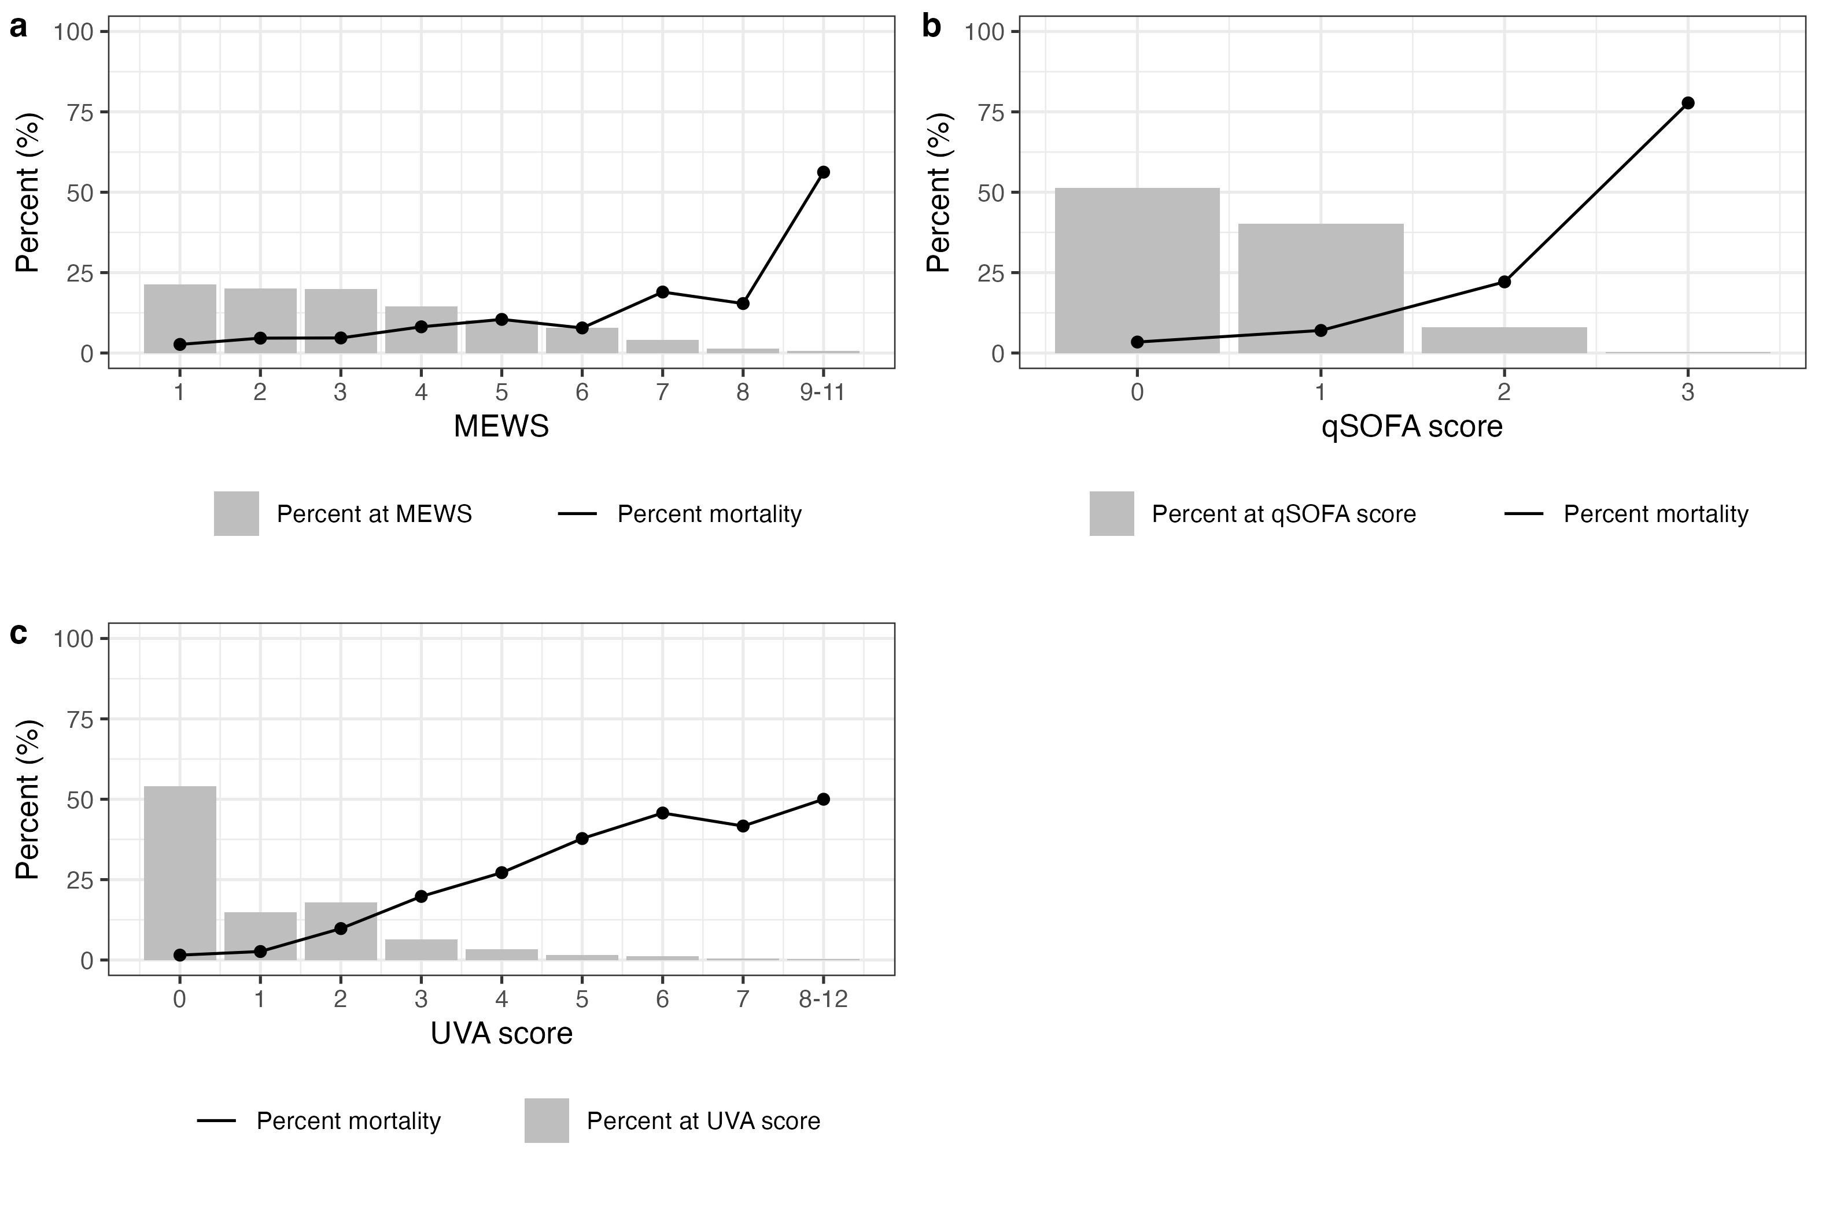

The percentage distribution of each severity score (MEWS, qSOFA and UVA) and associated mortality at time of day 28 follow-up, among febrile participants (aged ≥15 years) with complete data enrolled between 2018 and 2021 across four sites (Lao PDR, Malawi, Mozambique, and Zimbabwe). Severity scores above 8 for MEWS and above 7 for UVA were grouped due to less than 5 outcomes reported. MEWS=modified early warning score, qSOFA=quick sequential organ failure assessment, UVA=universal vital assessment score

### Figure 3a

#### MEWS ROC results

MEWS area under the curve = 0.67, 95% CI: 0.63-0.71

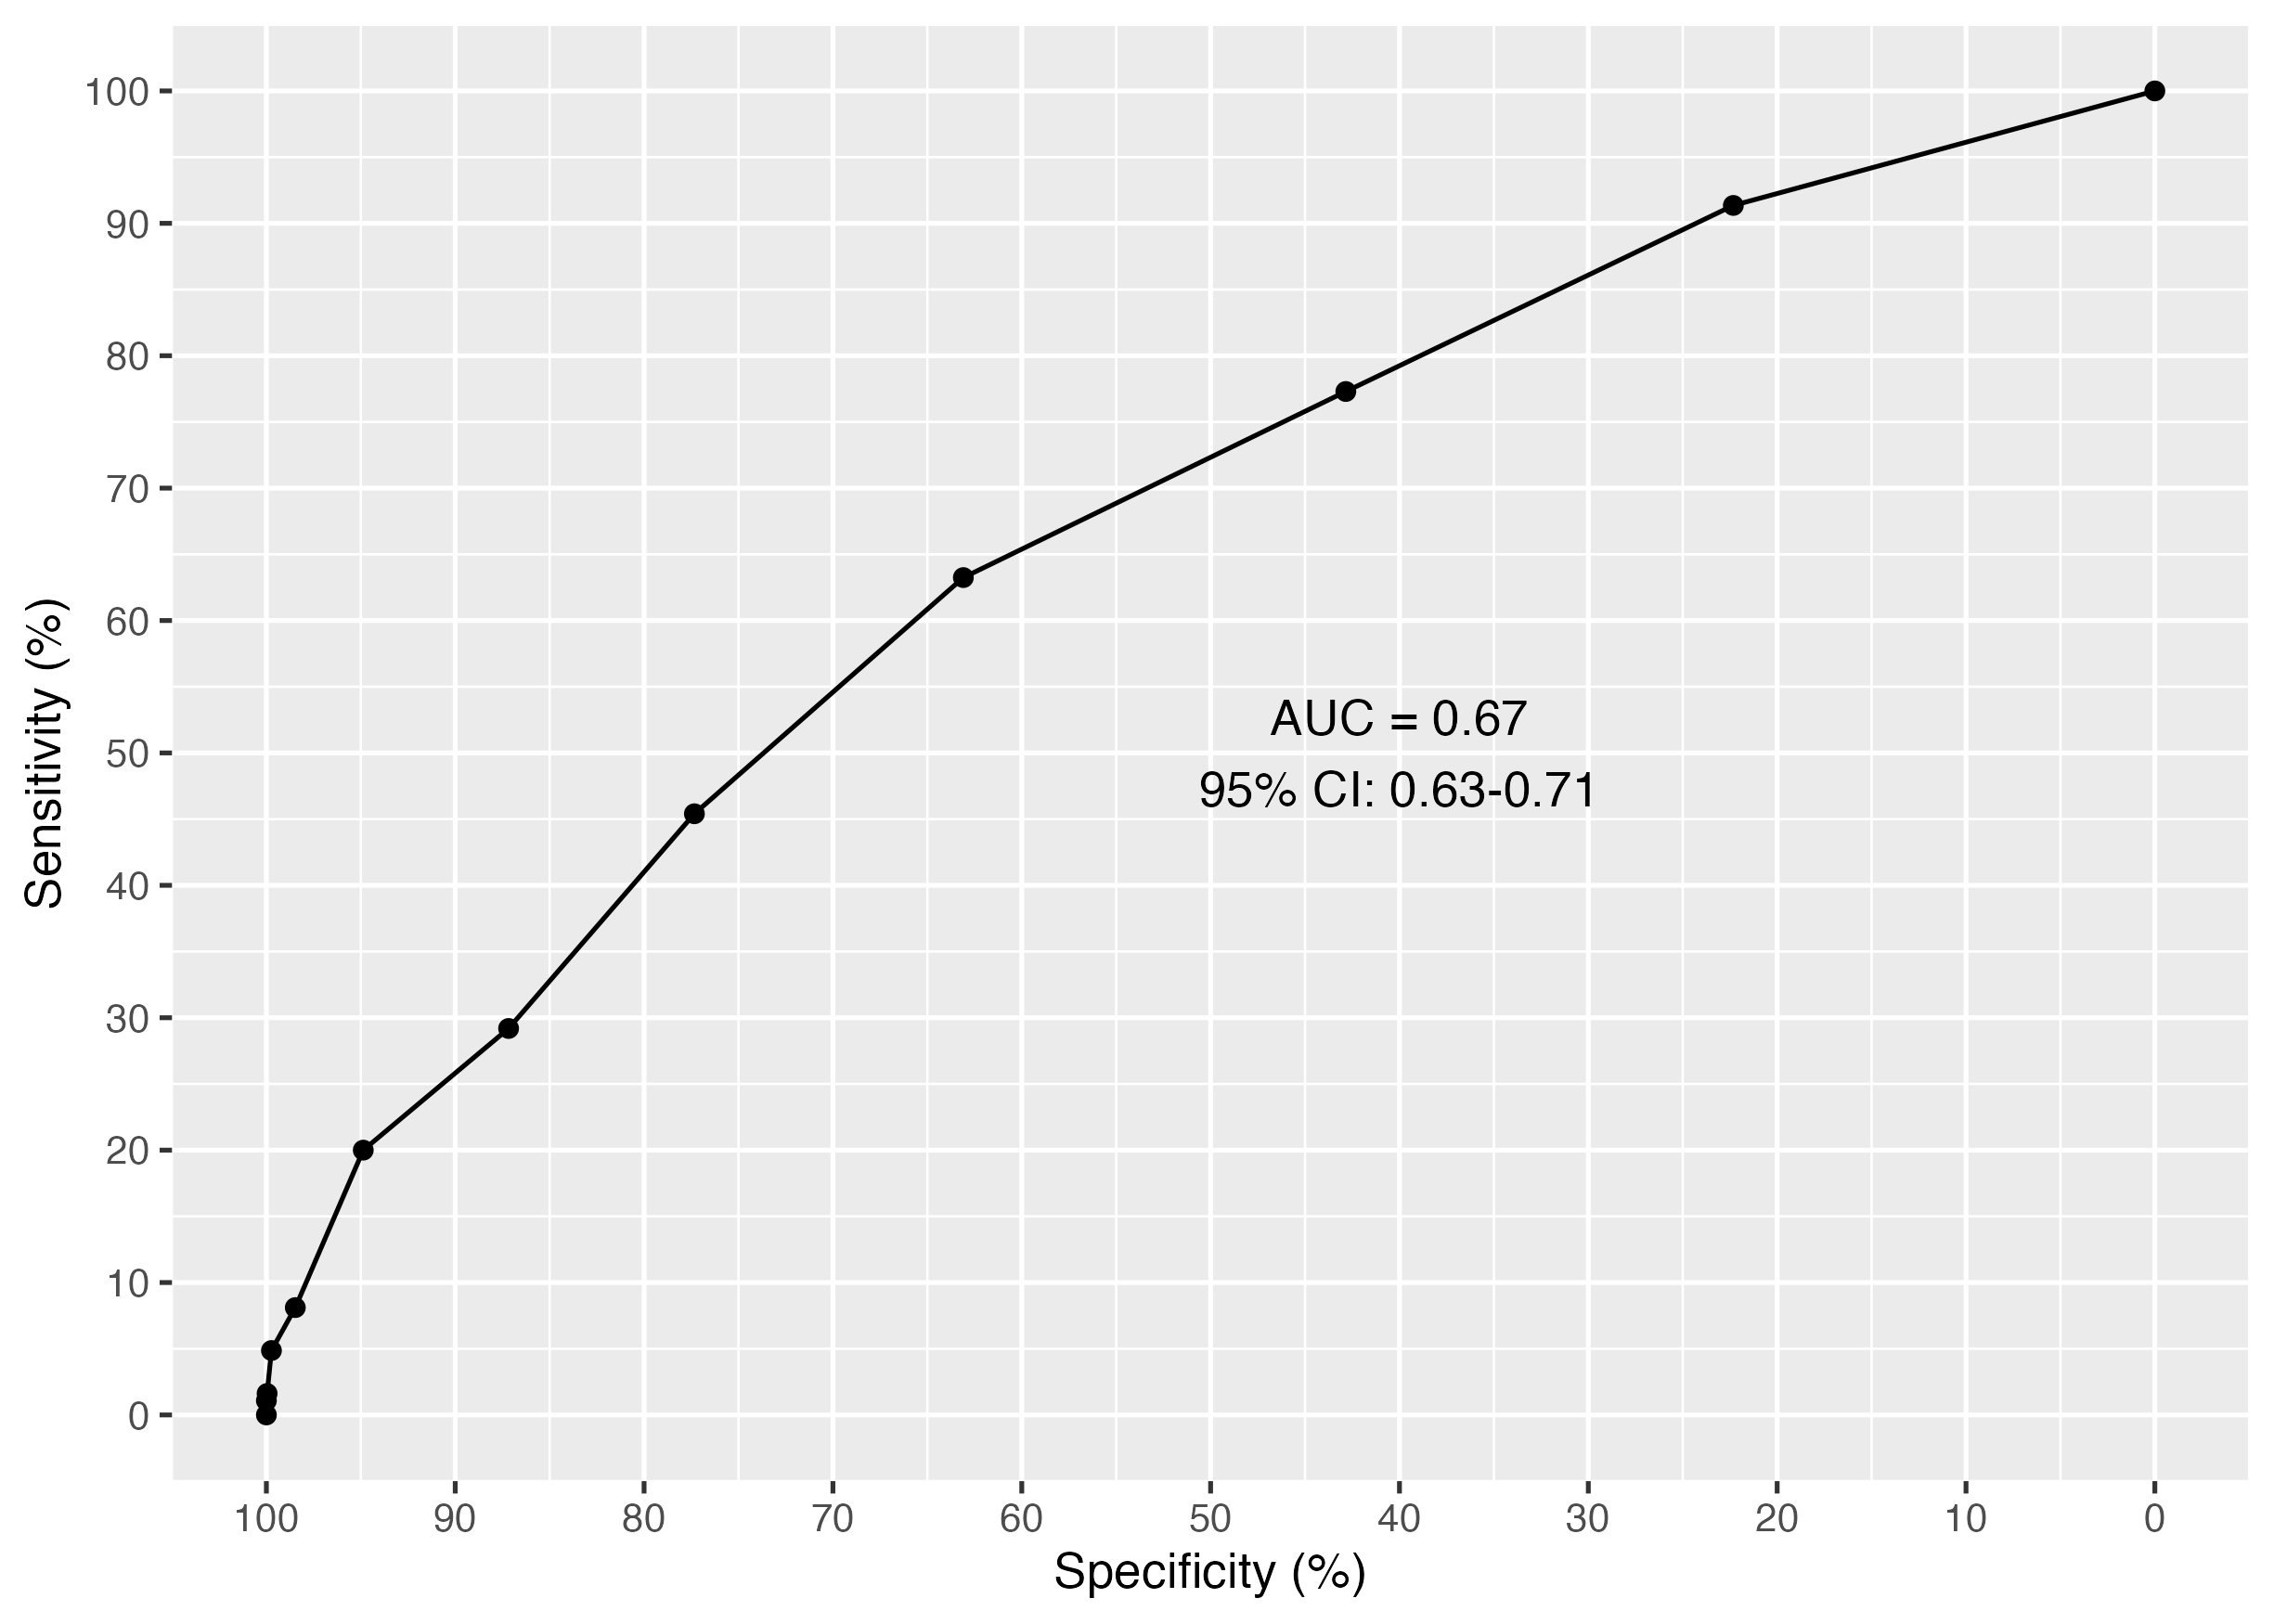

MEWS Receiver operating characteristic curve

| threshold_cat | specificity | sensitivity | npv | ppv |
| --- | --- | --- | --- | --- |
| 0 | 0.00 | 100.00 |  | 6.61 |
| 1 | 22.32 | 91.35 | 97.33 | 7.69 |
| 2 | 42.84 | 77.30 | 96.38 | 8.74 |
| 3 | 63.09 | 63.24 | 96.04 | 10.82 |
| 4 | 77.34 | 45.41 | 95.24 | 12.43 |
| 5 | 87.17 | 29.19 | 94.56 | 13.88 |
| 6 | 94.87 | 20.00 | 94.36 | 21.64 |
| 7 | 98.47 | 8.11 | 93.80 | 27.27 |
| 8 | 99.73 | 4.86 | 93.67 | 56.25 |
| 9 | 99.96 | 1.62 | 93.48 | 75.00 |
| 10 | 100.00 | 1.08 | 93.45 | 100.00 |
| 11 | 100.00 | 0.00 | 93.39 |  |

### Figure 3b

#### qSOFA ROC results

qSOFA area under the curve = 0.68, 95% CI: 0.64-0.72

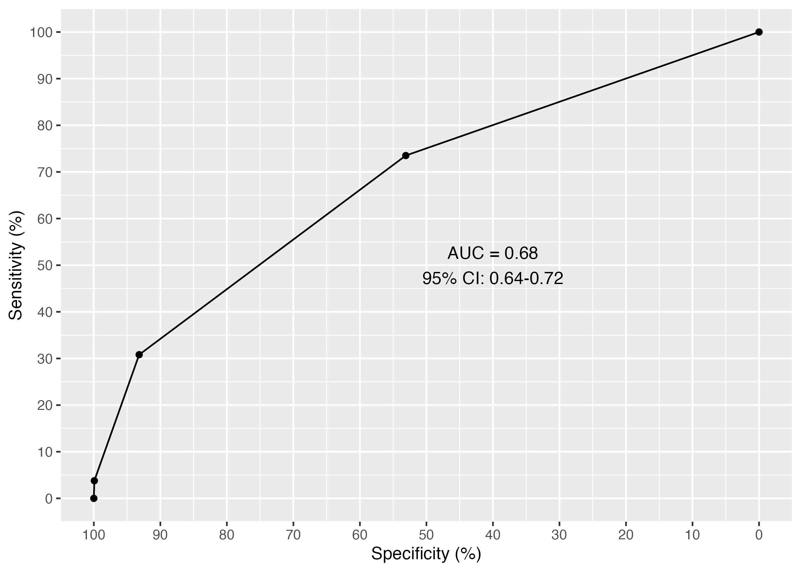

qSOFA Specificity (%) and specificity values

| threshold_cat | specificity | sensitivity | npv | ppv |
| --- | --- | --- | --- | --- |
| 0 | 0.00 | 100.00 |  | 6.61 |
| 1 | 53.10 | 73.51 | 96.59 | 9.99 |
| 2 | 93.19 | 30.81 | 95.00 | 24.26 |
| 3 | 99.92 | 3.78 | 93.62 | 77.78 |
| 4 | 100.00 | 0.00 | 93.39 |  |

### Figure 3c

#### UVA Score ROC results

UVA area under the curve (AUC) = 0.82, 95% CI: 0.79-0.85

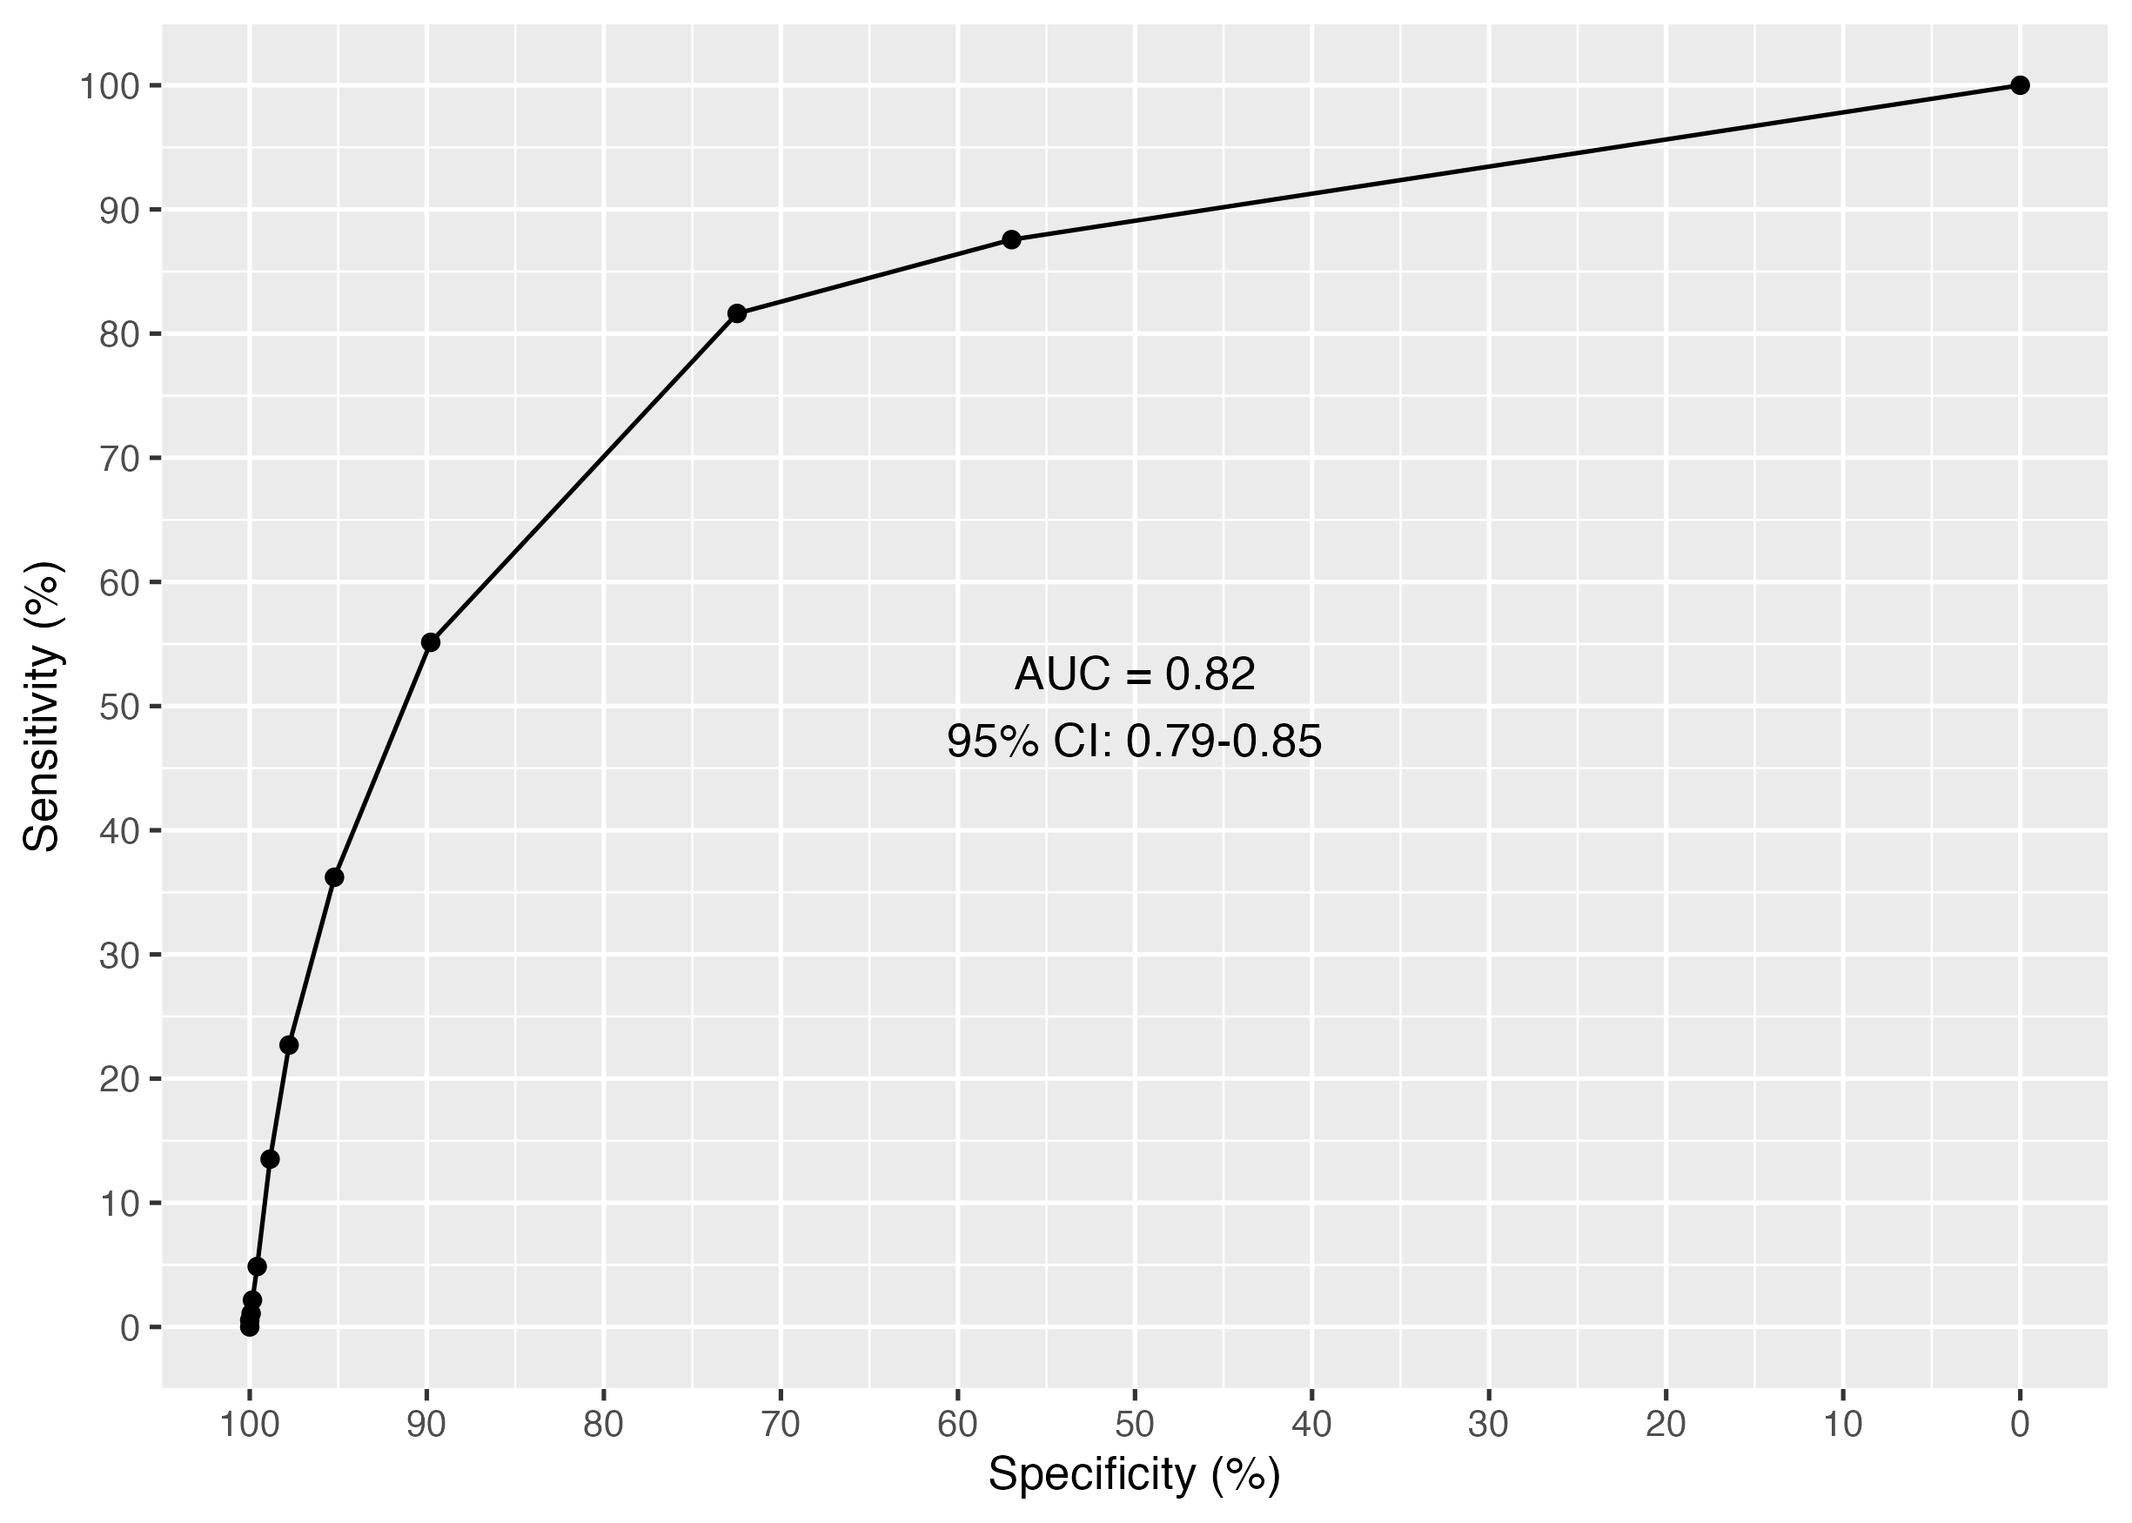

UVA Receiver operating characteristic curve

| threshold_cat | specificity | sensitivity | npv | ppv |
| --- | --- | --- | --- | --- |
| 0 | 0.00 | 100.00 |  | 6.61 |
| 1 | 56.97 | 87.57 | 98.48 | 12.60 |
| 2 | 72.47 | 81.62 | 98.24 | 17.36 |
| 3 | 89.78 | 55.14 | 96.58 | 27.64 |
| 4 | 95.21 | 36.22 | 95.47 | 34.90 |
| 5 | 97.78 | 22.70 | 94.70 | 42.00 |
| 6 | 98.85 | 13.51 | 94.16 | 45.45 |
| 7 | 99.58 | 4.86 | 93.66 | 45.00 |
| 8 | 99.85 | 2.16 | 93.51 | 50.00 |
| 9 | 99.92 | 1.08 | 93.45 | 50.00 |
| 10 | 100.00 | 0.54 | 93.42 | 100.00 |
| 11 | 100.00 | 0.00 | 93.39 |  |

### Figure 3: Combined ROC

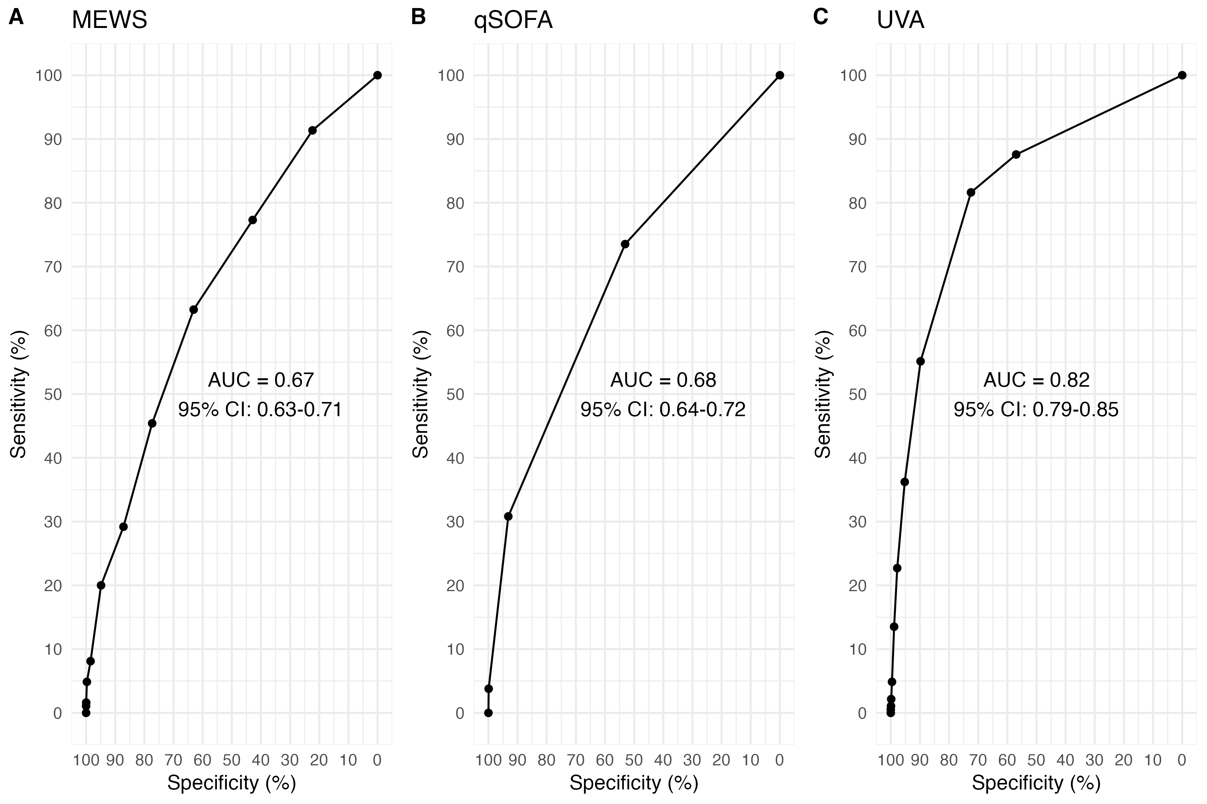

ROC curves for a) MEWS, b) qSOFA and c) UVA severity scores for predicting mortality by time of follow-up among febrile participants (aged ≥15 years) enrolled between 2018 and 2021 across four sites (Lao PDR, Malawi, Mozambique, and Zimbabwe). ROC=receiver operating characteristic, AUC=area under the curve, MEWS=modified early warning score, qSOFA=quick sequential organ failure assessment, UVA=universal vital assessment score, CI=confidence interval.

DeLong test, a pairwise comparison test for the equality of the area under the curve between;  
1) UVA (AUC:0.82, 95% CI: 0.79-0.85) vs. MEWS (AUC:0.67, 95% CI: 0.63-0.71), Z = 6.0902876, *p-value* = 0.00000000112708.  
2) UVA (AUC:0.82, 95% CI: 0.79-0.85) vs. qSOFA (AUC:0.68, 95% CI: 0.64-0.72), Z = 6.8039015, *p-value* = 0.00000000001018231.  
3) MEWs (AUC:0.67, 95% CI: 0.63-0.71) vs. qSOFA (AUC:0.68, 95% CI: 0.64-0.72), Z = -0.6513847, *p-value* = 0.5147982.

## Supplementary material figures

### Figure S1

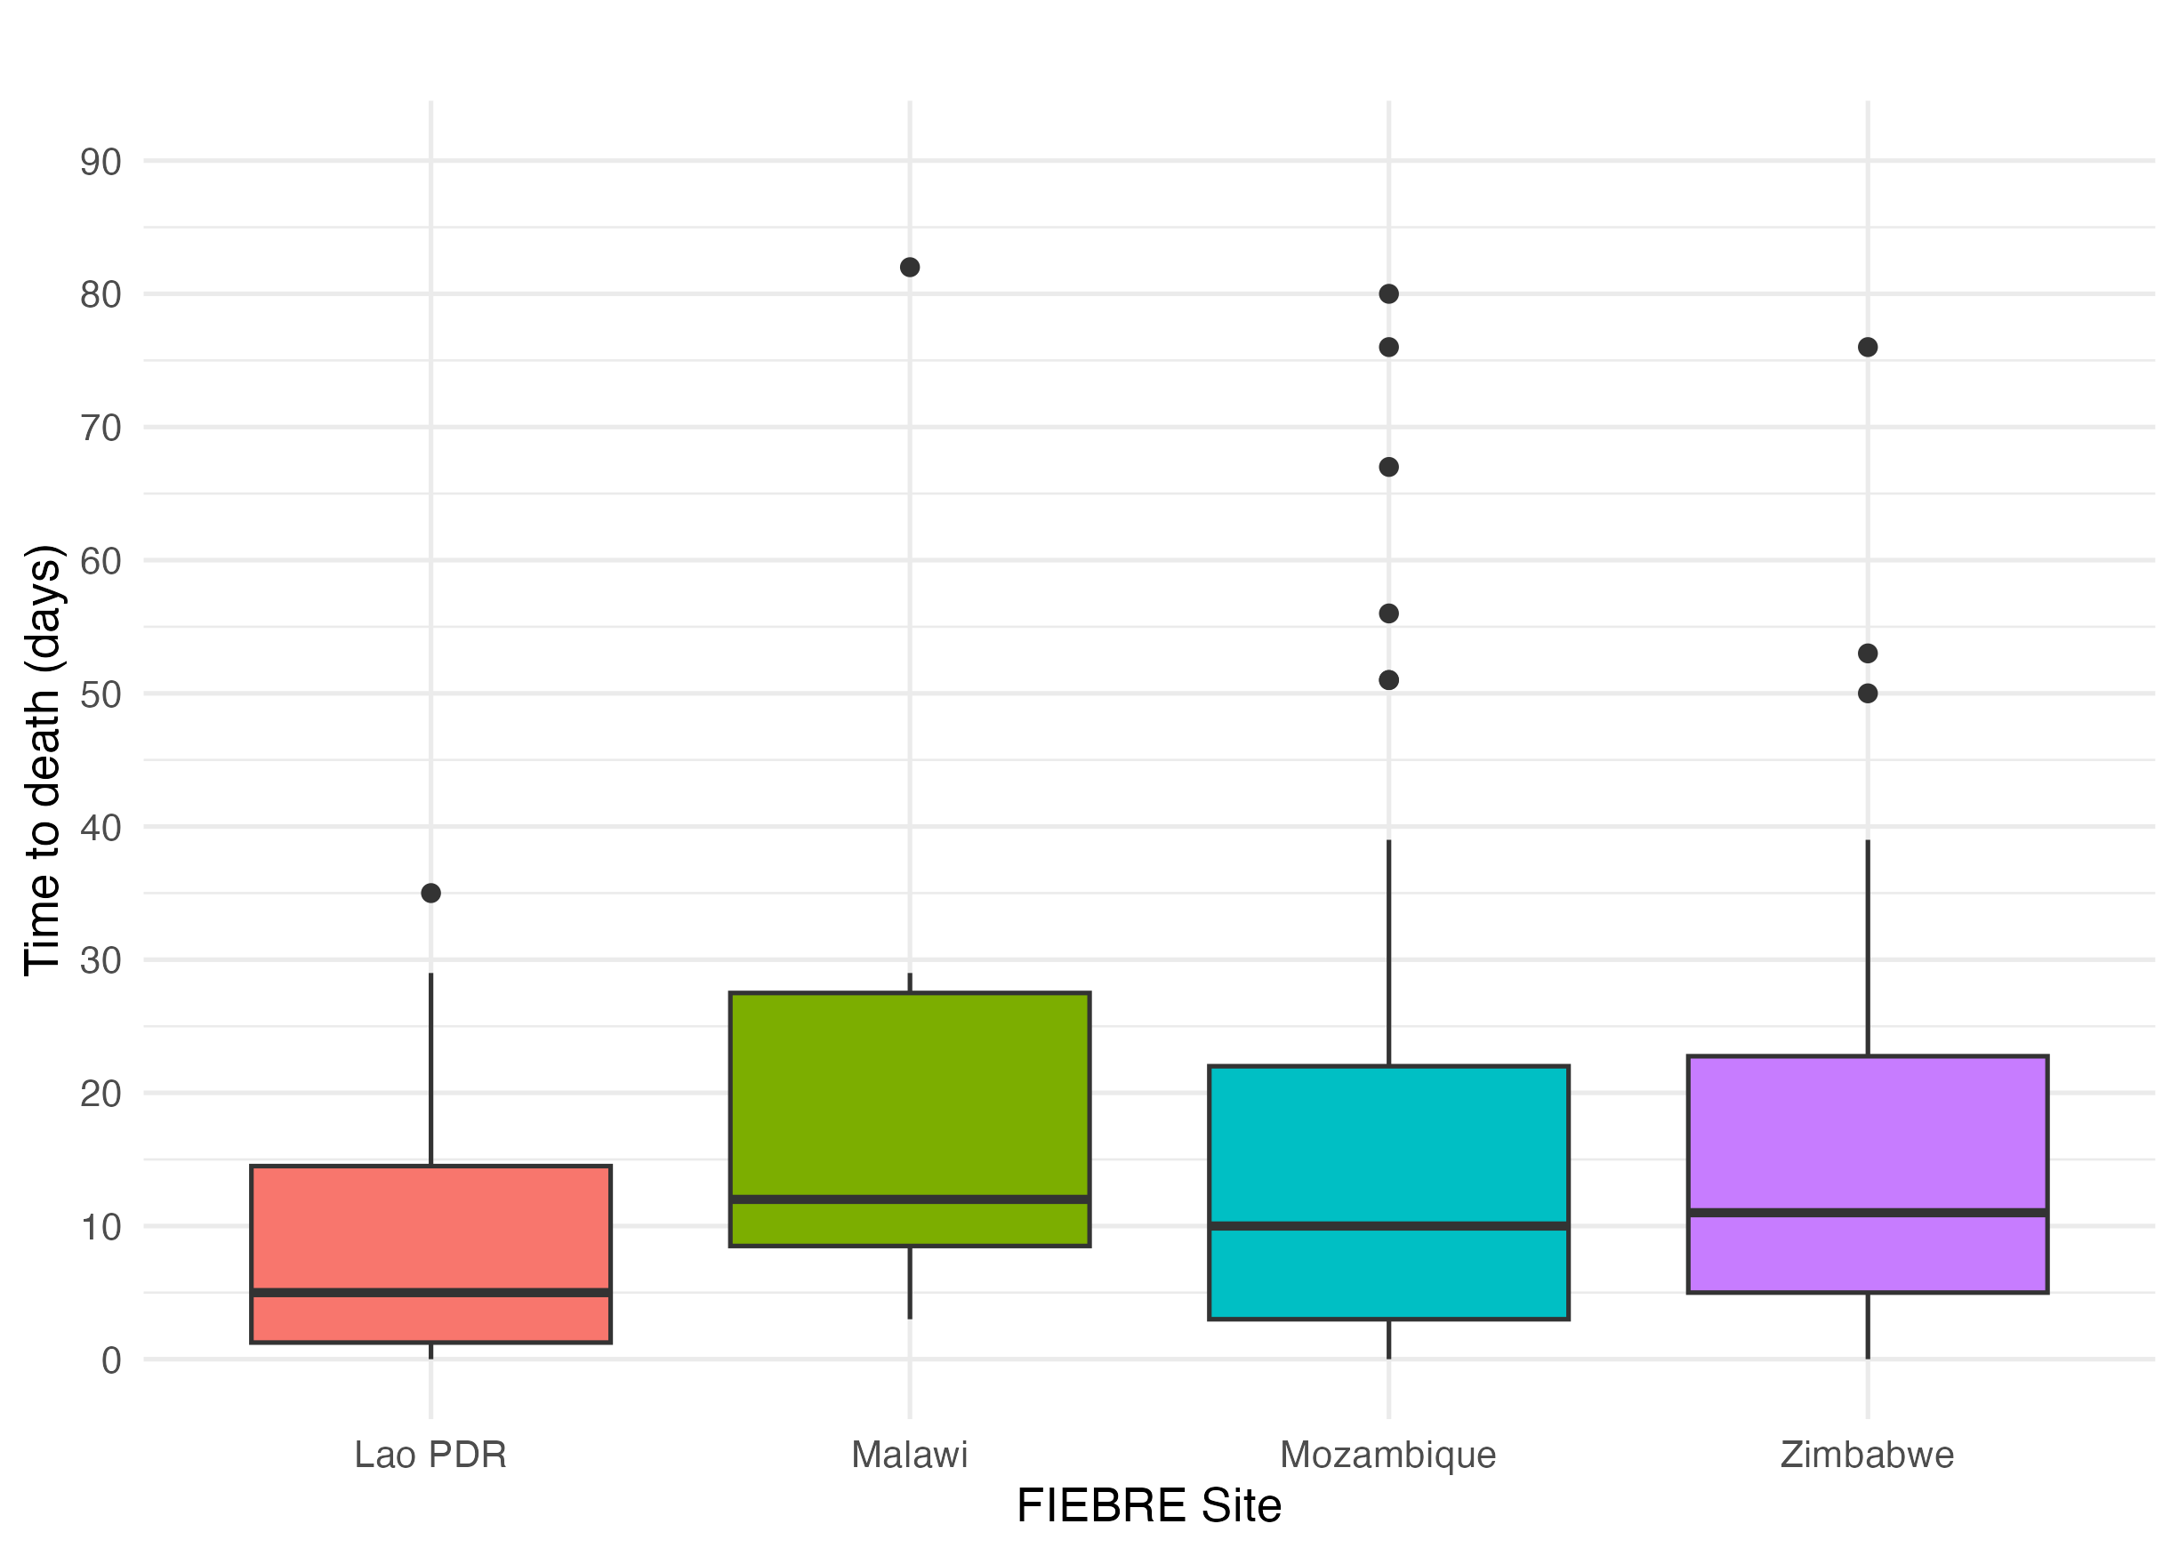

Box and whisker plot of time to death (days) by time to follow-up, by site among febrile participants (aged ≥15 years) enrolled between 2018 and 2021 across four sites (Lao PDR, Malawi, Mozambique, and Zimbabwe).

### Figure S2a

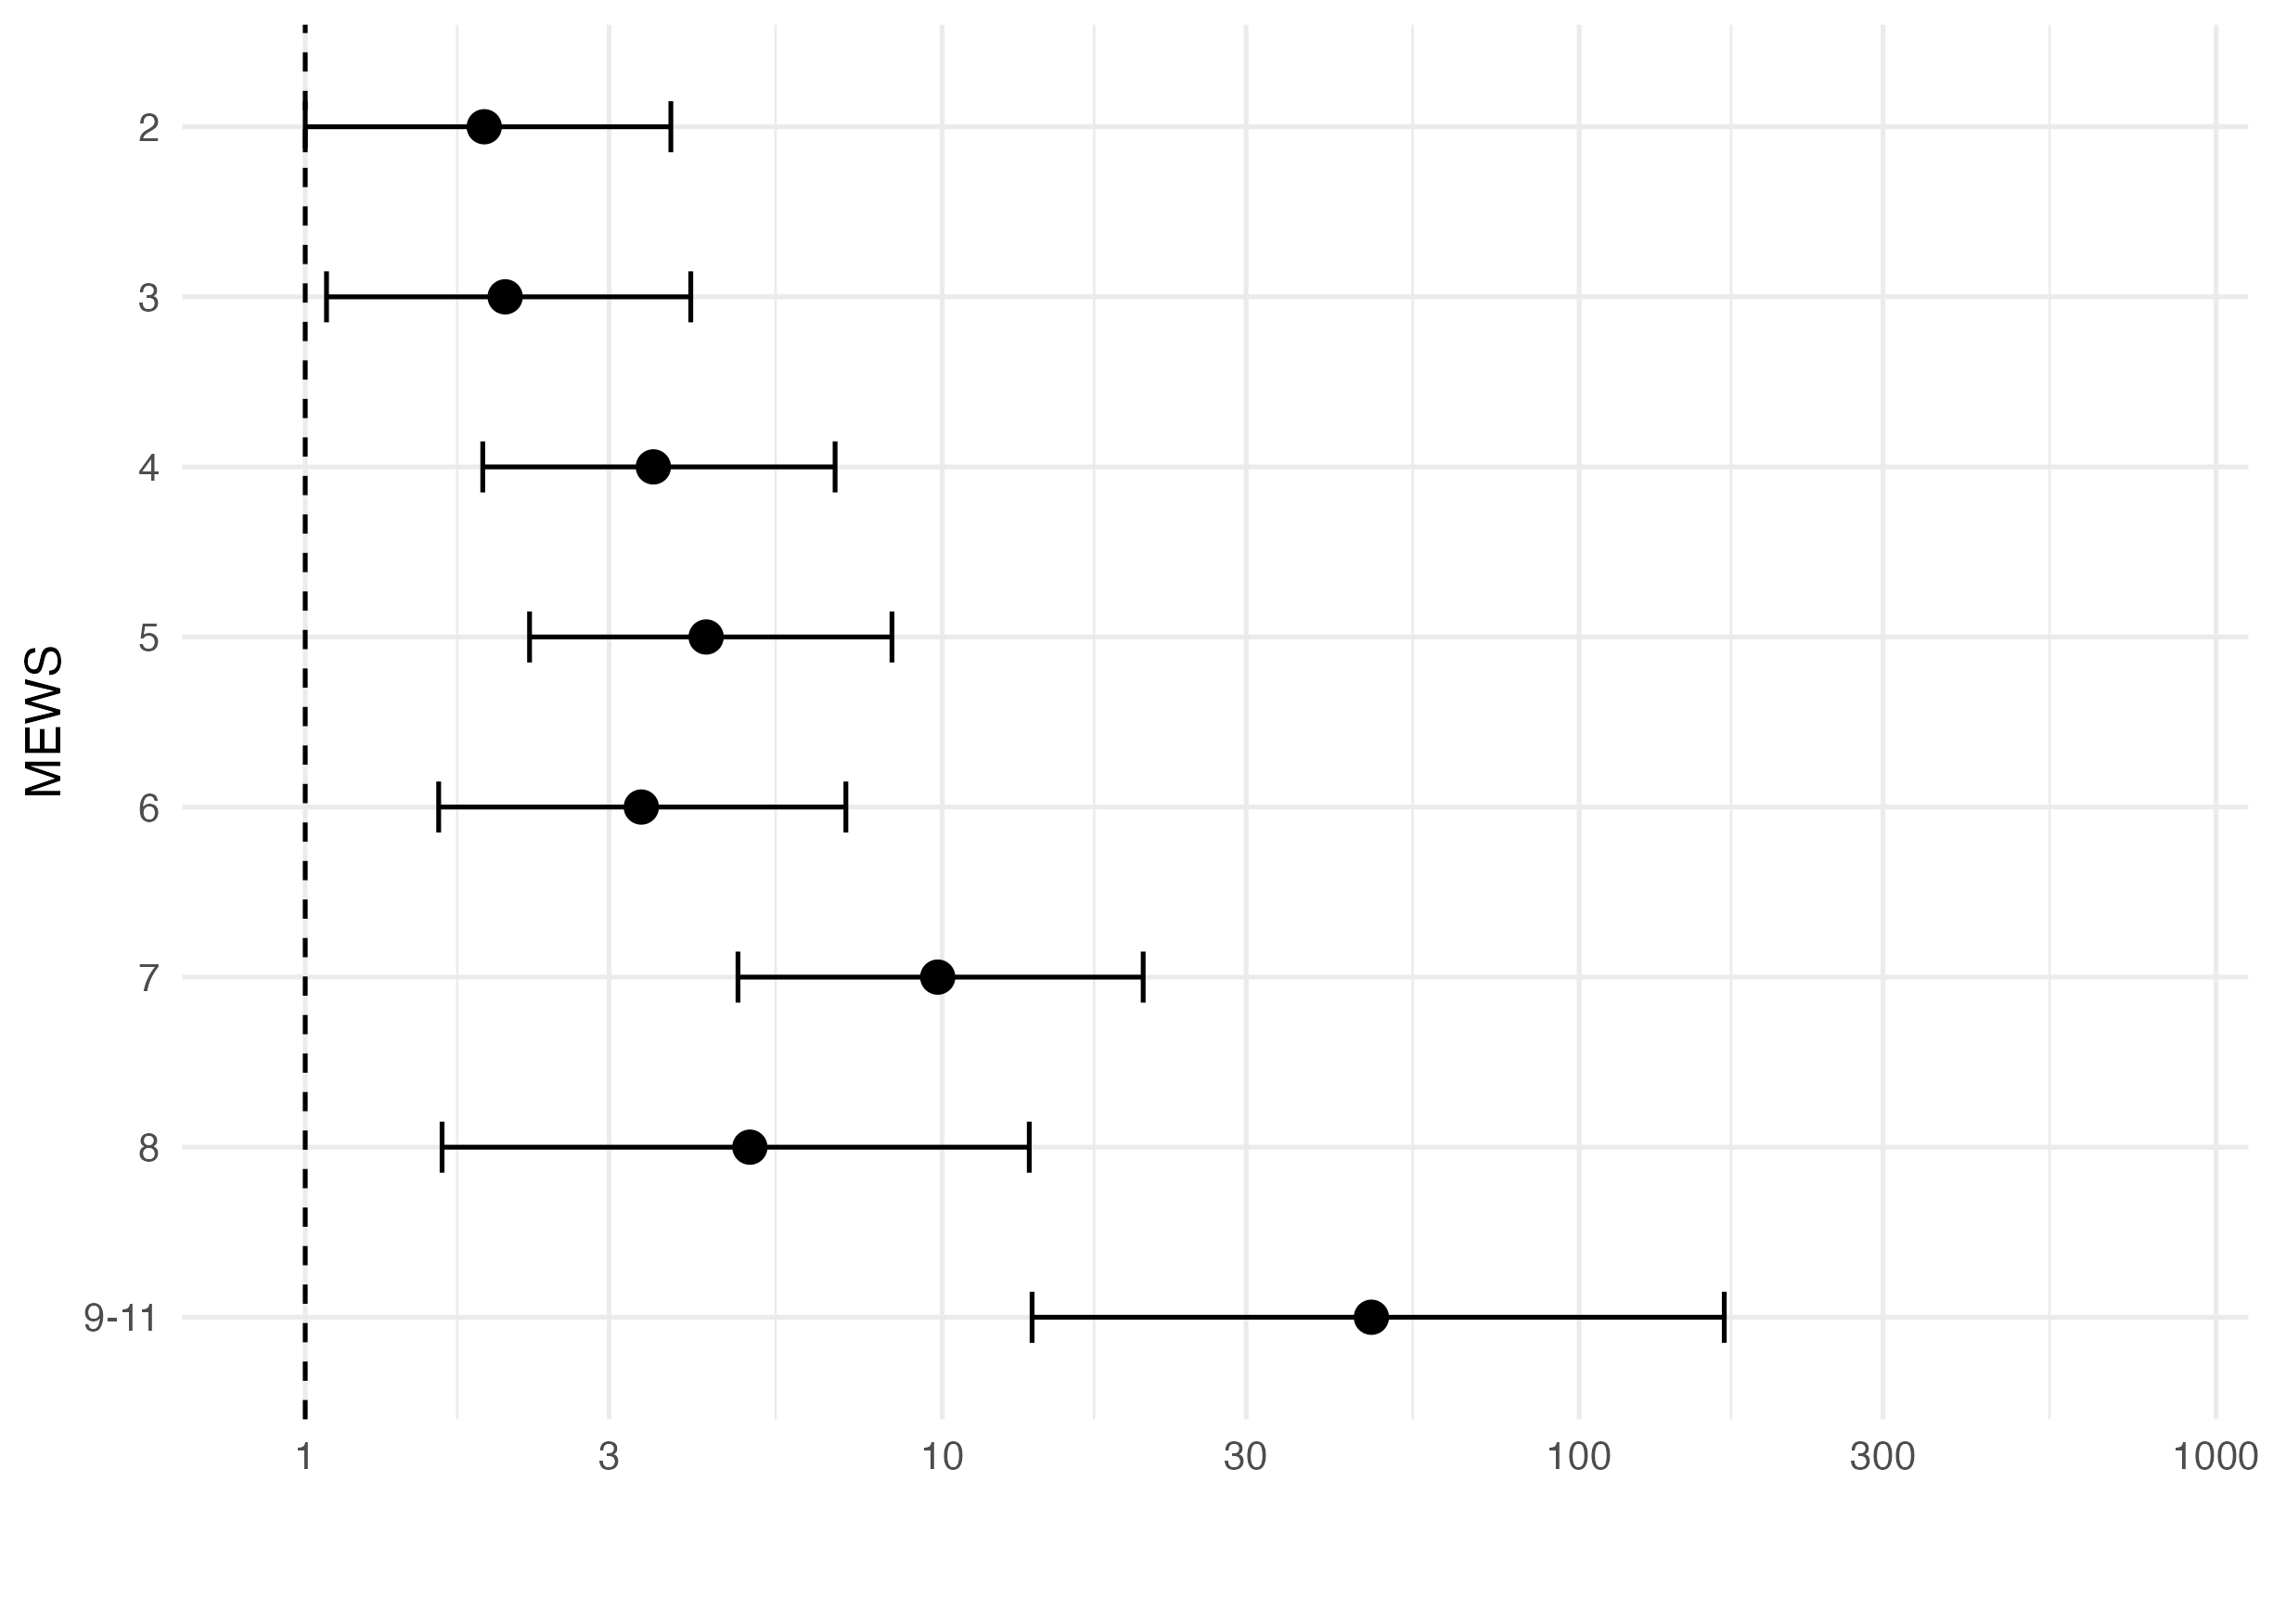

Adjusted odds ratios for MEWS plot

### Figure S2b

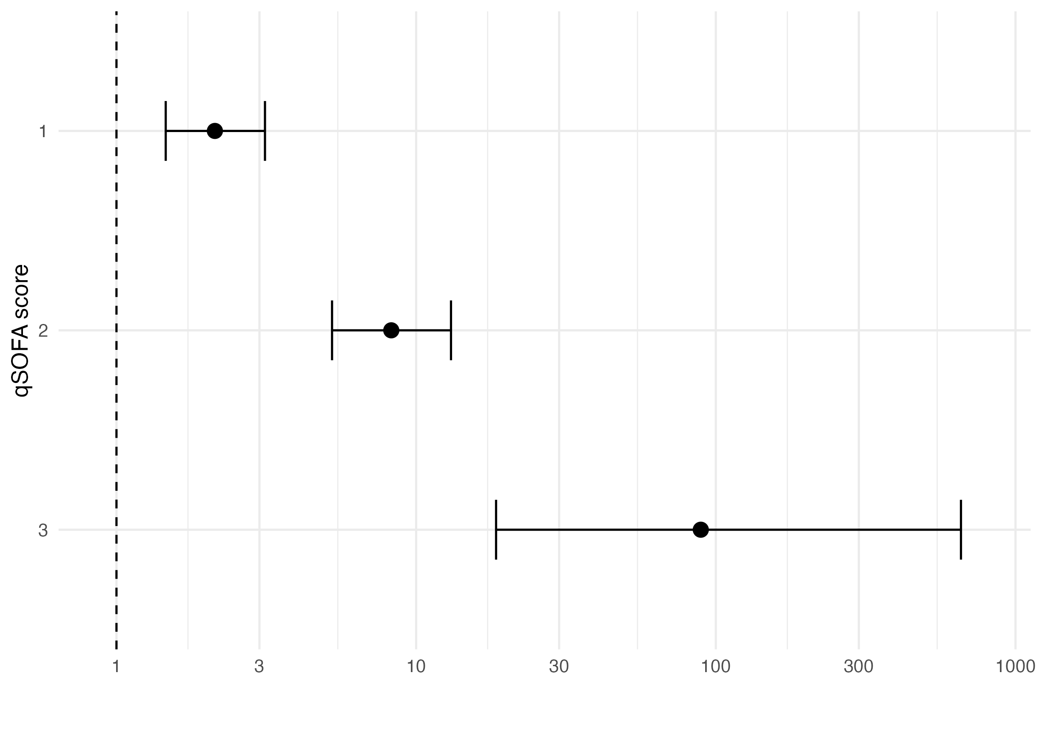

qSOFA Adjusted odds ratio plot

### Figure S2c

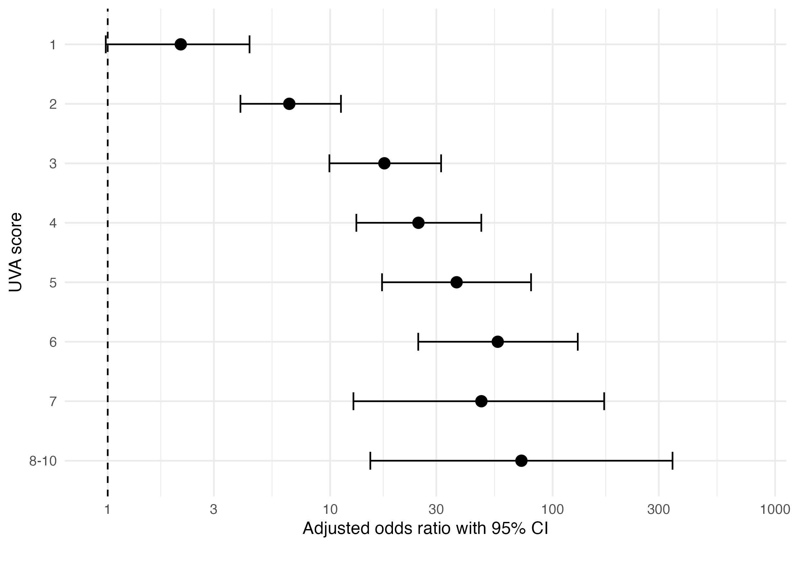

Adjusted odds ratios for UVA scores plot

### Figure S2

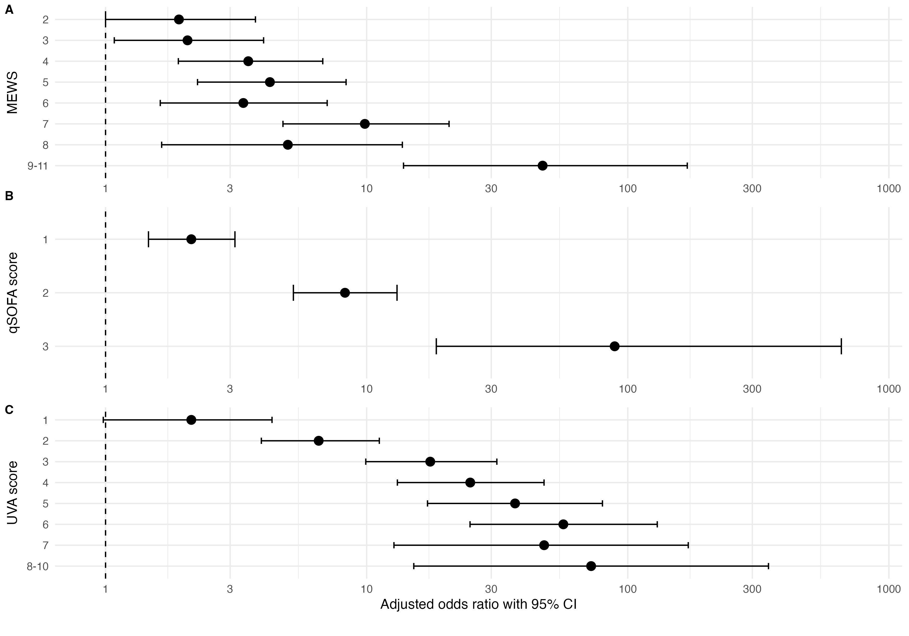

Adjusted odds ratios for a) MEWS, b) qSOFA and c) UVA severity scores predicting mortality at time of follow-up among febrile participants (aged ≥15 years) enrolled between 2018 and 2021 across four sites (Lao PDR, Malawi, Mozambique, and Zimbabwe). MEWS=modified early warning score, qSOFA=quick sequential organ failure assessment, UVA=universal vital assessment score

## Specificity (%) analysis

In this analysis we assume all those who are missing a day 28 outcome are either a) alive or b) dead and calculate AUC for each severity score.

### a) Assume all missing are alive.

Specificity (%) analysis (a) assuming all missing a day 28 outcome are alive

| Variable | **lost to fup**, N = 3,0571 | **Dead**, N = 1851 | **Overall**, N = 3,2422 |
| --- | --- | --- | --- |
| uva |  |  |  |
| 0 | 1,707 (99%) | 23 (1.3%) | 1,730 |
| 1 | 470 (98%) | 11 (2.3%) | 481 |
| 2 | 543 (92%) | 49 (8.3%) | 592 |
| 3 | 178 (84%) | 35 (16%) | 213 |
| 4 | 86 (77%) | 25 (23%) | 111 |
| 5 | 36 (68%) | 17 (32%) | 53 |
| 6 | 25 (61%) | 16 (39%) | 41 |
| 7 | 7 (58%) | 5 (42%) | 12 |
| 8 | 2 (50%) | 2 (50%) | 4 |
| 9 | 3 (75%) | 1 (25%) | 4 |
| 10 | 0 (0%) | 1 (100%) | 1 |
| mews |  |  |  |
| 1 | 681 (98%) | 16 (2.3%) | 697 |
| 2 | 602 (96%) | 26 (4.1%) | 628 |
| 3 | 616 (96%) | 26 (4.0%) | 642 |
| 4 | 444 (93%) | 33 (6.9%) | 477 |
| 5 | 306 (91%) | 30 (8.9%) | 336 |
| 6 | 245 (94%) | 17 (6.5%) | 262 |
| 7 | 114 (84%) | 22 (16%) | 136 |
| 8 | 42 (88%) | 6 (13%) | 48 |
| 9 | 6 (50%) | 6 (50%) | 12 |
| 10 | 1 (50%) | 1 (50%) | 2 |
| 11 | 0 (0%) | 2 (100%) | 2 |
| qsofa |  |  |  |
| 0 | 1,653 (97%) | 49 (2.9%) | 1,702 |
| 1 | 1,188 (94%) | 79 (6.2%) | 1,267 |
| 2 | 214 (81%) | 50 (19%) | 264 |
| 3 | 2 (22%) | 7 (78%) | 9 |
| Age group |  |  |  |
| 15 - <25 | 919 (98%) | 15 (1.6%) | 934 |
| 25 - <35 | 863 (95%) | 42 (4.6%) | 905 |
| 35 - <40 | 633 (93%) | 45 (6.6%) | 678 |
| 45 - <55 | 309 (91%) | 32 (9.4%) | 341 |
| 55 - <65 | 196 (88%) | 28 (13%) | 224 |
| 65+ | 137 (86%) | 23 (14%) | 160 |
| Gender |  |  |  |
| Female | 1,852 (96%) | 84 (4.3%) | 1,936 |
| Male | 1,205 (92%) | 101 (7.7%) | 1,306 |
| 1n (%) | | | |
| 2n | | | |

DeLong test, a pairwise comparison test for the equality of the area under the curve between for those with day 28 outcome missing set to alive.  
1) UVA (AUC: 0.81, 95% CI: 0.78-0.85) vs. MEWS (AUC: 0.66, 95% CI: 0.62-0.7), Z = 6.7894453, *p-value* = 0.00000000001125655.  
2) UVA (AUC: 0.81, 95% CI: 0.78-0.85) vs. qSOFA (AUC: 0.68, 95% CI: 0.64-0.72), Z = 5.7773562, *p-value* = 0.000000007588353.  
3) MEWs (AUC: 0.66, 95% CI: 0.62-0.7) vs. qSOFA (AUC: 0.68, 95% CI: 0.64-0.72), Z = -1.0141277, *p-value* = 0.3105218.

### Figure S3

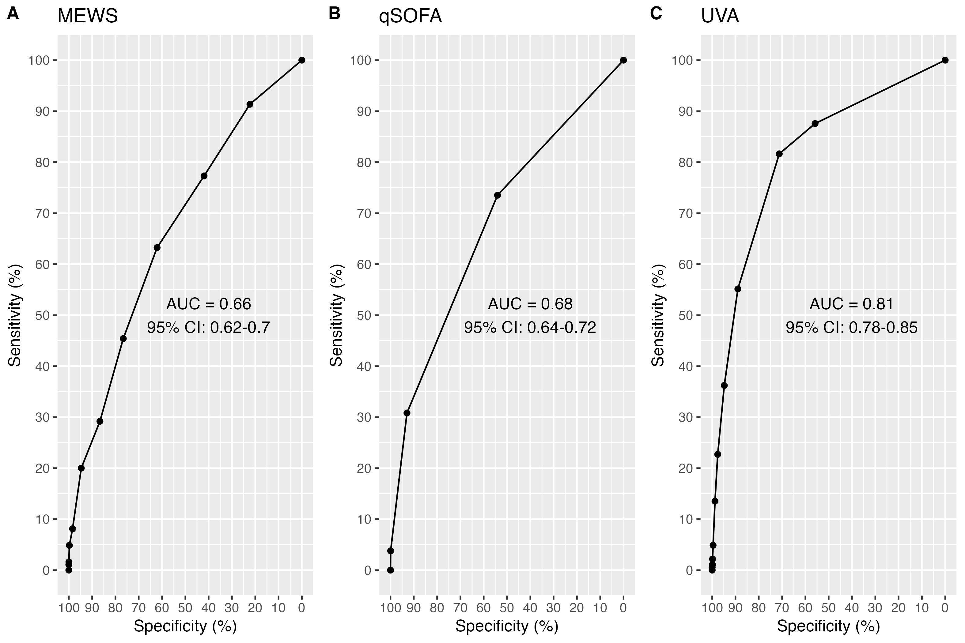

Figure S3: Sensitivity analysis ROC curves assuming all cases with missing data survived by follow-up, for a) MEWS, b) qSOFA and c) UVA severity scores for predicting mortality by time of follow-up among febrile participants (aged ≥15 years) enrolled between 2018 and 2021 across four sites (Lao PDR, Malawi, Mozambique, and Zimbabwe). ROC=receiver operating characteristic, AUC=area under the curve, MEWS=modified early warning score, qSOFA=quick sequential organ failure assessment, UVA=universal vital assessment score, CI=confidence interval.

### b) Assume all missing died.

Specificity (%) analysis (a) assuming all missing a day 28 outcome died

| Variable | **Alive**, N = 2,6121 | **lost to fup**, N = 6301 | **Overall**, N = 3,2422 |
| --- | --- | --- | --- |
| uva |  |  |  |
| 0 | 1,488 (86%) | 242 (14%) | 1,730 |
| 1 | 405 (84%) | 76 (16%) | 481 |
| 2 | 452 (76%) | 140 (24%) | 592 |
| 3 | 142 (67%) | 71 (33%) | 213 |
| 4 | 67 (60%) | 44 (40%) | 111 |
| 5 | 28 (53%) | 25 (47%) | 53 |
| 6 | 19 (46%) | 22 (54%) | 41 |
| 7 | 7 (58%) | 5 (42%) | 12 |
| 8 | 2 (50%) | 2 (50%) | 4 |
| 9 | 2 (50%) | 2 (50%) | 4 |
| 10 | 0 (0%) | 1 (100%) | 1 |
| mews |  |  |  |
| 1 | 583 (84%) | 114 (16%) | 697 |
| 2 | 536 (85%) | 92 (15%) | 628 |
| 3 | 529 (82%) | 113 (18%) | 642 |
| 4 | 372 (78%) | 105 (22%) | 477 |
| 5 | 257 (76%) | 79 (24%) | 336 |
| 6 | 201 (77%) | 61 (23%) | 262 |
| 7 | 94 (69%) | 42 (31%) | 136 |
| 8 | 33 (69%) | 15 (31%) | 48 |
| 9 | 6 (50%) | 6 (50%) | 12 |
| 10 | 1 (50%) | 1 (50%) | 2 |
| 11 | 0 (0%) | 2 (100%) | 2 |
| qsofa |  |  |  |
| 0 | 1,387 (81%) | 315 (19%) | 1,702 |
| 1 | 1,047 (83%) | 220 (17%) | 1,267 |
| 2 | 176 (67%) | 88 (33%) | 264 |
| 3 | 2 (22%) | 7 (78%) | 9 |
| Age group |  |  |  |
| 15 - <25 | 769 (82%) | 165 (18%) | 934 |
| 25 - <35 | 740 (82%) | 165 (18%) | 905 |
| 35 - <40 | 545 (80%) | 133 (20%) | 678 |
| 45 - <55 | 269 (79%) | 72 (21%) | 341 |
| 55 - <65 | 169 (75%) | 55 (25%) | 224 |
| 65+ | 120 (75%) | 40 (25%) | 160 |
| Gender |  |  |  |
| Female | 1,600 (83%) | 336 (17%) | 1,936 |
| Male | 1,012 (77%) | 294 (23%) | 1,306 |
| 1n (%) | | | |
| 2n | | | |

DeLong test, a pairwise comparison test for the equality of the area under the curve between for those with day 28 outcome missing set to dead.  
1) UVA (AUC: 0.63, 95% CI: 0.6-0.65) vs. MEWS (AUC: 0.57, 95% CI: 0.55-0.6), Z = 4.0699353, *p-value* = 0.00004702619.  
2) UVA (AUC: 0.63, 95% CI: 0.6-0.65) vs. qSOFA (AUC: 0.53, 95% CI: 0.51-0.56), Z = 6.8870486, *p-value* = 0.000000000005696175.  
3) MEWs (AUC: 0.57, 95% CI: 0.55-0.6) vs. qSOFA (AUC: 0.53, 95% CI: 0.51-0.56), Z = 3.1778952, *p-value* = 0.001483484.

### Figure S4

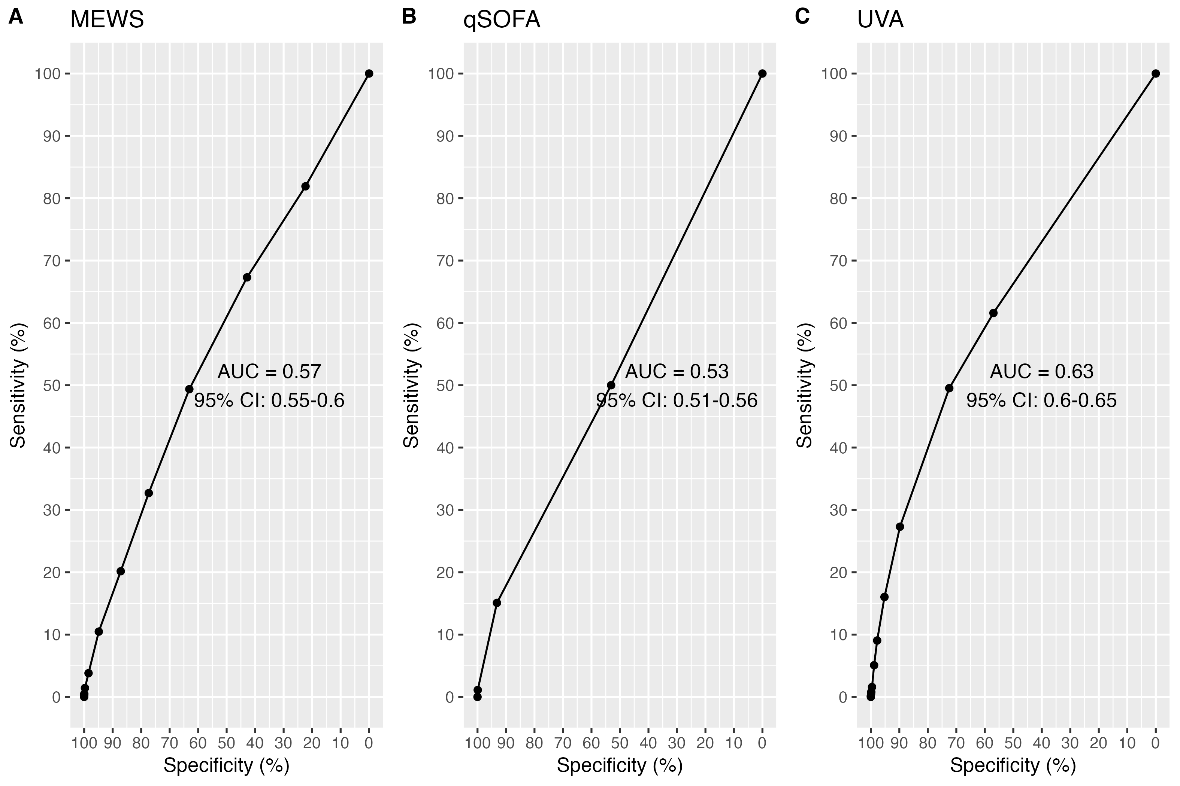

Figure S4: Sensitivity analysis ROC curves assuming all cases with missing data died by follow-up, for a) MEWS, b) qSOFA and c) UVA severity scores for predicting mortality by time of follow-up among febrile participants (aged ≥15 years) enrolled between 2018 and 2021 across four sites (Lao PDR, Malawi, Mozambique, and Zimbabwe). ROC=receiver operating characteristic, AUC=area under the curve, MEWS=modified early warning score, qSOFA=quick sequential organ failure assessment, UVA=universal vital assessment score, CI=confidence interval.

## Figure S5: ROCs for inpatients

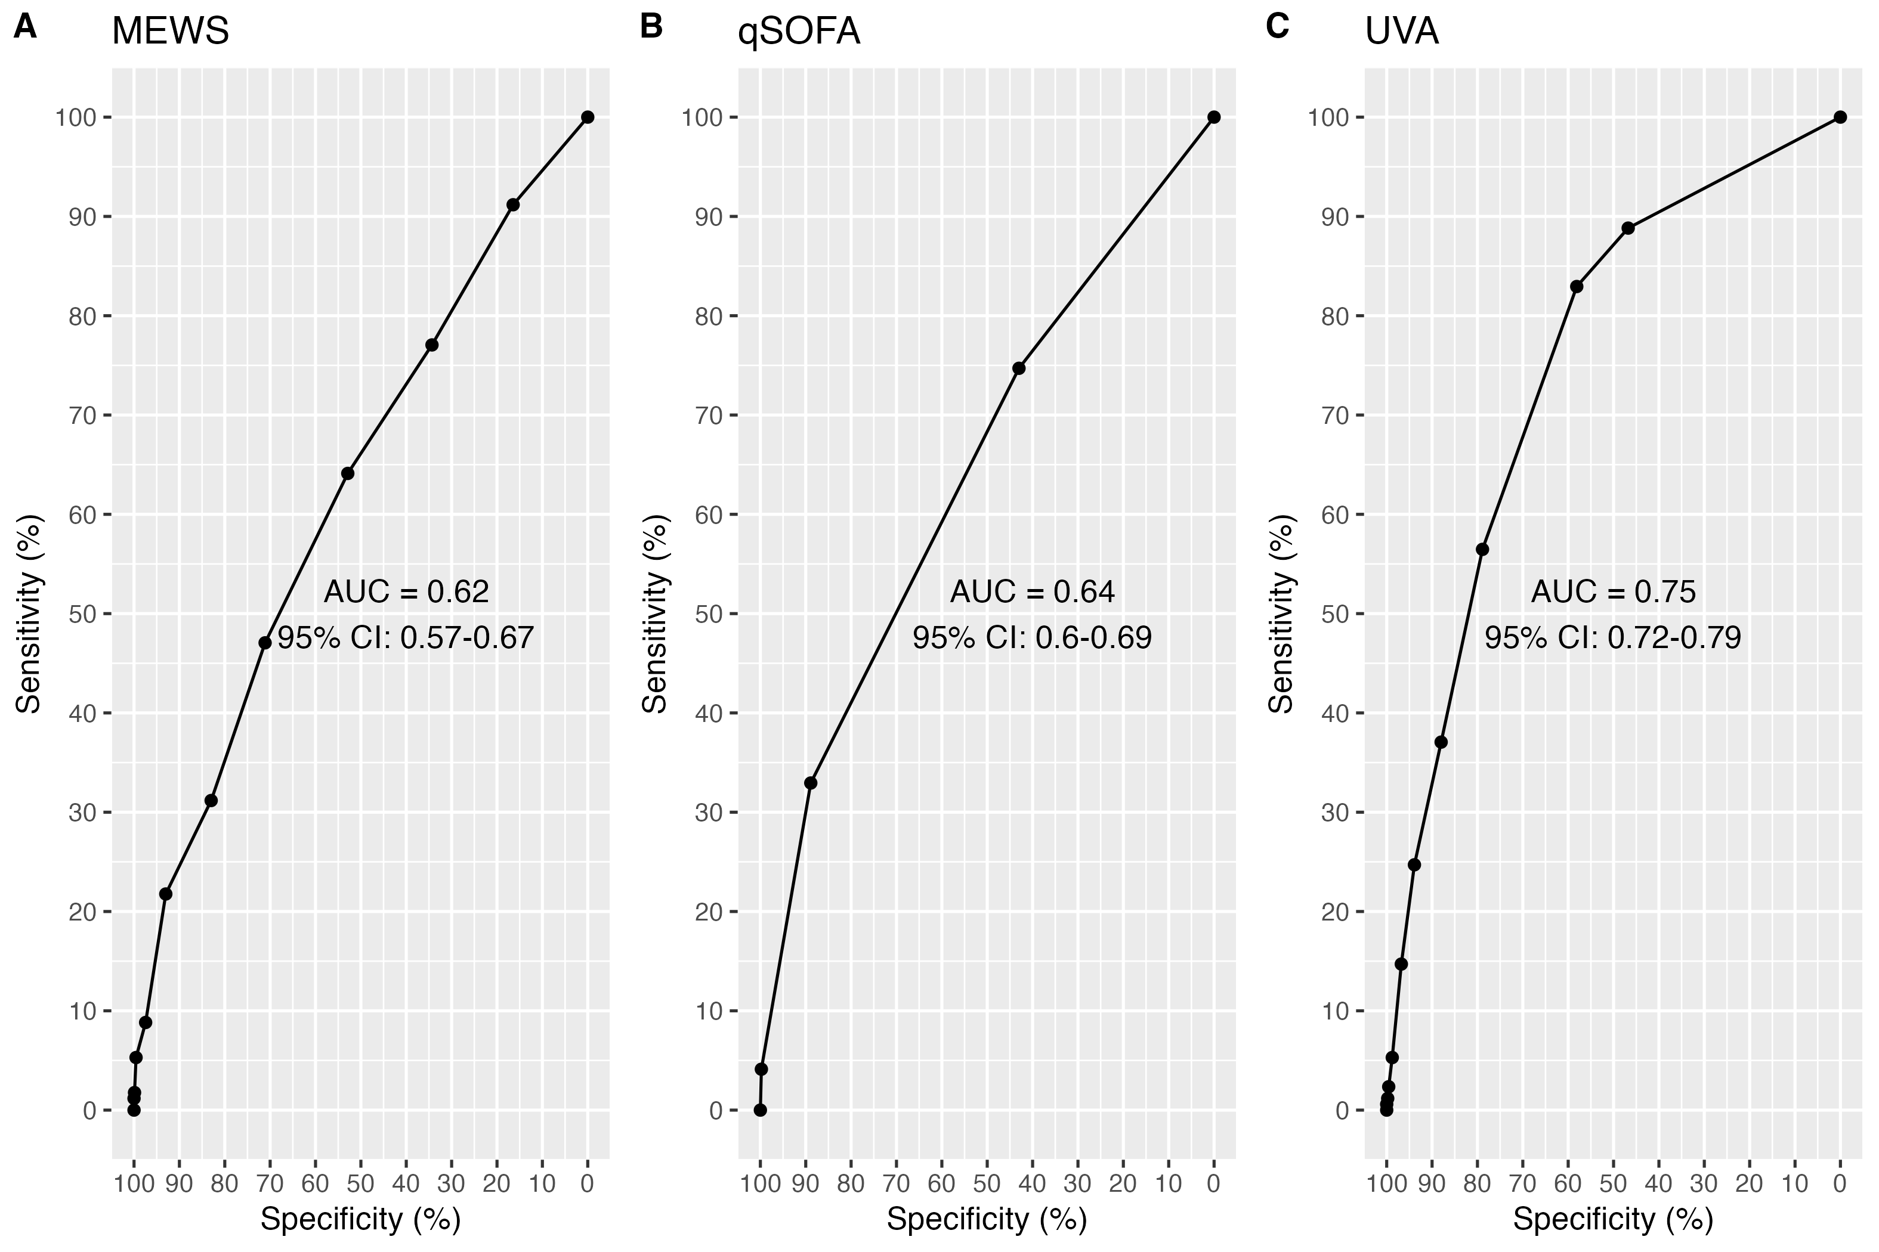

Inpatient ROC curves for a) MEWS, b) qSOFA and c) UVA severity scores for predicting mortality by time of follow-up among febrile participants (aged ≥15 years) enrolled between 2018 and 2021 across four sites (Lao PDR, Malawi, Mozambique, and Zimbabwe). ROC=receiver operating characteristic, AUC=area under the curve, MEWS=modified early warning score, qSOFA=quick sequential organ failure assessment, UVA=universal vital assessment score, CI=confidence interval.

DeLong test, for inpatients.  
1) UVA (AUC: 0.75, 95% CI: 0.72-0.79) vs. MEWS (AUC: 0.62, 95% CI: 0.57-0.67), Z = 5.2504646, *p-value* = 0.000000151716.  
2) UVA (AUC: 0.75, 95% CI: 0.72-0.79) vs. qSOFA (AUC: 0.64, 95% CI: 0.6-0.69), Z = 4.4455883, *p-value* = 0.000008765166.  
3) MEWs (AUC: 0.62, 95% CI: 0.57-0.67) vs. qSOFA (AUC: 0.64, 95% CI: 0.6-0.69), Z = -0.9294984, *p-value* = 0.3526308.

## Figure S6: ROCs for Outpatients

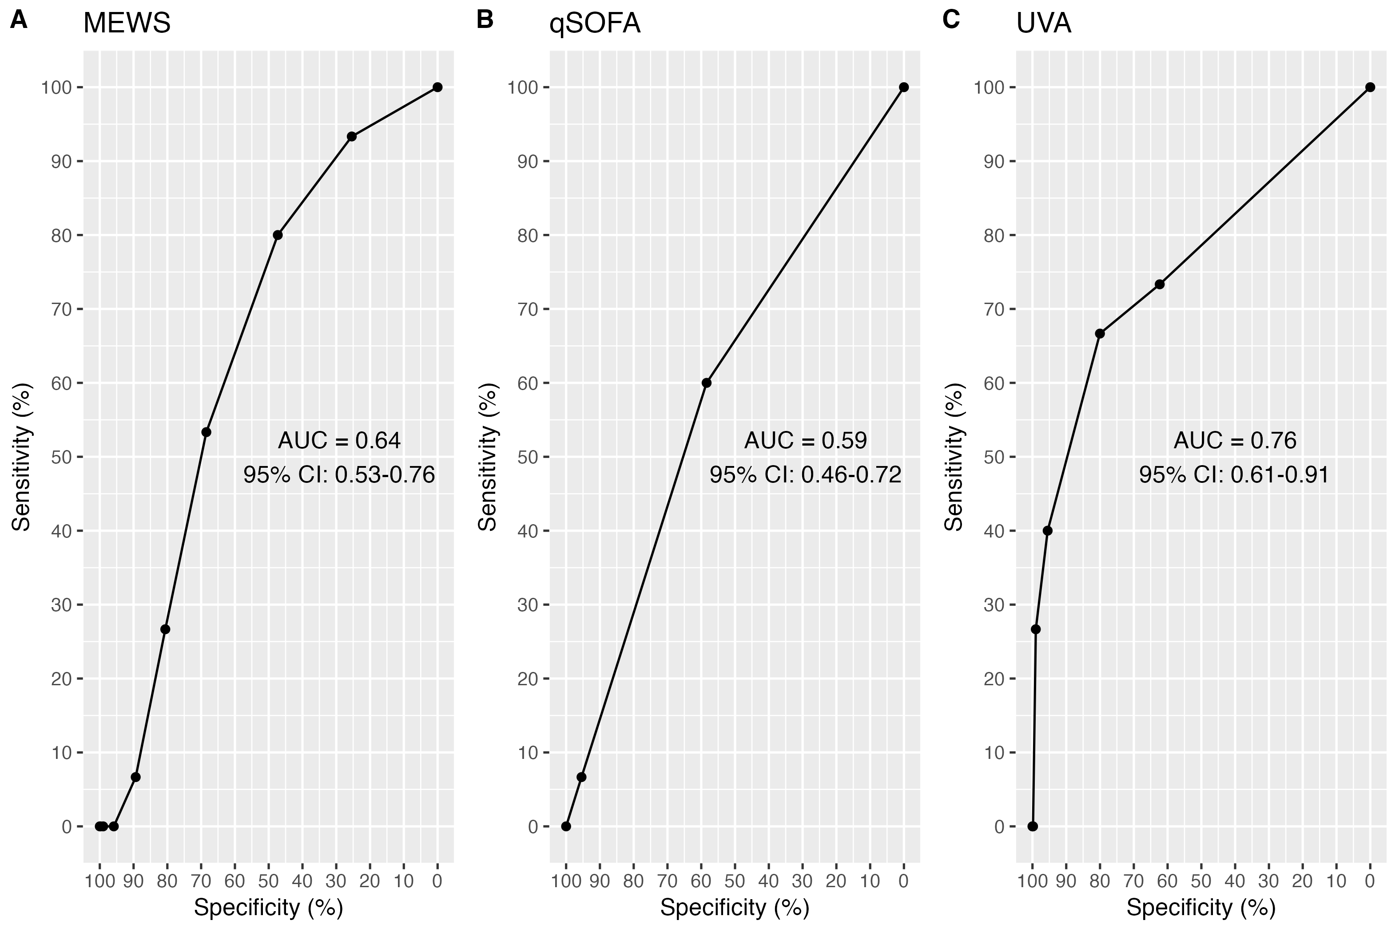

Outpatient ROC curves for a) MEWS, b) qSOFA and c) UVA severity scores for predicting mortality by time of follow-up among febrile participants (aged ≥15 years) enrolled between 2018 and 2021 across four sites (Lao PDR, Malawi, Mozambique, and Zimbabwe). ROC=receiver operating characteristic, AUC=area under the curve, MEWS=modified early warning score, qSOFA=quick sequential organ failure assessment, UVA=universal vital assessment score, CI=confidence interval.

DeLong test, for outpatients.  
1) UVA (AUC: 0.76, 95% CI: 0.61-0.91) vs. MEWS (AUC: 0.64, 95% CI: 0.53-0.76), Z = 1.9274789, *p-value* = 0.05391998.  
2) UVA (AUC: 0.76, 95% CI: 0.61-0.91) vs. qSOFA (AUC: 0.59, 95% CI: 0.46-0.72), Z = 1.9434827, *p-value* = 0.05195786.  
3) MEWs (AUC: 0.64, 95% CI: 0.53-0.76) vs. qSOFA (AUC: 0.59, 95% CI: 0.46-0.72), Z = 0.5630701, *p-value* = 0.5733871.

## Figure S7: Laos ROCs

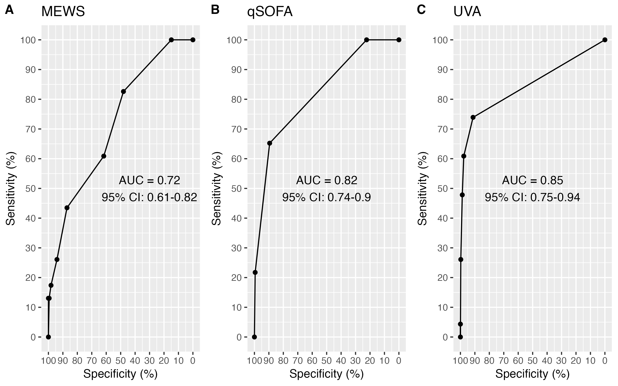

Lao PDR ROC curves for a) MEWS, b) qSOFA and c) UVA severity scores for predicting mortality by time of follow-up among febrile participants (aged ≥15 years) enrolled between 2018 and 2021. ROC=receiver operating characteristic, AUC=area under the curve, MEWS=modified early warning score, qSOFA=quick sequential organ failure assessment, UVA=universal vital assessment score, CI=confidence interval.

DeLong test for Laos site;  
1) UVA (AUC:0.85, 95% CI: 0.75-0.94) vs. MEWS (AUC:0.72, 95% CI: 0.61-0.82), Z = 0.6039, *p-value* = 0.01925943.  
2) UVA (AUC:0.85, 95% CI: 0.75-0.94) vs. qSOFA (AUC:0.82, 95% CI: 0.74-0.9), Z = 0.6039, *p-value* = 0.5459102.  
3) MEWs (AUC:0.72, 95% CI: 0.61-0.82) vs. qSOFA (AUC:0.82, 95% CI: 0.74-0.9), Z = -2.4901909, *p-value* = 0.01276745.

## Figure S8: Malawi ROCs

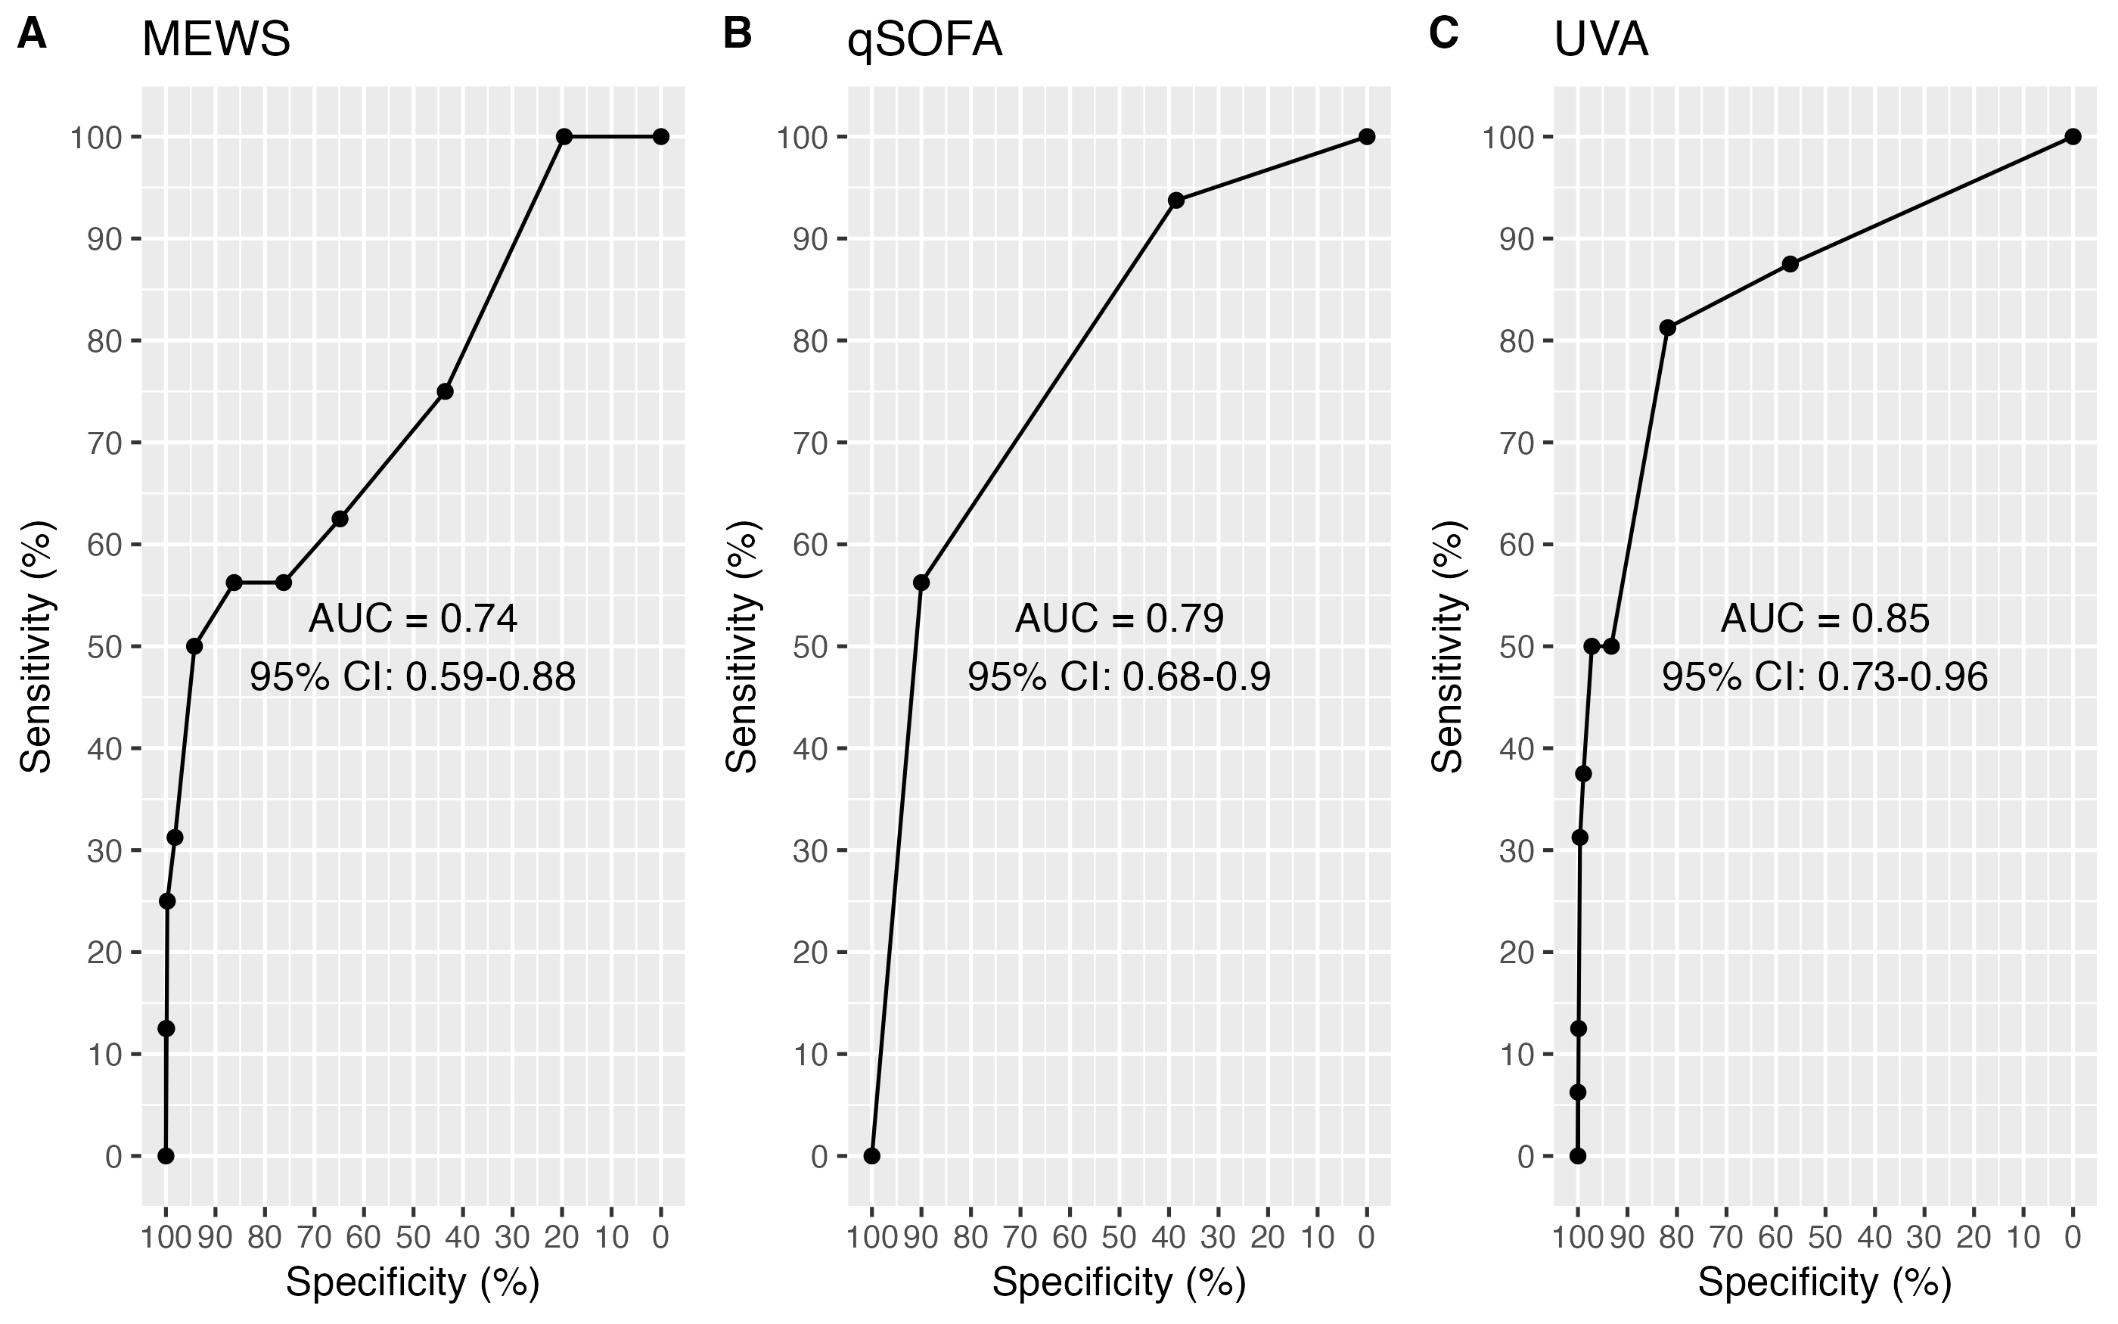

Malawi ROC curves for a) MEWS, b) qSOFA and c) UVA severity scores for predicting mortality by time of follow-up among febrile participants (aged ≥15 years) enrolled between 2018 and 2021. ROC=receiver operating characteristic, AUC=area under the curve, MEWS=modified early warning score, qSOFA=quick sequential organ failure assessment, UVA=universal vital assessment score, CI=confidence interval

DeLong test for Malawi site;  
1) UVA (AUC:0.85, 95% CI: 0.73-0.96) vs. MEWS (AUC:0.74, 95% CI: 0.59-0.88), Z = 1.5701774, *p-value* = 0.1163738.  
2) UVA (AUC:0.85, 95% CI: 0.73-0.96) vs. qSOFA (AUC:0.79, 95% CI: 0.68-0.9), Z = 1.0308086, *p-value* = 0.3026306.  
3) MEWs (AUC:0.74, 95% CI: 0.59-0.88) vs. qSOFA (AUC:0.79, 95% CI: 0.68-0.9), Z = -0.8673957, *p-value* = 0.3857252.

## Figure S9: Mozambique ROCs

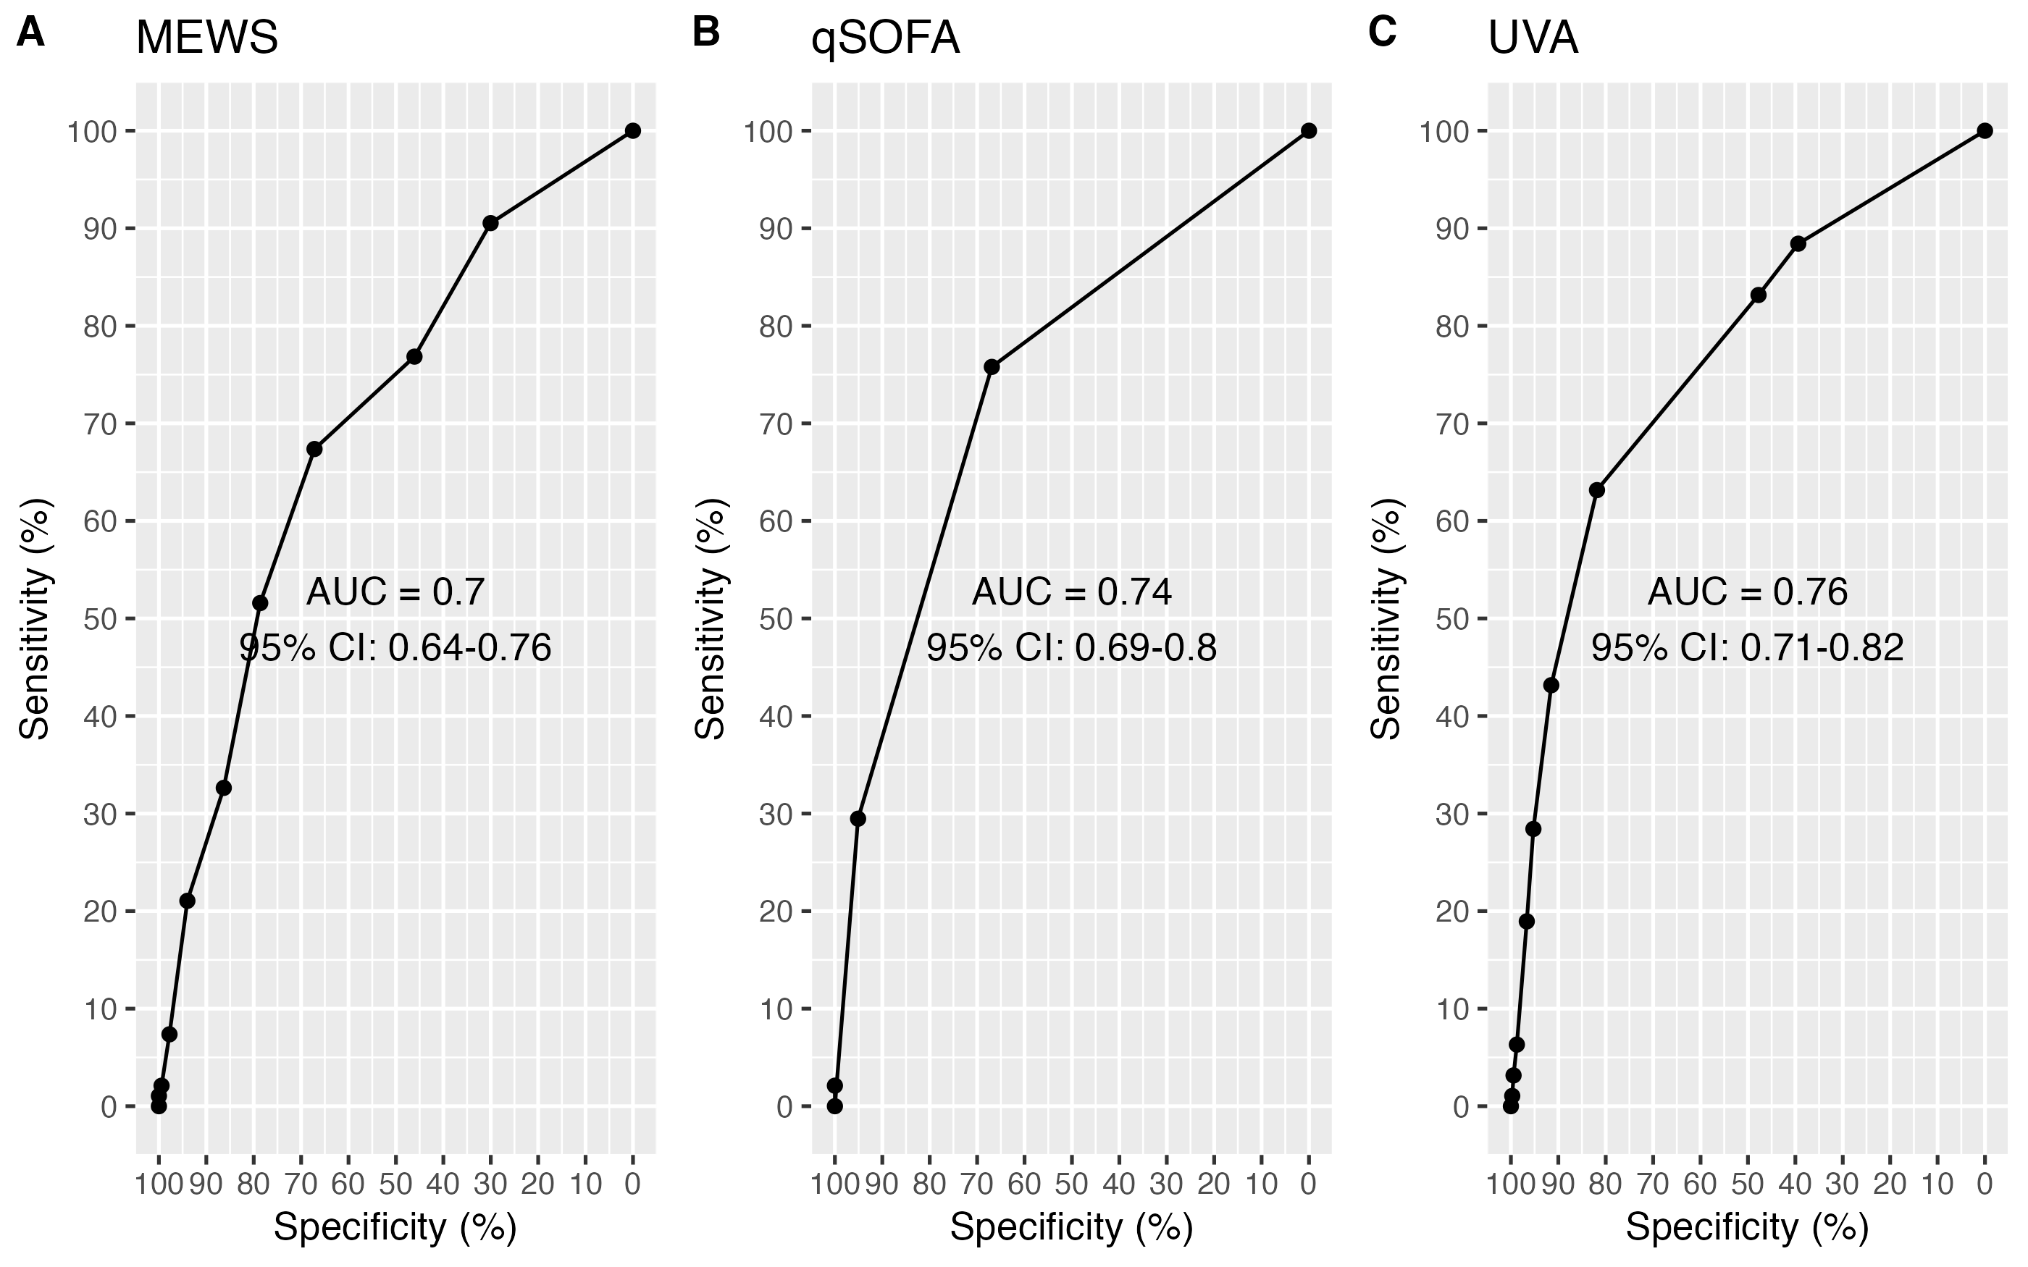

Mozambique ROC curves for a) MEWS, b) qSOFA and c) UVA severity scores for predicting mortality by time of follow-up among febrile participants (aged ≥15 years) enrolled between 2018 and 2021. ROC=receiver operating characteristic, AUC=area under the curve, MEWS=modified early warning score, qSOFA=quick sequential organ failure assessment, UVA=universal vital assessment score, CI=confidence interval

DeLong test for Mozambique site;  
1) UVA (AUC:0.76, 95% CI: 0.71-0.82) vs. MEWS (AUC:0.7, 95% CI: 0.64-0.76), Z = 2.0180635, *p-value* = 0.04358464.  
2) UVA (AUC:0.76, 95% CI: 0.71-0.82) vs. qSOFA (AUC:0.74, 95% CI: 0.69-0.8), Z = 0.7017259, *p-value* = 0.4828501.  
3) MEWs (AUC:0.7, 95% CI: 0.64-0.76) vs. qSOFA (AUC:0.74, 95% CI: 0.69-0.8), Z = -1.5575884, *p-value* = 0.1193308.

## Figure S10: Zimbabwe ROCs

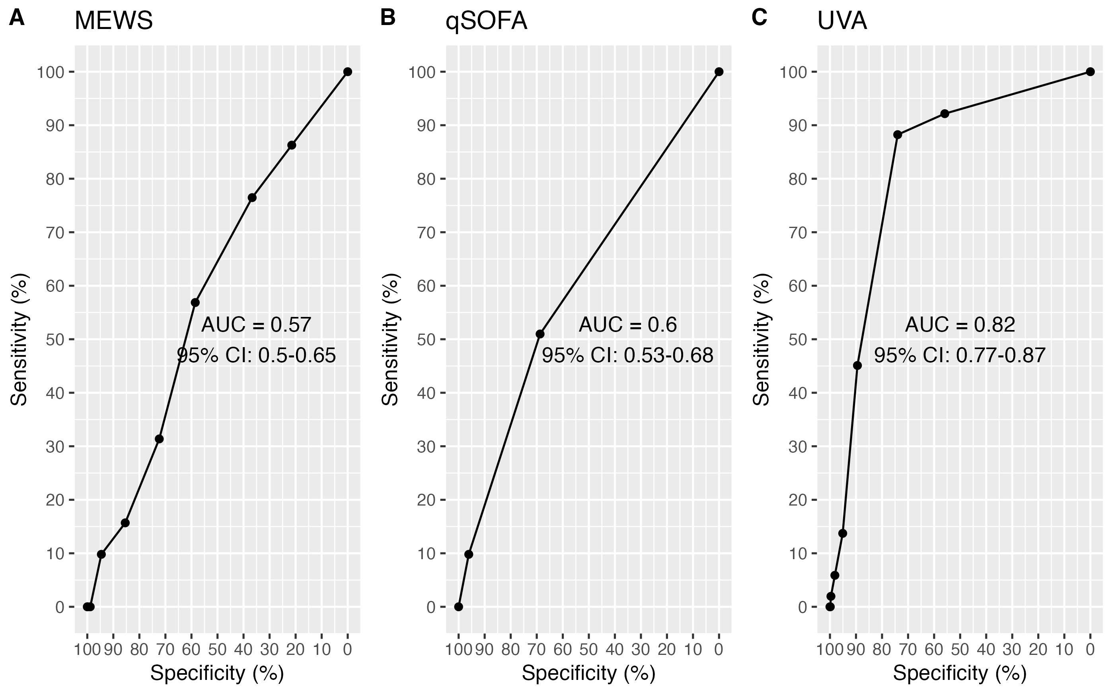

Zimbabwe ROC curves for a) MEWS, b) qSOFA and c) UVA severity scores for predicting mortality by time of follow-up among febrile participants (aged ≥15 years) enrolled between 2018 and 2021. ROC=receiver operating characteristic, AUC=area under the curve, MEWS=modified early warning score, qSOFA=quick sequential organ failure assessment, UVA=universal vital assessment score, CI=confidence interval

DeLong test for Zimbabwe site;  
1) UVA (AUC:0.82, 95% CI: 0.77-0.87) vs. MEWS (AUC:0.57, 95% CI: 0.5-0.65), Z = 5.9873309, *p-value* = 0.000000002133125.  
2) UVA (AUC:0.82, 95% CI: 0.77-0.87) vs. qSOFA (AUC:0.6, 95% CI: 0.53-0.68), Z = 5.2376128, *p-value* = 0.0000001626669.  
3) MEWs (AUC:0.57, 95% CI: 0.5-0.65) vs. qSOFA (AUC:0.6, 95% CI: 0.53-0.68), Z = -0.7623093, *p-value* = 0.4458754.

## Figure S11: MEWS + HIV ROCs

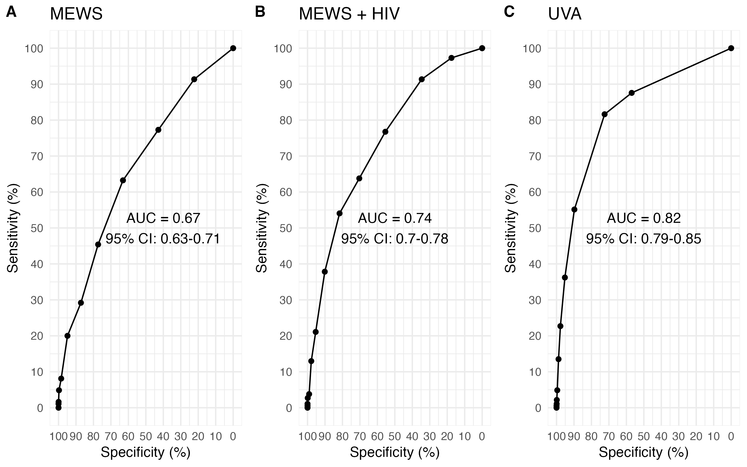

ROC curves for A) MEWS, B) MEWS + HIV and C) UVA score for predicting mortality by time of follow-up among febrile participants (aged ≥15 years) enrolled between 2018 and 2021 across four sites (Lao PDR, Malawi, Mozambique, and Zimbabwe). ROC=receiver operating characteristic, AUC=area under the curve, MEWS=modified early warning score, UVA=universal vital assessment score, CI=confidence interval.

## Figure S12: qSOFA + HIV ROCs

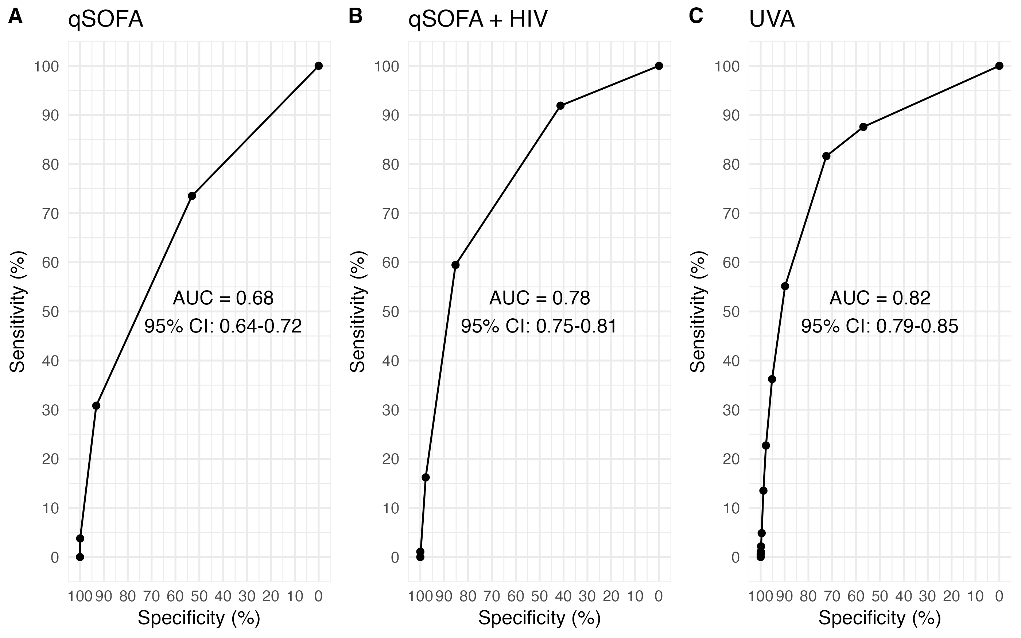

ROC curves for A) qSOFA, B) qSOFA + HIV and C) UVA score for predicting mortality by time of follow-up among febrile participants (aged ≥15 years) enrolled between 2018 and 2021 across four sites (Lao PDR, Malawi, Mozambique, and Zimbabwe). ROC=receiver operating characteristic, AUC=area under the curve, qSOFA= quick sequential organ failure assessment, UVA=universal vital assessment score, CI=confidence interval.

## Table 5: All AUC results

Comparative performance of MEWS, qSOFA and UVA scores and subgroup analyses in predicting mortality at time of follow-up of participants (aged ≥15 years) across four sites (Lao PDR, Malawi, Mozambique, and Zimbabwe). AUC=Area under the curve, MEWS=modified early warning score, qSOFA=quick sequential organ failure assessment, UVA=universal vital assessment score, CI=confidence intervals.

|  | Severity score AUC (95% CI) | | |
| --- | --- | --- | --- |
| analysis | MEWS | qSOFA | UVA |
| complete_data | 0.67  (0.63-0.71) | 0.68  (0.64-0.72) | 0.82  (0.79-0.85) |
| sensitivity_alive | 0.66  (0.62-0.7 | 0.68  (0.64-0.72) | 0.81  (0.78-0.85) |
| sensitivity_dead | 0.57  (0.55-0.6 | 0.53  (0.51-0.56) | 0.63  (0.6-0.65) |
| inpatients | 0.62  (0.57-0.67) | 0.64  (0.6-0.69) | 0.75  (0.72-0.79) |
| outpatients | 0.64  (0.53-0.76) | 0.59  (0.46-0.72) | 0.76  (0.61-0.91) |
| laos | 0.72  (0.61-0.82) | 0.82  (0.74-0.9 | 0.85  (0.75-0.94) |
| malawi | 0.74  (0.59-0.88) | 0.79  (0.68-0.9 | 0.85  (0.73-0.96) |
| moz | 0.7  (0.64-0.76) | 0.74  (0.69-0.8 | 0.76  (0.71-0.82) |
| zw | 0.57  (0.5-0.65) | 0.6  (0.53-0.68) | 0.82  (0.77-0.87) |