**1. Generate integrated noise data:**

Run noise analysis with “< pts_per_summary >” set to 1 (see section 15.3.4 of ngspice manual).

Save integrated noise data in ascii format. This is done with the below code:

setplot noise2

set filetype=ascii

remzerovec

write <filename>.raw

Run the simulation.

**2. Save the noise summary script:**

The noise summary script is called “noise_summary.awk” and is uploaded to the below location in github:

<https://github.com/SLICESemiconductor/OpenSourceTool_Examples/tree/main/Running_AC_noise_summary_in_ngspice>

Save this script to your rundir and run the following command to make it executable:

chmod a+x noise_summary.awk

**3. Run the noise summary script:**

To run the script, simply type:

./noise_summary.awk <filename>.raw > <outputfile>.txt

This runs the script on the raw data generated in step 1 and outputs it to a text file. You can call the text file anything you want but I typically call it noise_summary.txt to be compatible with Cadence.

The script runs instantly.

**4. Viewing the script:**

The text file generated in step 3 will output the total/thermal/flicker noise contributions for each MOS device and resistor in the netlist (other devices can be added (e.g. diodes) but at time of writing have not).

You can simply import this file into excel and play about from there.

**5. Example:**

A good example is found at:

~/xschem/tran_noise

All relevant files are checked into:

<https://github.com/SLICESemiconductor/OpenSourceTool_Examples/tree/main/Running_AC_noise_summary_in_ngspice>

As is, this example basically runs an AC noise analysis in ngspice (using xschem) on a resistor divider. AWK script is then run on the resulting ascii raw output file.

Below shows the resistor divider:

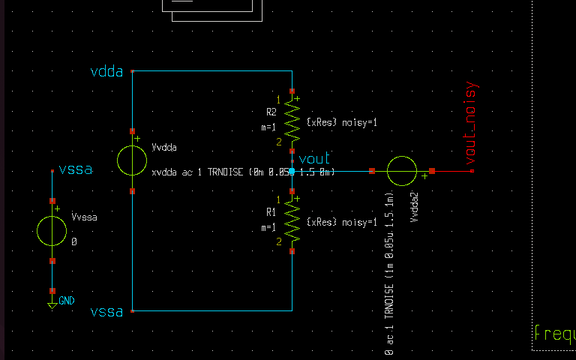

Below shows the rundir contents. In this you are able to see the AWK script and the ascii.raw data. In addition, the code line below the rundir contents examplifies the usage of the AWK script.

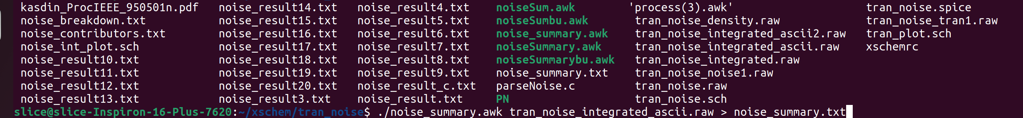

Final text file is shown below:

