Annotating DCOP to device symbols in ihp-sg13g2:

This guide shows how to annotate DCOPs to device symbols simliar to what is seen in commercial EDA tools. Although specifically shown for ihp-sg13g2, it can be applied to any PDK provided the correct NMOS/PMOS device and DCOP naming convention is used.

1. Save the required DCOPs for each interested device in your stim file.

E.g. The below saves various DCOPs for NMOS device “mndio” in block “xota”.

.save

+ @n.xota.xmndio.nsg13_lv_nmos[vgs]
+ @n.xota.xmndio.nsg13_lv_nmos[vds]
+ @n.xota.xmndio.nsg13_lv_nmos[vth]
+ @n.xota.xmndio.nsg13_lv_nmos[gds]
+ @n.xota.xmndio.nsg13_lv_nmos[gm]
+ @n.xota.xmndio.nsg13_lv_nmos[ids]
+ @n.xota.xmndio.nsg13_lv_nmos[vsat]

For multiple devices this will need to be copy pasted multiple times as there doesnt seem to be a way of achieving the above using wildcards. Possible to write a script to automate this process more but time taken to copy/paste/update is not that long in practice.

Note from the above how ihp uses “vsat” instead of “vdsat” and “ids” instead of “id”. All other DCOPs are as per normal naming convention.

2. Run DCOP analysis as normal in ngspice.

E.g. The below runs DCOP analysis, saving all results to file “tb_ota_1stage_op.raw”.

op
* set filetype=ascii
remzerovec
write tb_ota_1stage_op.raw

Note: The line set filetype=ascii is commented out. When setting up step 1, and you are not sure of a name used for a particular DCOP, uncomment this line. It will save results in ascii from which you can determine the name of your required DCOP (although, step 1 outputs the most typically used DCOPs in a design).

3. Update the symbols with the required tcl commands.

Open the symbols for the NMOS/PMOS devices as shown.

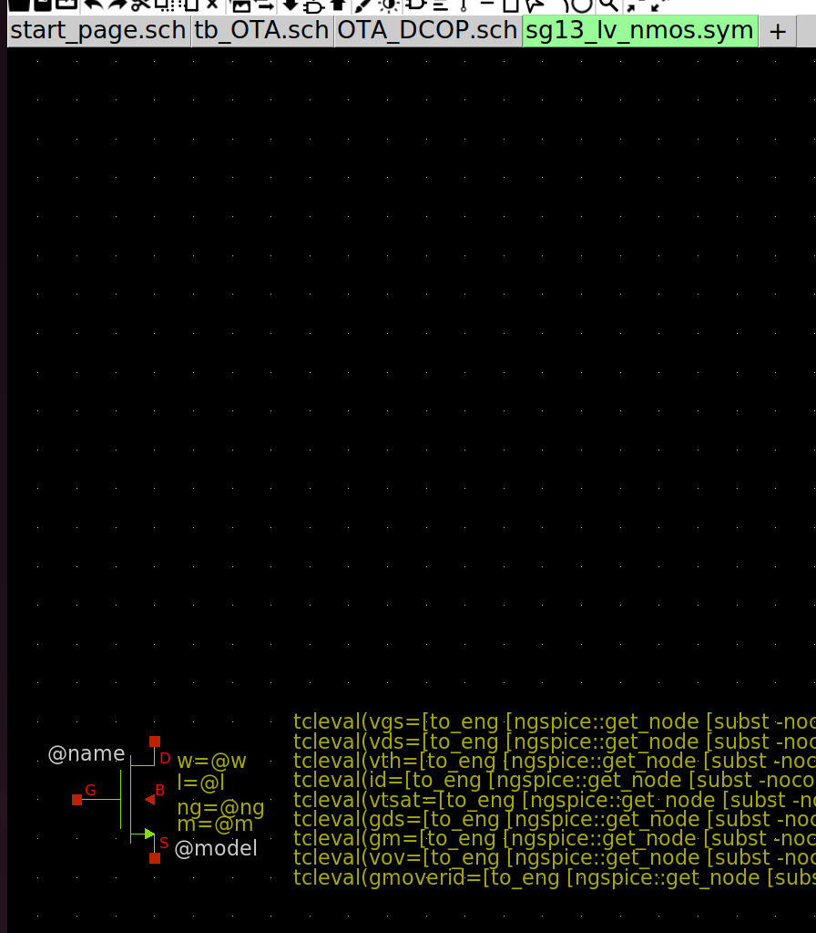

Copy/paste one of the tcl commands already included (e.g. the command “w = @w” as shown).
Edit that command to the following line:

tcleval(vgs=[to_eng [ngspice::get_node [subst -nocommand {v(\@n.${path}@spiceprefix@name\.nsg13_lv_nmos\[vgs])}]]])

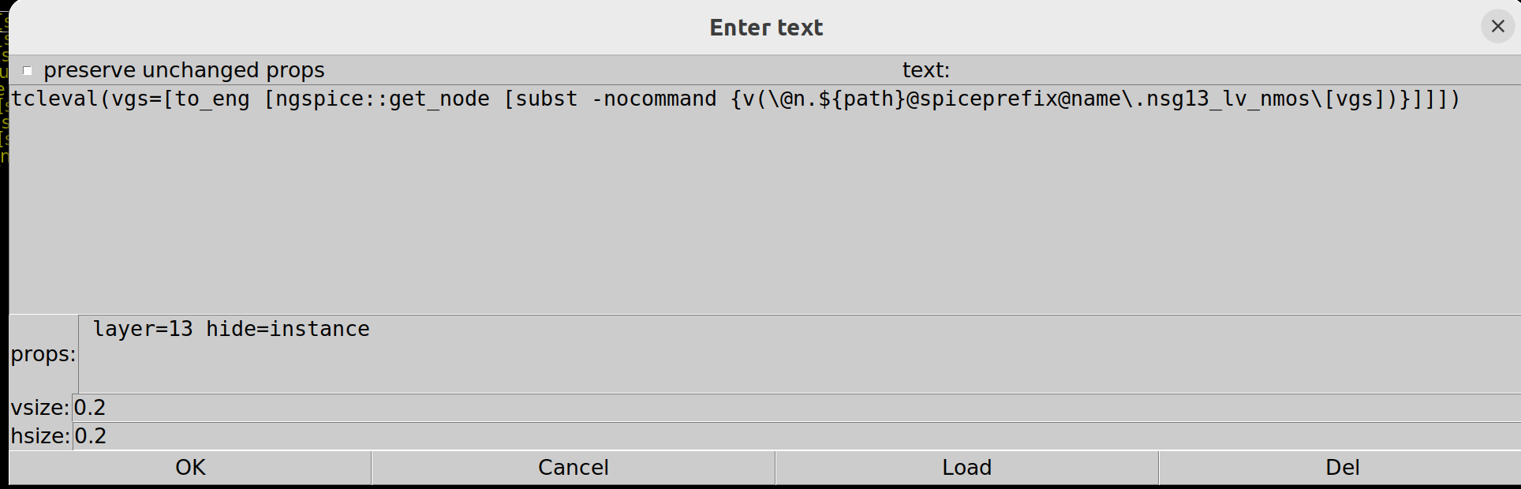
As shown, include the line “hide=instance” as this will enable you to turn on/off the DCOP displays.

Symbol is now set up to display “vgs” DCOP.

Repeat for the other DCOPs using the following tcl commands:

vds:

tcleval(vds=[to_eng [ngspice::get_node [subst -nocommand {v(\@n.${path}@spiceprefix@name\.nsg13_lv_nmos\[vds])}]]])

vth:

tcleval(vth=[to_eng [ngspice::get_node [subst -nocommand {v(\@n.${path}@spiceprefix@name\.nsg13_lv_nmos\[vth])}]]])

id:

tcleval(id=[to_eng [ngspice::get_node [subst -nocommand {i(\@n.${path}@spiceprefix@name\.nsg13_lv_nmos\[ids])}]]])

vtsat:

tcleval(vtsat=[to_eng [ngspice::get_node [subst -nocommand {v(\@n.${path}@spiceprefix@name\.nsg13_lv_nmos\[vsat])}]]])

gds:

tcleval(gds=[to_eng [ngspice::get_node [subst -nocommand {\@n.${path}@spiceprefix@name\.nsg13_lv_nmos\[gds]}]]])

gm:

tcleval(gm=[to_eng [ngspice::get_node [subst -nocommand {\@n.${path}@spiceprefix@name\.nsg13_lv_nmos\[gm]}]]])

vov:

tcleval(vov=[to_eng [ngspice::get_node [subst -nocommand {v(\@n.${path}@spiceprefix@name\.nsg13_lv_nmos\[vgs])}]]-[ngspice::get_node [subst -nocommand {v(\@n.${path}@spiceprefix@name\.nsg13_lv_nmos\[vth])}]]])

gm/id:

tcleval(gmoverid=[to_eng [ngspice::get_node [subst -nocommand {\@n.${path}@spiceprefix@name\.nsg13_lv_nmos\[gm]}]]/[ngspice::get_node [subst -nocommand {i(\@n.${path}@spiceprefix@name\.nsg13_lv_nmos\[ids])}]]])

Resulting symbol should look like:
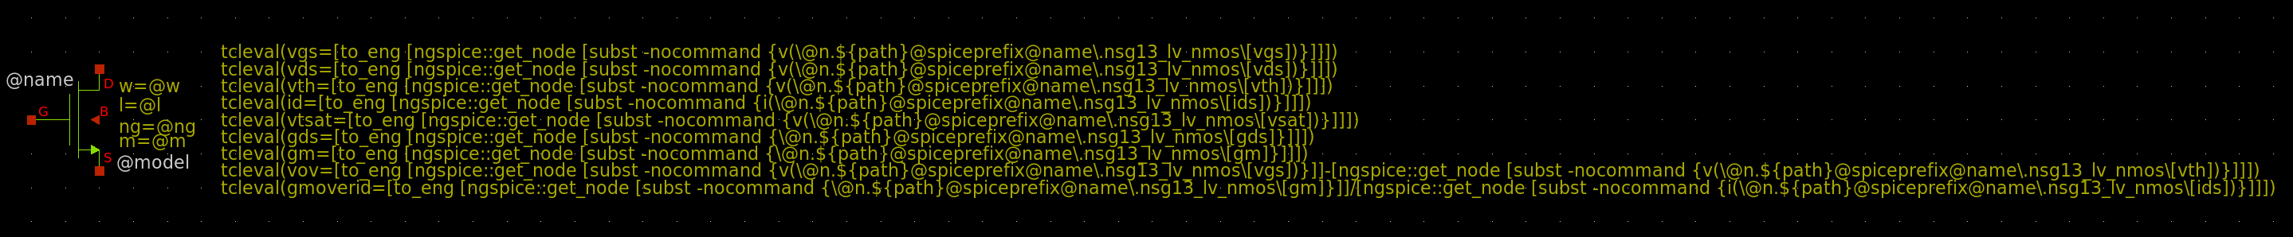
The final 2 DCOPs (vov and gm/id) are created from previous DCOPs. Using these as an example, user can create any expression they want (e.g. Rout = 1/gds).

Note that although this step may seem tedious, it only ever needs to be performed once for every symbol.

For completion, the below shows the set up for a PMOS device:

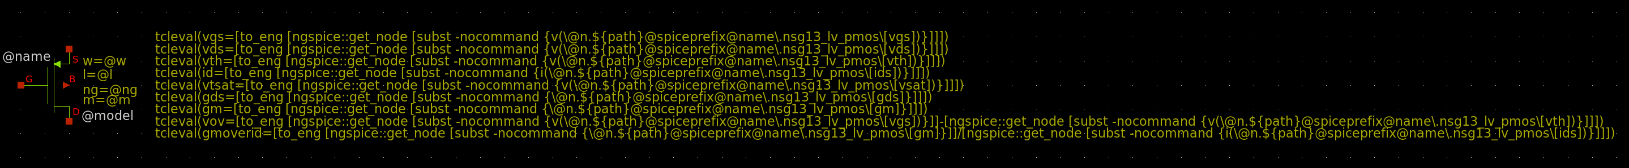
vgs:

tcleval(vgs=[to_eng [ngspice::get_node [subst -nocommand {v(\@n.${path}@spiceprefix@name\.nsg13_lv_pmos\[vgs])}]]])

vds:

tcleval(vds=[to_eng [ngspice::get_node [subst -nocommand {v(\@n.${path}@spiceprefix@name\.nsg13_lv_pmos\[vds])}]]])

vth:

tcleval(vth=[to_eng [ngspice::get_node [subst -nocommand {v(\@n.${path}@spiceprefix@name\.nsg13_lv_pmos\[vth])}]]])

id:

tcleval(id=[to_eng [ngspice::get_node [subst -nocommand {i(\@n.${path}@spiceprefix@name\.nsg13_lv_pmos\[ids])}]]])

vtsat:

tcleval(vtsat=[to_eng [ngspice::get_node [subst -nocommand {v(\@n.${path}@spiceprefix@name\.nsg13_lv_pmos\[vsat])}]]])

gds:

tcleval(gds=[to_eng [ngspice::get_node [subst -nocommand {\@n.${path}@spiceprefix@name\.nsg13_lv_pmos\[gds]}]]])

gm:

tcleval(gm=[to_eng [ngspice::get_node [subst -nocommand {\@n.${path}@spiceprefix@name\.nsg13_lv_pmos\[gm]}]]])
vov:

tcleval(vov=[to_eng [ngspice::get_node [subst -nocommand {v(\@n.${path}@spiceprefix@name\.nsg13_lv_pmos\[vgs])}]]-[ngspice::get_node [subst -nocommand {v(\@n.${path}@spiceprefix@name\.nsg13_lv_pmos\[vth])}]]])

gm/id:

tcleval(gmoverid=[to_eng [ngspice::get_node [subst -nocommand {\@n.${path}@spiceprefix@name\.nsg13_lv_pmos\[gm]}]]/[ngspice::get_node [subst -nocommand {i(\@n.${path}@spiceprefix@name\.nsg13_lv_pmos\[ids])}]]])

4. Netlist and run

5. Open Waves – Op and select the DCOP file specified in step 2.

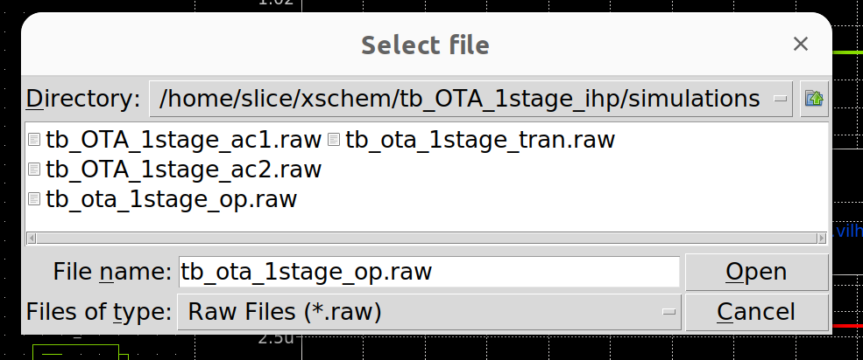
6. Descend into the block of interest

7. Go to View – Show / Hide – Show hidden texts

DCOPs will display as shown.

As can be seen this is identical to how DCOPs are displayed in a commercial EDA.

DCOPs displayed on every device can make a schematic look cluttered. Therefore once viewed, if desired, user can select not to display DCOPs by simply de-selecting “Show hidden texts”.

Note you can ignore the quite poor DCOPs display (gm/id ~ 20 for a current mirror!). Basic OTA design was literally thrown together in 5mins!
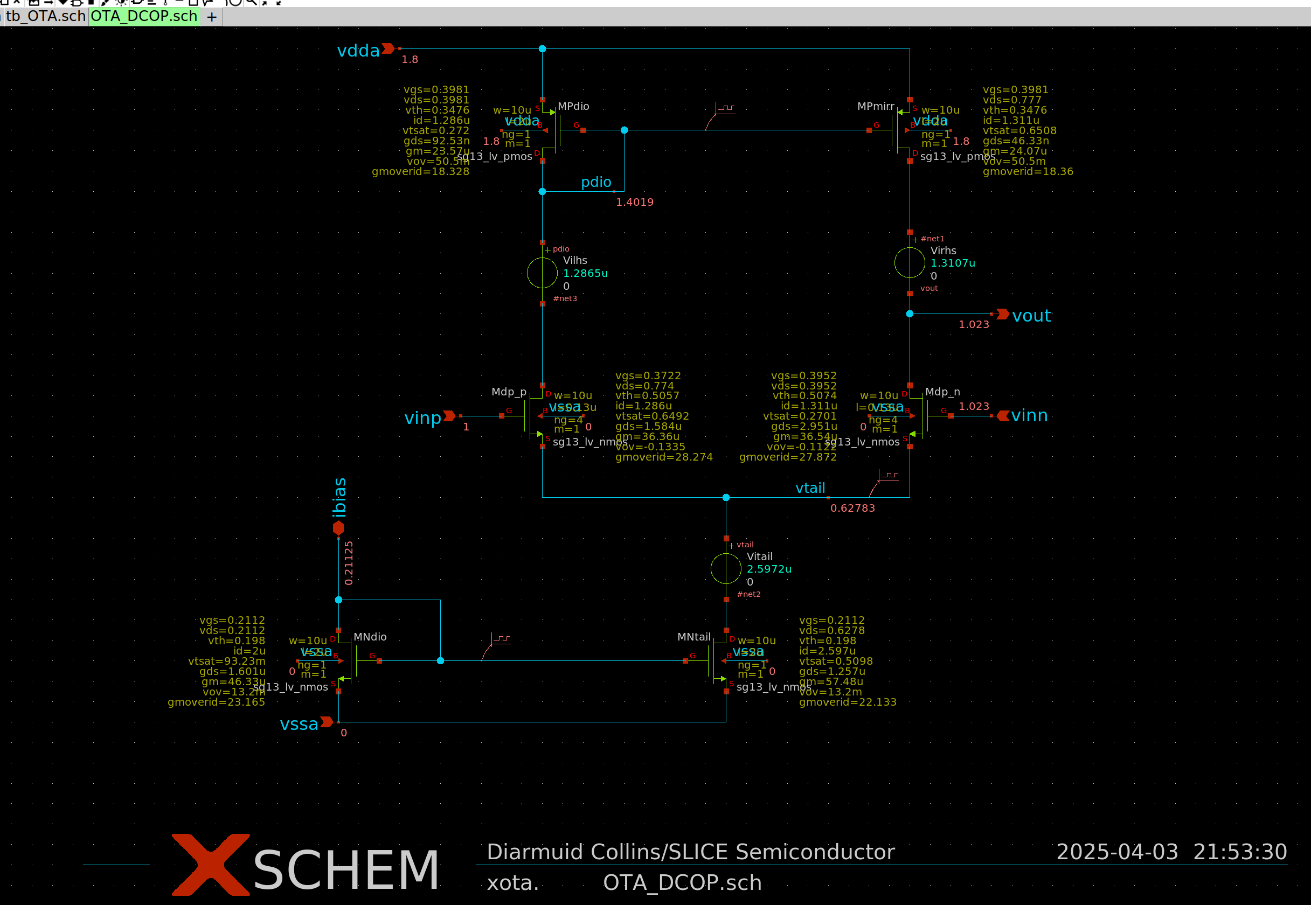

Acknowledgments:

Special thanks to Frederic Schrive (Co-founder / director at Reach Semiconductor) for showing how to do this.

