Annotating DCOP to device symbols in ihp-sg13g2:

This guide shows how to annotate DCOPs to device symbols simliar to what is seen in commercial EDA tools. Unlike the original version, this is more tailored to ihp.

1. Save the required DCOPs for each interested device in your stim file. Go to IHP/Create FET .save file and hit save.

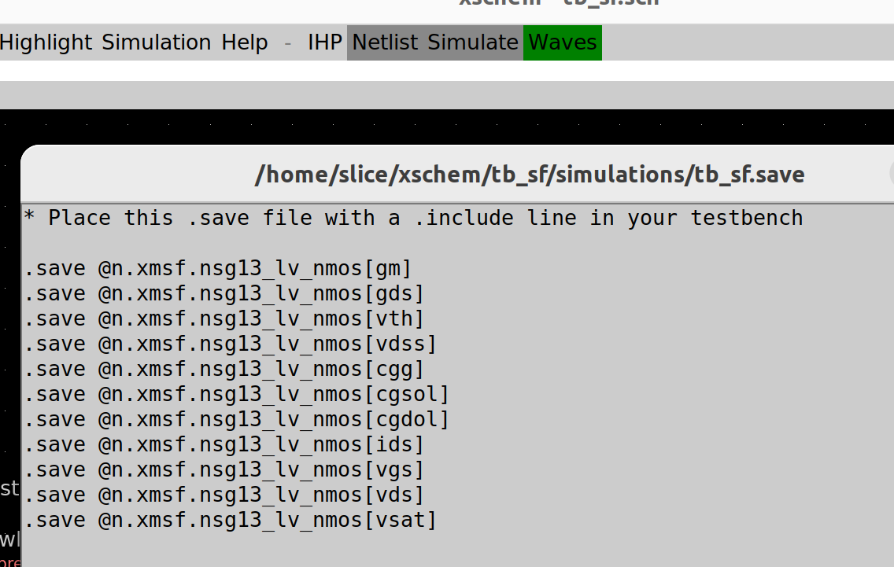
This will save various parameters (in a .save file) in the <dir>/simulations folder as shown below (tb_sf.save).

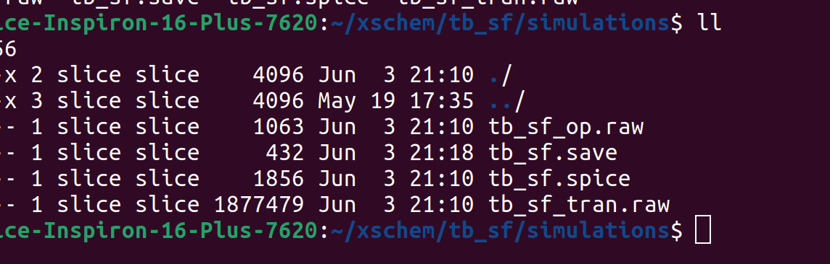
Exactly what can be saved can be edited with the xschemrc file. Search for [ids] and you will come to 2 locations. The first is shown below. Using the syntax shown, copy a line and edit as required according to the parameter you want to save.

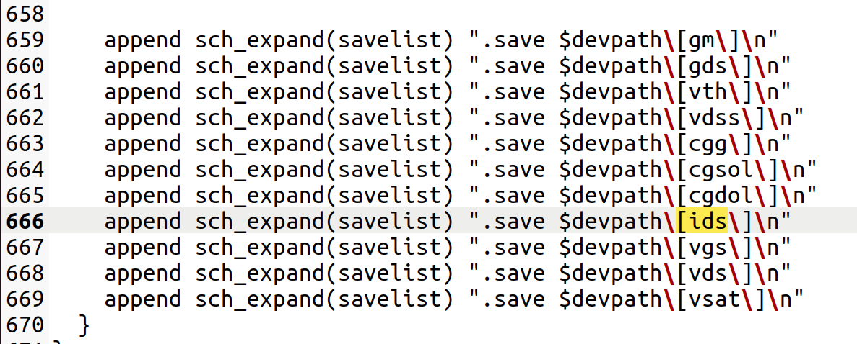
The 2nd location is shown below. Again, just copy a line and edit as required according to the parameter you want to save.

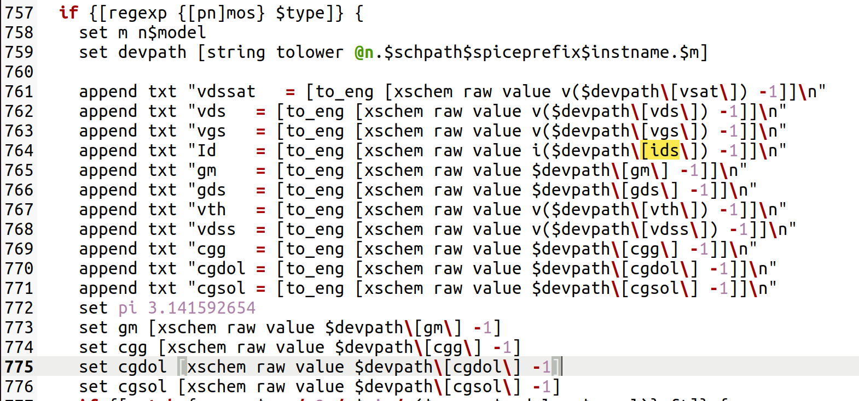
Note: You will see in the above I have added a parameter vsat. I thought this was vdsat so manually included it. Turns out it is the value of the extrapolated vt in the saturation region and not a very meaningful parameter, according to Boris Murmann. As a result, I have since removed it. Vdsat is referred to as “vdss” as can be found from the below:

https://www.cea.fr/cea-tech/leti/pspsupport/Documents/psp103p5_summary.pdf

Go into the <dir>/simulations folder and view the .save file, which will look something like:

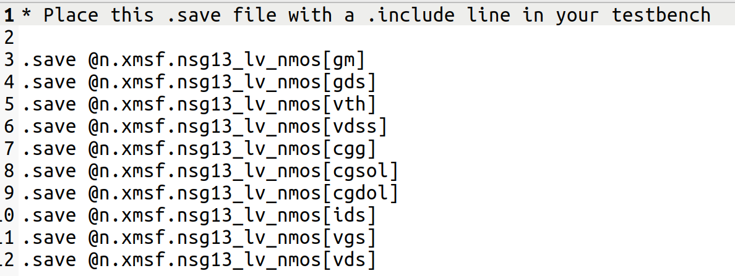

In the stim.file, include the .save file with a .include statement as shown below:

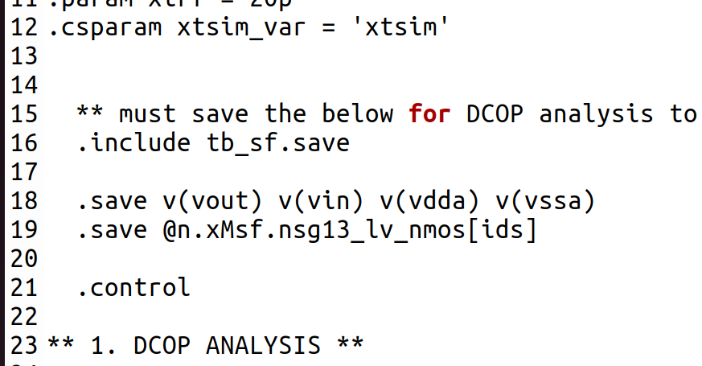

2. Run DCOP analysis as normal in ngspice.

E.g. The below runs DCOP analysis, saving all results to file “tb_ota_1stage_op.raw”.

op
* set filetype=ascii
remzerovec
write tb_ota_1stage_op.raw

Note: The line set filetype=ascii is commented out. When setting up step 1, and you are not sure of a name used for a particular DCOP, uncomment this line. It will save results in ascii from which you can determine the name of your required DCOP (although, step 1 outputs the most typically used DCOPs in a design). However, a more efficient way of doing this would be to view the below:

https://www.cea.fr/cea-tech/leti/pspsupport/Documents/psp103p5_summary.pdf

3. Update the symbols with the required tcl commands.

Open the symbols for the NMOS/PMOS devices as shown.

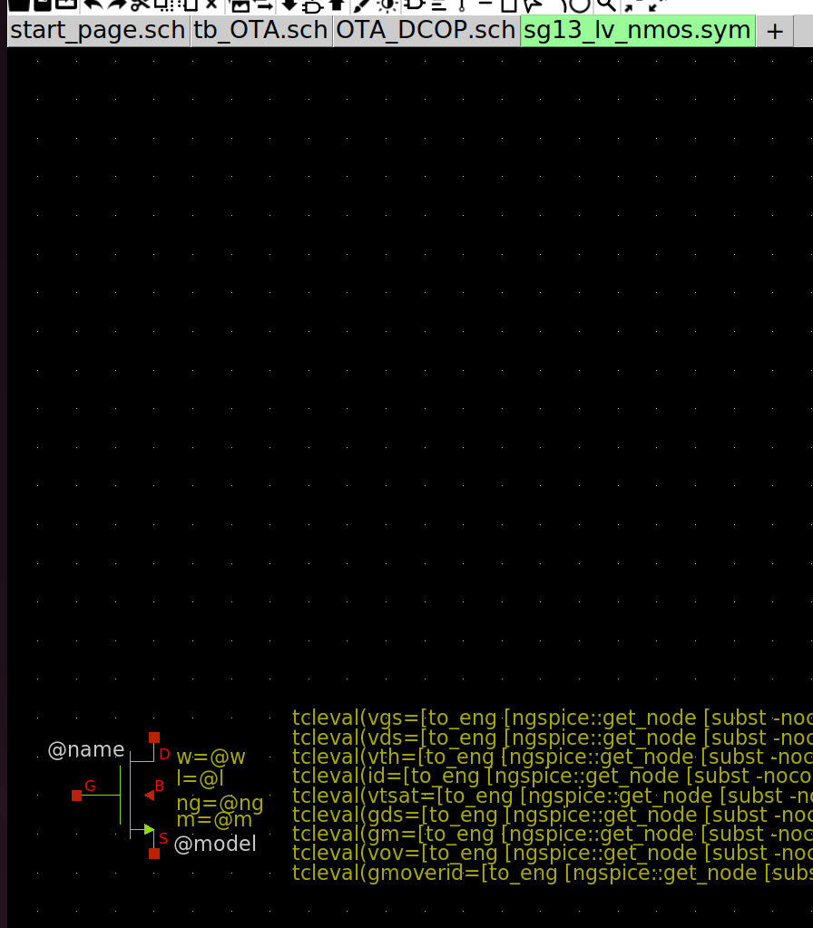

Copy/paste one of the tcl commands already included (e.g. the command “w = @w” as shown).
Edit that command to the following line:

tcleval(vgs=[to_eng [ngspice::get_node [subst -nocommand {v(\@n.${path}@spiceprefix@name\.nsg13_lv_nmos\[vgs])}]]])

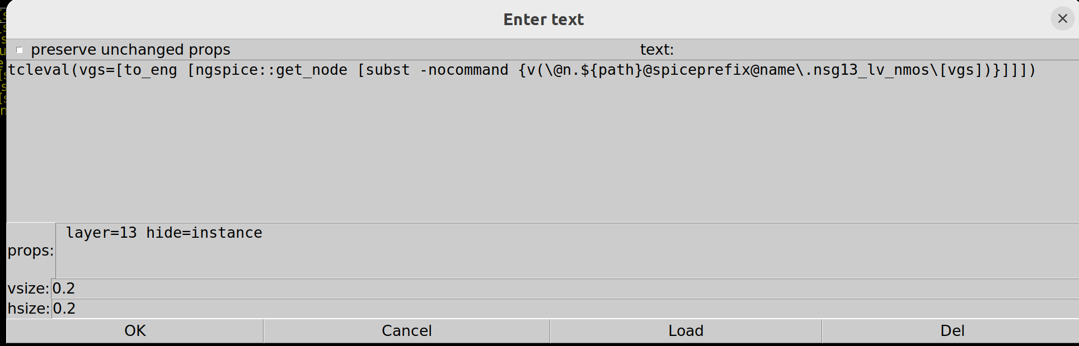
As shown, include the line “hide=instance” as this will enable you to turn on/off the DCOP displays.

Symbol is now set up to display “vgs” DCOP.

Repeat for the other DCOPs using the following tcl commands:

vds:

tcleval(vds=[to_eng [ngspice::get_node [subst -nocommand {v(\@n.${path}@spiceprefix@name\.nsg13_lv_nmos\[vds])}]]])

vth:

tcleval(vth=[to_eng [ngspice::get_node [subst -nocommand {v(\@n.${path}@spiceprefix@name\.nsg13_lv_nmos\[vth])}]]])

id:

tcleval(id=[to_eng [ngspice::get_node [subst -nocommand {i(\@n.${path}@spiceprefix@name\.nsg13_lv_nmos\[ids])}]]])

vdsat:

tcleval(vdsat=[to_eng [ngspice::get_node [subst -nocommand {v(\@n.${path}@spiceprefix@name\.nsg13_lv_nmos\[vdss])}]]])

gds:

tcleval(gds=[to_eng [ngspice::get_node [subst -nocommand {\@n.${path}@spiceprefix@name\.nsg13_lv_nmos\[gds]}]]])

gm:

tcleval(gm=[to_eng [ngspice::get_node [subst -nocommand {\@n.${path}@spiceprefix@name\.nsg13_lv_nmos\[gm]}]]])

vov:

tcleval(vov=[to_eng [ngspice::get_node [subst -nocommand {v(\@n.${path}@spiceprefix@name\.nsg13_lv_nmos\[vgs])}]]-[ngspice::get_node [subst -nocommand {v(\@n.${path}@spiceprefix@name\.nsg13_lv_nmos\[vth])}]]])

gm/id:

tcleval(gmoverid=[to_eng [ngspice::get_node [subst -nocommand {\@n.${path}@spiceprefix@name\.nsg13_lv_nmos\[gm]}]]/[ngspice::get_node [subst -nocommand {i(\@n.${path}@spiceprefix@name\.nsg13_lv_nmos\[ids])}]]])

Resulting symbol should look like:
Note: In the above screen shot, vdsat is incorrectly taken from vsat

The final 2 DCOPs (vov and gm/id) are created from previous DCOPs. Using these as an example, user can create any expression they want (e.g. Rout = 1/gds).

Note that although this step may seem tedious, it only ever needs to be performed once for every symbol.

For completion, the below shows the set up for a PMOS device:

vgs:

tcleval(vgs=[to_eng [ngspice::get_node [subst -nocommand {v(\@n.${path}@spiceprefix@name\.nsg13_lv_pmos\[vgs])}]]])

vds:

tcleval(vds=[to_eng [ngspice::get_node [subst -nocommand {v(\@n.${path}@spiceprefix@name\.nsg13_lv_pmos\[vds])}]]])

vth:

tcleval(vth=[to_eng [ngspice::get_node [subst -nocommand {v(\@n.${path}@spiceprefix@name\.nsg13_lv_pmos\[vth])}]]])

id:

tcleval(id=[to_eng [ngspice::get_node [subst -nocommand {i(\@n.${path}@spiceprefix@name\.nsg13_lv_pmos\[ids])}]]])

vtsat:

tcleval(vdsat=[to_eng [ngspice::get_node [subst -nocommand {v(\@n.${path}@spiceprefix@name\.nsg13_lv_pmos\[vdss])}]]])

gds:

tcleval(gds=[to_eng [ngspice::get_node [subst -nocommand {\@n.${path}@spiceprefix@name\.nsg13_lv_pmos\[gds]}]]])

gm:

tcleval(gm=[to_eng [ngspice::get_node [subst -nocommand {\@n.${path}@spiceprefix@name\.nsg13_lv_pmos\[gm]}]]])
vov:

tcleval(vov=[to_eng [ngspice::get_node [subst -nocommand {v(\@n.${path}@spiceprefix@name\.nsg13_lv_pmos\[vgs])}]]-[ngspice::get_node [subst -nocommand {v(\@n.${path}@spiceprefix@name\.nsg13_lv_pmos\[vth])}]]])

gm/id:

tcleval(gmoverid=[to_eng [ngspice::get_node [subst -nocommand {\@n.${path}@spiceprefix@name\.nsg13_lv_pmos\[gm]}]]/[ngspice::get_node [subst -nocommand {i(\@n.${path}@spiceprefix@name\.nsg13_lv_pmos\[ids])}]]])

4. Netlist and run

5. Open Waves – Op Annotate and select the DCOP file specified in step 2.

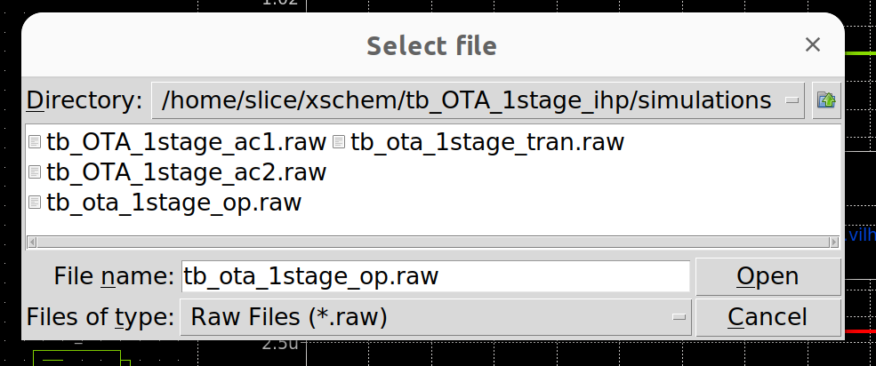
6. Descend into the block of interest

7. Go to View – Show / Hide – Show hidden texts

DCOPs will display as shown.

As can be seen this is identical to how DCOPs are displayed in a commercial EDA.

DCOPs displayed on every device can make a schematic look cluttered. Therefore once viewed, if desired, user can select not to display DCOPs by simply de-selecting “Show hidden texts”.

Note you can ignore the quite poor DCOPs display (gm/id ~ 20 for a current mirror!). Basic OTA design was literally thrown together in 5mins!
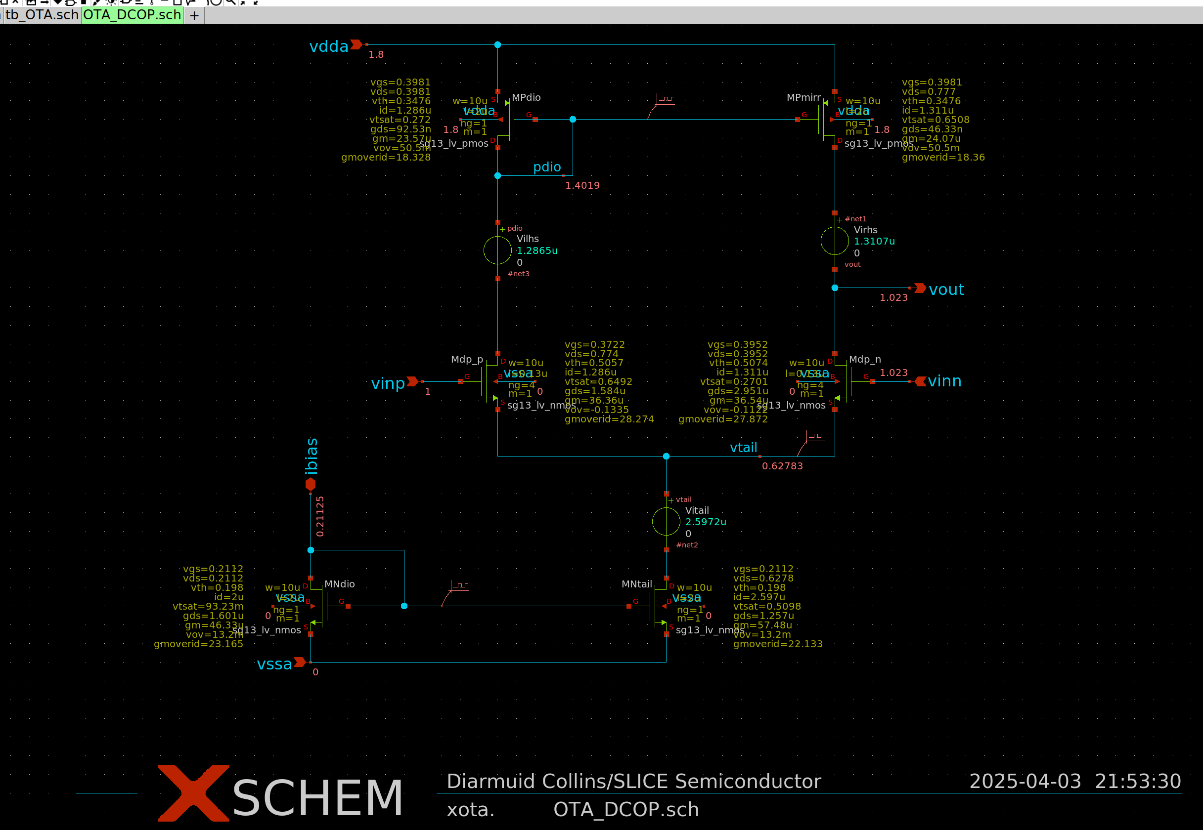

Another way to view DCOPs is as follows:

- Select a device
- IHP/Add FET param annotator
- Place block close to device of interest
- Netlist and run
- Load DCOP file

After this, all the DCOPs will appear in the device of interest. As shown below, it matches those displayed from the method described above.

This alternative method is a good cross check of the above documented one so good to run when setting up a new parameter to be saved. As shown below, both methods produce the same values verifying nothing strange has occurred.

You can of course use this method solely but I like the documented method as it is more in tune with a commercial EDA tool.

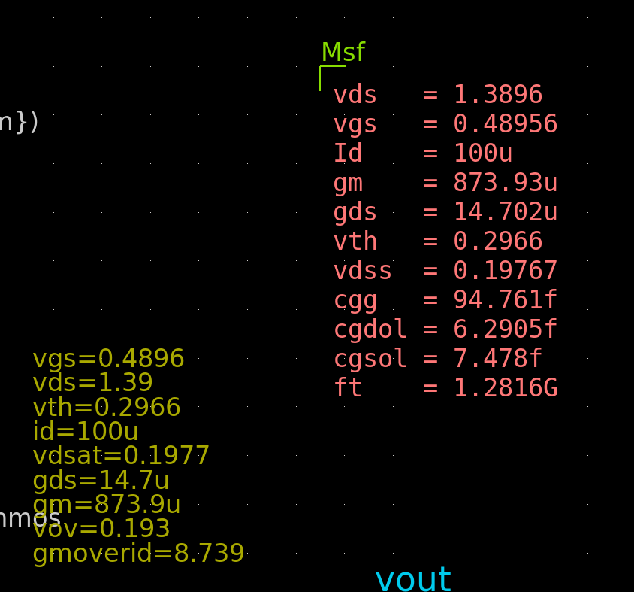

An amazing debug tool (not available in commercial EDA tools!) is the ability to view DCOPs across transient plots. Simply add “set appendwrite” after the first write statement in your tran analysis set up. I underlined after to ensure the .raw file is overwritten each time the sim is started (otherwise you will have a previous sims results being displayed in your transient outputs!).

** 2. TRAN ANALYSIS **

tran 1n $&xtsim_var
*set filetype=ascii
remzerovec
** Uncomment the below if you want to run DCOP across tran
write tb_sf_tran.raw
set appendwrite
*unset appendwrite

Then throw down a graph and load Waves/Op Annotate but this time load the tran.raw file instead of the op.raw file as shown below.

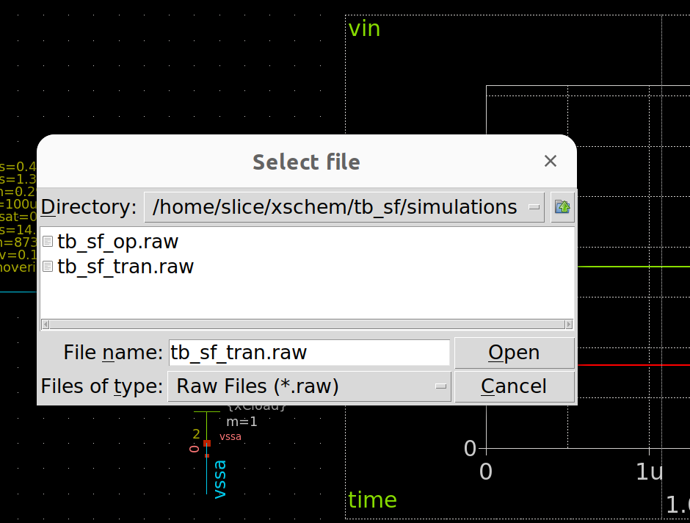
Then hit ‘b’ to display a vertical cursor and drag across the waveform to see DCOPs update as you progress through time.

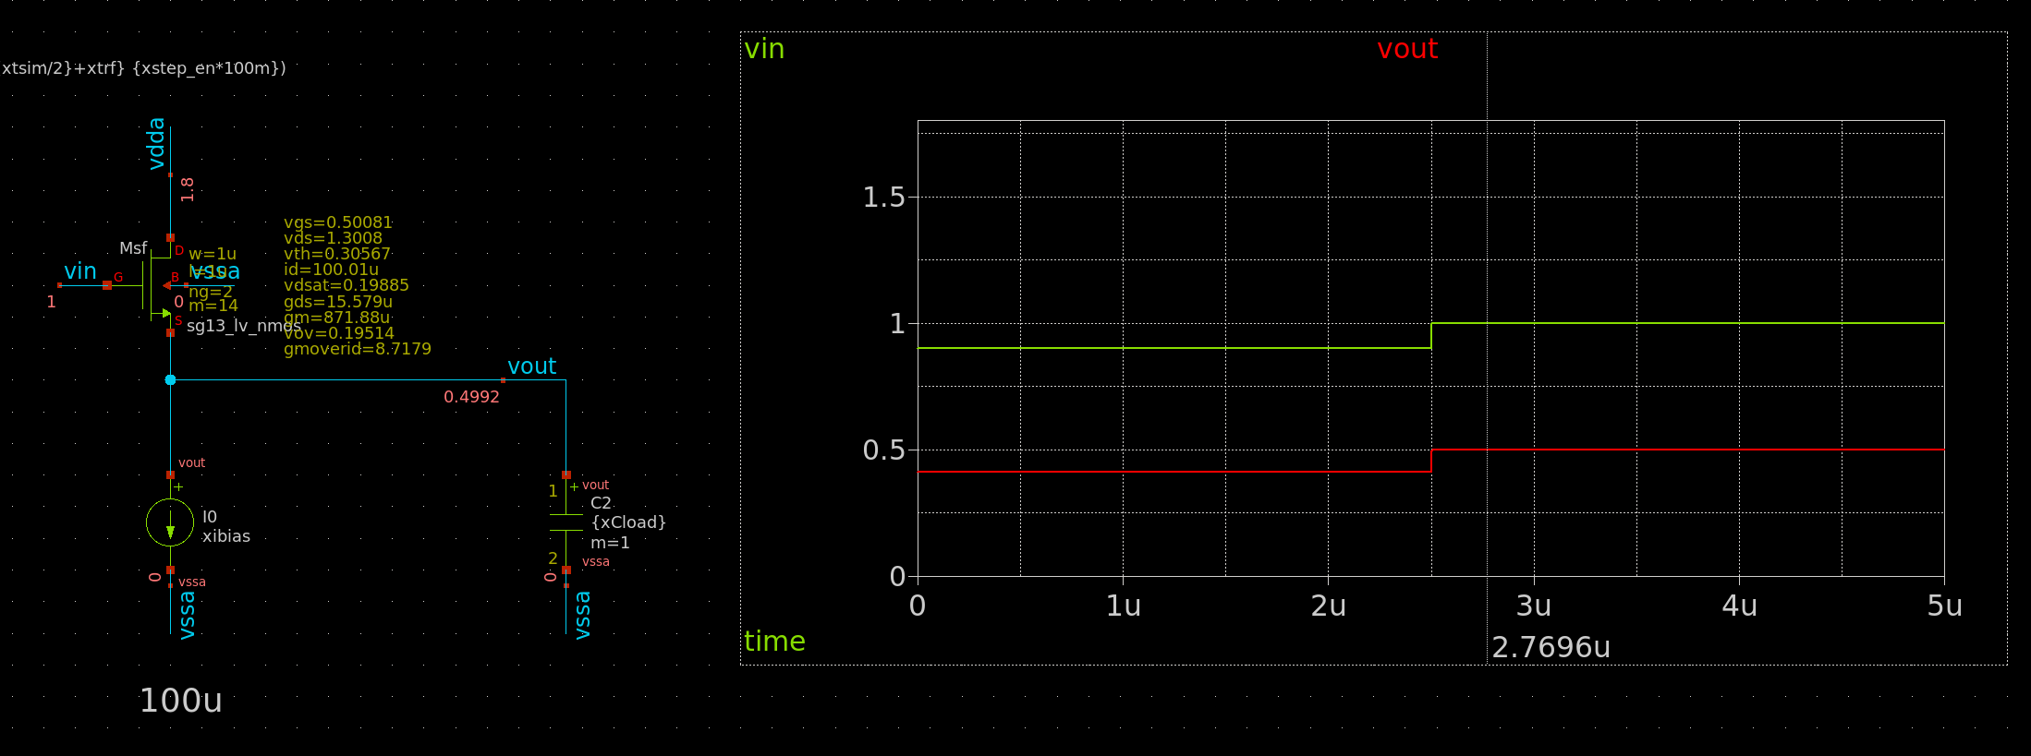
I cant stress enough how valuable a debug tool this is!!!

Acknowledgments:

Special thanks to Frederic Schrive (Co-founder / director at Reach Semiconductor) for showing how to do this.

