Running MC sims at TT:

1. Schematic setup:

Fig.1 shows a setup I used to characterise matching co-efficients for an NMOS.

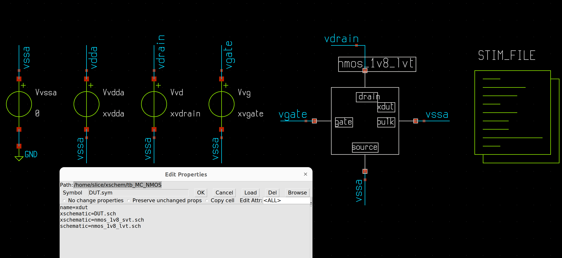
Fig.1

2. Stim setup:

Read in the MC lib as per below:

.lib /home/slice/pdk/SW130/share/pdk/sky130A/libs.tech/combined/sky130.lib.spice tt_mm

Inside the .control section, set up a loop corresponding to the number of runs you want:

.control
save all
let run = 1

dowhile run <= 200
* reset required to set new values for each run
reset
remzerovec
* want to append the result from each run to the same file
set appendwrite
set filetype=ascii
* MC data will all be contained in this file
write tb_MC_NMOS.raw
* release the memory holding the output data sets (good memory management)
destroy all
let run = run+1
end

3. Results:

The .raw file from section 2 is a raw dump of data which is useful for checking setup. Fig.2 shows a screenshot of its contents:

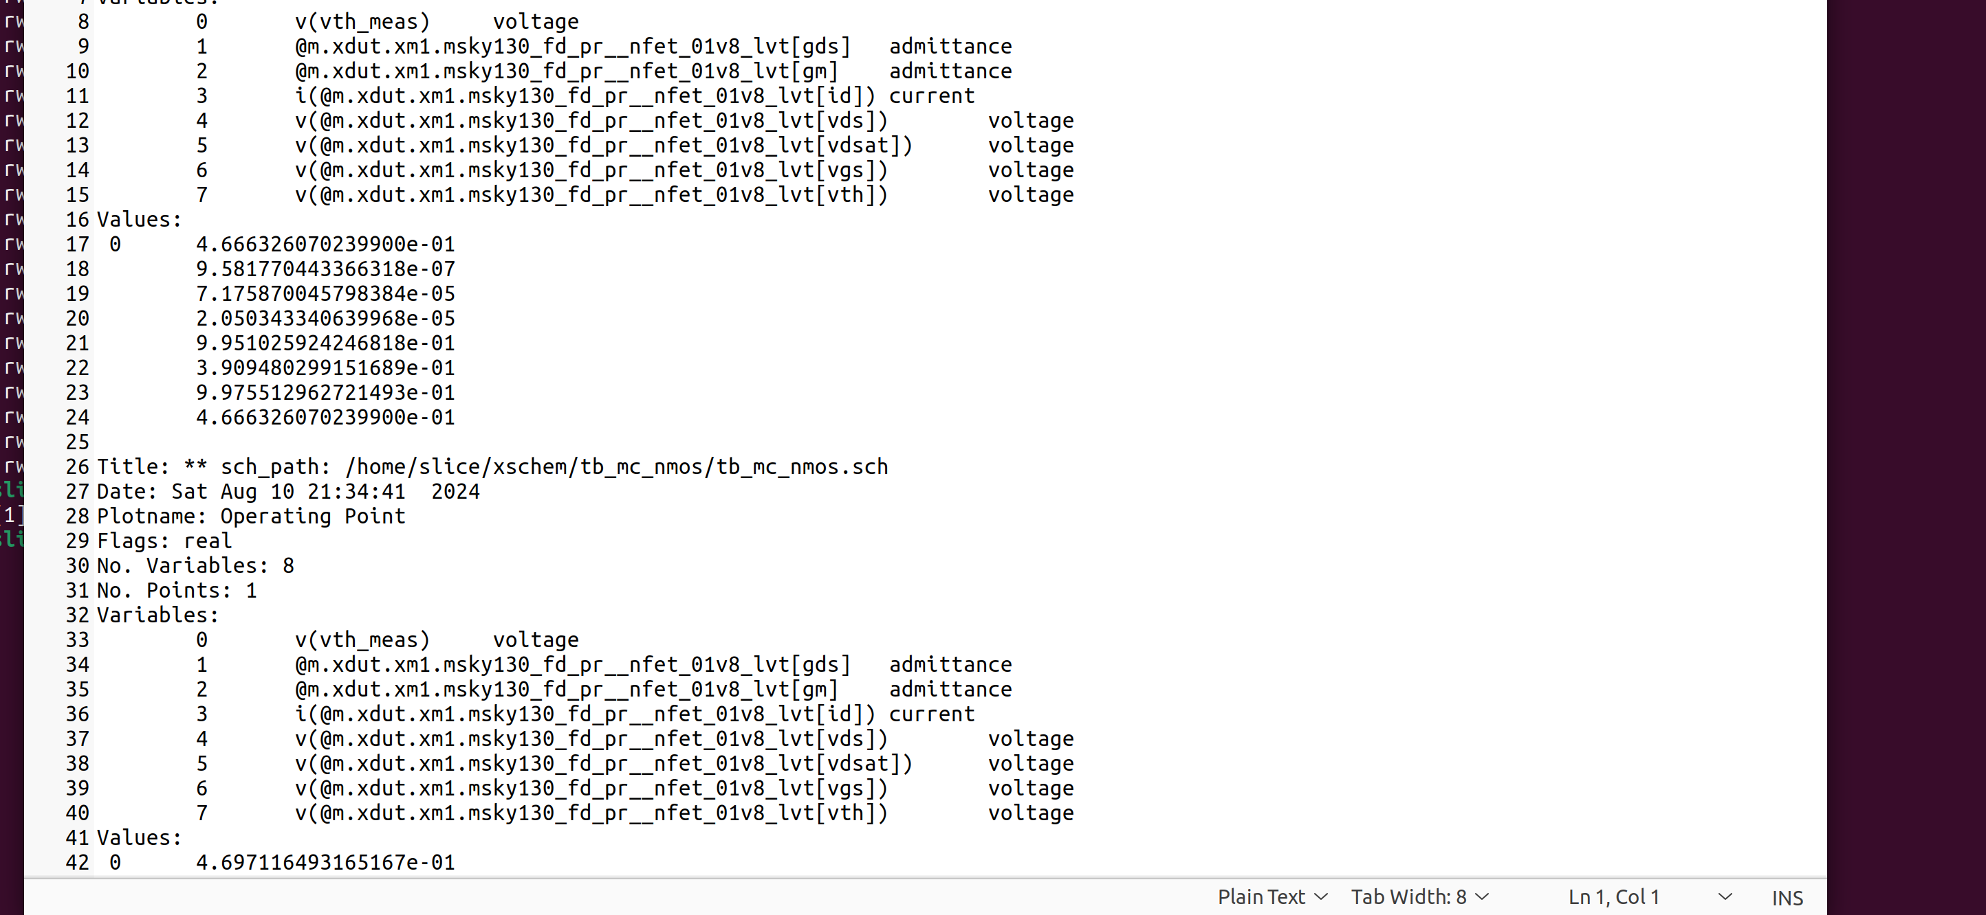
Fig.2

A more practical means of gathering data is to write a measure specific to the parameter you are interested. E.g. below measures the vth of lvt NMOS devices.

let vth_meas = @m.xdut.xm1.msky130_fd_pr__nfet_01v8_lvt[vth]

Then send this measure to an output file:

echo "$&vth_meas" >> vth_measures.txt

The resulting file will be a column of numers with #rows = #MC runs. An example screentshot is shown in Fig.3.

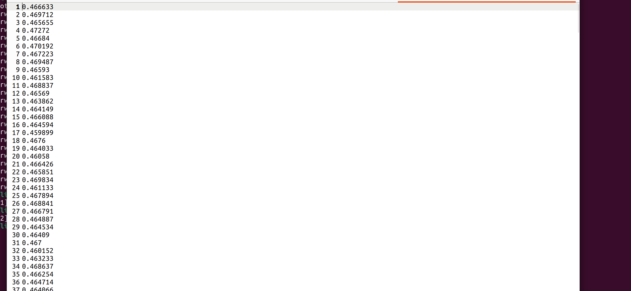
Fig.3
You can then read this into octave to do anything with. For example, I created the script “mc_data_analyser.m” which will output the histogram data in Fig.4 and the full statistical analysis in Fig.5.

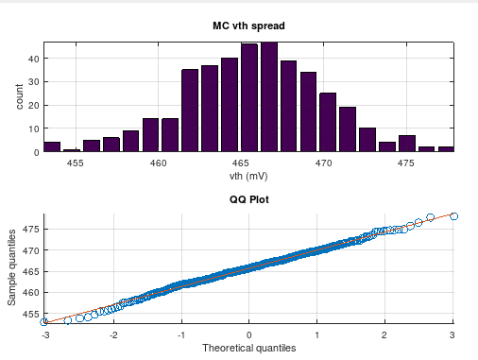
Fig.4

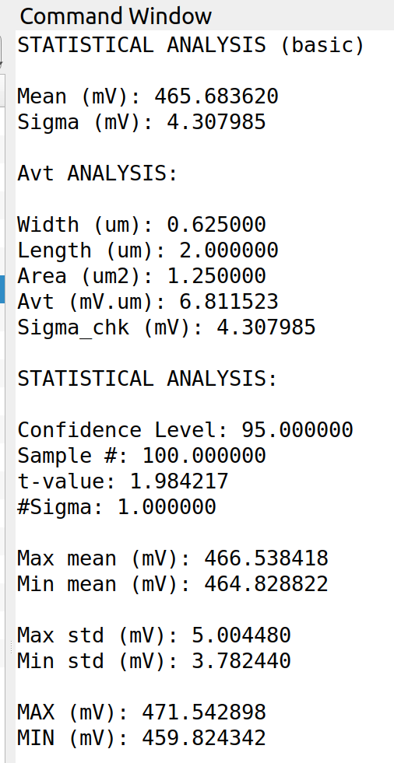

Fig.5
Note the statiscal analysis correlates with SDE for the same data set. Also note it uses confidence intervals where the user has the choice of selecting either 90 / 95 / 99% confidence levels in the code.

4. Github links:

I characterised matching data for SKY130 using the above procedure. All tbs / results / ppts are contained at the below link:

https://github.com/SLICESemiconductor/SW130_PDK/tree/main/Matching_data

