Running PVT sims:

1. System requirements:

This doc shows how to run PVT sims locally (i.e. not farming out to an external server). To do this we must be mindful of our computer resources. For my laptop I have 19 cores / 15G Ram and 2G of swap, as shown below:

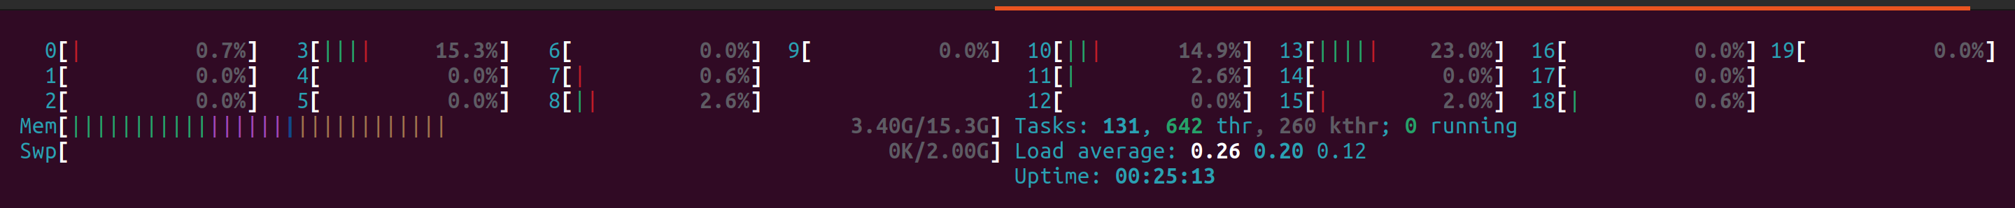
Fig.1

Ngspice uses 2 cores per sim => I can run 9 sims in paralell. But I need to be very careful I don’t use all my RAM otherwise, no results get written! This is why it is a good idea to keep a close eye on system resources when running PVT sims (by pressing htop command). If you keep running out of RAM you can think of adding more RAM or partitioning more of your hard drive for SWAP. Personally I think 15G RAM is not enough and would like to increase it to 32G with the same for SWAP. Quite possibly I will do this in the future. In addition, you can look into using the save command in ngspice more efficiently.

2. Tcl scripting:

To farm out the PVT sims locally you will use a tcl script run through xschem. This works as follows:

- Read in the netlist
- Using the string editor command (sed), change a parameter (say vdda) in the netlist
- Set up the raw file names to correspond to the given corner
- Simulate
- Wait 1 sec before moving onto the next corner

Central to the tcl scripts is the sed command. Below examplifies all the necessary options of this command to run PVT analysis.

exec sed -i {/^\.lib/s/tt/ff/} $spicefile

exec: executes the sed command in the tcl script
sed -i: edits in place i.e. makes the edit in the file which it finds a given pattern in
/xxxx/: Looks for expression “xxxx”
^: Means “beginning of line”
\.: means 'any single character', while \. means a literal . in the text. So to use “.” as a literal it must be preceeded by \
/^\.lib/: Expression = line starting with “.lib”
s: substitute
s/tt/ff/: substitute “tt” with “ff”
exec sed -i {/^\.lib/s/tt/ff/}: execute the string editor to find a line begining with “.lib”. When you find that line, look for pattern “tt” and substitute it with “ff” in the same file.
$spicefile: The above command is applied to the file contained in variable spicefile which is set equal to the netlist I want to edit with: set spicefile $netlist_dir/tb_OTA_PVT.spice
A similiar example is shown below:

exec sed -i {/^\.temp/s/27/125/} $spicefile

This executes the string editor to find a line begining with “.temp”. When you find that line, look for pattern “27” and substitute it with “125” in the same file, which is contained in variable spicefile, set equal to the netlist I want to edit with: set spicefile $netlist_dir/tb_OTA_PVT.spice

The above are involved examples since they look for common patterns such as 27 and tt. These could occur in multiple lines of the spice file creating the need to specify the specific line occurence we want to make the substition on, thus creating the need to look for lines starting with .lib or .temp. If we want to substitue a pattern which we are sure only occurs on one line, the command simplifies to:

exec sed -i {s/tb_OTA_PVT_tran.raw/tb_OTA_PVT_tran_ff_n40_1v7.raw/} $spicefile

This executes the string editor to look for pattern “tb_OTA_PVT_tran.raw” and substitute it with “tb_OTA_PVT_tran_ff_n40_1v7.raw” in the same file, which is contained in variable spicefile, set equal to the netlist I want to edit with: set spicefile $netlist_dir/tb_OTA_PVT.spice

The following summarises the use of the sed command in the various tcl scripts used for PVT sims.

# change to ff corner
exec sed -i {/^\.lib/s/tt/ff/} $spicefile
exec sed -i {s/tb_OTA_PVT_tran.raw/tb_OTA_PVT_tran_ff.raw/} $spicefile
exec sed -i {s/tb_OTA_PVT_ac1.raw/tb_OTA_PVT_ac1_ff.raw/} $spicefile
exec sed -i {s/tb_OTA_PVT_ac2.raw/tb_OTA_PVT_ac2_ff.raw/} $spicefile
exec sed -i {s/ac_measures.txt/ac_measures_ff.txt/} $spicefile
simulate
after 1000 ;# wait 1sec for ngspice to start and read netlist

Since the preceeding sim was at tt corner and we want to change to ff corner, the first line changes “tt” to “ff” in the line beginning with .lib. Next we change all the raw files to correspond to the new corner by apending “_ff” to the end of them. Finally, since the sim writes the various stb measures to a file called “ac_measures.txt”, we append “_ff” to this also.

The below tcl scripts are checked into github:

PVT_tcl_script.txt ... runs a full PVT corner sweep
PT_tcl_script.txt ... varies process and temp
P_tcl_script.txt ... varies process only
V_tcl_script.txt ... varies supply voltage only
T_tcl_script.txt ... varies temp only

Github location is:

https://github.com/SLICESemiconductor/OpenSourceTool_Examples/tree/main/PVT_corner_runs

3. Running tcl scripts in xschem:

In xschem, these tcl scripts are embedded in the launcher as shown.

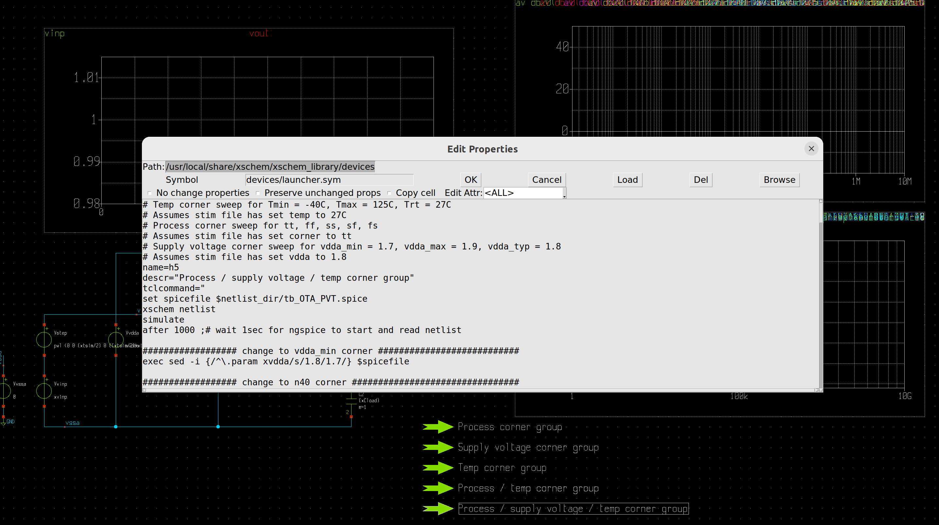
Fig.2
As the scripts are embedded into the lanucher, they can be run by ctrl + click on the relevant launcher.
Note: xschem launches a new terminal for each sim. This can be a problem when running a large number of corners as it will result in a large # of terminal windows on the screen. To avoid this you need to add the below line just before .endc in your ngspice file.
quit 0
Understanding this line gave rise to an interesting thread in the open source slack channel. My question on the channel is contained in Appendix 1. Darryl Miles’ response is given in Appendix 2 while Stefan Schippers response is given in Appendix 3.
4. Viewing the results in the xschem waveviewer:

PVT results are loaded in as normal. This is shown below where all raw files from a full PVT corner run are loaded in. Although this is working and effective, I have the followins issues with it:

- Legend at the top doesnt support many corners before individual corner texts become unreadable
- Little bit manual to load in each of the corners

But it does work and thats the main thing. To not view a file simply place an x before the waveform name. E.g. "ff1251v7;av db20()%tb_OTA_PVT_ac2_ff_125_1v7.raw" would change to "ff1251v7;xav db20()%tb_OTA_PVT_ac2_ff_125_1v7.raw"
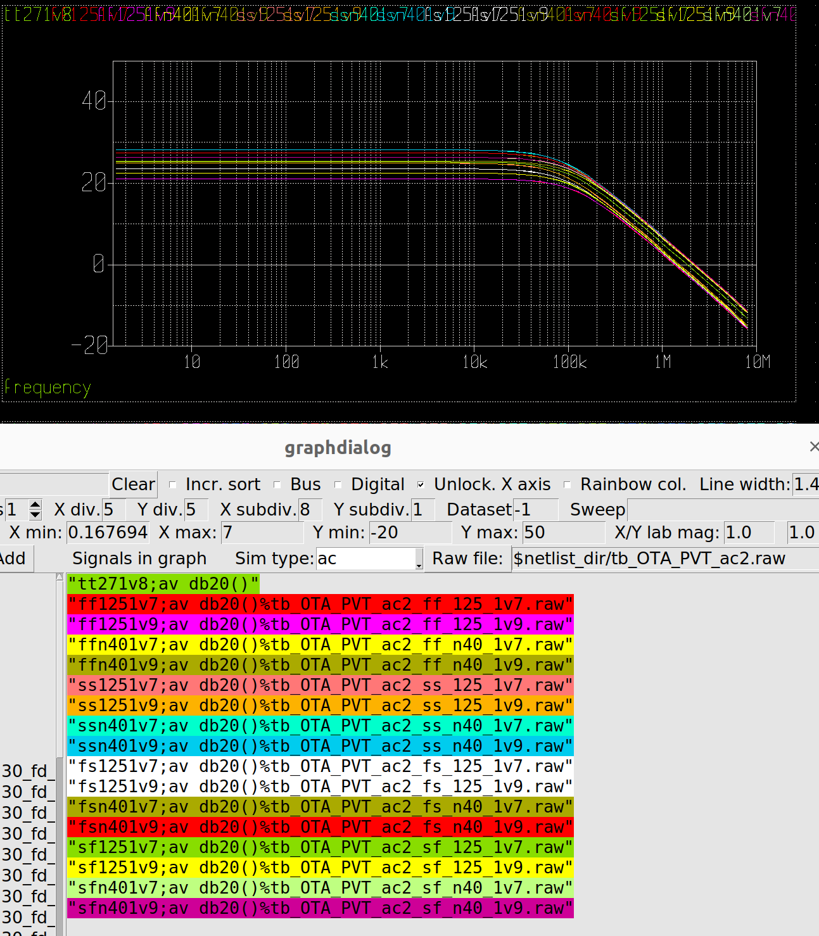
Fig.3
Note that you will have to manipulate the plot windows by zooming in / out. Below is Stefans on how to return to the original plot after you have zoomed in:
“Pressing 'f' with the mouse inside the graph will do a zoom x-axis to fit.
Pressing 'f' with the mouse pointer close to the left side of the y axis will do a zoom y-axis to fit.”
5. Post processing the PVT results:

When the sim runs, multiple raw files will be outputted to your home dir. To analyse these you need a post processing script. I use octave for this which basically sucks in all the raw files and summarises chosen data in one csv similiar to what you get from a commercial EDA. The file is called PVT_analyser.m and is saved at:

https://github.com/SLICESemiconductor/OpenSourceTool_Examples/tree/main/PVT_corner_runs

This version is saved to post process PVT data from a stability sim where it summarises the data into: Av0, BW, GBW, PM and GM, presented as below in the command window.

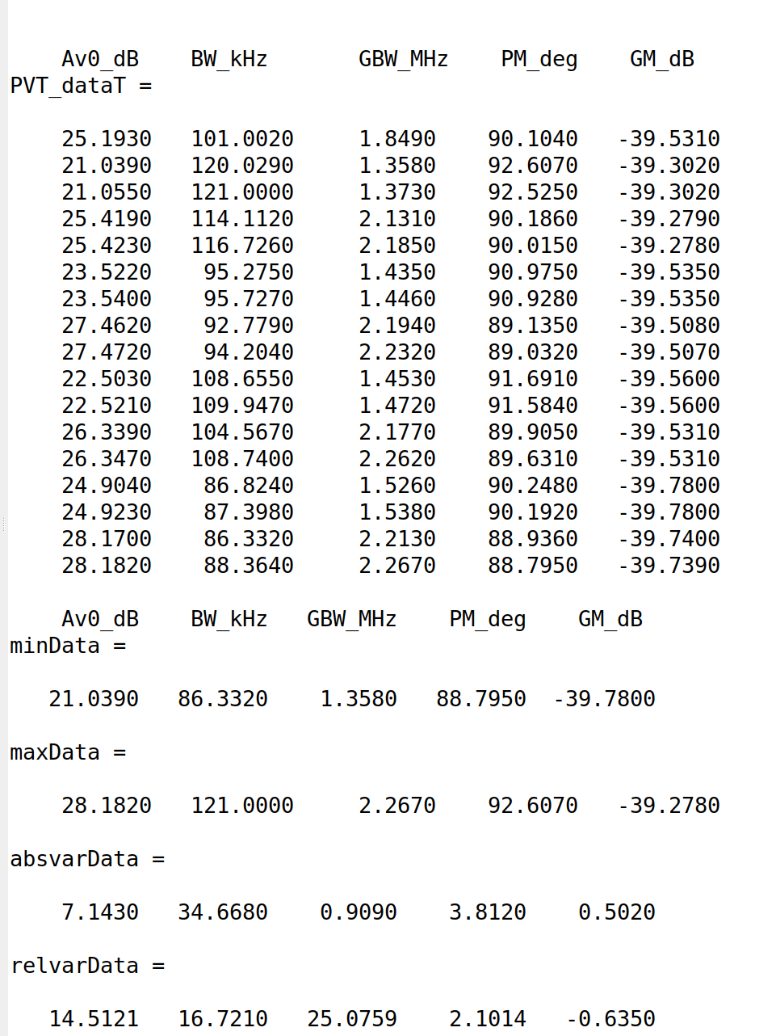

Fig.4

As you can see it also shows min / max / absolute and relvative variations.
In addition, it plots these spreads across corners as per Fig.5.

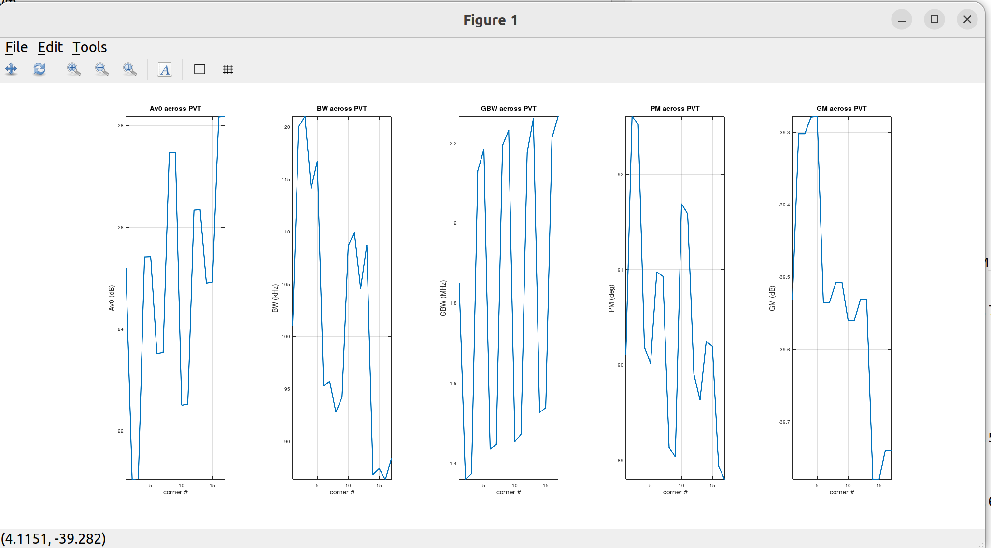
Fig.5

Most importantly the script writes the PVT data to a csv file called PVT_results.csv. To view this file, use libreoffice by typing: loffice PVT_results.csv in the terminal.

Fig.6 shows the contents of this csv file.

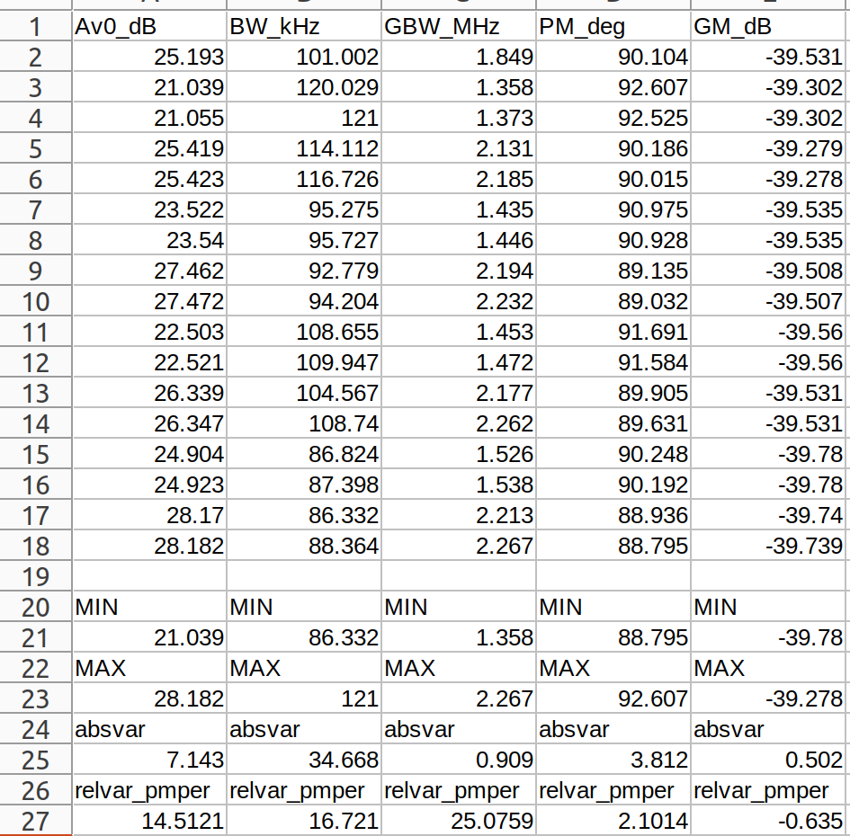
Fig.6

It is important to note from Fig.6 that all numbers are given to 3 decimal places. This is because the ngspice file is set up to output to 3 decimal places. Only numbers not in 3 decimal places are those which were rounded down from something like 121.0004 originally (becomes 121.000 which the ngspice script outputted as 121). The most important thing is that the numbers in Fig.6 match exactly the contents of the various “ac_measures” files. This allows you to locate the corner a particular number comes from by simply typing the following command into the linux terminal:

find ./ -type f -name "ac_measures*" -exec grep -l 'pattern' {} \;

Simply substitute pattern with the number you are interested. Because the tcl script outputted the data into ac_measures files which were named according to the corresponding corner they were run in (see section 2), when the above command returns the file a given number was contained in, it also displays which corner that number came from.

For example, Fig.7 shows the pattern 121 came from corner FF/125/1v9, which we know from Fig.6 is the corner that gives the max BW.

Fig.7

And thats it! Its not as automated as a commercial EDA point and click approach but the more you use it the more you will get used to editing the tcl / ngspice / octave scripts. And with this you will become faster and more efficient to the point where I dont see any loss in efficency from this approach. Even in a commercial EDA you will spend some time setting up measures so this really isnt that much different (just a few additional steps).

Appendix 1:
I placed "quit" at the end of my control block and the terminal exits automatically as desired. I get the same behavior when I place "quit 0" instead. The role of the exitcode 0 is not clear to me. The ngspice manual states:The optional parameter exitcode is an integer that sets the exit code for ngspice. This
is useful to return a success/fail value to the operating system.But still I am confused. Using quit with and without 0 close my terminal automatically. What exactly is the difference with using 0 or not? Thanks
Appendix 2:
it is a convention in many opererating systems that a ZERO process exit status indicates success to the parent process that has visibility of that exit status.
There is one kind of success and many kinds of failures ( but this isn't the place for my life story ). So the non-zero values provide a range to convey the reason for failure with a numeric course grained diagnostic code.When not explicitly providing the number after the exit directive you would hope ngspice will relay the status of the last operation that occured. Like a command shell does.
This means when the ngspice script failed, it can terminates early, like half way though the script usually with error message. As the failed command is the last command that failure gets indicated via the status.
If you provide the number after the `exit` then you are forcing what that exit status will be regardless for how successful the script was.Ideally maybe its possible to do something like
# this is pseudo code I don't grok ngspice
# enough to know if this is even possible

if exit_status == 0 {
exit
}
This will only close the windows on scripts that successfully completed without error .
This would provide you with UI feedback that everything was successful (because all the windows auto closed, those that remained open should have error reason visible at end of output).This is because it is unclear how to differentiate a successful batch of 17 runs to have all completed to a successful conclusion via any other means when run from xschem

Appendix 3:

just replace the ngspice invocation command, removing $terminal (Simulation-> COnfigure simulators and tools):

