OTA Layout:

Core schematic is shown below.

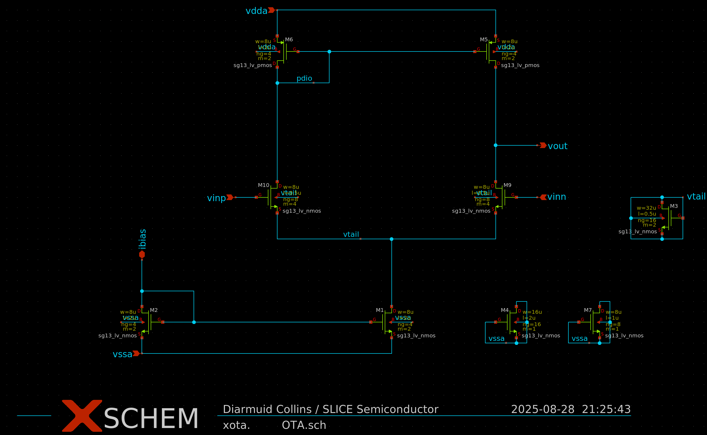

As can be seen, this is a basic 5T OTA except the diff pair is S/B connected. This means the NMOS devices will lie in an isolated PW, over DNW which is surrounded by NW. DNW and NW regions will be shorted and connected to vdda.

OTA layout is shown next. As can be seen it employs a standard OTA floorplan consisting of PMOS on top, diff pair in the middle and NMOS on the bottom. Dummies / GR’s and lots of tap included. Power grid is not yet implemented however. Layout is DRC clean apart from density errors. Layout is not yet LVS clean as I need to add PMOS dummies to the schematic. Once LVS clean, I will be running PEX so stay tuned!

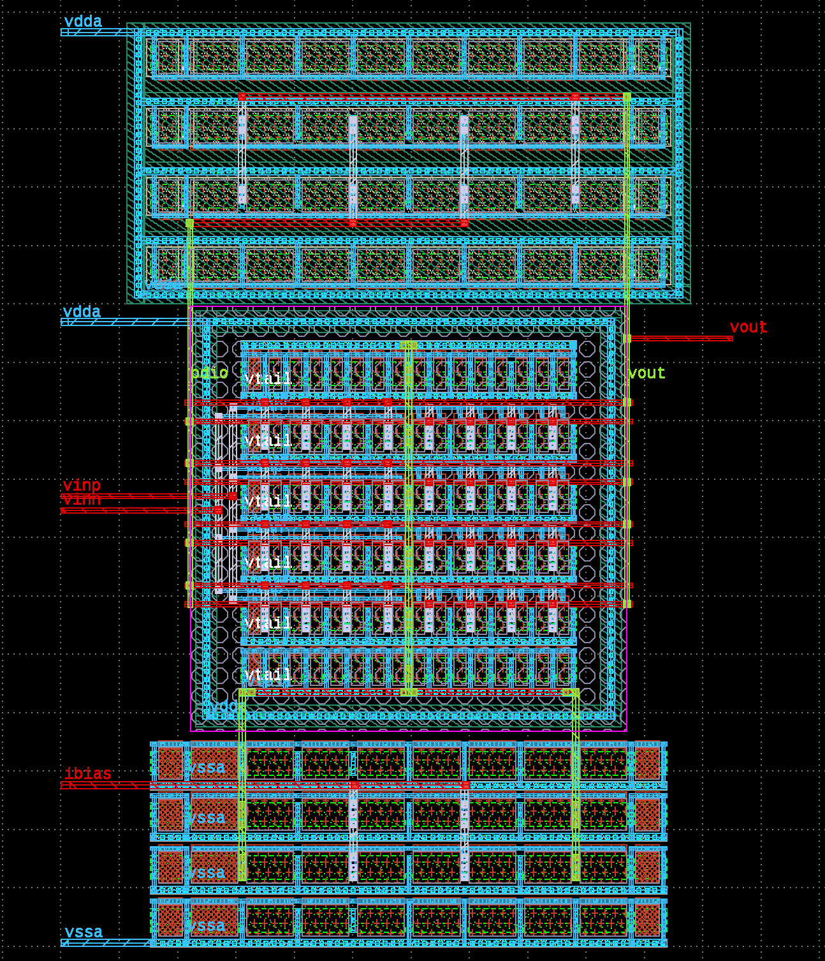
Diff pair is S/B connected as shown next.

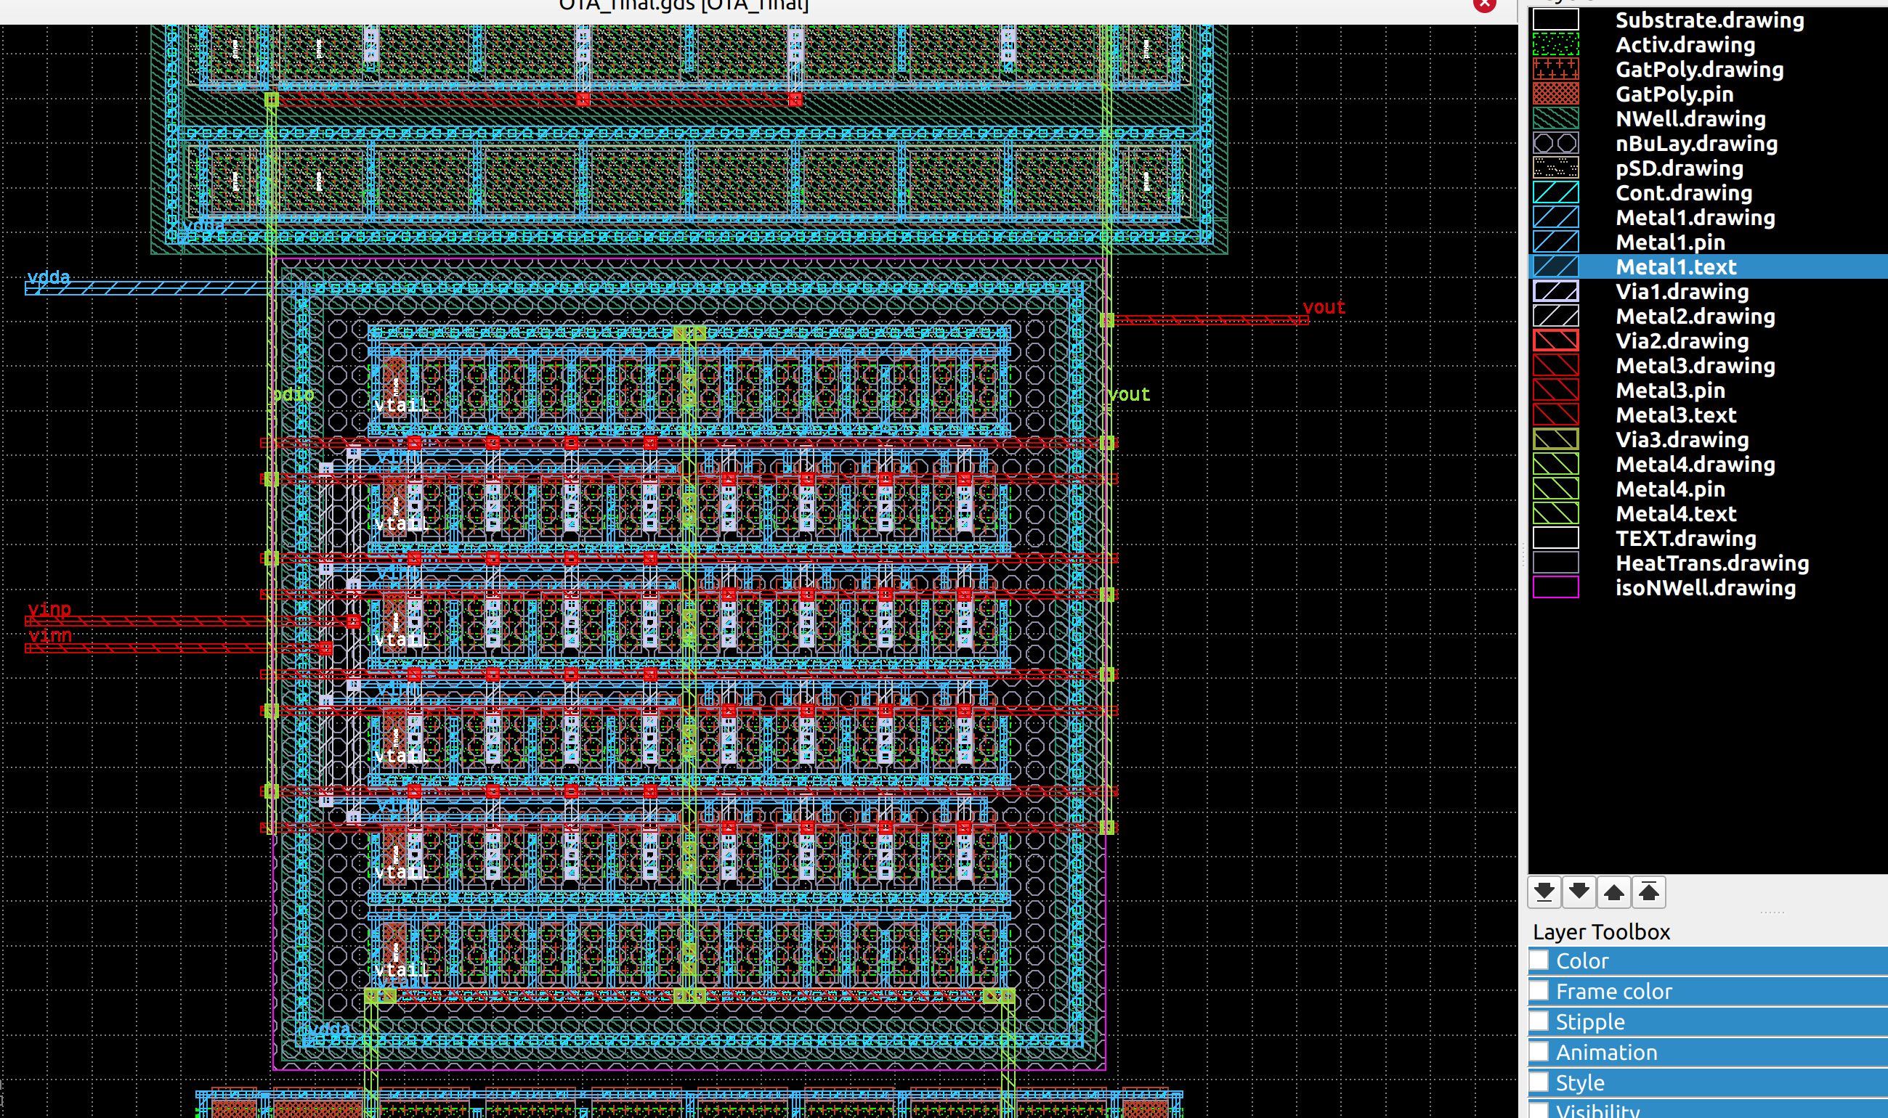
‘;

To do this the “nBuLay” is required to define the DNW, see below text from DRC manual.
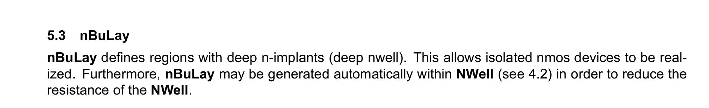
The DNW is then surrounded by an NW which is connected to vdda on M1. This means the DNW and NW are shorted, as is standard.

Layout and schematic are checked into:

xxx

