Installing and running kpex

KPEX is a PEX tool which is well integrated with klayout. Under the hood, the extractions can be run using the MAGIC engine or using the FasterCap field solver engine. At time of writing an engine called 2.5D is under construction which intends to implement the concepts and formulas of Magic but in a way that is best suited to the Klayout API.

1. Required python version:

KPEX requires python3.12 or newer to run. If you have an older version (e.g. python3.10 is default in Ubuntu 22.04), you need to update. Care must be taken when doing this so as not to “break” any other programmes which currently run on python3.10. Therefore, user should follow the instructions at the below link to safetly install python3.12:

https://linuxcapable.com/install-python-3-12-on-ubuntu-linux/

At the end of this step you should have python3.12 installed but not being used. Default python version (e.g. 3.10 in Ubuntu 22.04) should be used instead.

2. Virtual python environment:

KPEX installs and runs in a virtual python environment. Such an environment is installed with the below command:

sudo apt-get install python3.12-venv

Note that you must specify python3.12. Running “sudo apt-get install python3-venv” for example will not work.

3. Change to python3.12:

Confirm current version is not python3.10:

python3 -- version

List the available versions:

update-alternatives --config python3

This will output something like the below:

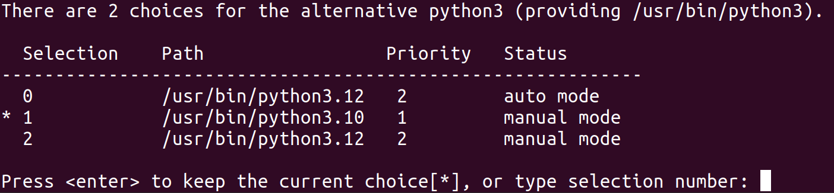
In the above I am currently using python3.10. To change to python3.12 I simply select 2. After this, confirm the correct python3 version is being used. Below shows the typical sequence of this:

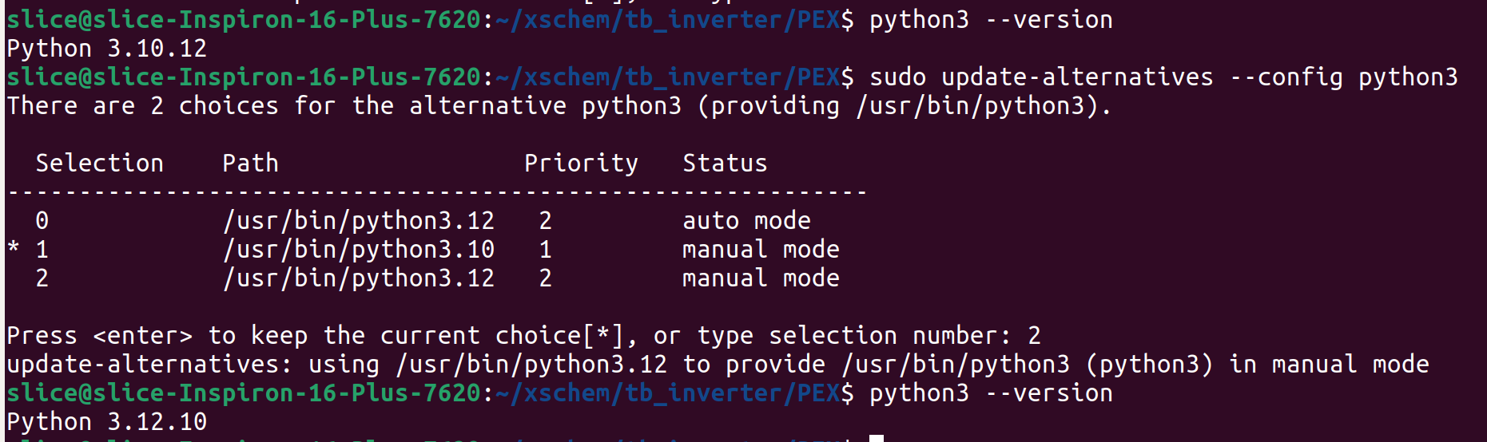
4. Install KPEX:

Install venv dir in your home dir:

mkdir -p ~/venv

Make virtual python environment in dir vlsi in ~/venv

python3 -m venv ~/venv/vlsi

Start the virtual python environment

source ~/venv/vlsi/bin/activate

Install KPEX:

pip3 install klayout-pex

Check installed version:

kpex --version

As per the below screenshot, v.0.2.5 was installed:

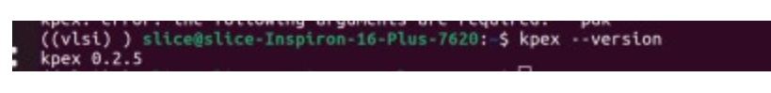
5. Update magic version (if required):

This doc focuses on how to run KPEX using the Magic extraction engine. KPEX requires Magic v8.3.508 or higher to run so, assuming you have already installed Magic, check the version installed:

magic--version

If the version is < v8.3.508, cd into where you originally cloned your magic install and do the following:

git pull
make
sudo make install
magic --version

Example output is:

6. Running KPEX:

cd into the relevant dir. An example structure would be:
<PROJECT_NAME><TOPLEVEL_BLOCK_NAME><SUBBLOCK_NAME><PEX><RC/C/R/FE>

It is reccomended to create directories for RC / C / R only and front end extractions as shown below:

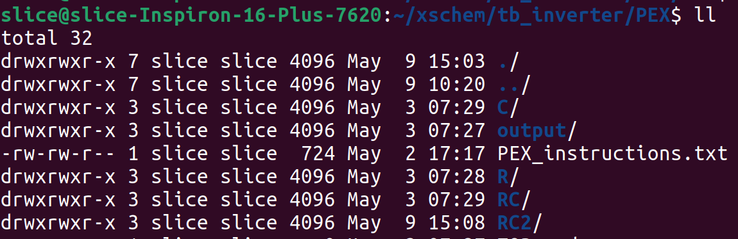
Once in the correct dir, invoke python3.12:

update-alternatives --config python3

Note: As you will be flipping back and forth between python3 versions using the above command, it is advisable to create an alias for it. Something like:

alias pyconfig='sudo update-alternatives --config python3'

Select the correct option to give python3.12 and verify with the below:

python--version

Since you will be checking python3 versions, many many times, it is advisable to create an alias for it. Something like:

alias pyver='python3 --version'

Go into the virtual python environment:

source ~/venv/vlsi/bin/activate

Note: As you will be going in and out of this environment quite regularily with PEX it is advisable to create an alias for it. Something like:

alias pyvenv='source ~/venv/vlsi/bin/activate'

Spend some time investigating KPEX options with:

kpex --help

Run kpex according to your require setup. Below are some examples:

E.g#1: Run KPEX on IHP_SG13G2 using magic (specifying magicrc file location), in Conly mode on layout “inverter2.gds” from the specified dir.

kpex --pdk ihp_sg13g2 --magic --magicrc $PDK_ROOT/$PDK/libs.tech/magic/ihp-sg13g2.magicrc --magic_mode CC --gds /home/slice/xschem/tb_inverter/LVS/inverter2.gds

E.g#2: Run KPEX on IHP_SG13G2 using magic (specifying magicrc file location), in Conly mode on layout “inverter2.gds” from the specified dir, choosing not to extract anything < 1fF.

kpex --pdk ihp_sg13g2 --magic --magicrc $PDK_ROOT/$PDK/libs.tech/magic/ihp-sg13g2.magicrc --magic_mode CC --gds /home/slice/xschem/tb_inverter/LVS/inverter2.gds --magic_cthresh 1

E.g#3: Run KPEX on IHP_SG13G2 using magic (specifying magicrc file location), in Ronly mode on layout “inverter2.gds” from the specified dir.

kpex --pdk ihp_sg13g2 --magic --magicrc $PDK_ROOT/$PDK/libs.tech/magic/ihp-sg13g2.magicrc --magic_mode R --gds /home/slice/xschem/tb_inverter/LVS/inverter2.gds

E.g#4: Run KPEX on IHP_SG13G2 using magic (specifying magicrc file location), in RC mode on layout “inverter2.gds” from the specified dir.

kpex --pdk ihp_sg13g2 --magic --magicrc $PDK_ROOT/$PDK/libs.tech/magic/ihp-sg13g2.magicrc --magic_mode R --gds /home/slice/xschem/tb_inverter/LVS/inverter2.gds

Note: At time of writing, setting a R threshold below which is not extracted (similiar to magic_rthres) is not implemented (but is planned)

Note: During PEX debug, it is often useful to extract the FE only. This can be achieved by running in Conly mode and setting--magic_cthresh to some very large number 1000 (1pF) as per below:

kpex --pdk ihp_sg13g2 --magic --magicrc $PDK_ROOT/$PDK/libs.tech/magic/ihp-sg13g2.magicrc --magic_mode CC --gds /home/slice/xschem/tb_inverter/LVS/inverter2.gds --magic_cthresh 1000

Note: At time of writing it is not possible to exclude nets from extraction since this feature is not available in the magic engine. For Conly debug this is most likely not problematic since suspected problem parasitics can be commented out. However, for Ronly debug it could be problematic. It also means you can’t exclude the power grid when extracting which effectively means all sub-blocks must be delivered with the power grid over them (not industry standard practice). A workaround however would be to omit the power grid at the sub-block level and flood the top metal with pwr/gnd pins to mimic a grid (current enters / leaves the extracted netlist through these pins).

7. Viewing KPEX results:

KPEX places its results in an “output” dir. 2 levels below this will be a magic_xx dir with xx indicating the type of extraction (e.g. xx = CC for Conly).

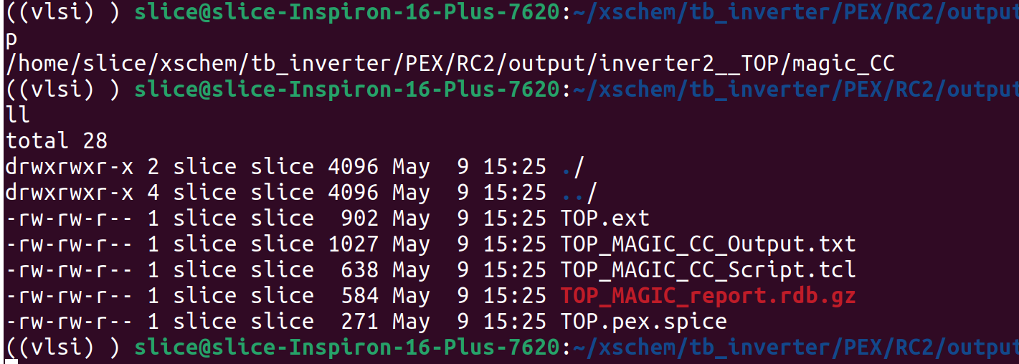
Inside this will be the .pex.spice file which is the extracted netlist, as shown.

Below is an example Conly extracted netlist for a basic inverter.

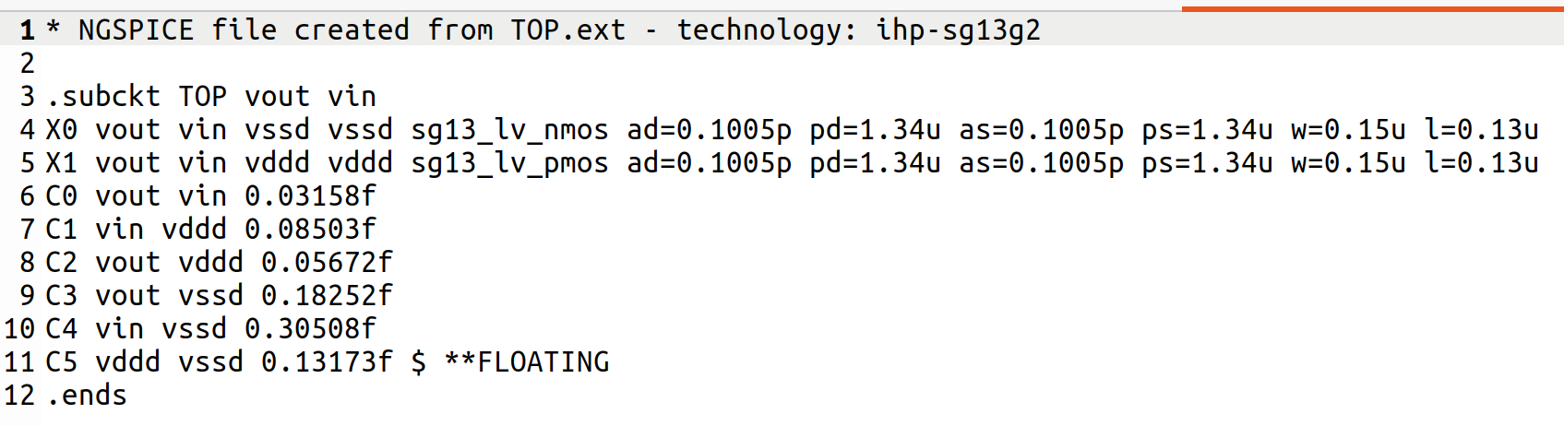
Note how extracted netlist does not contain pwr/gnd pins in its .subckt definition. This is a bug for which a ticket has been created at:

https://github.com/martinjankoehler/klayout-pex/issues

As it will create issues when running the netlist in xschem (no pwr/gnd!), for now, those pins need to be manually included as per below:

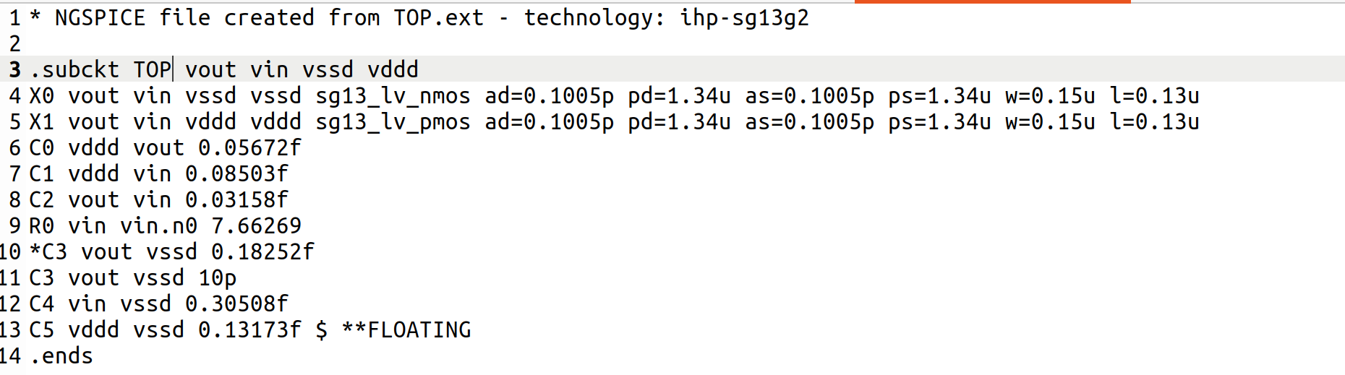
Also note you need to be careful with the naming of the .subckt file. Good practice is to name the file according to <blockname>_<x>pex where ‘x’ = R/C/RC/FE depending on your extraction. For example an RC extraction would have _rcpex appended to it.

An example is the below c extracted netlist for an inverter where the .subckt has been renamed to inverter_cpex.
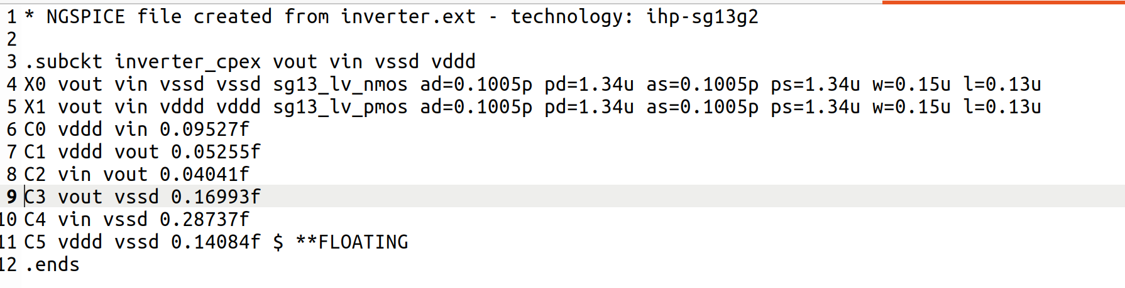

8. Exiting KPEX:

Exit out of the virtual python environment.

deactivate

Change python3 version back to the default version for your Linux distro using the alias created in step #6:

pyconfig

Confirm default python3 version is in use:

pyver

!!! This is an extremely important step. If you do not revert back to the default python3 version bad things will happen! E.g. you forget to revert and next time you start your session, the terminal will not open hence preventing access to anything! In such a scenario, open a virtual terminal (CTRL + ALT + F3), enter your username and password and from there revert the python3 version (pyconfig/pyver). Then exit out of virtual terminal (CTRL + ALT + F2). But best avoid the heartache and remeber to revert python3 everytime you finish kpex!

Acknowledgments:

Thanks to Martin Jan Kohler for his guidance.

