Running DRCs in ihp-sg13g2 using klayout

1. Running DRC:

Can be simply run by going to Tools / DRC. From here you can select maximal and minimal runs. Minimal run will be much faster as it doesn’t check as much. In the case of large blocks it can be useful to get a quick ideal for how many DRCs are present. Otherwise, use maximal DRC check.
Maximal and minimal DRC checks were run on the below inverter layout:
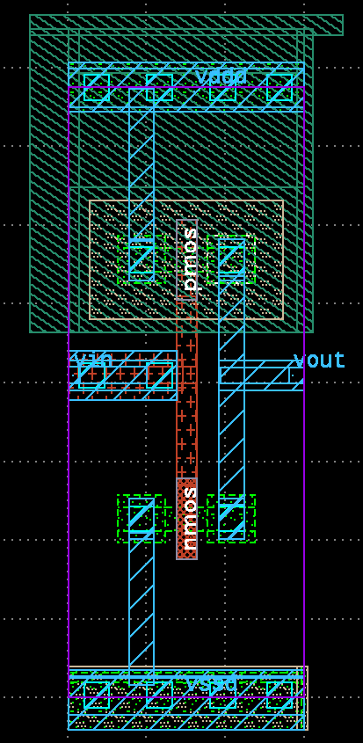
Minimal DRC check reported 5 DRC’s all of which were density related, which can be ignored at the sub-block level
Maximal DRC check reported an additional 2 DRCs (detailed in next section)

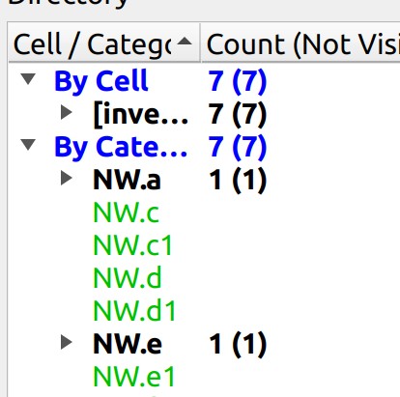
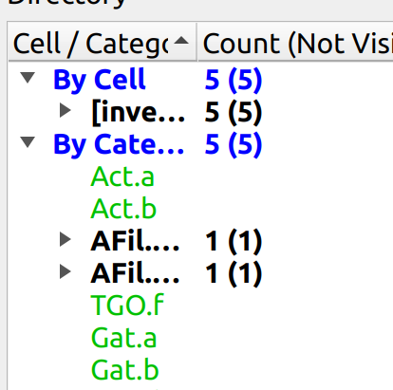

2. Debugging DRCs:
DRC manual found at: $PDK_ROOT/ihp-sg13g2/libs.doc/doc/SG13G2_os_layout_rules.pdf
Manual is suprisingly easy to read (for a DRC manual!).
As you will be referring to this quite regularily, it is good practice to make an alias to it. Something like below:
alias DRCdocs='evince /home/slice/pdk/iHP/IHP-Open-PDK/ihp-sg13g2/libs.doc/doc/SG13G2_os_layout_rules.pdf &'
Select a particular DRC error in the DRC report. This will report the error in the Info block highlight its occurence in the layout. E.g. Selecting NW.a in section 1 shows the following:
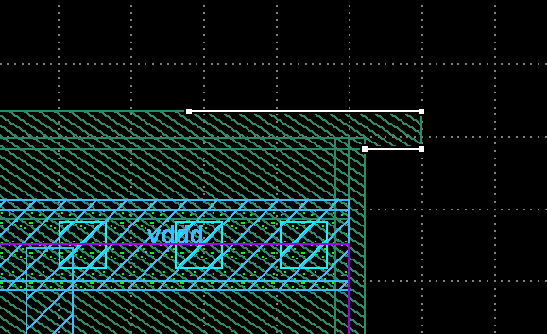
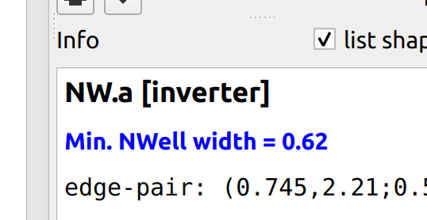

Further infomation can be found in the DRC manual. Navigating to the NWell section of it (section 5.1) shows the following:
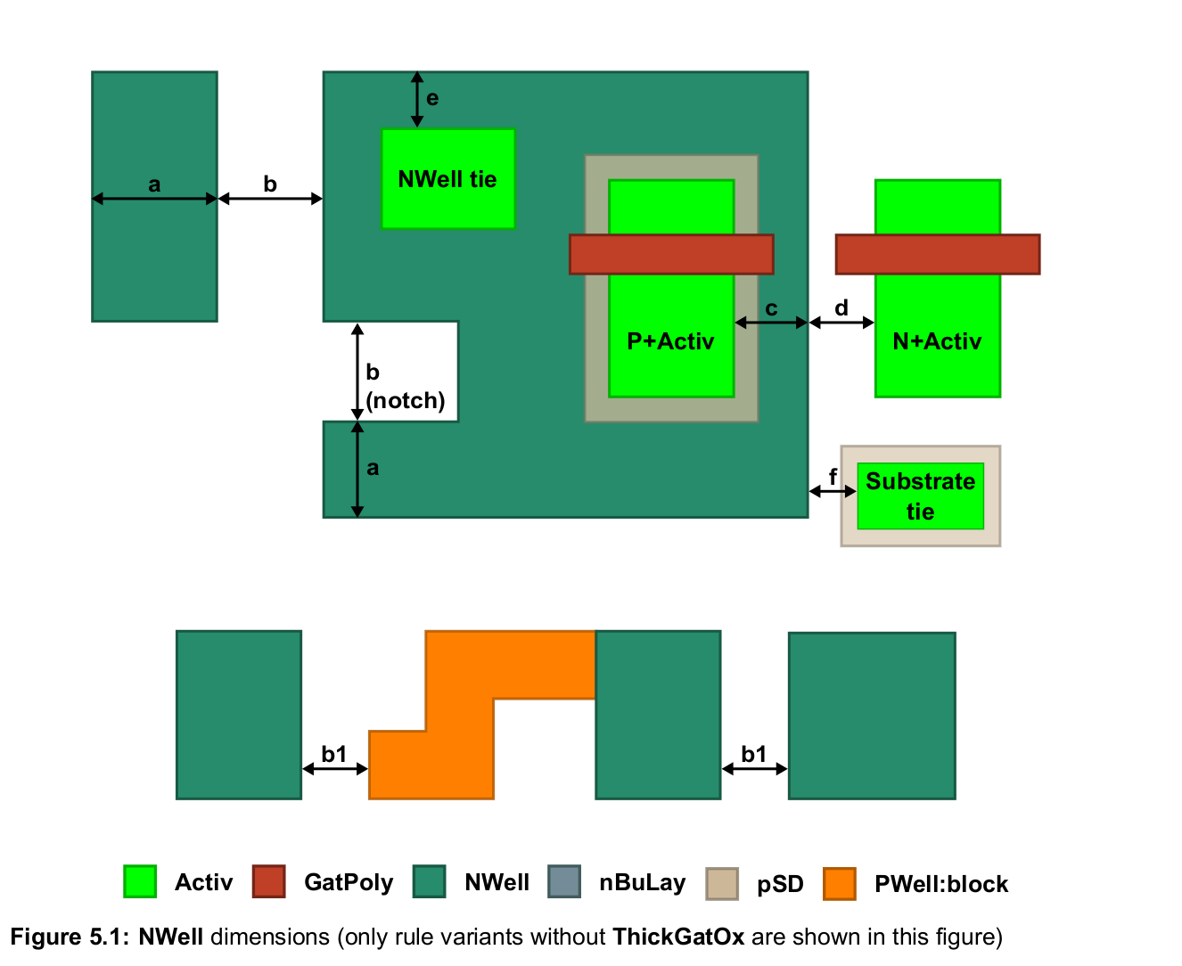
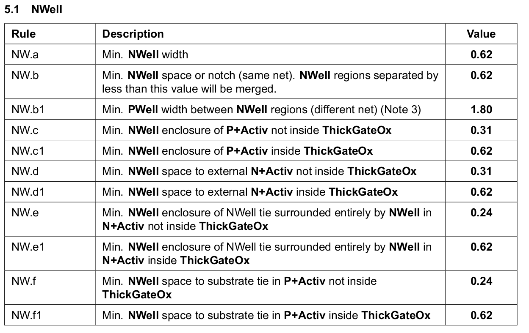

This DRC is easy to understand since it means the NW width is too narrow (< 0.62um).

Repeating for the NW.e error in section 1 gives:
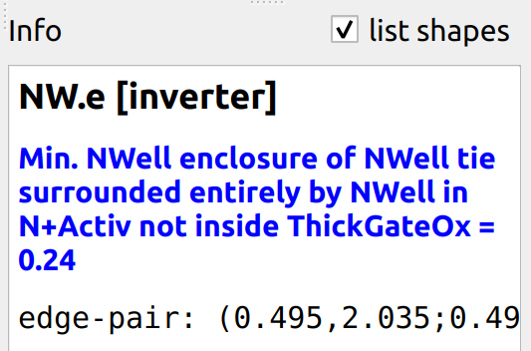
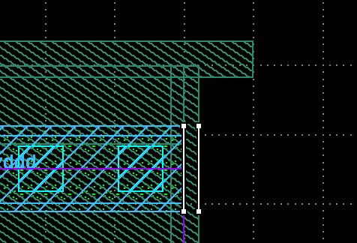

A little more involved to understand, this DRC means the NWell enclosure surrounding an Activ region is < 0.24um.

Both DRCs can be simultaneously fixed by extending the Nwell region (using the Partial command) as shown:
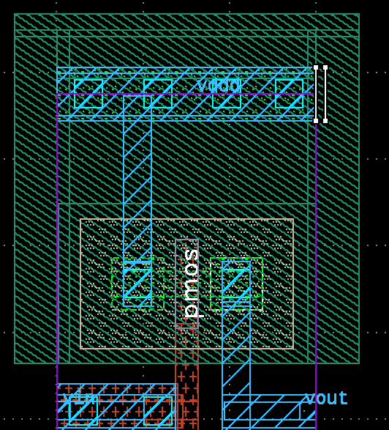
Re-running the maximal DRC check confirms this as it now only reports the 5 density related DRCs seen in the minimal check.

