OTA_final PEX analysis:

1. Summary of results:

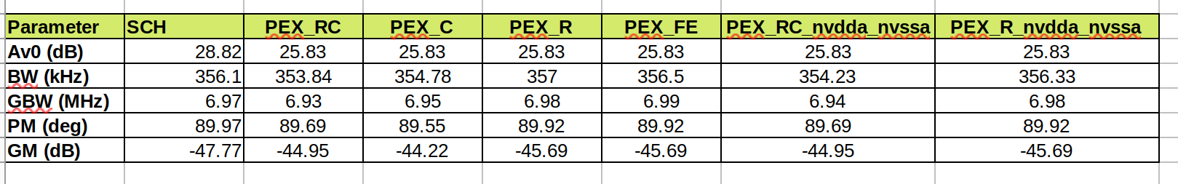

2. Step response:

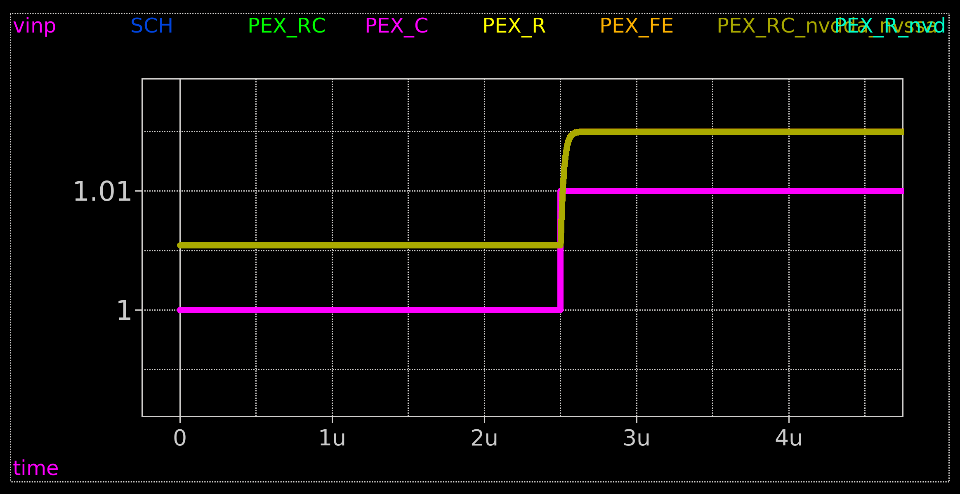

3. Magnitude:

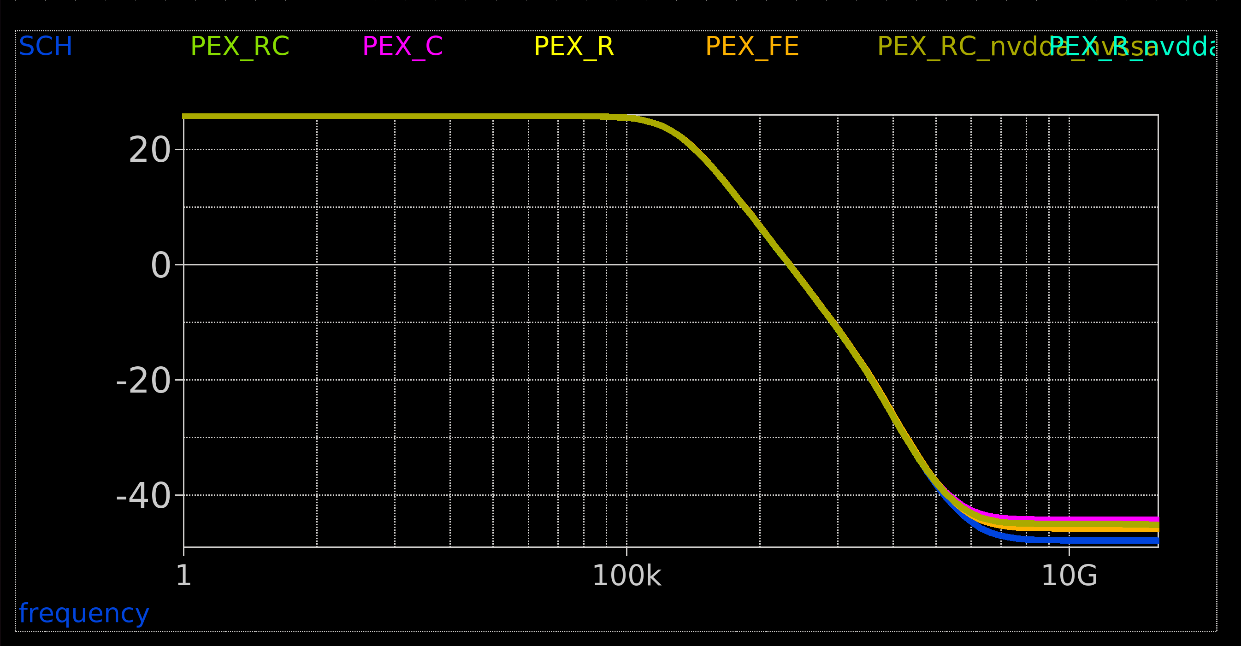

4. Phase:

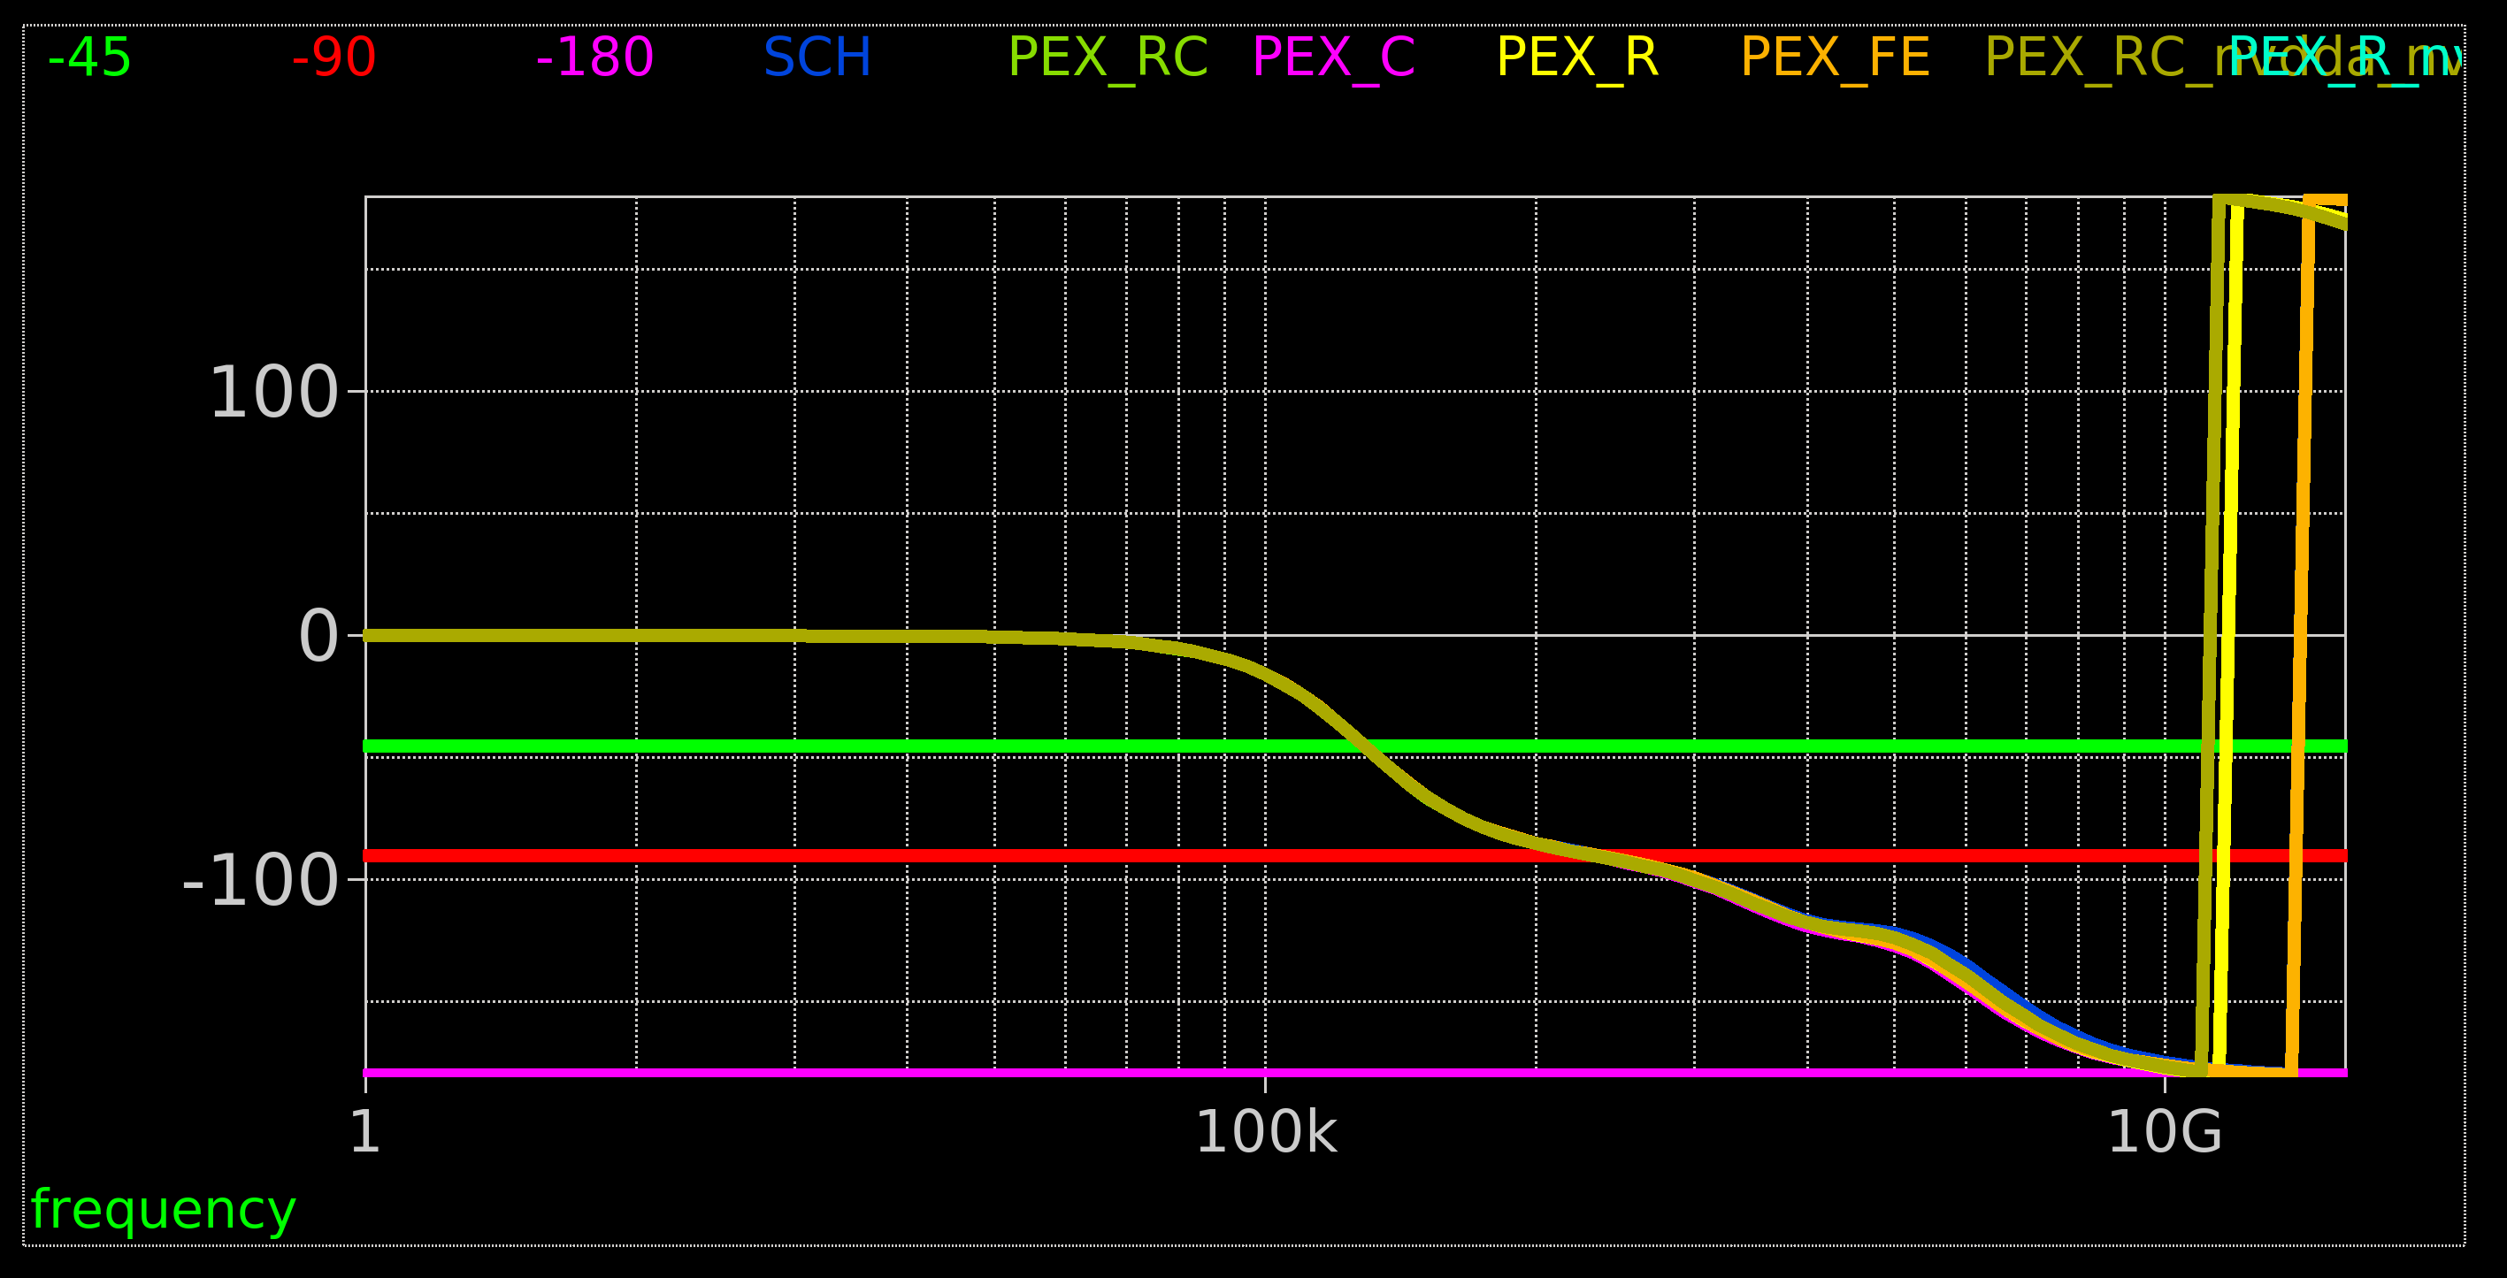
5. Summary:

Negligible difference pre and post layout.

Not surprising when we look at the Cpar values:
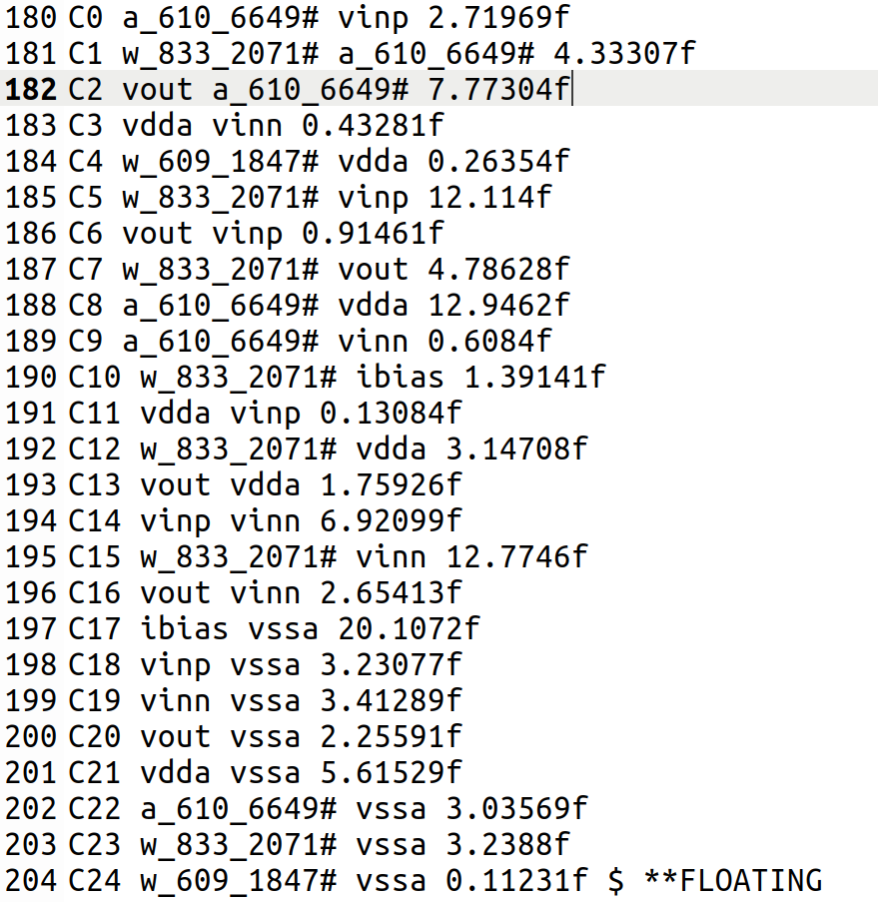

Most are < 10f (e.g. Cp_vout_vssa = 2.2f) with 3 < 15f and the ibias line at 20f.

Sheet resistances for this process are also very low ( ~ 0.1ohm/sq)

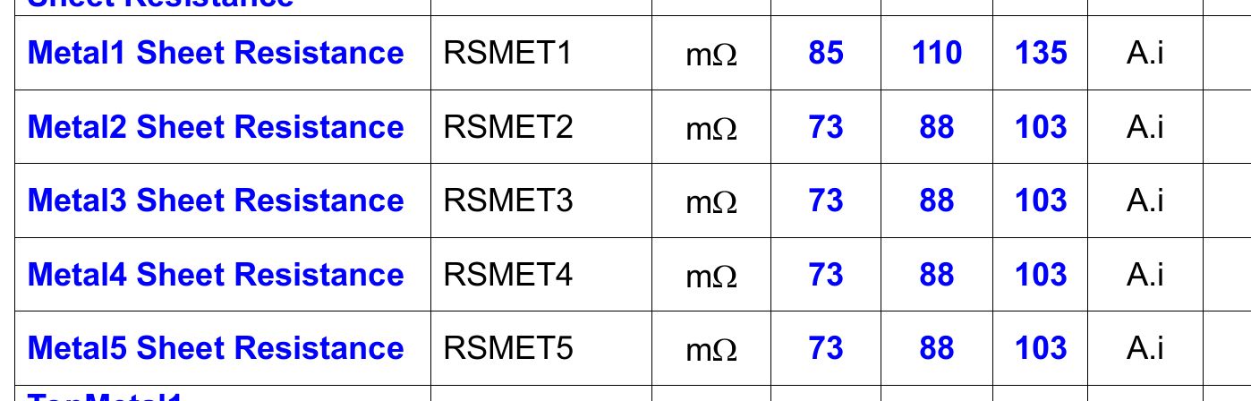
Therefore, probably shouldn’t be surprised the results are so similar.

