Creating parametric vloga models:

Assuming you already know how to create / run vloga models, next step is to be able to pass variables to them. The obvious example is you create a vloga block which converts decimal input codes to output binary streams. You will want to be able to pass the decimal code to the vloga block as an external parameter. This document shows you how to do this.

Section 1: No sweep

1. Create vloga file

- Take note of the port order, this is very important with all vloga files:

module dec2bin_10b(bin_out_9,bin_out_8,bin_out_7,bin_out_6,bin_out_5,bin_out_4,bin_out_3,bin_out_2,bin_out_1,bin_out_0,vdda,vssa);

- Take note we are dealing with an 10b output bit stream here. Openvaf was written for compact models which do not contain bus terminals and so will error out if you specify a bitstream using bracket notation, as is done using a commercial vloga compiler. E.g. bin_out[9:0] would not compile. The best workaround this is to split up the individual bits of the bus as shown. E.g. Instead of writting bin_out[9:0], you write in_out_9,bin_out_8,bin_out_7,bin_out_6,bin_out_5,bin_out_4,bin_out_3,bin_out_2,bin_out_1,bin_out_0.

- Include the following lines in your vloga file to accept an external parameter:

(* desc="dec_code", units="", type="instance" *) parameter integer dec_code = 0 from [0: 1023];

- Compile the vloga file into a .osdi file using openvaf as described in original vloga howto doc.

2. Create subctk:

- Create pins using NC’s as shown

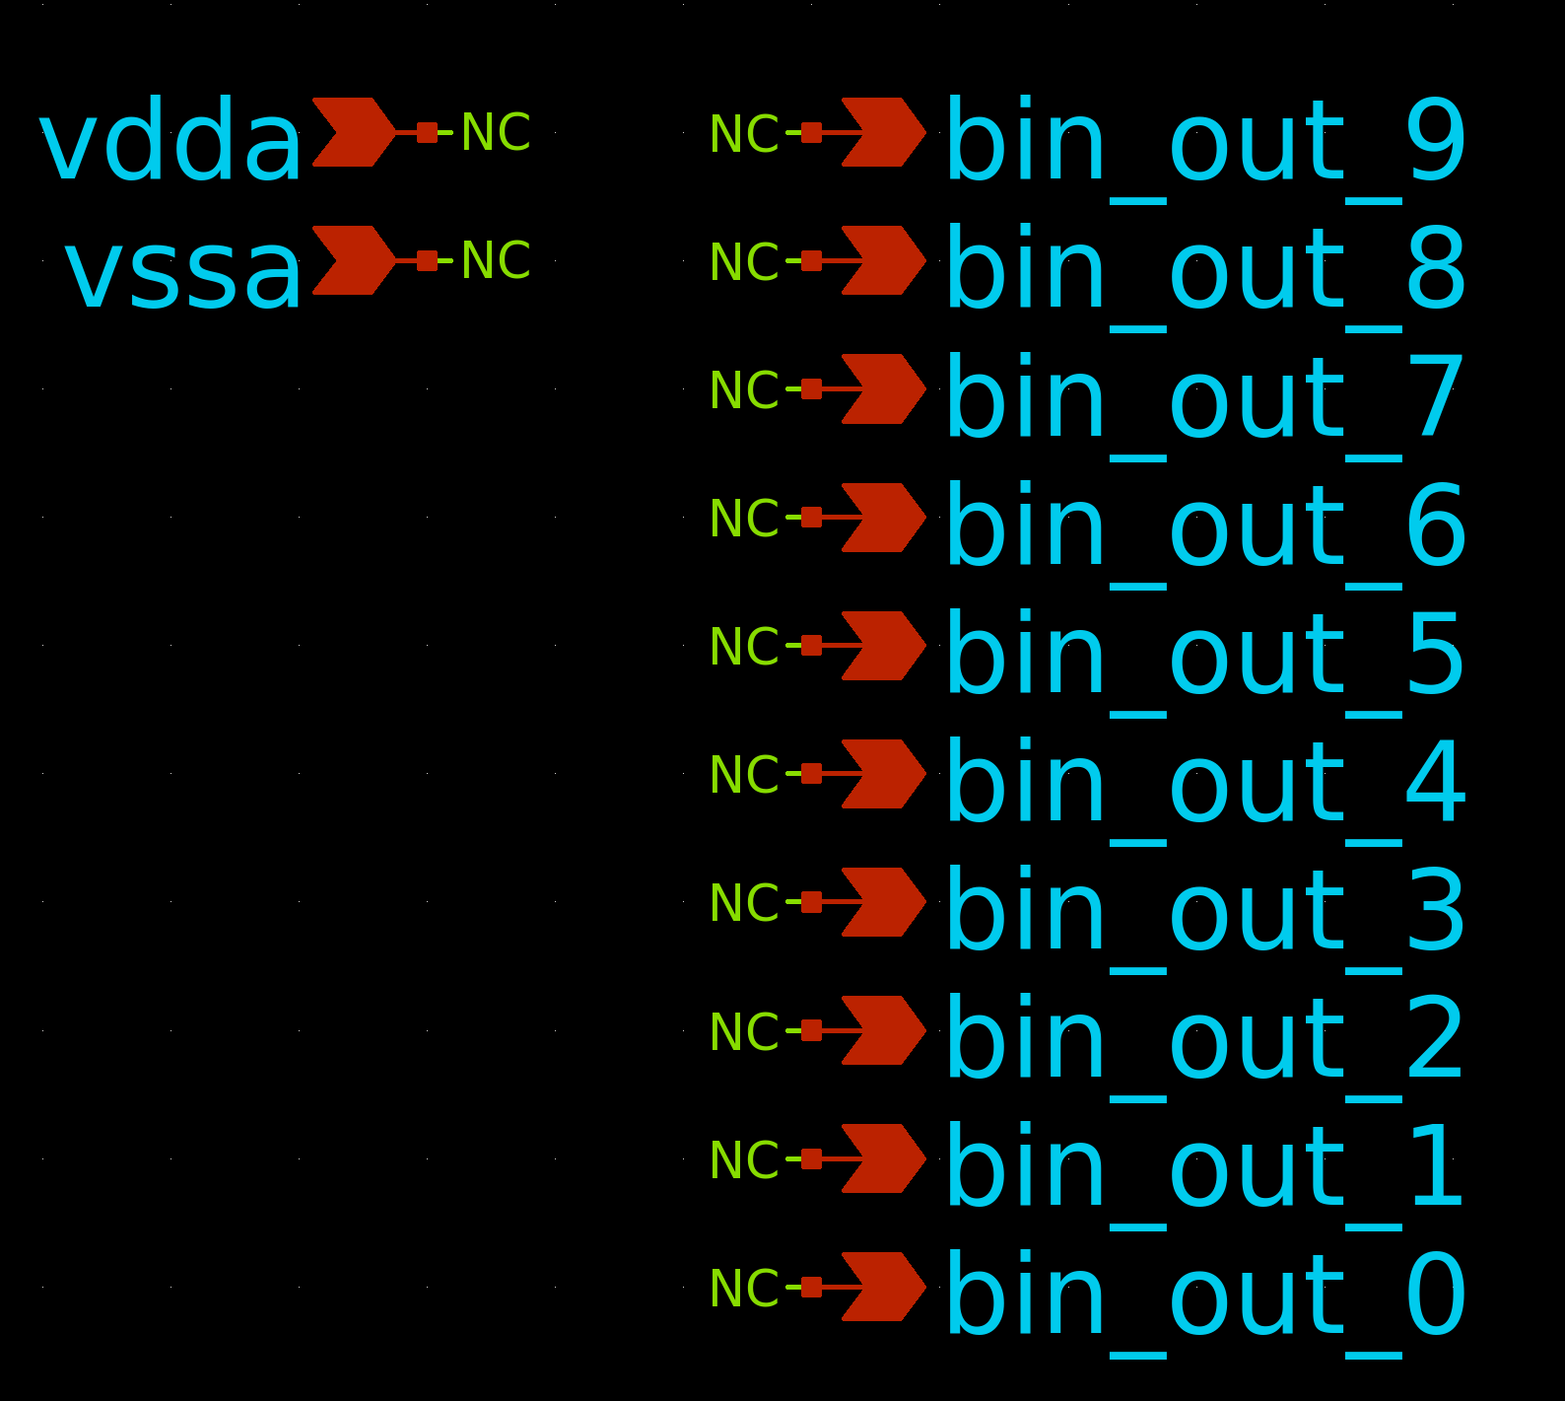

- Q and add the below text to create the subckt:

N1 bin_out_9 bin_out_8 bin_out_7 bin_out_6 bin_out_5 bin_out_4 bin_out_3 bin_out_2 bin_ou1 bin_out_0 vdda vssa dec2bin_10b dec_code = dec_code

Note the inclusion of dec_code = dec_code. Also note the line starts with N1 as per usual. In addition, beware that the port order here must match exactly the port order in your vloga file.

3. Create subckts symbol:

- Create the subckts symbol. Once created q on the symbol and enter the below:

type=subcircuit
format="@name @pinlist @symname dec_code=@dec_code"
template="name=x1 dec_code=0"

This is required to be able to pass the parameter down to through the symbol. Note how dec_code is set to 0. This is just a default value to be used if user does not explicitly set one.

- The port order on the symbol must match that in the vloga (which itself matches the subckt definition created inside the symbol). To do this press shift+s and manually enter the port order of each pin, as shown below, where I put in the port order for bin_out_9 (which as can be seen from the vloga/subckt descriptions was the first or 0th port).

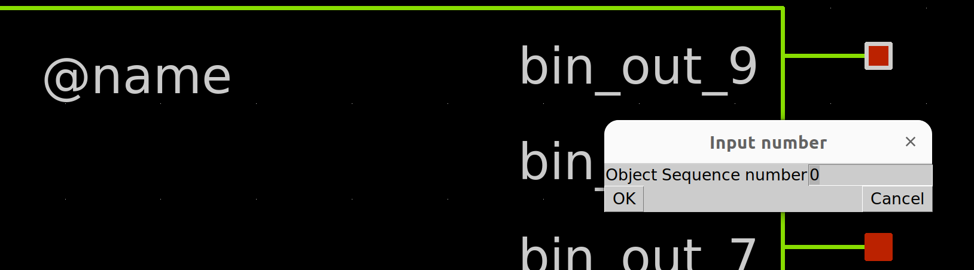

4. Instantiate the block:

- Q on the block and enter the following:

name=x2
xschematic=dec2bin_10b.sch
model=dec2bin_10b
dec_code = dec_code_var

Note how I have set dec_code = dec_code_var. This is because I will pass the decimal code to dec_code using variable dec_code_var in my stim file.

5. Set up stim file accordingly:

- Set up dec_code_var as a parameter at some default value, say 1 to differentiate from the default value in the subckt symbol which was 0 (allows you to confirm your stim file is working as shown later)

.param dec_code_var=1

- Include the vloga model as described in the original vloga howto doc.

.model dec2bin_10b dec2bin_10b

- Inside the .control loop, include the following line to load in the .osdi file.

pre_osdi dec2bin_10b.osdi

- Optional: In my sim I want to pass the current value of dec_code_var to an output file. This means writing it to a text file using the echo command. As this will be done inside the .control block, variable dec_code_var needs to be re-defined as variable

.csparam xdec_code_var = 'dec_code_var'

- Now you use the below statement to write the current value of xdec_code_var to an output text file (take note of the >> instead of > which cocantenates onto the previously written value in the line as opposed to overwriting it).

echo "$&xdec_code_var" >> code_measures.txt

6. Do an basic run:

- Run the sim as per normal to ensure all you have done up to now works. As you see from the below, when I load in the waveforms I can see my default value set in the stim file (= 1) works fine. Note in the below how I needed to load the outputs with something (I used resistors). Xschem or maybe is it ngspice Im not sure, will not output a value unless you do this.

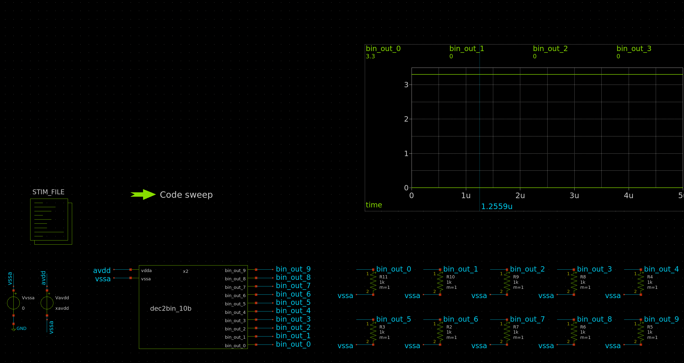
- Check your run dir to confirm a single .raw file has been written, and assuming you completed the optional step above, a single .txt file also. This is shown below along with the contents of the .txt file which of course is the number 1 since that is the single code we have written.

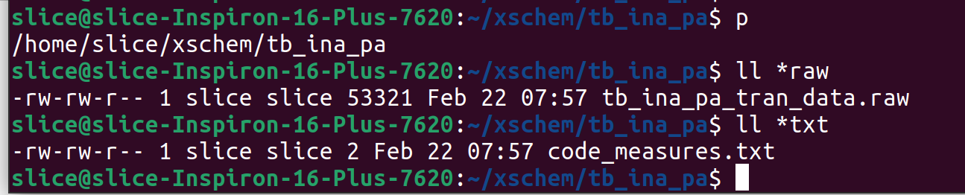
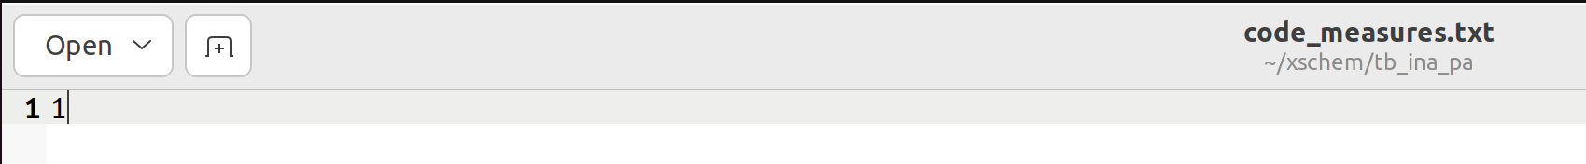
Full example can be found in;

https://github.com/SLICESemiconductor/OpenSourceTool_Examples/tree/main/Passing_variables_to_vloga_files

Use tb_dec2bin_10b.sch

Section 2: Sweep using loop method

1. Justifying this use case:

This is useful if you want to sweep through all of your trim codes and plat say gain vs trim code. However, only 1 .raw file will be generated and debateable how much use it is. This really is a loop to give you 2 parameters to plot without showing you individual waveforms. For a more complete sweep, showing you waveforms per each code step in that sweep, refer to the next section. As for justifying this case, suppose you had an INA with 10b PGA and you want to create a plot of gain vs the 1024 codes, this code would be useful.

2. Create a loop using the repeat statement:

Define a variable inside your .control loop as xdec_code_var. Then using the repeat keyword, create a loop for a specified no of times (e.g. 16). Using alterparam, set parameter dec_code_var to the current value of xdec_code_var and run the transient sim, outputting whatever it is you want to a measures .txt file (e.g. in the below example I simply output each bit of the code I am sweeping). At the end of each loop then increment the code and another loop will automatically start.

let xdec_code_var = 0

repeat 16 ; loop start
alterparam dec_code_var = $&xdec_code_var; ; alter the decimal code
reset

** 1. TRAN ANALYSIS **

tran 10n $&xtsim_var
remzerovec

*set filetype=ascii
write tb_ina_pa_tran_data.raw
set appendwrite

** 2. MEASURES **
echo "$&xdec_code_var" >> code_measures.txt
echo -- >> code_measures.txt
meas TRAN out0_ave AVG v(bin_out_0) from=0 to= $&xtsim_var
meas TRAN out1_ave AVG v(bin_out_1) from=0 to= $&xtsim_var
meas TRAN out2_ave AVG v(bin_out_2) from=0 to= $&xtsim_var
meas TRAN out3_ave AVG v(bin_out_3) from=0 to= $&xtsim_var
meas TRAN out4_ave AVG v(bin_out_4) from=0 to= $&xtsim_var
meas TRAN out5_ave AVG v(bin_out_5) from=0 to= $&xtsim_var
echo "$&out0_ave" >> code_measures.txt
echo "$&out1_ave" >> code_measures.txt
echo "$&out2_ave" >> code_measures.txt
echo "$&out3_ave" >> code_measures.txt
echo "$&out4_ave" >> code_measures.txt
echo "$&out5_ave" >> code_measures.txt
echo -- >> code_measures.txt

let xdec_code_var = xdec_code_var + 1;
end

Note that you are looping a variable created inside your control loop to adjust a parameter created outside of your control loop. For such instances the alterparam statement is required. If however you wanted to pass a variable created outside of your control loop to inside it the csparam statement would be required, as done for tsim and xtsim.

Below shows a portion of the .txt file written to.

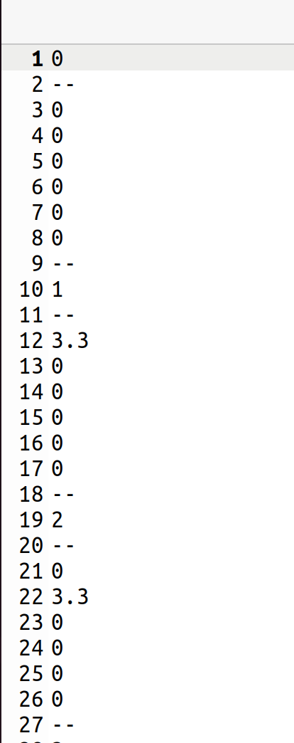

Full example can be found in:

https://github.com/SLICESemiconductor/OpenSourceTool_Examples/tree/main/Passing_variables_to_vloga_files

Use tb_dec2bin_10b_sweep.sch

Section 3: Sweep using tcl script

1. Justifying this use case:

Typically when dealing with such tbs I wont run all the codes. Instead I will run say min, mid-1,mid,mid+1 and max and maybe a code between min and mid and mid and max. In addition, during debug I may want to look at 2 or 3 codes around some failing code. When doing this I will want to be able to analyse all the sim outputs (i.e. have access to the .raw file specific to the entered code). The best way (in my opinion) to do this is using a Tcl script which will go into the stim file and set dec_code_var to whatever value I want. It is done similiar to the method I used for PVT sims except for some syntax differences.

2. Insert Tcl script:

- Insert the tcl script which can be found at:

- This contains the below code which will ouput the initial value for dec_code_var in the stim file then change to codes 1 / 6 / 3 and 15.

# Code sweep for dec_code_var
# Note: Whatever value for dec_code_var has originally been set in the stim file will
# first be outputted
name=h1
descr="Code sweep"
tclcommand="
set spicefile $netlist_dir/tb_dec2bin_10b.spice
xschem netlist
simulate
after 1000 ;# wait 1sec for ngspice to start and read netlist
# set dec_code_var = 1
exec sed -i {/^\.param dec_code_var/s/=.*/=1/} $spicefile
exec sed -i {s/tb_ina_pa_tran_data.raw/tb_ina_pa_tran_data_1.raw/} $spicefile
simulate
after 1000 ;# wait 1sec for ngspice to start and read netlist
# set dec_code_var = 6
exec sed -i {/^\.param dec_code_var/s/=.*/=2/} $spicefile
exec sed -i {s/tb_ina_pa_tran_data_1.raw/tb_ina_pa_tran_data_2.raw/} $spicefile
simulate
after 1000 ;# wait 1sec for ngspice to start and read netlist
# set dec_code_var = 3
exec sed -i {/^\.param dec_code_var/s/=.*/=3/} $spicefile
exec sed -i {s/tb_ina_pa_tran_data_2.raw/tb_ina_pa_tran_data_3.raw/} $spicefile
simulate
after 1000 ;# wait 1sec for ngspice to start and read netlist
# set dec_code_var = 15
exec sed -i {/^\.param dec_code_var/s/=.*/=15/} $spicefile
exec sed -i {s/tb_ina_pa_tran_data_3.raw/tb_ina_pa_tran_data_15.raw/} $spicefile
simulate
"
- As can be seen, for each code setting a specific .raw file is created. This is done using the same syntax as was seen in the PVT howto doc. We look for the name of the .raw file and then change it to data_<dec_code>, as examplified below.

exec sed -i {s/tb_ina_pa_tran_data.raw/tb_ina_pa_tran_data_1.raw/} $spicefile

- What is new to this Tcl code is the line which sets the new dec_code_var. This code goes to the line starting with .param dec_code_var, and then replaces = and anything that follows it with =<dec_code>, as examplified below.

exec sed -i {/^\.param dec_code_var/s/=.*/=15/} $spicefile

- Note =.*/=15 reads like “replace = and anything that follows it with =15”

3. Run a sim:

- Remove all .txt and .raw files.
- On the tcl symbol, hit “ctrl + left mouse click” as usual and watch it go!
- In the results dir, confirm all the raw files have been written, in addition to the .txt file.

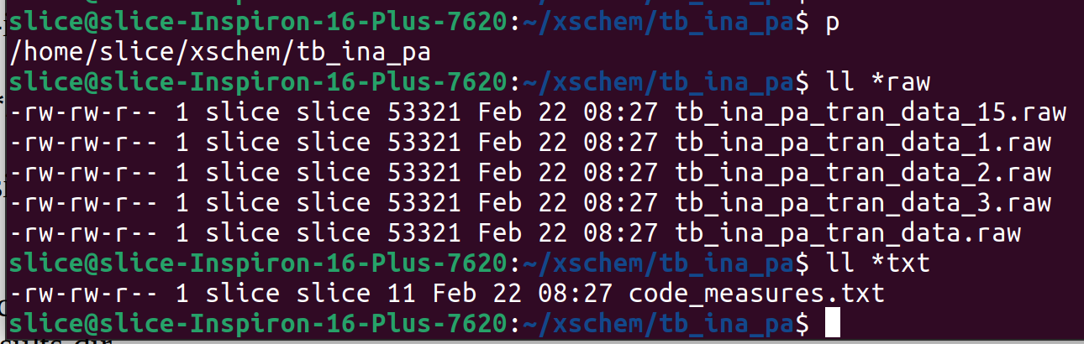
- Open the .txt file to confirm all the codes have been written.

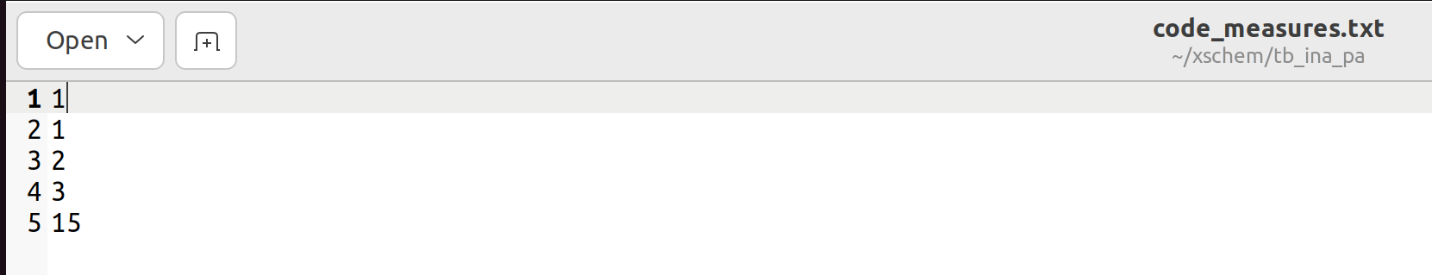
- Plot the waveforms from whatever .raw file you choose.

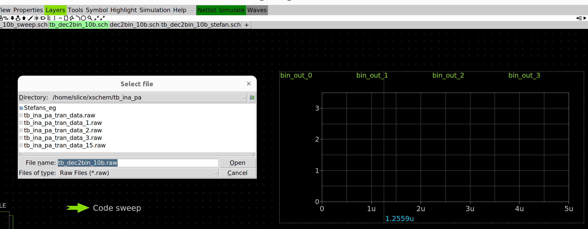
4. Edit the Tcl script as required:

- Once you have confirmed the above works, edit the tcl script by simply changing the code numbers to whatever you want to analyse. Easy as this step requires practically no tcl coding knowledge!

Full example can be found in:

https://github.com/SLICESemiconductor/OpenSourceTool_Examples/tree/main/Passing_variables_to_vloga_files

Use tb_dec2bin_10b.sch

5. Displaying the current code value in the symbol:

Suppose you want to display the current code on the symbol like below:

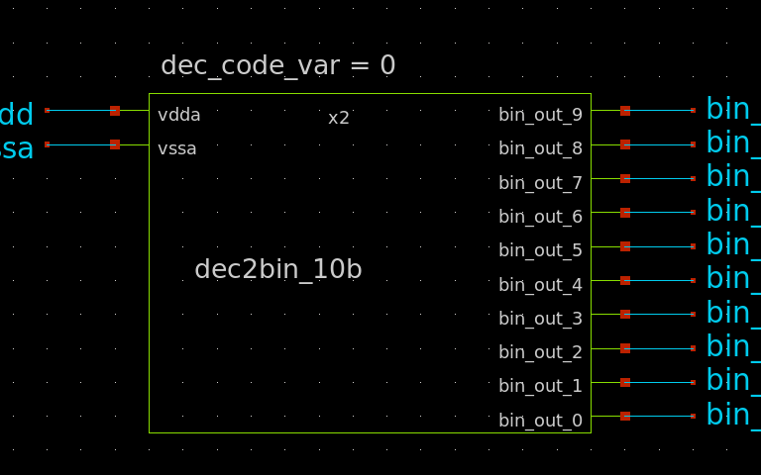

To do this, you need to add the below line to your symbol:

tcleval(dec_code_var = [xschem get_tok [xschem getprop instance STIMULI value] dec_code_var])

The symbol will look like below:

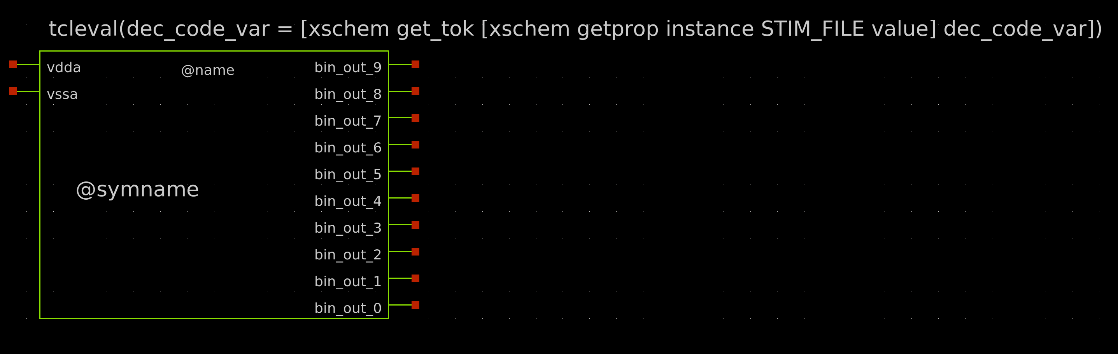
Below are Stefans instructions on how to do this:

if the value of dec_code is set as an instance parameter, like dec_code=9 then edit the symbol and add the text:
dec_code=@dec_code in the symbol. the @dec_code will be replaced by the 9 given in the instance.If you use another indirection level where the parameter is set in the spice commands as a .param dec_code_var = 9 then it is more complex.If the code block has name=STIMULI then the following command:xschem getprop instance STIMULI valuewill retrieve all the spice commands.You can further scan the result to get the value of dec_code_var:
xschem get_tok [xschem getprop instance STIMULI value] dec_code_varputting all things together you need to add this text into the symbol:tcleval(dec_code_var = [xschem get_tok [xschem getprop instance STIMULI value] dec_code_var])

