Running xspice:

ngspice has the capability to run behavioral models, also know as xspice models (see ch.8 of the manual). These are very handy especially for various scenarios. One such one is:

- You have a number of gates. The cosim option doesn’t allow you to simulate multiple .v files, only one as per the below thread:

- This would mean going the .v route requires creating a single behavioral .v description covering all the digital gates. This is fine, but if you wanted to do it structurally, you could netlist each digital gate as an xspice behavioural model.

So here’s how to simulate xspice:

1. Create the schematic:

I am creating an xspice model for an or gate so first create the below i/p and o/p pins:

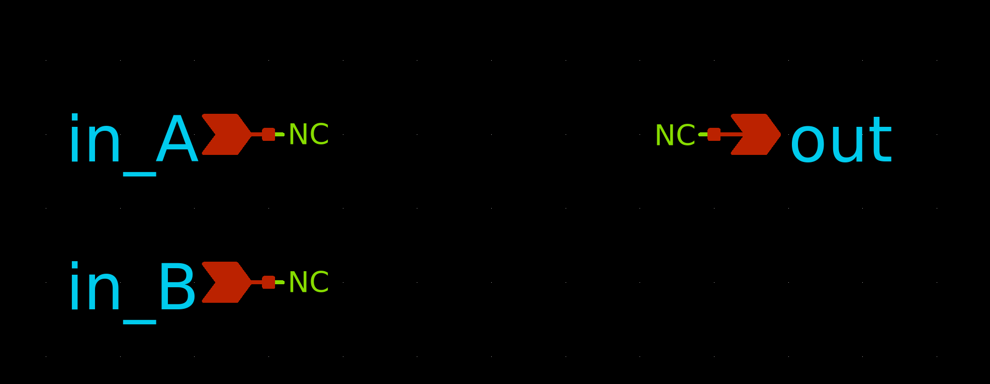
I then ‘q’ on the schematic and enter the below:

Agate [in_A in_B] out or_gate_xs

Here “or_gate_xs” is the schematic name and Agate the xspice model name. Note, if there are multiple inputs, they must be contained in squared brackets.

2. Create the symbol:

Create the symbol by pressing ‘a’.

If there q on the symbol and enter the following:

type=subcircuit
format="@name [ @@in_A @@in_B ] @@out @symname"
template="name=x1"

This is required to force xschem to netlist the xspice model correctly, namely place multiple inputs inside square brackets.
3. Instantiate the xspice model:

Instanatiate the xspice model.
Important: Instance name must start with an ‘a’ (e.g. below is a1).

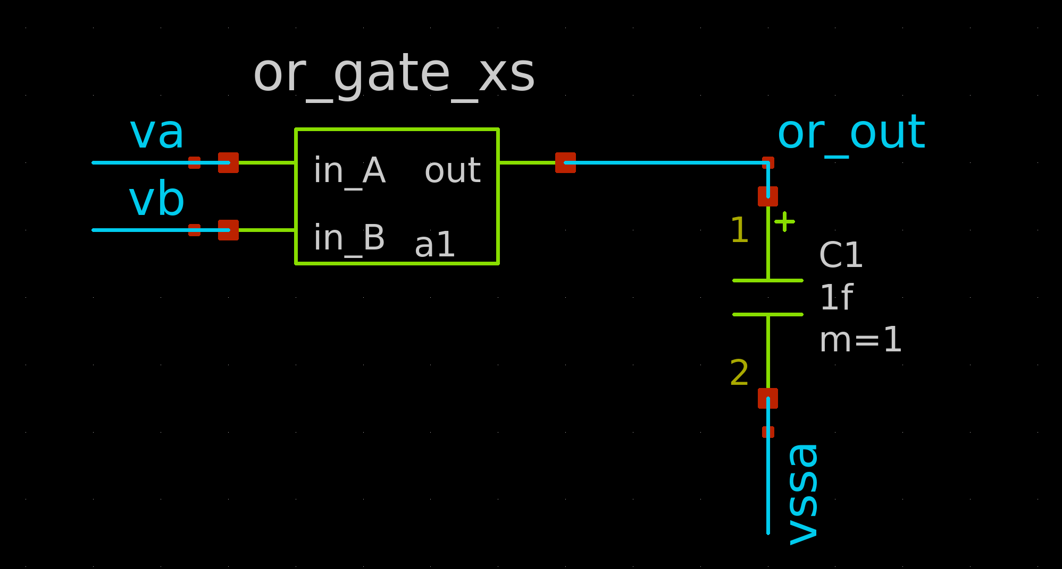

4. Include the dac bridge:

You are outputting digital values (1 or 0) from your xspice model. These need to be converted to analog voltages in order to be useable in a spice environment. For this you need to include a dac_bridge. These are described in section 8.3.1 of the manual and are automatically inserted by ngspice. The problem however with automatic insertion is it will use the default values which most likely will not correspond to what you want. It is therefore advisable to specifically include a line like the below, to set the required values.

.model auto_dac dac_bridge(out_low = 0 out_high = 1.8 t_rise = 10p t_fall = 10p)

E.g. The above specifies the DAC to output 0V low voltages, 1.8V high voltages with 10ps rise and fall times.

Arguable if the above is thorough enough since it does leave some default values. In order to set all values, use something like below:

.model dac1 dac_bridge(out_low = 0.7 out_high = 3.5 out_undef = 2.2 input_load = 5.0e-12 t_rise = 50e-9 t_fall = 20e-9)

This example is taken directly from the manual and sets the low voltage at 0.7V and high voltage at 3.5V. Input load is set to 5ps with rise time at 50ns and fall time at 20ns. The out_undef sets the output voltage if the input = ‘U’ (input to DAC can be either 0 / 1 / U). I havent encountered a ‘U’ input yet in practice.

Finally, this .model line must be included before the .control statement, something like below:

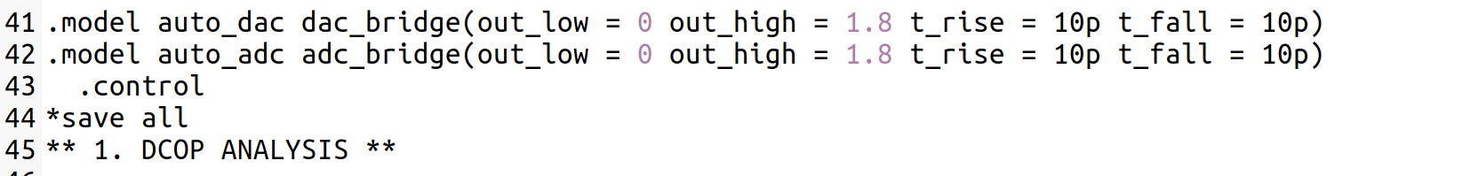
When you netlist, it is useful to verify the dac_bridges (and adc_bridges if any are requried) are placed in the correct places. To enable you to do this, place the line:

listing e

At the end of the stim file (below setplot).

5. Netlist:

Check that the model has been netlisted correctly. Specifically, for multiple inputs ensure they are contained between square brackets.

a1 [ va vb ] or_out or_gate_xs

Then verify the subckt itself looks ok.

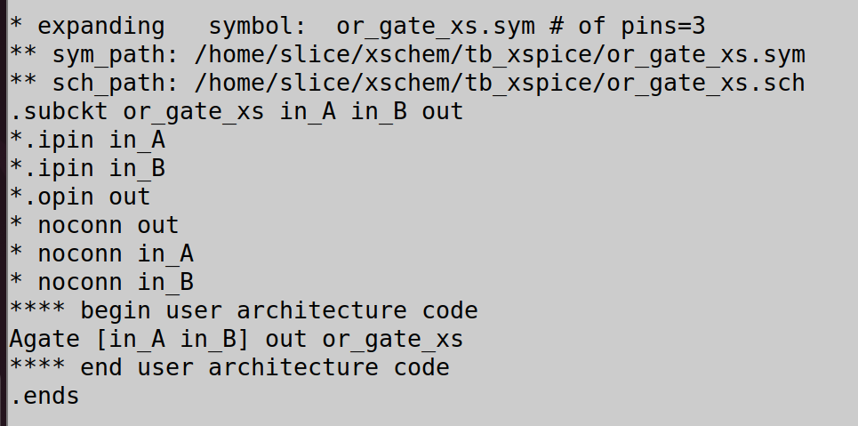
6. Setup outputs:

If the outputs are going directly to spice. If not going anywhere, and you want to view them, you will need to place a cap on them so that ngspice will automatically place the dac_bridge on the outputs (cap is analog so needs a dac_bridge inserted). Doing this will allow you to check the waveforms on unused nets to verify the bridge settings / .v code.

Note: The reason you dont need to do this on any nets going directly to a spice element (transistor / gate / etc) is the tool will recognise the need for a transision between .v to spice at this connection point and automatically insert a dac bridge.

In the below, I had nothing connected to the or gate output. So to allow me to analyse it, I simply placed 1fF on it to effectively tell the tool to create dac_bridges between the xspice outputs and the caps.

7. Simulate:

At the end of the simulate file, verify the dac_bridge has been inserted in the correct place. This appears because of the “listing e” command in step 4. As you can see below, auto_dac3 has been inserted on the or_out net.

Then just check the outputs. From below, you see the or gate output (or_out) is hi because one of the inputs (vb) is also hi. Because of the dac_bridge, hi = 1.8V.

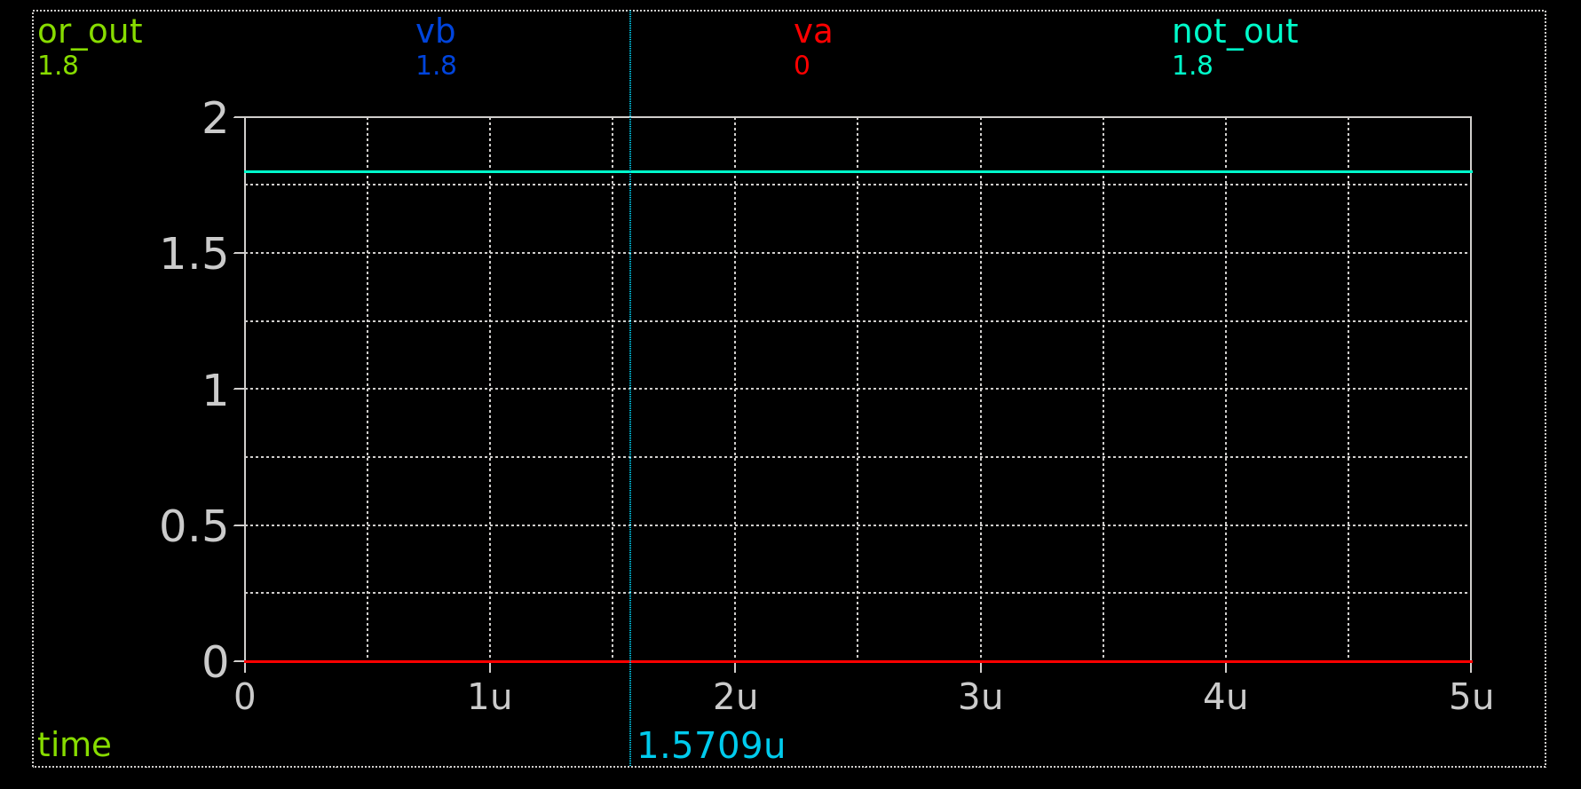
8. Running single input xspice models:

The only thing to take note here is when there is only 1 input, you don’t use squared bracket notation. The below examplifes the changes using an inverter (called not_gate_xs).

Inside the schematic you q and enter the below:

Agate in out not_gate_xs

Inside the symbol you q and enter the below:

type=subcircuit
format="@name @@in @@out @symname"
template="name=x1"

Instantiate by starting the name with ‘a’ and place a cap on the output if not going anywhere.

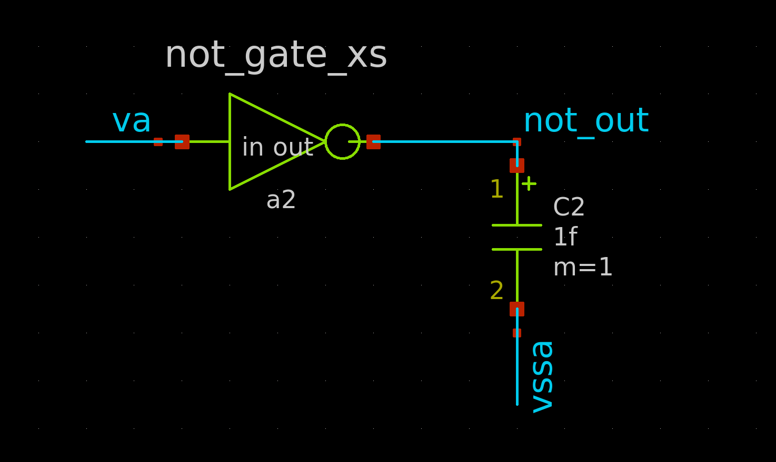
After you netlist, verify the xspice model has been netlisted correctly, with an ‘a’ and no square brackets around the inputs.

a2 va not_out not_gate_xs

Then verify the .subckt.
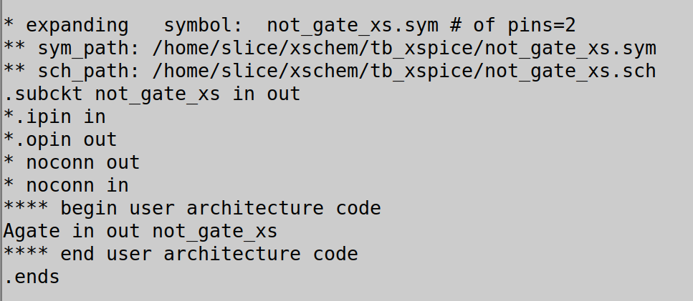
Then simulate and check the output. From below, you see the not gate output (not_out) is hi because its input (va) is lo. Because of the dac_bridge, hi = 1.8V.

A good example tb can be found at:

https://github.com/SLICESemiconductor/OpenSourceTool_Examples/tree/main/Running_xspice_models

