Installing and running klayout

1. Download the following package dependancies:

sudo apt install qtcreator qtbase5-dev qt5-qmake
sudo apt install qtmultimedia5-dev libqt5xmlpatterns5-dev
sudo apt install libqt5svg5-dev qttools5-dev-tools qttools5-dev
sudo apt install python3-dev
sudo apt install ruby-dev
sudo apt install libgit2-devel ... for Fedora/CentOS,
sudo apt install libgit2-dev ... for Ubuntu/Debian
sudo pip install psutil
2. Clone klayout:
Go to where you want to clone klayout into (anywhere really but be systematic in that you place it in the same dir that you clone all your OS tools into) and type:
git clone https://github.com/KLayout/klayout

3. Compile or build:

Normally at this stage you do a make install to compile the package into a globally accessible directory and create globally accessable symbolic links. Such an option is not available in klayout meaning you manually need do this. To compile into the /usr/local/share/ dir type:

./build.sh -prefix /usr/local/share/klayout

Note: klayout is not written in C and so takes a long time to compile (4-8hrs or more depending on system capabilities)

Once compiled, you should see the below:
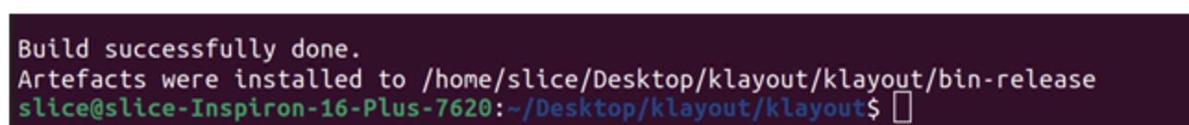
Note: You will see the above was not installed / compiled to /usr/local/share/. This was an error by me as discussed in the section at the end of this doc.

4. Create executable:

Next step is to create an executable (one word command) which can call klayout from anywhere it is entered. This means creating a symbolic link called “klayout” to /usr/local/share/klayout/klayout. Placing that link in /usr/local/bin/ means it can be called anywhere.

All this is achieved with the following command:

sudo ln -s /usr/local/share/klayout/klayout /usr/local/bin/klayout

5. Running klayout:

In any terminal simply type klayout and it will open in read mode. Type klayout -e to open in edit mode.

6. Customising klayout:

The only customisation I have done is to set the background to black (default = white) to make it more similiar to a commercial layout editor. This is done by going to File/Setup/Display/Background as shown below:

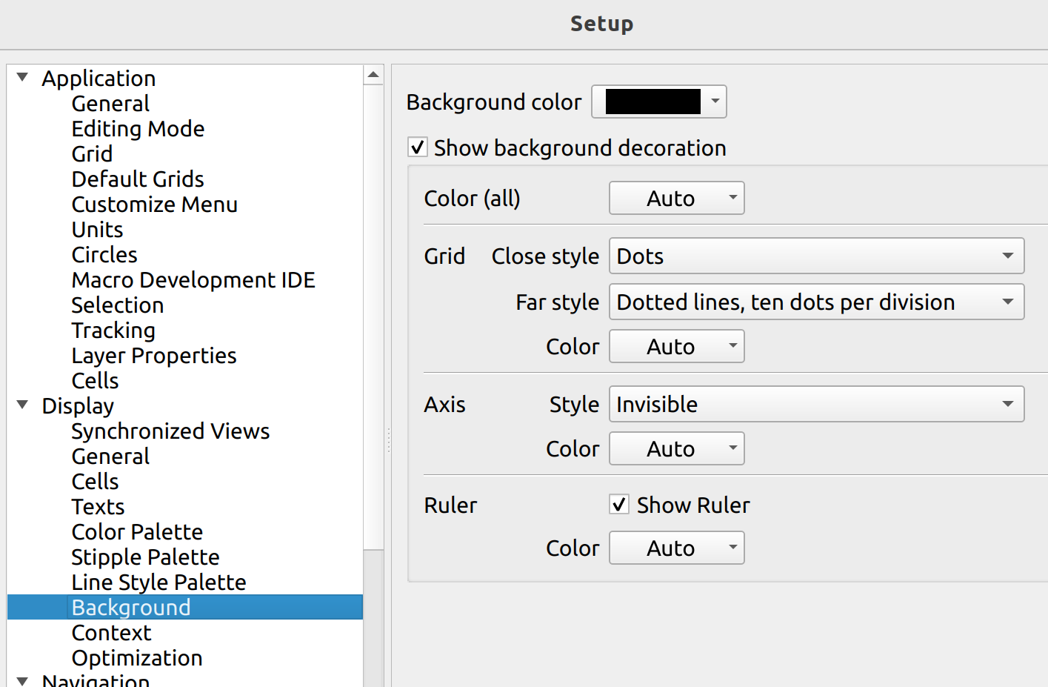

An example layout of an inverter is shown below to give the reader an idea of the klayout UI:

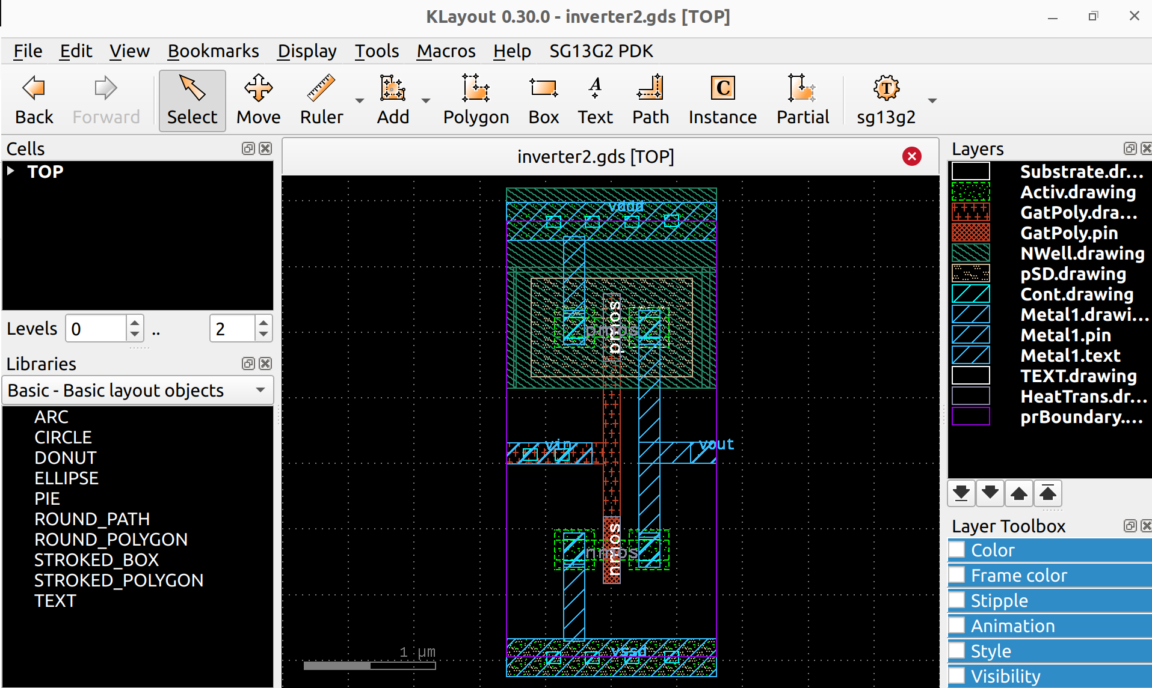
Aside: Running the build stage without parsing options

Initially I did not know ./build.sh has parsing options so just ran ./build.sh from some local dir. This meant after the compile stage was complete, I needed to do the following steps:

- Move the bin-release dir to /usr/local/share/

sudo mv bin-release /usr/local/share/klayout

Note: This step assumes there is no dir in /usr/local/share already called klayout. If so, mv that to klayout_bu or something before running the above. Otherwise a new dir called /usr/local/share/klayout/bin-release will be created which is not what you want.

- Create the symbolic link as already described

sudo ln -s /usr/local/share/klayout/klayout /usr/local/bin/klayout

- Create a file in some local dir called: klayout-x86_64.conf. Place the following line in this file:

gedit klayout-x86_64.conf
/usr/local/share/klayout

- Move that file to /etc/ld.so.conf.d/
sudo mv klayout-x86_64.conf /etc/ld.so.conf.d

- Change owenership of the file to root
sudo chown root:root /etc/ld.so.conf.d/klayout-x86_64.conf

- Update the systems linker cache
sudo ldconfig

Acknowledgments:

Thanks to Tim Edwards, D.M.Bailey, Leo Moser and Sylvain for their valuable inputs.

