Running LVS using klayout (KLVS) and netgen

1. Install netgen:

cd into the dir you clone all your OS tools into and type the following command:

git clone git://opencircuitdesign.com/netgen netgen
cd netgen
./configure
make
make install
netgen --version

Ensure version 1.5 is installed as this is the latest. Total compile time is in mins.

Useful links:
http://opencircuitdesign.com/netgen/index.html
https://web02.gonzaga.edu/faculty/talarico/vlsi/netgen.html

2. Run LVS using klayout (KLVS):

This assumes you already have klayout installed.

cd into the following dir:

cd /home/slice/pdk/iHP/IHP-Open-PDK/ihp-sg13g2/libs.tech/klayout/tech/lvs

For efficiency it is advised to create an alias for the above, something like:

alias KLVS='cd /home/slice/pdk/iHP/IHP-Open-PDK/ihp-sg13g2/libs.tech/klayout/tech/lvs'

python3 run_lvs.py –layout=<PATH_TO_GDS_FILE> --netlist=<PATH_TO_SPICE_FILE--run_dir=<PATH_TO_RUNDIR>

An example is shown below:

python3 run_lvs.py --layout=/home/slice/xschem/tb_inverter/LVS/inverter2.gds --netlist=/home/slice/xschem/tb_inverter/LVS/inverter2.spice --run_dir=/home/slice/xschem/tb_inverter/LVS

When run, you may (or may not!) see the below message:

When run, the tool will create an _extracted.cir which is essentially a spice representation of the .gds file. It will also create a .lvsdb file which is intended to be the LVS debug file. I say “intended” as debug with KLVS is extremely difficult (no meaningfull statements produced!). In fact, this is one of the main drawbacks of KLVS in my opinion.

2. Run LVS using netgen:

In order to compare the layout with the schematic, netgen first needs a spice representation of the .gds layout file. KLVS is perfect for generating this, as described above.

cd into the directory containing the _extracted.cir and .spice file and run the following command:

netgen -batch lvs "inverter2_extracted.cir TOP" "inverter2.spice TOP" /home/slice/pdk/iHP/IHP-Open-PDK/ihp-sg13g2/libs.tech/netgen/ihp-sg13g2_setup.tcl

Note how the .subckt name (e.g. TOP) needs to be specified for both netlists.

Upon running the above, user will notice a dramatic speed increase over KLVS. When complete, user may see the below message:

Run results are contained in a comp.out file located in the dir netgen was run from. As per below, you can see the results to be very easy to read and hence debug if required.

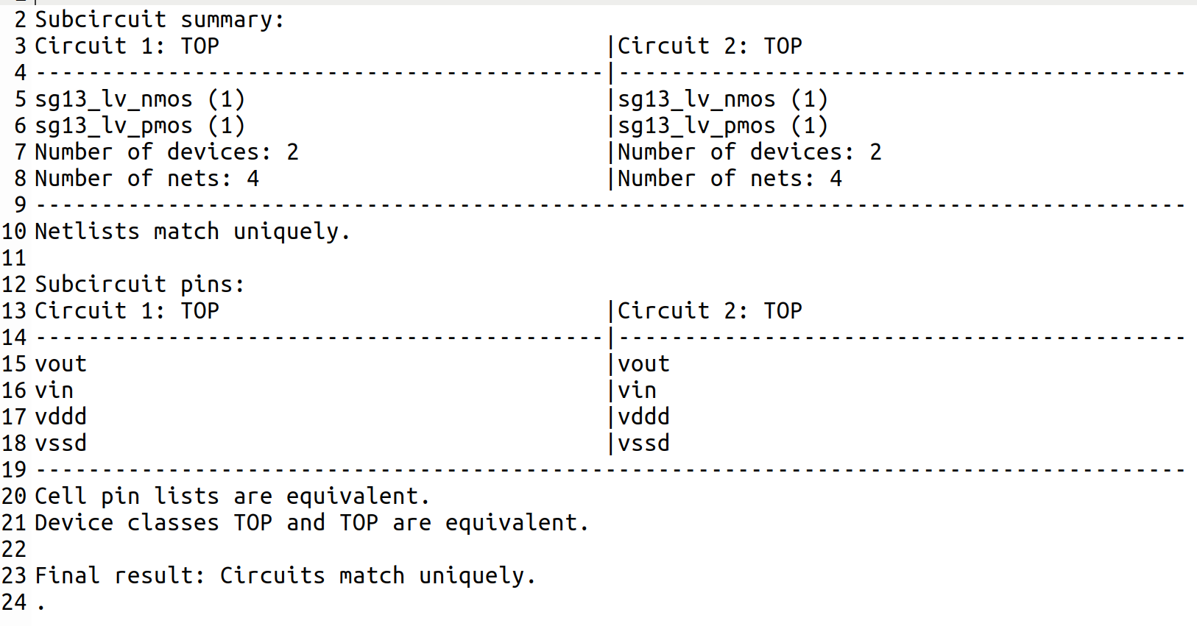
3. Conclusions:

KLVS is slower than netgen and extremely difficult to debug. In addition, it has been found to not detect differences in netnames (see Appendix #1). In contrast, netgen is faster, much easier to debug and found to reliably report LVS differences. The recommended flow (in my opinion anyway!) is to run KLVS to generate the _extracted.cir representation of the .gds file and then run netgen on this.

Unfortunately neither KLVS or netgen give a happy face when netlists match (as we are all used to with Calibre :-(!!!).

Appendix #1: LVS investigations using klayout (KLVS) and netgen:

Following are 6 examples testing LVS using klayout / netgen on a simple inverter

Main points:

- Example #1 confirms KLVS is working for matching .spice / .gds files
- Example #1 confirms netgen is working for matching .spice / .cir files
- Examples #2 and #3 show KLVS doesn’t flag an error if net names are not the same (e.g. vout2 in .spice file and vout in .gds file or vice versa)
- Examples #2 and #3 show netgen does flag an error if net names are not the same (e.g. vout2 in .spice file and vout in _extracted.cir file or vice versa)
- Example #4 and #5 show debug to be very difficult in KLVS while netgen clearly shows the the cause of LVS errors.
- Example #6 shows KLVS and netgen to ignore ‘ng’ parameter (# of fingers), as expected
- Running all examples showed netgen to be much faster than KLVS

Example #1: LVS clean example:

- Extracted.cir file:

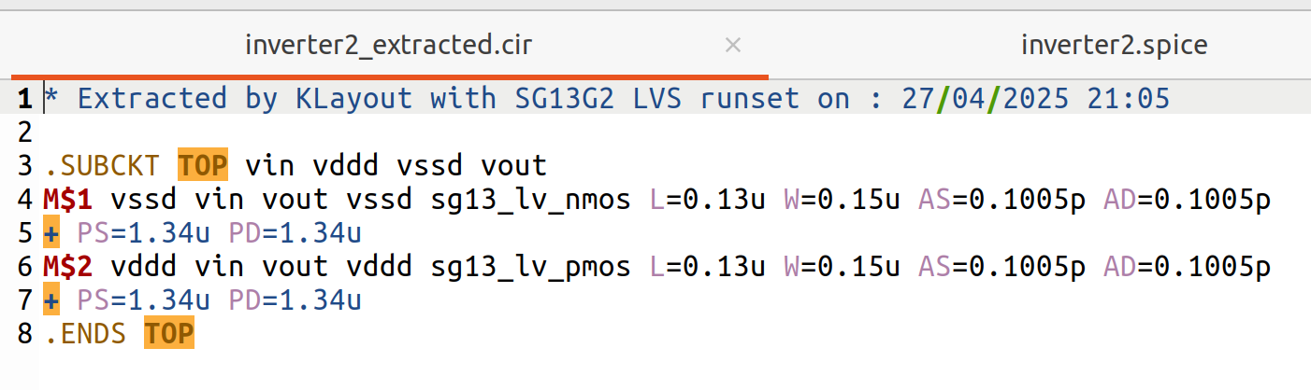
- Spice file:

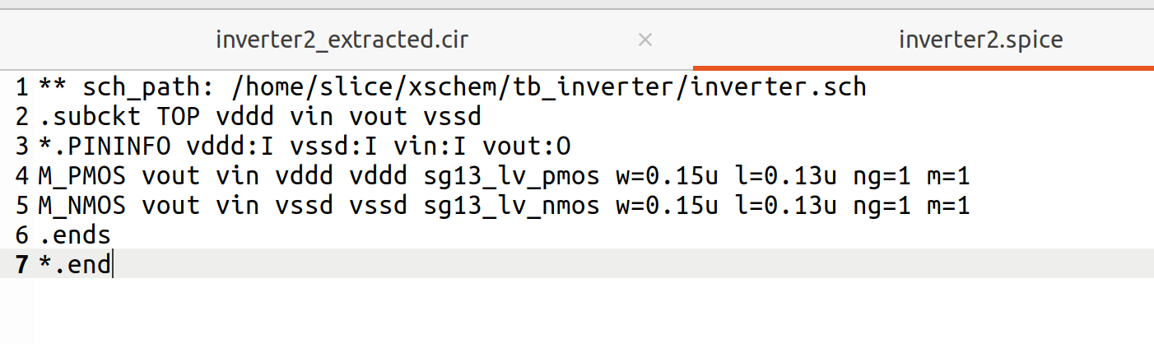
- Result:
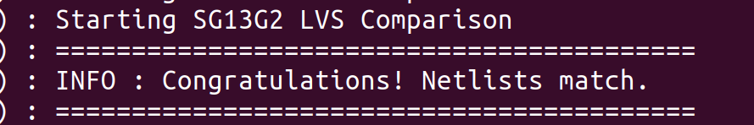

- Netgen result:

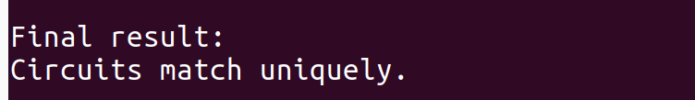
Example #2: Manually edit spice file (change vout to vout2):

- Extracted.cir file: No change from example #1.

- Spice file:
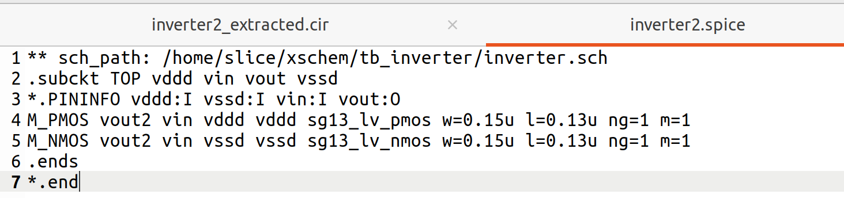

- Result:

- Netgen result:

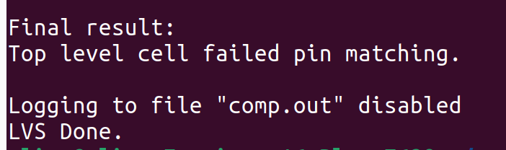

Example #3: Manually edit layout (change vout to vout2):

- Extracted.cir file:

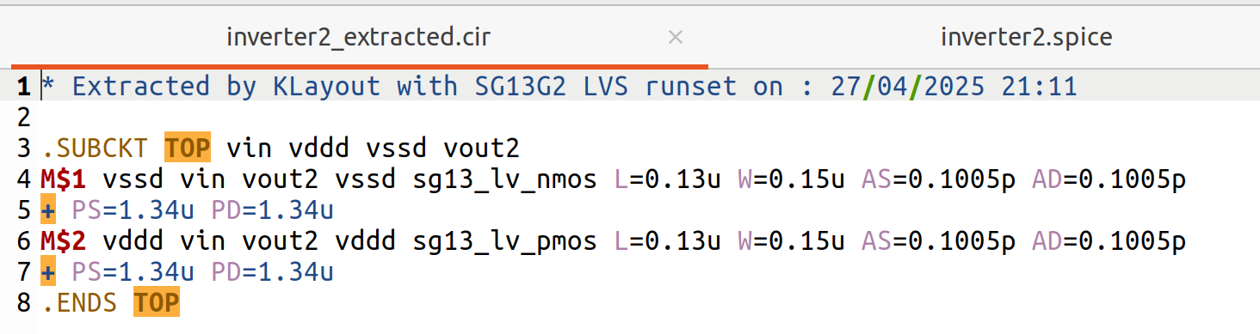

- Spice file: No change from example #1.

- Result:

- Netgen result:

Example #4: Manually edit spice file (change PMOS channel length from 0.13 to 0.14u):

- Extracted.cir file: No change from example #1.

- Spice file:
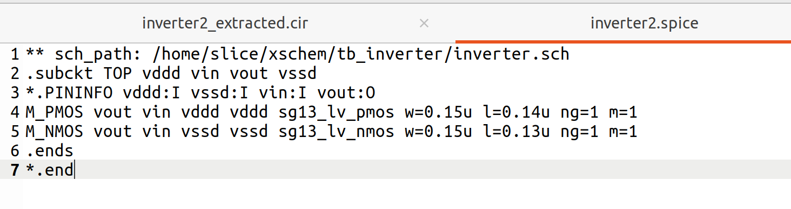

- Result:

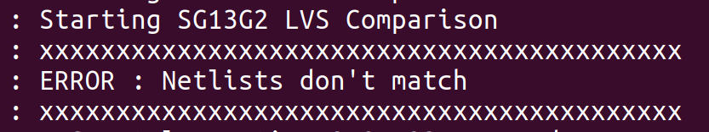
- Debug:

Contents of .lvsdb file do not obviously show that the reason for the LVS error is due to the PMOS channel lengths not matching.

- Netgen result:

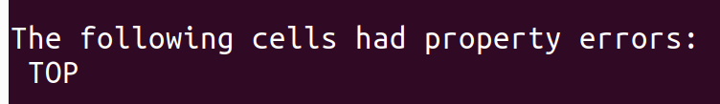
- Netgen debug:

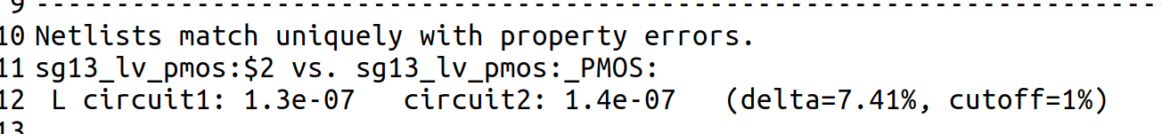

Example #5: Manually edit spice file (change PMOS m from 1 to 2):

- Extracted.cir file: No change from example #1.

- Spice file:

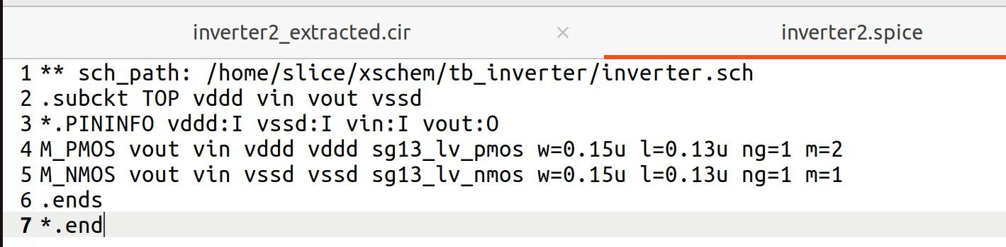

- Result:
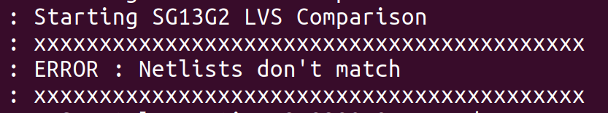

- Debug:

Contents of .lvsdb file do not obviously show that the reason for the LVS error is due to the PMOS mults not matching.

- Netgen result:

- Netgen debug:

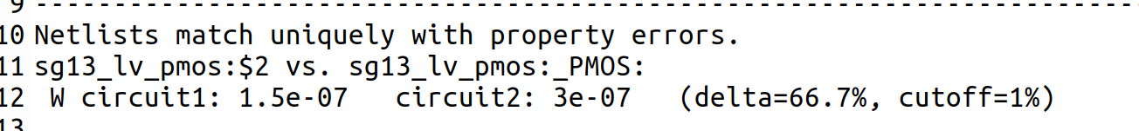

Example #6: Manually edit spice file (change PMOS ng from 1 to 2):

- Extracted.cir file: No change from example #1.

- Spice file:
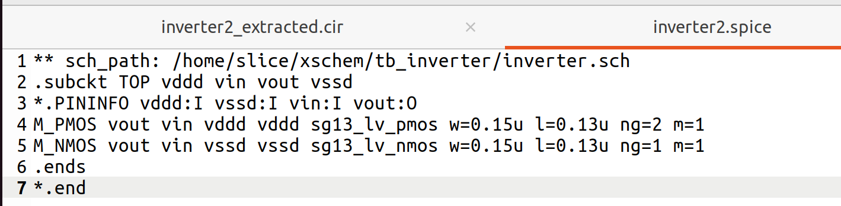

- Result:

- Netgen result:

- Remark:

This result is expected since as stated in the docs:

The ng parameter will be ignored, as the w represents total width of all fingers.

Ref [Tim Edwards}: “This is in line with BSIM definitions which treat W as total width of all fingers. There is clearly some confusion on that point, and it may be that some foundries have opted to treat W as width of each finger in spite of the BSIM spec”

This means the following in schematic:

- The below device has a physical width = 0.3um.
- It does not have a physical width = 0.3um*2
- In other words “w” does not mean finger width but total width
- The below device in layout will appear as 2 fingers each with width = 0.15um to give a 0.3um total width
- This is slightly different to other pdks where finger width is specified instead of total width

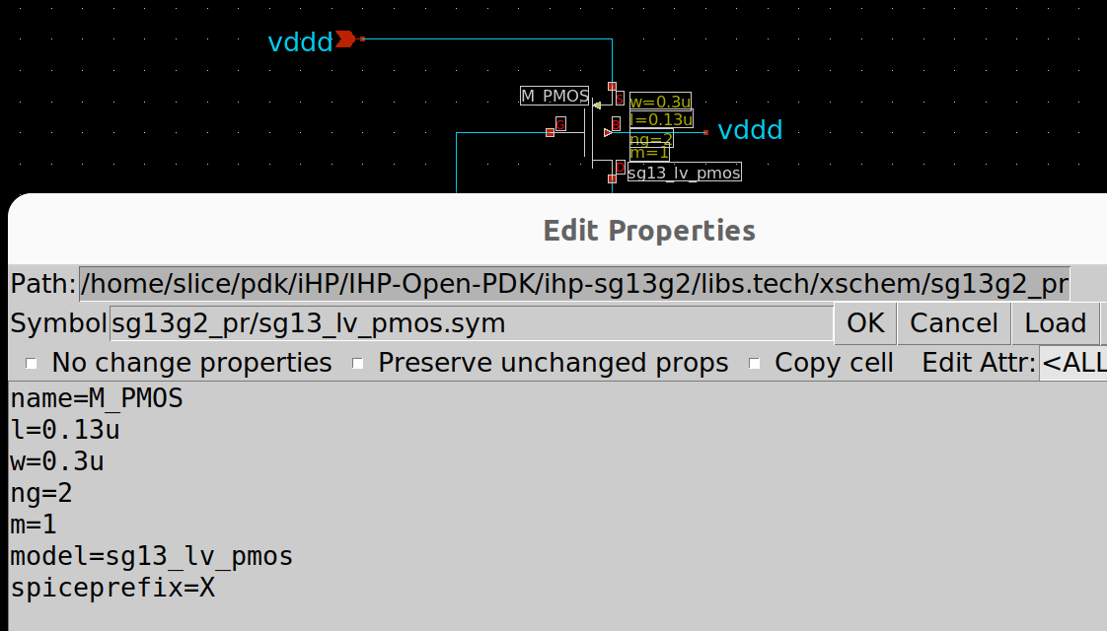
Acknowledgments:

Thanks to Tim Edwards, D.M.Bailey and Krzysztof Herman for their valuable inputs.

