Running extracted sims in xschem

There are 3 different ways to do this. The first 2 are documented by Stefan Schippers at:

https://xschem.sourceforge.io/stefan/xschem_man/tutorial_use_existing_subckt.html

https://www.youtube.com/watch?v=zs6JPXk074c

1. Method #1:

‘q’ on the symbol and place the following lines:

schematic=<.subckt name of the PEX netlist>
spice_sym_def="tcleval(.include <PATH_TO_PEX_NETLIST>)"
tclcommand="tcleval(textwindow <PATH_TO_PEX_NETLIST>)"

The first line creates an empty schematic.
The second line reads in the PEX netlist.
The third line enables you to read the PEX netlist from the tb by selecting the symbol and hitting ctrl+h.

An example is shown below:

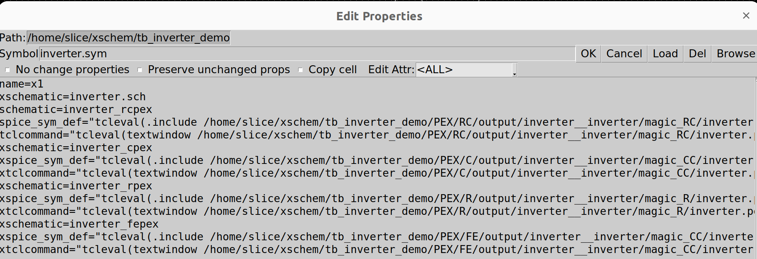
This is a good example as it clearly illustrates the use of the symbol editor as a config file. First line is “xschematic=inverter.sch”. In this example “inverter.sch” is the name of the transistor level schematic so removing the x from this line (keeping for all others) will enable the transistor level to be used. Next 3 lines are to do the RC extraction so removing the x’s from these lines (keeping them on all others) will enable an RC extraction. After that the next 3 lines define a C extraction, then an R extraction and finally a FE extraction.

Note the naming convention of the schematics are inverter_rcpex/ inverter_cpex/ inverter_rpex/ inverter_fepex. This is to match the .subckt definitions of the extracted files which have following the above naming conventions for good practice, as described in the kpex howto doc.

Note how you can just use the file from the place kpex places it (only editing you need to have done is changing the .subckt name to <blockname>_’x’pex and adding vssd & vddd to the pin list).

Below shows the PEX netlist when you select the symbol and hit ctrl + h.
Note the name of the .subckt matches the schematic= name above. In general this is a really good check to confirm the correct PEX netlist is being used.

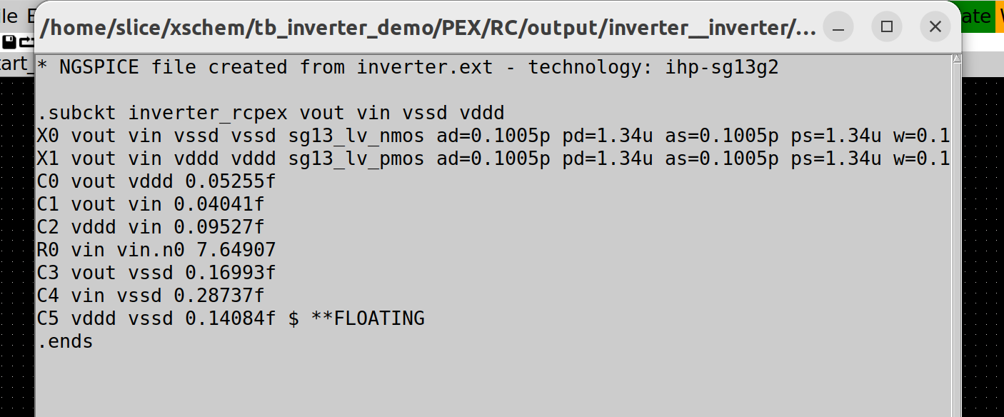
Another good check is to view the netlist which at the end should indicate the correct PEX file has been included. Reason this is a good check is when I have had issues these lines often do not appear!

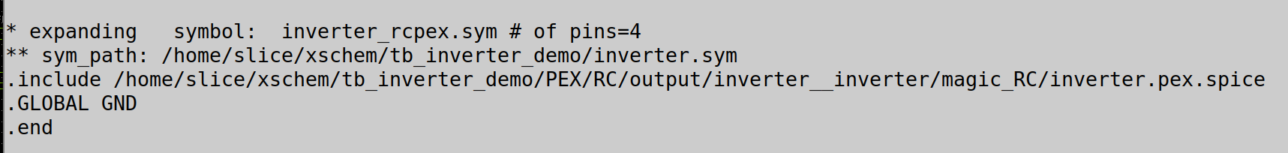
2. Method #2:

This is the same as Method #1 apart from 1 difference:

Instead of specifying the entire path, use the “abs_sym_path” command to find the correct file, as shown below.

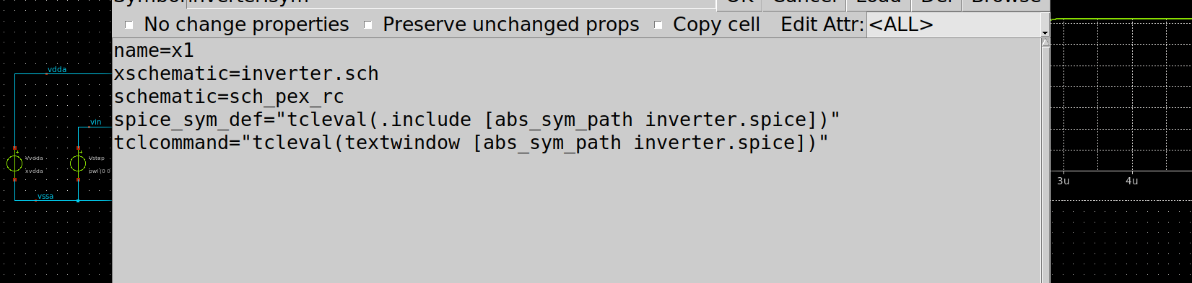
Details of how the “abs_sym_path” finds the correct file are contained in the youtube link given at the start of this doc.

3. Method #3:

Don’t edit the symbol properties and simply place a .include statement at the top of the stim file as shown below:

This .include file causes the subcircuit to be defined twice with the 2nd definition (the PEX netlist) overwriting the first (the .spice netlist). Although this method may appear more straight forward, it is not advised because port orders of the PEX netlist must match exactly that of the symbol. Although for small subcircuits this is not too laborious a task, for larger ones it can be very cumbersome (and hence error prone) as it will require you to go into the symbol view and, using shift+s, update the port orders accordingly.

4. Conclusion:

Use either method #1 or #2 but not #3, it was only included for completeness.

Acknowledgments:

Thanks to Stefan Schippers for his guidance.

