Running MC analysis across PVT sims:

This essentially combines the PVT approach we have documented in doc “Running_PVT_analysis” with the MC appraoch we have documented in doc “Running_MC_analysis”. Note that SKY130 doesnt provide a GMC corner. This means you will need to run analysis across corners individually using “tt_mm, ss_mm, ff_mm, sf_mm, fs_mm” but not corner “mc” as I am unsure exactly what this is supposed to represent. This linear summing of process spread with local mismatch is overly pessimistic since both process spread and local mismatch are Gaussian and so should root sum. I am not too bothered by this since it is the right side of wrong in that this overly pessimistic will produce a more conservative design. Only downside is it will require some extra area but in anycase, it is all we have and is the appraoch taken for the lower technology nodes of 16nm and below.

1. MC analysis

Set up your MC analysis as described in “Running_MC_analysis”. Only addition are the below lines inside the .control loop.

let cor_id = 1
echo "$&cor_id" >> vth_measures_tt_mm.txt

As will be shown, variable “cor_id” will be used to identify the process corner.

Note: This cor_id approach was extremely effective and should be integrated into my PVT analysis to avoid me having to find corners based on file names (that approach worked but I feel the corID appraoch will be that bit more direct and in line with what the commercial EDA tools are doing).

Run this to ensure MC analysis has outputted the data correctly.

Note: Because you will be looping the sim ‘x’ number of times where ‘x’ = number of runs, it is advisble not to save the .raw file since it could use a significant amount of diskspace. Since .raw files are only needed when we want to display waveforms, which is typically not the case for MC analysis, not saving them will typically not result in any loss of information. This is why you will see the lines to save .raw files typically commented out in my scripts when performing MC analysis, as shown below.

* "tb_MC_PMOS.raw" to save diskspace.
*set appendwrite
*set filetype=ascii
*write tb_MC_PMOS.raw

2. PVT analysis

Set up your PVT analysis using the scripting approach detailed in doc “Running_PVT_analysis”. Below is an example line where we change from tt_mm at 27C (cor_id = 1) to ff_mm at 125C (cor_id = 2).

####################### set T = 125C #######################
exec sed -i {/^\.temp/s/27/125/} $spicefile
# change to ff corner
exec sed -i {s/let cor_id = 1/let cor_id = 2/} $spicefile
exec sed -i {/^\.lib/s/tt_mm/ff_mm/} $spicefile
exec sed -i {s/vth_measures_tt_mm.txt/vth_measures_ff_mm_125.txt/} $spicefile

Ctrl + left click to run. E.g. In this example I am running MC across process and temp so will ctrl + left click that arrow.

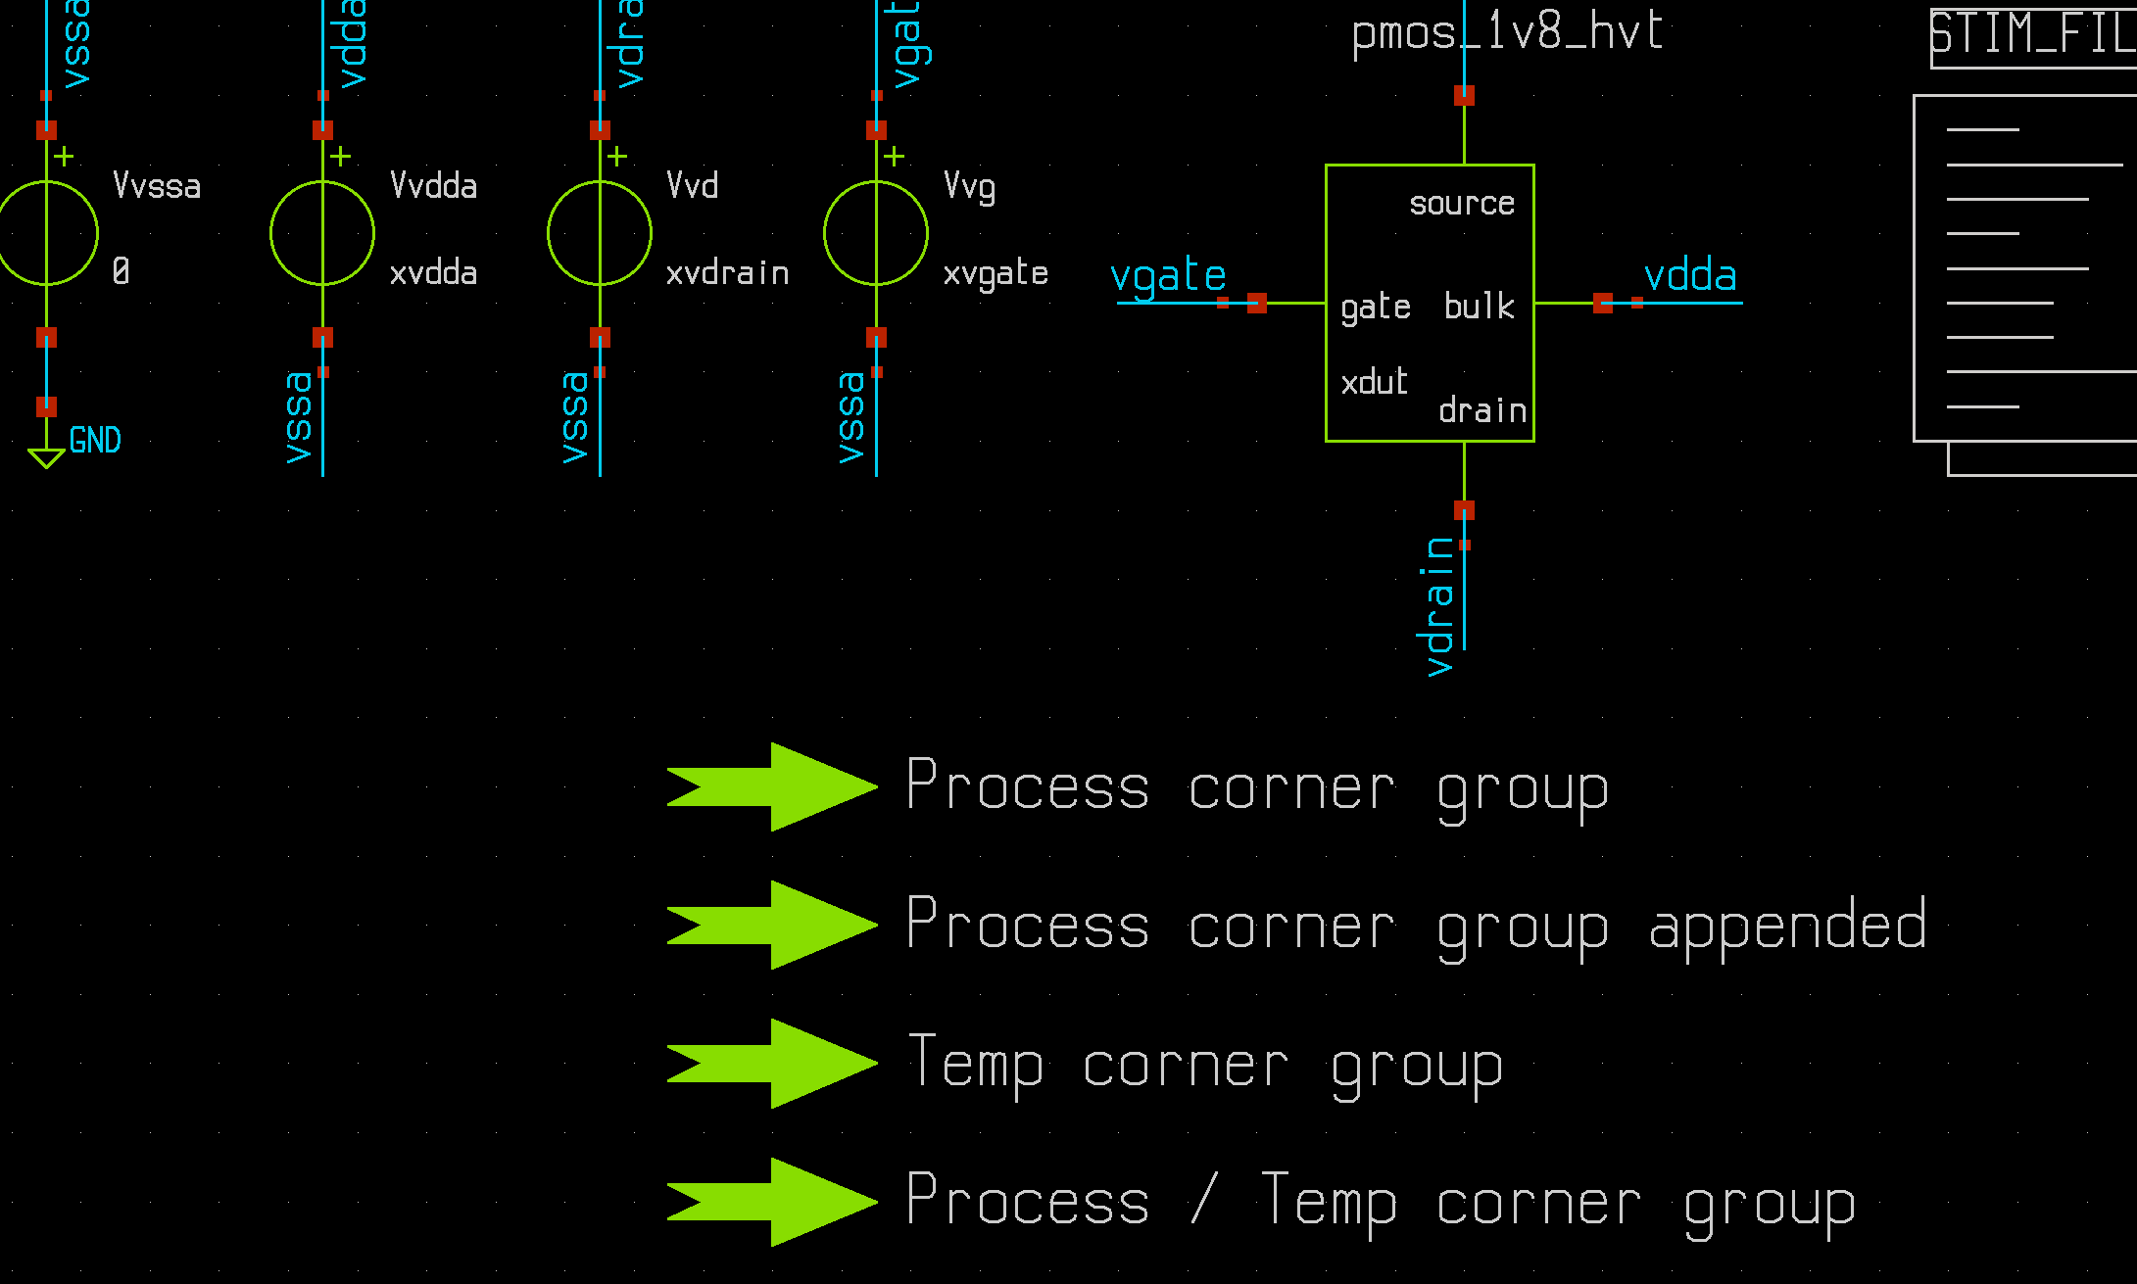
The results will be lots of measure files in your results dir. E.g. In the below I was running MC across 9 corners. Since number of MC samples (N) = 200, the resulting file will be 201x9. Why 201 and not 200 – because line 1 contains the corID data.

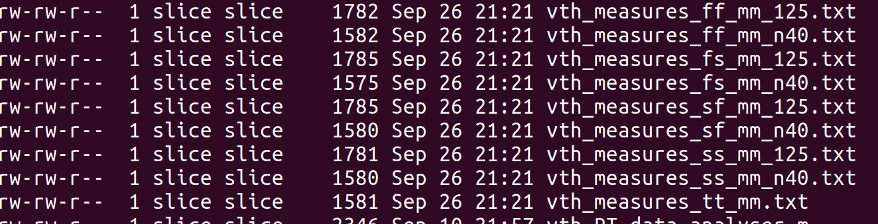

Next call the octave script to post process all this data. Octave script is called “mc_data_analyser_process_temp2.m”. Simply run it in the results dir to output all the required stastical data for each corner, based on the ‘N’ pts used at that particular corner.

The console will output a summary of all the data as shown below, in addition to outputting the raw matrix of data.
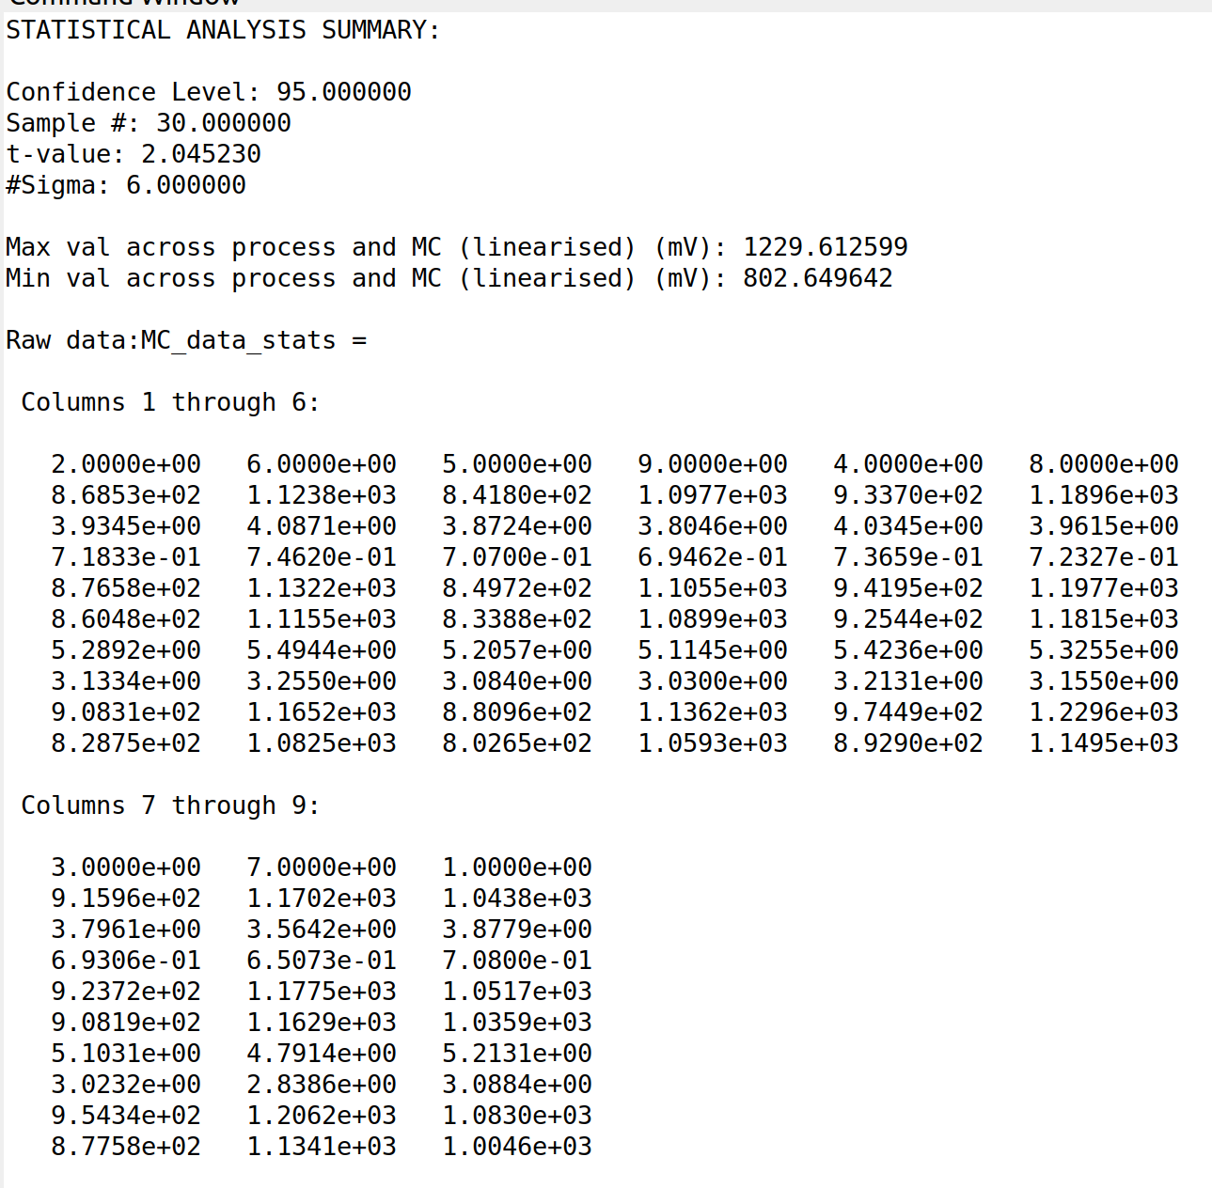
Finally, the script will output the data to a nice table in a .csv file, which will look like:

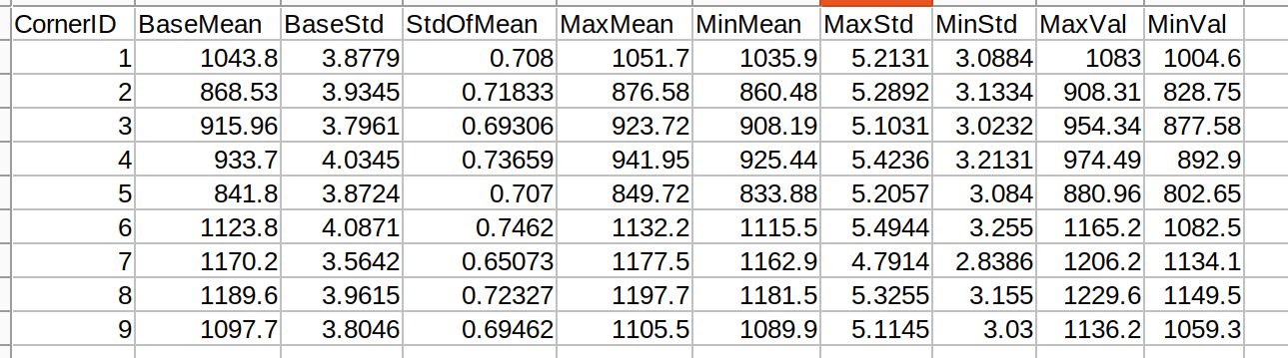
This is the final product which gives a statistical summary at each corner. You just neet to know what corner corresponds to what corID to translate corID to say ff/125 or something. Might seem arduous but this is the way Solido works (you need to translate corner #’s to a corner file description).

In this analysis, BaseMean and BaseStd are found using the normal formulae. StdOfMean is found using ‘N’ which using the t-value corresponding to ‘N’ gives us the MaxMean, MinMean numbers. MaxStd and MinStd are then found using that equation which took me years to find (!). Combining this with the MaxMean and MinMean numbers thus outputs the final MaxVal and MinVal numbers using the required t-values. If you scan through these MaxVal and MinVal cols you will see the max value across process and MC = 1229.6mV while that for the min value = 802.65mV. Checking back at the Octave console you will see it had already provided this info, as per below:

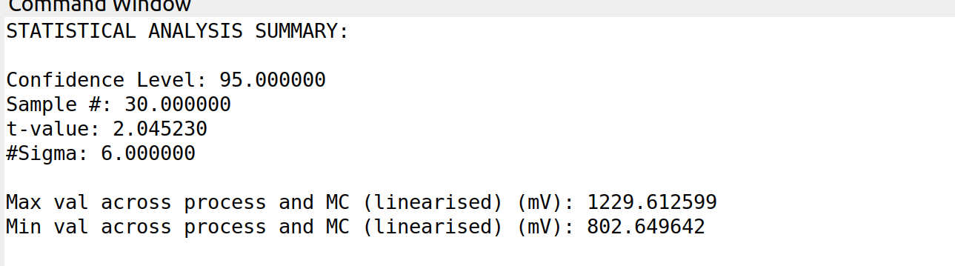
What I like also about the console is it gives the CL, sigma #, sample # and t-value used.

Testbench demonstrating all this is checked into the below gitHub location:

https://github.com/SLICESemiconductor/OpenSourceTool_Examples/tree/main/MC_analysis_across_corners

