Note: Forum thread which lead to the below is found at:

https://sourceforge.net/p/ngspice/discussion/ngspice-tips/thread/6a5b9dd2/

1. Install latest version of verilator:

To run this, verilator version 4.2.10 or later is required. Chances are the version which comes bundeled with your linux distro will be older than this. You can check with the below link:

https://repology.org/project/verilator/versions
For example, this link shows version 4.038 comes with Ubuntu 22.04.
To update the latest version follow the instructions on the below link:
https://verilator.org/guide/latest/install.html
Specifically this means doing the following:

git clone https://github.com/verilator/verilator
unset VERILATOR_ROOT
cd verilator
autoconf
./configure
make
sudo make install

2. Run the example code created by Giles.

This can be found at:

https://ngspice.sourceforge.io/docs/others/Verilog-CoSim.pdf

To do this, download the files at the following links:

https://sourceforge.net/p/ngspice/ngspice/ci/master/tree/src/xspice/verilog/
https://sourceforge.net/p/ngspice/ngspice/ci/master/tree/examples/xspice/verilator
Download to a directory naming structure like: <name_top>/<name>
The idea here is that you will store the files in the <name> directory and move one level above (to <name_top> to run the following command:
ngspice vlnggen <name>/adc.v
After this, go into <name> and run:
ngspice adc.cir
You should get an output like the below:

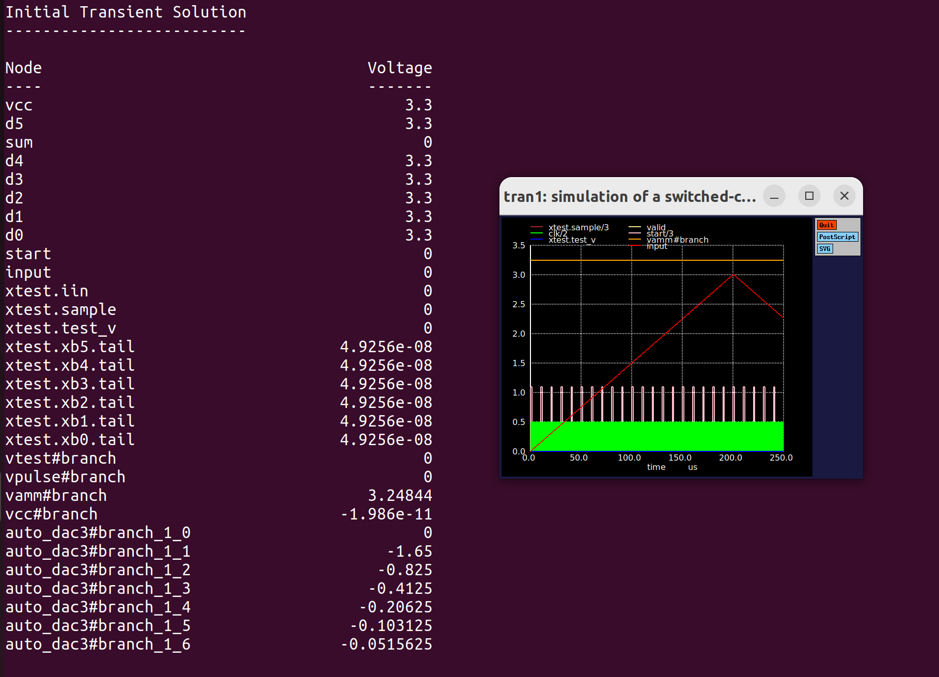
3. Create an ‘n’ bit counter in verilog:

In the below example I have created a 4bit counter:

*******************************************************************************

module counter(out, clk, reset);

parameter WIDTH = 4;

output [WIDTH-1 : 0] out;
input clk, reset;

reg [WIDTH-1 : 0] out;
wire clk, reset;

always @(posedge clk or posedge reset)
if (reset)
out <= 0;
else
out <= out + 1;

endmodule // counter

In the above example the always loop is triggered upon a +ve clock or reset edge. Once done, if reset is high, clock outputs a 0. Otherwise it increments the output upon each +ve clock edge. This means that until reset goes hi, the output is undefined.

4. Create a tb to test that counter in verilog:

In the below example, I create a tb which asserts reset after 10 clocks and de-aserts it after 5 clocks, stopping after 200 clocks. The period of the clock sent to the counter is then 10 clocks.

********************************************************************************

module counter_tb;

/* Make a reset that pulses once. */
reg reset = 0;
initial begin
$dumpfile("counter_data.vcd");
$dumpvars(0,counter_tb);
# 10 reset = 1;
# 5 reset = 0;
# 200 $stop;
end

/* Make a regular pulsing clock. */
reg clk = 0;
always #5 clk = !clk;

wire [3:0] value;
counter c1 (value, clk, reset);

initial
$monitor("At time %t, value = %h (%0d)",
$time, value, value);
endmodule // test

********************************************************************************

What we will expect when we run this is that after 10 clocks reset will go high. Its +ve edge will activate the always loop in the verilog file which will set the output to 0. This will only last half a clock period (after which point reset goes low). Then clock will increment from there.

5. Install icarus:

Icarus will be used to verify the verilog code. Its full installation instructions are found at the below link:

https://steveicarus.github.io/iverilog/usage/installation.html

6. Install gtk:

Icarus is used to compile and run verilog code but needs gtk to view the outputs. My experience with the gtk install was not good when I attempted a manual install. After a few hours of unsuccessfully trying this I resorted to installing the version which came with Ubuntu (using sudo agt get). Gtk is a very mature digital waveviewer so the version with Ubuntu (altho prob not the most up to date version) worked fine.

7. Run verification:

As described at the following link:

https://steveicarus.github.io/iverilog/usage/gtkwave.html

Compile the verilog files created in steps 3 and 4 using icarus with the following code:

iverilog -o dsn counter_tb.v counter.v

This compiles into a file called dsn. Run this using the below:
vvp dsn
This dumps all the data to a .vcd file called “counter_data.vcd” as per below:
gtkwave then needs to be used to view this .vcd file with the below command:
gtkwave counter_data.vcd &
The results is shown below:

Behaviour is as expected. Counter output is undefined until reset goes high whose +ve edge sends it low for half a clock period. Once low, the next clock increments the count to 16 after which of course it resets.

So in a nutshell, commands to compile/run/verify are:

# compile vlog files
iverilog -o dsn counter_tb.v counter.v

# execute vlog files
vvp dsn

#open gtkwave to view them
gtkwave counter_data.vcd &

To be efficient you can place these in an executable (called run) using chmod + x. Now by typing /.run you will do all the above.

8. Convert .v to .so file:

Create a directory structure like /counter_top/counter.
In directory counter, place the verilog code created in step 3.
Go one level above and write the line: ngspice vlnggen counter/counter.v
This will create all the necessary files, and the all important .so file which is what will be used to represent the counter in verilog:

9. Create a tb in xschem:

You will be running all this through xschem so use that to create the required stimulus. As shown below this is a ground, reset, clk and vdda (stimulus details are shown later).

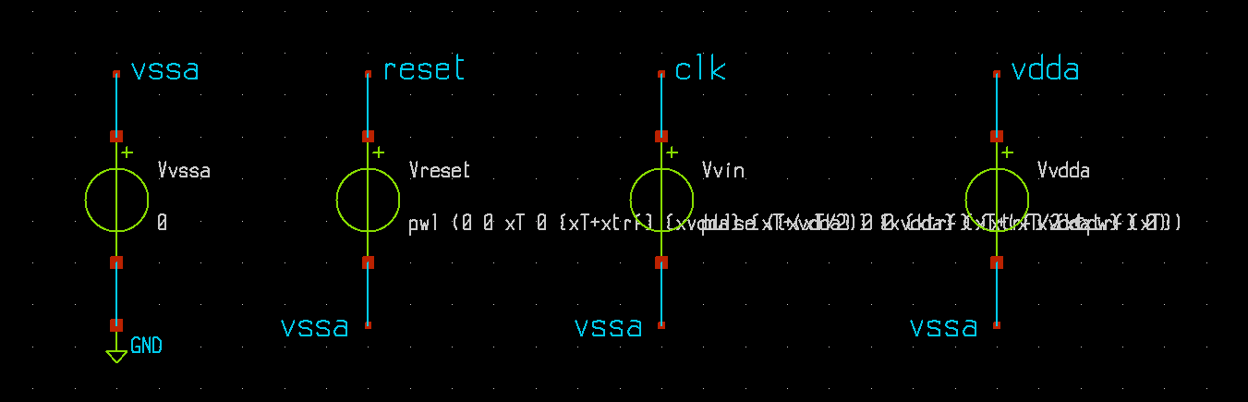
Next create a counter symbol with all the required pins:

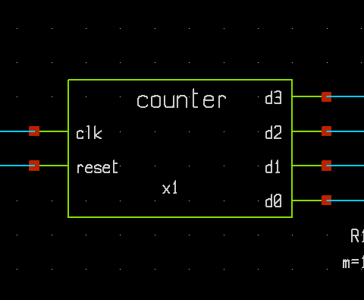

Inside that symbol, place noConns on all the pins (otherwise xschem will error out):

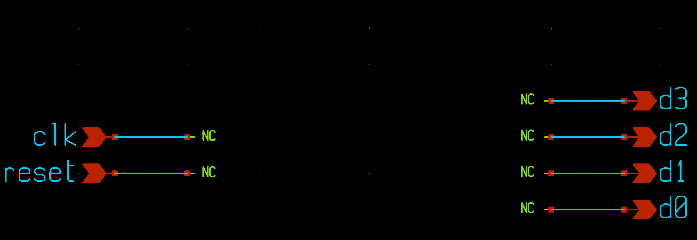
Next ‘q’ on the symbol and place the following in the text field:

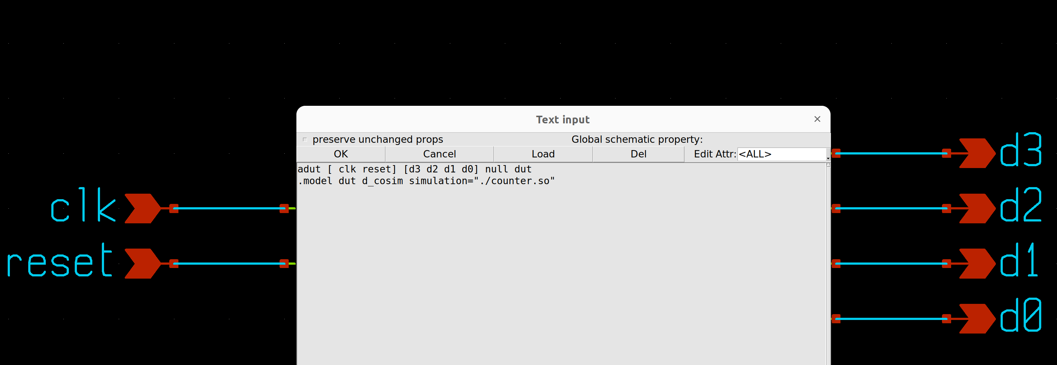
This code is pretty generic and to get a true understanding of it, the user is directed to the following sections of the ngspice manual:

Relevant sections are 12.1 XSPICE (device and model card format), 14.3 (digital devices with behaviour defined by Verilog) and 12.4.25 (the d_cosim code model that is used to create such simulated devices). Assuming there are analogue nodes and devices in the circuit, 12.6 (automatic analogue-digital bridges) is also relevant.

Looking at the above one can see the adut command format as [inputs] [outputs]. In addition, the above assumes the .so file is saved in the same directory within which xschem is running.

Netlisting will then give you the below:

*******************************************************************************

** sch_path: /home/slice/mmsim/counter_top/counter_tb.sch
**.subckt counter_tb
Vvssa vssa GND 0
Vvin clk vssa pulse ({xvdda} 0 0 {xtrf} {xtrf} {xtpw} {xT})
Vreset reset vssa pwl (0 0 xT 0 {xT+xtrf} {xvdda} {xT+(xT/2)} {xvdda} {xT+(xT/2)+xtrf} 0)
x1 d3 clk d2 reset d1 d0 counter
R1 d0 vssa 1k m=1
R2 d1 vssa 1k m=1
R3 d2 vssa 1k m=1
R4 d3 vssa 1k m=1
Vvdda vdda vssa xvdda
**** begin user architecture code

* Parameters
.param xvdda = 3.3
.param xtrf = 50p
.param xfreq = 1Meg
.param xT = {1/xfreq}
.param xtpw = {(xT/2)-xtrf}
.param numPeriods = 17
.csparam xtsim = {numPeriods*xT}

.control

save all
echo $&xtsim

** 1. TRAN SIM **

tran 1n $&xtsim

remzerovec
write tran_data.raw

*plot tran.v(clk) tran.v(reset)
*plot tran.v(reset)
*plot clk reset+2 d0+4 d1+5.5 d2+7 d3+8.5

*compose d0 xspice

set filetype=ascii
remzerovec
write tran_data_ascii.raw

setplot

.endc

**** end user architecture code
**.ends

* expanding symbol: counter.sym # of pins=6
** sym_path: /home/slice/mmsim/counter_top/counter.sym
** sch_path: /home/slice/mmsim/counter_top/counter

.subckt counter d3 clk d2 reset d1 d0
*.ipin clk
*.ipin reset
*.opin d3
*.opin d2
*.opin d1
*.opin d0
* noconn d3
* noconn d2
* noconn d1
* noconn d0
* noconn clk
* noconn reset
**** begin user architecture code
adut [ clk reset] [d3 d2 d1 d0] null dut
.model dut d_cosim simulation="./counter.so"
**** end user architecture code
.ends

.GLOBAL GND
.end

*******************************************************************************

In the above I have highlighted the nets which refer to the counter and its subckt definition. In addition I have made in bold the stimulus as it shows how to pass variables to them, as per the below thread:

https://sourceforge.net/p/ngspice/discussion/127605/thread/2d238b9f6c/

10. View the outputs using xschem waveviewer:

After a netlist and run, you can view the results in xschem as per the below:

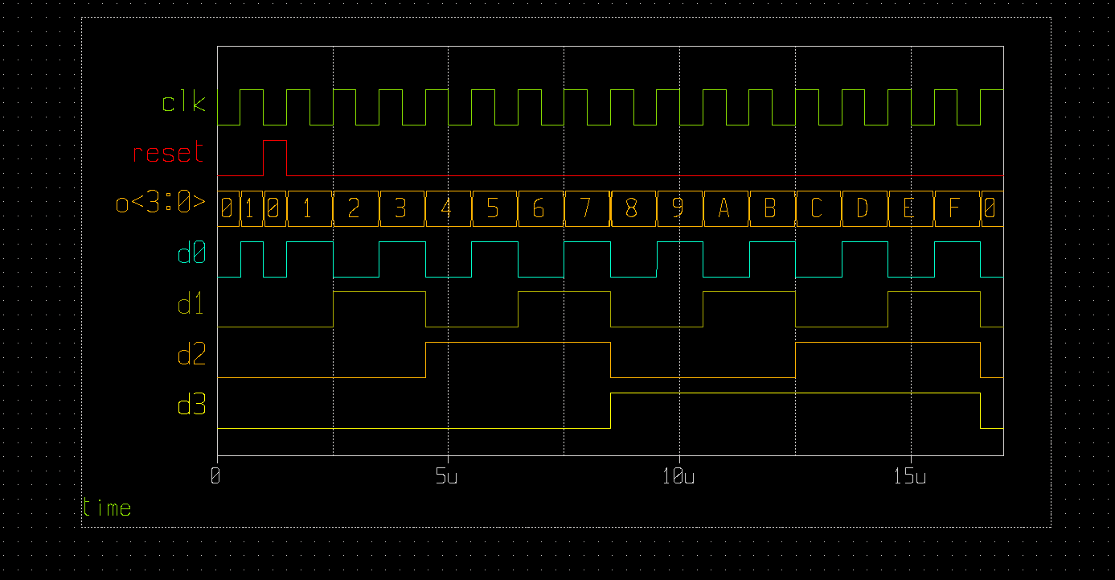
Cross checking with the gtk results in step 7 should match perfectly.

11. Example:

A good eample is located at:

~/mmsim/counter_top

This will produce all the plots shown throughout this doc.

This example can also be found on the below public repository in github:

https://github.com/SLICESemiconductor/OpenSourceTool_Examples/tree/main/Running_vlog_in_ngspice

12. Conclusion:

This shows the basic setup of creating a verilog file, verifying in a digital simulator (icarus) and converting to a form which ngspice will understand before re-running it inside there (through xschem). We can build from this example to make more complex ones but they should all follow this general flow. If and when you have issues, email the forum and Giles should pick up the ticket.

13. Add on:

To verify the verilated code will work with SW130 digital gates I connect the outputs to the below digital gates. These are just symbols, there is no schematic, all is contained within the cells (or something like that).

To use these cells include the below line:

.include /home/slice/pdk/SW130/share/pdk/sky130A/libs.ref/sky130_fd_sc_hd/spice/sky130_fd_sc_hd.spice

Note it is .include as opposed to .lib. Unsure exactly why but .lib errors out.

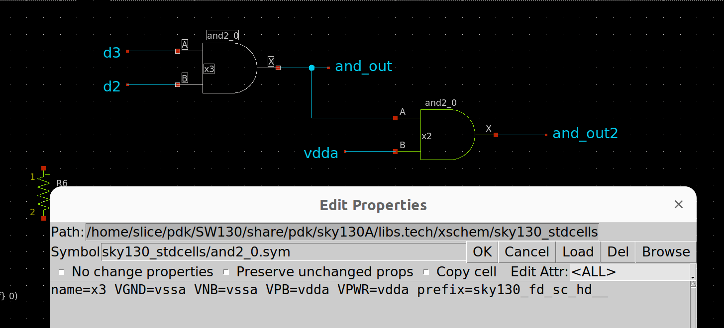
Everything worked out fine proving no issues with d2a’s between the verilated code and the digital gates.

14. Additional learnings from my LFSR experience:

I needed to create a 5b LFSR to run at 10GHz. The LFSR I built using iHP std cells was not nearly fast enough (could not go > 200MHz) since the std cells use quite large devices. Below documents how this was achieved as there was massive learnings from it w.r.t running co-sims.

14.1 Create .v code:

I got some basic prbs.v code online and hacked it to give me the required no of bits, and inverted outputs. Below is the code:

---------------------------------------------------------------------------------

module prbs_5 (
input clk,
input reset,
output reg d4,
output reg d4b,
output reg d3,
output reg d3b,
output reg d2,
output reg d2b,
output reg d1,
output reg d1b,
output reg d0,
output reg d0b
);

reg [4:0] shift_reg;

always @(posedge clk) begin
if (reset) begin
shift_reg <= 5'b00001; // Initial seed
end else begin
d4 <= shift_reg[4];
d4b <= shift_reg[4];
d3 <= shift_reg[3];
d3b <= ~shift_reg[3];
d2 <= shift_reg[2];
d2b <= ~shift_reg[2];
d1 <= shift_reg[1];
d1b <= ~shift_reg[1];
d0 <= shift_reg[0];
d0b <= ~shift_reg[0];
shift_reg[4:1] <= shift_reg[3:0];
shift_reg[0] <= shift_reg[4] ^ shift_reg[1]; // XOR feedback tap for PRBS5
end
end

endmodule

---------------------------------------------------------------------------------

This was saved in dir prbs_5_v5 as prbs_5_v5.v.

A variant of this code which also worked is:

module prbs_5_v4 (
input clk,
input reset,
output reg d4,
output reg d4b,
output reg d3,
output reg d3b,
output reg d2,
output reg d2b,
output reg d1,
output reg d1b,
output reg d0,
output reg d0b
);

reg [4:0] shift_reg;
reg [4:0] shift_reg_nxt;

always@(*) begin
// XOR feedback tap for PRBS5
shift_reg_nxt = {shift_reg[3:0], shift_reg[4] ^ shift_reg[1]};
end

always @(posedge clk) begin
if (reset) begin
shift_reg <= 5'b00001; // Initial seed
end else begin
shift_reg <= shift_reg_nxt;
end
end

always@(*) begin
d4 = shift_reg[4];
d4b = ~shift_reg[4];
d3 = shift_reg[3];
d3b = ~shift_reg[3];
d2 = shift_reg[2];
d2b = ~shift_reg[2];
d1 = shift_reg[1];
d1b = ~shift_reg[1];
d0 = shift_reg[0];
d0b = ~shift_reg[0];
end

endmodule
---------------------------------------------------------------------------------
This was saved in dir prbs_5_v4 as prbs_5_v4.v.

14.2 Compile .v code:

To compile the code I just typed:

iverilog -o dsn prbs_5_v4.v and verilog -o dsn prbs_5_v5.v from within their respective folders.

To make this step more efficient (as I regularily needed to compile) I created the below alias:

# Compile .v file using iverilog
alias ivcompile='iverilog -o dsn'

So could compile as:

ivcompile prbs_5_v4.v and ivcompile prbs_5_v5.v

Once compiled, if there are no errors, it will report nothing. If there are, it will report them.
After a successful compile, a dsn file is created as shown below:

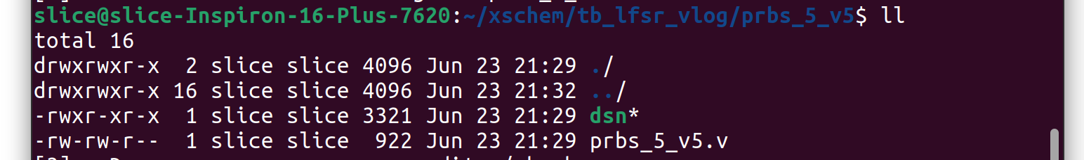
Note that previously I had said to create a tb to test the .v code where outputs could be viewed using gtkwave. Would have been handy and indeed best practice. However, my basic knowledge of verilog let me down here and I wasnt able to code up a tb so just went straight to xschem instead.

14.3 Verilate:

I went one dir above that where the .v file is and verilated wtih the following command:

ngspice vlnggen prbs_5_v4/prbs_5_v4.v and ngspice vlnggen prbs_5_v5/prbs_5_v5.v

Again, to make this step more efficient, I created the below alias:

# Verilate .v files i.e. create them to cpp models and output a .so file (must be run
# one level above the .v file)
alias verilate='ngspice vlnggen'

I had to re-verilate everytime the .v file was edited. Using the alias made this more efficient as it could be simply completed as:

verilate prbs_5_v4/prbs_5_v4.v and verilate prbs_5_v5/prbs_5_v5.v

Once completed successfully, you will see the relevant .so files in the dir where the verilate command was run. E.g. the below shows the prbs_5_v4 / v5.so files were created successfully.

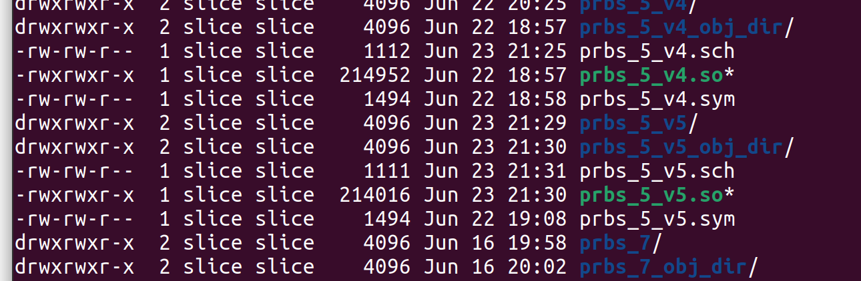
14.4 Setup PDK environment:

At this point we want to co-simulate the .so files with spice and so will be running all this using some sort of PDK. If that PDK is iHP you need to take care of the following:

The xschemrc file for iHP places all simulation results and netlists in a folder called simulations. This is good practice as it makes results / netlists easier to find. It does so, with the below setting on line #54.

set netlist_dir $env(PWD)/simulations

For some reason this is a problem with the cosim where results will not get written when it is done. You therefore, need to override this setting by placing the below line at any point after it:

set netlist_dir $env(PWD)

This means results / netlists will get written to the dir from where xschem is run. Things get a bit messy which is why I dont really like having to do it. Nevertheless it works and for the few tbs I will be running a cosim on, I am willing to put up with it. However, it would be a good idea to debug further in the future as most likely there is some simple setting to avoid all this.

Tip: In my custom xschemrc file I place the following line at the end of it:

# if running co-sim (in ihp) you need to uncomment the below to overwrite line #54. Not quite sure why but for some reason when results are saved in a simulations dir, outputs dont get written
set netlist_dir $env(PWD)

By default I comment it out the above line, as I like results / netlists being written to the simulations dir. Just means I need to remember to uncomment when running a cosim (which is where this doc becomes useful!)

14.5 Create schematic:

I created schematics prbs_5_v4.sch and prbs_5_v5.sch. Inside each I created inputs / outputs / noconns as shown:

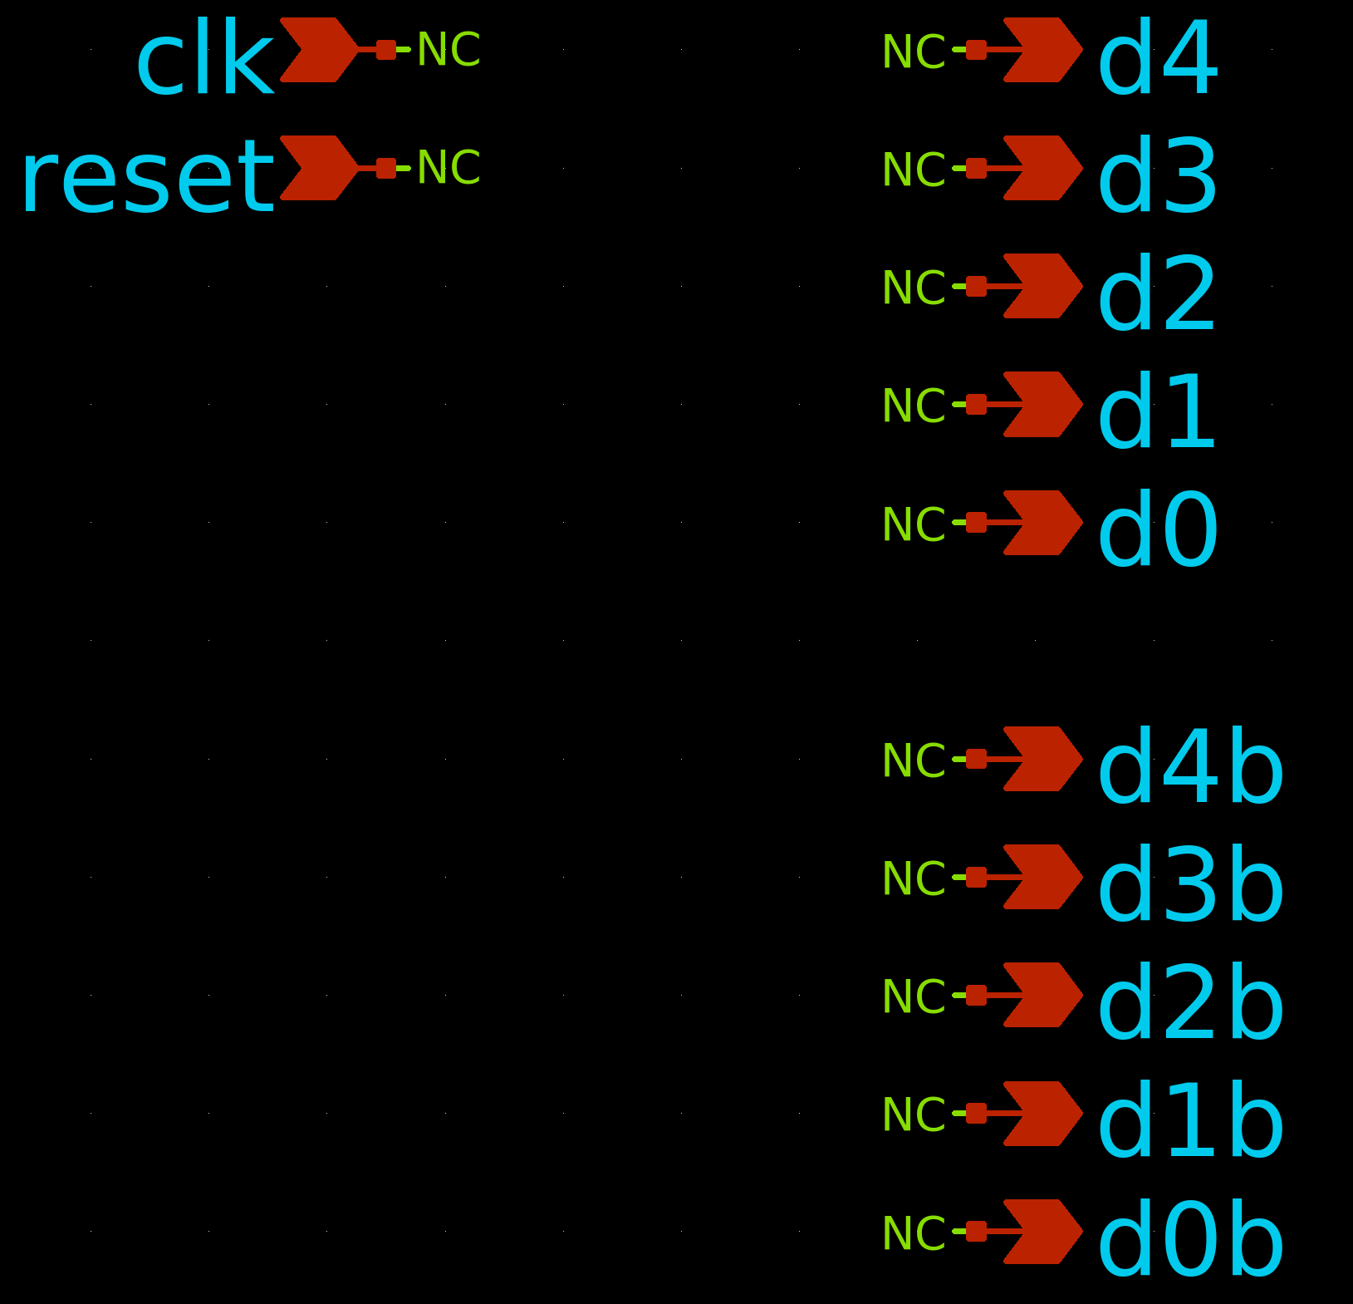

In each schematic, I ‘Q’ed and placed the following text:

adut [clk reset] [d4 d4b d3 d3b d2 d2b d1 d1b d0 d0b] null dut
.model dut d_cosim simulation="./prbs_5_v4.so"

What is extremely important to note here is the port order. It MUST match that of the original .v file. As you can see from the below thread, I initially included the below line:

adut [clk reset] [d4 d3 d2 d1 d0 d4b d3b d2b d1b d0b] null dut
.model dut d_cosim simulation="./prbs_5_v4.so"

Outputs were not correct since port orders did not match.

https://sourceforge.net/p/ngspice/discussion/133842/thread/b2a96200b6/

Obviously the above was only included in schematic prbs_5_v4.sch. For prbs_5_v5.sch I would have included:

adut [clk reset] [d4 d4b d3 d3b d2 d2b d1 d1b d0 d0b] null dut
.model dut d_cosim simulation="./prbs_5_v5.so"

14.6 Create symbol:

Create symbol as normal by pressing ‘a’. As a measure of good practice, I manually order all the ports starting with inputs to outputs. You dont need to do this however, but if you want to, simply select a port with ‘shift + s’ and enter the required port order number.

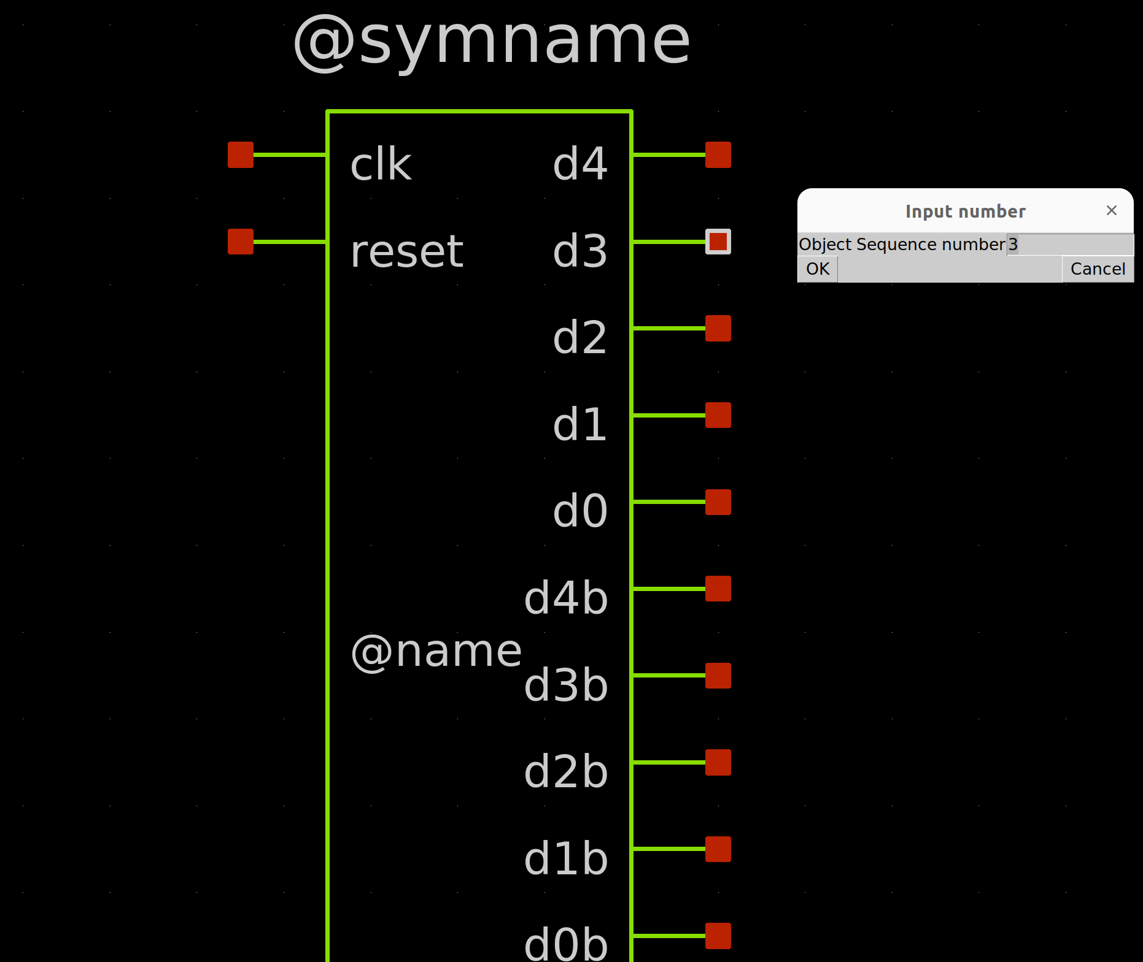

14.7 Netlist and check:

Checking the netlist showed:

If I really wanted to be pedantic here, I would have ordered the ports in the symbol to match that of the .v file (e.g. d4 = sequence number 2, d4b = sequence number 3 and not d3 = sequence number 3).

Confirm the port order in the below code at the end of the netlist:

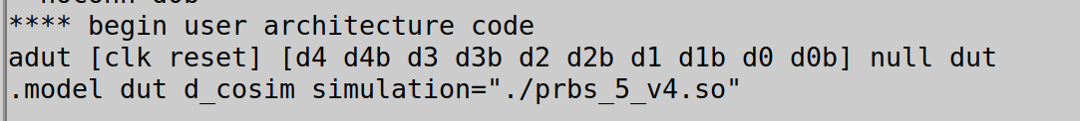

14.8 Include the dac bridge:

You are outputting digital values (1 or 0) from a .v (or more specifically a .so) file. These need to be converted to analog voltages in order to be useable in a spice environment. For this you need to include a dac_bridge. These are described in section 8.3.1 of the manual and are automatically inserted by ngspice. The problem however with automatic insertion is it will use the default values which most likely will not correspond to what you want. It is therefore advisable to specifically include a line like the below, to set the required values.

.model auto_dac dac_bridge(out_low = 0 out_high = 1.8 t_rise = 10p t_fall = 10p)

E.g. The above specifies the DAC to output 0V low voltages, 1.8V high voltages with 10ps rise and fall times.

Arguable if the above is thorough enough since it does leave some default values. In order to set all values, use something like below:

.model dac1 dac_bridge(out_low = 0.7 out_high = 3.5 out_undef = 2.2 input_load = 5.0e-12 t_rise = 50e-9 t_fall = 20e-9)

This example is taken directly from the manual and sets the low voltage at 0.7V and high voltage at 3.5V. Input load is set to 5ps with rise time at 50ns and fall time at 20ns. The out_undef sets the output voltage if the input = ‘U’ (input to DAC can be either 0 / 1 / U). I havent encountered a ‘U’ input yet in practice.

Finally, this .model line must be included before the .control statement, something like below:

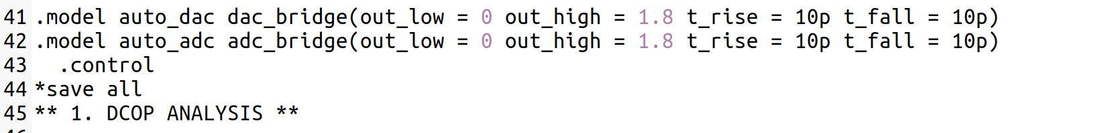
When you netlist, it is useful to verify the dac_bridges (and adc_bridges if any are requried) are placed in the correct places. To enable you to do this, place the line:

listing e

At the end of the stim file (below setplot).

14.9 Setup verilog outputs:

If the outputs are going directly to spice gates you can ignore this step. If not going anywhere, and you want to view them, you will need to place a cap on them so that ngspice will automatically place the dac_bridge on the outputs (cap is analog so needs a dac_bridge inserted). Doing this will allow you to check the waveforms on unused nets to verify the bridge settings / .v code.

Note: The reason you dont need to do this on any nets going directly to a spice element (transistor / gate / etc) is the tool will recognise the need for a transision between .v to spice at this connection point and automatically insert a dac bridge.

In the below, I had nothing connected to any of the below outputs. So to allow me to analyse them I simply placed 1fF on each of them to effectively tell the tool to create dac_bridges between the .v outputs and the caps.

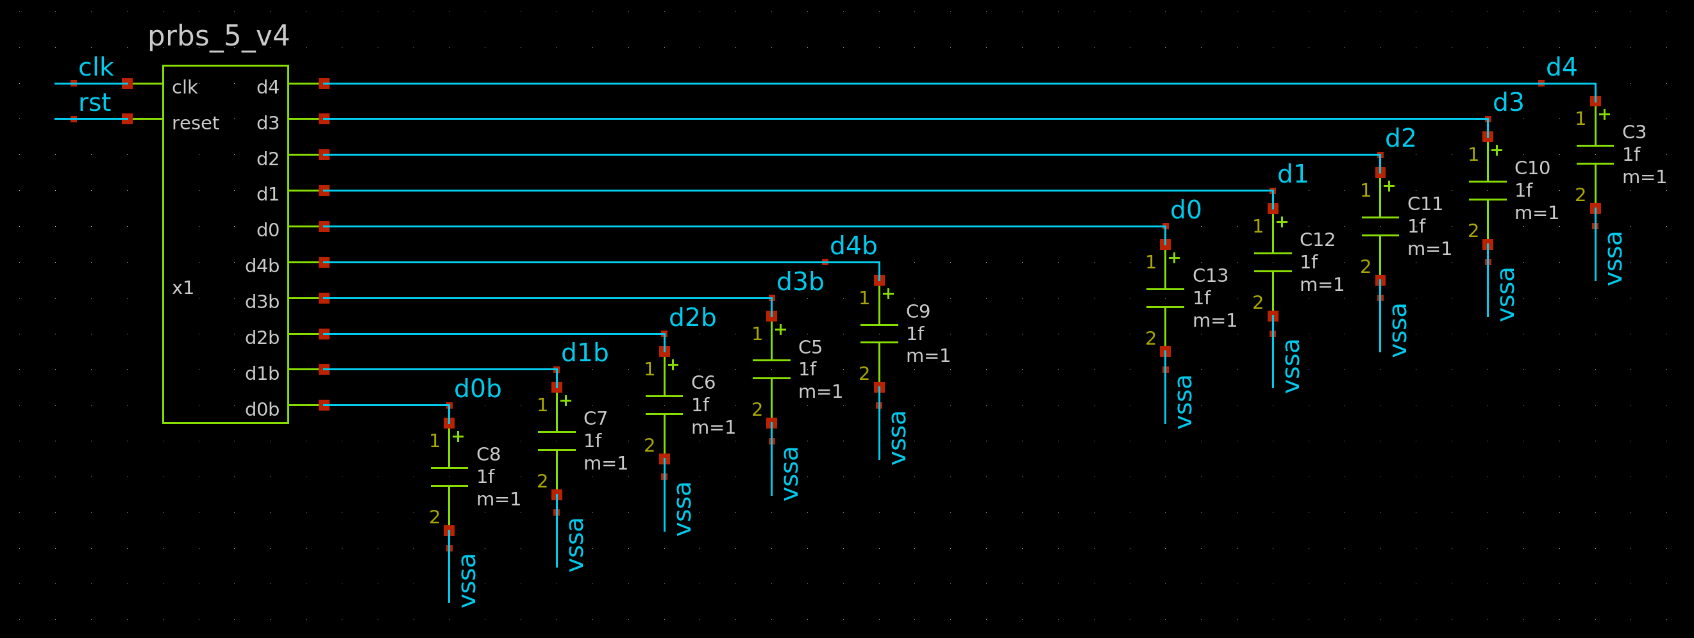
14.10 Netlist and sim:

Netlist again. This time checking the DAC has been correctly netlisted.
When you simulate, because you included the line “listing e” at the end of the stim file (as described in section 14.8) you can verify where the dac_bridges have been placed.

In the below example, we are happy as the dac_bridges have been placed on all the .v outputs.

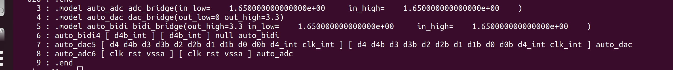
Then, assuming you saved the correct nodes (saved as v(node_name) instead of just node_name since they are analog voltages now), you can simply plot them.

When plotting these, I typically use the digital option in the xschem waveviewer.

E.g. In the stim file I placed the following:

.save v(d4) v(d3) v(d2) v(d1) v(d0) v(prbs) v(d4b) v(d3b) v(d2b) v(d1b) v(d0b)

This allowed me to plot all the outputs from my .v block as:

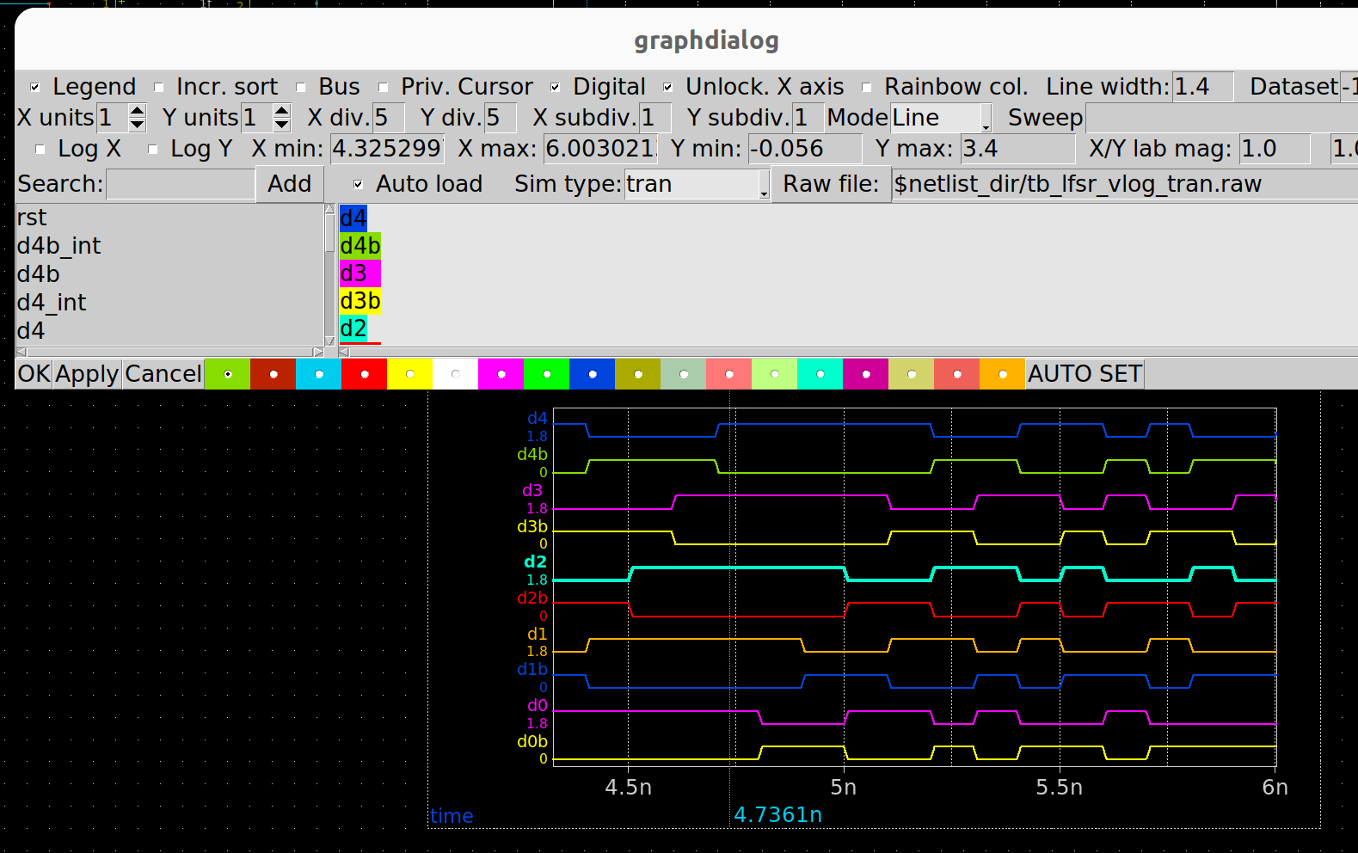
And thats it! May seem long winded but that is just because I have documented every detail very thoroughly and repeated to some extent previously documented steps (just to have everything in the one place). In practice, once you run through the flow a couple of times you will find it very seamless and quick. In the end, I was editing .v files / verilating / simulating in a turn around time of secs to mins. What is really good about these later learnings is they really cover most aspects of cosim so should equip the reader with very broad applicability w.r.t all this. They also very the whole cosim to be robust and reliable to a fairly involved testcase. Therefore, confidence of this cosim capability is high.

