Sunrise D/A interfacing
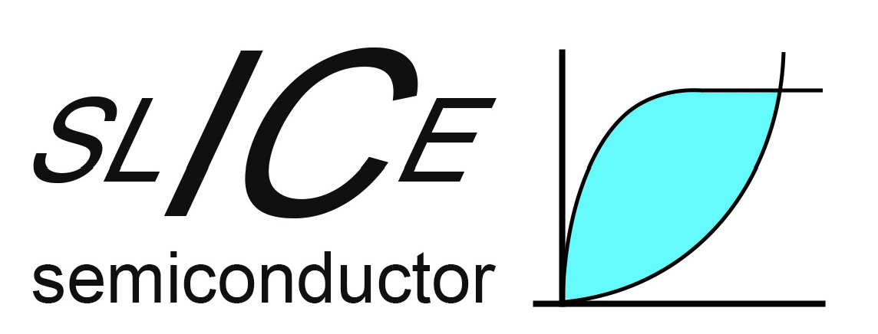
Project developed by: SLICE Semiconductor
Project funded by: nlnet foundation
Document ID: Sunrise D/A interfacing
Created by: Diarmuid Collins
Date created: 25/05/2026
Date modified: 14/06/2026
Revision: B
Valid from | 18.03.2025
Table of Contents
1 General information 2
2 Digital control 2
3 Start up sequence 4
4 Readiness 5
5 Top level floorplan 5
6 Digital macro requirements 6
7 Risk mitigation 6
8 Revision History 6

General information

Interfacing the digital with the analog (D/A) is the riskiest part of sunrise (and indeed most ASICs). Chips typically don’t fail post tapeout due to opamps or high performance blocks, they fail due to incorrect interaction between D/A blocks (e.g. unclear requirements, incorrect power up sequence, poor level shifters). To avoid what can often be trivial errors which lead to full chip functional failure, an entire document has been assigned to clearly define this interface for sunrise (required signals from digital, power on sequence, level shifters used).

Digital control

Digital interaction with the analog is shown in Figure 1.

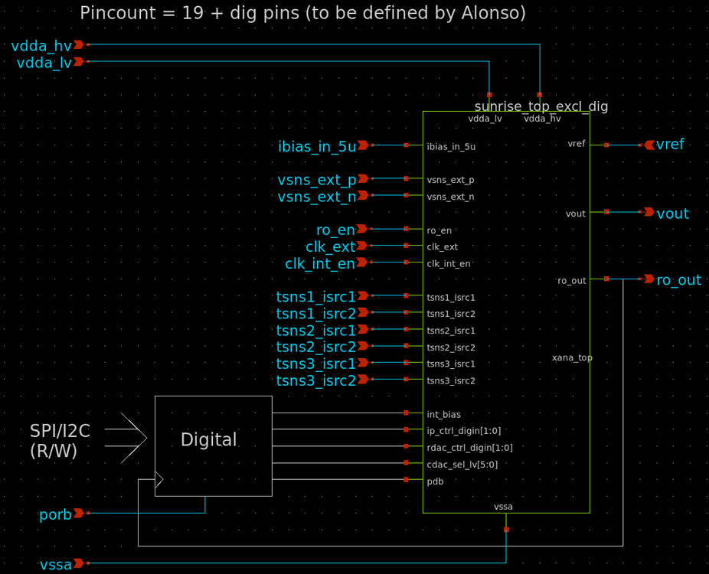
Figure 1 D / A interface
As shown, a total of 12 signals are required from the digital. These are detailed in Table 1.

Dig ctrl | Description | Default
int_bias | Sets INA bias: 0 = external bias, 1 = internal bias | 0 (external bias)
pdb | Pd signal for the analog domain: 0 = power down, 1 = power up | 0 (power down)
ip_ctrl_digin[1:0] | Mux in inputs: 0 = external sense, 1,2,3 = internal temp sensors | 0 (external sense)
rdac_ctrl_digin[1:0] | Sets INA gain: 0 = 1, 1 = 5, 2 = 11, 3 = 21 | 0 (Av = 1)
cdac_sel_lv[5:0] | Trims the ring osc | 000000 (fmax)

Table 1: Digital signals to the analog
As shown in Figure 2 and Figure 3, these inputs are configured in block “sunrise_logic_wlvl_shft” (contained in “sunrise_top_excl_dig”), where they are then level shifted to 3v3 before being sent to the INA.

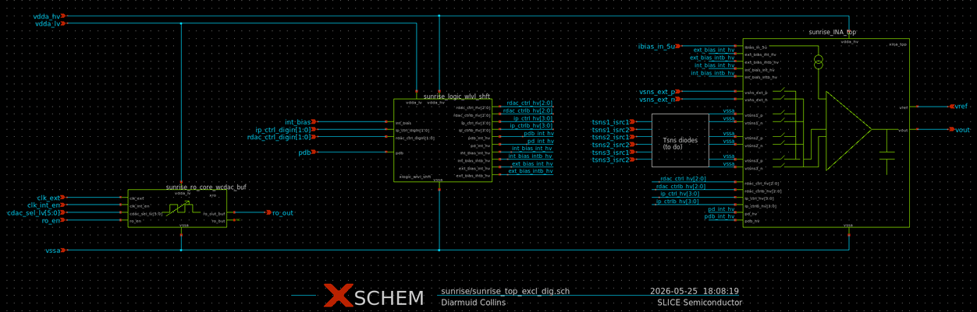
Figure 2 sunrise_top_excl_dig
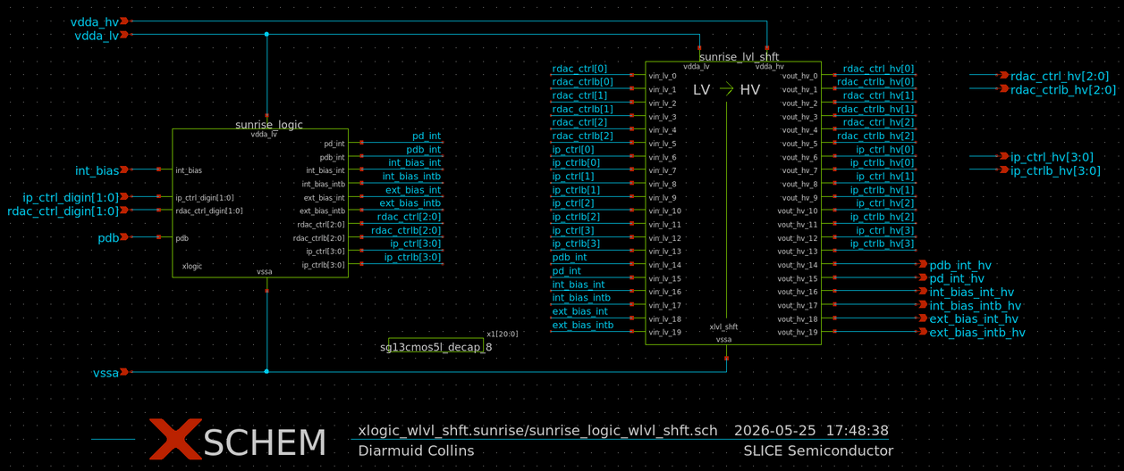
Figure 3 logic reconfiguration + level shifting

Start up sequence

Start up sequence is shown in Figure 4.
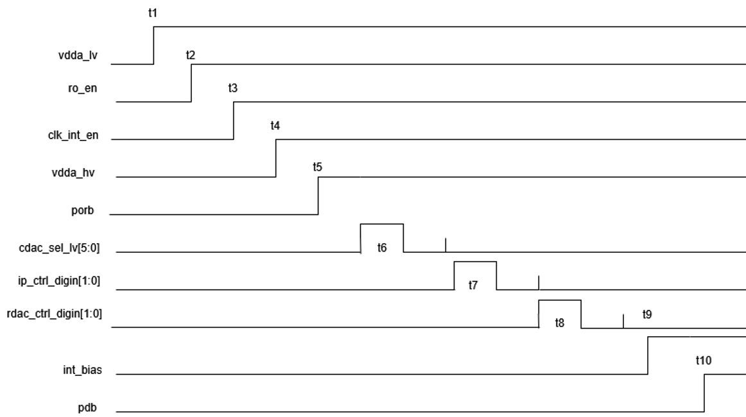
Figure 4 Startup sequence waveforms
Each time point is detailed in Table 2
Time point | What happens | Description | Comment
t1 | vdda_lv ramps | Bring up the digital supply
t2 | ro_en asserts | RO starts oscillating
t3 | clk_int_en asserts | RO passes to the output / digital | If RO is not working, apply an external clk and set clk_int_en = 0
t4 | vdda_hv ramps | Bring up the analog supply | Vdda_hv must come up after vdda_lv as level shifters have no reset
t5 | porb asserts | Digital comes out of power on reset | Up to this point all digital o/p’s = 0
t6 | Program cdac_sel_lv[5:0] | Tune the RO 10MHz | Programmed through SPI / I2C
t7 | Program ip_ctrl_digin[1:0] | Select the input to be sensed by the INA | Programmed through SPI / I2C
t8 | Program rdac_ctrl_digin[1:0] | Set the gain of the INA | Programmed through SPI / I2C
t9 | Set int bias | If using internal bias, int_bias = 1, if using external bias, int_bias = 0 | External current source must only be turned on after int_bias = 0, or not at all
t10 | Assert pdb | Take the analog out of reset | Since bias has been applied and all config bits set, analog can now be used

Table 2: Time point descriptions throughout the startup sequence

Readiness

Block “sunrise_logic_wlvl_shft” has been thoroughly verified with level shifter performance guaranteed across PVT.
Block layout is also complete - DRC / LVS clean and passing PEX. Layout is shown in Figure 5 (footprint = 140x40um).
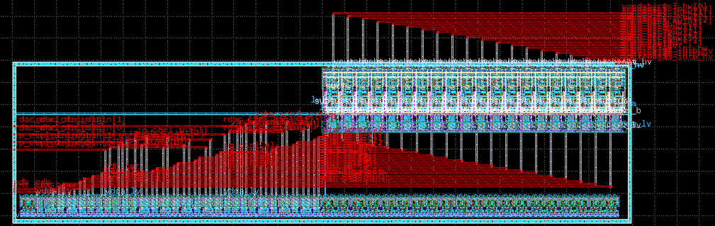
Figure 5 Layout of sunrise_logic_wlvl_shft

Top level floorplan

ASIC top level at time of writing is shown in Figure 6.
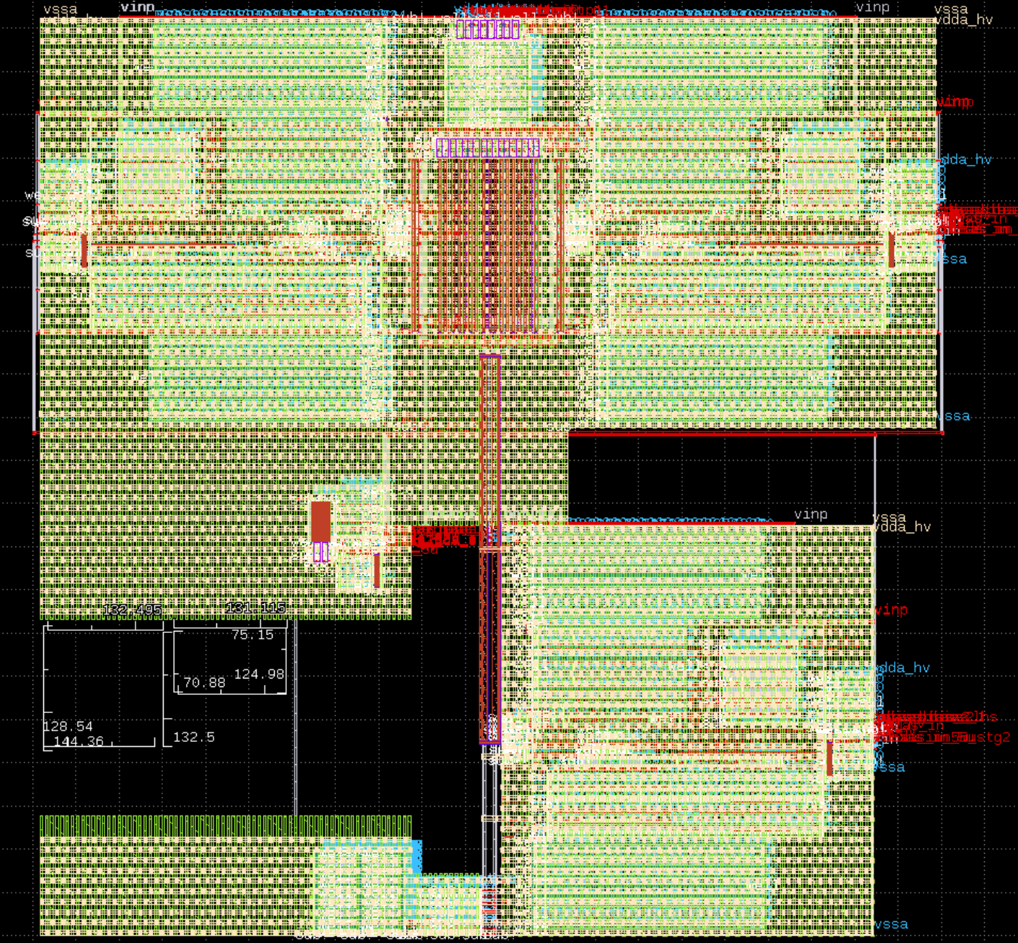
Figure 6 ASIC top level
Digital macro to be inserted in the 130x130um footprint shown as the orange box (note there is space for footprint to grow > 130x130um). Outputs from this will travel vertically in M2 to sunrise_logic_wlvl_shft in the blue box, whose outputs will be buffered around the chip (sunrise_logic_wlvl_shft and top level buffering will be implemented on ~ 16/06).

Digital macro requirements

Below summarizes the requirements for the final gds delivery of the digital macro:
- All outputs (see Table 1) exit at the top or right side of the block
- All output pins to be in M2
- Block routing to follow pattern of even metals = vertical, odd = horizontal (e.g. M2 = vertical, M3 = horizontal)
- Top 2 metals (M4, TM1) not to be used for signal routing
- Bock to be delivered with power / gnd straps on M4 / TMI
- Input pins to the block to be placed on the left hand side / bottom
- All input pins to be in M3
- Block to output c2p_en for control of the tristate IO’s
- Block to be delivered by 21.06 for instantiation into the top level on 22.06
- Block must be DRC clean (excl. density checks)

On the last point, I assume it will be DRC clean since it is output from the Librelane flow but I will check anyways.

Risk mitigation

As documented at: https://github.com/SLICESemiconductor/Sunrise/blob/main/digital/docs/dft.md

Revision History

Rev. | Date | Author | Changes, Remarks
A | 25.05.2026 | Diarmuid Collins | Created
B | 14.06.2026 | Diarmuid Collins | Added floorplan + digital macro requirements
Table 3: Revision history

