Sunrise Pinlist / Padring
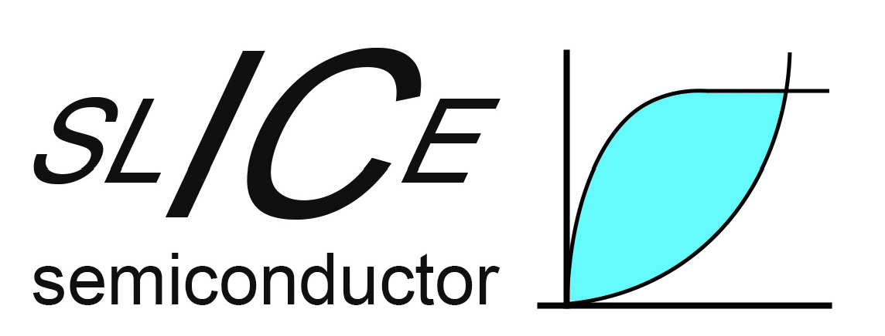
Project developed by: SLICE Semiconductor
Project funded by: nlnet foundation
Document ID: Sunrise Pinlist * Padring
Created by: Diarmuid Collins
Date created: 26/06/2026
Date modified:
Revision: D
Valid from | 18.03.2025
Table of Contents
1 General information 2
2 Pinlist 2
3 Padring 3
4 Revision History 4

General information

This document defines the top level pin list and padring for Sunrise.

Pinlist

Full pinlist of the ASIC is shown in Table 1.

# | Name | Description | IO Type | Domain | Value
1 | SPI_CPOL | Mode select (or rdac_ctrl[1]) | IP | Digital | 0 / vdda_hv
2 | SPI_CPHA | Mode select (or rdac_ctrl[0]) | IP | Digital | 0 / vdda_hv
3 | I2C_SCL | I2C serial clock lin (or cdac_sel[4]) | IP | Digital | 0 / vdda_hv
4 | I2C_SDA_O | I2C data out | TRI | Digital | 0 / vdda_hv
5 | I2C_SDA_I | I2C data in (or cdac_sel[3]) | IP | Digital | 0 / vdda_hv
6 | SPI_nCS | SPI chip select (or INA pd) | IP | Digital | 0 / vdda_hv
7 | SPI_SCLK | SPI serial clock line (or int bias) | IP | Digital | 0 / vdda_hv
8 | SPI_MOSI | SPI MOSI data line (or ip_ctrl[1]) | IP | Digital | 0 / vdda_hv
9 | SPI_MISO | SPI MISO data line | TRI | Digital | 0 / vdda_hv
10 | SPI_MISO_CTRL | SPI MISO tri-stat ctrl bypassl (or ip_ctrl[0]) | IP | Digital | 0 / vdda_hv
11 | CLK_EXT | External clock | IP | Digital | 0 / vdda_hv
12 | RO_OUT | RO output | OP | Digital | 0 / vdda_hv
13 | CLK_INT_EN | Pass RO o/p to digital | IP | Digital | 0 / vdda_hv
14 | RO_EN | Enable the RO | IP | Digital | 0 / vdda_hv
15 | VTSNS2_N | Temp sensor bias | ANA | Analog | 1 / 10uA
16 | VTSNS2_P | Temp sensor bias | ANA | Analog | 1 / 10uA
17 | VREF | Voltage VOUT is referred to | ANA | Analog | 0 – Vref_max
18 | VOUT | INA output | ANA | Analog | 50mV – 3.3-50mV
19 | VSSD | Digital ground | Supply | Digital | 0V
20 | VDDA_LV | Low voltage supply | PWR | Digital | 1.2 – 1.5V
21 | IBIAS_IN_5U | External bias | ANA | Analog | 5uA
22 | INT_BIAS | Sense int_bias internal signal | OP | Digital | 0 / vdda_hv
23 | PORB | Power on reset (active lo) | IP | Digital | 0 / vdda_hv
24 | SERIAL_SEL | Select between SPI and I2C (or cdac_sel[5]) | IP | Digital | 0 / vdda_hv
25 | TEST_MODE | Repurpose SPI / I2C controls as direct i/p’s | IP | Digital | 0 / vdda_hv
26 | VSSA | Analog ground | GND | Analog | 0V
27 | VDDA_HV | High voltage supply | PWR | Analog | 3.3V
28 | VSNS_EXT_N1 | External sense (-ve) | ANA | Analog | 0.9 – Vcm_max_n
29 | VSNS_EXT_P1 | External sense (-ve) | ANA | Analog | 0.9 – Vcm_max_n
30 | VTSNS1_N | Temp sensor bias | ANA | Analog | 1 / 10uA
31 | VTSNS1_P | Temp sensor bias | ANA | Analog | 1 / 10uA
32 | VSNS_EXT_N2 | External sense (-ve) with 260Ω CDM protection | ANA | Analog | 0.9 – Vcm_max_n
33 | VSNS_EXT_P2 | External sense (+ve) with 260Ω CDM protection | ANA | Analog | 0.9 – Vcm_max_p
34 | I2C_ADDR[0] | Address (or cdac_sel[0]) | IP | Digital | 0 / vdda_hv
35 | I2C_ADDR[1] | Address (or cdac_sel[1]) | IP | Digital | 0 / vdda_hv
36 | I2C_ADDR[2] | Address (or cdac_sel[2]) | IP | Digital | 0 / vdda_hv

Table 1 Top level pinlist

As shown, the ASIC will occupy 35 pins + 1 spare. The spare pin is included as final ASIC will fit into a 36QFN package (provided by Serma).
As shown, VSNS_EXT_P/N inputs can vary between 0.9V and Vcm_max_p/n where:
$$V_{cm_{maxp}}= vdda_{hv}-50mV-Av_{nia}∆v_{in}…(1)$$
$$V_{cm_{maxn}}= V_{cm_{maxp}}- ∆v_{in} …(2)$$
As shown, VREF can vary between 0 and Vref_max where:
$$V_{refmax}=vdda_{hv}-50mV-Av_{ina}∆v_{in}…(3)$$
Note: In (1), $Av_{nia}$ = gain of the non-inverting loop. In (3), $Av_{ina}$ = gain of the INA. In (1) and (3), 50mV represents the margin from the supply rails which vout can swing.
All the digital pins (apart from the Tristate ones) can be repurposed as direct control inputs. The direct control corresponding to each input is shown in italics in the description.
All digital inputs will use the “digital_in” IO.
All digital outputs will use the “digital_out” IO.
All digital tristate pins will use the “digital_io” IO. The c2p_en inputs to these IO’s will be controlled by the digital logic.

Padring

Padring is shown in Figure 1.
Note that pin locations are driven mainly by layout floorplan.

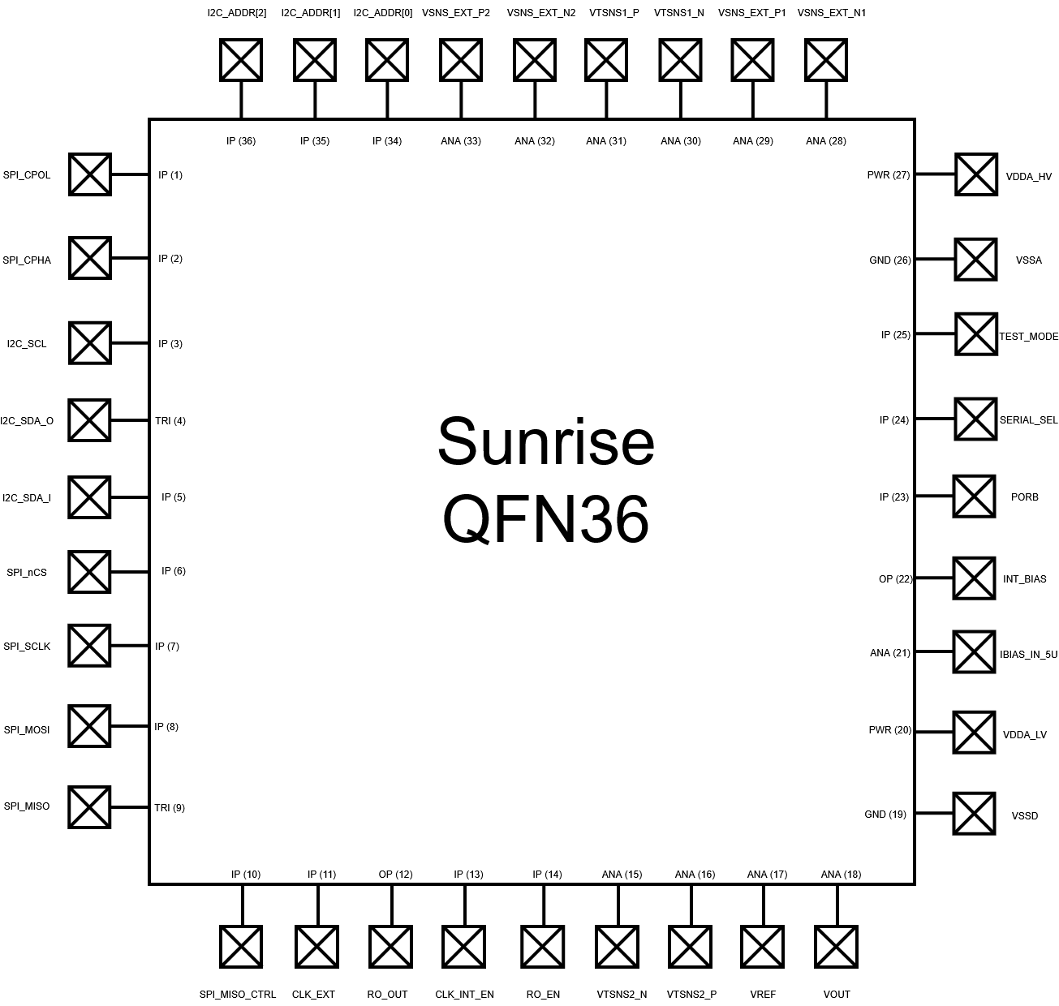
Figure 1 Sunrise padring

Revision History

Rev. | Date | Author | Changes, Remarks
A | 13.06.2026 | Diarmuid Collins | Created
B | 22.06.2026 | Diarmuid Collins | Re-arranged pinlist / padring
C | 23.06.2026 | Diarmuid Collins | Re-arranged ro_en / spare pins to avoid antenna violations
D | 26.06.2026 | Diarmuid Collins | Re-arranged digital pins / corrected typos
Table 2: Revision history

