Assuming ascending array of 7 elements. This code is modeled after the algorithm in the lectures.

We use this code to generate the indentation. This was earlier submitted as part of the Practical in Quick Sort, however I modified this to show the indentation.

We use the SortsTestHarness to call upon this by typing the command ```java SortsTestHarness 7 qa``` And we use the leftmost pivot.

P.T.O for the output.

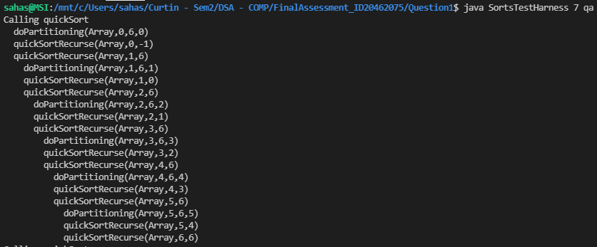

The indent from line 1 to line 2 can be ignored. Afterwards, the indenting shows the depth of recursion that it is in.

Code has been attached to this directory.