# REST API, Web Client, Sensor App Installation

## Installation steps :

Step 01 : Head to the GitHub Repository <https://github.com/SLIIT-DS/DS-Assignment-2_yr3_sem1.git> and go to the branch “***Jayagoda”***  and get a clone of the repository Jayagoda branch.

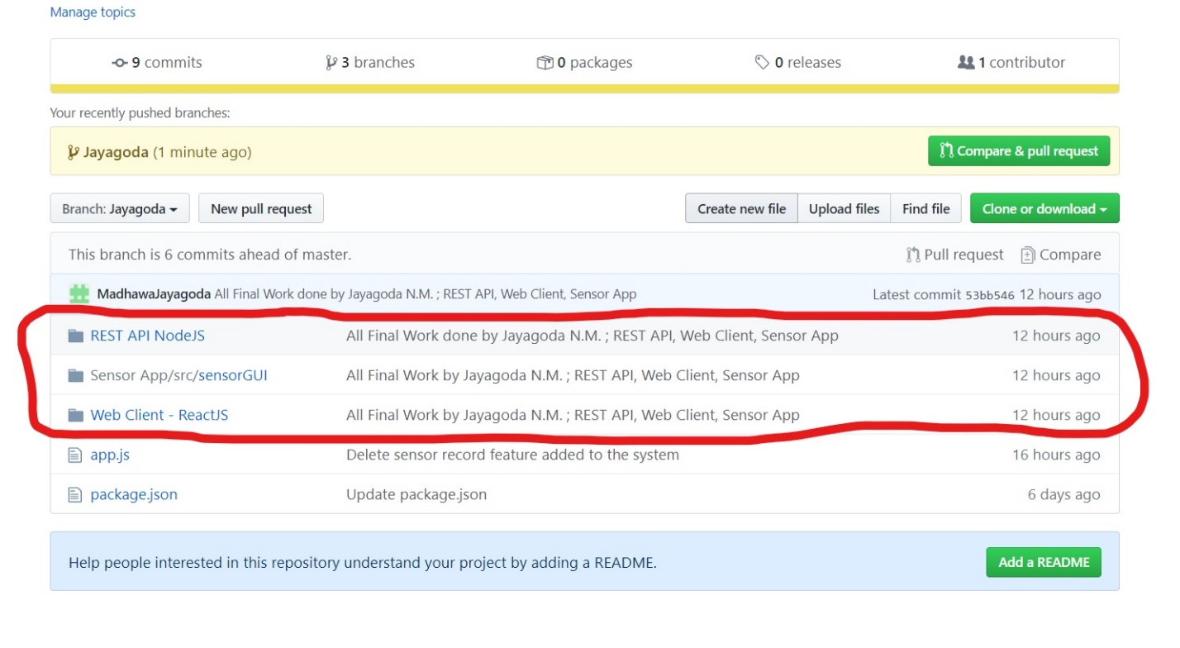

Step 02 : Download the files marked in red in the above diagram : REST API NodeJS, Sensor App, and Web Client – ReactJS .

Step 03 : Create the database in MySQL as follows :

Note that the Database name should be “**fire_alarm**” and the table name should be “**sensors”.**

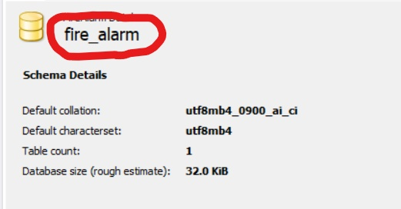

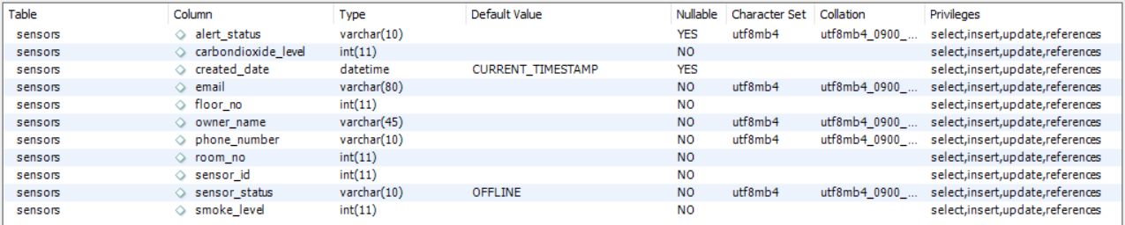

Also make sure to add the column names as it is in the above diagram.

Step 04 : Import the REST API NodeJS into a new project in WebStorm, install all the dependencies using the ‘npm install’ command and run the project using the app.js file. ( Make sure to run the Server first before the Sensor app or the Web Client )

Step 05 : Import the Sensor App to a new project in Eclipse, and run the project as a Java Application. Before executing the project, make sure to import all the necessary jar files needed.

Note that some .jar files are added externally to the build path.

Step 06 : Import the Web Client – ReactJS into a new project in WebStorm in a new window. Download all the dependencies using the command ‘npm install’. Then run the project using the command ‘ npm start ’.

* If any queries, **Contact**: Jayagoda N.M. **email**: [nipunajayagoda@gmail.com](mailto:nipunajayagoda@gmail.com)

# RMI installation

Step 01 : Go to GitHub DS organization and open the branch , Thilini : <https://github.com/SLIIT-DS/DS-Assignment-2_yr3_sem1.git>

Step 02 : Then download RMIDesktopClient zip file and extract it.

Step 03 : Open netbeans and import RMIDesktopClient project.

Step 04 : Make sure the libraries are imported properly.If not import the missing libraries.

Step 05 : Next run the RMI fireAlarmServer first.

Step 06 : Then start RMI client ( Home.java ) to launch desktop application.

# Email Service installation

Step 01 : Go to Git hub DS organization and open branch name thilini.

Step 02 : Then download MailApp zip file and extract it.

Step 03 : Open the webstorm or any other suitable software and import extracted MailApp.

Step 04 : Then right click the MailApp and open terminal and go to the relevant correct path.

Step 05 : Install all dependencies using "npm install" command.

Step 06 : Give command as "nodemon sever"

* If any queries, **Contact**: J.L. Thilini Randika **email**: [thilinijayasekara97@gmail.com](mailto:thilinijayasekara97@gmail.com)
* If any queries, **Contact**: I.G. Hansani Yasodya **email**: hansaniyasodya@gmail.com