SE4041 – Mobile Application Design and Development
Spot Saver
Assignment 02 – Part A: Advanced iOS App Report

Student name | Asan M A M
Student ID | IT22253262
Module | SE4041 – Mobile Application Design and Development
Assessment | Assignment 02, Part A – Advanced iOS App (15%)
Platform | iOS 26 · SwiftUI · SwiftData · MapKit
Repository | github.com/SLIIT-IM-Y4S2/it22253262-spot-saver-ios
Date | 15 October 2026

Contents
1. Purpose and target audience 3
The problem 3
The solution 3
Target audience 3
2. User guide 4
2.1 First launch 4
2.2 Browse the map 5
2.3 Save a new spot 6
2.4 Find spots in the list 7
2.5 Spot details, directions and visits 8
2.6 Dark Mode and landscape 9
3. Technical documentation 11
3.1 Architecture 11
3.2 Project structure 11
3.3 Data persistence 11
3.4 Emerging technology: MapKit and CoreLocation 12
3.5 Custom components and modifiers 12
3.6 Build and run 12
4. Design decisions 13
4.1 Visual design and branding 13
4.2 Animations and gestures 13
4.3 Accessibility and adaptive layout 13
5. Testing and performance 15
5.1 Unit tests (Swift Testing) 15
5.2 UI tests (XCUITest) 15
5.3 User acceptance testing 15
5.4 Performance optimisations 16
6. Challenges and reflections 17
6.1 Development challenges 17
6.2 Reflections 17
6.3 AI-assisted development 17
6.4 References 17

1. Purpose and target audience
Spot Saver solves a small but constant problem: people find a good café, a quiet study corner or a free parking lane, then forget exactly where it was or why they liked it.

The problem
- General map apps show every business, not the places you rated, and their saved lists hold no personal notes or visit history.
- Notes apps keep the text but not the location, so getting back to the place takes a second app.
- Photos of a place have a location but no rating, category or comment.

The solution
Spot Saver puts all of this in one place: a pin on a map with a category, a 0–5 star rating, notes, a photo, the address and a visit history. One tap gives walking or driving directions through Apple Maps.

Target audience
Group | Why the app fits them
University students (primary) | Constantly look for study spots, cheap food and parking around campus; the sample data is built around SLIIT Malabe
People new to a city | Need to remember useful places quickly while still learning the area
Commuters and drivers | Save reliable parking and stop-off points, then navigate back with one tap

The design choices follow from this audience: one-handed use on a phone, a long-press to save a place in under five seconds, large readable text, and full offline storage so saved spots work without data.

2. User guide
The app has two tabs, Map and Spots; every task below starts from one of them and takes three taps or fewer.

2.1 First launch
On first launch the app asks for location access, with a message explaining why. Choosing Allow While Using App enables "Nearest" sorting and centres the map on you. The app still works if you choose Don't Allow; the map then opens on SLIIT Malabe.
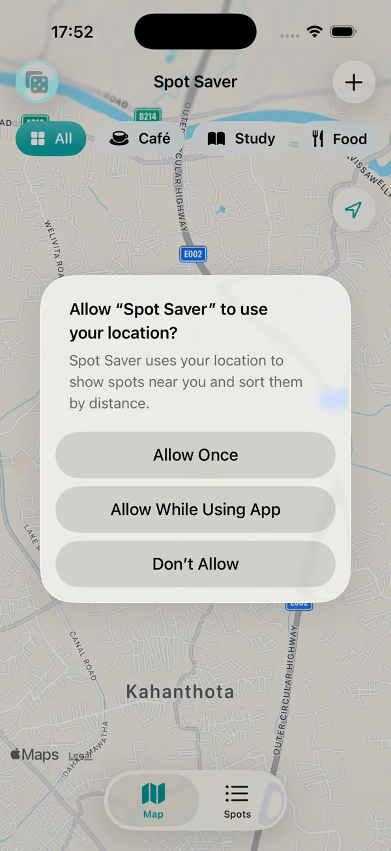
Figure 1 – Location permission prompt on first launch
If the list is empty, tap Spots → Load Sample Spots to add four demo places around campus.

2.2 Browse the map
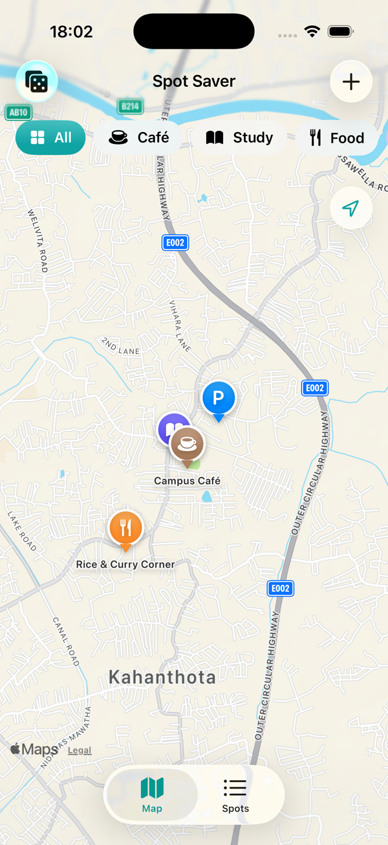
Figure 2 – Map screen with category chips and pins
1. Each saved spot is a coloured pin; the colour and icon show its category.
2. Tap a chip (All, Café, Study, Food, Parking, Other) to show only that category.
3. Tap a pin to see a summary card with the name, address and rating. Tap the card to open the full details, or × to close it.
4. Tap the dice button (top left) for Surprise Me: the map flies to a spot you have not visited for two weeks or more.
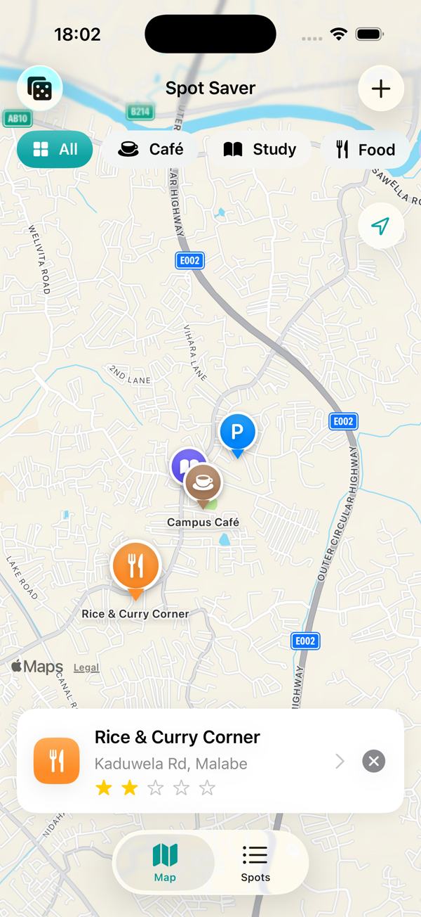
Figure 3 – A selected pin with its summary card

2.3 Save a new spot
1. Long-press anywhere on the map, or tap +.
2. Enter a name and choose a category. Tap or drag across the stars to rate it.
3. The address fills in automatically. Tap the small map to move the pin if needed.
4. Optionally add a photo, notes, and mark it as a favourite.
5. Tap Save. Save stays disabled until the spot has a name.
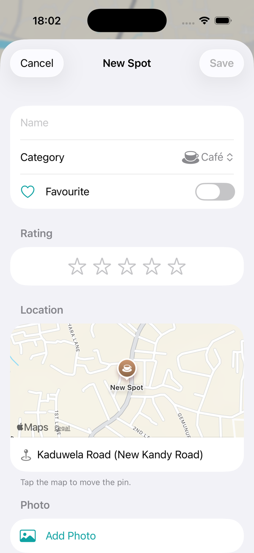
Figure 4 – New Spot form

2.4 Find spots in the list
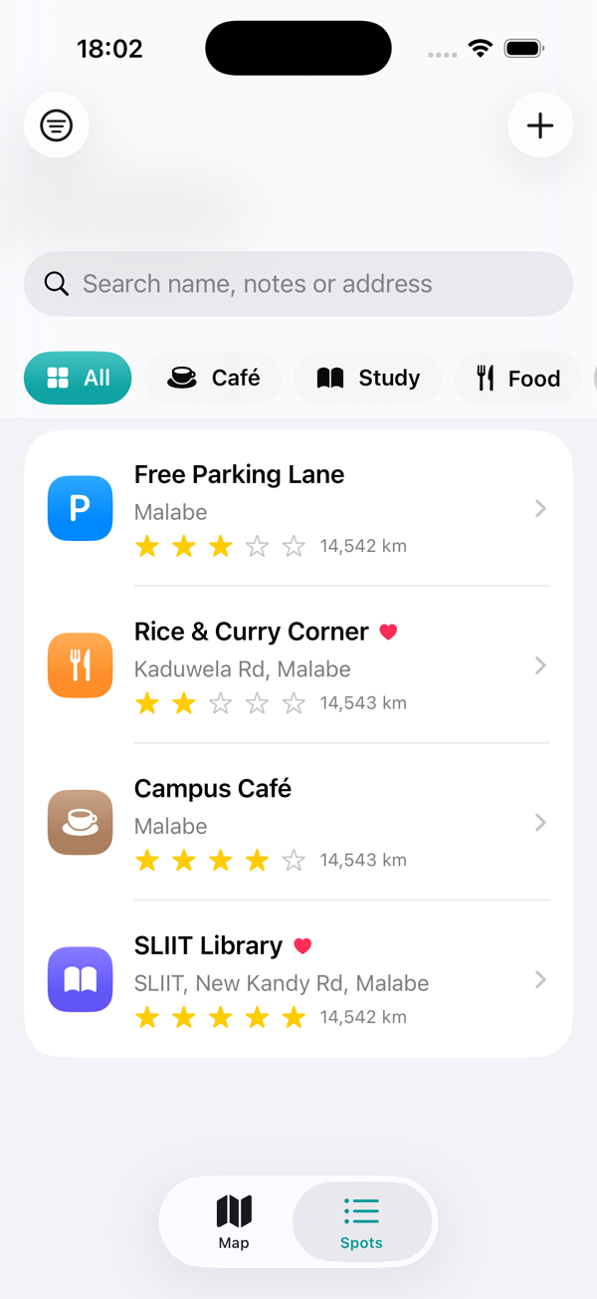
Figure 5 – Spots list with search and category chips
- Type in the search bar to match names, notes or addresses.
- Use the filter button (top left) to sort by Newest, Top Rated, Name or Nearest, or to show favourites only.
- Swipe a row left to delete it, or right to mark it as a favourite.

2.5 Spot details, directions and visits
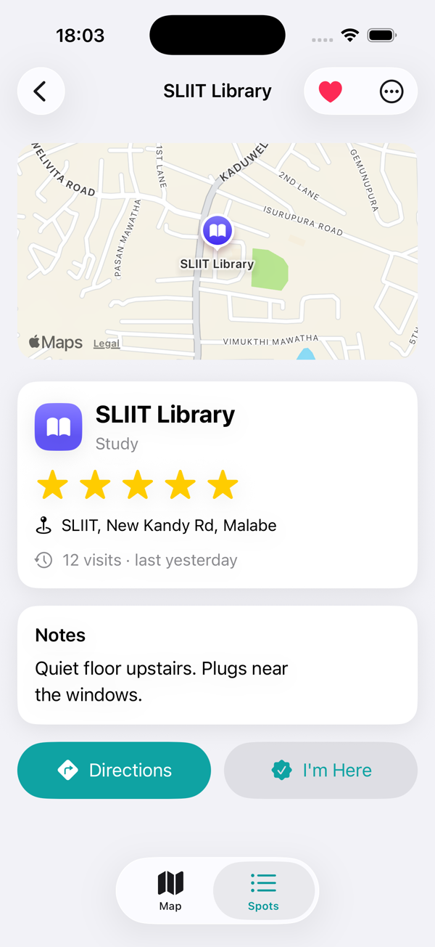
Figure 6 – Spot detail screen
- Directions opens Apple Maps with a route to the spot.
- I'm Here records a visit; the card shows the visit count and when you were last there.
- Tap the heart to favourite it. The … menu has Edit and Delete; delete asks for confirmation.
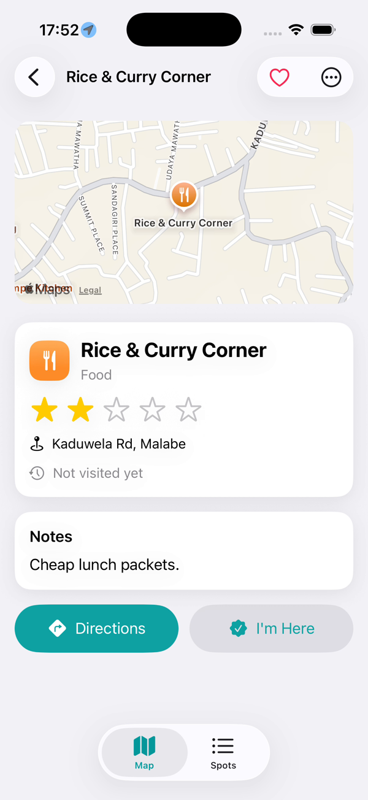
Figure 7 – Edit and Delete menu

2.6 Dark Mode and landscape
The app follows the system appearance and works in every orientation, and on iPad the tabs become a sidebar.
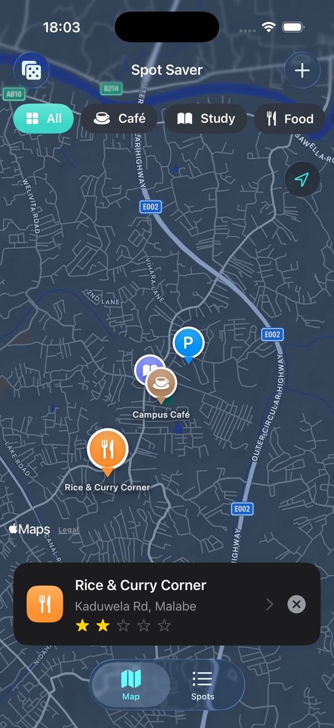 | 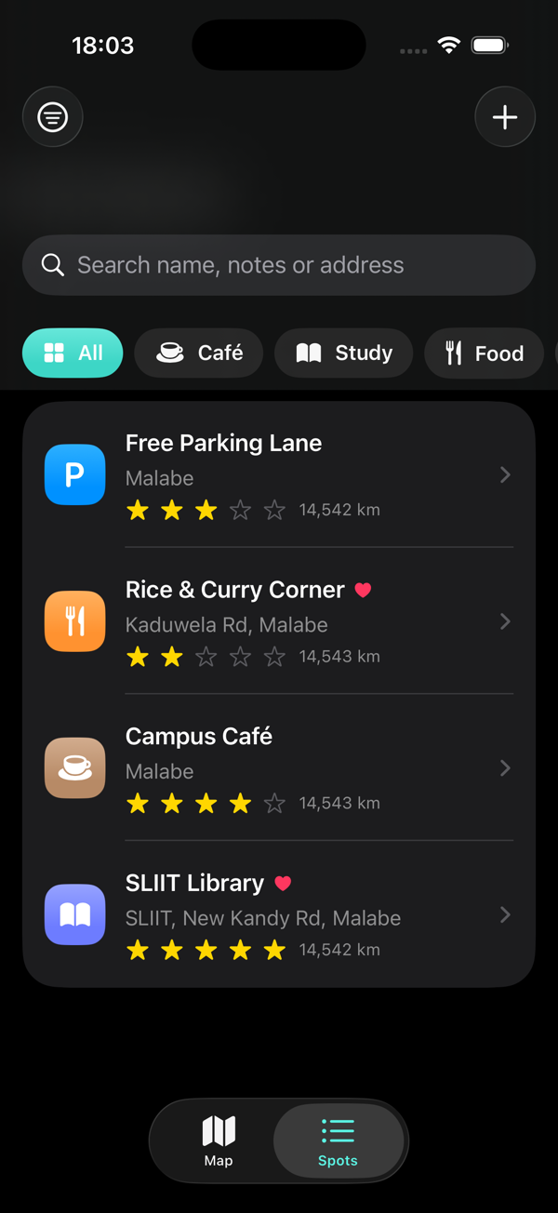
Figure 8 – Map in Dark Mode | Figure 9 – Spots list in Dark Mode
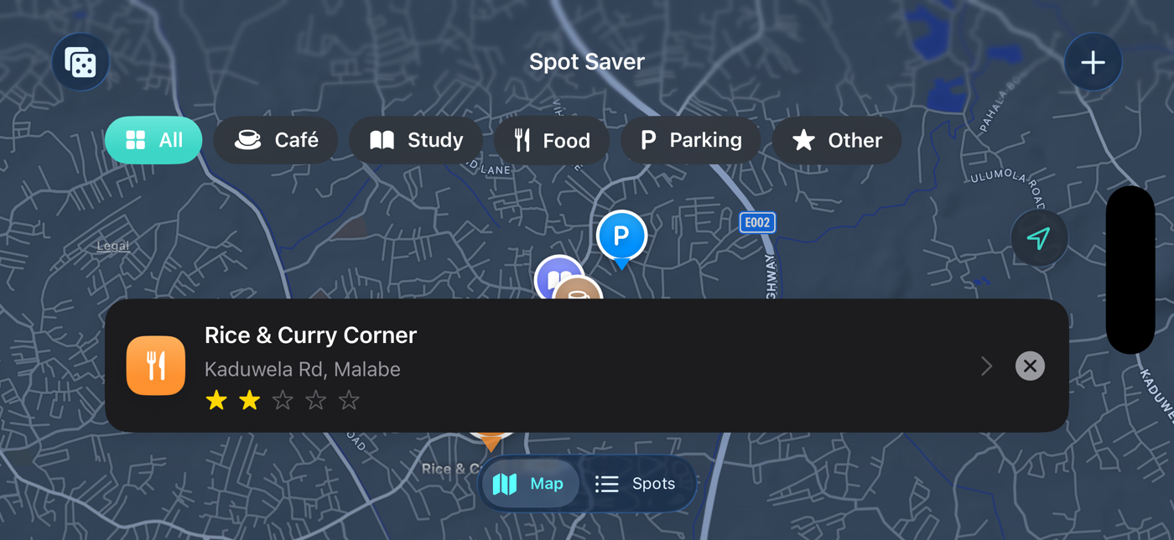
Figure 10 – Map in landscape

3. Technical documentation
Spot Saver is a SwiftUI app targeting iOS 26.5 on iPhone and iPad, structured in layers so that all search, sorting and validation logic runs without any UI.

3.1 Architecture
Views (SwiftUI, NavigationStack per tab)
RootView · MapScreen · SpotListScreen · SpotDetailView · SpotEditorView
▼ depends on
Custom components and theme
StarRatingView · SpotPin · CategoryChipBar · SpotRow · CardStyle modifier · PressableButtonStyle
▼ depends on
Models and logic (no UI code, unit tested)
Spot (@Model) · SpotCategory · SpotDraft · SpotFilter (search, sort, Surprise Me) · SampleData
▼ depends on
Services
LocationManager (async location updates) · MapServices (geocoding, directions) · ImageResizer
▼ depends on
Apple frameworks
SwiftData (on-device store) · MapKit · CoreLocation · PhotosUI
Figure 11 – Spot Saver architecture: views depend only downward, so the logic is testable without UI
Views read data through SwiftData's @Query and shared state through the SwiftUI environment. Pure logic lives in SpotFilter and SpotDraft, which is why it can be unit tested without launching the app.

3.2 Project structure
Folder | Contents
SpotSaverApp.swift | App entry point; creates the SwiftData ModelContainer (in-memory during UI tests)
Models/ | Spot (@Model), SpotCategory, SpotDraft (editable copy used by the editor)
Logic/ | SpotFilter (search, category, favourites, 4 sort orders, Surprise Me), SampleData
Services/ | LocationManager, MapServices (reverse geocoding, directions, distance), ImageResizer
Theme/ | Brand colours, CardStyle view modifier, PressableButtonStyle
Components/ | StarRatingView, SpotPin, CategoryChipBar, SpotRow, CategoryBadge
Views/ | RootView, MapScreen, SpotListScreen, SpotDetailView, SpotEditorView

3.3 Data persistence
Spots are stored on the device with SwiftData. The Spot model holds the name, notes, category, rating (clamped to 0–5), coordinates, address, favourite flag, created date, last visit and visit count.
- The category is stored as a raw string, so an unknown future value falls back to "Other" instead of crashing.
- Photos use @Attribute(.externalStorage), which keeps large image data outside the main database file and keeps queries fast.
- The editor works on a SpotDraft copy; Cancel discards it, so half-edited data never reaches the database.

3.4 Emerging technology: MapKit and CoreLocation
Feature | API used
Custom animated pins, user location, compass, scale | Map, Annotation, UserAnnotation, mapControls
Long-press on the map to drop a spot | MapReader + MapProxy.convert(_:from:)
Address filled in automatically | MKReverseGeocodingRequest (iOS 26)
Directions | MKMapItem.openInMaps
Live location and "Nearest" sorting | CLLocationUpdate.liveUpdates(), CLServiceSession
Surprise Me camera fly-to | animated MapCameraPosition

The integration is central to the app rather than decorative: a spot is a location, and saving, finding and returning to it all run through these frameworks.

3.5 Custom components and modifiers
- StarRatingView – tap or drag to rate; VoiceOver users swipe up or down to adjust.
- SpotPin – a pin that drops in with a spring animation and grows when selected.
- CategoryChipBar – filter chips whose highlight slides between them (matchedGeometryEffect).
- CardStyle – a reusable ViewModifier for rounded, elevated cards that adapt to Dark Mode.
- PressableButtonStyle – buttons shrink slightly while pressed.

3.6 Build and run
1. Open iOS/asanios/asanios.xcodeproj in Xcode 26 or later on macOS.
2. Set your signing team under Signing & Capabilities.
3. Choose an iPhone simulator and press ⌘R.
4. Optional: Features → Location → Custom Location = 6.9147, 79.9729 (SLIIT Malabe).
5. Run the tests with ⌘U.

4. Design decisions
Every design choice aims at one goal: saving or finding a place should take seconds, one-handed, in any lighting.
Decision | Reason
Map as the home screen | Places are remembered by where they are; the map gives instant context
Long-press to drop a pin | The fastest way to save the spot you are standing at or looking at, without typing coordinates
Two tabs, each with its own NavigationStack | Map and list keep their own back history; on iPad .sidebarAdaptable turns the tabs into a sidebar
Colour + icon per category | Pins can be told apart at a glance, even in a dense area
Editor works on a draft | Cancel is always safe; Save is disabled until a name is entered
"Surprise Me" | A small, original feature that brings back spots you have forgotten, instead of only showing favourites
Sample data around SLIIT | Lets a first-time user (and the examiner) see a full app immediately

4.1 Visual design and branding
- One brand colour, teal, defined in the asset catalog with separate light and dark values, used for buttons, the selected chip and controls.
- Category colours use system colours (brown, indigo, orange, blue, pink), which adapt automatically to Dark Mode.
- Rounded cards (CardStyle) and consistent 16-point spacing on every screen.
- The app name shown on the home screen is "Spot Saver".

4.2 Animations and gestures
Interaction | Implementation
Pins drop in and grow when selected | Spring animations on SpotPin
Highlight slides between filter chips | matchedGeometryEffect
Summary card slides up from the bottom | .transition(.move(edge: .bottom))
Camera flies to a spot (Surprise Me) | Animated MapCameraPosition
Stars bounce when rated | symbolEffect(.bounce) + haptic feedback
Long-press, drag-to-rate, swipe actions, tap-to-move pin | LongPressGesture, DragGesture, swipeActions, onTapGesture

4.3 Accessibility and adaptive layout
- Dark Mode: all colours are system or asset colours with dark variants (see section 2.6).
- Dynamic Type: only system text styles are used, and custom sizes (pins, stars, badges) scale with @ScaledMetric.
- VoiceOver: list rows read as one element; the star rating is an adjustable control; decorative images are hidden.
- Adaptive layout: the detail screen shows media and information side by side on wider screens, and action buttons stack vertically when space is short (ViewThatFits). All orientations are supported.

5. Testing and performance
The app has 14 unit tests and 4 UI tests. It built and ran on the iPhone 17 Pro simulator, and every feature shown in section 2 was exercised there by hand.

5.1 Unit tests (Swift Testing)
Area | What is checked
Search | Matches name, notes and address, case-insensitively; blank search returns everything
Filters | Category and favourites-only filters, alone and combined
Sorting | Top Rated (ties broken by newest), Name (natural order: "spot 2" before "Spot 10"), Nearest, and the fallback to Newest without a location
Surprise Me | Prefers spots not visited for 14+ days, falls back to all spots, returns nothing for an empty list
Model | Rating clamped to 0–5, unknown category falls back to Other, visit counting
Persistence | Spots saved into an in-memory SwiftData store are fetched back correctly
Draft validation | Blank or over-60-character names rejected; names trimmed; edits applied to the right spot

5.2 UI tests (XCUITest)
Test | Steps
Add a spot | Open Spots → + → check Save is disabled → type a name → Save → spot appears in the list
Search | Load sample spots → search "parking" → only Free Parking Lane remains
Record a visit | Open a spot → I'm Here → "1 visit" appears
Launch performance | Measures app launch time

UI tests launch the app with -ui-testing, which uses an empty in-memory store and skips the location prompt, so every run starts from the same state.
Result of the latest ⌘U run: to be added (screenshot of the Test Navigator).

5.3 User acceptance testing
Testers were asked to complete five tasks without help: save a spot by long-pressing, find a spot by search, filter by category, get directions, and record a visit.
Tester | Tasks completed (of 5) | Rating (of 5) | Feedback
Tester 1 | 5 | 4 | Long-press to save was not obvious at first; liked Surprise Me
Tester 2 | 4 | 4 | Took a while to find the sort menu
Tester 3 | 5 | 5 | Dark Mode looks good; would like iCloud sync

5.4 Performance optimisations
- Memory: photos are downscaled to at most 1,024 px and saved as JPEG (a full camera photo can be over 10 MB), and stored outside the database with external storage.
- Responsiveness: location updates smaller than 25 m are ignored, which avoids needless redraws and saves battery.
- Load time: the address lookup runs asynchronously and is cancelled automatically when the pin moves again; the UI never waits for it.
- Efficient lists: filtering and sorting are done once per render in SpotFilter; list rows show a category badge instead of decoding photos.

6. Challenges and reflections
The biggest challenge was not technical: the app was developed on Windows, and Xcode runs only on macOS.

6.1 Development challenges
Challenge | How it was handled
No Mac available | Code was written on Windows, and the project was built, run and screenshotted on a friend's Mac. The app compiled and ran on the first build
Testing location features in a simulator | A fixed custom location (SLIIT Malabe) and built-in sample data make results repeatable
Long-press on a map that also pans and zooms | A sequenced long-press then drag gesture, attached with simultaneousGesture so normal map gestures keep working
Large photos slowing the app | Photos are downscaled before saving and kept in external storage
Cancel leaving half-saved edits | The editor edits a SpotDraft copy and only writes to SwiftData on Save
Distance shown in thousands of km in early screenshots | The simulator was still set to its default US location; setting the custom location fixes it

6.2 Reflections
- Separating logic (SpotFilter, SpotDraft) from views made the tests short and fast, and would make it easy to add an iCloud sync layer later.
- Building around Apple's newest APIs (SwiftData, CLLocationUpdate, MKReverseGeocodingRequest) removed a lot of boilerplate compared with older delegate-based code.
- Next steps: iCloud sync between devices, sharing a spot with friends, a home-screen widget for nearby spots, and a custom app icon.

6.3 AI-assisted development
As required by the brief, AI use is declared. Claude Code (Anthropic) was used to summarise the brief, suggest app ideas, generate the initial project structure, code and tests, and draft this report. All output was reviewed and built in Xcode. The prompts and responses are recorded in the AI Usage Log folder of the submission.

6.4 References
- Apple Developer Documentation: SwiftUI, SwiftData, MapKit for SwiftUI, Core Location
- Apple Human Interface Guidelines

