Sri Lanka Institute of Information Technology



**Human Computer Interaction-IT3060**

**Assignment 1**

Project Name – art.yale.edu

**Project Group ID:** **2022-WE-S2-86**

|  |  |  |  |
| --- | --- | --- | --- |
|  | Student ID | Name | Work Distribution |
| 1 | IT20146238 | Jayathunga T.M. | * Sign In Sign Up Page * Home Page * Faculty Staff Page |
| 2 | IT20272654 | Rajapaksha R.P.S.V | * About Us Page * Contact Us Page * News Page |
| 3 | IT20173104 | Shavinda Y.A.D.P | * Courses Page * Current Student Page * Apply To School Page |
| 4 | IT19967844 | Kavishka A.J.P.G | * Public Events * Exhibitions Page * Calendar |
| 5 | IT19964874 | Sadaruwan K.K.C.S | * Newsletter Signup * Publications Page * Graduate Study Areas & Admission Page |

Table of Contents

1. Project Description 3

2. Alternative Considered 3

3. User Group Identified 3

4. Three Personas for Selected 3

5. Usability Issues Identified by the Student 5

6. Usability Issues Identified Base on Contextual Inquiry 6

7. Scripts for Contextual Inquiry for 3 Users 6

8. Three Video Links 9

9. Time Schedule (Gantt Chart) 10

10. References 10

11. Appendix 10

### Project Description

Our "**Error503**" Project Team chose the "Yale School of Art" website for a website with usability issues. This is one of the worst creative websites on the internet. Here are the reasons why we are redesigning this again by UI / UX. These are the lack of artistry on the home page, the fact that a new user cannot find the content here easily, the background images mentioned here are not used correctly, and the Header, Footer, Body Content contained in a website are not properly matched.

### Alternative Considered

* courseweb.sliit.lk
* open.uom.lk
* britishcouncil.lk
* iihe.lk

### User Group Identified

Primary User – Mr.Shavinda

Secondary User – Mr.Chamindu

Third User - Mr.Gihan

### Three Personas for Selected

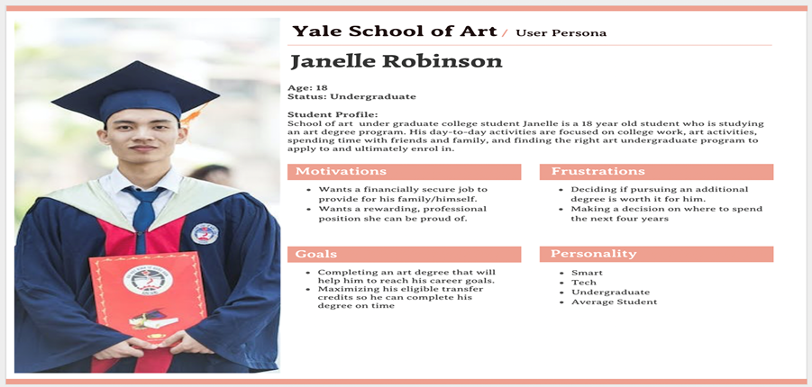

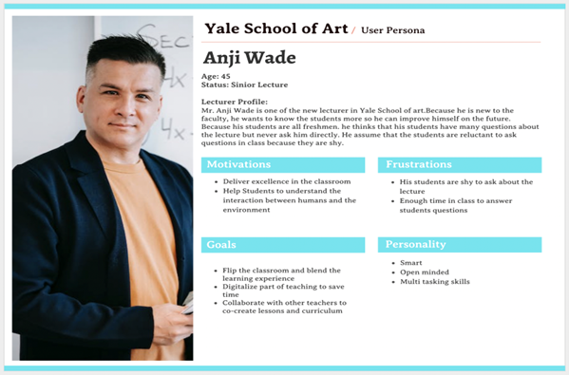

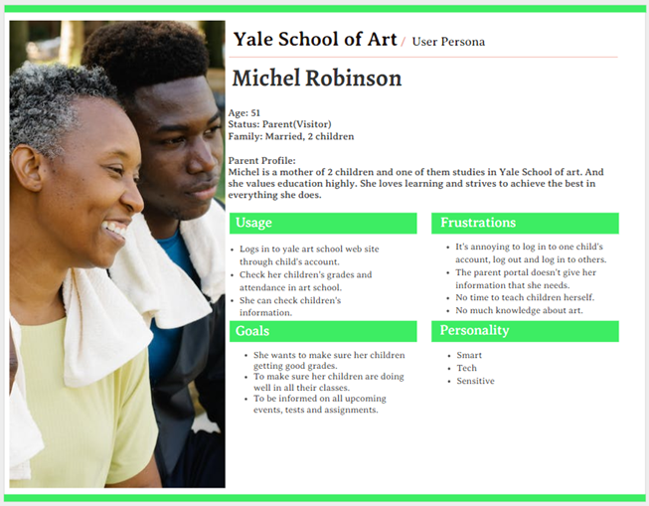

### Usability Issues Identified by the Student

|  |  |  |  |  |  |
| --- | --- | --- | --- | --- | --- |
|  | **Prototype screen / UI** | **User’s feedback /Problem** | **Reason for negative feedback** | **Severity (high/ medium/ low) and justification.** | **Way(s) to rectify and any tradeoffs** |
| 1 |  | When we go to the home page, header, footer, and home page contents are not visible clearly. | Home page not created properly. Overall interface hasn’t color combination. The background image is not clear. | **High**  As soon As, first time user or visitor come to the home page, he cannot find categories. | The Home page should be created correctly in an attractive way. |
| 2 |  | Faculty and Staff details are not clearly mentioned properly. | Faculty and staff information are displayed in one interface. Color combination not much. | **Medium**  It is difficult to find faculty notices and information user needs. | The faculty page and staff page are created as 2 separate pages. |
| 3 |  | Contact pages have more email links and visitors can’t identify clearly. | User cannot identify which email address he uses or not. There isn't any direct contact form. | **High**  Visitor or User cannot contact their support service directly. | Contact details must be provided clearly and User-friendly. |
| 4 |  | Feature news and previous news are in same structure. | News boxes size mismatching and not User-friendly. | **Low**  Users cannot find special news properly. | Featured news is added to the top the page and old news is added to bottom of the page use Cards. |
| 5 |  | There are many numbers of subtopics inside the Apply to school heading. | This page structure is very confusing for users to understand and find courses. | **Medium**  It brings all the functions that users want to use but it not User-friendly. | Create content into proper structure and create good navigations. |
| 6 |  | The about section, their goal, mission, and vision is not user-friendly. | Background image and page color combination is not good. | **Low**  About section is not user-friendly. | It can add small picture with their goals, mission and vision contents. |
| 7 |  | Colors and background mismatch and poor visual designing. | This page background contains too many colors and background used low quality photo. | **Medium**  The exhibition notices and other exhibition details are not clear to visitors. | Use simple and harmonious color combinations for the content. |

### Usability Issues Identified Base on Contextual Inquiry

|  |  |  |  |  |  |
| --- | --- | --- | --- | --- | --- |
|  | **Prototype screen / UI** | **User’s feedback /Problem** | **Reason for negative feedback** | **Severity (high/ medium/ low) and justification.** | **Way(s) to rectify and any tradeoffs** |
| 8 |  | User cannot find their student details and their courses type properly. | All year’s student’s details are in one page. There isn’t any search bar icon here. | **High**  User cannot fine their student’s name easy. | Classify the course related to the relevant year and enter the list of student list inside it. |
| 9 |  | Student goes to the course’s page, he can see many types of course in one page. Cannot search course id or course name. | Courses categories are not user friendly and background image is doesn’t fit. There is no search bar icon for find course module easily. | **Medium**  Students find to hard their current year courses category quickly. | Create a select tab related to the current year and enter only courses related to that year. |
| 10 |  | When we go to the graduate study areas page, All the category and certificate areas are mixed. | Category types are not user-friendly. Background image is not eye-catch. | **High**  Graduate category types are not in proper type. | Create cards for each category section and reed more details link to another page. |
| 11 |  | The Public events page doesn’t have a category of events and events details properly. | Public events page background image color is not good. Event details are not clear. | **High**  Event details are not clear to visitors and other users. | Create Upcoming event and ongoing events using dropdown box. |

### Scripts for Contextual Inquiry for 3 Users

* **Contextual inquiry 1**

Thirosh : Hello Mr. Shavinda. Good morning. Thank for you joining with me.

We want to know the feedback based on your user experience on our website.

Mr.Shavinda : Hello Thirosh. Good morning. It's okay. I’m ready.

Thirosh : I’ll send a website link in your chat box. Can you open it?

Mr.Shavinda : Ok. Sure. Give me a second.

Thirosh : Are you using this website in your first time?

Mr.Shavinda : No, I am using this website in my 3rd time.

Thirosh : Umm... Okay Mr.Shavinda. That’s good. I’ll ask some questions of you.

Mr.Shavinda : Ok, please wait. I’ll opening this web site link.

Thirosh : Mr.Shavinda, can you show me, Where your student name is in the

course table for the current year.

Mr.Shavinda : Ok. Sure. Give me a time. I cannot find anything yet. I will try. Ok, Mr.Thirosh

I found this student name list page.

Thirosh : Ok, Mr.Shavinda. that’s good. Can you tell me, do you face any problems,

Find this current student name list page?

Mr.Shavinda : Yes Mr.Thirosh. I have faced many problems.

Because no header footer section, these pages color combination is not good, and links are nor clear to the user-friendly. Not only that, but there is also have more issues. First one is User cannot find their student details and their courses type properly. Another issue is all the year’s student’s details are in one page. There isn’t any search bar icon here to find their student’s name.

Thirosh : Oh. Mr.Shavinda, I think you are facing lots of problems while using this website.

Mr.Shavinda : Yeah. (laughs) That’s right.

Thirosh : Okay. Mr.Shavinda, I will report these issues.

Finally again thank for you joining with me.

Have a great day. Thank For joining Us.

Mr.Shavinda : It’s Okay. Thanks for inviting me.

* **Contextual inquiry 2**

John is a father of a student studying in Yale school. Thirosh is the organizer of the art society of the same school.

Thirosh : Hello Mr. John, good morning! Thank for you joining with me.

We want to know the feedback based on your user experience on our website.

Jhon : Hello Mr. Thirosh, Good morning! It’s okay. I’m ready.

Thirosh : Great Mr.Jhon. Are you aware that the school is conducting an art festival?

Jhon : I don’t know, there was no mention of it on the notice board at school.

Thirosh : Oh... It has been mentioned on our website. Give me a second,

I will send the website link.

Jhon : Okay Mr.Thirosh.

Thirosh : Are you using this website in your first time.

Jhon : Yes, Mr.Thirosh, I think this is my 5th time?

Can you tell, where is the festival notice was published?

Thirosh : There is a tab called public events in the upper left corner.

Click that button and go inside our public events page. Mr. Jhon, we are publishing all notices and upcoming events notices inside this page. Can you tell me, do you face any problems, while find the public events page notices?

Jhon : Yes Mr.Thirosh. I have faced many problems. Because The Public events page

doesn’t have a category of events and events details properly. Not only that, but public events page background image color is also not good. Event details are not clear and not user-friendly UI.

Thirosh : I understand that too, I will report this issues.

Finally, again thank for you joining with me.

Have a great day. Thank For joining Us.

I think you will come to the art festival

Jhon : Yes, I will definitely come. Thanks for inviting me.

Thirosh : Ok, See you in festival. Bye...!

* **Contextual inquiry 3**

Thirosh : Hello Mr. Gihan. Good morning. Thank you for joining with me.

We want to know the feedback based on your user experience on our website.

Chamindu  : Good morning! Mr.Thirosh. It’s okay. I’m ready.

Thirosh : Where are you working now?

Chamindu  : I am a Lecturer at Yale School of Art.

Thirosh  : Nice to hear, Mr. Gihan, I’ll give a small task for you.

I will share the link in our website. Can you open it?

Chamindu : Ok Mr.Thirosh. I got the link. Wait, I will check now.

Thirosh : Home many times you using this website?

Chamindu : I log into this website about twice a week for update exams notices and

courses assignments.

Thirosh : Great. Mr. Gihan, can you show me, How to find Graphic design methodologies in course page.

Chamindu : Wait, Mr.Thirosh. I will show you.

I found the graphic design methodology course category in the courses page.

Thirosh : Ok, Mr. Gihan. that’s good. Can you tell me, do you face any problems,

Find this courses page?

Chamindu : Yes, In course’s page, we can see many types of course in one page.

Cannot search course id or course name. Courses categories are not user friendly and background image is doesn’t fit. There is no search bar icon for find course module easily.

Thirosh : Oh. Mr. Gihan, I think you are facing lots of problems while using this website.

Chamindu : Yeah. (laughs) That’s right.

Thirosh : I understand that too, I will report this issues.

Finally, again thank for you joining with me.

Have a great day. Thank For joining Us.

### Three Video Links

* **Contextual inquiry 1 link:** [**https://drive.google.com/drive/folders/1hX5G0CRoxSqur6ua3dBBy8K24G91VmGd?usp=sharing**](https://drive.google.com/drive/folders/1hX5G0CRoxSqur6ua3dBBy8K24G91VmGd?usp=sharing)
* **Contextual inquiry 2 link:** [**https://drive.google.com/drive/folders/1hX5G0CRoxSqur6ua3dBBy8K24G91VmGd?usp=sharing**](https://drive.google.com/drive/folders/1hX5G0CRoxSqur6ua3dBBy8K24G91VmGd?usp=sharing)
* **Contextual inquiry 3 link:** [**https://drive.google.com/drive/folders/1RQOBETS3E3XBuwXzBSy14iwjgFhlUma7?usp=sharing**](https://drive.google.com/drive/folders/1RQOBETS3E3XBuwXzBSy14iwjgFhlUma7?usp=sharing)

### Time Schedule (Gantt Chart)

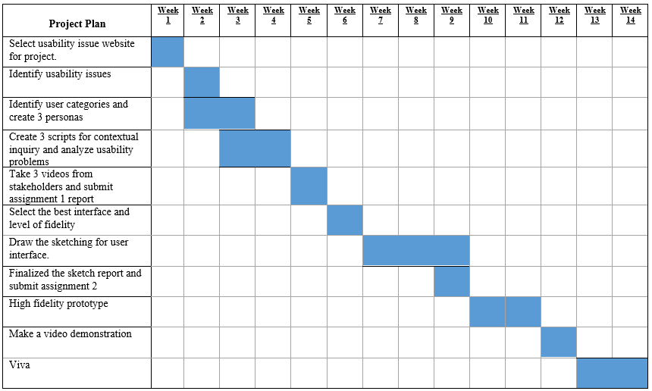

### References

* Human Computer Interaction (HCI) Lecture Recordings
* <https://www.art.yale.edu/>
* <https://uxplanet.org/how-to-create-personas-step-by-step-guide-303d7b0d81b4>
* <https://www.usability.gov/how-to-and-tools/methods/personas.html>

### Appendix

* Workload

|  |  |  |  |
| --- | --- | --- | --- |
| IT Number | Name | Selected Interfaces | Identified Issues |
| IT20146238 | Jayathunga T.M. | Home Page | * Header, Footer section not clearly visible * Page color combination is not user-friendly * Background image not good * Very hard to access website using mobile device |
| Login & Signup | * Small clickable areas * Color combination not good |
| Faculty Staff Page | * Faculty notices are not visible * Staff and Faculty Notes are mixed * UI is not user-friendly |
| IT20272654 | Rajapaksha R.P.S.V | About Us Page | * Page background color combination is not good * Goal, Mission and Visions are not visible. |
| Contact Us Page | * Contact page has more email links * Contact details are not clear |
| News Page | * Page color combination is not user-friendly. * News notices are not clearly visible. * Upcoming event notices are not clearly mentioned. |
| IT20173104 | Shavinda Y.A.D.P | Courses Page | * Courses are not clear for user * All course content are visible in same page |
| Current Student Page | * All student details display same page * User cannot find their student details and their courses type properly * Search Bar icon is mission. Its hard-to-find username. |
| Apply to School Page | * Page color combination is not good * There are many subtitles inside to school page |
| IT19967844 | Kavishka A.J.P.G | Public Events | * Page background is not clear * Upcoming events are not clearly missioned * Event calendar size is too much |
| Exhibitions Page | * Visiting area is not cleared * Background image is not clear |
| Calendar | * Colander events are not merge with public events and news calendar |
| IT19964874 | Sadaruwan K.K.C.S | Newsletter Signup | * Page is not user-friendly * User cannot find newsletter * Page color combination is not good |
| Publications Page | * Posts are not same size * Posts image and content is not clear * Page is not user-friendly |
| Graduate study areas & Admission page | * Background image is not user-friendly * Programs are not clear to user. |