AL SATWA RENTAL MARKET
Analysis & Building Investment Projections

Comprehensive Market Study

Date: March 12, 2026
Data Source: 6,414 Rental Contracts | Al Satwa, Dubai
Building Model: 24 Studios + 32 One-Bedrooms (56 Units)
Prepared by: Eva Real Estate LLC / Market Analysis Division

Table of Contents
1. Executive Dashboard
2. Market Analysis: Studio & 1-Bedroom Rents
3. Price Distribution (AED 5,000 Increments)
4. Rent per Square Foot Analysis
5. Top Communities & Highest-Paying Comments
6. Occupancy Rate Analysis
7. Building Projections: Optimal Pricing
8. Furnished vs Unfurnished ROI
9. Holiday Home / Airbnb Analysis
10. Strategy Comparison & Recommendation

1. Executive Dashboard
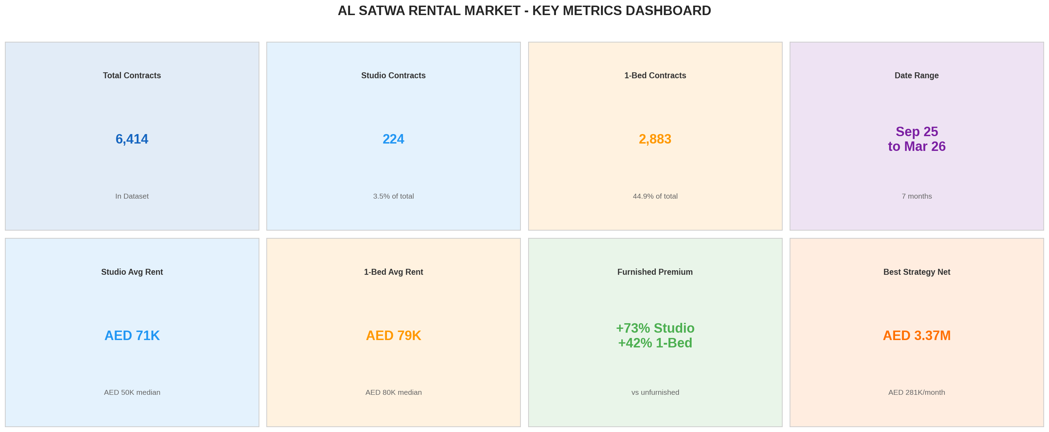

Metric | Value
Total Contracts Analyzed | 6,414
Studio Contracts | 224 (3.5%)
1-Bedroom Contracts | 2,883 (44.9%)
Date Range | September 2025 - March 2026
Studio Average Rent | AED 71,000 / year
1-Bed Average Rent | AED 78,992 / year
Furnished Premium (Studio) | +73.3%
Furnished Premium (1-Bed) | +41.5%
Best Strategy Net Revenue | AED 3,372,592 / year (AED 281,049 / month)

2. Market Analysis: Studio & 1-Bedroom Rents

Price Statistics
Metric | Studio (224 contracts) | 1-Bedroom (2,883 contracts)
Highest Rent | AED 961,000 (Sep 20, 2025 - KAY 1 Building, JGC) | AED 289,895 (Feb 2, 2026 - Eden House)
Lowest Rent | AED 10,928 (Feb 1, 2026) | AED 20,000 (Jan 1, 2026)
Average Rent | AED 71,000 | AED 78,992
Median Rent | AED 50,000 | AED 79,999
Std Deviation | AED 79,186 (high variance) | AED 20,262 (consistent)

Key Insight: Studio rents show extremely high variance (std AED 79K on avg AED 71K) due to a wide range from basic units (AED 35-50K) to premium furnished units (AED 100-150K+). One-bedroom pricing is much more consistent, tightly clustered around AED 70-90K.
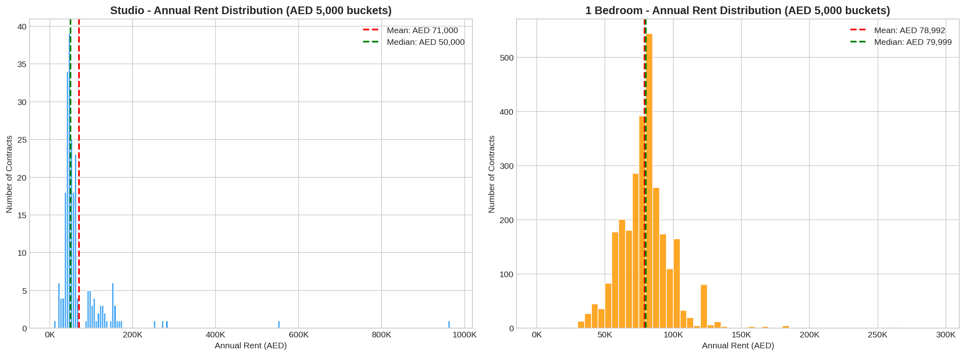

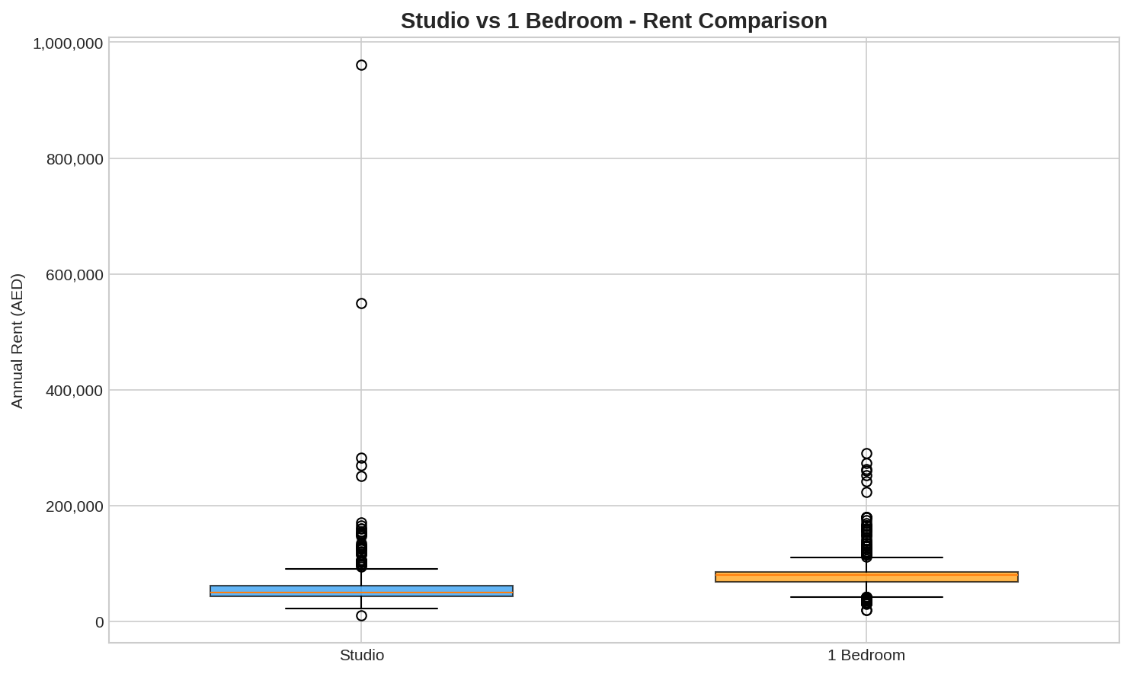

Price Trend Over Time
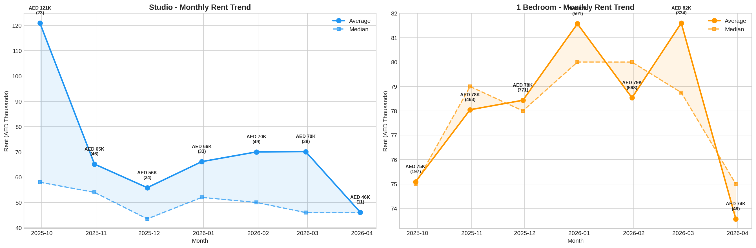

3. Price Distribution (AED 5,000 Increments)

Studio - Most Common: AED 45,000 - 50,000 (39 contracts, 17.4%)
Price Range (AED) | Contracts | Share
45,000 - 50,000 | 39 | 17.4%
40,000 - 45,000 | 34 | 15.2%
50,000 - 55,000 | 25 | 11.2%
60,000 - 65,000 | 23 | 10.3%
35,000 - 40,000 | 18 | 8.0%
55,000 - 60,000 | 18 | 8.0%

1-Bedroom - Most Common: AED 80,000 - 85,000 (544 contracts, 18.9%)
Price Range (AED) | Contracts | Share
80,000 - 85,000 | 544 | 18.9%
75,000 - 80,000 | 392 | 13.6%
70,000 - 75,000 | 286 | 9.9%
85,000 - 90,000 | 260 | 9.0%
60,000 - 65,000 | 201 | 7.0%
65,000 - 70,000 | 181 | 6.3%

Key Insight: Studios concentrate in the AED 35,000-65,000 range (72% of contracts). 1-bedrooms are tightly clustered around AED 70,000-90,000 (51.4%). The market sweet spots are AED 45-50K for studios and AED 80-85K for 1-beds.

4. Rent per Square Foot Analysis
Metric | Studio | 1-Bedroom
Average Rent/sqft | AED 158 | AED 102
Median Rent/sqft | AED 150 | AED 100
Max Rent/sqft | AED 402 | AED 340
Avg Unit Size | 428 sqft | 809 sqft
Studio Premium per sqft | +55% | (baseline)

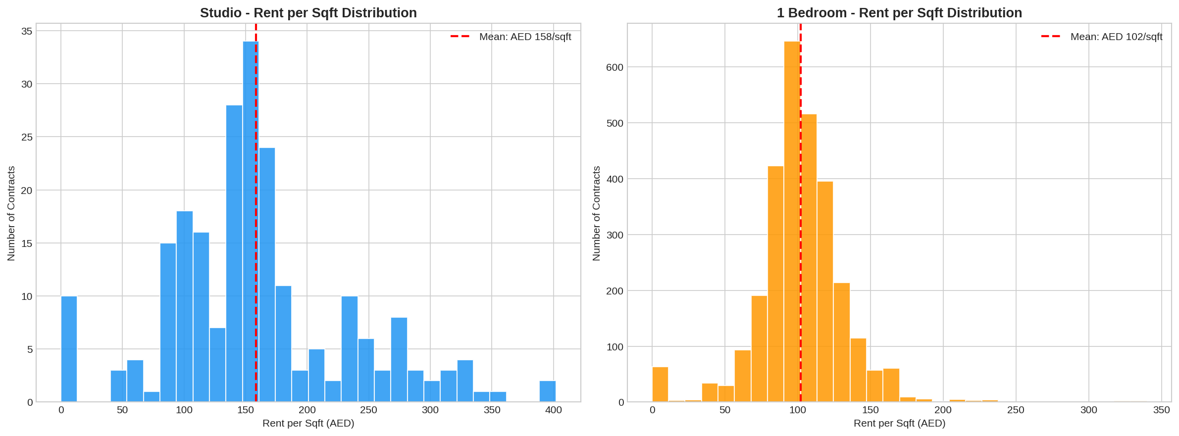

Unit Size vs Rent Relationship
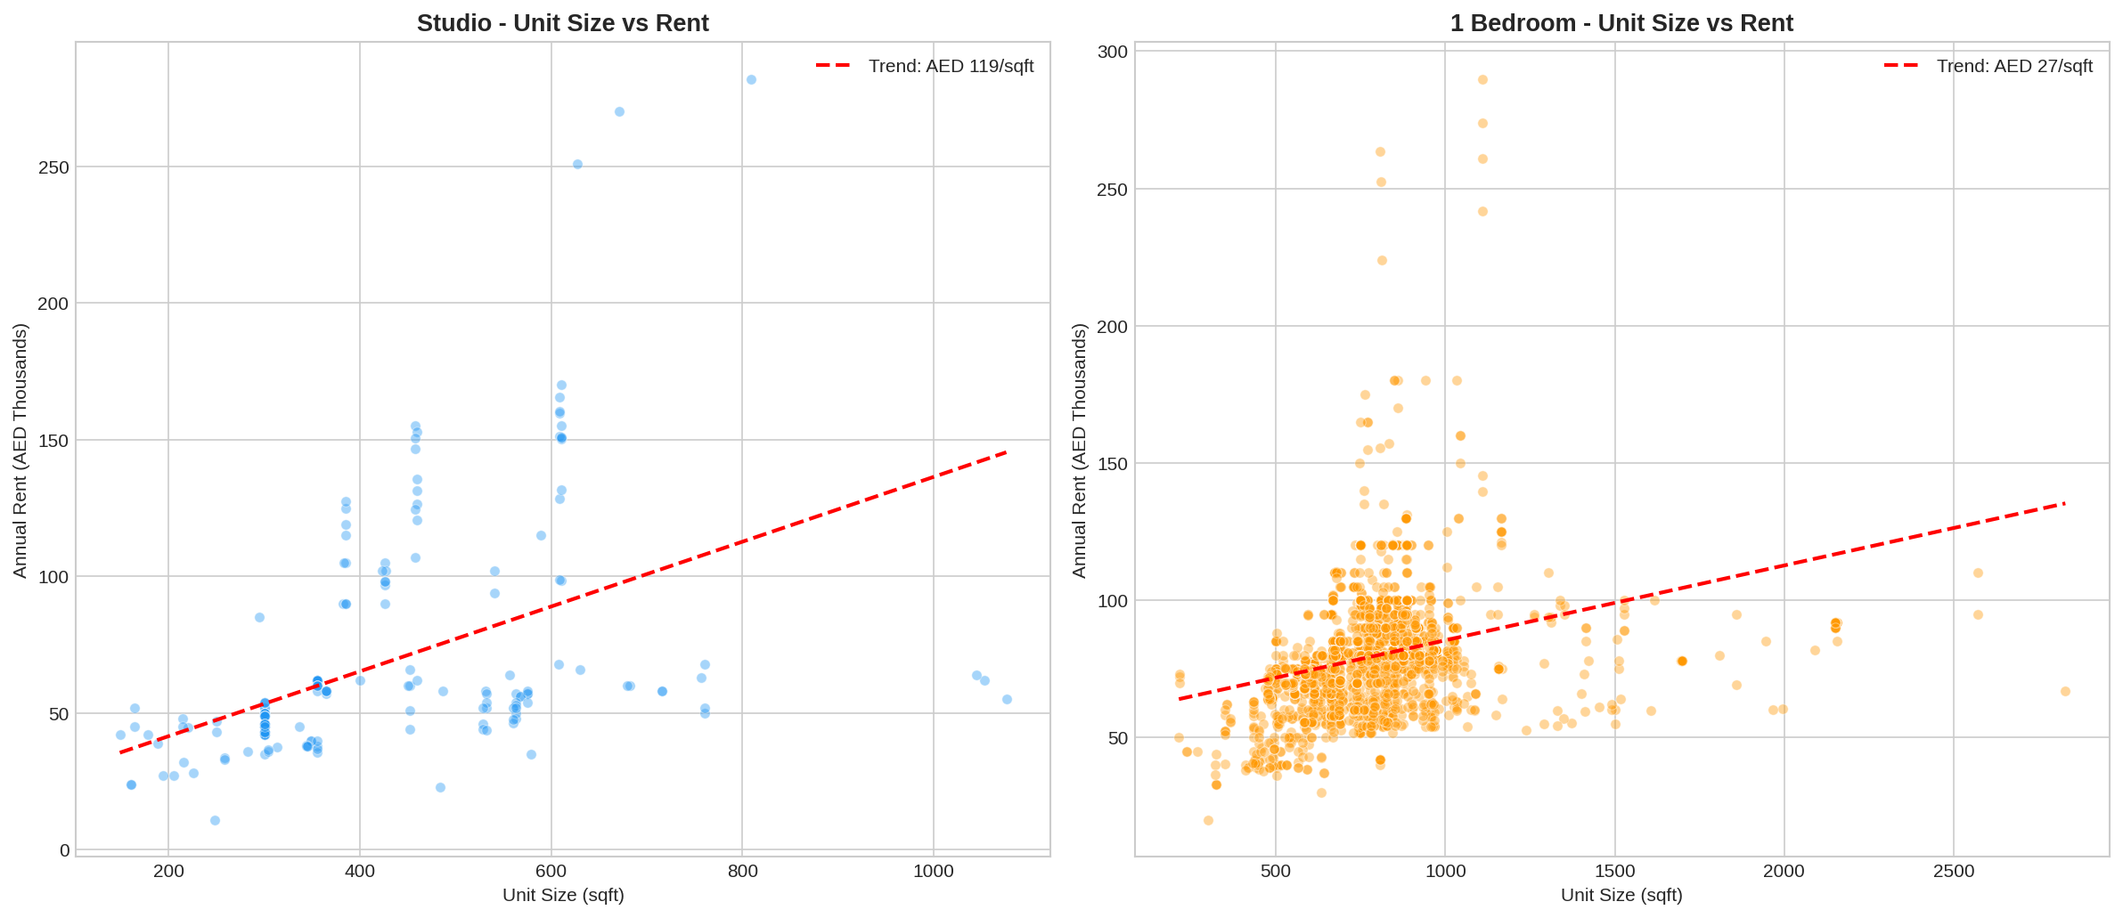

Key Insight: Studios command a 55% premium per square foot (AED 158 vs AED 102) despite being roughly half the size. This makes studios more efficient from a landlord yield perspective.

5. Top Communities & Highest-Paying Comments

Top Communities by Average Rent
Community | Type | Avg Rent | Max Rent | Contracts | Avg/sqft
Eden House | Studio | AED 146,005 | AED 282,000 | 24 | AED 265
Eden House | 1-Bed | AED 130,613 | AED 289,895 | 279 | AED 140
Jumeirah Garden City | Studio | AED 65,746 | AED 961,000 | 82 | AED 162
Jumeirah Garden City | 1-Bed | AED 82,043 | AED 270,000 | 1,097 | AED 105
South Heights Tower | Studio | AED 46,749 | AED 63,000 | 29 | AED 120
South Heights Tower | 1-Bed | AED 68,310 | AED 93,000 | 378 | AED 85

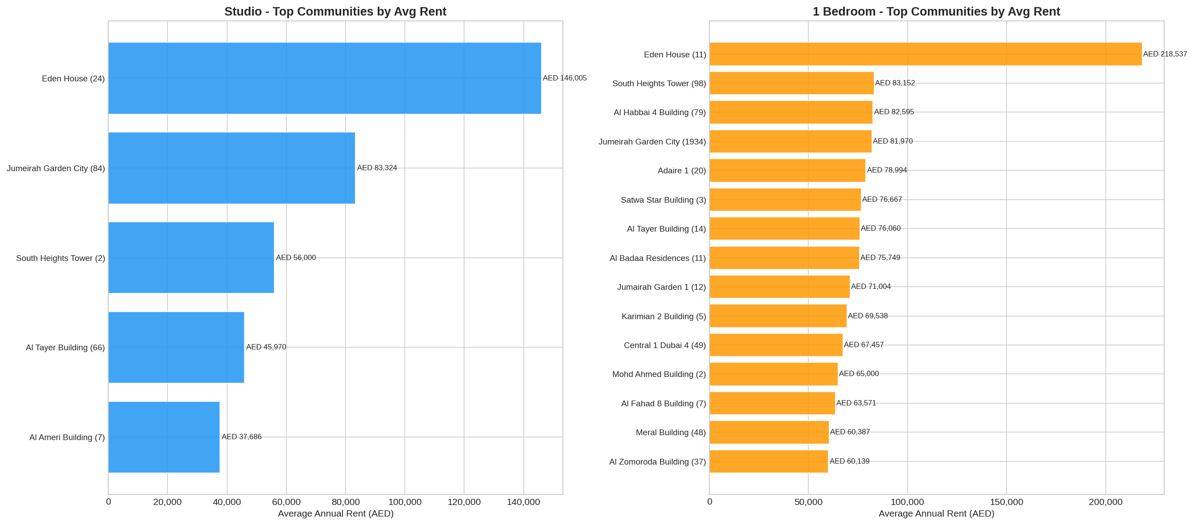

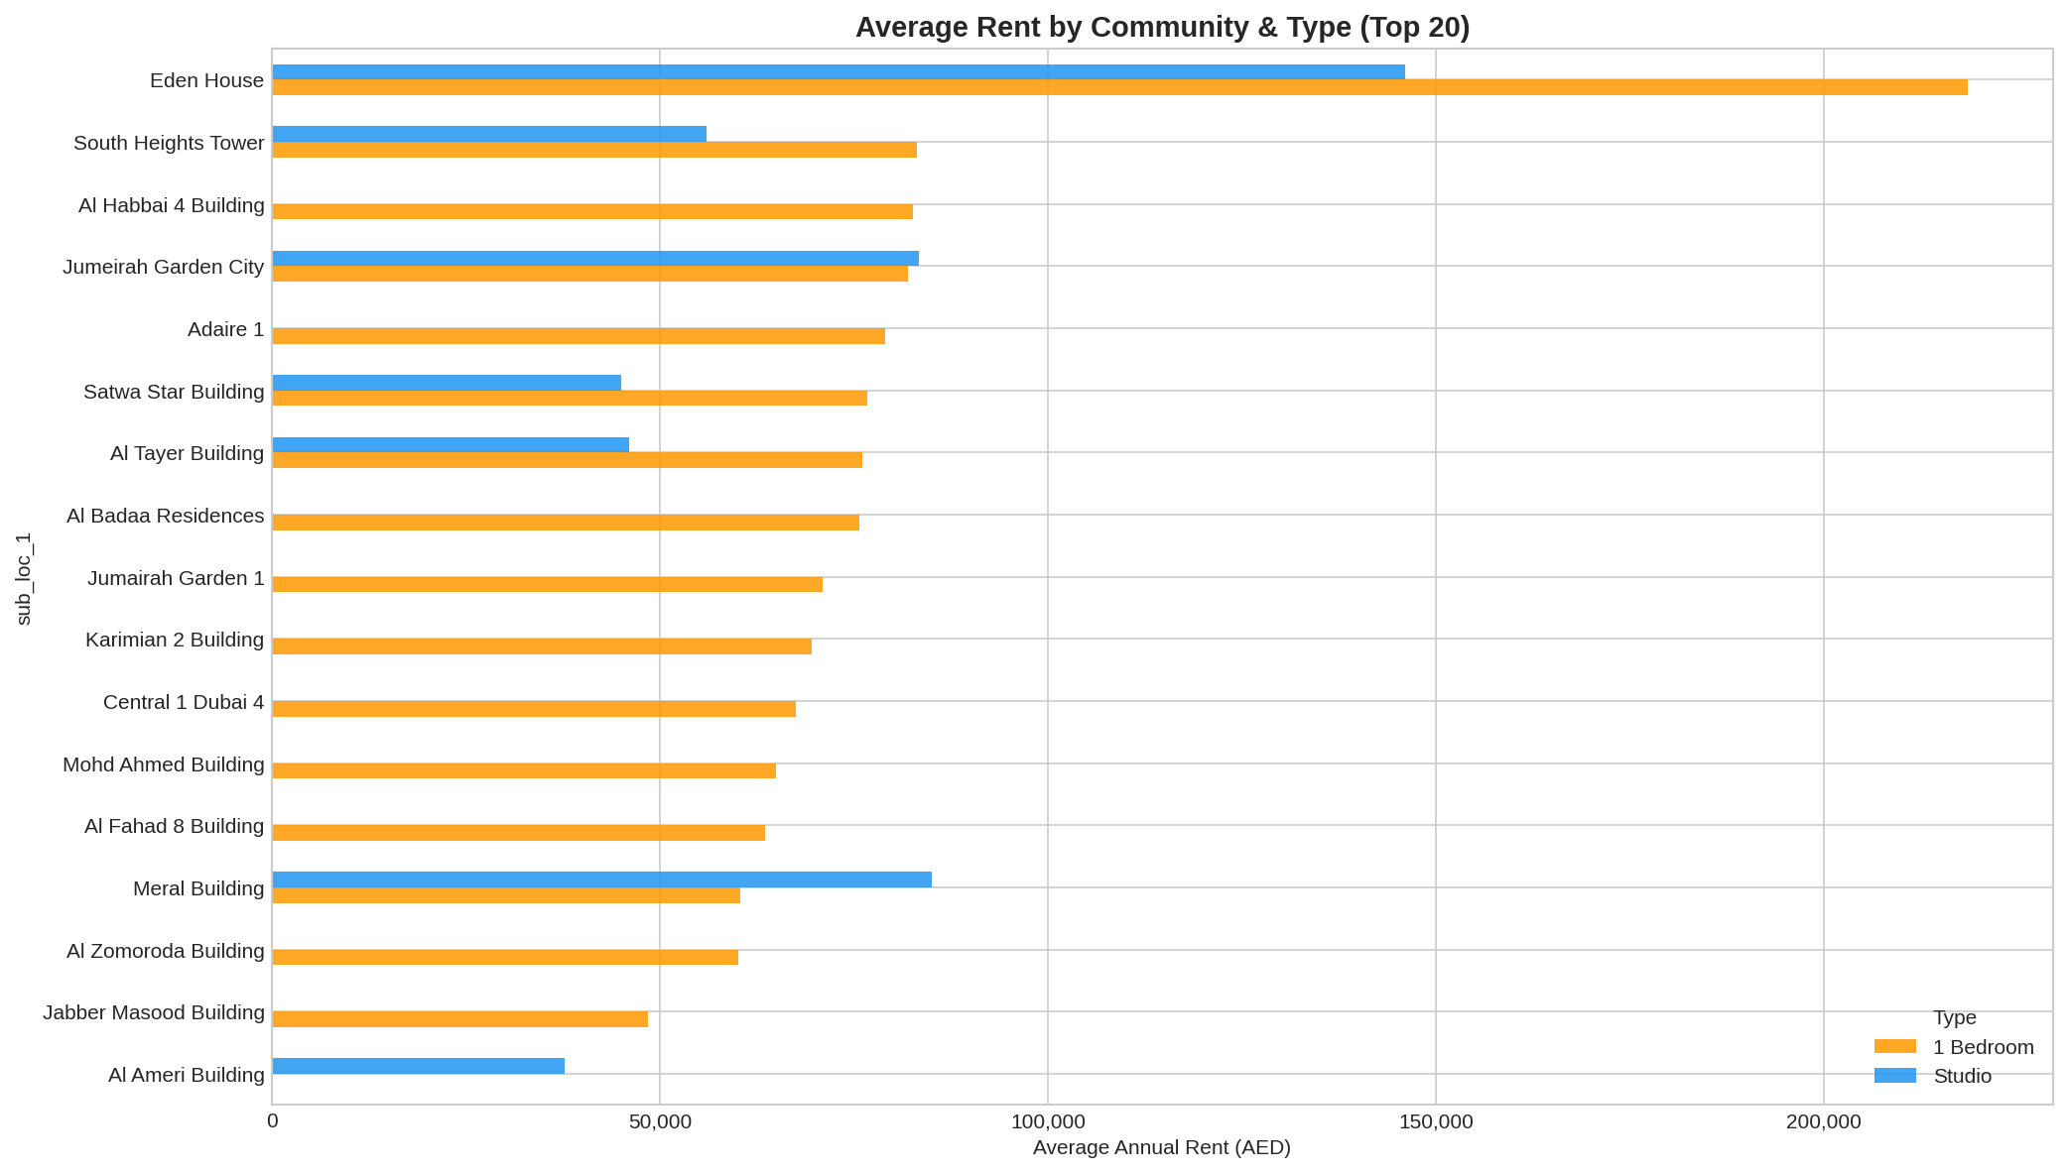

Comments with Highest Rents
Key Insight: Listings with "Furnished", "Brand New", "Burj Khalifa View" consistently command premiums of AED 150,000-290,000 - roughly 2-3x the market average.
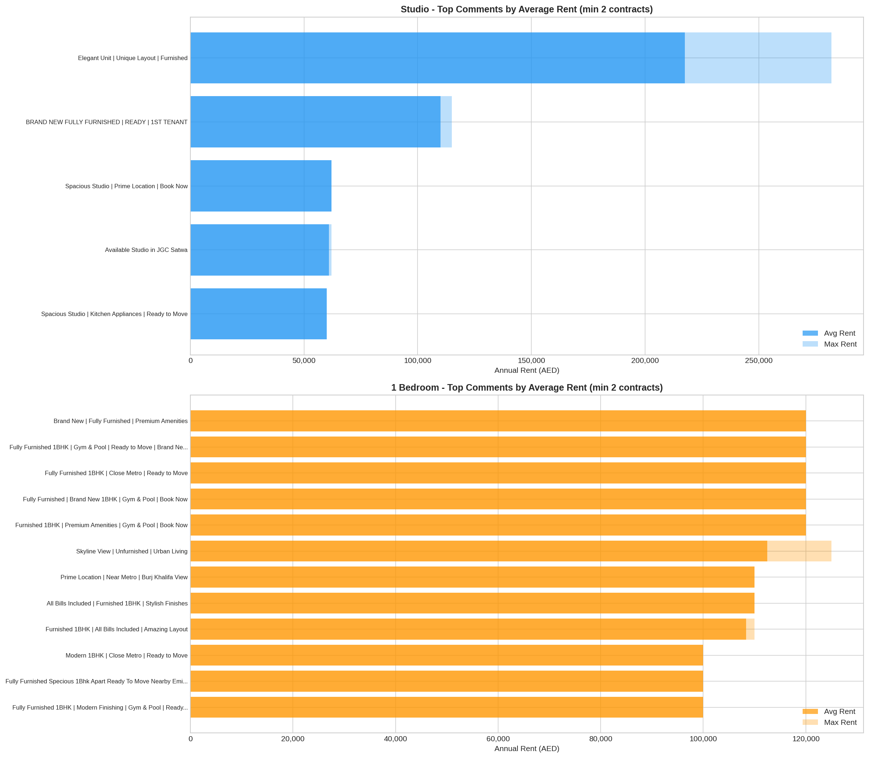

6. Occupancy Rate Analysis

Contract Type Distribution (Occupancy Proxy)
Metric | Studio | 1-Bedroom | All Types
Renewals | 113 (50.4%) | 946 (32.8%) | 2,390 (37.3%)
New Contracts | 70 (31.2%) | 570 (19.8%) | 1,145 (17.9%)
Est. Occupancy Rate | 50.4% | 32.8% | 37.3%

Key Insight: Studios show notably higher tenant retention (50.4% renewal) vs 1-bedrooms (32.8%), suggesting the studio market is tighter with fewer alternatives.
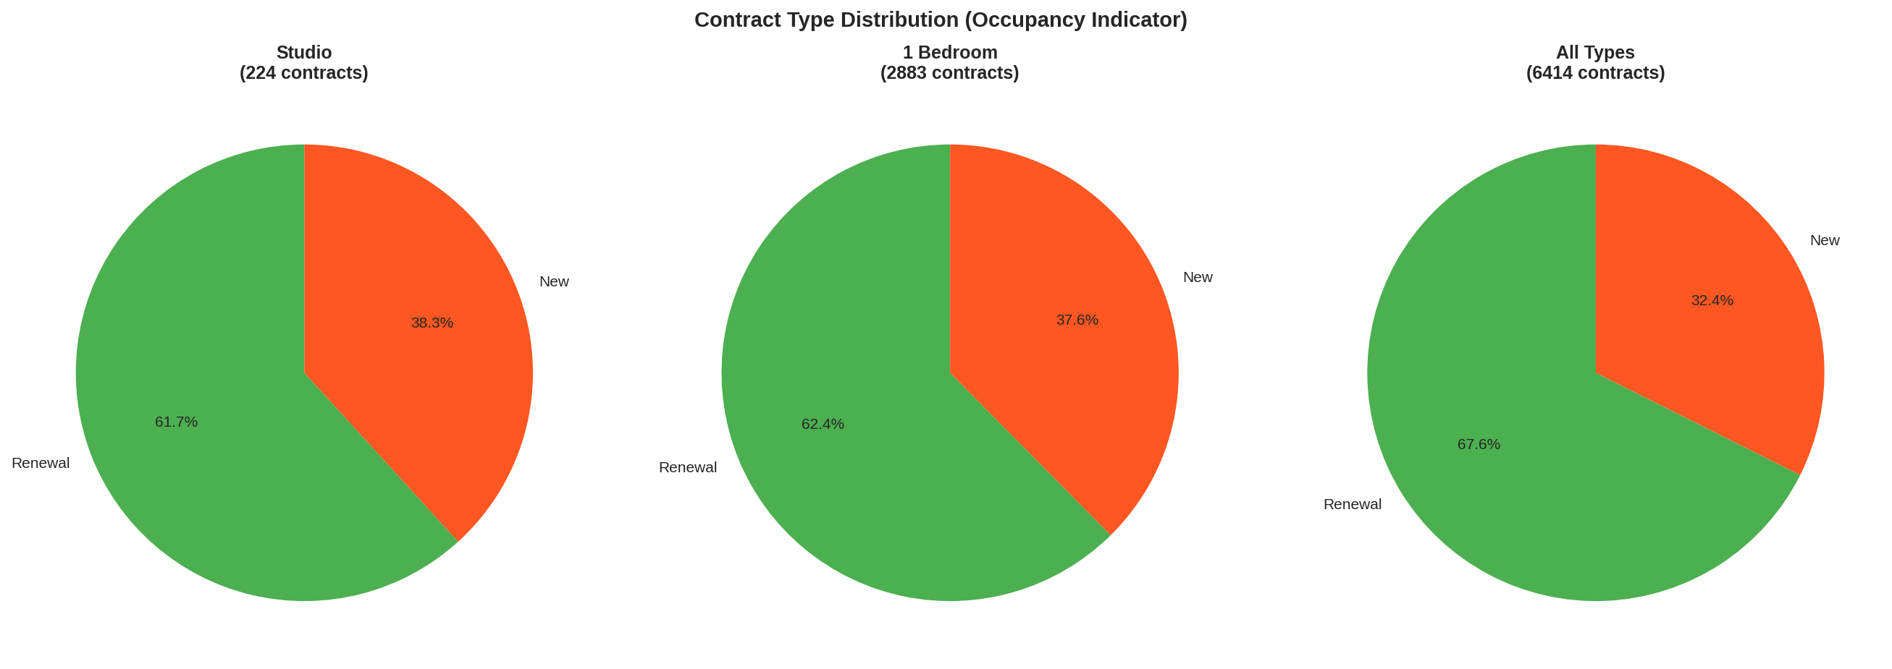

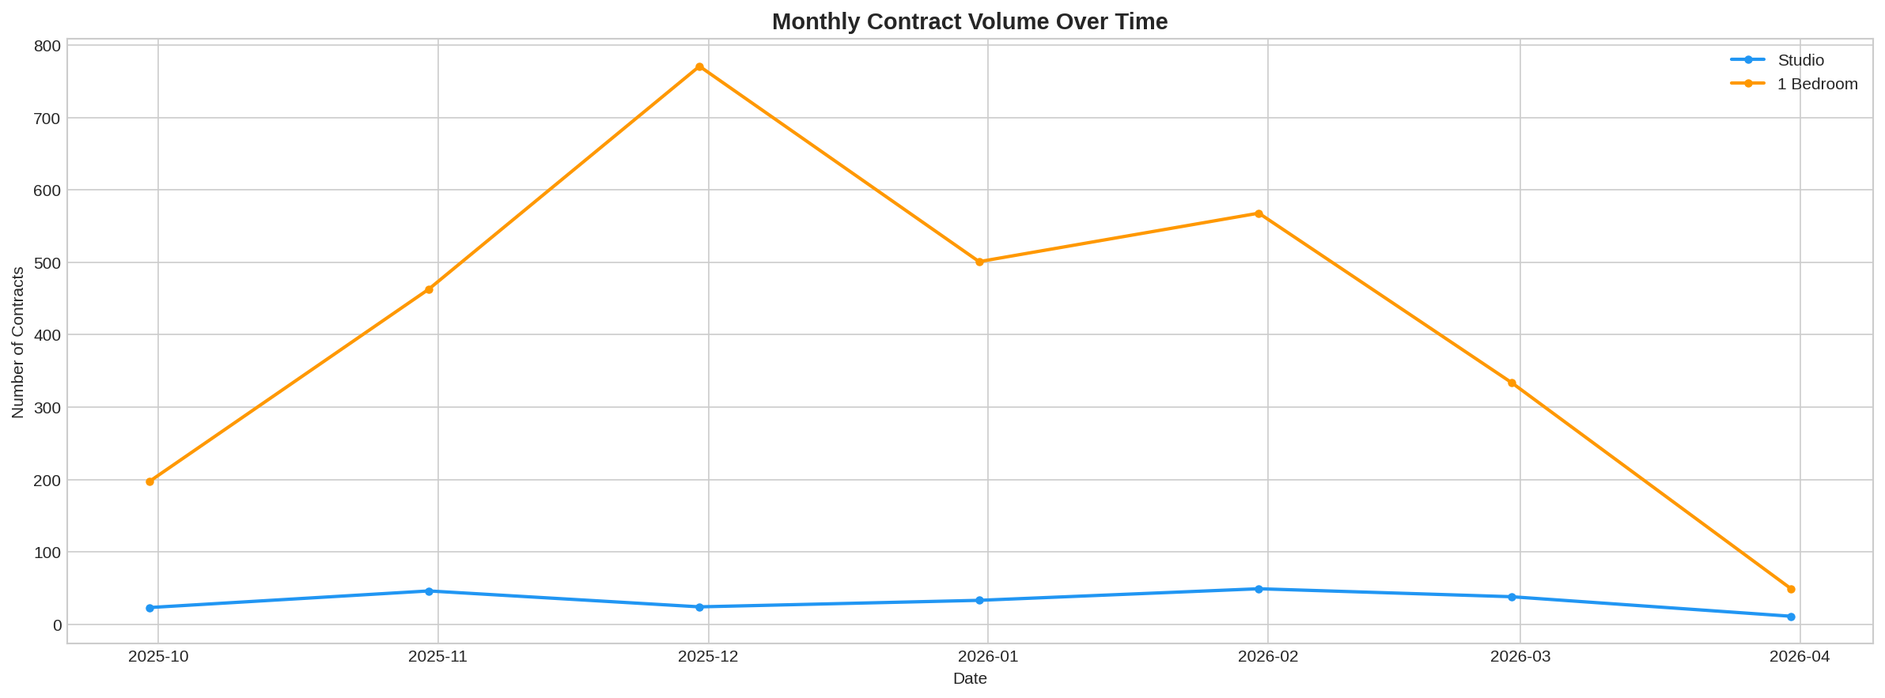

Contract Duration
Duration | Count | Share
Short-term (<6 months) | 1,416 | 45.6%
Standard (6-12 months) | 1,583 | 50.9%
Long-term (>12 months) | 108 | 3.5%

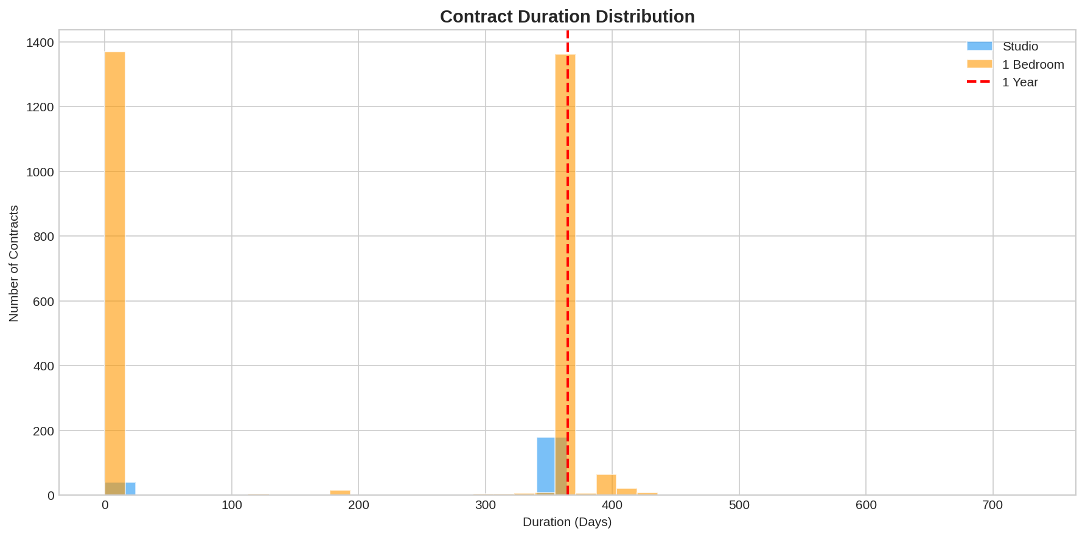

Airbnb / Short-Term Indicators
Indicator | Studio | 1-Bedroom
Furnished/All-bills listings | 12 (5.4%) | 263 (9.1%)
Avg rent (furnished keywords) | AED 118,375 | AED 107,625
Premium vs market average | +67% | +36%

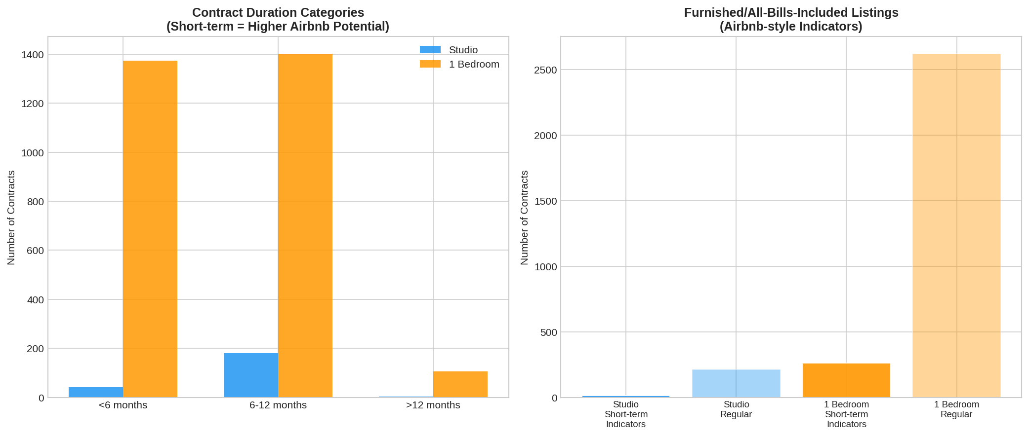

7. Building Projections: 24 Studios + 32 One-Beds

Expected Rent Per Unit (Market Rate, 100% Occupancy)
Unit Type | Per Unit/Year | Per Unit/Month | All Units/Year
Studio Unfurnished | AED 68,319 | AED 5,693 | AED 1,639,656
Studio Furnished (+73.3%) | AED 118,375 | AED 9,865 | AED 2,841,000
1-Bed Unfurnished | AED 76,132 | AED 6,344 | AED 2,436,224
1-Bed Furnished (+41.5%) | AED 107,724 | AED 8,977 | AED 3,447,168
TOTAL (Unfurnished) |  |  | AED 4,075,880
TOTAL (Furnished) |  |  | AED 6,288,168

Optimal Pricing for Target Occupancy
Unit Type | 90% Occ Price/yr | 90% Monthly | 80% Occ Price/yr | 80% Monthly
Studio Unfurnished | AED 40,000 | AED 3,333 | AED 53,000 | AED 4,417
Studio Furnished | AED 69,320 | AED 5,777 | AED 91,849 | AED 7,654
1-Bed Unfurnished | AED 60,000 | AED 5,000 | AED 70,000 | AED 5,833
1-Bed Furnished | AED 84,900 | AED 7,075 | AED 99,050 | AED 8,254

Key Insight: To guarantee 90% occupancy, price ~25% below market average. For 80%, price ~10-15% below. The revenue-maximizing sweet spot is at 72-76% occupancy.

Demand Curves & Revenue Optimization
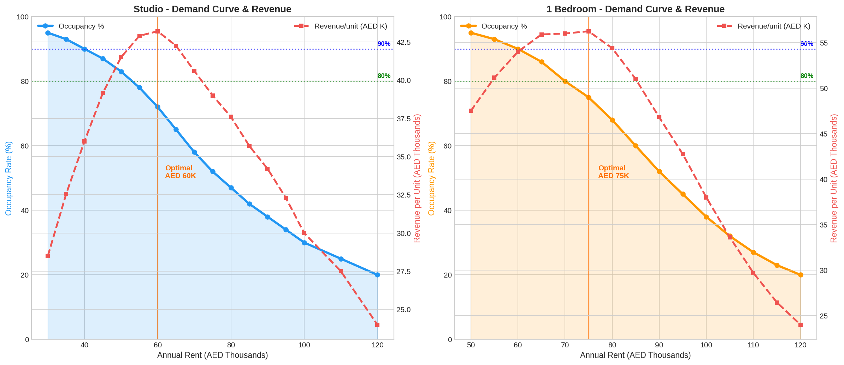

Revenue Maximization Sweet Spots
Unit Type | Optimal Price | Occupancy | Total Revenue/Year
Studio Unfurnished | AED 60,000/yr | 72% | AED 1,036,800
Studio Furnished | AED 100,000/yr | 75% | AED 1,794,142
1-Bed Unfurnished | AED 75,000/yr | 75% | AED 1,800,000
1-Bed Furnished | AED 105,000/yr | 76% | AED 2,546,714

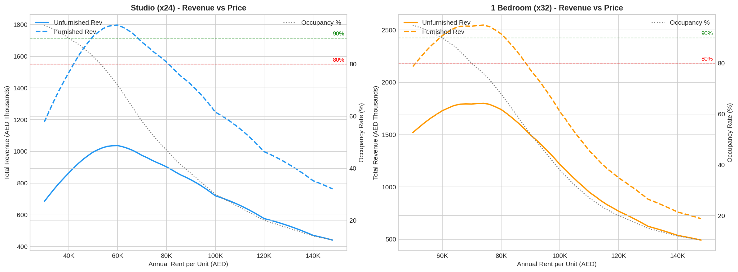

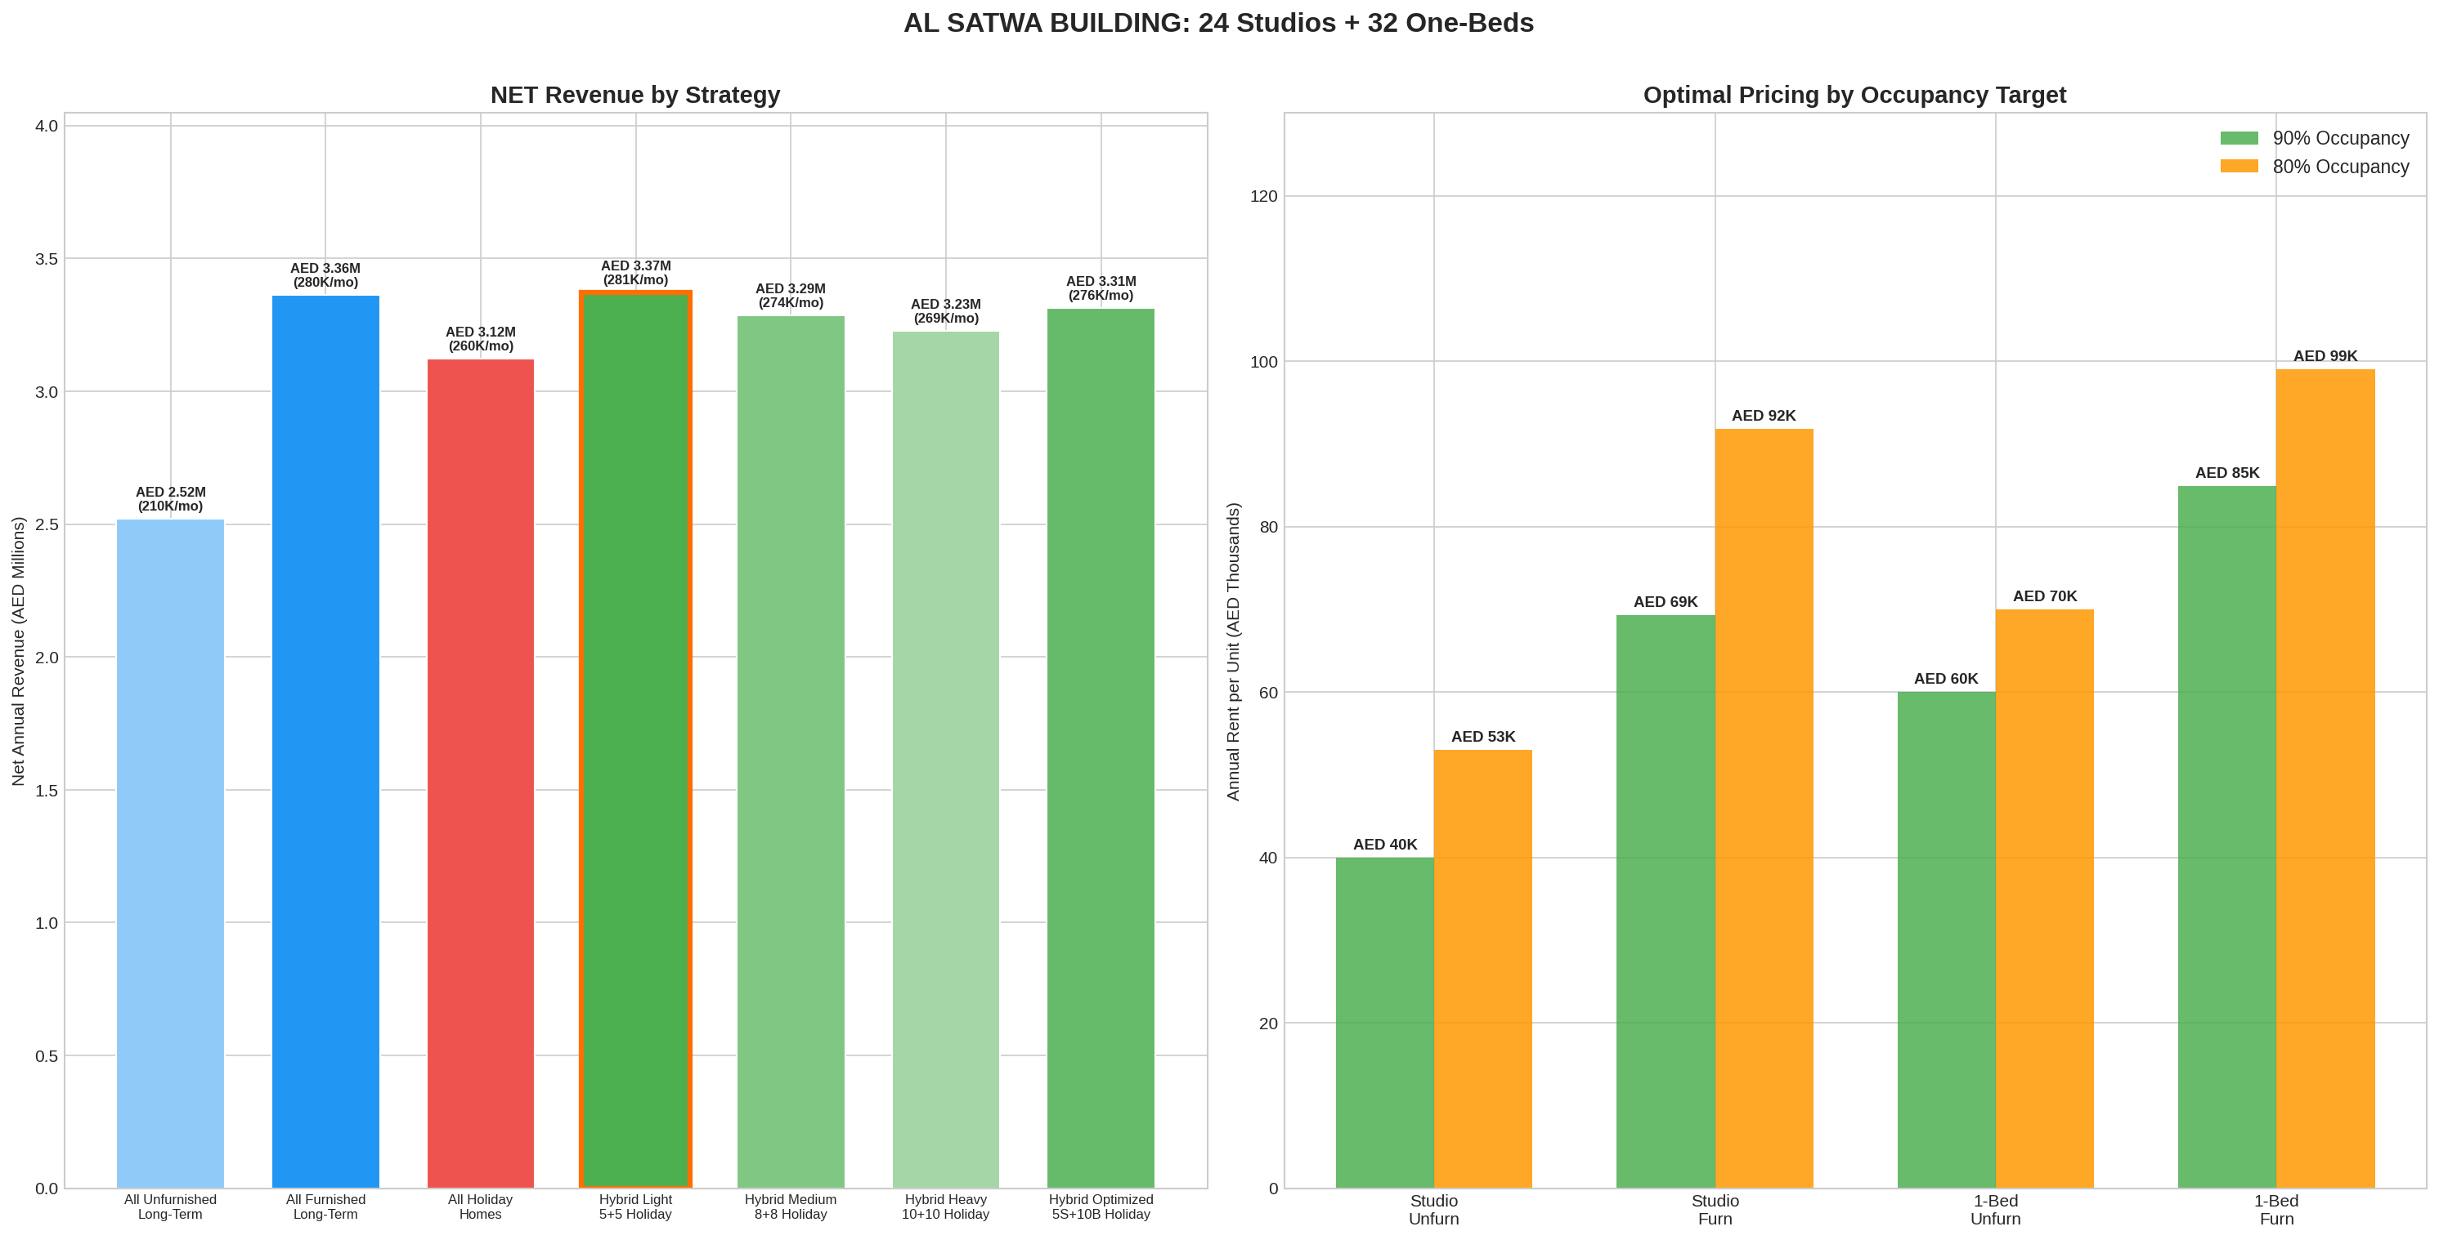

8. Furnished vs Unfurnished ROI

Furnishing Investment
Item | Cost
Studio furnishing (x24 @ AED 25,000) | AED 600,000
1-Bed furnishing (x32 @ AED 40,000) | AED 1,280,000
Total Investment | AED 1,880,000
Annual amortization (4yr cycle) | AED 470,000/yr

Net Revenue Comparison - 80% Occupancy
Metric | Unfurnished | Furnished | Difference
Studio Rent/yr | AED 53,000 | AED 91,849 | +AED 38,849
1-Bed Rent/yr | AED 70,000 | AED 99,050 | +AED 29,050
Gross Revenue/yr | AED 2,757,000 | AED 4,221,381 | +AED 1,464,381
Furniture Cost/yr | AED 0 | AED 470,000
Net Revenue/Year | AED 2,757,000 | AED 3,751,381 | +AED 994,381
Net Revenue/Month | AED 229,750 | AED 312,615 | +AED 82,865
Year 1 ROI |  |  | 77.9%

Net Revenue Comparison - 90% Occupancy
Metric | Unfurnished | Furnished | Difference
Studio Rent/yr | AED 40,000 | AED 69,320 | +AED 29,320
1-Bed Rent/yr | AED 60,000 | AED 84,900 | +AED 24,900
Gross Revenue/yr | AED 2,520,000 | AED 3,832,920 | +AED 1,312,920
Furniture Cost/yr | AED 0 | AED 470,000
Net Revenue/Year | AED 2,520,000 | AED 3,362,920 | +AED 842,920
Net Revenue/Month | AED 210,000 | AED 280,243 | +AED 70,243
Year 1 ROI |  |  | 69.8%

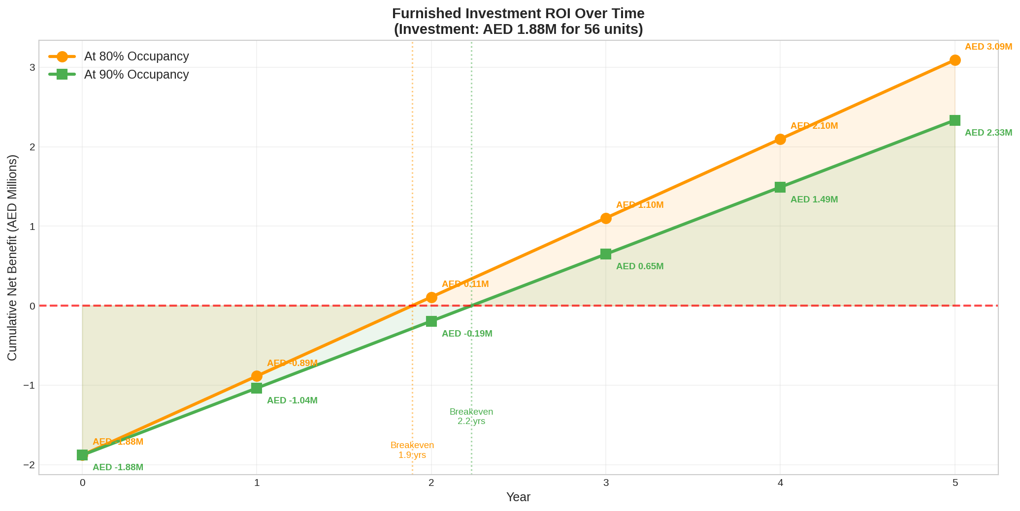

RECOMMENDATION: Furnished is clearly worth the investment
The AED 1.88M furnishing investment pays back within 1.9-2.2 years and delivers an additional AED 843K-994K per year in net revenue. Over a 5-year period, the cumulative benefit is AED 3-4 million.

9. Holiday Home / Airbnb Analysis

Seasonal Occupancy & Nightly Rates
Month | Season | Occupancy | Studio Rate | 1-Bed Rate
January | Peak | 82% | AED 450 | AED 600
February | Peak | 85% | AED 450 | AED 600
March | Peak | 78% | AED 450 | AED 600
April | Shoulder | 68% | AED 350 | AED 480
May | Low | 45% | AED 250 | AED 350
June | Low | 35% | AED 250 | AED 350
July | Low | 38% | AED 250 | AED 350
August | Low | 40% | AED 250 | AED 350
September | Shoulder | 48% | AED 350 | AED 480
October | Peak | 72% | AED 450 | AED 600
November | Peak | 80% | AED 450 | AED 600
December | Peak | 88% | AED 450 | AED 600

Average annual occupancy: 63%
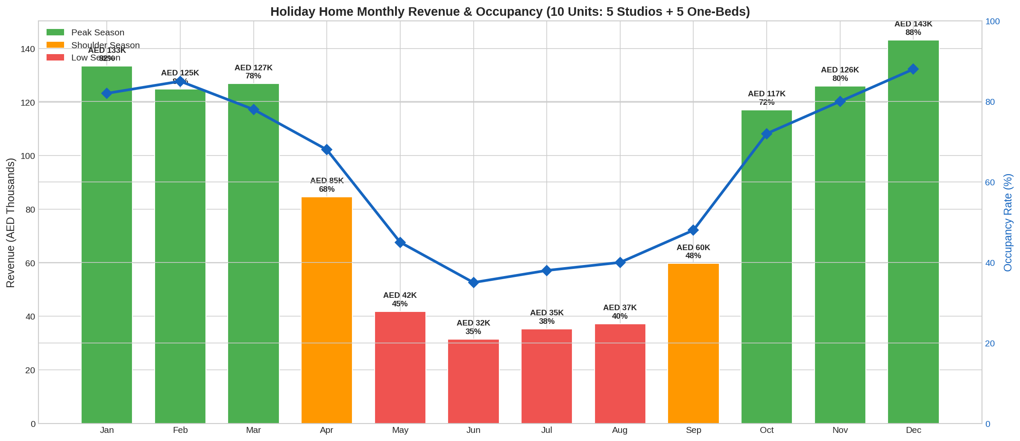

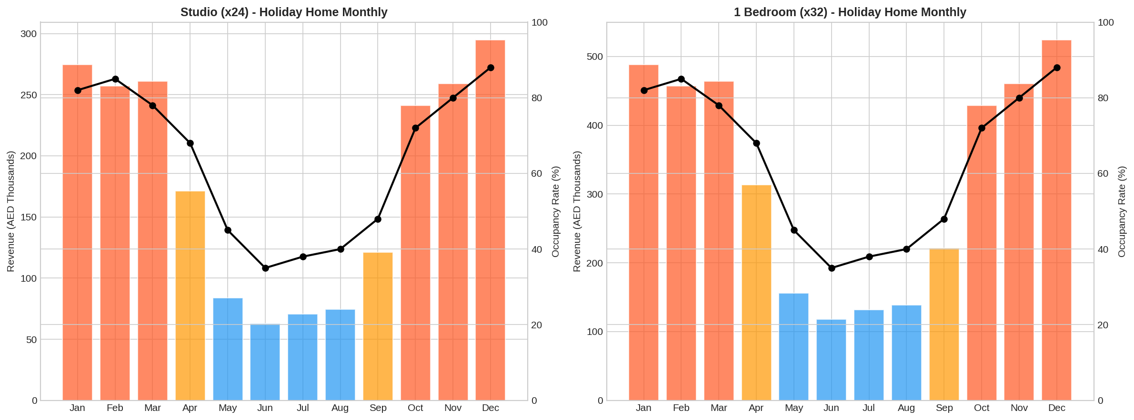

Holiday Home Operating Costs (All 56 Units)
Cost Item | Amount
Gross Revenue | AED 6,073,284
Management fee (20%) | -AED 1,214,657
Cleaning/turnovers (3,226 turnovers) | -AED 576,075
Utilities (AED 500/unit/month) | -AED 336,000
DTCM Licensing | -AED 85,120
Insurance | -AED 112,000
Furniture replacement (3yr cycle) | -AED 626,667
Total Costs | -AED 2,950,518
NET Revenue | AED 3,122,766 (AED 260K/month)

Warning: While holiday homes generate the highest gross (AED 6.07M), operating costs consume 49% of revenue. Summer months (May-Aug) see occupancy drop to 35-45%, creating cash flow volatility.

10. Strategy Comparison & Final Recommendation

All Strategies Compared
Strategy | Gross Rev/yr | Costs/yr | Net Rev/yr | Net Rev/mo
A: All Long-Term Unfurnished (90%) | AED 2,520,000 | AED 0 | AED 2,520,000 | AED 210,000
B: All Long-Term Furnished (90%) | AED 3,832,920 | AED 470,000 | AED 3,362,920 | AED 280,243
C: All Holiday Homes (56 units) | AED 6,073,284 | AED 2,950,518 | AED 3,122,766 | AED 260,230
D: Hybrid Light (5S+5B holiday) | AED 4,278,100 | AED 905,508 | AED 3,372,592 | AED 281,049
E: Hybrid Medium (8S+8B holiday) | AED 4,452,676 | AED 1,166,814 | AED 3,285,862 | AED 273,822
F: Hybrid Heavy (10S+10B holiday) | AED 4,569,060 | AED 1,341,017 | AED 3,228,043 | AED 269,004
G: Hybrid Optimized (5S+10B) | AED 4,463,222 | AED 1,149,307 | AED 3,313,915 | AED 276,160

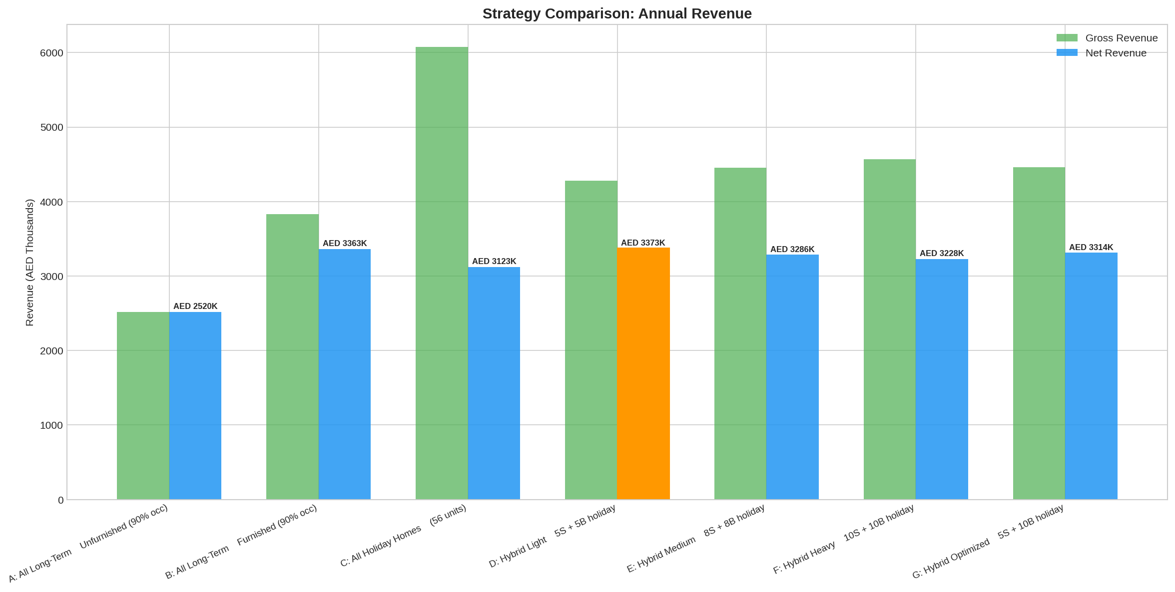

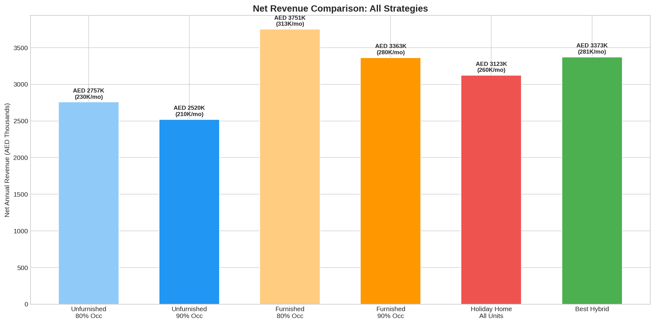

RECOMMENDED: Strategy D - Hybrid Light
19 Studios + 27 One-Beds as Long-Term Furnished
5 Studios + 5 One-Beds as Holiday Homes
Revenue Component | Amount
Long-term rental income | AED 3,216,040
Holiday home income | AED 1,062,060
Total gross | AED 4,278,100
Total costs | -AED 905,508
NET ANNUAL REVENUE | AED 3,372,592
NET MONTHLY REVENUE | AED 281,049

+33.8% uplift vs all-unfurnished baseline (AED +852,592/yr additional revenue)
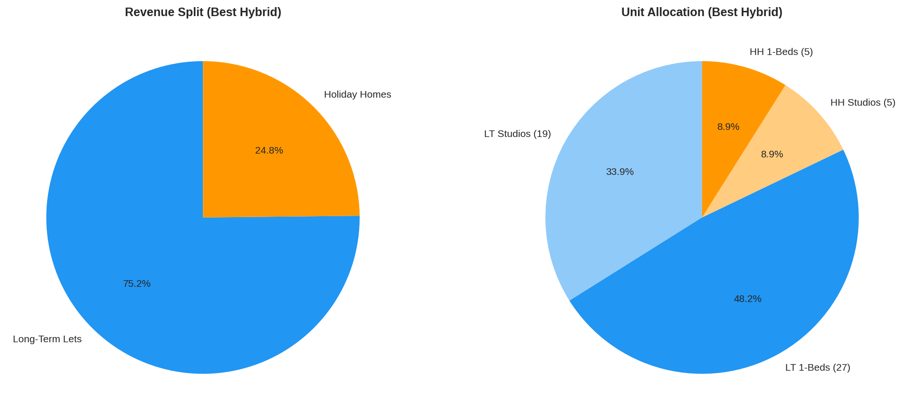

Why This Strategy Wins
Highest net revenue: AED 3.37M beats both pure long-term (AED 3.36M) and pure holiday home (AED 3.12M)
Diversified income: 75% stable long-term + 25% variable short-term reduces overall risk
Manageable complexity: Only 10 units need holiday home management vs 56 in the all-holiday-home strategy
Summer protection: 46 long-term units provide steady income during the May-August low season
Lower costs: AED 906K vs AED 2.95M for all holiday homes; costs are only 21% of gross revenue
Upside optionality: Can convert more units to holiday homes during peak season if demand justifies it

Key Takeaways
1. Furnished always beats unfurnished - 70-78% ROI on the AED 1.88M furnishing investment in Year 1 alone.
2. Pure holiday home is NOT the best - Despite highest gross (AED 6M), operating costs (AED 2.95M) eat into margins, netting only AED 3.12M vs AED 3.37M for the hybrid.
3. The hybrid light model wins - Just 10 units as holiday homes with 46 as long-term furnished delivers the highest net revenue at AED 3,372,592/yr.
4. More holiday homes = diminishing returns - Each additional holiday home unit adds operational complexity and cost that outweighs the revenue premium.
5. Pricing sweet spots: Studios AED 40-53K unfurnished / AED 69-92K furnished. 1-Beds AED 60-70K unfurnished / AED 85-99K furnished.
6. Summer (May-Aug) is the holiday home weakness - Occupancy drops to 35-45%, making the all-holiday-home strategy risky.
7. Revenue maximization prices (72-76% occupancy sweet spot): Studio furnished AED 100K/yr, 1-Bed furnished AED 105K/yr.
8. Eden House dominates premium rents across both categories at approximately 2x the area average.

Al Satwa Rental Market Analysis & Building Projections Report
Generated March 12, 2026 | Based on 6,414 rental contracts | Al Satwa, Dubai
Data Source: Al Satwa Market Data (Eva Real Estate LLC)

