MSOrganiser

User Documentation

Version 0.0.1

2018

# Version Control Table

|  |  |
| --- | --- |
| **Title** | MSOrganiser User Documentation |
| **Created By** | Jeremy John Selva |
| **Date Created** | 10 October 2018 |
| **Maintained By** | Jeremy John Selva |

|  |  |  |  |  |
| --- | --- | --- | --- | --- |
| **Version Number** | **Modified By** | **Date Modified** | **Modifications Made** | **Status** |
| 0.0.1 | Jeremy John | 10 October 2018 | Initial commit and review | Draft |

# Content Page

Content Page 1

1 Introduction 3

1.1 Purpose 3

1.2 Scope 3

2 Starting the MSOrganiser 3

2.1 Starting the system 3

3 Exporting MRM transition names data 4

3.1 Exporting MRM transition names data from MassHunter by Agilent 4

3.1.1 WideTable Form 4

3.1.2 CompoundTable Form 5

3.2 Exporting MRM transition names data from MultiQuant by SciEx 7

4 Data extraction/calculation from MRM transition names data 11

4.1 Data Extraction Steps 11

4.2 Data Calculation Steps 14

5 Other Features in MSOrganiser 19

5.1 Output_Format 19

5.2 Transpose_Results 19

5.3 Testing Mode 20

5.4 Saving your settings with a Json file 20

5.5 Log files 20

6 Errors, Warnings and Troubleshooting 21

6.1 Parsing problems from MSOrganiser 21

6.2 Reading MRM transition names data related problems 22

6.2.1 In General 22

6.2.2 MassHunter from Agilent 22

6.2.3 Quant from SciEx 23

6.3 Reading MS Annotation Template Creator related problems 24

6.4 Calculation issues 25

6.4.1 normArea calculation 25

6.4.2 normConc Calculation 26

6.5 Output to Excel problems 27

6.6 Report creation problems 27

# Introduction

This document highlights the functionalities of MSOrganiser

## Purpose

MSOrganiser is created to provide users a convenient way to extract and organise MRM output files from MassHunter and Quant into an Excel file in a few button clicks.

With the addition of the MS Annotation Template Creator, the software is also able to normalized the peak area with respect to the internal standard’s peak area as well as calculating the concentration of the analytes.

## Scope

This guide will assist users to use the MSOrganiser properly in SLING. The guide does not cover how to use the MS Annotation Template Creator and assumes that it was used correctly.

# Starting the MSOrganiser

## Starting the system

Go to the folder called MSOrganiser. Double click on MSOrganiser.exe



A successful startup will look like this

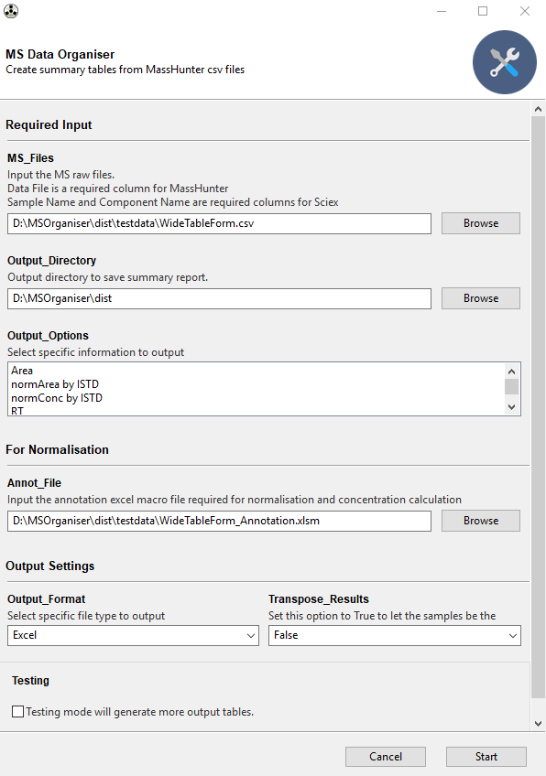

# Exporting MRM transition names data

MSOrganiser currently supports certain MRM transition names data format.

## Exporting MRM transition names data from MassHunter by Agilent

### WideTable Form

Ensure that you are viewing the MRM transition names data under “Flat Table” and “Display Multiple Compounds/Sample in Batch Table”

|  |  |
| --- | --- |
|  |  |

Ensure that “Data File” is present under the Sample Column as it will be used

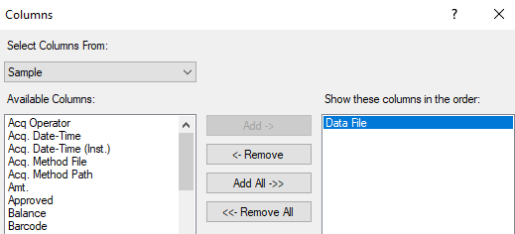

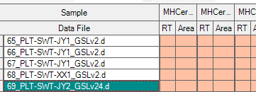

Click on File -> Export -> Export Table

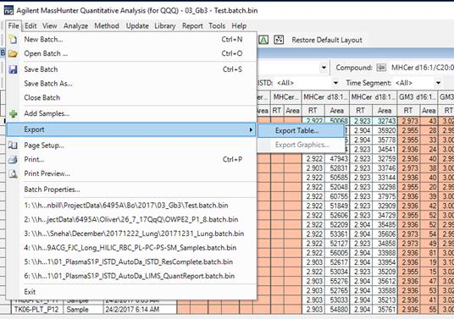

Choose File type as csv

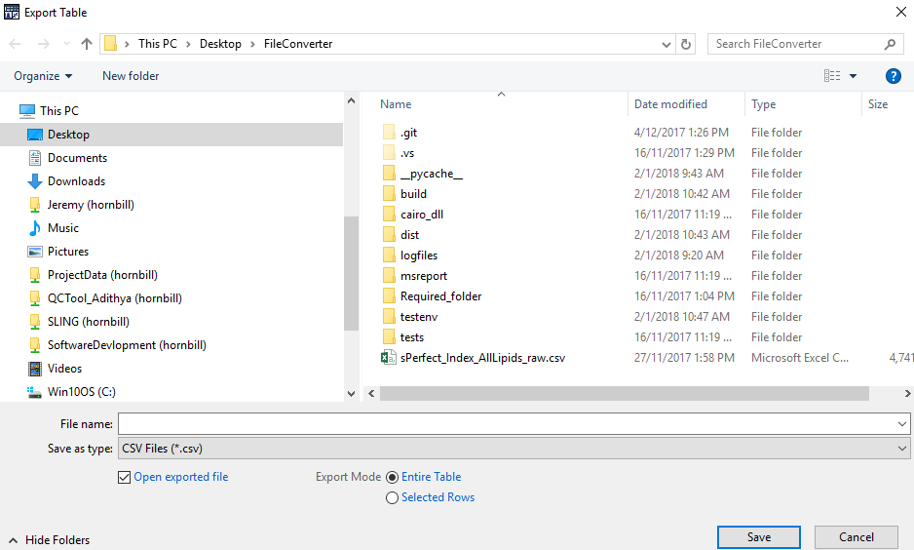

The exported raw data should look like this

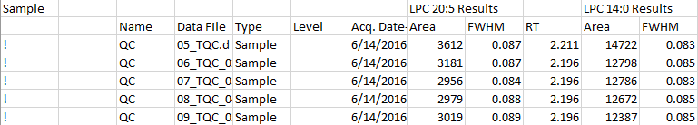

### CompoundTable Form

Ensure that you are viewing the MRM transition names data under “Compound Table” and “Display Multiple Compounds/Sample in Batch Table”

|  |  |
| --- | --- |
|  |  |

Ensure that “Name” is present under the Compound Method Column.

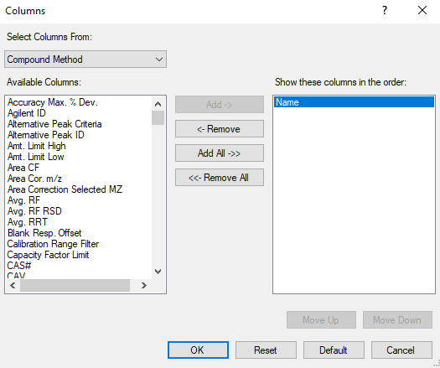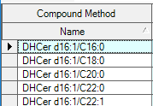

Ensure that “Data File” is present under the Sample Column.

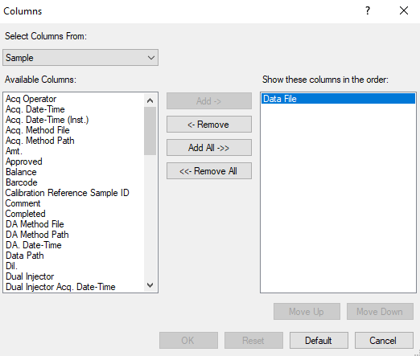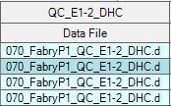

Click on File -> Export -> Export Table

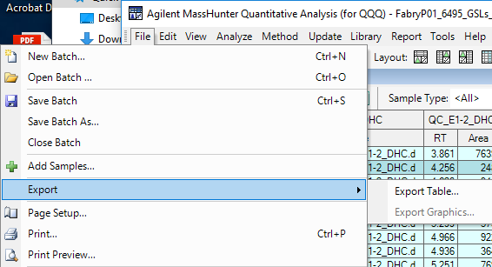

Choose File type as csv

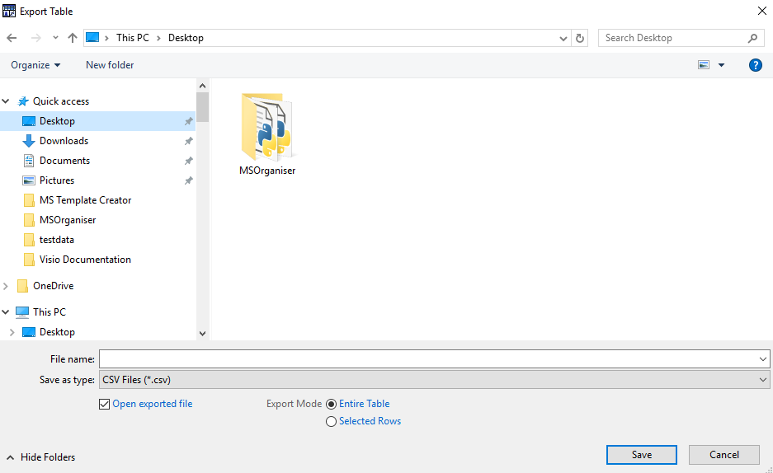

The exported raw data should look like this

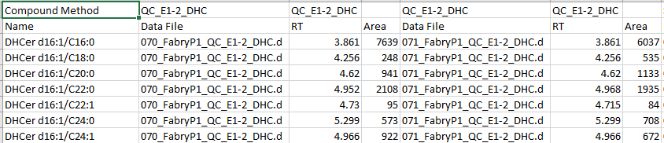

## Exporting MRM transition names data from MultiQuant by SciEx

Open your MultiQuant session file, in MultiQuant



You will see this

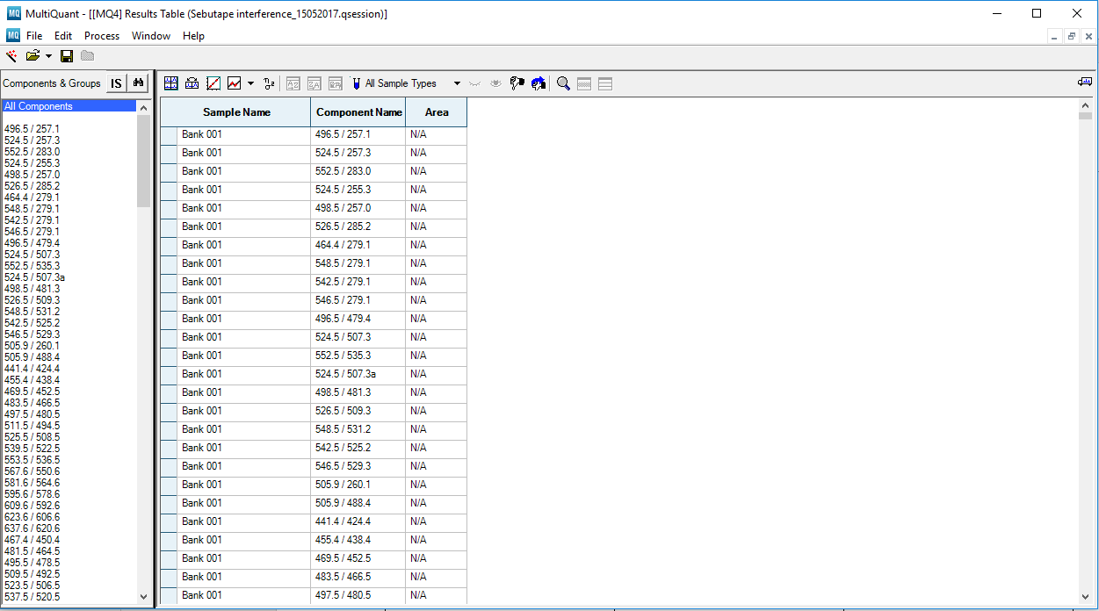

Right click on the “Results Table”. Click on “Column Settings”

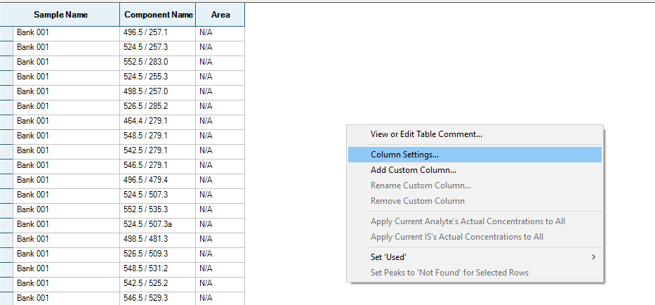

Choose your relevant columns that you wish to display in the “Results Table” and click Ok.

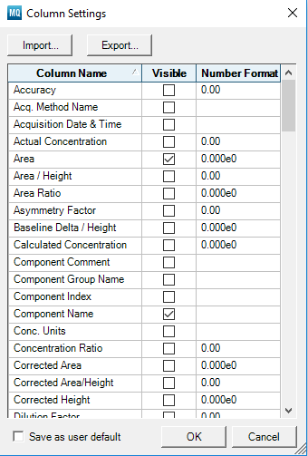

The relevant columns are as follows:

|  |
| --- |
| Compulsory Columns |
|  |
|  |
| Output Options |
|  |
|  |
|  |
|  |

The output will look like this

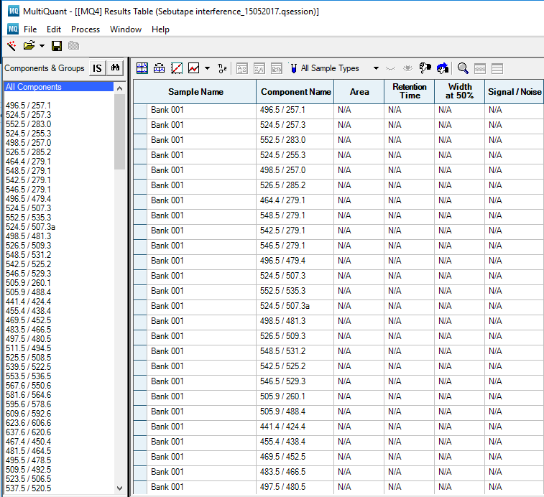

To export the file correctly, make sure “All Components” is selected

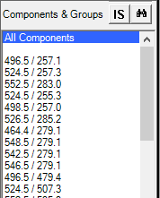

Click on File -> Export -> Results Table… You will see

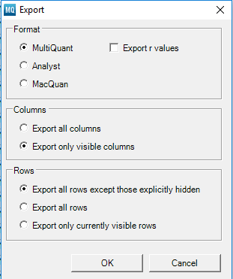

Just keep the settings the same as the above figure and click Ok.

You will now need to select the folder to output the text file. Click Save

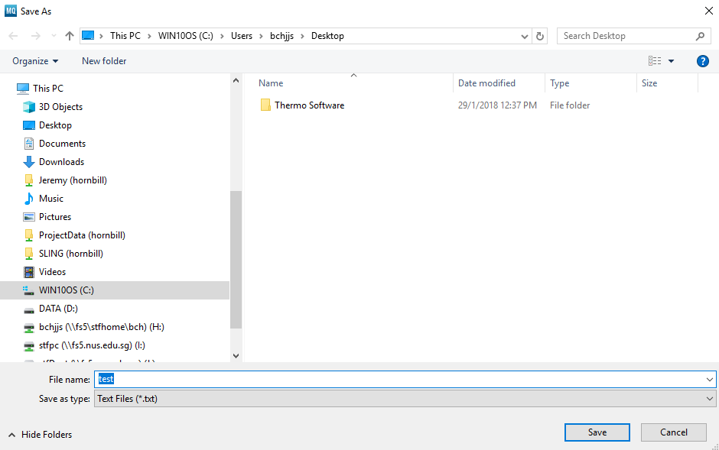

MultiQuant will save a text file which looks like this

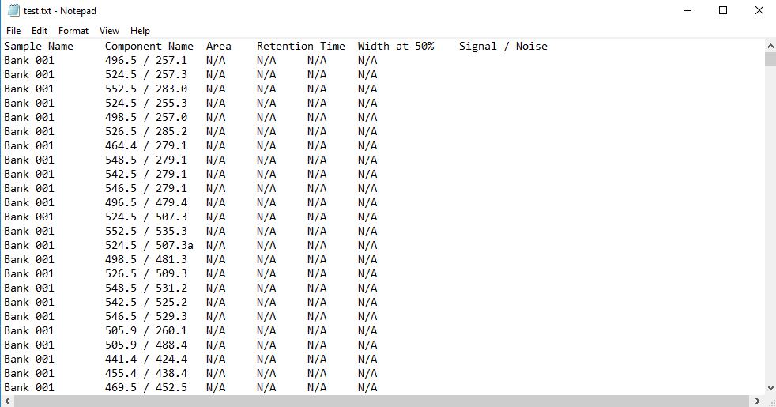

# Data extraction/calculation from MRM transition names data

MSOrganiser is able to extract the following information from the MRM transition name data and output as an Excel or csv file.

Table 4‑1: Things you can extract out from MRM transition name data

|  |  |  |
| --- | --- | --- |
| MSOrganiser Output Options | MassHunter from Agilent | Quant from SciEx |
| Area | Area | Area |
| RT | RT | Retention Time |
| FWHM | FWHM | Width at 50% |
| S/N | S/N | Signal / Noise |

## Data Extraction Steps

Ensure that the MRM transition name data are exported properly as described in 3.

Under the MS_Files section, click on Browse to select your input file

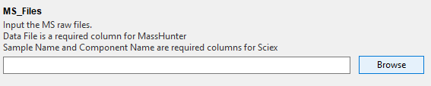

And choose the files. You may pick more than one.

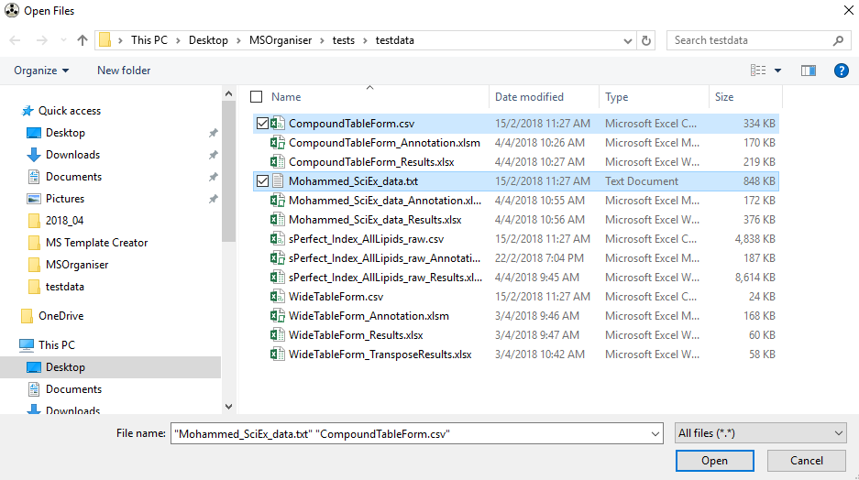

The files that you have chosen will be recorded.

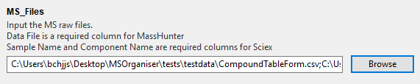

Under the Output_Directory section, click on Browse to select the folder where you wish to output your data.

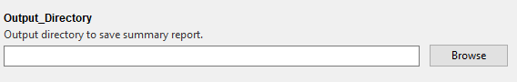

You can only select one directory

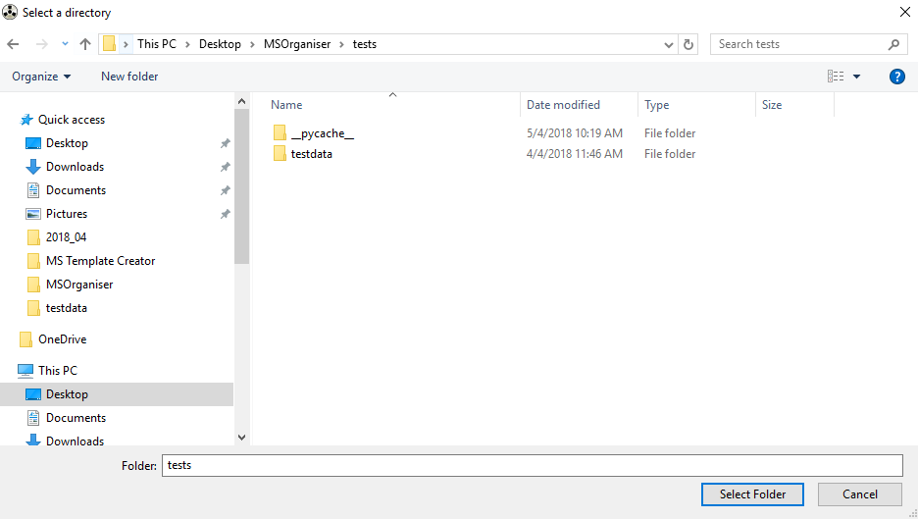

The output folder that you have chosen will be recorded.

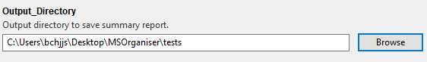

Under the Output_Options section, click on the information that you wish to extract from your data. For the list of what kind of info can be extracted, refer to Table 4.1

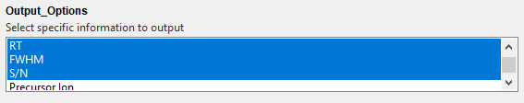

When you are done click Start.

The machine will pop out this message box below when it has finished the data extraction successfully.

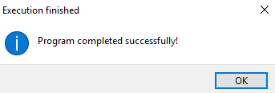

In the output folder, you will be a able to see an excel file containing the extracted data as well as a pdf file containing a report for each data set chosen earlier.

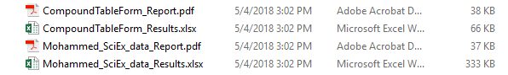

Extracted data will look like this

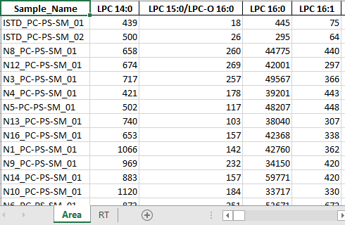

The machine also indicate the status of its extraction process.

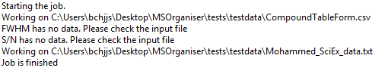

Warnings will be given out when there is something is not right with the input file.

## Data Calculation Steps

With the addition of the MS Annotation Template Creator, we are able to create additional annotation information that will allows us to do additional calculation with the MSOrganiser.

To this date, MSOrganiser can do the following calculations

Equation 4‑1: Equation for normArea by ISTD

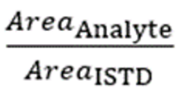

Equation 4‑2: Equation for normConc by ISTD

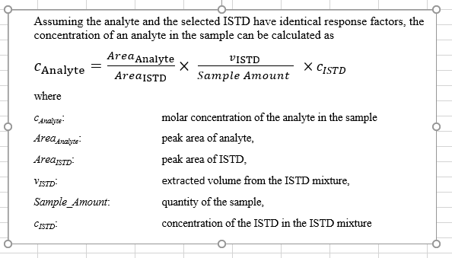

The requirements to perform these calculations are as follows:

Table 4‑2: Calculation requirements

|  |  |  |
| --- | --- | --- |
| MSOrganiser Output Options | MRM transition name data requirements | MS Annotation Template Creator requirements |
| normArea by ISTD | Peak Area | Transition_Name_Annot sheet filled correctly |
| normConc by ISTD | Peak Area | Transition_Name_Annot, ISTD_Annot and Sample_Annot sheet filled in corrrectly |

Samples of the completed sheets are as follows:

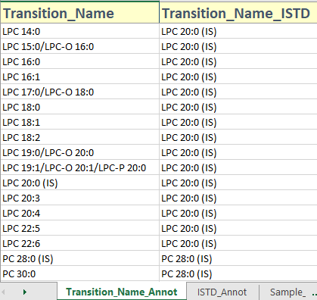

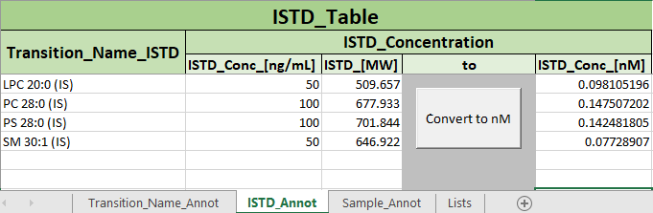

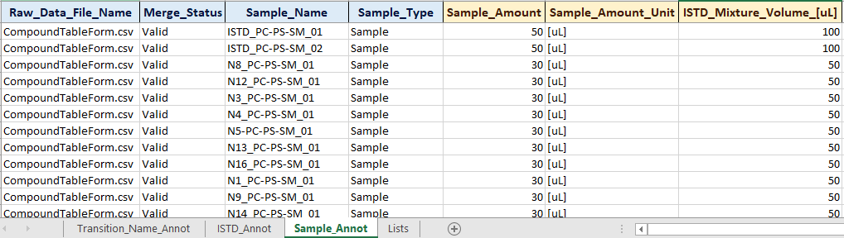

The procedures on how to fill in the sheet correctly in MS Annotation Template are not discussed here. Users can refer to the *.xlsm file in test data set for example

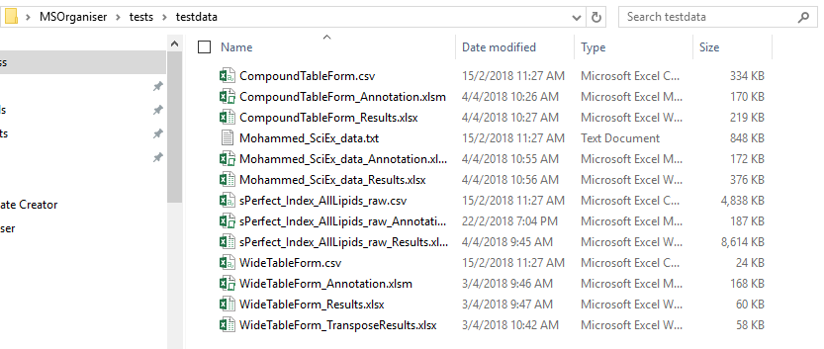

The steps are similar to 4.1 except for these additional changes

Firstly, you will need to select the output options listed in Table 4-2

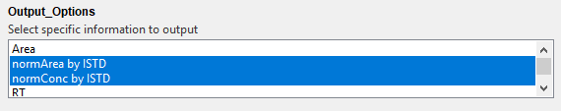

Secondly, you will need to input the MS Template Creator Excel Macro file under the ISTD_Map section. Click on Browse

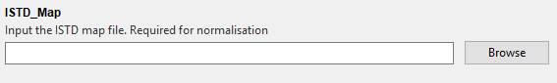

You can only select one Excel Macro file

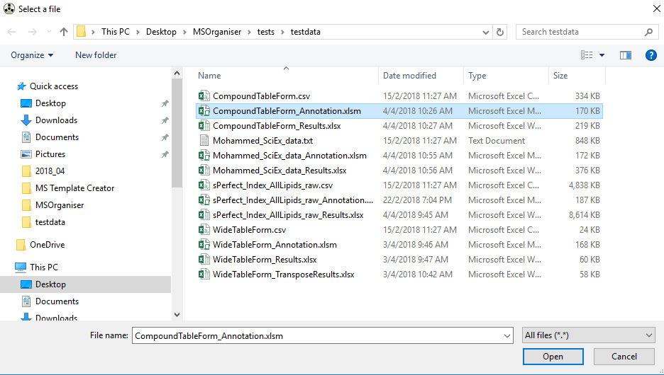

The file that you have chosen will be recorded.

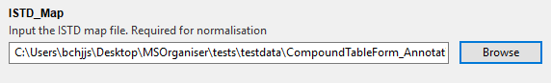

Click on Start.

The machine will pop out this message box below when it has finished the data extraction successfully.



In the output folder, you will be a able to see an excel file containing the extracted data as well as a pdf file containing a report for each data set chosen earlier.



Extracted data will look like this

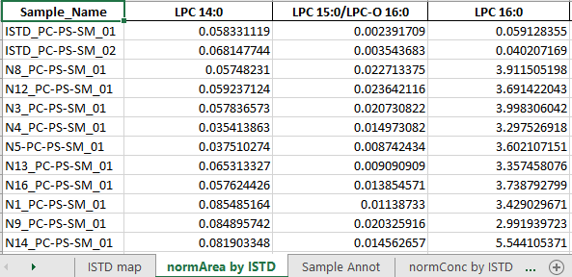

# Other Features in MSOrganiser

## Output_Format

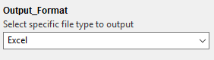

We only have two ways to output the file which is in Excel and csv.

## Transpose_Results

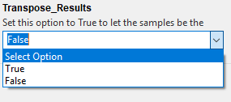

By default, this is set to False. Setting it to True will transpose your output data.

No Transpose Output

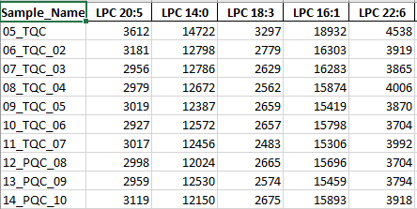

Transposed Output

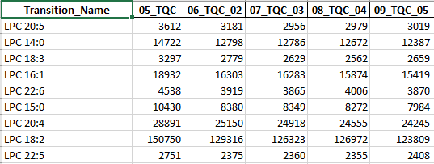

## Testing Mode

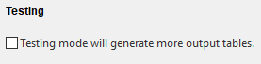

You may check this box if you wish to run the program on testing mode.

The purpose of the testing mode is to generate more output sheets to check for logical errors

By default, this is set to False and will not be saved.

## Saving your settings with a Json file

When you open MSOrganiser for a second time, you will realise that MSOrganiser is able to remember your previous settings. This is due to the presence of a json file created when the software starts to run



To clear your settings, just delete the json file.

## Log files

MSOrganiser also keep some log files to keep track of its work status and save any warnings that you have missed.

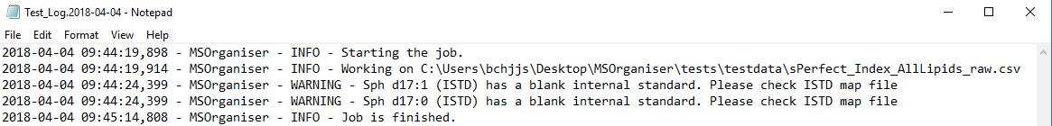

Currently MS Organiser is able to keep track of log files for three days.

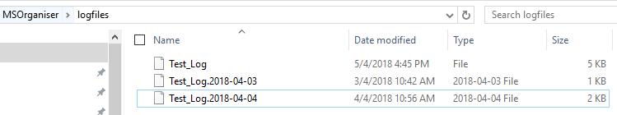

# Errors, Warnings and Troubleshooting

MSOrganiser is able to issue some warnings and error messages when there is something wrong with the data set.

We provide the following known warnings and errors and ways to troubleshoot them.

## Parsing problems from MSOrganiser

|  |  |
| --- | --- |
| Warning/Error Messages | Troubleshooting procedures |
| Please key in at least one input MS file | Ensure that this is filled |
| Please key in at least one output directory | Ensure that this is filled |
| Please key in at least one result to output | Ensure that this is filled |
| Warning: Unable to save input settings in {file_path} due to this error message. {error_message} | MSOrganiser has problems trying to output the json file. Ensure that MSOrganiser is in a folder with read and write permissions. |
| Unable to create log directory in {file_path} due to this error message. {error_message} | MSOrganiser has problems trying to create a log directory to output its log files. Ensure that MSOrganiser is in a folder with read and write permissions. |

## Reading MRM transition names data related problems

### In General

|  |  |
| --- | --- |
| Warning/Error Messages | Troubleshooting procedures |
| {file_path} is empty. Please give an input file | Ensure that this is filled |
| Filepath {file_path} could not be found  {file_path} does not exists. Please check the input file | While the MS_Files entry is filled with at least one file path, the software could not find the file based on the file path. Ensure that the file path is correct. |
| Filepath {file_path} is not a file | While the MS_Files entry is filled with at least one file path, the software thinks it is not a file but something else, example a directory. Ensure that the file path is correct. |
| {file_path} is an empty file. Please check the input file | The MS_Files has no data. Please output the MS file correctly |

### MassHunter from Agilent

|  |  |
| --- | --- |
| {file_path} is not in Wide Table or Compound Table form. Please check the input file. | The software could not identify if the MassHunter MRM transition name data file is in the WideTable or CompoundTable form. Please output the file from MassHunter correctly. |
| {Some Output_option} is not a valid column in MassHunter or not available as a valid output for this program. | The software finds an invalid output option for MassHunter’s MRM transition name data. Current accepted output options are  ('Area', 'RT', 'FWHM', 'S/N' , 'Precursor Ion', 'Product Ion') |
| {file_path} has no column “Name” in Compound Method. Please check the input file | The software recognises that it is a MassHunter’s MRM transition name data in the CompoundTable form. However, it does not have the column “Name” containing the transition names |
| {file_path} has no column “Data File”. Please check the input file | There are two possible reasons why this can happen  The software recognises that it is a MassHunter’s MRM transition name data in the WideTable form. However, it does not have the column “Data File” containing the sample names    The software recognises that it is a MassHunter’s MRM transition name data in the CompoundTable form. However, it does not have the column “Data File” containing the sample names |
| Unable to read csv file with the available encoders. (Or any errors related to pd.read_csv ) | Currently, MSOrganiser uses the following encoders in order to read the csv file.  ["ANSI","ISO-8859-1","utf-8"].  This implies that Agilent Masshunter may use a different encoder to create the csv file. By right a csv file should be encoded in UTF-8…  Please send your data to the developers for testing |

### Quant from SciEx

|  |  |
| --- | --- |
| Warning/Error Messages | Troubleshooting procedures |
| {file_path} must have Sample Name and Component Name present in the Sciex file. | The Sciex Text file is missing the “Sample Name” and the “Component Name” column. |
| {Output_option} is not a valid column in Sciex or not available as a valid output for this program | The software finds an invalid output option for Quant’s MRM transition name data. Current accepted output options are  ('Area', 'RT', 'FWHM', 'S/N' ) |

## Reading MS Annotation Template Creator related problems

|  |  |
| --- | --- |
| Warning/Error Messages | Troubleshooting procedures |
| A ISTD map file is required to perform this calculation | The software is unable to perform the calculation because the ISTD map file is empty. Ensure that this is filled. |
| {file_path} does not exists. Please check the input file. | While the ISTD map entry is filled with a file path, the software could not find the file based on the file path. Ensure that the file path is correct. |
| This program no longer accept csv file as input for the ISTD map file. Please use the excel template file given | We do not accept csv file as an input for the ISTD_map file. Please use the MS Annotation Template Creator Excel Macro file. |
| Unable to read excel file {file_path} | The input seems to be an invalid excel file which could not be read by the software. Ensure that the Excel Macro file is uncorrupted. |
| Sheet name {sheet_name} does not exists. Please check the input excel file. | The MS Annotation Template Creator is missing some important sheets. Please do not modify the sheet names. |
| The input {sheet_name} has no data. | While the sheet exists, the software realise there is no data in the excel sheet. Please check that the excel sheet template is not modified. |
| The {col_name} in the {sheet_name} has duplicate transition names at row {some_number} | In the “Transition _Name_Annot” sheet, “Transition_Name” column has duplicated transition name which is not allowed. Please correct the Excel sheet. |
| Sheet ISTD_Annot is missing the column Transition_Name_ISTD at position A2  Sheet ISTD_Annot is missing the column ISTD_Conc_nM at position E3 | In the ISTD_Annot sheet, the important column names could be modified or it has shifted to another cell. Please do not change the column name or shift it around. |

## Calculation issues

### normArea calculation

|  |  |
| --- | --- |
| Warning/Error Messages | Troubleshooting procedures |
| There are Transition_Name_ISTD in Transition_Name_Annot not mentioned in ISTD_Annot  {Some lists of Transition_Name_ISTD } | Please ensure that these Transition_Name_ISTD are in the sheet ISTD_Annot. |
| The input data frame does not contain the column Sample_Name. If input raw file is from MassHunter, make sure the column Data File is present. If input raw file is from Sciex, make sure the column Sample Name is present | The transition name data frame is missing the sample names. Please check the input file. |
| The sample annotation file does not contain the column Sample_Name | The sample annotation data frame does not have no column “Sample_Name”. Please ensure that the column “Sample_Name” in the excel sheet has not been removed. |
| There are Transition_Names in data set not mentioned in the Transition_Name_Annot sheet.  {Some lists of Transition Name} | Please ensure that all transition names are indicated in the “Transition Name” column in the Transition Name Annot sheet. |
| There are Transition_Names in data set with more than one Transition_Name_ISTDs mentioned in the Transition_Name_Annot sheet.  {Some lists of Transition Name} | Please ensure that there are no duplicate transition names in the “Transition Name” column in the Transition Name Annot sheet. |
| There are Transition_Names in data set mentioned in the Transition_Name_Annot sheet but have a blank Transition_Name_ISTD.  {Some lists of Transition Name} | Please ensure that all ISTD are filled in the “Transition Name ISTD” column in the Transition Name Annot sheet. |
| There are Transition_Name_ISTDs in the Transition_Name_Annot sheet that cannot be found in data set.  {Some lists of Transition Name ISTD} | Please ensure that all ISTD are present in the MRM transition data set. |
| There are Transition_Name_ISTDs in the Transition_Name_Annot sheet that are duplicated in data set. Please check input file  {Some lists of Transition Name ISTD} | Please ensure that the MRM transition data set has a unique ISTD reading |
| {Some Transition Name} has an invalid Transition_Name_ISTD of {Some ISTD}. Please check ISTD map file | The Excel file has a strange ISTD input that the software cannot recognise or able to handle. |
| The input Transition_Name data frame has no data. Skipping normalisation by Transition_Name_ISTD | The transition name data frame is empty. The MS_Files could have no data. Please output the MS file correctly. |

### normConc Calculation

|  |  |
| --- | --- |
| Skipping step to get normConc. The input Transition_Name data frame has no data. | The transition name data frame is empty. The MS_Files could have no data. Please output the MS file correctly. |
| Skipping step to get normConc. The input ISTD_Annot data frame has no data. | The ISTD_Annot data frame is empty. Please ensure that the Transition_Name_Annot and the ISTD_Annot sheet is filled up as there are used to create the ISTD_Annot data |
| {Some ISTD column} is not a column in the ISTD_Annot sheet. Returning an empty data frame | Please ensure that this column is not modified or removed in the ISTD_Annot sheet. |
| Skipping step to get normConc. ISTD_Annot sheet does not have column name ISTD_Conc_[nM]. | The ISTD_Annot data frame does not have no column “ISTD_Conc_[nM]”. Please ensure that the column “ISTD_Conc_[nM]” in the excel sheet “ISTD_Annot” has not been removed. |
| Skipping step to get normConc. The Sample Annotation data frame has no data. | The Sample_Annot data frame is empty. Please ensure that the SAmple_Annot sheet is filled up |
| Skipping step to get normConc. Sample Annotation data frame is missing column  {list of columns} | Please ensure that these columns are not removed or modified in the excel sheet “Sample_Annot” |

## Output to Excel problems

|  |  |
| --- | --- |
| Warning/Error Messages | Troubleshooting procedures |
| {Some Output_option} has no data. Please check the input file | The software is unable to extract this output option info as it is not presence in the MRM transition name file in the first place. Please check the file and export the file correctly if this information is truly missing. |
| Unable to save Excel file due to {error_message} | MSOrganiser has problems trying to create an excel file to output its results. Ensure that MSOrganiser is in a folder with read and write permissions. Ensure that the excel is sheet is not opened before overwriting it. |

## Report creation problems

|  |  |
| --- | --- |
| Warning/Error Messages | Troubleshooting procedures |
| Parameters_df is empty | This implies that there are no parameters input for the MSOrganiser to report. Ensure that these are filled |
| Cannot locate MSreport resources. It seems that the program was frozen, but resource files were not copied into directory of the executable file. Please copy `msreport` folders from gooey module directory into {resource_dir_path} directory. Using PyInstaller, a.datas in .spec file must be specified | This error message is copied and pasted from the Gooey package. Please ensure that all resource files are copied into resource directory path indicated. See the Developers documentation for more info on what needs to be in the resource directory. |