MS Template Creator

Developer Documentation

Version 0.0.6

2018

# Version Control Table

|  |  |
| --- | --- |
| **Title** | MS Template Creator Developer Documentation |
| **Created By** | Jeremy John Selva |
| **Date Created** | 27 March 2018 |
| **Maintained By** | Jeremy John Selva |

|  |  |  |  |  |
| --- | --- | --- | --- | --- |
| **Version Number** | **Modified By** | **Date Modified** | **Modifications Made** | **Status** |
| 0.0.6 | Jeremy John | 28 Sept 2021 | Changed   * 6. Code Structure Overview   Added   * 7 b) ix Concentration_Unit module * 7 d) iv Concentration_Unit_Test module * 7 f) i Autofill_By_Sample_type * 7 f) vi Concentration_Unit_MsgBox * 7 f) x Load_Transition_Name_Tidy | Draft |
| 0.0.5 | Jeremy John | 14 Aug 2021 | Changed   * 7 b) i “Button” module * 10 Code Update guidelines | Draft |
| 0.0.4 | Jeremy John | 9 Mar 2021 | Added   * 7 a) vii Load_Tidy_Data module * 7 d) ii Load_Tidy_Data_Test module * 7 f) vii Load_Sample_Annot_Raw * 7 f) viii Load_Sample_Annot_Tidy * 8 a) iv Categorising Unit Test | Draft |
| 0.0.3 | Jeremy John | 28 Jan 2021 | Added   * 5a) iv 64-bit compatibility * 10d) Dilution_Annot changes * 10e) Additional help | Draft |
| 0.0.2 | Jeremy John | 21 Aug 2018 | Added   * 2. Code Repository * 5. Excel Add-Ins * 8. Unit and Integration Test * 9. Version Control   Changed   * 6. Code Structure Overview * 7. Code Structure Details | Draft |
| 0.0.1 | Jeremy John | 3 May 2018 | Initial commit and review | Draft |

# Content Page

Version Control Table 1

Content Page 2

1. Introduction 4

a) Purpose 4

b) Scope 4

c) Displaying the developer tab on the toolbar 4

2. Code Repository 4

3. Excel Column Settings 4

4. Excel Buttons and Textboxes Settings 5

a) Buttons Settings 5

i. Code in the Buttons 5

ii. Moving Buttons 5

iii. Buttons format 5

b) Textboxes Settings 6

5. Excel Add-Ins 6

a) Rubberduck 6

b) Excel VBA Developer Tools 7

i. Microsoft Visual Basic for Applications Extensibility 5.3 7

ii. Trust access to Visual Basic Project 8

iii. Enable the Excel VBA Developer Tools 9

iv. 64-bit compatibility 10

6. Code Structure Overview 12

7. Code Structure Details 13

a) Vba Dependencies 13

b) Annotation Creating Modules 13

i. “Button” module 13

ii. Utilities module 13

iii. Transition_Name_Annot module 13

iv. ISTD_Annot module 13

v. Sample_Annot module 13

vi. Load_Raw_Data module 14

vii. Load_Tidy_Data module 14

viii. Sample_Type_Identifier module 14

ix. Concentration_Unit module 14

c) Sheet Tracking Modules 14

i. ColourTracker 14

d) Unit Test Modules 14

i. Load_Raw_Data_Test module 14

ii. Load_Tidy_Data_Test module 14

iii. Sample_Type_Identifier_Test module 14

iv. Concentration_Unit _Test module 14

v. Utilities Test module 14

e) Integration Test Modules 14

i. Integration_Test module 14

f) Forms 14

i. Autofill_By_Sample_Type 14

ii. Clear_Dilution_Annot 14

iii. Clear_ISTD_Table 15

iv. Clear_Sample_Annot 15

v. Clear_Transition_Name_Annot 15

vi. Concentration_Unit_MsgBox 15

vii. Invalid_ISTD _MsgBox 15

viii. Load_Sample_Annot_Raw 15

ix. Load_Sample_Annot_Tidy 15

x. Load_Transition_Name_Tidy 15

xi. Overwrite 15

8. Unit and IntegrationTest 15

a) Rubberduck for unit testing 15

i. Initialising the Rubberduck 15

ii. Opening the Unit Test 16

iii. Adding a new unit test module 17

iv. Categorising Unit Test 18

v. Running the Unit Test 18

b) Integration Test 19

9. Version Control 20

a) Exporting modules using Excel VBA Developer Tools 20

b) Importing modules using Excel VBA Developer Tools 22

10. Code Update guidelines 23

a) Transition_Name_Annot changes 23

i. Changes in the name of the column where the transition name is placed 23

ii. Changes in the name of the column where the transition name ISTD is placed 24

iii. Changes in the sheet name 26

b) ISTD_Annot changes 27

i. Changes in the name of the column where the transition name ISTD is placed 27

ii. Changes in the column name used in the calculation of ISTD concentration from ng/ML to nM 28

iii. Changes in the sheet name 30

c) Sample_Annot changes 30

i. Changes in the column names for MRM transition name data input 30

ii. Changes in the column names for sample annotation input 32

iii. Changes in the sheet name 33

iv. Changes in the listbox in Sample_Type and Sample_Amount_Unit 34

d) Dilution_Annot changes 34

i. Changes in the name of the column where raw data file name and sample name is placed. 34

ii. Changes in the sheet name 35

e) Additional help 36

# Introduction

## Purpose

This document highlights the Excel VBA code structure for MS Template Creator.

The excel macro is created to provide users a more friendly interface to take in raw data exported directly from the mass spectrometry machines and create several annotation templates suited for automated data processing and statistical analysis.

## Scope

This guide will assist developers to understand the organisation of the code structure. We are still working on making the codes more modular so that changes in the feature of the MS Template Creator will require minimal efforts

## Displaying the developer tab on the toolbar

As the excel sheet contains macros, to modify the codes, the developer tab must be present in the toolbar.

Refer to <https://www.excel-easy.com/examples/developer-tab.html> to display the developer tab

# Code Repository

The codes can be found in <https://github.com/SLINGhub/MSTemplate_Creator>

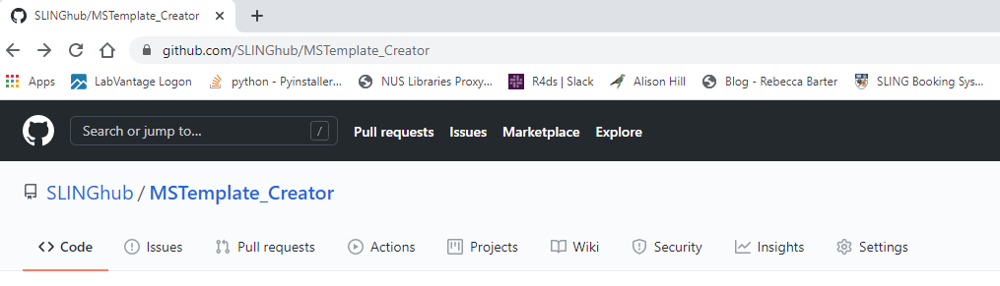

# Excel Column Settings

All headers in the excel column are fixed using Data validation

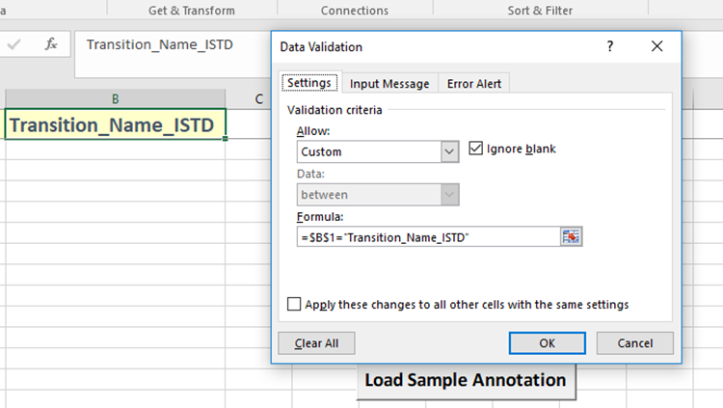

To change the column names in the excel sheet, you must disable the validation criteria first.

Please note that by changing the column names, the code in the macro file will be needed to be updating in order to be in working condition.

The updating steps can be found on Section “Code Updating Guidelines”

# Excel Buttons and Textboxes Settings

## Buttons Settings

### Code in the Buttons

Buttons in excel are Active X control to ensure that they can be moved around freely. However, their codes will be sheet specific

Deleting the sheet will cause these sheets’ specific function to be deleted. Remember to back up the code before deleting the script

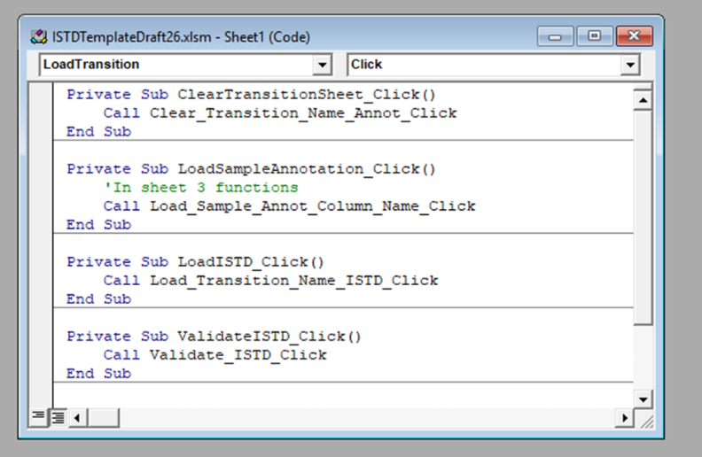

All functions in the sheet leads to the Button Module.

### Moving Buttons

To move the button, go to the Developer tab and click on “Design Mode”

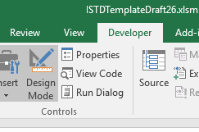

### Buttons format

All buttons are set to this format property

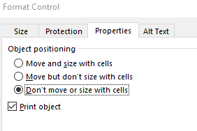

We take into consideration that users will change the number of rows more often than to change the number of columns.

If the number of columns need to be changed of resized, the buttons will not move with the columns. To move the button manually, refer to Section “Moving Buttons”.

## Textboxes Settings

All textboxes are set to this format shape property

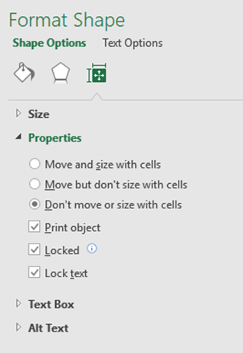

We take into consideration that users will change the number of rows more often than to change the number of columns.

If the number of columns need to be changed of resized, the textboxes will not move with the columns. There will be a need to move the textbox manually.

# Excel Add-Ins

## Rubberduck

The RubberDuck is used to create a fully integrated test environment for the VBA codes in MS Template Creator.

It can be installed in <http://rubberduckvba.com/>

A successful installation will give an additional “Rubberduck” tab in Microsoft Visual Basic for Applications

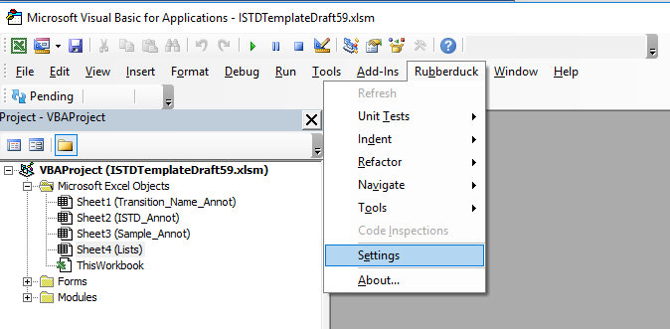

## Excel VBA Developer Tools

The Excel VBA Developer Tools is used to convert the VBA codes in the Excel macro file to text files. These text files can then be monitored by Git and send to Bitbucket for Version Control of the VBA scripts.

It can be installed in http://vbatools.sourceforge.net/

Please following the instructions given in the webpage carefully.

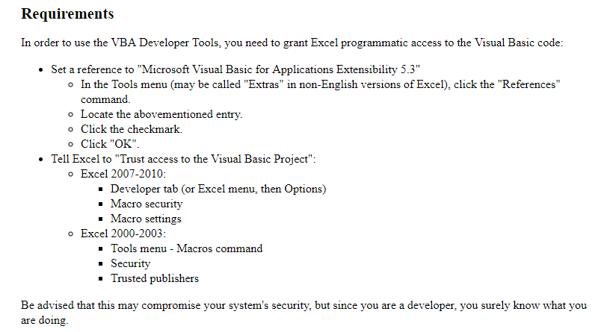

### Microsoft Visual Basic for Applications Extensibility 5.3

To do so open the Visual Basic in Excel in the Developer Tab.

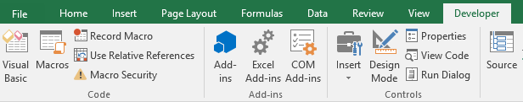

Click on Tools -> Reference

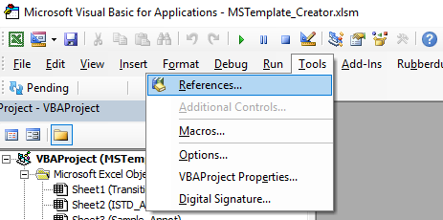

Look for Microsoft Visual Basic for Applications Extensibility 5.3 and click on the check box.

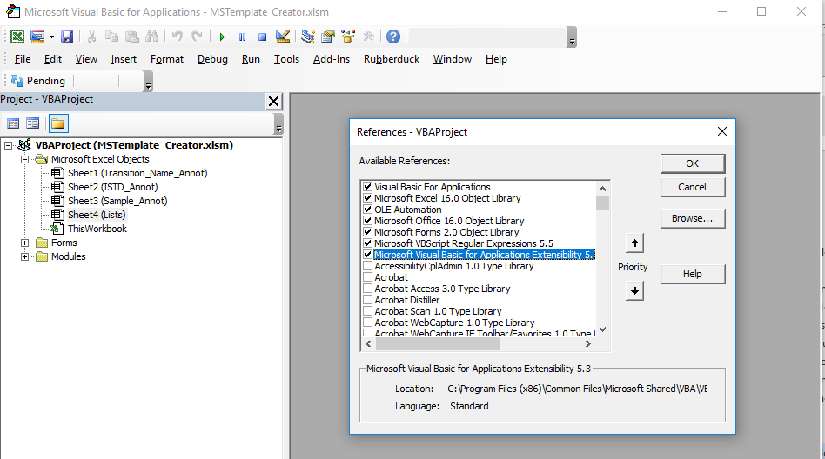

### Trust access to Visual Basic Project

To do so go to File tab. Click on Options. Click on Trust Center

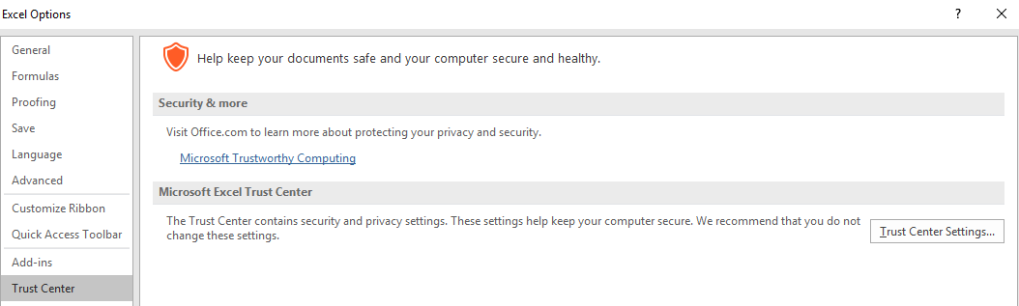

Click on Trust Center Settings and then Macro Settings. Check the box Trust access to the VBA project object model. Click Ok

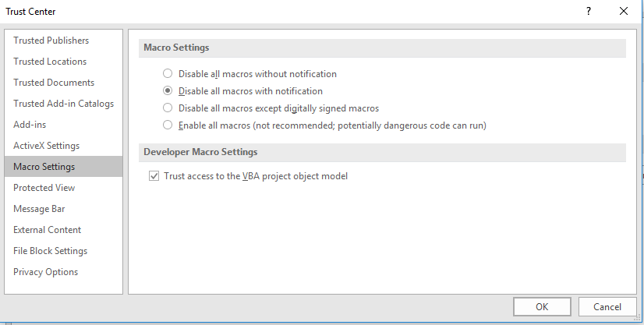

### Enable the Excel VBA Developer Tools

When the Excel VBA Developer Tools is downloaded, it will appear as an Excel Add-In file.



You must manually add this Excel Add In file when you need to use it.

To do so, on the Developer Tab, click on “Excel Add-Ins”



Browse for that Excel Add-In file

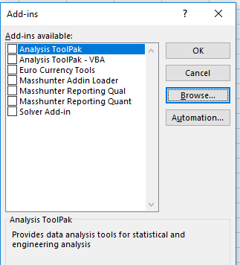

When it is added, it will look like this. Click Ok

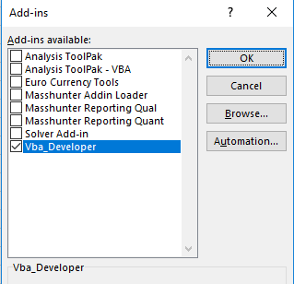

To check that it is working, open the Visual Basic in the Developer Tab. You will see an additional tab called “XL Dev Tools”

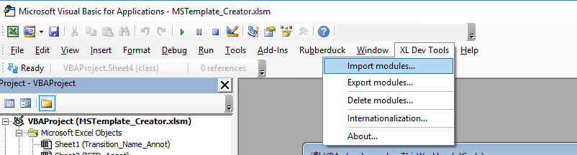

Note:

Each time that you close Microsoft Excel, this Add-In will be disabled automatically even though there is a tick on the check box.

To call it again, just uncheck the box, click Ok. Reopen the Excel Add-In box, rechecked the VBA Developer box and click Ok.

### 64-bit compatibility

Unfortunately, Excel VBA Developer Tools is meant to be used with 32-bit application. When you load the Add in for the first time, the following error may pop up

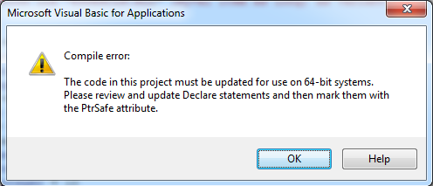

From <https://docs.microsoft.com/en-us/office/vba/language/concepts/getting-started/64-bit-visual-basic-for-applications-overview> ,

The key to resolve this error is to add the “PtrSafe” keyword beside each Declare in the source code of Excel VBA Developer Tools

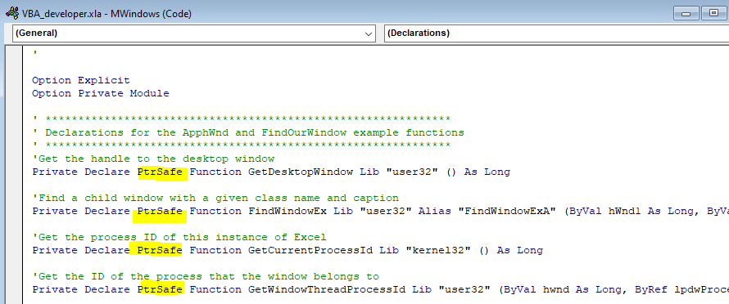

More info in <https://docs.microsoft.com/en-us/office/vba/language/reference/user-interface-help/ptrsafe-keyword>

# Code Structure Overview



# Code Structure Details

## Vba Dependencies



## Annotation Creating Modules

### “Button” module

The Button module serves as an interface/wrapper between the Active X buttons in the excel sheets to the modules are user forms in e\Excel VBA.

Please ensure that new Active X buttons are directed to this module first before linking it to other modules.

A total of four button modules are created for each excel sheet.

* Transition_Name_Annot_Buttons
* ISTD_Annot_Buttons
* Sample_Annot_Buttons
* Dilution_Annot_Buttons

### Utilities module

The Utilities module are a collection of functions that is mostly used throughout the excel macro file. All forms and modules depend on this Utilities module. Please change this file with caution.

### Transition_Name_Annot module

Functions that are applied only the sheet “Transition_Name_Annot” should be written in this module.

### ISTD_Annot module

Functions that are applied only the sheet “ISTD_Annot” should be written in this module.

### Sample_Annot module

Functions that are applied only the sheet “Sample_Annot” and to create arrays directly from Sample Annotation files should be written in this module.

### Load_Raw_Data module

Functions that are designed to create arrays directly from Mass spec raw data files are to be written there.

### Load_Tidy_Data module

Functions that are designed to create arrays from csv files that in a in table form.

### Sample_Type_Identifier module

Functions to help identify the Sample Type from the Sample Name using regular expression are to be written there.

### Concentration_Unit module

Functions to help identify the correct final concentration unit given the Sample Amount Unit from the Sample_Annot sheet and the ISTD Concentration Custom Unit used from the ISTD_Annot sheet.

## Sheet Tracking Modules

### ColourTracker

Functions to add colours to cell when it has been modified unnecessarily. It only runs on Sheet 1 (Transition_Name_Annot) and Sheet 2 (ISTD_Annot)

## Unit Test Modules

### Load_Raw_Data_Test module

Functions to test the Load_Raw_Data module for logical errors.

### Load_Tidy_Data_Test module

Functions to test the Load_Tidy_Data module for logical errors.

### Sample_Type_Identifier_Test module

Functions to test the Sample_Type_Identifier module for logical errors

### Concentration_Unit _Test module

Functions to test the Concentration_Unit module for logical errors

### Utilities Test module

Functions to test the Utilities module for logical errors.

## Integration Test Modules

### Integration_Test module

Functions to run an integration test for MS Template Creator.

## Forms

### Autofill_By_Sample_Type

UserForm and Functions to autofill the Sample_Amount, Sample_Amount_Unit and the ISTD_Mixture_Volume_[uL] column by a fixed value based on a given Sample_Type.

### Clear_Dilution_Annot

UserForm and Functions to clear columns in sheet “Dilution_Annot”

### Clear_ISTD_Table

UserForm and Functions to clear columns in sheet “ISTD_Annot”

### Clear_Sample_Annot

UserForm and Functions to clear columns in sheet “Sample_Annot”

### Clear_Transition_Name_Annot

UserForm and Functions to clear columns in sheet “Transition_Name_Annot”

### Concentration_Unit_MsgBox

UserForm and Funtions to indicate what concentration units are generated automatically in sheet “Sample_Annot”

### Invalid_ISTD _MsgBox

UserForm and Functions to highlight to users of potential invalid ISTD

### Load_Sample_Annot_Raw

UserForm and Functions to help users load Sample Annotation from raw data file

### Load_Sample_Annot_Tidy

UserForm and Functions to help users load Sample Annotation from csv files in table form.

### Load_Transition_Name_Tidy

UserForm and Functions to help users load Transition Annotation from csv files in table form.

### Overwrite

UserForm and Functions to ask users if a particular column should be overwritten or not.

# Unit and IntegrationTest

## Rubberduck for unit testing

### Initialising the Rubberduck

When you open the Visual Basic from the Developer Tab, Rubberduck is not activated yet.

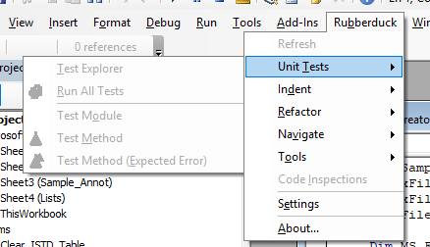

To start the Rubberduck, click on “Pending”

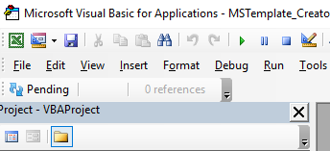

When it appears as “Ready”, you can start the unit testing

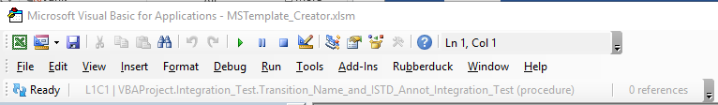

If it appears like this

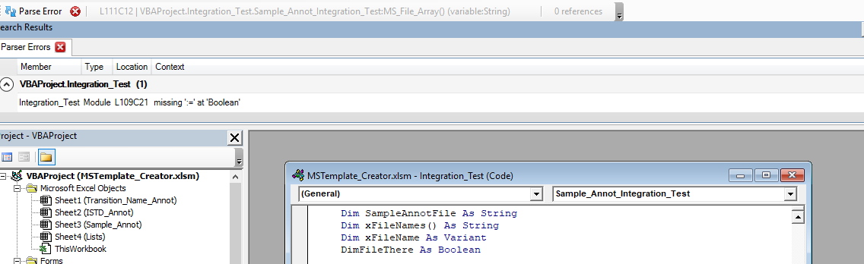

It means you have a syntax error (Should be “Dim FileThere” instead of “DimFileThere”) and Rubberduck clearly cannot proceed with unit testing on codes with bugs.

### Opening the Unit Test

To start the unit testing, go to Rubberduck, Unit tests, Test Explorer

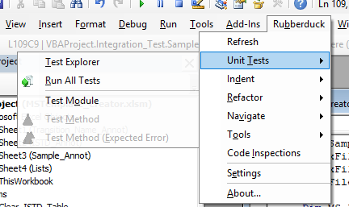

You will see this

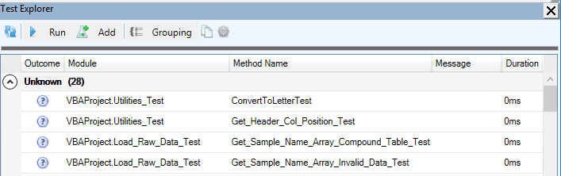

You will need to Group the unit test according to their respective modules. Click on Grouping and then “By Location”

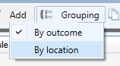

You will see the unit test are grouped based on the unit test modules

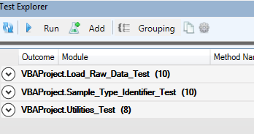

### Adding a new unit test module

Go to Add, Click on Test Module

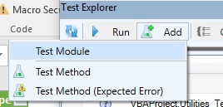

A new test module will be automatically created

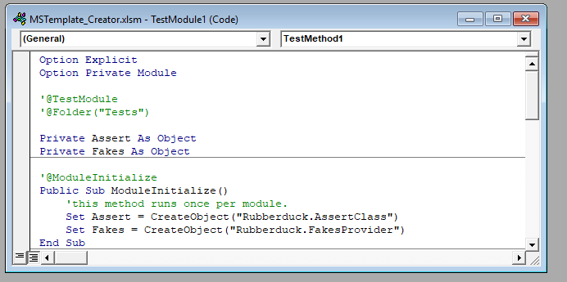

Refer to the documentation to see how to write a unit test properly

<https://github.com/rubberduck-vba/Rubberduck/wiki/Unit-Testing>

### Categorising Unit Test

To group unit test into the same category, put the group name beside

‘@TestMethod({Your group name})

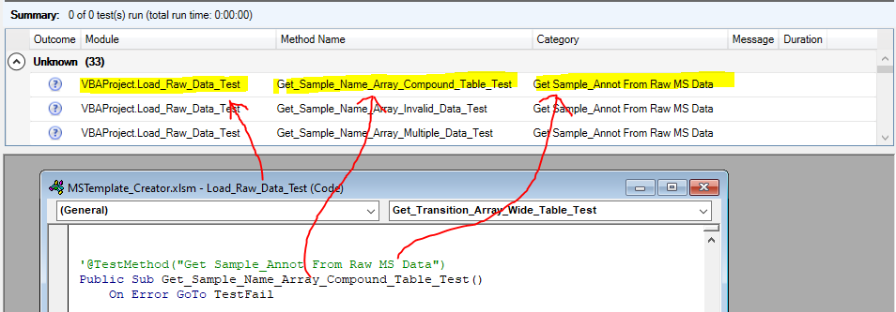

### Running the Unit Test

Click on the refresh button to update the Test Explorer to find any newly created unit test

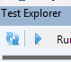

To run all the unit test, Click on Run, then all test

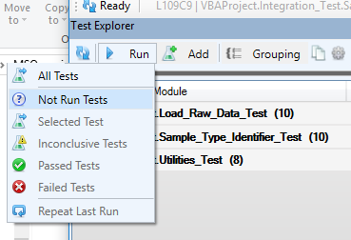

To run a specific test, highlight a specific test, click on run and then “Selected test”

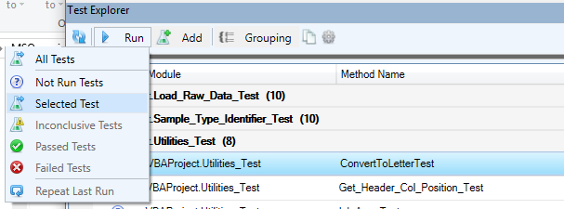

A passed test will look like this



A failed test will look like this



## Integration Test

Open the Intergration_Test module and run all the functions in this module.

What each test is doing can be found in the comments of the code

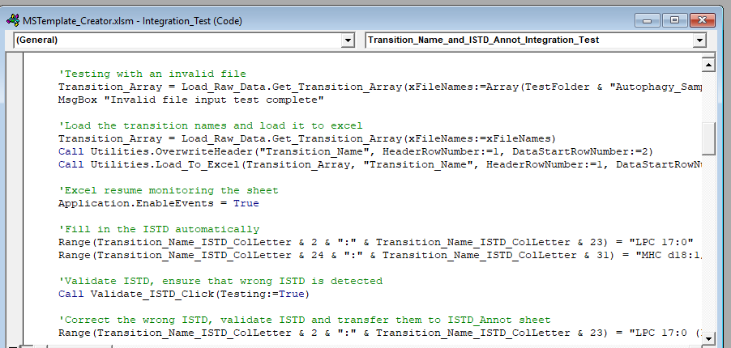

Click Ok for every message box that appears.

Make sure all sheets are tested successfully

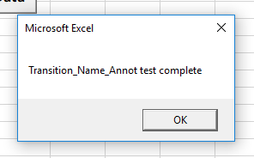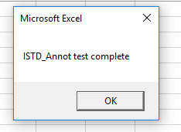

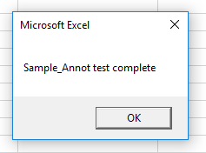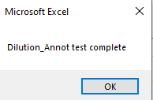

# Version Control

## Exporting modules using Excel VBA Developer Tools

When you open the Visual Basic from the Developer Tab, click on XL Dev Tools, Export modules

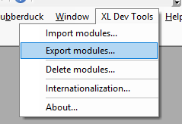

The following box will pop up

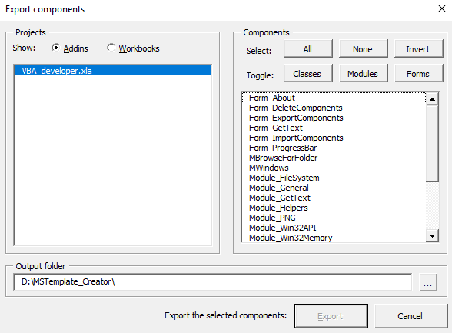

Click on Workbooks, make sure the MSTemplate_Creator macro file is selected and you can see all its modules.

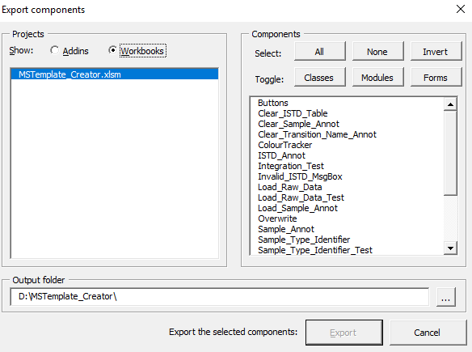

Select any modules you wish to export and click on export.

Modules will be exported as text files which Git can handle to do version control and send to a remote repository.

## Importing modules using Excel VBA Developer Tools

You can also import modules when you open the Visual Basic from the Developer Tab, click on XL Dev Tools, Import modules

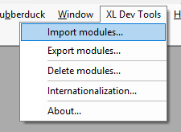

Locate the folder with the module text files and import them to the correct workbook.

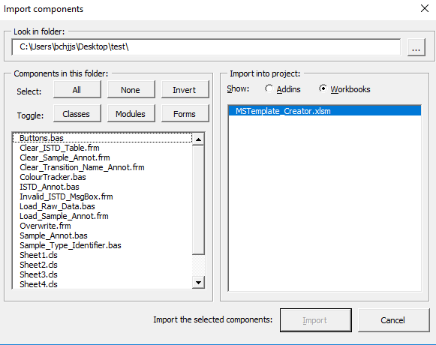

Note:

The software however is unable to copy cls type files, so copy and paste is required for this part.

# Code Update guidelines

Below are some guiding steps to change in the code should there be any small minor changes needed.

## Transition_Name_Annot changes

### Changes in the name of the column where the transition name is placed

In the Transition_Name_Annot_Buttons Modules, go to GetTranstionArray_Click function and update the function Utilities.OverwriteHeader and Utilities.Load_To_Excel

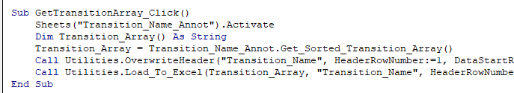

In the Userform Clear_Transition_Name_Annot, change the column name in

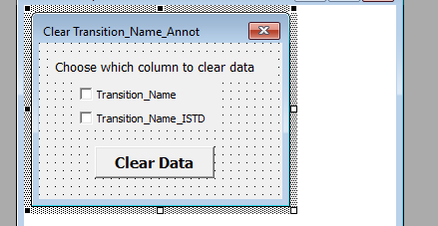

Change the relevant code for the userform

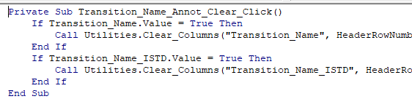

In the Colour Tracker module, , go to ChangeToBlankWhenChanged function and update the function Utilities.Get_Header_Col_Position and Utilities.ConvertToLetter

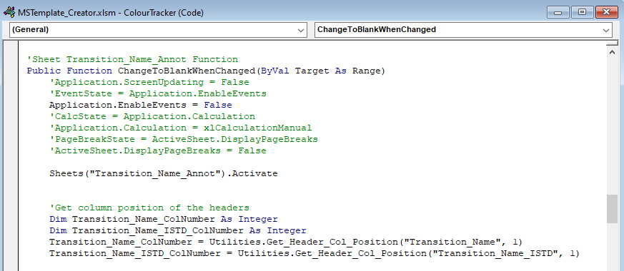

In the Integration_Test module, go to Transition_Name_and_ISTD_Annot_Integration_Test and update the functions such as Utilities.Get_Header_Col_Position, Utilities.ConvertToLetter, etc

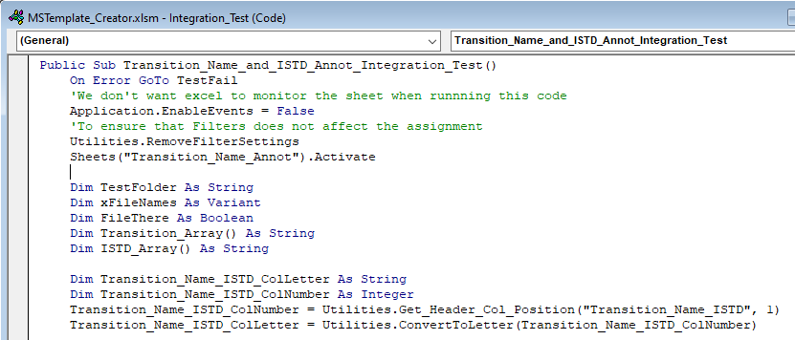

### Changes in the name of the column where the transition name ISTD is placed

Firstly, you must change the column in both the sheet Transition_Name_Annot and ISTD_Annot to the one you have changed

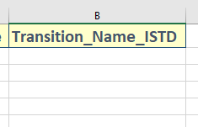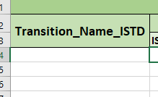

In the Transition_Name_Annot_Button Modules, go to Load_Transition_Name_ISTD_Click function and change the function, Utilities.Load_Columns_From_Excel, Utilities.OverwriteHeader and Utilities.Load_To_Excel

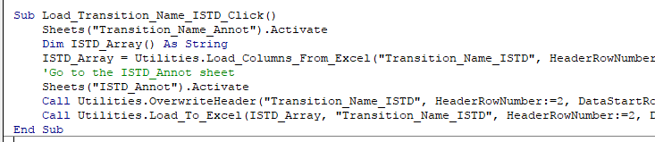

In the Userform Clear_Transition_Name_Annot, change the column name in



Change the relevant code for the userform



In the userform Clear ISTD_Table, change the column name in

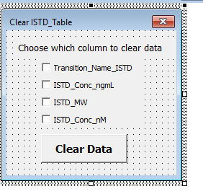

Change the relevant code for the userform

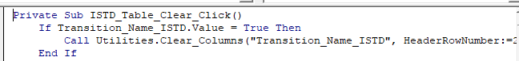

In the Colour Tracker module, , go to ChangeToBlankWhenChanged function and update the function Utilities.Get_Header_Col_Position and Utilities.ConvertToLetter



In the Integration_Test module, go to Transition_Name_and_ISTD_Annot_Integration_Test and update the functions such as Utilities.Get_Header_Col_Position, Utilities.ConvertToLetter, etc



### Changes in the sheet name

In the Button Modules, go to Load_Transition_Name_ISTD_Click function and GetTranstionArray_Click function change the sheet name in the command



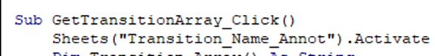

In the Colour Tracker module, go to ChangeToBlankWhenChanged function and update the sheet name to activate



In the Integration_Test module, go to Transition_Name_and_ISTD_Annot_Integration_Test and update the sheet name.



## ISTD_Annot changes

### Changes in the name of the column where the transition name ISTD is placed

Following the steps in 10a) part ii

In the Colour Tracker module , go to ISTDCalculationChecker function and update the function Utilities.Get_Header_Col_Position and Utilities.ConvertToLetter

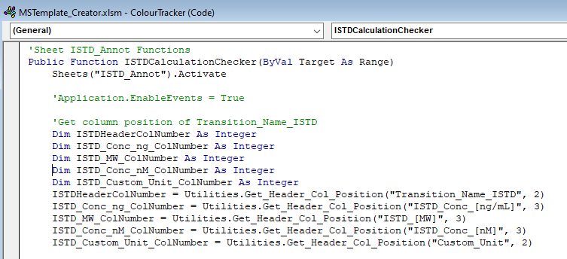

In the Integration_Test module, go to Transition_Name_and_ISTD_Annot_Integration_Test and update the functions such as Utilities.Get_Header_Col_Position, Utilities.ConvertToLetter, etc



### Changes in the column name used in the calculation of ISTD concentration from ng/ML to nM

In the ISTD_Annot module, go to Get_ISTD_Conc_nM_Array. Update the function Utilities.Load_Columns_From_Excel

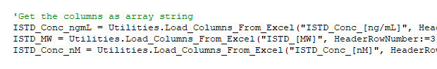

In the ISTD_Annot_Buttons module, go to nM_Calculation_Click. Update Utilities.Load_To_Excel “”ISTD_Conc_[nM]” if this column name is changed



In the userform Clear ISTD_Table, change the column name in



Change the relevant code for the userform

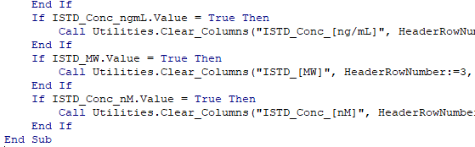

In the Colour Tracker module , go to ISTDCalculationChecker function and update the function Utilities.Get_Header_Col_Position and Utilities.ConvertToLetter



In the Integration_Test module, go to Transition_Name_and_ISTD_Annot_Integration_Test and update the functions such as Utilities.Get_Header_Col_Position, Utilities.ConvertToLetter, etc



### Changes in the sheet name

In the Button Modules, go to Load_Transition_Name_ISTD_Click function function change the sheet name in the command



In the Colour Tracker module , go to ISTDCalculationChecker function and update the sheet name to activate.



In the Integration_Test module, go to Transition_Name_and_ISTD_Annot_Integration_Test and update the sheet name



## Sample_Annot changes

### Changes in the column names for MRM transition name data input

The column names affected are



If Sample_Name has been change, update the userfrom Load_Sample_Annot

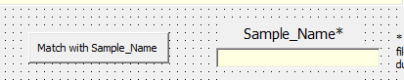

And the corresponding codes with Sample_Name involved if necessary. You may wish to use

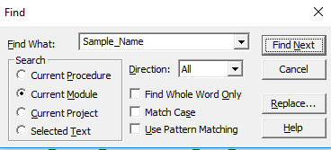

If Sample_Name and Sample_Type column has been changed, go to the Buttons module and update the function Autofill_Sample_Type_Click()

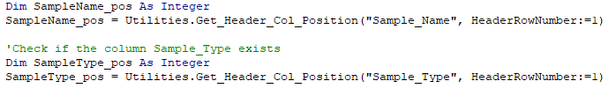



In the Sample_Annot module, update the function

Create_New_Sample_Annot_Raw, Create_New_Sample_Annot_Tidy and Merge_With_Sample_Annot

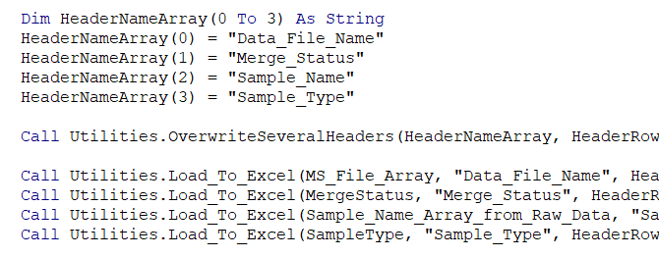

In the userform Clear_Sample_Annot, change the column name in

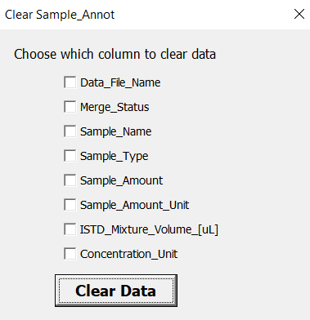

Change the relevant code for the userform

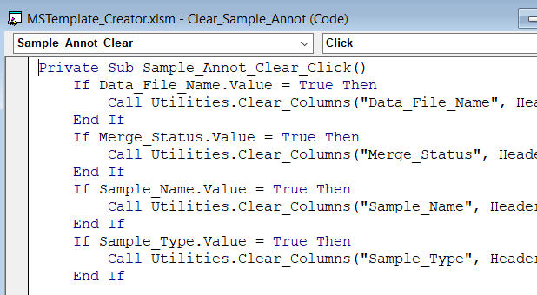

In the Integration_Test module, go to Sample_Annot_Integration_Test and Sample_Annot_and_Dilution_Annot_Integration_Test to update functions such as Utilities.Clear_Columns

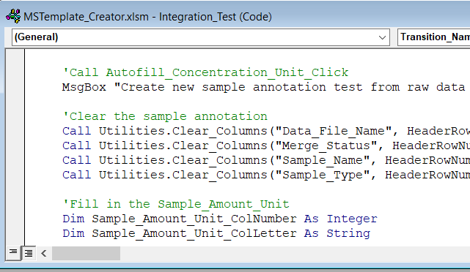

### Changes in the column names for sample annotation input

The column names affected are

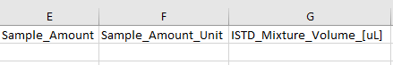

If Sample_Name has been change, update the userfrom Load_Sample_Annot

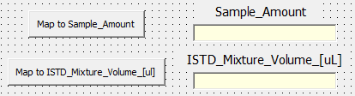

And the corresponding codes with Sample_Amount and ISTD_Mixture_Volume_[uL] involved if necessary.

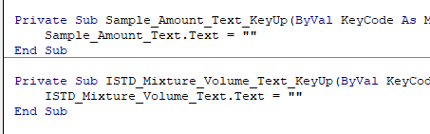

There will be a lot of changes. Use Ctrl-F to help you.

In the Sample_Annot module, update the function Load_Sample_Info_To_Excel

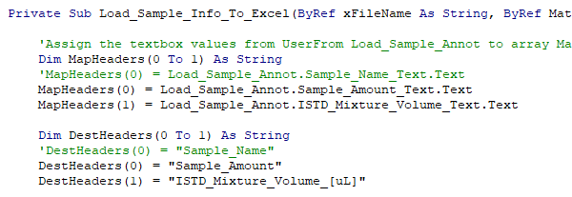

In the userform Clear_Sample_Annot, change the column name in



Change the relevant code for the userform

In the Sample_Annot_Buttons module, update the function Load_Sample_Name_To_Dilution_Annot_Click and make the changes where Utilities.Get_Header_Col_Position and Utilities.Load_Columns_From_Excel is called



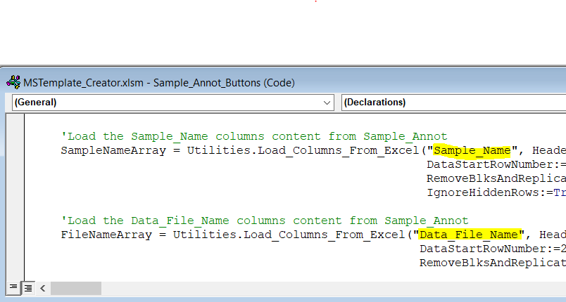

### Changes in the sheet name

In the Sample_Annot Modules, go to Create_new_Sample_Annot and Merge_With_Sample_Annot functions to change the sheet name





In the Button Modules, go to Autofill_Sample_Type_Click, Load_Sample_Annot_Column_Name_Click and Load_Sample_Name_To_Dilution_Annot_Click to change the sheet name



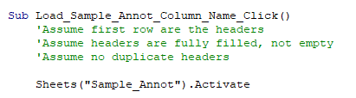



### Changes in the listbox in Sample_Type and Sample_Amount_Unit

Go to the sheet “Lists” and update the table accordingly

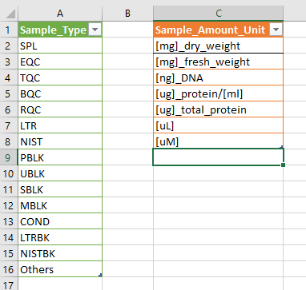

In the Integration_Test module, go to Sample_Annot_Integration_Test and Sample_Annot_and_Dilution_Annot_Integration_Test to update the sheet name

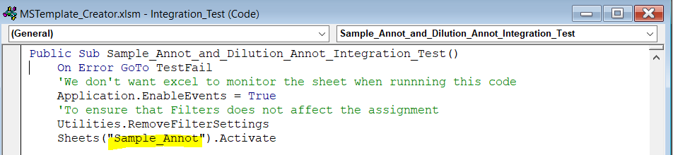

## Dilution_Annot changes

### Changes in the name of the column where raw data file name and sample name is placed.

In the Sample_Annot_Buttons Modules, go to Load_Sample_Name_To_Dilution_Annot_Click function and update the function Utilities.OverwriteHeader and Utilities.Load_To_Excel

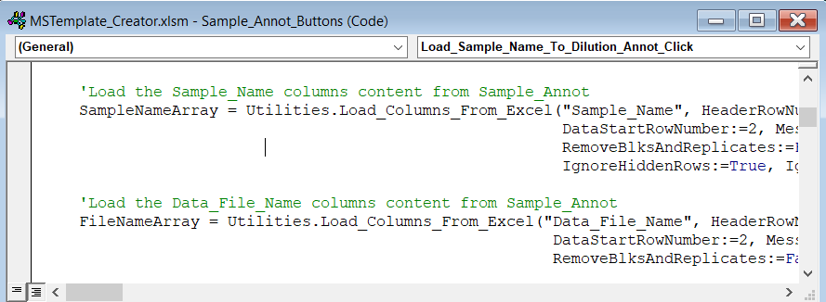

In the Userform Clear_Dilution_Annot, change the column name in

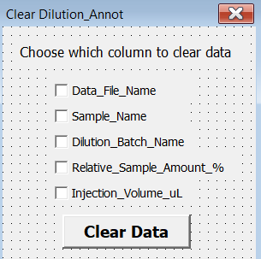

Change the relevant code for the userform

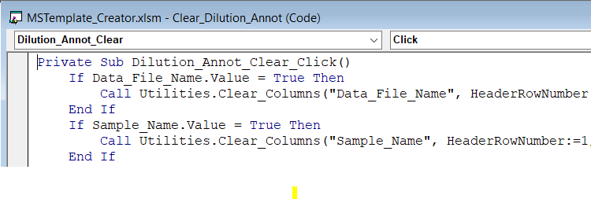

In the Integration_Test module, go to Sample_Annot_and_Dilution_Annot_Integration_Test to update functions such as Utilities.Clear_Columns

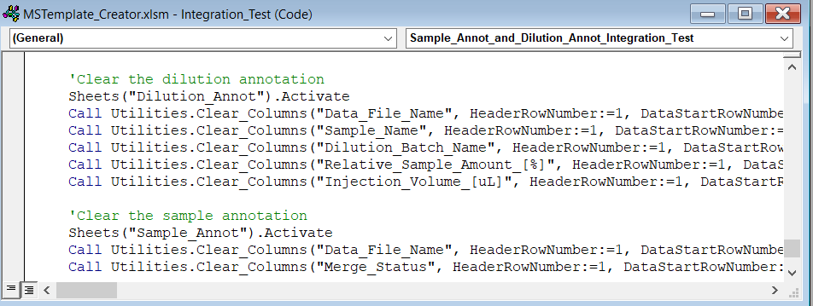

### Changes in the sheet name

In the Sample_Annot_Buttons Modules, go to Load_Sample_Name_To_Dilution_Annot_Click function and change the sheet name in the command

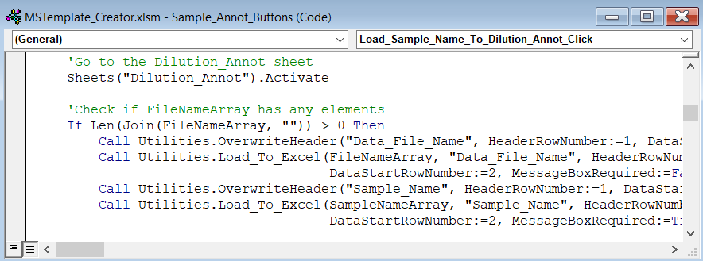

In the Integration_Test module, go to Sample_Annot_and_Dilution_Annot_Integration_Test to update the sheet name to activate.

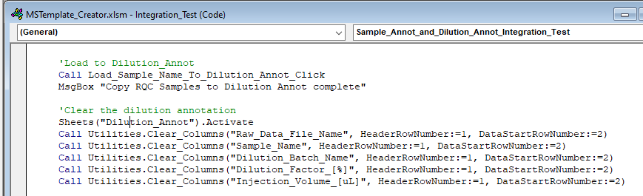

## Additional help

If you have troubles looking for a particular phrase, you may use the find button on Visual Basic or the Code Explorer in Rubberduck.

