MS Template Creator

Developer Documentation

Version 0.0.4

2018

# Version Control Table

|  |  |
| --- | --- |
| **Title** | MS Template Creator Testing Checklist |
| **Created By** | Jeremy John Selva |
| **Date Created** | 27 March 2018 |
| **Maintained By** | Jeremy John Selva |

|  |  |  |  |  |
| --- | --- | --- | --- | --- |
| **Version Number** | **Modified By** | **Date Modified** | **Modifications Made** | **Status** |
| 0.0.4 | Jeremy John | 29 Sep 2021 | Whole document as physical looks in excel has changed | Draft |
| 0.0.3 | Jeremy John | 14 Aug 2021 | Whole document as test dataset has changed | Draft |
| 0.0.2 | Jeremy John | 3 March 2021 | Added   * Part Four Testing “Dilution_Annot” sheet | Draft |
| 0.0.1 | Jeremy John | 3 May 2018 | Initial commit and review | Approved |

# Content Page

Version Control Table 1

Content Page 2

Testing Checklist 4

Purpose 4

Test Datasets 4

Part One: Testing “Transition_Name_Annot” sheet 4

a) Loading of Transition Names from MRM transition names data 4

i. Loading from Agilent csv file in WideTable form 4

ii. Loading from Agilent csv file in CompoundTable form 5

iii. Loading from Sciex txt file 6

iv. Loading multiple files both Agilent and Sciex 7

v. Loading an invalid raw data file 9

vi. Loading from a csv file in table form with transition as column variables 10

vii. Loading from a csv file in table form with transition as row observations 11

b) Validating the ISTD 12

i. Using the “Validate ISTD” button 12

c) Copying Transition Names from “Transition_Name_Annot” to “ISTD_Annot” 14

i. Using the “Load ISTD to ISTD_Table” button 14

d) Clearing of columns in the “Transition_Name_Annot” sheet 15

i. Using the “Clear Columns” button 15

Part Two: Testing “ISTD_Annot” sheet 16

a) Calculation of ISTD concentrations from ng/mL to nM 16

i. Using the “Convert to nM and Verify” button 16

ii. Converting concentration from nM to other units 17

b) Clearing of columns in the “ISTD_Annot” sheet 18

i. Using the “Clear ISTD_Table Columns” button 18

Part Three: Testing “Sample_Annot” sheet 19

a) Creating a new sample annotation template 19

i. Creating from Agilent csv file in WideTable form 19

ii. Creating from Agilent csv file in CompoundTable form 21

iii. Creating from Sciex txt file 23

iv. Creating from multiple files both Agilent and Sciex 25

v. Loading an invalid raw data file 27

vi. Creating from a csv file in table form with sample name as column variable 29

vii. Creating from a csv file in table form with sample name as row observations 30

b) Autofill blank entries in the “Sample_Type” column 32

i. Using the “Autofill ‘Sample’ in Sample_Type” button 32

c) Merging an existing sample annotation file 33

i. Merging an Agilent csv file in WideTable form with a sample annotation file 33

ii. Merging an Agilent csv file in CompoundTable form with a sample annotation file 40

iii. Merging a Sciex txt file with a sample annotation file 44

iv. Merging multiple files with a sample annotation files 48

v. Loading an invalid raw data file 50

d) Autofill columns by “Sample_Type” 52

i. Using the “Autofill by Sample_type” button 52

e) Autofill Concentration Unit 53

i. Using the “Autofill Concentration_Unit” 53

f) Clearing of columns in the “Sample_Annot” sheet 54

i. Using the “Clear Columns” button 54

g) Copying RQC Samples from “Sample_Annot” to “Dilution_Annot” 55

Part Four: Testing “Dilution_Annot” sheet 57

a) Clearing of columns in the “Dilution_Annot” sheet 57

ii. Using the “Clear Columns” button 57

# Testing Checklist

## Purpose

To check if the MS Template Creator Excel macro file is still in working condition when new codes has been added or old codes has been changed and updated.

Please update this book regularly so that we can create a program that works for everyone and in different situations.

## Test Datasets

The test files are as follows

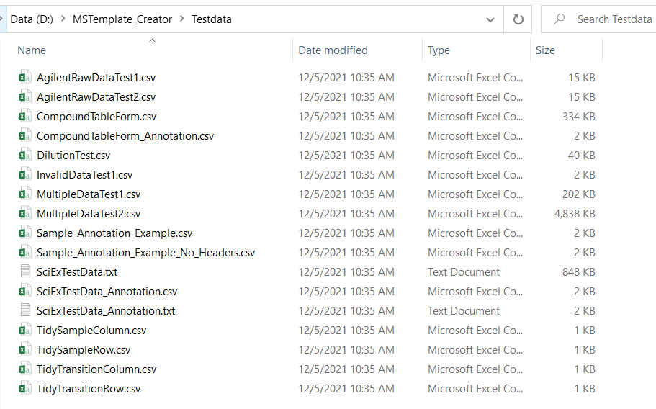

# **Part One: Testing “Transition_Name_Annot” sheet**

## Loading of Transition Names from MRM transition names data

### Loading from Agilent csv file in WideTable form

#### Requirements

AgilentRawDataTest1.csv

#### Preconditions

Users exported the csv file from MassHunter correctly.

#### Steps

Click on the button “Load Transition_Name from Raw Data”



Browse for the file AgilentRawDataTest1.csv. Click Open

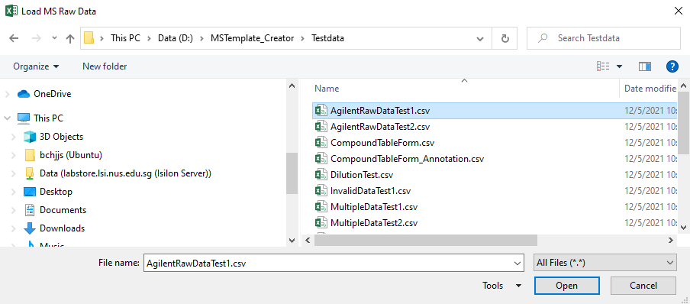

#### Expected Results

If there are existing entries in the “Transition_Name” column. A message box will pop up saying that there are existing entries and ask the user if the data should be overwritten

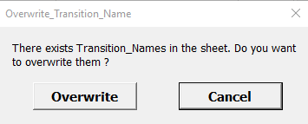

Clicking on Cancel should cause the message box to leave and the original inputs are left alone

Clicking on Overwrite should cause the original inputs to be replaced with the Transition Names found in AgilentRawDataTest1.csv

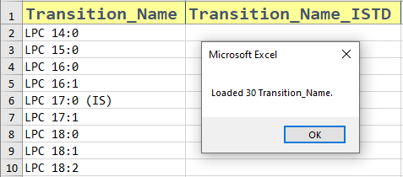

Ensure that

* Transition_Name are loaded unto the right column in the sheet
* 30 Transition_Names should be found in AgilentRawDataTest1.csv
* Duplicates are removed
* Sorted in alphabetical order [A-Za-z]

### Loading from Agilent csv file in CompoundTable form

#### Requirements

CompoundTableForm.csv

#### Preconditions

Users exported the csv file from MassHunter correctly.

#### Steps

Click on the button “Load Transition_Name from Raw Data”



Browse for the file CompoundTableForm.csv. Click Open

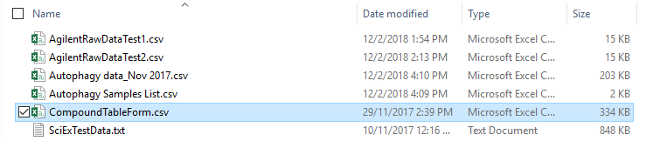

#### Expected Results

If there are existing entries in the “Transition_Name” column. A message box will pop up saying that there are existing entries and ask the user if the data should be overwritten



Clicking on Cancel should cause the message box to leave and the original inputs are left alone

Clicking on Overwrite should cause the original inputs to be replaced with the Transition Names found in CompoundTableForm.csv

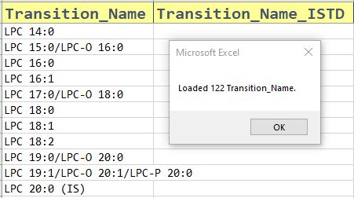

Ensure that

* Transition_Name are loaded unto the right column in the sheet
* 122 Transition_Names should be found in CompoundTableForm.csv
* Duplicates are removed
* Sorted in alphabetical order [A-Za-z]

### Loading from Sciex txt file

#### Requirements

SciExTestData.txt

#### Preconditions

Users exported the txt file from MultiQuant correctly.

#### Steps

Click on the button “Load Transition_Name from Raw Data”



Browse for the file SciExTestData.txt . Click Open

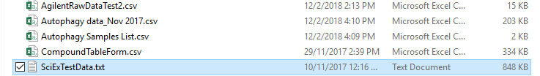

#### Expected Results

If there are existing entries in the “Transition_Name” column. A message box will pop up saying that there are existing entries and ask the user if the data should be overwritten



Clicking on Cancel should cause the message box to leave and the original inputs are left alone

Clicking on Overwrite should cause the original inputs to be replaced with the Transition Names found in SciExTestData.txt

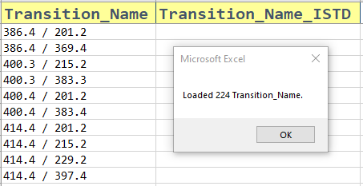

Ensure that

* Transition_Name are loaded unto the right column in the sheet
* 224 Transition_Names should be found in CompoundTableForm.csv
* Duplicates are removed
* Sorted in increasing order

### Loading multiple files both Agilent and Sciex

#### Requirements

MultipleDataTest1.csv

MultipleDataTest2.csv

SciExTestData.txt

#### Preconditions

Users exported the csv file from MassHunter and the txt file from MultiQuant correctly.

#### Steps

Click on the button “Load Transition_Name from Raw Data”



Browse for the three files. Click Open

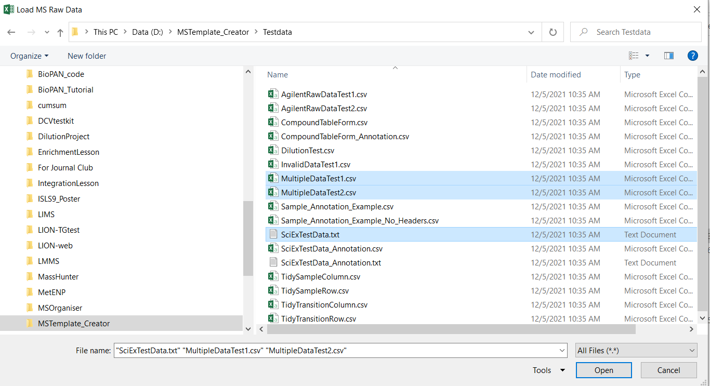

#### Expected Results

If there are existing entries in the “Transition_Name” column. A message box will pop up saying that there are existing entries and ask the user if the data should be overwritten



Clicking on Cancel should cause the message box to leave and the original inputs are left alone

Clicking on Overwrite should cause the original inputs to be replaced with the Transition Names found in all three files

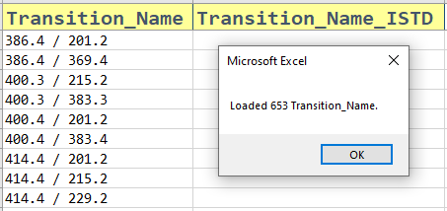

Ensure that

* Transition_Name are loaded unto the right column in the sheet
* 653 Transition_Names should be found in CompoundTableForm.csv
* Duplicates are removed
* Sorted in increasing order

#### Notes

You may wish to load both MultipleDataTest1.csv and sPerfect_Index_AllLipids_raw.csv to double check that it is working.

MultipleDataTest1.csv has 419 Transition names.

sPerfect_Index_AllLipids_raw.csv has 421 Transition names.

Their union gives 429 Transition names.

### Loading an invalid raw data file

#### Requirements

InvalidDataTest1.csv (that is a sample annotation file)

#### Preconditions

None

#### Steps

Click on the button “Load Transition_Name from Raw Data”



Browse for InvalidDataTest1.csv. Click Open

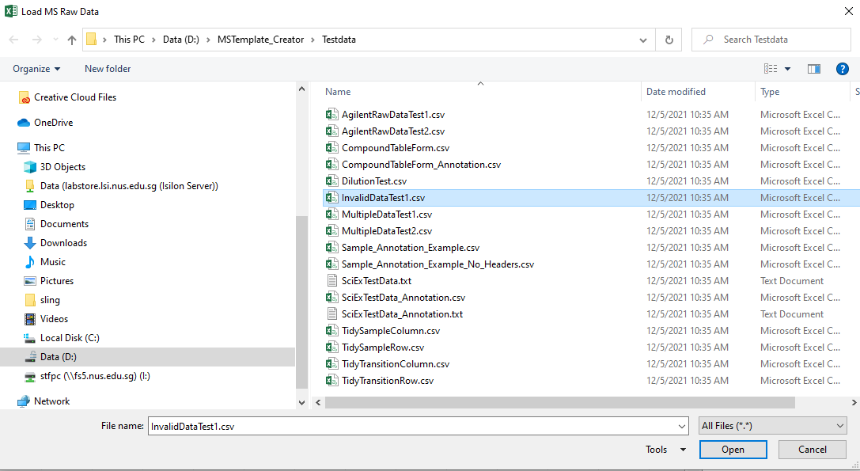

#### Expected Results

A message box will appear, telling the file is invalid.

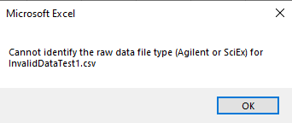

### Loading from a csv file in table form with transition as column variables

#### Requirements

TidyTransitionColumn.csv

#### Preconditions

Users imported the csv file in table form with transition as column variables.

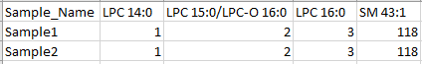

#### Steps

Click on the button “Load Transition_Name from Table Data”



Fill in the entries as follows:

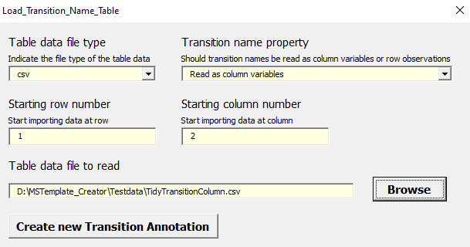

#### Expected Results

If there are existing entries in the “Transition_Name” column. A message box will pop up saying that there are existing entries and ask the user if the data should be overwritten



Clicking on Cancel should cause the message box to leave and the original inputs are left alone

Clicking on Overwrite should cause the original inputs to be replaced with the Transition Names found in all three files

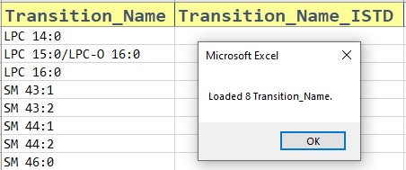

Ensure that

* Transition_Name are loaded unto the right column in the sheet
* 8 Transition_Names should be found in TidyTransitionColumn.csv
* Duplicates are removed
* Sorted in increasing order

### Loading from a csv file in table form with transition as row observations

#### Requirements

TidyTransitionRow.csv

#### Preconditions

Users imported the csv file in table form with transition as row variables.

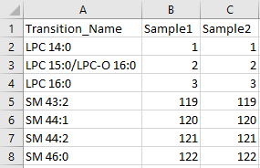

#### Steps

Click on the button “Load Transition_Name from Table Data”



Fill in the entries as follows:

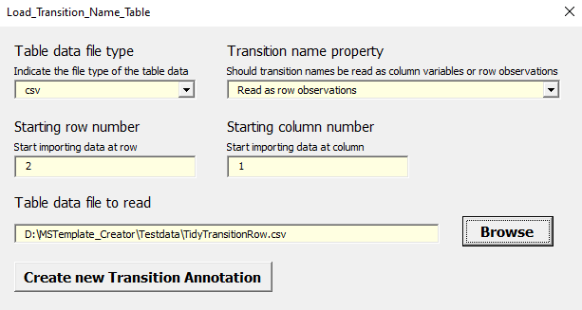

#### Expected Results

If there are existing entries in the “Transition_Name” column. A message box will pop up saying that there are existing entries and ask the user if the data should be overwritten



Clicking on Cancel should cause the message box to leave and the original inputs are left alone

Clicking on Overwrite should cause the original inputs to be replaced with the Transition Names found in all three files

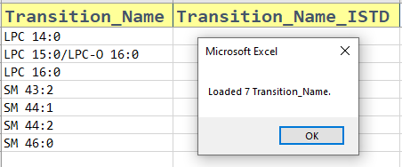

Ensure that

* Transition_Name are loaded unto the right column in the sheet
* 7 Transition_Names should be found in TidyTransitionRow.csv
* Duplicates are removed
* Sorted in increasing order

## Validating the ISTD

### Using the “Validate ISTD” button

#### Requirements

AgilentRawDataTest1.csv

#### Preconditions

Users must be able to successfully load some entries in the column “Transition Name”

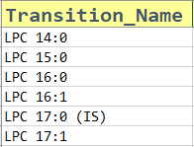

Users key in some ISTD entries in the column “Transition_Name_ISTD”

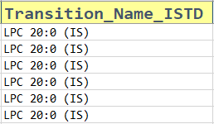

#### Steps

Click on the button “Validate ISTD”



#### Expected Results

If both “Transition_Name” or “Transition_Name_ISTD” are empty,

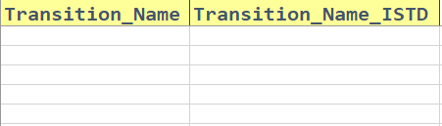

Clicking on the button should give

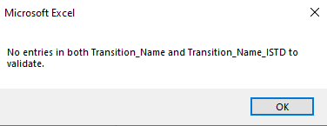

If only “Transition_Name” is empty,

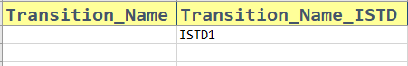

Clicking on the button should give

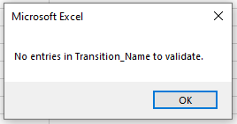

If only “Transition_Name_ISTD” is empty,



Clicking on the button should give

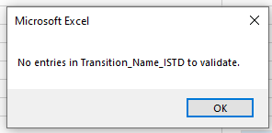

If both entries are filled, the following will occur,

If there are no issues with the ISTD, this message box will appear.

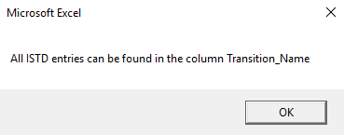

Else, the program will show which ISTD are invalid

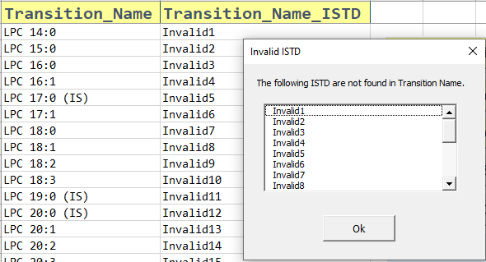

Ensure that

* Blank entries in Transition_Name_ISTD are ignored and should be treated as valid.
* Invalid ISTD are rightly indicated. (ISTD that are not found in the column “Transition_Name”)

## Copying Transition Names from “Transition_Name_Annot” to “ISTD_Annot”

### Using the “Load ISTD to ISTD_Table” button

#### Requirements

None

#### Preconditions

Users key in some ISTD entries in the column “Transition_Name_ISTD”



#### Steps

Click on the button “Load ISTD to ISTD_Table”



#### Expected Results

If “Transition_Name_ISTD” is empty



Clicking on the button should give

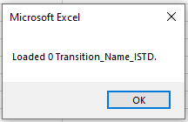

If there is at least one ISTD, users will be directed unto the “ISTD_Annot” sheet.

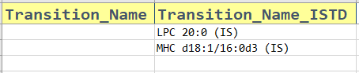

Following that, the program will check if there are existing entries in the ”ISTD_Annot” sheet. If there is, an overwrite message box will appear

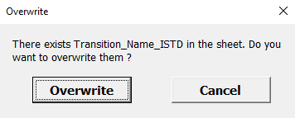

Clicking on Cancel should cause the message box to leave and the original inputs are left alone

Clicking on Overwrite should cause the original inputs to be replaced with the most recent ISTD entries in the “Transition_Name_Annot” sheet.

A message box will pop up saying the number of ISTD copied unto the “ISTD_Annot” sheet

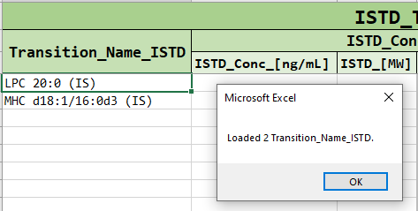

Ensure that

* Transition_Name_ISTD are loaded unto the right column in the sheet
* Correct amount of ISTD are copied
* Duplicate/Blank ISTD should be removed

## Clearing of columns in the “Transition_Name_Annot” sheet

### Using the “Clear Columns” button

#### Requirements

None

#### Preconditions

Users key in some entries in the sheet

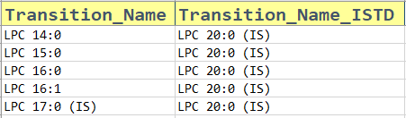

#### Steps

Click on the button “Clear Columns”



A message box will appear, asking which column to clear. Users can choose the columns by checking on the check box

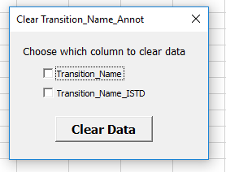

When they have chosen their columns, click on “Clear Data

#### Expected Results

Data is cleared the data when the “Clear Data” button is pressed.

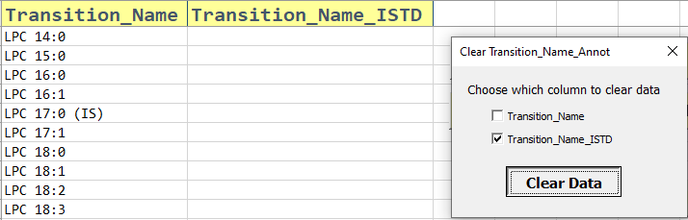

Ensure that

* The choices of which columns to clear are present and in the correct spelling.
* The correct columns are cleared.
* Only the contents are cleared, not the format. No cells should be deleted as well.

# **Part Two: Testing “ISTD_Annot” sheet**

## Calculation of ISTD concentrations from ng/mL to nM

### Using the “Convert to nM and Verify” button

#### Requirements

None

#### Preconditions

Users key in some entries in the “ISTD_Conc_[ng/mL]” and the “ISTD_[MW] column”

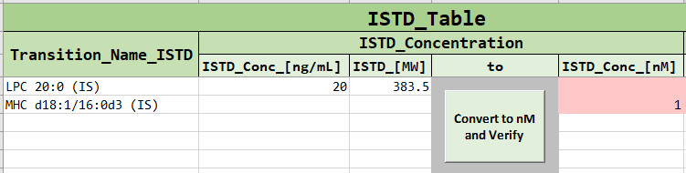

#### Steps

Click on the button “Convert to nM and verify”

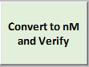

#### Expected Results

ISTD values will be calculated automatically

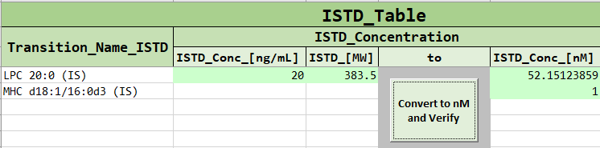

Ensure that

* Only positive numbers are accepted in “ISTD_Conc_[ng/mL]”, “ISTD_[MW]” and “ISTD_Conc_[nM]”. Error should be given if an invalid values are given.

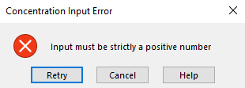

* Calculation is done only when both columns “ISTD_Conc_[ng/mL]”, “ISTD_[MW]” are filled in a given row. Existing values of “ISTD_Conc_[nM]” are left alone
* Calculation is “ISTD_Conc_[ng/mL]” divided by “ISTD_[MW]”
* Custom Unit values are correctly converted

### Converting concentration from nM to other units

#### Requirement

First part is competed

#### Steps

Change the custom unit

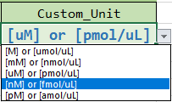

#### Expected Results

Values should be converted correctly.

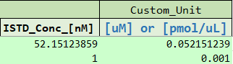

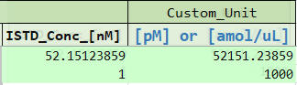

## Clearing of columns in the “ISTD_Annot” sheet

### Using the “Clear ISTD_Table Columns” button

#### Requirement

None

#### Preconditions

Users key in some entries in the sheet



#### Steps

Click on the button “Clear ISTD_Table Columns”



A message box will appear, asking which column to clear. Users can choose the columns by checking on the check box

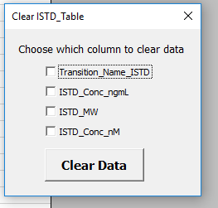

When they have chosen their columns, click on “Clear Data”

#### Expected Results

Data is cleared the data when the “Clear Data” button is pressed.

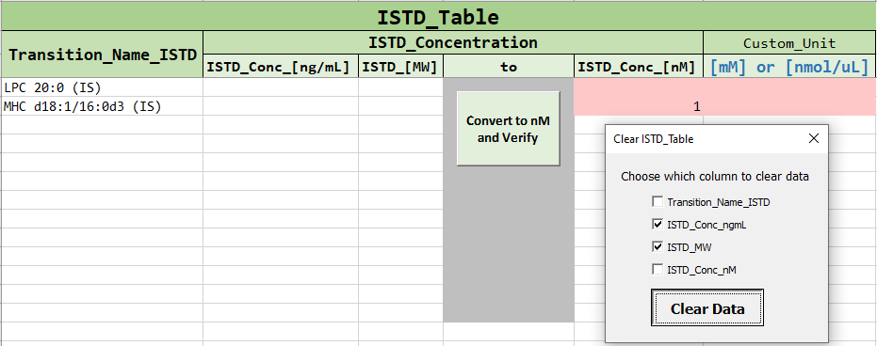

Ensure that

* The choices of which columns to clear are present and in the correct spelling.
* The correct columns are cleared.
* Only the contents are cleared, not the format. No cells should be deleted as well.

# **Part Three: Testing “Sample_Annot” sheet**

## Creating a new sample annotation template

### Creating from Agilent csv file in WideTable form

#### Requirements

MultipleDataTest2.csv

#### Preconditions

Users exported the csv file from MassHunter correctly.

#### Steps

Click on the button “Load Sample Annotation”



The following userform will appear.

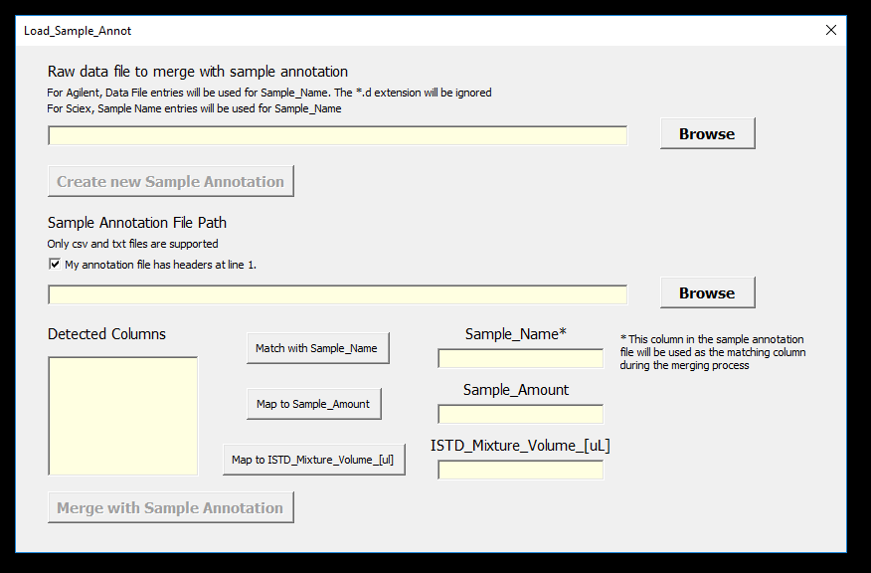

Click on the top “Browse” button to upload the raw data file MultipleDataTest2.csv

Once done, you can see the file path of the raw data being recorded and the button “Create new Sample Annotation” being activated. Click on that button.



#### Expected Results

If there are existing entries in the sheet. A message box will pop up saying that there are existing entries and ask the user if the data should be overwritten

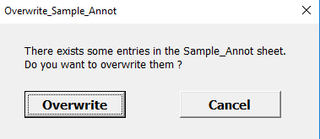

Clicking on Cancel should cause the message box to leave and the original inputs are left alone

Clicking on Overwrite should cause some columns (Raw_Data_File_Name, Merge_Status, Sample_Name and Sample_Type) to be replaced with the data found in MultipleDataTest2.csv

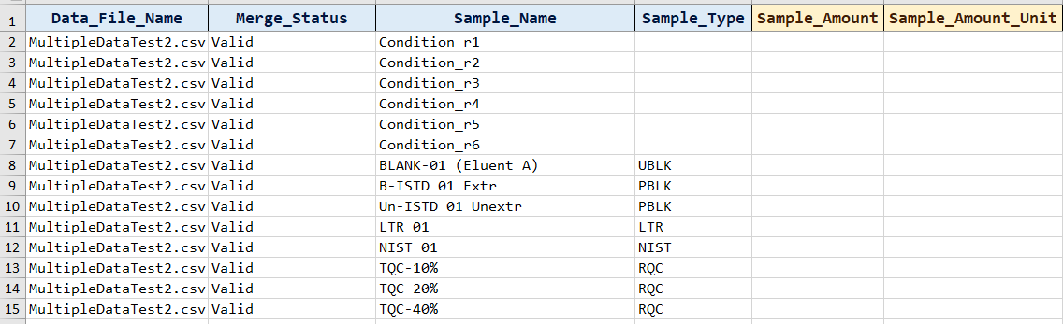

The other columns should be left alone.

Ensure that

* Data file MultipleDataTest2.csv can be browse, selected and recorded
* The “Create new Sample Annotation” button is activated when there is a data file recorded
* Users are able to clear the data file path with a backspace. Users should not be able to edit the file path by keyboard.
* Make sure the “Create new Sample Annotation” gets deactivated when the data file entry is clear.
* When the “Create new Sample Annotation” button is clicked. The four columns (Data_File_Name, Merge_Status, Sample_Name and Sample_Type) should be filled with some data
* Check that all the data has been loaded, especially the last row. There are a total of 534 lines used

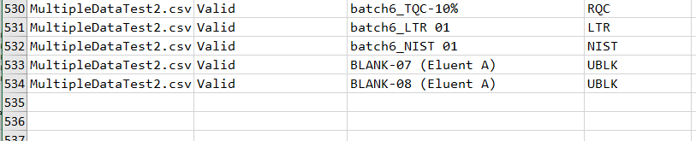

* Check that the Data_File_Name is correct
* Check that the merge status is all set to Valid
* Check that there is an attempt by the macro file to guess if the sample is a “Blank, TQC, PQC, etc …”
* Ensure that it works even when the data has been filtered. The program should first unfiltered the data first before creating/overwrite a sample annotation template

### Creating from Agilent csv file in CompoundTable form

#### Requirements

CompoundTableForm.csv

#### Preconditions

Users exported the csv file from MassHunter correctly.

#### Steps

Click on the button “Load Sample Annotation”



The following userform will appear.



Click on the top “Browse” button to upload the raw data file CompoundTableForm.csv



Once done, you can see the file path of the raw data being recorded and the button “Create new Sample Annotation” being activated. Click on that button.



#### Expected Results

If there are existing entries in the sheet. A message box will pop up saying that there are existing entries and ask the user if the data should be overwritten



Clicking on Cancel should cause the message box to leave and the original inputs are left alone

Clicking on Overwrite should cause some columns (Raw_Data_File_Name, Merge_Status, Sample_Name and Sample_Type) to be replaced with the data found in CompoundTableForm.csv

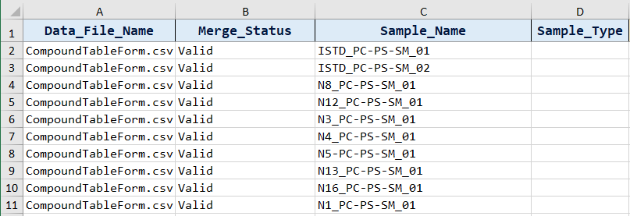

The other columns should be left alone.

Ensure that

* Data file CompoundTableForm.csv can be browse, selected and recorded
* The “Create new Sample Annotation” button is activated when there is a data file recorded
* Users are able to clear the data file path with a backspace. Users should not be able to edit the file path by keyboard.
* Make sure the “Create new Sample Annotation” gets deactivated when the data file entry is clear.
* When the “Create new Sample Annotation” button is clicked. The four columns (Data_File_Name, Merge_Status, Sample_Name and Sample_Type) should be filled with some data
* Check that all the data has been loaded, especially the last row. There are a total of 51 lines are used

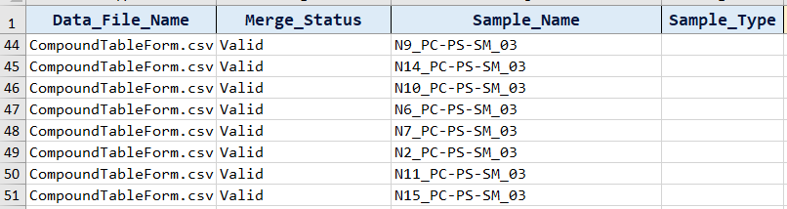

* Check that the Data_File_Name is correct
* Check that the merge status is all set to Valid
* Ensure that it works even when the data has been filtered. The program should first unfiltered the data first before creating/overwrite a sample annotation template

### Creating from Sciex txt file

#### Requirements

SciExTestData.txt

#### Preconditions

Users exported the txt file from MultiQuant correctly.

#### Steps

Click on the button “Load Sample Annotation”



The following userform will appear.



Click on the top “Browse” button to upload the raw data file SciExTestData.txt



Once done, you can see the file path of the raw data being recorded and the button “Create new Sample Annotation” being activated. Click on that button.



#### Expected Results

If there are existing entries in the sheet. A message box will pop up saying that there are existing entries and ask the user if the data should be overwritten



Clicking on Cancel should cause the message box to leave and the original inputs are left alone

Clicking on Overwrite should cause some columns (Raw_Data_File_Name, Merge_Status, Sample_Name and Sample_Type) to be replaced with the data found in SciExTestData.txt

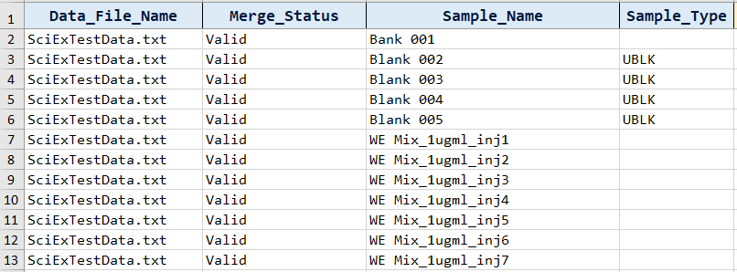

The other columns should be left alone.

Ensure that

* Data file SciExTestData.txt can be browse, selected and recorded
* The “Create new Sample Annotation” button is activated when there is a data file recorded
* Users are able to clear the data file path with a backspace. Users should not be able to edit the file path by keyboard.
* Make sure the “Create new Sample Annotation” gets deactivated when the data file entry is clear.
* When the “Create new Sample Annotation” button is clicked. The four columns (Data_File_Name, Merge_Status, Sample_Name and Sample_Type) should be filled with some data
* Check that all the data has been loaded, especially the last row. There are a total of 62 lines are used

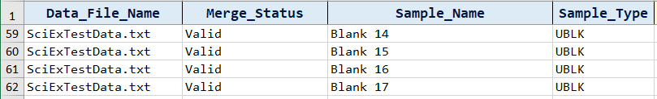

* Check that the Data_File_Name is correct
* Check that the merge status is all set to Valid
* Check that there is an attempt by the macro file to guess if the sample is a “Blank, TQC, PQC, etc …”
* Ensure that it works even when the data has been filtered. The program should first unfiltered the data first before creating/overwrite a sample annotation template

### Creating from multiple files both Agilent and Sciex

#### Requirements

MultipleDataTest1.csv

MultipleDataTest2.csv

SciExTestData.txt

#### Preconditions

Users exported the csv file from MassHunter and the txt file from MultiQuant correctly.

#### Steps

Click on the button “Load Sample Annotation”



The following userform will appear.



Click on the top “Browse” button to upload the three files



Once done, you can see the file path of the raw data being recorded and the button “Create new Sample Annotation” being activated. Click on that button.



#### Expected Results

If there are existing entries in the sheet. A message box will pop up saying that there are existing entries and ask the user if the data should be overwritten



Clicking on Cancel should cause the message box to leave and the original inputs are left alone

Clicking on Overwrite should cause some columns (Data_File_Name, Merge_Status, Sample_Name and Sample_Type) to be replaced with the data found in the three files

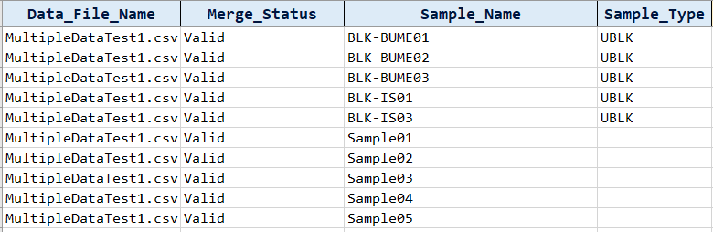

The other columns should be left alone.

Ensure that

* Data file can be browse, selected and recorded
* The “Create new Sample Annotation” button is activated when there is a data file recorded
* Users are able to clear the data file path with a backspace. Users should not be able to edit the file path by keyboard.
* Make sure the “Create new Sample Annotation” gets deactivated when the data file entry is clear.
* When the “Create new Sample Annotation” button is clicked. The four columns (Data_File_Name, Merge_Status, Sample_Name and Sample_Type) should be filled with some data
* Check that all the data has been loaded, especially the last row. There are a total of 665 lines are used

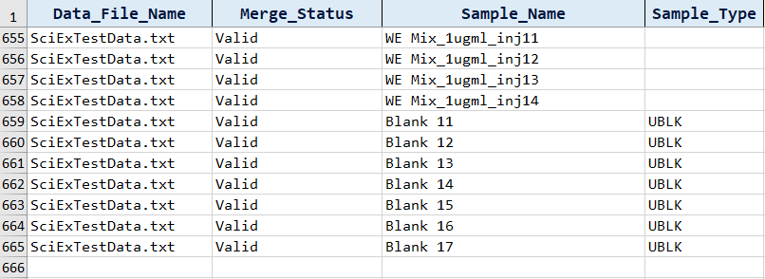

* Check that the Data_File_Name is correct
* Check that the merge status is all set to Valid
* Check that there is an attempt by the macro file to guess if the sample is a “Blank, TQC, PQC, etc …”
* Ensure that it works even when the data has been filtered. The program should first unfiltered the data first before creating/overwrite a sample annotation template

### Loading an invalid raw data file

#### Requirements

InvalidDataTest1.csv (that is a sample annotation file)

#### Preconditions

None

#### Steps

Click on the button “Load Sample Annotation”



The following userform will appear.



Click on the top “Browse” button to upload InvalidDataTest1.csv



Once done, you can see the file path of the raw data being recorded and the button “Create new Sample Annotation” being activated. Click on that button.



#### Expected Results

A message box will appear, telling the file is invalid.



### Creating from a csv file in table form with sample name as column variable

#### Requirements

TidySampleColumn.csv

#### Preconditions

Users imported the csv file in table form with sample names as column variables.

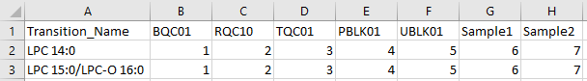

#### Steps

Click on the button “Load Sample Annotation from Table Data”



Fill in the entries as follows:

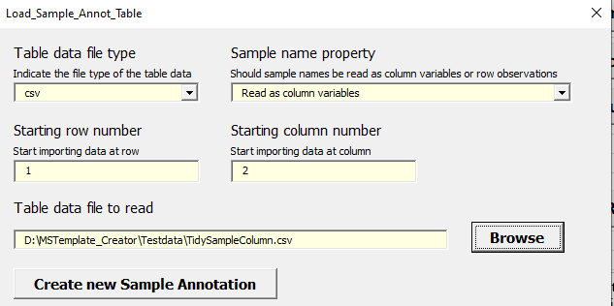

#### Expected Results

If there are existing entries in the sheet. A message box will pop up saying that there are existing entries and ask the user if the data should be overwritten



Clicking on Cancel should cause the message box to leave and the original inputs are left alone

Clicking on Overwrite should cause some columns (Data_File_Name, Merge_Status, Sample_Name and Sample_Type) to be replaced with the data found in TidySampleColumn.csv.

The other columns should be left alone.

Ensure that

* Data file TidySampleColumn.csv can be browse, selected and recorded
* The “Create new Sample Annotation” button is activated when there is a data file recorded
* Users are able to clear the data file path with a backspace. Users should not be able to edit the file path by keyboard.
* Make sure the “Create new Sample Annotation” gets deactivated when the data file entry is clear.
* When the “Create new Sample Annotation” button is clicked. The four columns (Data_File_Name, Merge_Status, Sample_Name and Sample_Type) should be filled with some data
* Check that all the data has been loaded, especially the last row. There are a total of 8 lines used

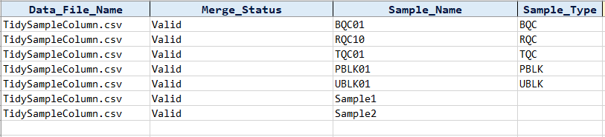

* Check that the Data_File_Name is correct
* Check that the merge status is all set to Valid
* Check that there is an attempt by the macro file to guess if the sample is a “Blank, TQC, PQC, etc …”
* Ensure that it works even when the data has been filtered. The program should first unfiltered the data first before creating/overwrite a sample annotation template

### Creating from a csv file in table form with sample name as row observations

#### Requirements

TidySampleRow.csv

#### Preconditions

Users imported the csv file in table form with sample names as column variables.

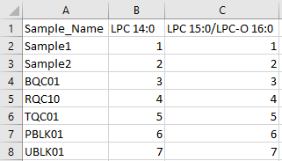

#### Steps

Click on the button “Load Sample Annotation from Table Data”



Fill in the entries as follows:

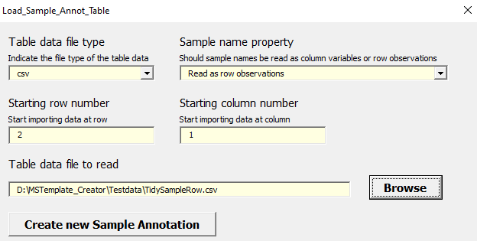

#### Expected Results

If there are existing entries in the sheet. A message box will pop up saying that there are existing entries and ask the user if the data should be overwritten



Clicking on Cancel should cause the message box to leave and the original inputs are left alone

Clicking on Overwrite should cause some columns (Data_File_Name, Merge_Status, Sample_Name and Sample_Type) to be replaced with the data found in TidySampleColumn.csv.

The other columns should be left alone.

Ensure that

* Data file TidySampleRow.csv can be browse, selected and recorded
* The “Create new Sample Annotation” button is activated when there is a data file recorded
* Users are able to clear the data file path with a backspace. Users should not be able to edit the file path by keyboard.
* Make sure the “Create new Sample Annotation” gets deactivated when the data file entry is clear.
* When the “Create new Sample Annotation” button is clicked. The four columns (Data_File_Name, Merge_Status, Sample_Name and Sample_Type) should be filled with some data
* Check that all the data has been loaded, especially the last row. There are a total of 8 lines used

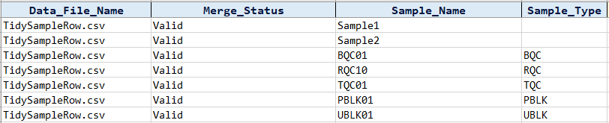

* Check that the Data_File_Name is correct
* Check that the merge status is all set to Valid
* Check that there is an attempt by the macro file to guess if the sample is a “Blank, TQC, PQC, etc …”
* Ensure that it works even when the data has been filtered. The program should first unfiltered the data first before creating/overwrite a sample annotation template

## Autofill blank entries in the “Sample_Type” column

### Using the “Autofill ‘Sample’ in Sample_Type” button

#### Requirements

#### MultipleDataTest2.csv

#### Preconditions

Users should have created a new template from MultipleDataTest2.csv

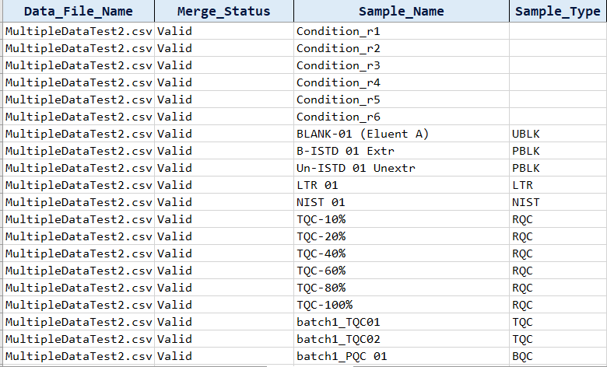

And change the Sample_Type to a relevant category that is not ‘SPL’

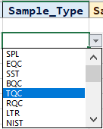

#### Steps

Click on the button “Autofill ‘Sample’ in Sample_Type”



#### Expected Results

All empty cells in the column “Sample_Type” should be filled with the word “SPL” till the end of the data

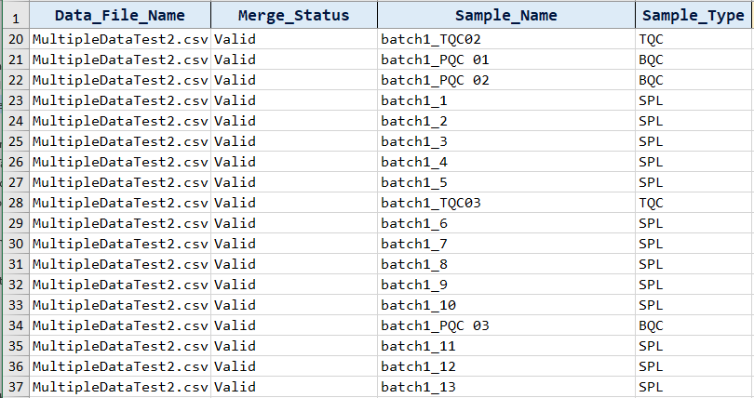

Ensure that

* In the “Sample_Type” column, users can only choose a limited amount of options provided in the list box



* Users are not allowed to put in any input they want

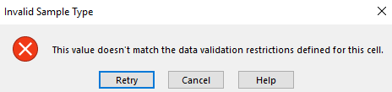

* The program works even when the data has been filtered. The program should first unfiltered the data first before filling the entries.

## Merging an existing sample annotation file

### Merging an Agilent csv file in WideTable form with a sample annotation file

#### Requirements

AgilentRawDataTest1.csv

Sample_Annotation_Example.csv

#### Preconditions

Users exported the csv file from MassHunter correctly and created their own annotation file in csv.

For Agilent Raw Data, users need to create a column in the sample annotation file that matches the Data File entries from MassHunter.

Data File entries in AgilentRawDataTest1.csv

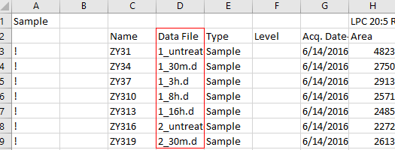

Matching column from Sample_Annotation_Example.csv

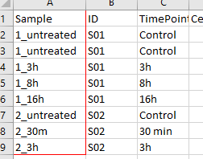

#### Steps

Click on the button “Load Sample Annotation”



The following userform will appear.



Click on the top “Browse” button to upload the raw data file AgilentRawDataTest1.csv

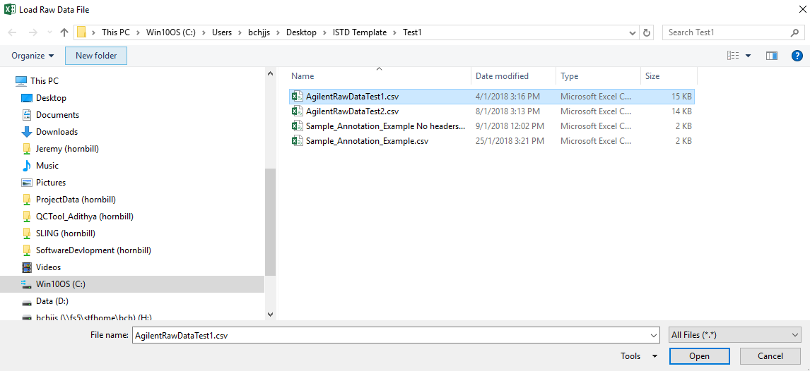

Once done, you can see the file path of the raw data being recorded.

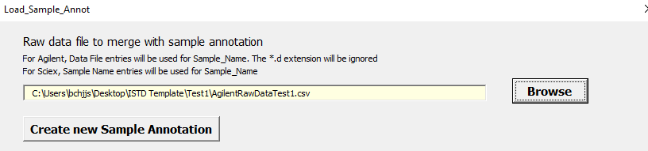

Click on the “Browse” button to upload the sample annotation file Sample_Annotation_Example.csv

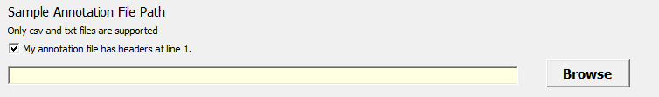

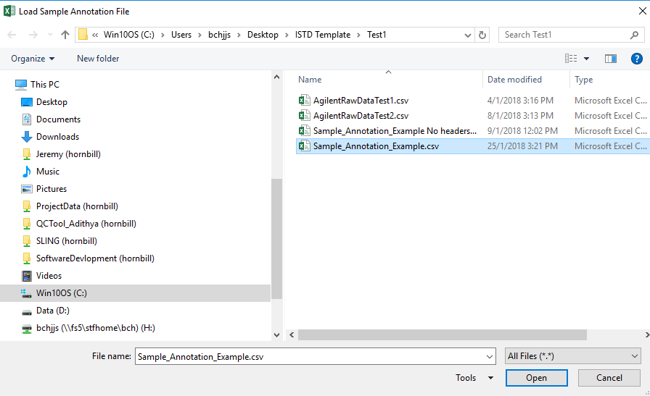

Once done, you can see the file path of the sample annotation being recorded.

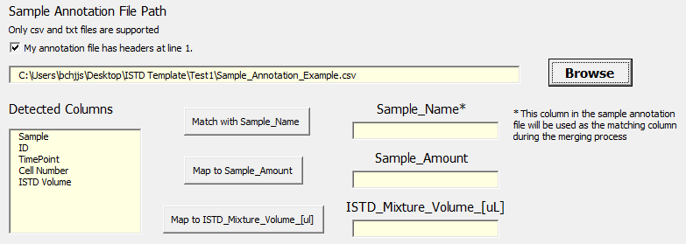

The program will list the column names found at the first line of the annotation file

Under the “Detected Columns” list box, choose “Sample” and then click on the button “Match with Sample_Name”

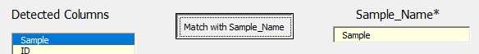

In doing so, the button “Merge with Sample Annotation” should be activated.

Under the “Detected Columns” list box, choose “Cell Number” and then click on the button “Map to Sample_Amount”

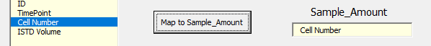

Under the “Detected Columns” list box, choose “ISTD Volume” and then click on the button “Map to ISTD_Mixture_[uL]”

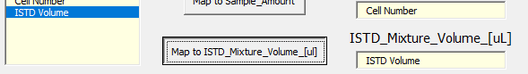

Click on the button “Merge with Sample Annotation”



#### Expected Results

If there are existing entries in the sheet. A message box will pop up saying that there are existing entries and ask the user if the data should be overwritten



Clicking on Cancel should cause the message box to leave and the original inputs are left alone

Clicking on Overwrite, the following message box should appear

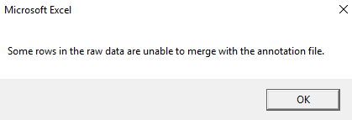

Some columns (Raw_Data_File_Name, Merge_Status, Sample_Name, Sample_Amount and ISTD_Mixture_Volume_[uL]) will be replaced with the data found in AgilentRawDataTest1.csv and

Sample_Annotation_Example.csv

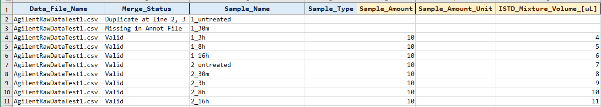

The merge status for 1_untreated and 1_30m should be unsuccessful

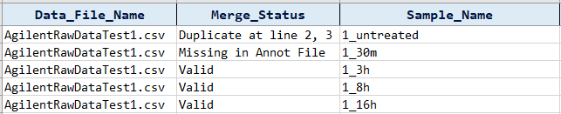

As 1_untreated appeared twice in the sample annotation file

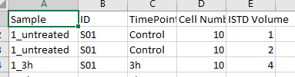

And 1_30m is not presence in the sample annotation file

Ensure that

* Data file can be browse, selected and recorded
* Users are able to clear the data file path with a backspace. Users should not be able to edit the file path.
* Make sure the “Merge with Sample Annotation” button gets deactivated when the data file entry is cleared.
* Sample Annotation file can be browsed, selected and recorded.
* When the annotation file Sample_Annotation_Example.csv is recorded, the program should be able to display the headers found in the first row of the annotation file in the “Detected Columns” list box.

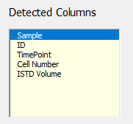

* In the case when the annotation file has no headers like Sample_Annotation_Example No headers.csv, the check box button beside “My annotation file has header at line 1” must be unchecked before loading the sample annotation file. When the annotation file is loaded, the “Detected Columns” list box will print out “Column 1”, “Column 2”, etc…

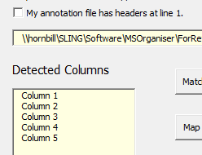

* Ensure that the three button “Match with Sample_Name”, “Map to Sample_Amount” and “Map to ISTD_Mixture_Volume_[uL]” are working
* Ensure that the button “Merge with Sample Annotation” is activated only when the data file, sample annotation file and the Sample_Name entries are filled

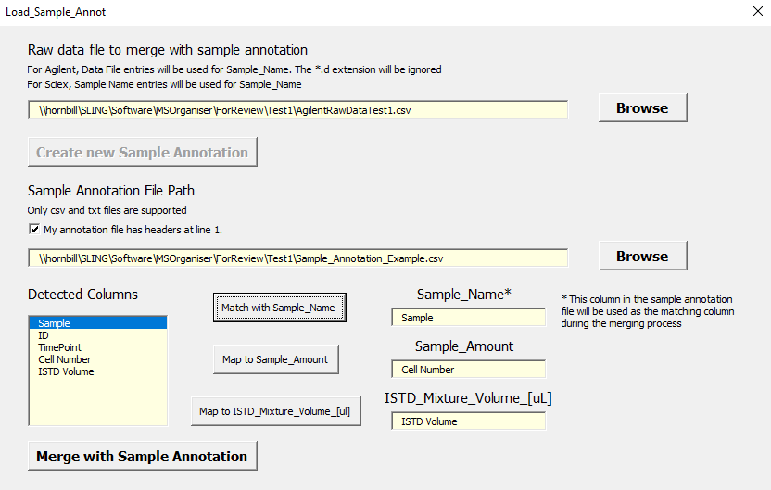

* Users are able to clear the sample annotation file path with a backspace. Users should not be able to edit the file path.
* Make sure the “Merge with Sample Annotation” button gets deactivated and all related entries (Detected Columns, Sample_Name, Sample_Amount, etc…) are also cleared.
* Users are able to clear the entries (Detected Columns, Sample_Name, Sample_Amount, etc…) with a backspace. Users should not be able to edit them.
* Make sure the “Merge with Sample Annotation” button gets deactivated when the entries in “Sample_Name” removed.
* Columns “Sample_Amount” and “ISTD_Mixture_Volume_[uL]” accepts non negative values. Error should be given if an invalid values are given.

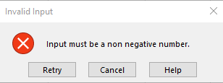

* Sample_Amount_Unit should have a drop down list available.

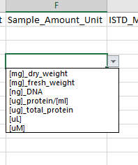

Users, however are still given a choice to type anything they want

Column names should be editable by the user

### Merging an Agilent csv file in CompoundTable form with a sample annotation file

#### Requirements

CompoundTableForm.csv

CompoundTableForm_Annotation.csv

#### Preconditions

Users exported the csv file from MassHunter correctly and created their own annotation file in csv.

For Agilent Raw Data, users need to create a column in the sample annotation file that matches the Data File entries from MassHunter.

Data File entries in CompoundTableForm.csv

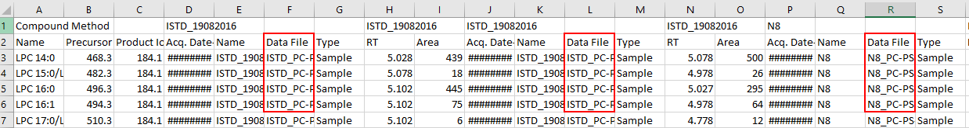

Matching column from CompoundTableForm_Annotation.csv

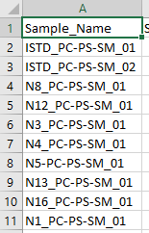

#### Steps

Click on the button “Load Sample Annotation”



The following userform will appear.



Click on the top “Browse” button to upload the raw data file CompoundTableForm.csv

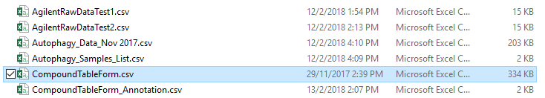

Once done, you can see the file path of the raw data being recorded.

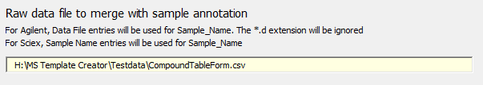

Click on the “Browse” button to upload the sample annotation file CompoundTableForm_Annotation.csv





Once done, you can see the file path of the sample annotation being recorded.

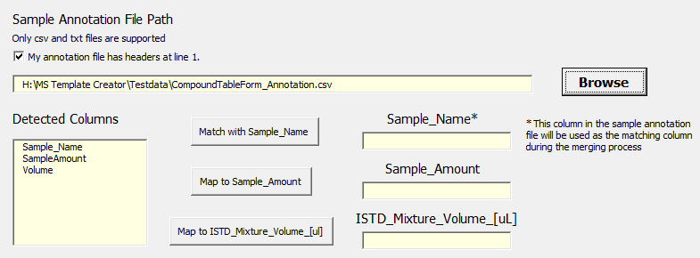

The program will list the column names found at the first line of the annotation file

Under the “Detected Columns” list box, choose “Sample_Name” and then click on the button “Match with Sample_Name”

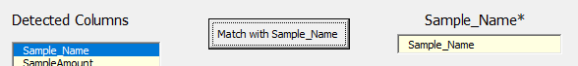

In doing so, the button “Merge with Sample Annotation” should be activated.

Under the “Detected Columns” list box, choose “SampleAmount” and then click on the button “Map to Sample_Amount”

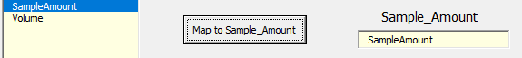

Under the “Detected Columns” list box, choose “Volume” and then click on the button “Map to ISTD_Mixture_[uL]”

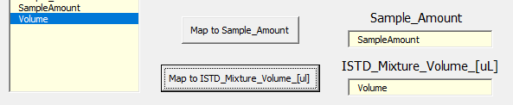

Click on the button “Merge with Sample Annotation”



#### Expected Results

If there are existing entries in the sheet. A message box will pop up saying that there are existing entries and ask the user if the data should be overwritten



Clicking on Cancel should cause the message box to leave and the original inputs are left alone.

Clicking on Overwrite, the merged sample annotation template should be created.

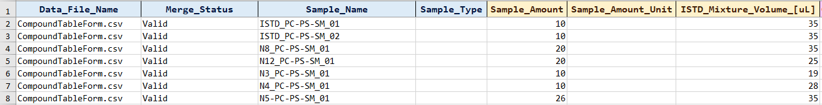

Ensure that

* Data file can be browse, selected and recorded
* Users are able to clear the data file path with a backspace. Users should not be able to edit the file path.
* Make sure the “Merge with Sample Annotation” button gets deactivated when the data file entry is cleared.
* Sample Annotation file can be browsed, selected and recorded.
* When the annotation file Sample_Annotation_Example.csv is recorded, the program should be able to display the headers found in the first row of the annotation file in the “Detected Columns” list box.

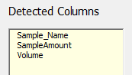

* Ensure that the three button “Match with Sample_Name”, “Map to Sample_Amount” and “Map to ISTD_Mixture_Volume_[uL]” are working
* Ensure that the button “Merge with Sample Annotation” is activated only when the data file, sample annotation file and the Sample_Name entries are filled
* Users are able to clear the sample annotation file path with a backspace. Users should not be able to edit the file path.
* Make sure the “Merge with Sample Annotation” button gets deactivated and all related entries (Detected Columns, Sample_Name, Sample_Amount, etc…) are also cleared.
* Users are able to clear the entries (Detected Columns, Sample_Name, Sample_Amount, etc…) with a backspace. Users should not be able to edit them.
* Make sure the “Merge with Sample Annotation” button gets deactivated when the entries in “Sample_Name” removed.
* Columns “Sample_Amount” and “ISTD_Mixture_Volume_[uL]” accepts non negative values. Error should be given if an invalid values are given.



* Sample_Amount_Unit should have a drop down list available.



Users, however are still given a choice to type anything they want

Column names should be editable by the user

### Merging a Sciex txt file with a sample annotation file

#### Requirements

SciExTestData.txt

SciExTestData_Annotation.txt

#### Preconditions

Users exported the txt file from MultiQuant correctly and created their own annotation file in txt.

For SciEx data, users need to create a column in the sample annotation file that matches the “Sample Name” entries from MultiQuant.

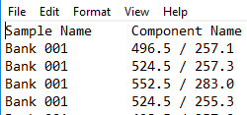

Matching column from SciExTestData_Annotation.txt

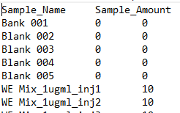

#### Steps

Click on the button “Load Sample Annotation”



The following userform will appear.



Click on the top “Browse” button to upload the raw data file SciExTestData.txt



Once done, you can see the file path of the raw data being recorded.

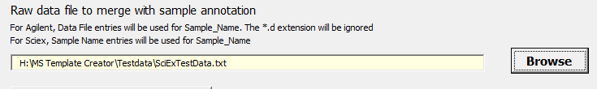

Click on the “Browse” button to upload the sample annotation file SciExTestData_Annotation.txt





Once done, you can see the file path of the sample annotation being recorded.

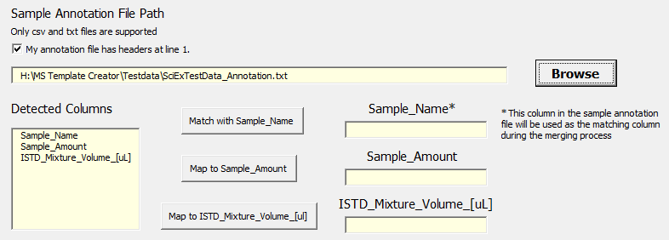

The program will list the column names found at the first line of the annotation file

Under the “Detected Columns” list box, choose “Sample_Name” and then click on the button “Match with Sample_Name”



In doing so, the button “Merge with Sample Annotation” should be activated.

Under the “Detected Columns” list box, choose “Sample_Amount” and then click on the button “Map to Sample_Amount”

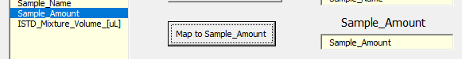

Under the “Detected Columns” list box, choose “ISTD_Mixture_Volume_[uL]” and then click on the button “Map to ISTD_Mixture_[uL]”

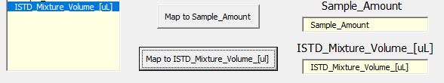

Click on the button “Merge with Sample Annotation”



#### Expected Results

If there are existing entries in the sheet. A message box will pop up saying that there are existing entries and ask the user if the data should be overwritten



Clicking on Cancel should cause the message box to leave and the original inputs are left alone.

Clicking on Overwrite, the merged sample annotation template should be created.

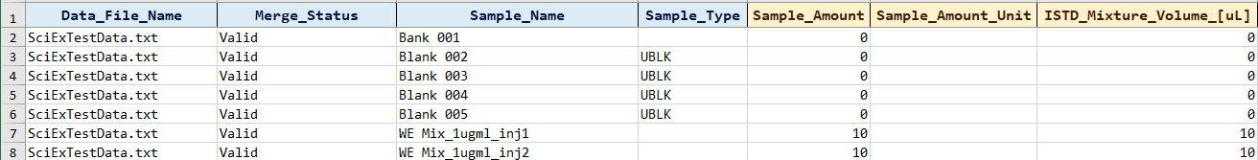

Ensure that

* Data file can be browse, selected and recorded
* Users are able to clear the data file path with a backspace. Users should not be able to edit the file path.
* Make sure the “Merge with Sample Annotation” button gets deactivated when the data file entry is cleared.
* Sample Annotation file can be browsed, selected and recorded.
* When the annotation file Sample_Annotation_Example.csv is recorded, the program should be able to display the headers found in the first row of the annotation file in the “Detected Columns” list box.

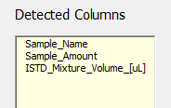

* Ensure that the three button “Match with Sample_Name”, “Map to Sample_Amount” and “Map to ISTD_Mixture_Volume_[uL]” are working
* Ensure that the button “Merge with Sample Annotation” is activated only when the data file, sample annotation file and the Sample_Name entries are filled
* Users are able to clear the sample annotation file path with a backspace. Users should not be able to edit the file path.
* Make sure the “Merge with Sample Annotation” button gets deactivated and all related entries (Detected Columns, Sample_Name, Sample_Amount, etc…) are also cleared.
* Users are able to clear the entries (Detected Columns, Sample_Name, Sample_Amount, etc…) with a backspace. Users should not be able to edit them.
* Make sure the “Merge with Sample Annotation” button gets deactivated when the entries in “Sample_Name” removed.
* Columns “Sample_Amount” and “ISTD_Mixture_Volume_[uL]” accepts non negative values. Error should be given if an invalid values are given.



* Sample_Amount_Unit should have a drop down list available.

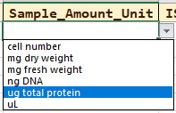

Users, however are still given a choice to type anything they want

Column names should be editable by the user

#### Notes

For this test, we use input the sample annotation file as a txt file. The program should still work if the file is in csv form.

### Merging multiple files with a sample annotation files

#### Requirements

AgilentRawDataTest1.csv

AgilentRawDataTest2.csv

Sample_Annotation_Example.csv

#### Preconditions

Users exported the csv file from MassHunter correctly and created their own annotation file in csv.

For Agilent Raw Data, users need to create a column in the sample annotation file that matches the Data File entries from MassHunter.

#### Steps

The same as part(i) except that we take in the two csv files.

#### Expected Results

If there are existing entries in the sheet. A message box will pop up saying that there are existing entries and ask the user if the data should be overwritten



Clicking on Cancel should cause the message box to leave and the original inputs are left alone

Clicking on Overwrite, the following message box should appear



Some columns (Raw_Data_File_Name, Merge_Status, Sample_Name, Sample_Amount and ISTD_Mixture_Volume_[uL]) will be replaced with the data found in AgilentRawDataTest1.csv and AgilentRawDataTest2.csv

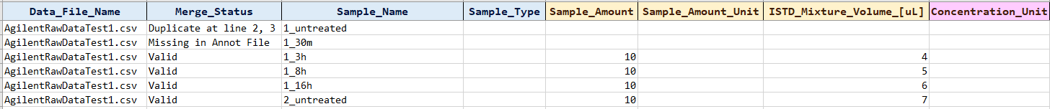

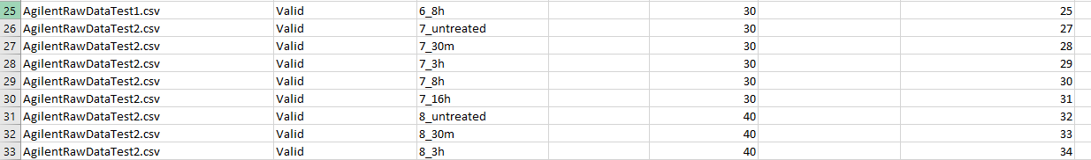

The merge status for 1_untreated and 1_30m should be unsuccessful



As 1_untreated appeared twice in the sample annotation file



And 1_30m is not presence in the sample annotation file

There should not be any merging issues with AgilentRawDataTest2.csv

Ensure that

* Same as i)

#### Notes

The above only test the case of two Agilent csv files WideTable form.

The program should also work in a mixture of Agilent CompoundTable form and Sciex txt files.

However, we only allow the input of one sample annotation files. Multiple annotation files will not be implemented as it will make the program more complicated and confusing for users

### Loading an invalid raw data file

#### Requirements

InvalidDataTest1.csv (that is a sample annotation file)

Sample_Annotation_Example.csv

#### Preconditions

None

#### Steps

Click on the button “Load Sample Annotation”



The following userform will appear.



Click on the top “Browse” button to upload Sample_Annotation_Example



Once done, you can see the file path of the raw data being recorded.

Click on the “Browse” button to upload the sample annotation file Sample_Annotation_Example.csv





Once done, you can see the file path of the sample annotation being recorded.

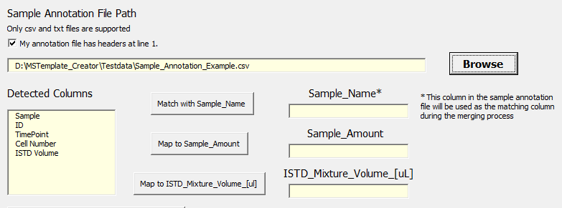

The program will list the column names found at the first line of the annotation file

Under the “Detected Columns” list box, choose “Sample” and then click on the button “Match with Sample_Name”

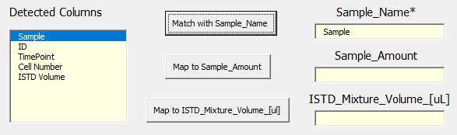

In doing so, the button “Merge with Sample Annotation” should be activated

Click on the button “Merge with Sample Annotation”

#### Expected Results

A message box will appear, telling the file is invalid.



## Autofill columns by “Sample_Type”

### Using the “Autofill by Sample_type” button

#### Requirements

None

#### Preconditions

Users key in some entries in the sheet

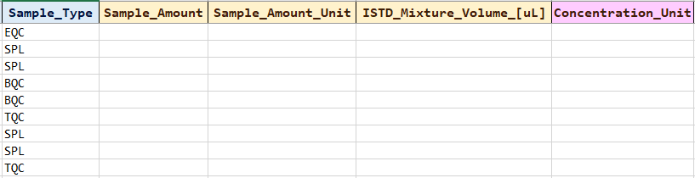

#### Steps

Click on the button “Autofill by Sample_Type”



A message box will appear

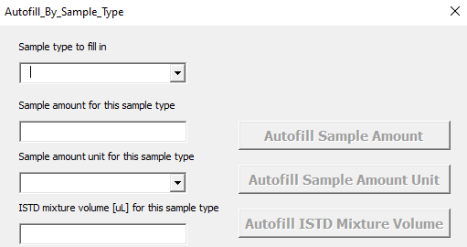

Choose the Sample type and key in the relevant values. The buttons will be unmasked. Click on the Autofill button

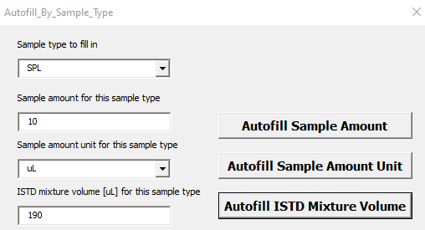

#### Expected Results

Sample_Amount, Sample_Amount_Unit and ISTD_Mixture_Volume_[uL] values are fill according to the input value

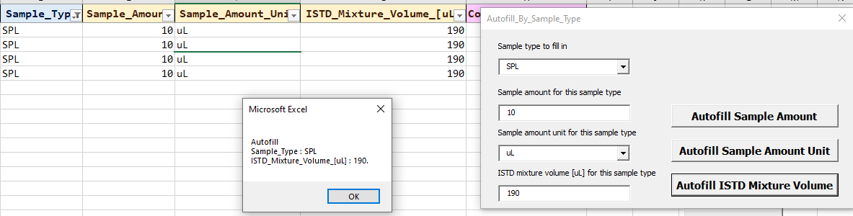

Ensure that

* The correct columns and Sample Type are filled with the user input values
* Invalid inputs are given a warning

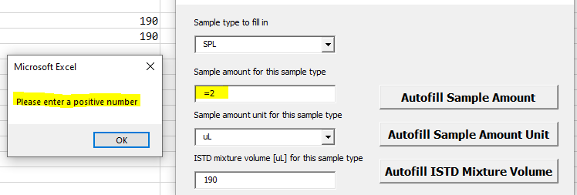

## Autofill Concentration Unit

### Using the “Autofill Concentration_Unit”

#### Requirement

None

#### Preconditions

Users key in some entries in the sheet

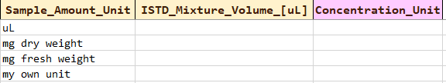

Users to choose an ISTD concentration unit (below case is nmol)



#### Steps

Click on the button “Autofill Concentration_Unit”



#### Expected Results

Concentration Unit is filled in

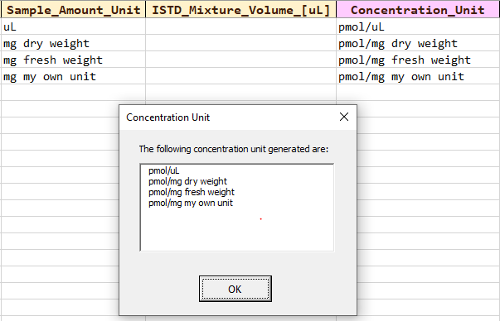

Ensure that

* Changing the ISTD concentration unit after this step with update the column. This is because the sample amount unit has been changed.

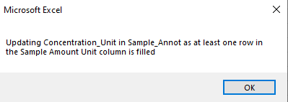

## Clearing of columns in the “Sample_Annot” sheet

### Using the “Clear Columns” button

#### Requirements

None

#### Preconditions

Users key in some entries in the sheet

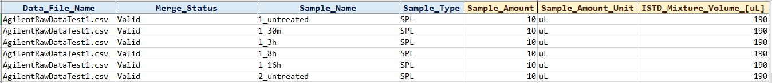

#### Steps

Click on the button “Clear Columns”



A message box will appear, asking which column to clear. Users can choose the columns by checking on the check box

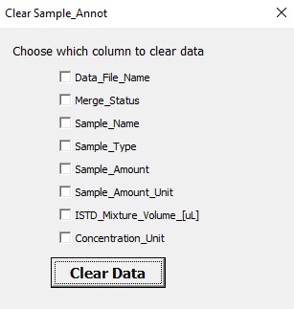

When they have chosen their columns, click on “Clear Data

#### Expected Results

Data is cleared the data when the “Clear Data” button is pressed.

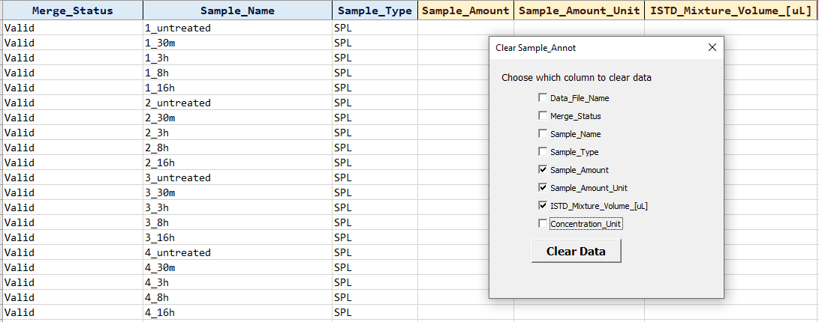

Ensure that

* The choices of which columns to clear are present and in the correct spelling.
* The correct columns are cleared.
* Only the contents are cleared, not the format. No cells should be deleted as well.

## Copying RQC Samples from “Sample_Annot” to “Dilution_Annot”

#### Requirements

None

#### Preconditions

Users key in some entries in the sheet. Ensure that there are some sample with Sample Type RQC

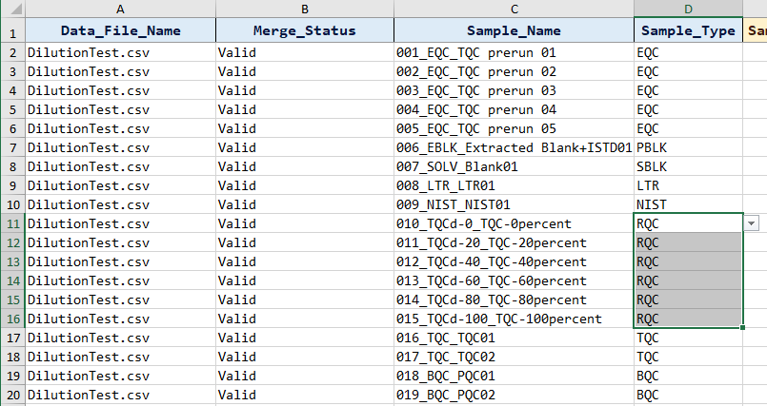

#### Steps

Click on the button “Load RQC Samples to Dilution_Table”



#### Expected Results

If there is no RQC Samples, there will be a message box pop up saying

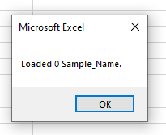

If there are RQC samples,

users will be directed unto the “Dilution_Annot” sheet.

Following that, the program will check if there are existing entries in the ”Dilution_Annot” sheet. If there is, overwrite message boxes will appear

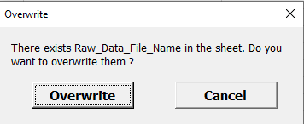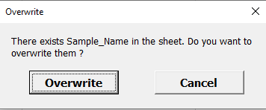

Clicking on Cancel should cause the message box to leave and the original inputs are left alone

Clicking on Overwrite should cause the original inputs to be replaced with the most recent entries in the “Dilution_Annot” sheet.

A message box will pop up saying the number of things copied unto the “Dilution_Annot” sheet

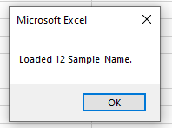

Ensure that

* Data_File_Name and Sample_Name are loaded unto the right column in the sheet
* Correction information (Only RQC samples) are copied
* Duplicate/Blank ISTD should be removed
* Replicated Sample_Name is allowed for now.

# Part Four: Testing “Dilution_Annot” sheet

## Clearing of columns in the “Dilution_Annot” sheet

### Using the “Clear Columns” button

#### Requirements

None

#### Preconditions

Users key in some entries in the sheet

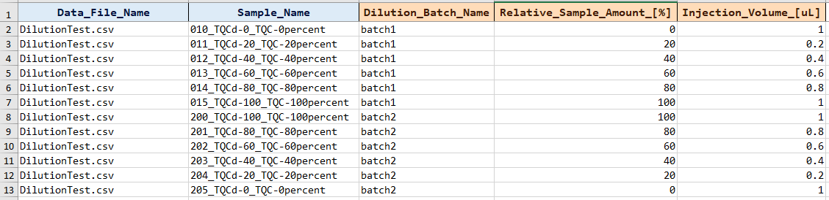

Steps

Click on the button “Clear Columns”



A message box will appear, asking which column to clear. Users can choose the columns by checking on the check box

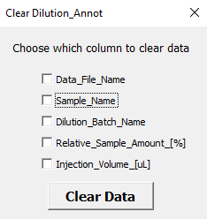

When they have chosen their columns, click on “Clear Data

#### Expected Results

Data is cleared the data when the “Clear Data” button is pressed.

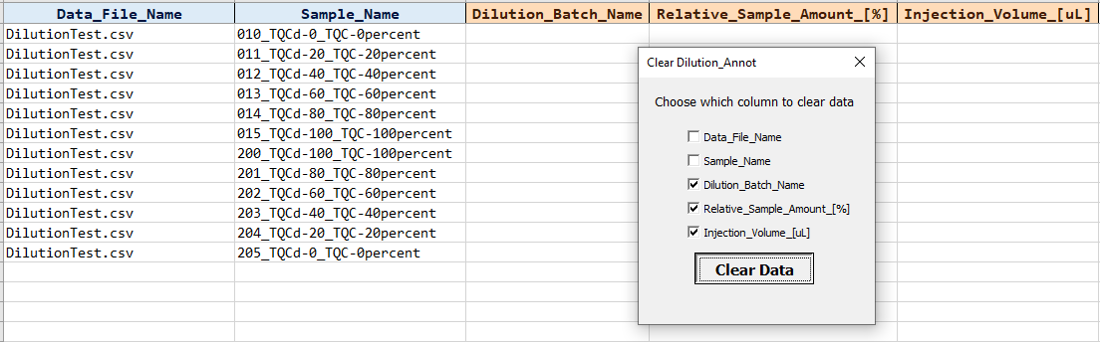

Ensure that

* The choices of which columns to clear are present and in the correct spelling.
* The correct columns are cleared.
* Only the contents are cleared, not the format. No cells should be deleted as well.