MS Template Creator

User Documentation

Version 0.0.9

2018

# Version Control Table

|  |  |
| --- | --- |
| **Title** | MS Template Creator User Documentation |
| **Created By** | Jeremy John Selva |
| **Date Created** | 27 March 2018 |
| **Maintained By** | Jeremy John Selva |

|  |  |  |  |  |
| --- | --- | --- | --- | --- |
| **Version Number** | **Modified By** | **Date Modified** | **Modifications Made** | **Status** |
| 0.0.9 | Jeremy John | 13 Oct 2021 | Added   * 3.2.2 WideTable Form with Qualifier * 3.2.4 CompoundTable Form with Qualifier | Draft |
| 0.0.8 | Jeremy John | 29 Sep 2021 | Whole document as physical looks in excel has changed | Draft |
| 0.0.7 | Jeremy John | 14 Aug 2021 | Changed   * 8.3.4 Merge with Sample Annotation * 8.6 Copying RQC samples * 9 Using sheet “Dilution_Annot” | Draft |
| 0.0.6 | Jeremy John | 4 Apr 2021 | Changed   * 8.2.2 Sample_Amount, Sample_Amount_Unit and ISTD_Mixture_Volume_[uL] | Draft |
| 0.0.5 | Jeremy John | 28 Jan 2021 | Added   * 6.1.1 Loading from the vendor’s software * 6.1.2 Loading from files exported in a form of a table * 8.1.1 Loading from the vendor’s software * 8.1.2 Loading from files exported in a form of a table * 9 Using sheet “Dilution_Annot” | Draft |
| 0.0.4 | Jeremy John | 3 Mar 2019 | Added   * 7.4 Concentration | Draft |
| 0.0.3 | Jeremy John | 21 Aug 2018 | Changed   * 8.2.1 Sample Type | Draft |
| 0.0.2 | Jeremy John | 16 May 2018 | Added   * 3.3 Bug Reports * 5.1 Compulsory Features * 6.5 Colour Tracker in Transition_Name_Annot * 7.3 Colour Tracker in ISTD_Annot | Draft |
| 0.0.1 | Jeremy John | 3 May 2018 | Initial commit and review | Draft |

# Content Page

Version Control Table 1

Content Page 3

List of Tables 4

List of Equations 4

1 Introduction 5

1.1 Purpose 5

1.2 Scope 5

1.3 Bug Reports 5

1.3.1 Bug Report Example 5

2 Starting the MS Annotation Template Creator 6

2.1 First time users 6

2.2 Starting the system 6

3 Exporting MRM transition names data 7

3.1 Compulsory Features. 7

3.2 Exporting MRM transition names data from MassHunter by Agilent 8

3.2.1 WideTable Form 8

3.2.2 WideTable Form with Qualifier 9

3.2.3 CompoundTable Form 10

3.2.4 CompoundTable Form with Qualifier 11

3.3 Exporting MRM transition names data from MultiQuant by SciEx 12

3.3.1 LongTable Form 12

4 Using sheet “Transition_Name_Annot” 17

4.1 Loading MRM transition names into the sheet “Transition_Name_Annot” 17

4.1.1 Loading from the vendor’s software 17

4.1.2 Loading from files exported in a form of a table 18

Validating column MRM transition names’ ISTD 20

4.2 Copying MRM transition names’ ISTD to sheet “ISTD_Annot” 21

4.3 Clearing entries in the sheet “Transition_Name_Annot” 22

4.4 Colour Tracker in Transition_Name_Annot 22

4.4.1 Modifying Transition_Name column 23

4.4.2 Modifying Transition_Name_ISTD column 23

5 Using sheet “ISTD_Annot” 23

5.1 Calculating ISTD from ng/mL to nM 23

5.2 Clearing entries in the sheet “ISTD_Annot” 24

5.3 Colour Tracker in ISTD_Annot 24

5.4 Concentration convertion 24

6 Using sheet “Sample_Annot” 25

6.1 Creating a new sample annotation template from MRM transition names data 25

6.1.1 Loading from the vendor’s software 25

6.1.2 Loading from files exported in a form of a table 27

6.2 Filling up the Sample_Annot columns 29

6.2.1 Sample_Type 29

6.2.2 Sample_Amount, Sample_Amount_Unit and ISTD_Mixture_Volume_[uL] 30

6.2.3 Autofill by Sample Type 31

6.2.4 Autofill Concentration Unit 33

6.3 Merging MRM transition names data with an existing sample annotation file 34

6.3.1 Match with Sample_Name (Compulsory for merging) 35

6.3.2 Map to Sample_Amount 36

6.3.3 Map to ISTD_Mixture_Volume_[ul] 36

6.3.4 Merge with Sample Annotation 36

6.4 Troubleshooting merging problems 37

6.5 Clearing entries in the sheet “Sample_Annot” 37

6.6 Copying RQC samples to sheet “Dilution_Annot” 38

7 Using sheet “Dilution_Annot” 39

7.1 Filling up the Dilution_Annot columns 39

7.2 Clearing entries in the sheet “Dilution_Annot” 39

# List of Tables

Table 8‑1 : Table of Abbreviation for Sample Type 28

Table 8‑2 : Table of people to approach to edit “Sample_Type” 29

Table 8‑3 : Table of units of measurement for the “Sample_Amount_Unit” column 29

Table 8‑4 : Table of people to approach to edit “Sample_Type_Unit” 30

Table 8‑5 : Table of possible reasons for merging problem 36

# List of Equations

Equation 8‑1 : Formula to calculate the concentration of analyte. 24

# Introduction

This document highlights the functionalities of the excel macro file MS Annotation Template Creator.

## Purpose

The excel macro is created to provide users a more friendly interface to take in MRM transition names data exported directly from mass spectrometry software and create several annotation templates suited for automated data processing and statistical analysis.

## Scope

This guide will assist users to use the excel macro file MS Annotation Template Creator properly in SLING.

## Bug Reports

When a bug is encountered, please report them Jeremy via email [bchjjs@nus.edu.sg](mailto:bchjjs@nus.edu.sg).

Please create the bug report in the following way so that we can reproduce the error

* Email Subject Title in the form
  + [Software/Script Name] – [Summary of bug report]
* Attached dataset that produce the error
* Version number of the software used
* Steps to reproduce the error
* Expected Results
* Actual Results + ( Screenshots or log files)

For more info, see <https://testlio.com/blog/the-ideal-bug-report/>

### Bug Report Example

Subject: MS Template Creator - Unable to load MRM data into Sample_Annot sheet

Dear SoftwareDeveloper,

I am currently using MS Template Creator v1.0.0 and wanted to load this MRM data attached onto the sheet “Sample_Annot”.

I first click on the button “Load Sample Annotation”, browse for the attached dataset and click on “Create new Sample Annotation”. I expected the Sample Name column to be filled automatically but the following error message appeared.

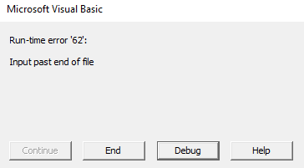

Please advise on what to do next. Thank you

Regards,

BugReporter

# Starting the MS Annotation Template Creator

## First time users

Please ensure that Microsoft Excel 2016 is installed.

## Starting the system

Double click on MS Annotation Template Creator to open the file. Upon opening you may encounter this security warning

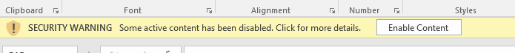

Click on **Enable Content** so that the macro in the file will be activated.

Alternatively, you ca go to File -> Info -> Enable Content -> Advanced Option

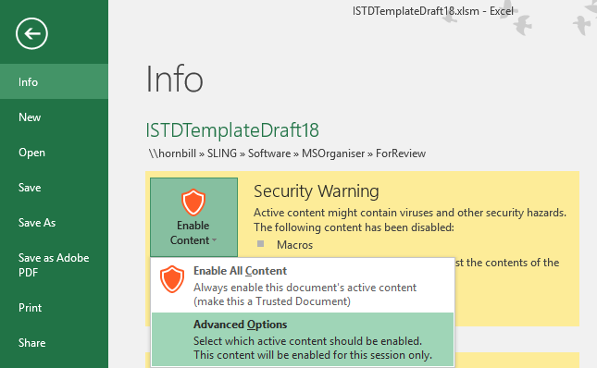

Select “Enable content for this session” and click Ok.

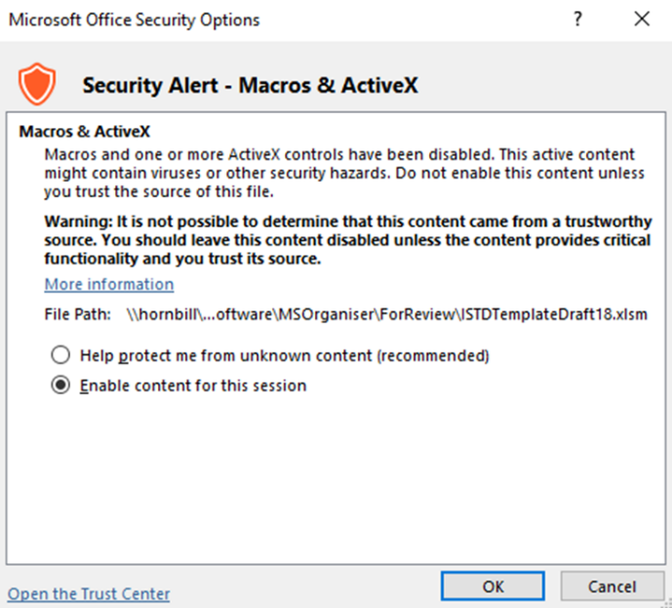

# Exporting MRM transition names data

MS Template Creator currently supports certain MRM transition names data format.

We define them as WideTable and CompoundTable form from Agilent and LongTable form from SciEx

## Compulsory Features.

Before showing how to export the MRM transition names data correctly for the program to work, we shall show the compulsory column names that the program use. You may use the below tables as a checklist.

Please note that there are also restricted column names that we advise having them removed before outputting them as text file of csv

|  |  |  |  |
| --- | --- | --- | --- |
| **MRM transition names data form** | **Compulsory column names** | | **Restricted column names** |
| **Without Qualifiers** | **With Qualifier** |
| Agilent’s WideTable form | Sample   * Data File   Compound Results   * Area | Qualifier Results   * Area | Sample   * Quantitation Message   Columns from   * ISTD Compound Methods * ISTD Compound Results |
| Agilent’s CompoundTable form | Sample   * Data File   Compound Method   * Name   Compound Results   * Area | Qualifer Method   * Transition   Qualifier Results   * Area |
| Sciex’s LongTable form | Sample Name  Component Name | Not Applicable |  |

## Exporting MRM transition names data from MassHunter by Agilent

### WideTable Form

Ensure that you are viewing the MRM transition names data under “Flat Table” and “Display Multiple Compounds/Sample in Batch Table”

|  |  |
| --- | --- |
|  |  |

Ensure that “Data File” is present under the Sample Column.

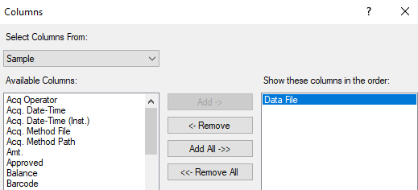



Click on File -> Export -> Export Table

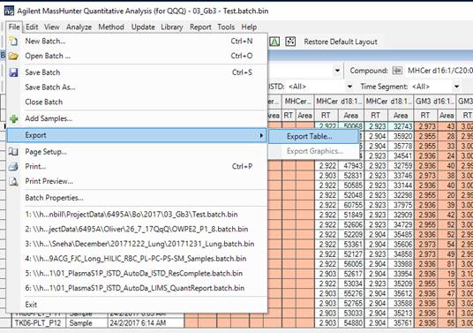

Choose File type as csv

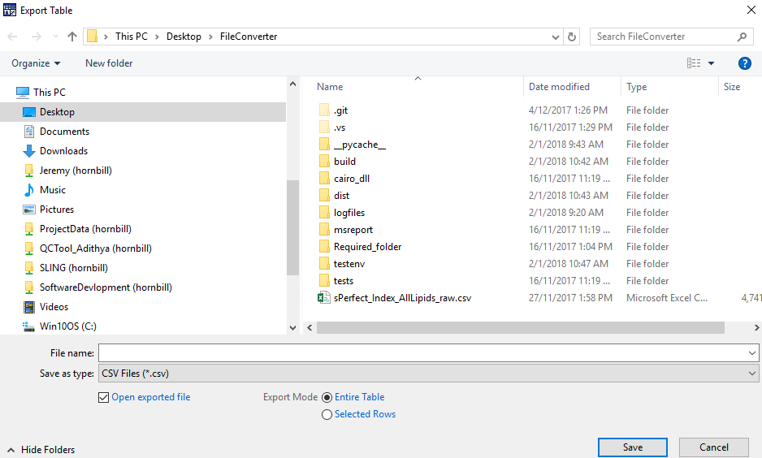

The exported raw data should look like this

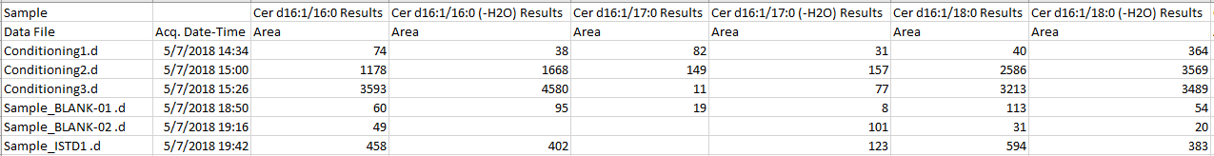

### WideTable Form with Qualifier

In addition to the conditions mentioned in the previous section,

Ensure that relevant columns from the Qualifier Results Column are selected.

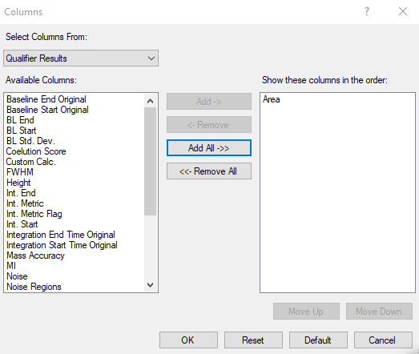

To give

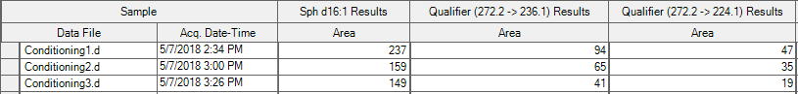

### CompoundTable Form

Ensure that you are viewing the MRM transition names data under “Compound Table” and “Display Multiple Compounds/Sample in Batch Table”

|  |  |
| --- | --- |
|  |  |

Ensure that “Name” is present under the Compound Method Column.

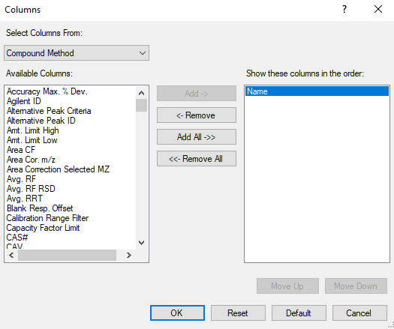 

Ensure that “Data File” is present under the Sample Column.

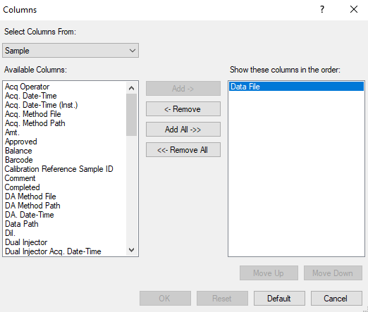 

Click on File -> Export -> Export Table

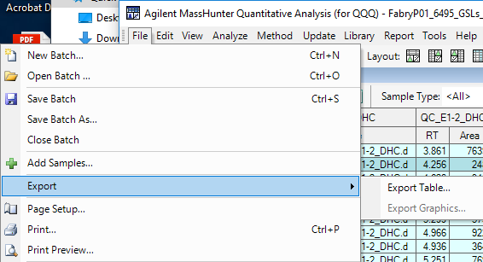

Choose File type as csv

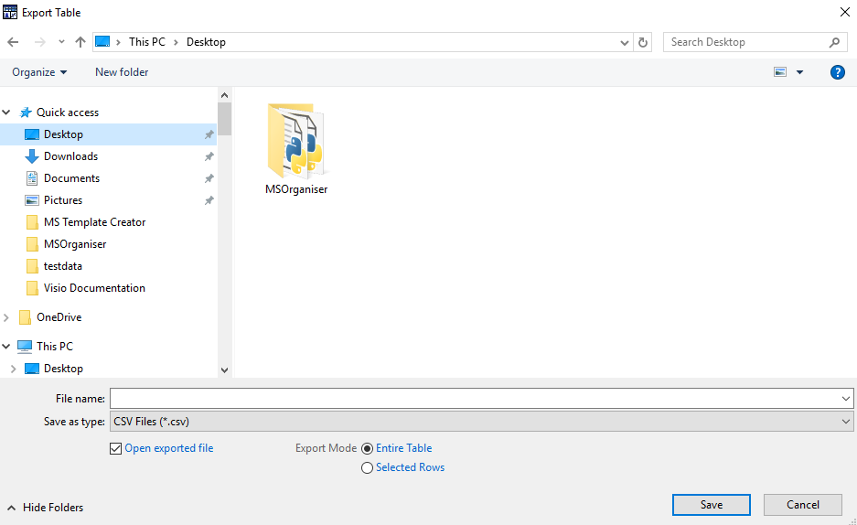

The exported raw data should look like this

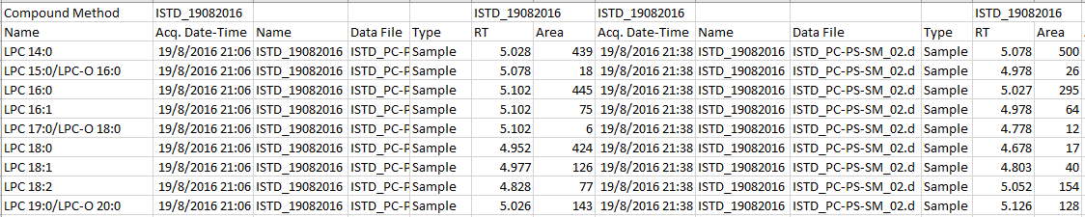

### CompoundTable Form with Qualifier

In addition to the conditions mentioned in the previous section,

Ensure that relevant “Transition” from the Qualifier Method Column is selected

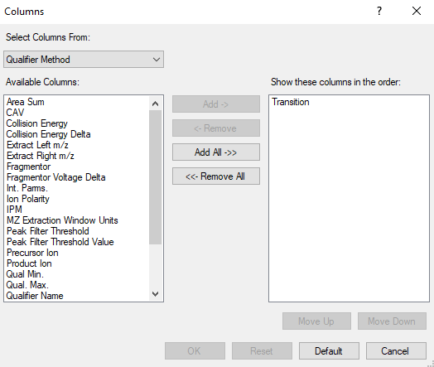.



Ensure that relevant columns from the Qualifier Results Column are selected.



To give

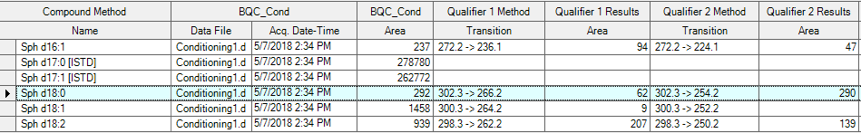

## Exporting MRM transition names data from MultiQuant by SciEx

### LongTable Form

Open your MultiQuant session file, in MultiQuant



You will see this

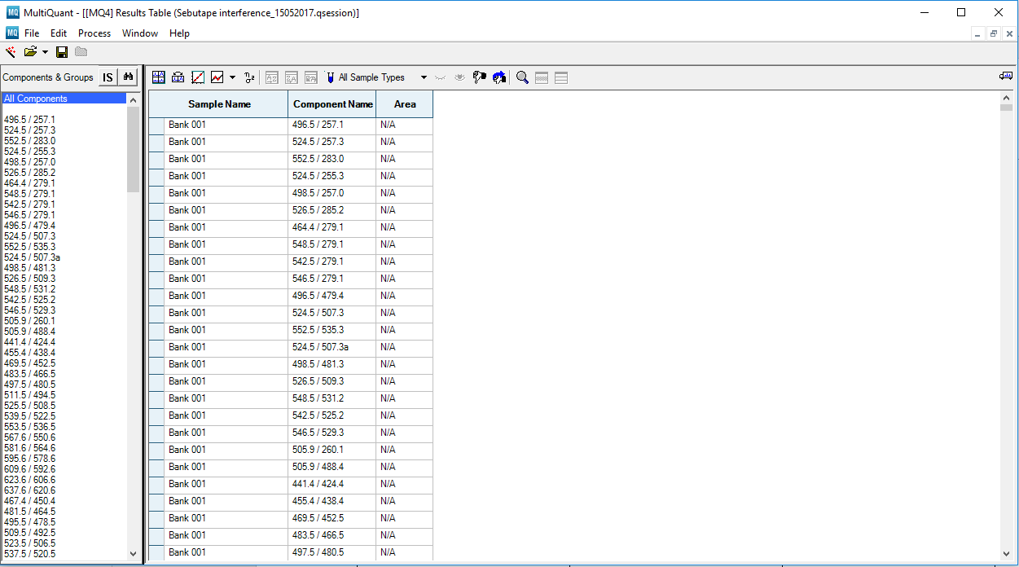

Right click on the “Results Table”. Click on “Column Settings”

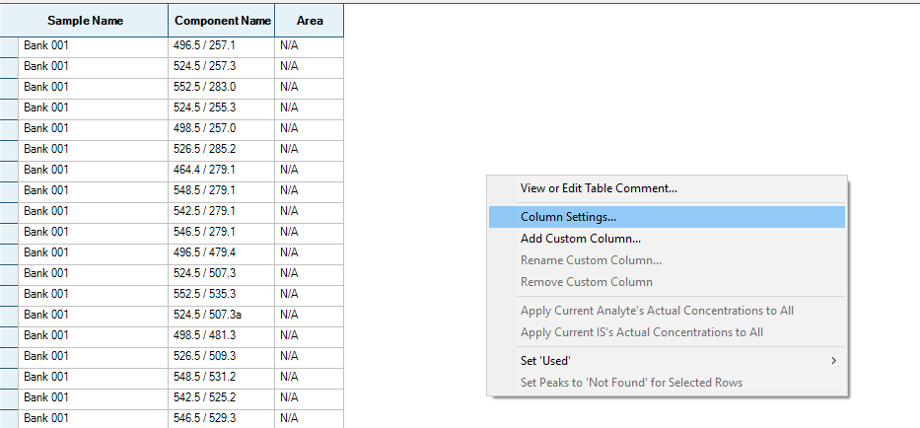

Choose your relevant columns that you wish to display in the “Results Table” and click Ok.

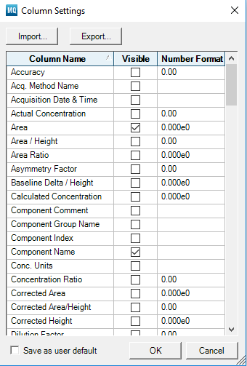

The relevant columns are as follows:

|  |
| --- |
| Compulsory Columns |
|  |
|  |
| Output Options |
|  |
|  |
|  |
|  |

The output will look like this

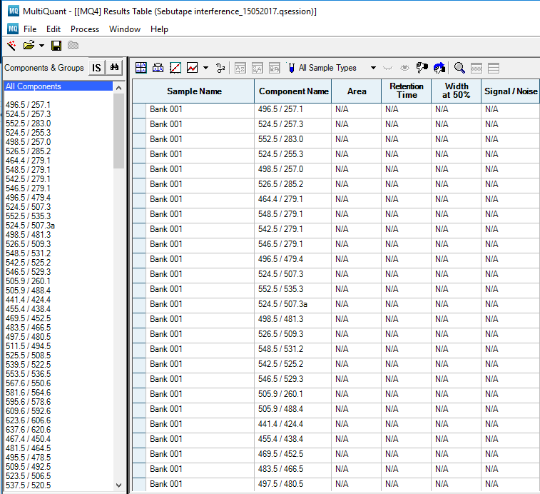

To export the file correctly, make sure “All Components” is selected

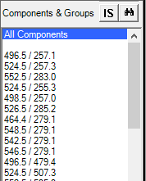

Click on File -> Export -> Results Table… You will see

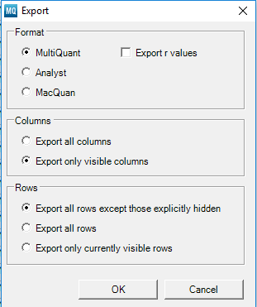

Just keep the settings the same as the above figure and click Ok. You will now need to select the folder to output the text file. Click Save

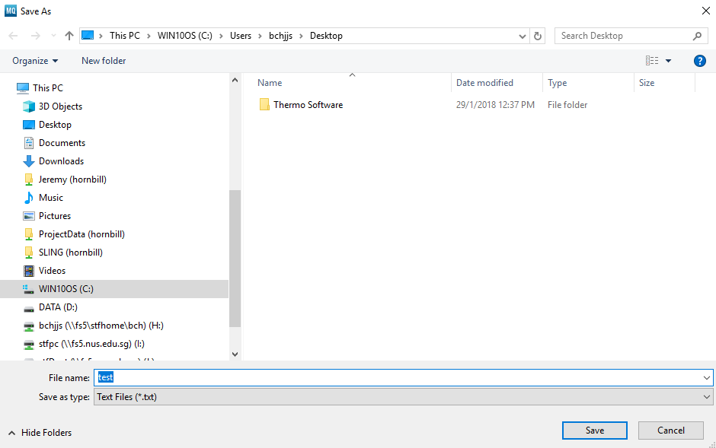

MultiQuant will save a text file which looks like this

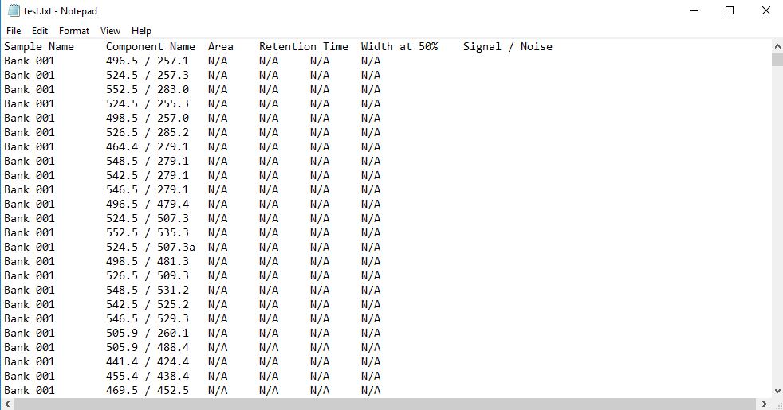

# Using sheet “Transition_Name_Annot”

This sheet is meant to record the transition names present in multiple MRM transition names data files and sort them in alphabetical order. Users can key in their internal standard (ISTD) for each transition names and send them the list of ISTD from the “Transition_Name_Annot” sheet to the “ISTD_Annot” sheet

## Loading MRM transition names into the sheet “Transition_Name_Annot”

### Loading from the vendor’s software

Click on the button “Load Transition_Name from Raw Data”



You will be prompted to load the MRM transition names raw data exported via the steps in Section 6. You may select multiple files.

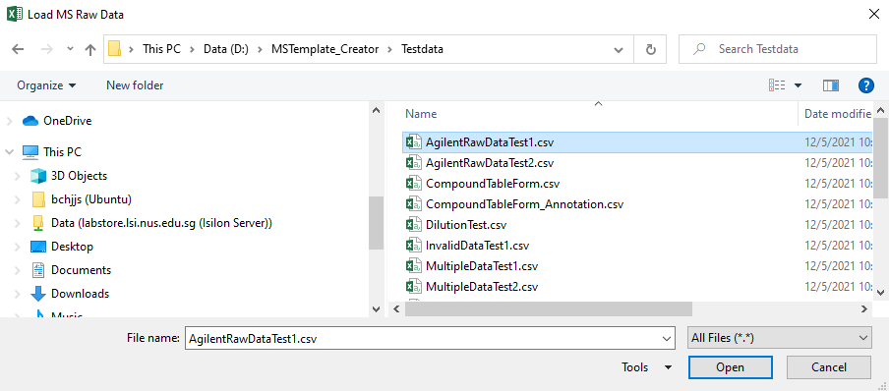

Click on “Open” and the transition names from the raw data will automatically be loaded

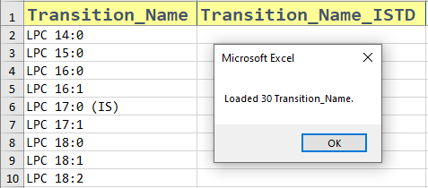

If there are existing entries in the “Transition_Name” column, there will be a prompt to ask users to overwrite the existing entries and replace them with the most recent one.

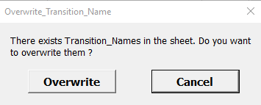

Once the transition name has been loaded, users can key in the ISTD for each transition name.

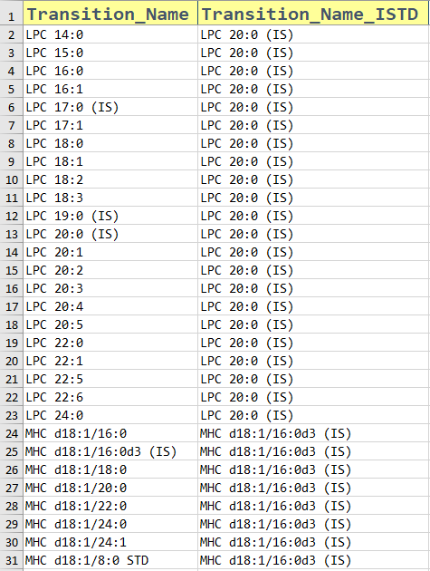.

### Loading from files exported in a form of a table

If the input file is in a table form like the below examples,

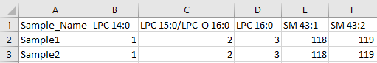

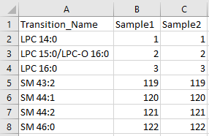

It can be read into the excel sheet by clicking on the button,



Clicking the button will give

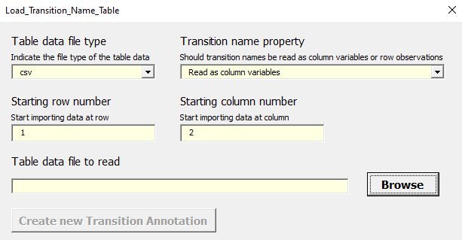

If your table data has the transition names as columns, pick “Read as column variables”

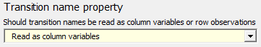

Next, you have to pick the row and column number where the transition name starts.

In the above example, the transition name starts from the first row, second column. Hence, we input the following values.

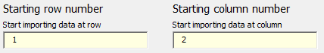

Next, we need to browse for the file.

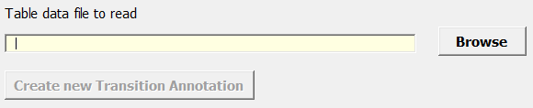

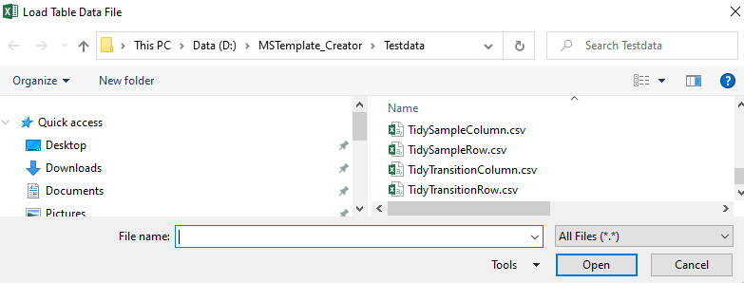

Once loaded, the button “Create new Transition Annotation” will be made available.

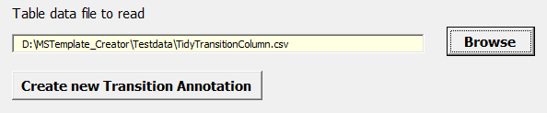

When “Create new Transition Annotation” is clicked, the transitions will be loaded.

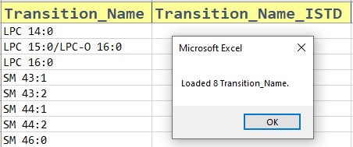

On the other hand, if your table data has the transition names as columns, pick “Read as row observations”

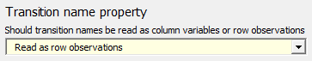

In the above example, the transition name starts from the second row, first column. Hence, we input the following values.

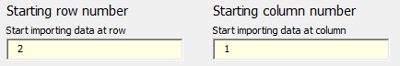

Browse for the file and click on “Create new Transition Annotation”

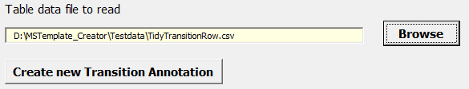

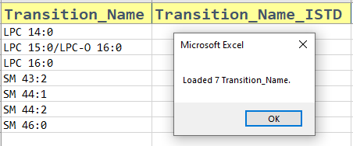

## Validating column MRM transition names’ ISTD

At times, users may input an ISTD that is not found in the raw data set. This is considered as an invalid input and users must be informed about this. A button has been created to assist the user about this

Click on the button “Validate ISTD”



If there are no issues with the ISTD, this message box will appear

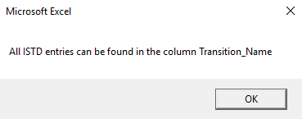

Else, the program will show which ISTD are invalid

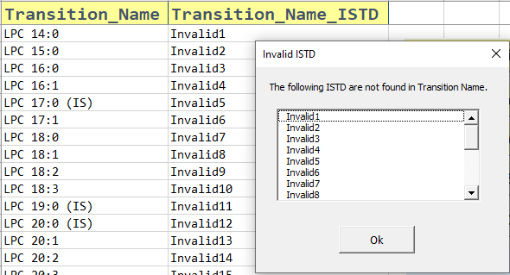

## Copying MRM transition names’ ISTD to sheet “ISTD_Annot”

After users have keyed in their internal standard (ISTD) for each transition name, they will need to calculate the concentration of the ISTD. While the calculation is done in the sheet “ISTD_Annot”. There exists a button to help transfer the ISTD listed in the column “Transition_Name_ISTD” from the sheet “Transition_Name_Annot” to the ISTD table in the sheet “ISTD_Annot”.

Click on the button “Load ISTD to ISTD_Table”



The ISTD listed in the “Transition_Name_ISTD” column is copied automatically to the sheet “ISTD_Annot” with the duplicates removed.

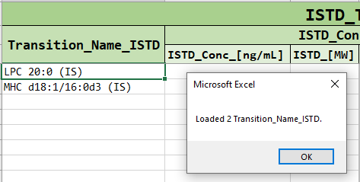

If there are existing entries in the “ISTD_Annot” sheet, there will be a prompt to ask users to overwrite the existing entries and replace them with the most recent one.

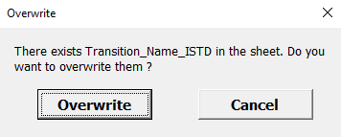

Users can then proceed to calculate ISTD concentration following the instructions given in section 7.

## Clearing entries in the sheet “Transition_Name_Annot”

To clear the existing entries of the sheets quickly, click on the button “Clear Columns”



A message box will appear, asking which column to clear.

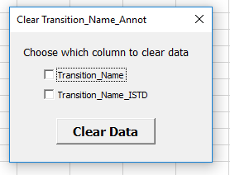

Checking on the “Transition_Name_ISTD” box and clicking clear data will clear all entries in the column “Transition_Name_ISTD”. The same applies for the other columns

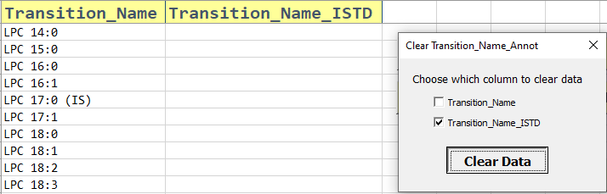

## Colour Tracker in Transition_Name_Annot

This is to alert users if they have accidentally modified any cells by mistake after ISTD validation

When users press the button “Validate ISTD”, the cell will change its format to

* Green when there is a valid ISTD
* Yellow when there is a blank ISTD
* No fill when there is an invalid ISTD

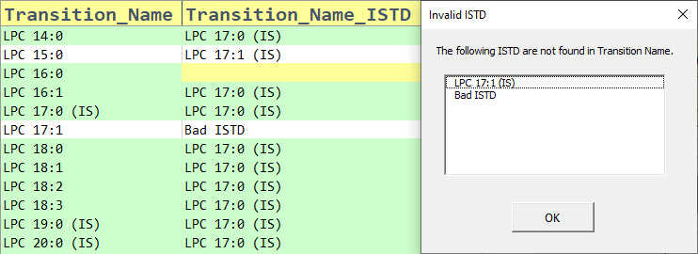

It is advisable for all cells to turn green before proceeding to the next step

### Modifying Transition_Name column

When a “Transition_Name” column cells are in the green fill, modifying it will cause the colour to be remove. It will also cause the whole column of “Transition_Name_ISTD” to have no fill.

This is because

### Modifying Transition_Name_ISTD column

When a “Transition_Name_ISTD” column cells are in the green fill, modifying it will cause the colour to be remove

# Using sheet “ISTD_Annot”

This sheet helps the user to calculate the concentration of the ISTD from ng/mL to nM automatically in a click of a button without using any formulas

## Calculating ISTD from ng/mL to nM

Key in the entries in the columns “ISTD_Conc_[ng/mL]” and “ISTD_[MW]”. Once done, click on the button “Convert to nM and Verify”. If calculation is not required, users can just key in the values to the “ISTD_Conc_[nM]” directly.

The ISTD values in “ISTD_Conc_[nM]” will be calculated automatically. If calculation is not required, users can just key in the values to the “ISTD_Conc_[nM]” directly.

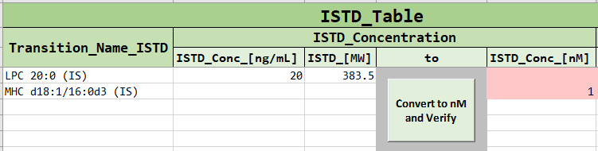

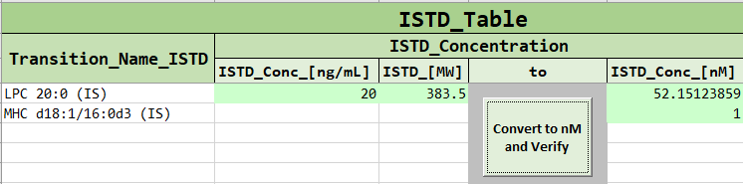

## Clearing entries in the sheet “ISTD_Annot”

To clear the existing entries of the sheets quickly, click on the button “Clear ISTD_Table Columns”



The following message box will appear

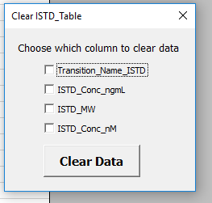

Users can select the relevant columns to clear and click on “Clear Data”.

## Colour Tracker in ISTD_Annot

This is to alert users if they have accidentally modified any cells by mistake.

Pressing the button “Convert to nM and Verify” will cause the three columns “ISTD_Conc_[ng/mL]”, “ISTD_[MW]” and “ISTD_Conc_[nM]” to have a green fill if valid values are put in

Modifying any columns will cause the green colour to be remove from columns “ISTD_Conc_[ng/mL]” and “ISTD_[MW]” and change the colour of “ISTD_Conc_[nM]” from green to red

## Concentration convertion

User can change the concentration from nM to the desired units that is required

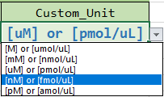

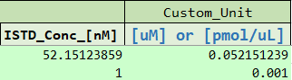

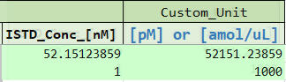

The desired units will be used by the MSOrganiser during the calculation of the concentration of the analyte.

# Using sheet “Sample_Annot”

This sheet has several uses:

1. Assist users in creating a new sample annotation file that can be merged with the raw data.
2. Check if an existing sample annotation file is compatible to the raw data. If not, what changes can be made to the sample annotation file.
3. Force users to categorise their samples to different sample types (e.g TQC, BQC, etc...) in a standardised way. This is to avoid the input of ambiguous sample type names.
4. This template for now will be used by another in house software called the MSOrganiser to calculate the concentration of the analyte via this formula.

Equation 8‑1 : Formula to calculate the concentration of analyte.

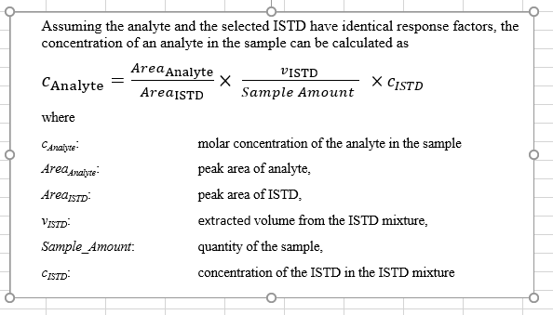

## Creating a new sample annotation template from MRM transition names data

### Loading from the vendor’s software

To create the MRM transition name data, please refer to Section 6 before proceeding.

Click on the button “Load Sample Annotation”



The following message box will appear.

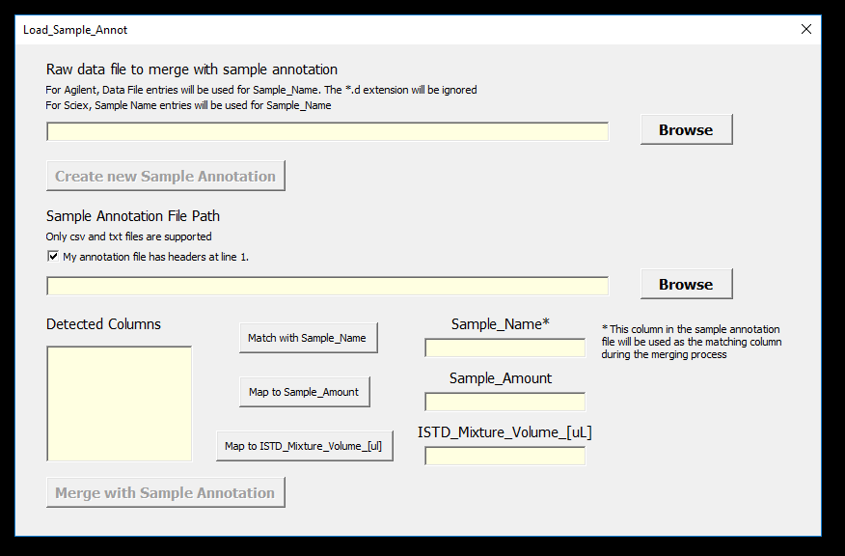

To load the MRM transition name data file, click on the “Browse” button shown below.

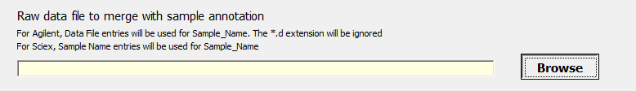

You will be prompted to load the MRM transition names raw data exported via the steps in Section 6. You may select multiple files.

Choose the raw data and click “Open”

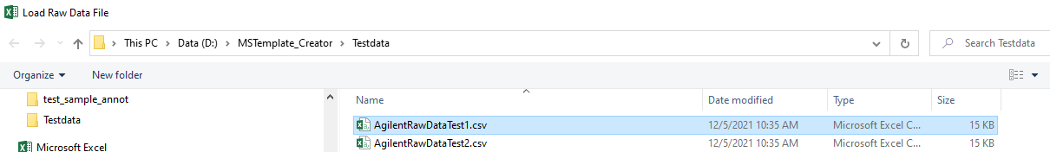

You should see the file path being recorded and the button “Create new Sample Annotation” activated.

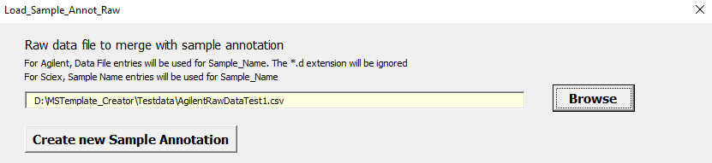

Click on “Create new Sample Annotation”

If the loading is successful, you should see some column been filled up.

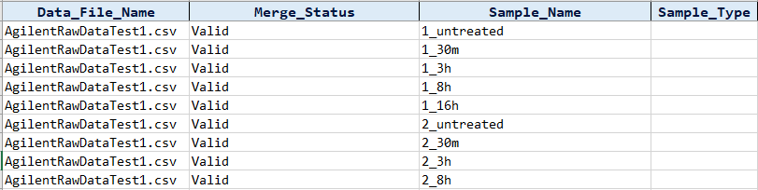

The columns that are filled up tells the following

* The name of the raw data file
* The merge status (should be all valid since it is a new annotation file)
* The name of the sample given in the raw data
* The sample type based on how the Sample_Name is recorded. The excel template will try to guess the sample type based on the sample name. Unknown sample types will be left blank.

### Loading from files exported in a form of a table

If the input file is in a table form like the below examples,

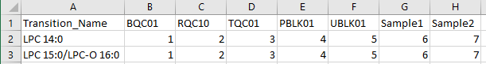

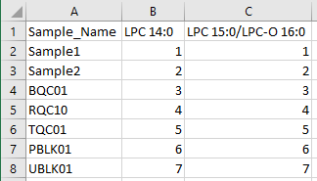

It can be read into the excel sheet by clicking on the button,



Clicking the button will give

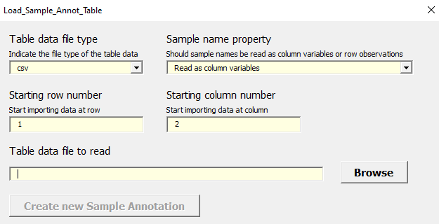

If your table data has the transition names as columns, pick “Read as column variables”



Next, you have to pick the row and column number where the sample name starts.

In the above example, the transition name starts from the first row, second column. Hence, we input the following values.



Next, we need to browse for the file.

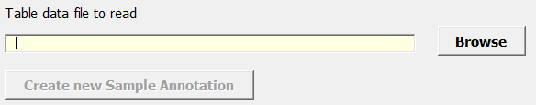



Once loaded, the button “Create new Transition Annotation” will be made available.

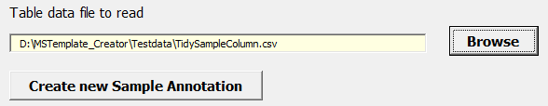

When “Create new Sample Annotation” is clicked, the sample names will be loaded.

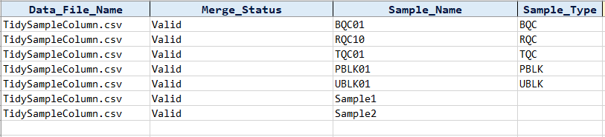

On the other hand, if your table data has the sample names as columns, pick “Read as row observations”



In the above example, the sample name starts from the second row, first column. Hence, we input the following values.



Browse for the file and click on “Create new SampleAnnotation”

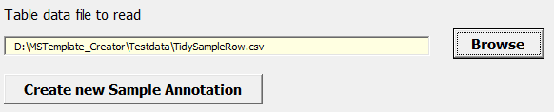

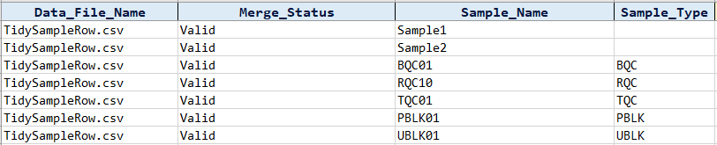

## Filling up the Sample_Annot columns

### Sample_Type

Users will need to fill/edit the “Sample_Type” manually from a list of options

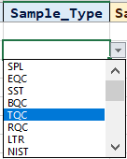

The meaning of these options are as follows

Table 8‑1 : Table of Abbreviation for Sample Type

|  |  |  |
| --- | --- | --- |
| **Abbreviation** | **Name** | **Description** |
| SPL | Study sample | “Unknown” sample |
| EQC | Equilibration QC | Verification of Instrument Equilibration |
| SST | Instrument Suitability Test | Instrument Suitability Test |
| BQC | Batch QC | Process/Pooled QC |
| TQC | Technical QC | Instrument QC (System Suitability) |
| RQC | Response  QC | Dilution series to check for linear response/saturation (e.g TQC) |
| LTR | Long Term Reference Plasma (with ISTD) | Long Term Reference Plasma (with ISTD) |
| NIST | NIST SRM1950 reference plasma (with ISTD)​ | NIST SRM1950 reference plasma (with ISTD)​ |
| SRM | Sample Reference Material | Sample Reference Material |
| PBLK | Process/Batch Blank | Processed or Extracted solvent/buffers with ISTD |
| UBLK | Unextracted Blank (Solvent with ISTD) | Unextracted Blank (Solvent with ISTD) |
| SBLK | Solvent Blank | Unextracted solvent used for extraction (e.g. used for Solvent with ISTD mixture) |
| MBLK | Matrix Blank | Sample processed without ISTD to check for interference of endogenous compounds |
| STD | Standard Sample Type | Standard Sample Type |
| LQQ | Lower Limit of Quantitation QC | Lower Limit of Quantitation QC |
| CTRL | Control Sample Type | Control Sample Type |
| DUP | Duplicate Sample Type | Duplicate Sample Type |
| SPIK | Spike Sample Type | Spike Sample Type |
| LTRBK | Long Term Reference Plasma (without ISTD) | Long Term Reference Plasma (without ISTD) |
| NISTBK | NIST SRM1950 Reference Plasma (without ISTD) | NIST SRM1950 Reference Plasma (without ISTD) |

The options are currently in line to how the LIMS system in SLING organised its sample. If a new Sample_Type is required in SLING, please contact these people in following order to ensure changes can be made as soon as possible.

Table 8‑2 : Table of people to approach to edit “Sample_Type”

|  |  |  |  |
| --- | --- | --- | --- |
| **Order** | **Name** | **Email** | **Reason** |
| 1st | Bo | [bo.burla@nus.edu.sg](mailto:bo.burla@nus.edu.sg) | For approval |
| 2nd | Jeremy | [bchjjs@nus.edu.sg](mailto:bchjjs@nus.edu.sg) | To update the LIMS and Excel Macro file |

Users can autofill any blank cells with the word “SPL” by clicking the button “Autofill ‘Sample’ in Sample_Type”



### Sample_Amount, Sample_Amount_Unit and ISTD_Mixture_Volume_[uL]

To calculate the concentration of an analyte given in this equation

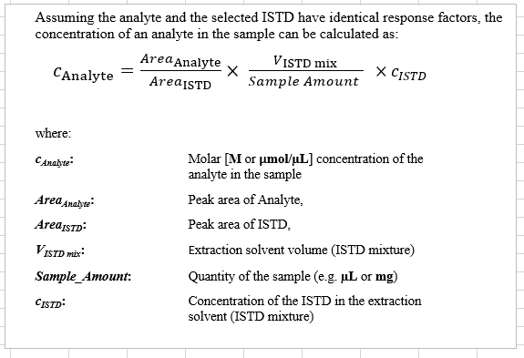

These columns must be filled manually.

For the “Sample_Amount_Unit” column, the following units are given

Table 8‑3 : Table of units of measurement for the “Sample_Amount_Unit” column

|  |
| --- |
| **Sample_Amount_Unit** |
| cell number |
| mg dry weight |
| mg fresh weight |
| ng DNA |
| ug total protein |
| uL |

If a new “Sample_Type_Unit” is required in SLING, please contact the following people in following order to ensure changes can be made as soon as possible.

Table 8‑4 : Table of people to approach to edit “Sample_Type_Unit”

|  |  |  |  |
| --- | --- | --- | --- |
| **Order** | **Name** | **Email** | **Reason** |
| 1st | Bo | [bo.burla@nus.edu.sg](mailto:bo.burla@nus.edu.sg) | For approval |
| 2nd | Jeremy | [bchjjs@nus.edu.sg](mailto:bchjjs@nus.edu.sg) | To update the Excel Macro file |

Users can also put in their own “Sample_Amount_Unit” for their one time off experiment.



### Autofill by Sample Type

Users may wish to use autofill the Sample_Amount, Sample_Amouont_Unit and ISTD_Mixture_Volume_[uL] column with the button.



Clicking on this button will give the following:

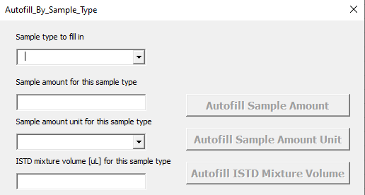

For example, to fill in all NIST with 10 as the sample amount, uL as the sample amount unit and 190 as the ISTD mixture volume. We fill in as follows:

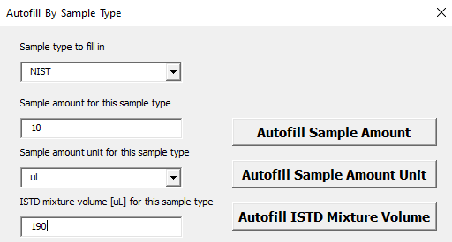

Click on the respective autofill buttons to fill the values accordingly.

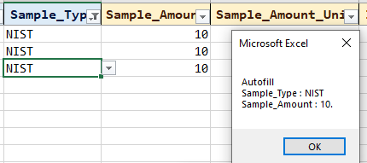

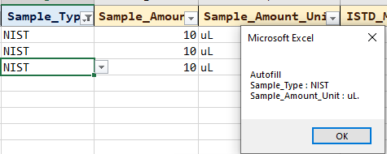

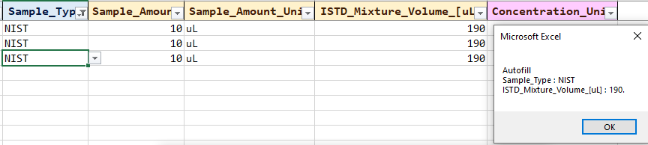

The final output should look like this

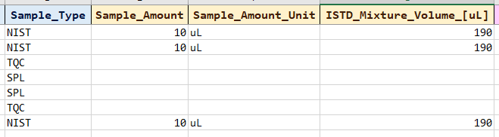

### Autofill Concentration Unit

The concentration unit can be filled automatically by the button



The required input is to have some entry in the Sample_Amount_Unit column.

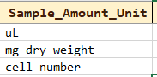

And choose your desired ISTD concentration, under the custom unit section from the ISTD_Annot sheet



Clicking on the button will give the following

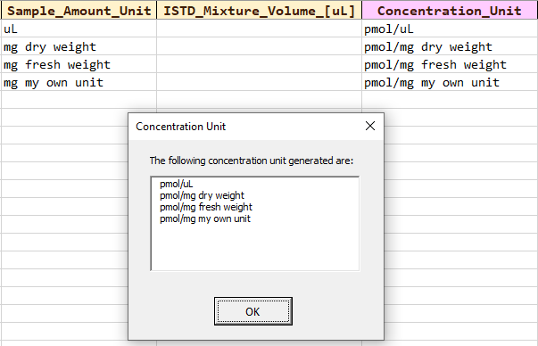

When the desired ISTD concentration, under the custom unit section is changed,

* if there are entries in the Sample_Unit_Column in Sample_Annot sheet and
* if there are entries in the Custom Unit Column in ISTD_Annot sheet

then the Concentration Unit column will be updated automatically if there are entries in the Sample_Unit_Column.

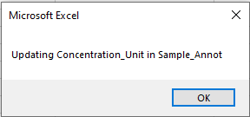

## Merging MRM transition names data with an existing sample annotation file

There are times when users have created their own sample annotation file beforehand and wishes to merge it with the MRM transition names data.

The template provides an option to merge both the MRM transition names data and the sample annotation file using a common column “Sample_Name”

This template can serve the needs to

* Check the existing sample annotation file is compatible to the raw data file
* Map specific columns from the sample annotation to the columns in the template to calculate the concentration of the analyte.

To perform this merging process, following the instructions in Section 9.1 to record the MRM transition name data being used.

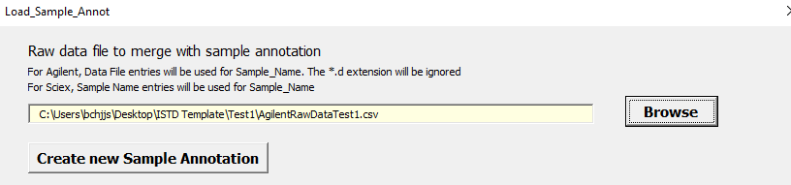

Next, use browse button below to upload the sample annotation file.

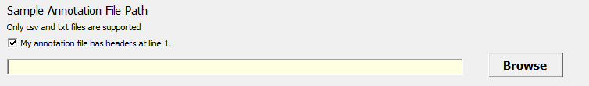

Once the file is uploaded, the program will list the column names found at the first line of the annotation file.

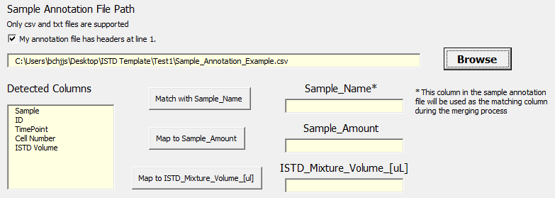

You can choose which columns in the annotation files goes to the three slots on the right by the use of three corresponding buttons “Match with Sample_Name”, “Map to Sample_Amount” and “Map to ISTD_Mixture_Volume_[ul]”.

The instruction to use them can be found in the next three sections respectively.

Once the mapping is done, you may proceed to Section 9.3.4 to perform the merging.

### Match with Sample_Name (Compulsory for merging)

The slot “Sample_Name” determines which column in the sample annotation file will be used to merge/join with a default column from the MRM transition name data.

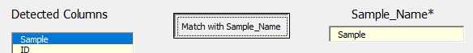

For Agilent, Data File entries will be used to match with Sample_Name. The *.d extension will be ignored.

For Sciex, Sample Name entries will be used to match with Sample_Name

Names of the sample in both the MRM transition name data and the annotation file must be the same for the merge to be successful.

### Map to Sample_Amount

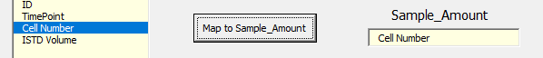

This map determines which column in the sample annotation file goes to the “Sample_Amount” column in the “Sample_Annot” sheet given the merge is successful.

### Map to ISTD_Mixture_Volume_[ul]

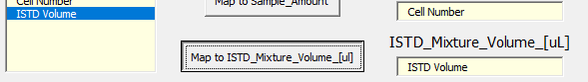

This map determines which column in the sample annotation file goes to the “ISTD_Mixture_Volume-[uL]” column in the “Sample_Annot” sheet given the merge is successful.

### Merge with Sample Annotation

Once the mapping is done, click on the button “Merge with Sample Annotation”



If there are existing entries in the “Sample_Annot” sheet, there will be a prompt to ask users to overwrite the existing entries and replace them with the most recent one.

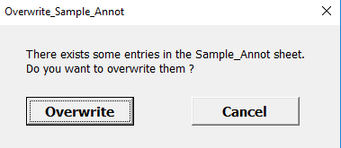

The program will then proceed to merge the two data together and the output may look like this.

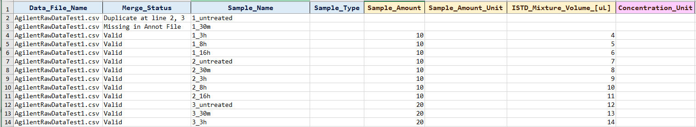

The first three columns comes from the raw data file and the last three columns comes from the sample annotation file.

## Troubleshooting merging problems

If there is some problem will the merge, a message box will appear.

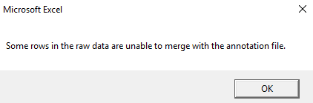

User can then check the reason by checking on the column “Merge Status”

The merge status usually comes in three form.

Table 8‑5 : Table of possible reasons for merging problem

|  |  |
| --- | --- |
| **Merge Status Results** | **Results Implication** |
| Valid | The merge is a success and nothing more needs to be done. |
| Missing in Annot File | The Sample_Name could not be found in the sample annotation file. Please add the missing sample names in the annotation file and reload it again. |
| Duplicate at line {some_number} | The Sample_Name is indicated twice in the annotation file. Please clear one of the extra rows and reload the sample annotation file again |

## Clearing entries in the sheet “Sample_Annot”

To clear the existing entries of the sheets quickly,

Click on the button “Clear Columns”.



A message box will appear, asking which column to clear.

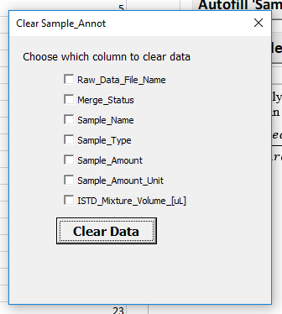

Users can select the relevant columns to clear and click on “Clear Data”.

## Copying RQC samples to sheet “Dilution_Annot”

Users may transfer their RQC samples easily to the sheet “Dilution_Annot”

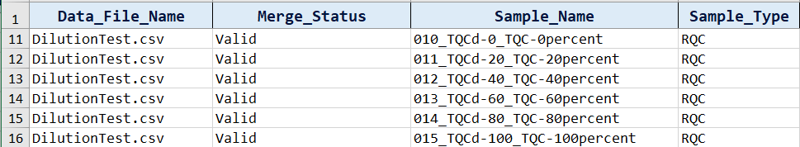

Click on the button “Load RQC Samples to Dilution_Table”



The system will copy all RQC samples into the sheet “Dilution_Annot”

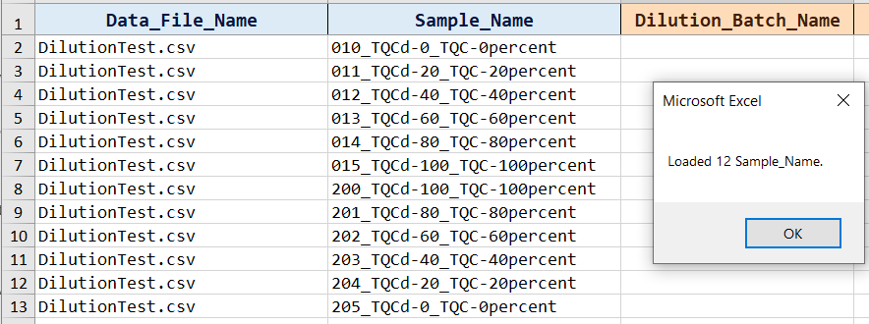

If there are existing entries in the “Dilution_Annot” sheet, there will be a prompt to ask users to overwrite the existing entries and replace them with the most recent one.

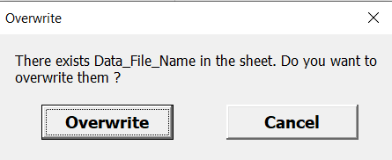

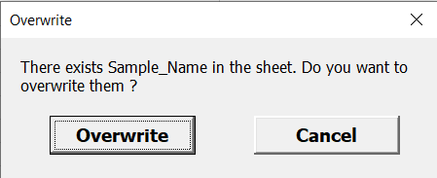

Users can then proceed to fill in the “Dilution_Annot” sheet following the instructions given in section 9.

# Using sheet “Dilution_Annot”

This sheet helps the user to fill in relevant information about of their RQC samples or samples that is related to a dilution series or calibration curve.

## Filling up the Dilution_Annot columns

For Raw_Data_File_Name and Sample Name, uses can key them in manually or load the samples in the “Sample_Annot” sheet and click on “Load RQC Samples to Dilution_Table” to copy the RQC samples.



For the other columns, they need to be filled manually.

## Clearing entries in the sheet “Dilution_Annot”

To clear the existing entries of the sheets quickly, click on the button “Clear Columns”



A message box will appear, asking which column to clear.

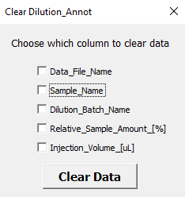

Checking on the “Data_File_Name” box and clicking clear data will clear all entries in the column “Data_File_Name”. The same applies for the other columns

