<https://hadoop.apache.org/docs/r2.7.2/hadoop-project-dist/hadoop-common/SecureMode.html>

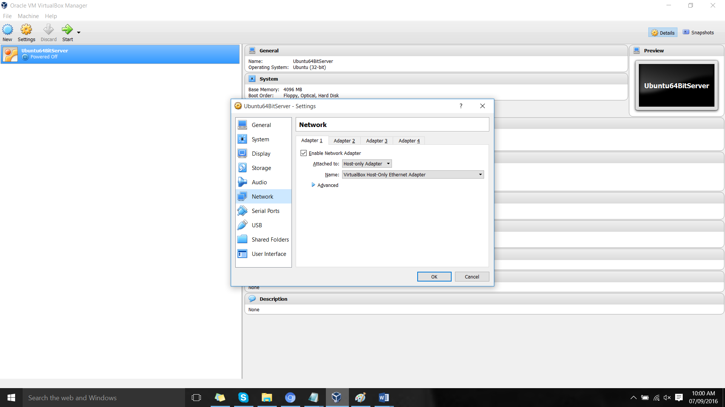

install virtual box

normal installation

then import ubuntu 64 server

then u ill get error

setting config

network congig

