Computer recommendations

Operational system | Ubuntu 20.04 LTS or newer. Debian 10 or newer. CentOS/Rocky Linux 8 or newer.
Software | Python 3.8.x or higher are recommended. Anaconda 3 is suggested, as well to manage Python virtual environments
Libraries to be installed | All dependencies of this version of SELENE can be checked in selene_training.yml  To install these dependencies, create a Python virtual environment through the mentioned file :  cd /Path/package/installed  conda env create -f ./selene_training.yml  conda env list  conda activate selene_training  conda deactivate

Note: If the above recommendations cannot be met, it is possible that SELENE would not work on your PC during this workshop.

Input data format
The format of sea level input data managed by this version of SELENE is built around these fields / columns :
- station identifier as seven digit code
- date in YYYYMMDD format.
- time in HHMMSS format
- sea level in mm
- quality index under Copernicus Conventions (and not mandatory)
The data is organized in ASCII files with .data extension.
You can see below a sample of data recorded in a .data file
2059388 20181128 010000 1121 1
2059388 20181128 020000 1481 1
2059388 20181128 030000 2098 1
There are two alternatives to this data configuration:
- Date / Time inf format YYYY-MM-DD HH:MM:SS
1000001 2025-12-30 21:35:00 3896 1
- No QC column
1000000 20140619 133500 6413

How to launch SELENE in a Unix terminal
The whole process of reprocessing sea level data with SELENE runs through three main blocks: SELENE, BUDDY-CHECK and SELENEVIS.
To launch these functions, execute these commands in the terminal from the path where the package has been deployed:
Algorithm | Command (after activating selene_training virtual environment and move to the path where SELENE is deployed)
Selene.py | python selene.py [target_station as declared in code_guide.csv file]  Example:  python selene.py 1000001
Buddy_check.py | python buddy_check.py [target_station as declared in code_guide.csv file] [target_year as last year of data]  Example:  python buddy_check.py 1000001 2025
Selenevis.py | python selenevis.py -station [target_station]  Example:  python selenevis.py -station 1000001

During the execution some runtime warnings may arise due to changes in the implementation of some methods by the imported libraries, but they shouldn’t prevent for the process to finish and generate results.
Outputs
All outputs are stored in the “output” directory inside the path where SELENE has been deployed
Algorithm | What it does
Selene.py | Produces [code2]_original_sampling_flags.out
Buddy_check.py | Produces  [code2]_original_sampling_buddy.out  [code2]_hourly_slev_buddy.out, [code2]_hourly_surge_buddy.out, [code2]_hourly_tide_buddy.out
Selenevis.py | Visualizes the product series above and create a PNG file in “output” directory.  *Depending on the configuration of the console (if you are working in a headless console), the generated graphics doesn’t show directly, but they remain saved in “output” directory

How to launch SELENE with your own data
To try with your own data these are the steps you need to follow:
- Prepare a ASCII file with .data extension following the format declared in Input data format section of this guidelines and allocate it in SELENE_TRAINING/datafiles/. The name of this file has to be specified in the stations.json file .
- Create an entry in code_guide.csv file (SELENE_TRAINING/ code_guide.csv). This file records different fields used for internal checks inside the code :
  - Filename => You can set “XX_XX_XX_MYSTATION.nc” as generic reference
  - Leader => You can set “XX” as generic reference
  - Region => you can set “XX” as generic reference
  - #ID => you can set “MYSTATION” as generic reference
  - code2; => set the 7 digit reference that you want. This code has to match with the corresponding entry in stations.json file
  - lon => the longitude coordinate of your station, with “.” as decimal separator
  - lat => the latitude coordinate of your station, with “.” as decimal separator
  - sampling => you can set “one_sampling” as generic reference.
This is an example of a generic entry you can customize for your station:
XX_XX_XX_MYSTATION.nc;XX;XX;MYSTATION;1000000;20;20;one_sampling
- Create an entry for your station in stations.json file (SELENE_TRAINING/configuration/stations.json). The identifier of the entry you create has to match with the field “code2” you specify in code_guide.csv.
The fields of the entry are used during the computation and you can adjust the values to refine the results.

- The station id is the main label used for identification of the station (usually a number), in this case “3853”.
- foremanharmfile: harmonic constants file . The path is
relative to the harmonics folder element included in config.ini. If this field is
empty (“”), the tide and residuals are not computed (only the first step of the
quality control is applied to total sea level).
- name: human-readable name of the station.
- latitude: latitude of the station (float).
- longitude: longitude of the station (float).
- seriesfile: path and file name with input raw data (ascii column file).
- seriesseparator: column separator in the input raw data file.
- seriesdatecolumns: comma separated values with the columns containing the
date and time considering the separator indicated in seriesseparator.
- seriesdateformat: date format considering the date as the concatenation of
values of the columns indicated in seriesdatecolumns. It follows the python
datetime format:
https://docs.python.org/3/library/datetime.html#strftime-strptime-behavior
- seriesvaluecolumn: column of raw sea level data considering the separator
indicated in seriesseparator.
- seriesqccolumn: column containing the quality control flag considering the
separator indicated in seriesseparator. If you indicate “null” you specify that the .data file doesn’t contain QC column.
- qc_level_nsigma: sigma value used to flag data by the spline fit algorithm,
applied to raw sea level data
- qc_level_winsize: window size of the spline fit algorithm for raw sea level data
- qc_level_splinedegree: spline degree of the spline fit algorithm applied to raw
sea level data
- qc_surge_nsigma: sigma value used to flag data by the spline fit algorithm,
applied to residual data
- qc_surge_winsize: window size of the spline fit algorithm for residual data
- qc_surge_splinedegree: spline degree of the spline fit algorithm applied to
residual data
- qc_stucklimit: maximum number of data with same value (stuck value) allowed
in the quality control module
The fields in bold are the main ones you should set to guide SELENE to process your data.
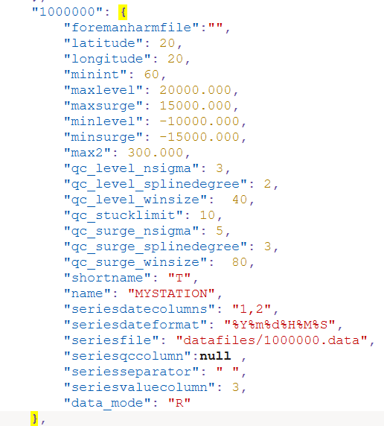

- If you have pre-computed harmonics for your station in the format processed by SELENE, you can allocate it in SELENE_TRAINING/configuration/ and they will be used to compute surge/tide. You must specified the path in the field “foremanharmfile” of the stations.json
In case you don't have harmonics, the code works without assessing surge/tide analysis.

Links for more information
https://data.marine.copernicus.eu/product/INSITU_GLO_PHY_SSH_DISCRETE_MY_013_053/description

