



BUSINESS PROPOSAL FOR

Enterprise_STest 1{companyName}
Proposal Ref. No. 1-WF8VSRZ{refNo}
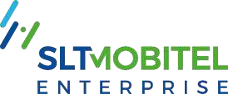

TABLE OF CONTENTS

COMPANY OVERVIEW 3
OUR STRENGTHS 4
WHY WITH US 5
ABOUT YOU & HOW WE CAN HELP YOU 6
PROPOSED SOLUTION 7
YOUR INVESTMENT 8
TERMS AND CONDITIONS 9
CUSTOMER ACKNOWLEDGEMENTS 10
SME SOLUTIONS 11
AWARDS AND ACCOLADES 12
CONTACT US 15

23/09/202523/09/2025{proposalDate}
{companyName}
{recipientDesignation}
{address}
No 125, Lotus Road, Colombo 01, Colombo, Western, Sri Lanka, 00100No 125, Lotus Road, Colombo 01, Colombo, Western, Sri Lanka, 00100
Dear Sir/ Madam
Business Proposal for {companyName}
We understand that every organisation needs to create an edge to succeed in the current complex business environment and how technology could help to achieve this. That is why we at SLT-MOBITEL, have created a suite of customisable and scalable intelligent enterprise solutions designed to help you make that crucial leap to take your business beyond where it can be to where it should be.
As we combine the strength of fixed and mobile, we pride ourselves on our unmatched enterprise capabilities and expert experience spanning for decades. Moreover, we have dedicated Account Managers at your service, ensuring we are not only your provider but also your partner in progress.
We are pleased to submit the attached proposal for {refNo}. Our proposal briefs on
{@letterXml}
We look forward to discussing the proposal in detail. Do not hesitate to reach out {amName} on 0701314128{amPhone} should you require any assistance.
We are committed to partnering with you in your journey to success and look forward to empowering your business with our intelligent business solutions.
Thank you
Yours sincerely
{amName}

COMPANY OVERVIEW
SLT-MOBITEL, has been instrumental in inspiring the vision and growth of Sri Lanka’s economy and technological advancement as the national Information and Communications Technology (ICT) solutions provider. With the power of fixed and mobile, we provide a range of comprehensive tech driven products, services, and solutions to complement evolving digital lifestyles. We take pride in serving over nine million customers across the island through our high-speed fibre, copper, and mobile access networks. Furthermore, through our participation in international submarine cable systems, SLT-MOBITEL has connected Sri Lanka to the world, thereby creating numerous global opportunities.
Apart from fixed and mobile telephony, broadband, data services, and Internet Protocol Television (IPTV), our comprehensive and future-ready portfolio includes cloud computing, data center solutions, cybersecurity, IoT platforms, and advanced enterprise networking. SLT-MOBITEL is at the forefront of integrating cutting-edge technologies to deliver diversified ICT solutions to the enterprise segment, enabling local enterprises, small and medium-sized enterprises (SMEs), and government institutions to unlock growth potential in both local and global markets.
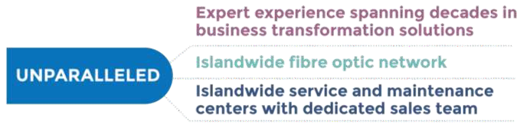

The company's widespread presence across the island, with regional telecommunication offices, Teleshops, and an extensive dealer and reseller network, ensures that customers, irrespective of their location, can easily access its services. This extensive reach benefits a vast array of customers ranging from domestic users, SMEs, and retail customers to multinational corporations, enterprises and public sector institutions.
Drawing upon its legacy of 165+ years, SLT-MOBITEL is ready to meet the challenges of the Nation’s digitalization process and the emerging digital economy head-on. It has strengthened its commitment to providing lifestyle services to customers and delivering world-class platforms and solutions to enterprises. By leveraging this wealth of experience, SLT-MOBITEL continues to offer unparalleled solutions, perfectly poised to revolutionize the SME sector and drive its participation in the global digital economy.

OUR STRENGTHS

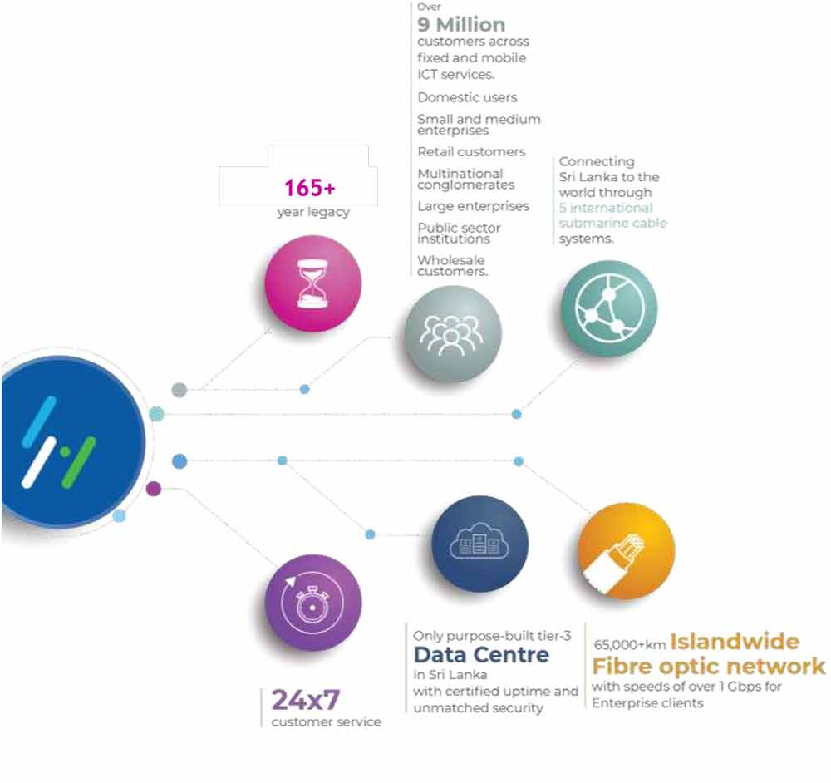

WHY WITH US

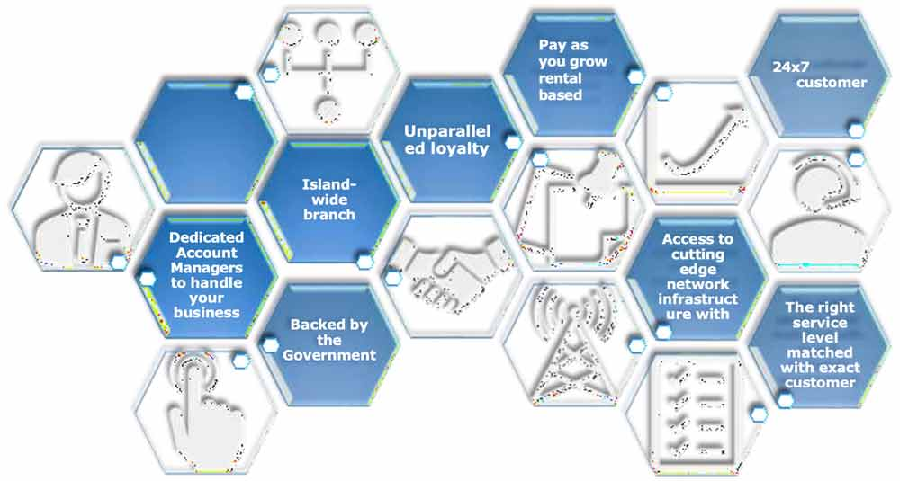

ABOUT YOU & HOW WE CAN HELP YOU

PROPOSED SOLUTION

{@requirementsXml}

YOUR INVESTMENT

Name/ Description | Speed /Bandwidth | QoS Template | One Time Charge(LKR) | Monthly Rental Without Taxes(LKR)
{#investment}{name} | {speed} | {qos} | {oneTime} | {monthly}{/investment}

TERMS AND CONDITIONS
{@termsAndConditionsXml}

CUSTOMER ACKNOWLEDGEMENTS
Regional Enterprise Business Manager
Sri Lanka Telecom PLC
Dear Sir/Madam,
We hereby confirmed our acceptance of the proposal submitted on {proposalDate} under Proposal reference number {refNo},

Company Name : {ackCompanyName}

Address : {ackAddress}

Solution : ………………………………………………………………….

Initial Charge : ………………………………………………………………….

Monthly Charge : ………………………………………………………………….

Commitment Period : ………………………………………………………………….

By signing this Proposal Acknowledgement, the Customer confirms that they have read, understood, and accepted the SLT’s Terms and Conditions applicable to the Services, as published at https://slt.lk/en/sme-micro-business on 3rd Oct 2025 V1.0which shall be considered part and parcel of and form the complete Agreement between the Customer and SLT.
The Customer agrees that by signing this acknowledgement or proceeding with the Services shall constitute acceptance of the Terms and Conditions referenced above. The Terms and Conditions accepted shall be those in effect as of the date stated herein, and such version shall remain binding on both Parties for the duration of this Agreement.
This Agreement may be executed in counterparts, including electronically or by email confirmation, each of which shall be deemed an original, Each such execution shall be deemed an original, and all of them shall have the same legal effect as handwritten signatures.
(Physical Execution)
IN WITNESS WHEREOF the signatures of the authorized signatory of SLT and the Customer were placed hereto at the place and on this ……. ……………..(date).

……………………………………… ……………………………………
SLT Authorized Officer Customer -
…………………………………….. Name -
SLT Service Account No NIC/Registration No -

SME SOLUTIONS


COMMUNICATION
Ability to stay connected with your customers and provide prompt responses are key aspects of customer service to ensure no business opportunity is missed. It is important that both internal and external communication channels are organised to achieve this, and we offer a range of communication solutions from voice to messaging over fixed and mobile to help streamline communication.

DATA HOSTING, STORAGE & SECURITY
Fuel your business growth with SLT-MOBITEL's bespoke services from our purpose-built Tier III data centre, recognized by the Uptime Institute. Our "Gold Rated" facility, certified by the Green Building Council of Sri Lanka, aligns with your diverse business requirements, while championing environmental sustainability.

NETWORKING SOLUTIONS
A wide range of networking solutions to connect your business to the highest levels of security and reliability at the fastest speeds. With multiple access modes, we can provide you with multiple high- bandwidth solutions for both internet access and Private Network Connections.

IoT SOLUTIONS
Unleash the power of connectivity with our IoT solutions. Transform your business operations with real-time data, enhanced efficiency, and smart automation. From device integration to data analytics, we bridge the gap between your business and the digital world.
Experience the future of intelligent business today with our IoT solutions.

SOFTWARE DEVELOPMENT
Stay up to date with new tech solutions in today's competitive market with SLT-MOBITEL’S affordable, dependable, and tailor-made Software Solutions. Propel your business to new heights in your niche, leveraging our unmatched technological expertise.

MARKETING SOLUTIONS
Maximize your brand's reach engaging your target audience through marketing efforts that deliver impactful results. Leverage our comprehensive targeting capabilities and data-driven insights. Drive brand awareness, increase conversions, and stay ahead in the digital marketing landscape with SLT-MOBITEL.

AWARDS AND ACCOLADES
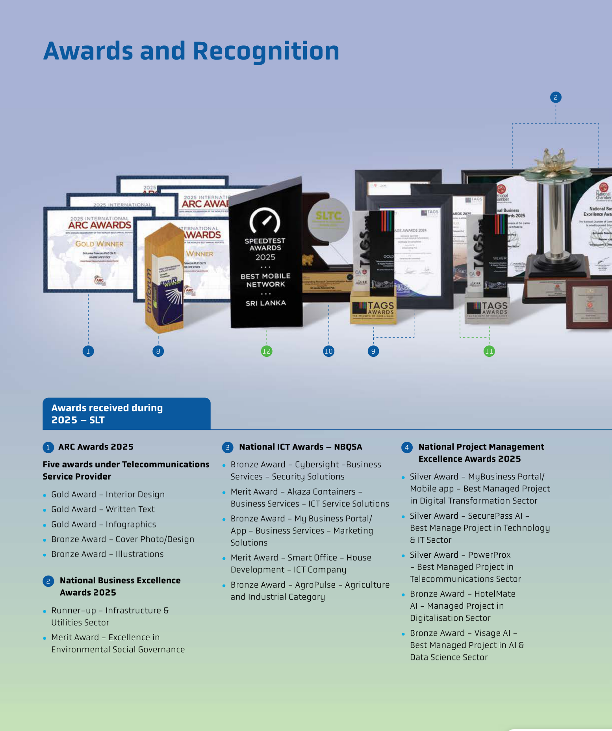

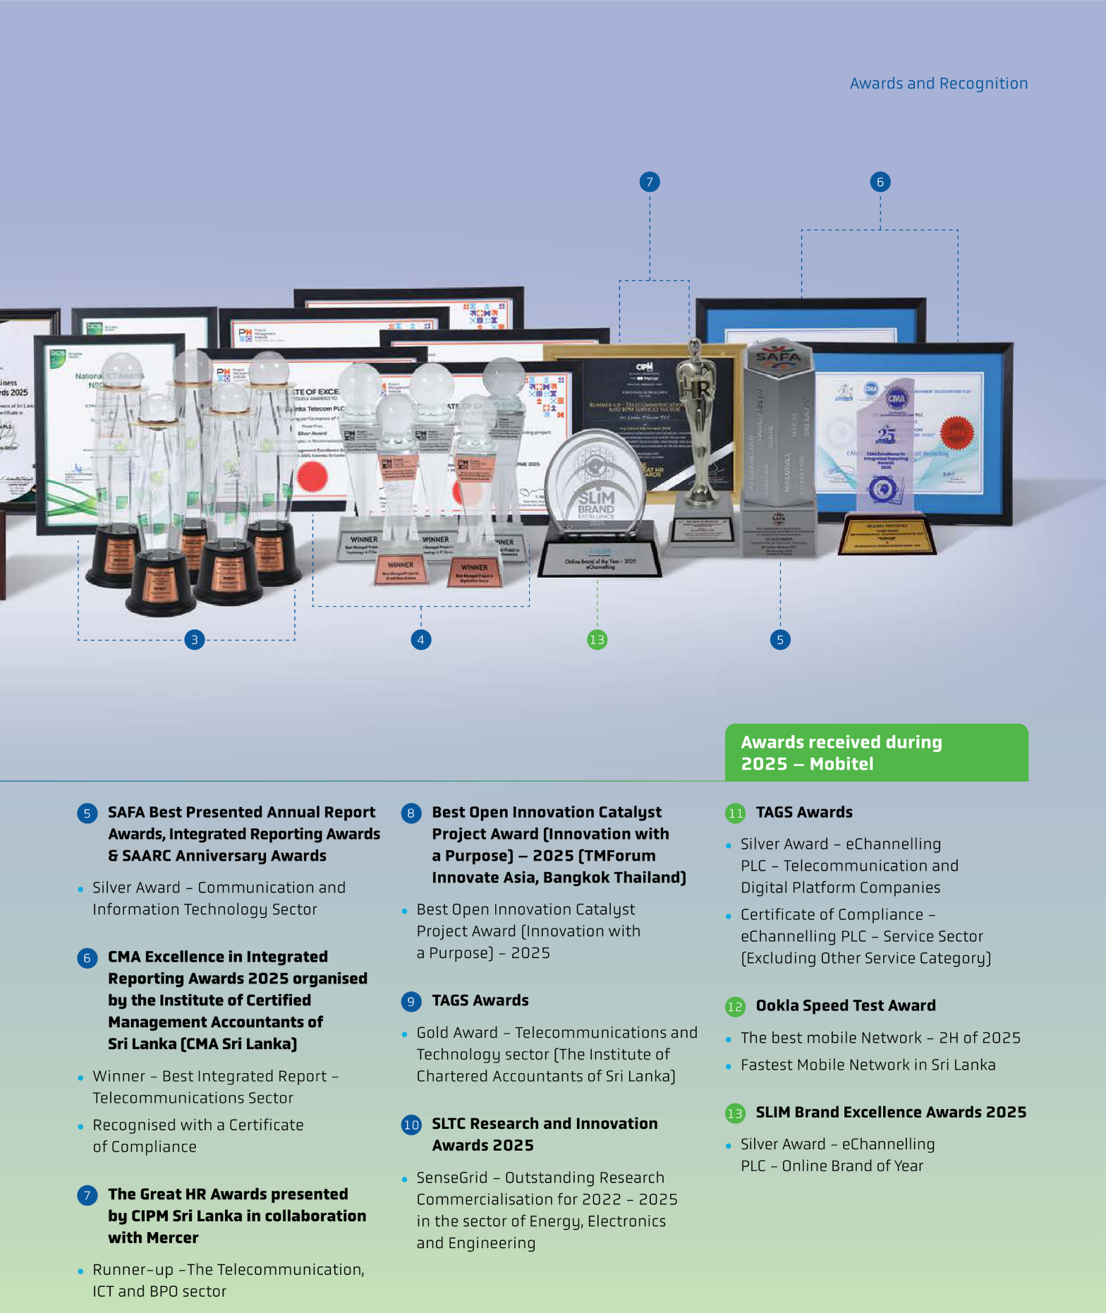

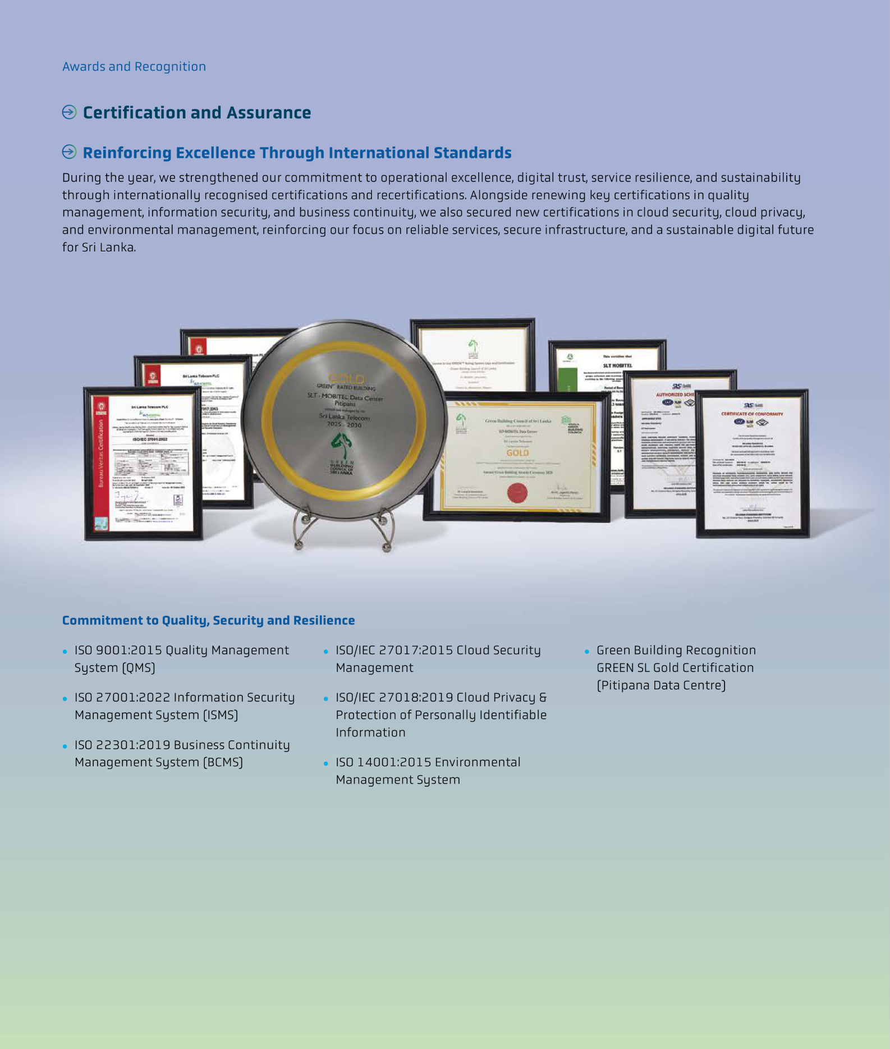

CONTACT US

Please contact us for all your inquiries. We are more than happy to help you!
Primary Contact
Name: Hasanthi Lanka{amName}
Designation:
Contact Number: 0701314128{amPhone}
Email: lankahasanthi@gmail.com{amEmail}
Division: PSM CPN
Secondary Contact
Name | Chandima DharmadasaChandima Dharmadasa
Designation | Regional Enterprise Business Manager
Contact Number
Email
Division | PSM CPNPSM CPN
Other Contacts




Telephone: 0112 389 389
WhatsApp: 070 500 4000
E-mail: bizsolutions@slt.com.lk
Website: www.bizleads.slt.lk

