**Policy Memorandum**

To: Dr. James F. Gilsinan, Professor of Political Science, Saint Louis University

From: Malcolm S. Townes, Ph.D. student, Public and Social Policy, Saint Louis University

Date: May 8, 2019

Re: Strengthening Pub.L. 97-219 The Small Business Innovation Development Act of 1982

**Introduction**

This memorandum details a strategy for effectuating changes to the policy design of The Small Business Innovation Development Act of 1982 (Pub.L. 97-219). The proposed changes are intended to better harmonize the policy in intention of the policymakers that implemented the legislation with the policy in experience that small businesses encounter relative to the stated objectives to the policy. In developing the strategy outlined below, I used the Polis model of political decision making put forward by Deborah Stone, Advocacy Coalition Framework (ACF), multiple streams and policy windows model, and the Narrative Policy Framework (NPF) to guide the analysis. This memorandum provides background about Pub.L. 97-219, reviews its legislative history, discusses why modifying the policy is an important issue and should be on the policy agenda, recommends a preferred problem definition, suggests a specific way of framing the argument for modifying the policy, and outlines an approach for managing the politics associated with the proposed policy changes.

**Background**

Pub.L. 97-219 falls within the technology transfer policy domain, which focuses on promoting the transfer of technologies derived from federally-funded research to the private sector to benefit the public interest. The policy has distributive, redistributive, and regulatory elements. It requires all federal agencies with extramural research and development (R&D) budgets greater than $100 million to set aside of a predetermined percentage of their budgets specifically dedicated to making R&D awards to small businesses under the Small Business Innovation Research (SBIR) program. The policy must be reauthorized periodically.

The issue of technology transfer was and remains of particular importance for a number of reasons. It has been a concern of presidential administrations since the end of the Second World War, when President Franklin Delano Roosevelt commissioned Vannevar Bush to analyze federal R&D policy and make policy recommendations. President Roosevelt recognized the important role that scientific advancement and technological innovation played in securing military success. Moreover, he wanted to identify ways to leverage the nation’s technological infrastructure to advance the public interest during peace time (Bush, 1945). As such, the interest in technology transfer is driven in large part by the link between economic prosperity, national security, and technological innovation. Solow (1957) estimated that roughly 88 percent of the total increase in real Gross National Product (GNP) was attributable to technological progress.

Pub.L. 97-219 was also important in the context of efficient use of public funds given the economic strains of the times. In 1982, when the law was enacted total U.S. R&D expenditures were $87.1 billion (American Association for the Advancement of Science [AAAS], 2018). This was more than U.S. expenditures in 1980 for law courts ($1.8 billion), transportation ($20.6 billion), food and nutrition assistance ($15.6 billion), and community development ($8.3 billion) combined and represented an amount equal to 68 percent of the federal deficit ($128 billion) at the time (U.S. Spending, n.d.). It was also more than the gross domestic product (GDP) of at least 21 countries at the time (World Development Indicators, n.d.). This general trend has remained true to the present.

The issue of technology transfer and the participation of small businesses in federally-funded R&D is an important topic of interest to political leaders to this day. Improving technology transfer outcomes has been a stated priority for the presidential administrations of Donald J. Trump, Barrack H. Obama, and George W. Bush (Office of Management and Budget [OMB], 2002; Daily Comp. Pres. Doc., 2011, October 28; OMB, 2018). Many policymakers and interest groups remain dissatisfied with the amount and rate of transfer of technologies derived from federally-funded R&D to the private sector to benefit the public interest. Specifically, they argue that technology transfer is slow and requires too much effort and resources (i.e., efficiency issues). It remains the case that only a very small percentage of technologies derived from federally-funded R&D are transferred to the private sector to benefit the public interest (i.e., effectiveness issues). Moreover, the share of federal R&D funding awarded to small businesses remains low.

**Legislative History**

At the time of its initial consideration, Pub.L. 97-219 was framed as a way to help address two key problems the United States was facing. In the early 1980s, the United States economy was in recession (CBO, 1982). Many political leaders also argued that the nation’s global competitiveness was eroding. They believed that technological innovation was the remedy for both problems. Academic research suggested that independent innovators and small businesses were responsible for a disproportionate share of “significant” innovations but received no more than 4 percent of all federal funding for research and development (Statement of Sen. Warren Rudman, 1981). Many political leaders were dissatisfied with the participation rate of small businesses in federal R&D and identified it as a significant contributing factor in the trends of economic recession and eroding global competitiveness. They argued that small businesses were an under-utilized resource that could generate the technological innovation needed to reverse economic trends and restore the global competitiveness of the United States. The legislative action that resulted in Pub.L. 97-219 was first introduced in the Senate and then taken up by the House of Representatives under the following bills, respectively:

* S.881 - Small Business Innovation Development Act of 1981 - 97th Congress (1981-1982)
* H.R.4326 - Small Business Innovation Development Act of 1982 - 97th Congress (1981-1982)

The policy had four stated objectives:

* To stimulate technological innovation;
* To use small business to meet Federal research and development needs;
* To foster and encourage participation by minority and disadvantaged persons in technological innovation; and
* To increase private sector commercialization of innovations derived from Federal research and development.

This analysis highlights key policy provisions primarily related to the first two stated objectives. Most of the debate seemed to focus on the role of small business in technological innovation and how the country could benefit.

The original policy design established a gradually increasing set-aside that would reach 1.25% of extramural R&D budgets in excess of $100 million. This set-aside was dedicated for making R&D awards to small businesses. The schedule for increasing the set-aside was as follows:

* 0.2% in fiscal year 1983
* 0.6% in fiscal year 1984
* 1.0% in fiscal year 1985
* 1.25% thereafter

The legislation also established a gradually increasing set-aside for R&D awards to small businesses that would reach 1.25% of extramural R&D budgets greater than $10 billion. The schedule for increasing the set-aside in this provision of the legislation was as follows:

* 0.1% in fiscal year 1983
* 0.3% in fiscal year 1984
* 0.5% in fiscal year 1985
* 1.0% in fiscal year 1986
* 1.25% thereafter

The original policy design was also structured so that the legislation would have to be reauthorized after a period of 10 years.

Currently, the policy seems to be firmly established. It has been in place for nearly 40 years. There have been very few significant modifications to the basic design of the policy since its original enactment. The legislation has been amended to increase the set-aside to its current level of 3.2% of extramural R&D budgets greater than $100 million and set maximum award amounts. The policy has been reauthorized four times under the following legislation:

* Public Law 102-564 - Small Business Research and Development Enhancement Act of 1992 - 102nd Congress
* Public Law 106-554 - Small Business Innovation Research Program Reauthorization Act of 2000 - 106th Congress
* Public Law 112-81 - 2012 National Defense Reauthorization Act - 112th Congress (2011-2012)
* Public Law 114-328 - 2017 National Defense Authorization Act - 114th Congress (2015-2016)

There have also been the following unsuccessful attempts to modify the policy:

* H.R.448 - SBIR Enhancement Act of 2011 - 112th Congress (2011-2012)
  + Increase minimum set-aside for SBIR from 2.5% to 5% of extramural research and development budgets in excess of $100 million
  + Increase minimum set-aside from 0.3% to 0.6% of extramural research and development budgets in excess of $1 billion.
  + Increases maximum award amounts from $100,000 to $200,000 for Phase 1 grants and from $750,000 to $1.5 million for Phase 2 grants.
* H.R.2772 - SBIR and STTR Enhancement Act - 111th Congress (2009-2010)
  + Increase award levels.
  + Provide authority for agencies to award sequential Phase 2 grants.
  + Provide authority for agencies to award Phase 2 grants to applicants that have not been awarded Phase 1 grants.
  + Require agencies to issue solicitations at least twice per year.
  + Establish reporting requirements.
* H.R.4213 - Amend the SBIR program to increase award amounts - 110th Congress (2007-2008)
  + Allow agencies to increase award amounts.
  + Require agencies to adjust award amounts every five years to reflect economic adjustments and programmatic considerations.
* H.R.4684 - Amend the SBIR program to increase award amounts - 109th Congress (2005-2006)
  + Allow agencies to increase award amounts.
  + Require agencies to adjust award amounts every five years to reflect economic adjustments and programmatic considerations.

**Policy Problem**

While Pub.L. 97-219 has been public policy for nearly 40 years and is generally considered a success by various stakeholders and policymakers, there are still several problems with it. I propose that efforts to effect changes to the policy should define these problems in terms of equity for small businesses. The data and facts of the situation lend themselves to such a definition. A problem definition focused on equity for small businesses is also very much aligned with the stated objectives of the policy. Moreover, small business is a favored group that is typically perceived positively by the general public, which tends to believe that small businesses often get the short end of the stick when it comes to public policy. This perception was reinforced by the events of the Great Recession of 2008, which occurred recently enough that it probably remains sufficiently relevant in the public psyche.

Progress in achieving the goal of increasing small business participation in federally-funded R&D has been stymied. During the House hearings about the policy in 1981, Senator Warren Rudman stated that from 1977 to 1980 small businesses received only an estimated 3 to 4 percent of federal funding for research performed by industry (Statement of Sen. Warren Rudman, 1981). As it turned out, this overestimated the actual percent participation by at least an order of magnitude. As shown in Figure 1, from 1983, the first year the Pub.L. 97-219 was effective, through 1997, the percent of federal funds for R&D awarded to small businesses increased from 0.2 percent to about 3.5 percent. However, since 1997 the percent has risen for a while only to trend downward back towards the minimum set-aside level.

It seems that the minimum set-aside acts as an anchor holding down small business participation in federally-funded research and development. In the absence of any guidance, the federal agencies are likely using the minimum set-aside as a guide to determine the appropriate amount of their extramural R&D budgets to direct to small businesses. The situation is akin to asking someone to balance the weight of a quantity of two different types of materials (e.g., silver and gold) but the balance pointer is obscured and the only direction provided is that one side has to be a minimum percentage of the total amount.

As a result of this situation, the development of valuable innovations by small businesses is still being systematically impeded. The percentage of federal funds for R&D received by small businesses is essentially no different than the original estimate stated by Sen. Rudman nearly 40 years ago. Consequently, the United States is only realizing about 45 percent of the innovative potential of small businesses as shown in Figure 2.

Almost four decades after the implementation of Pub.L. 97-219, small businesses still are not receiving their fair share of federal funds for R&D performed by industry. As Figure 3 shows, an analysis of the number of proposals submitted to the National Science Foundation (NSF) and the National Institutes of Health (NIH) by industry performers estimates the fair share for small businesses is around 10 to 12 percent. This suggests that small business participation in federally-funded R&D is 6 to 8 percentage points below what it could and should be. Each percentage point of the funding gap amounts to roughly $732 million in additional funding that should be going to small businesses, which is an amount equal to roughly two (2) Boeing 777F airliners. The total gap between the current amount of funding that should be going to small businesses and the actual amount is about $4.4 to $5.8 billion, which is more than the gross domestic product (GDP) of several countries including South Sudan, Sierra Leone, Montenegro, Barbados, Liberia, and the British Virgin Islands (“GDP and its breakdown”, 2018).

Another significant shortcoming of Pub.L. 97-219 is the timing of funding. Most agencies still use solicitation cycles that specify certain periods of time during which they accept proposals. This arrangement seems more conducive to the agencies than small businesses. It’s often the case that a solicitation period is not open when a small business could make the most effective use of the funds.

The current method of evaluating R&D proposals also creates a bias in the implementation of Pub.L. 97-219. In theory, the agencies generally rate each proposal on a scale comprising ratings of fair, good, very good, and excellent or something analogous to this structure. However, in practice most reviewers implement this scheme as a relative proposal rating scale. For any given batch of proposals that a reviewer is given, he or she will often assign an excellent rating to a limited number of what the reviewer deems as the best proposals in the batch and assign a very good rating to a certain number of the next best proposals, and so on (Straussmann, 2013). This creates a subjective skewing in the ratings of the proposals. As a result very worthwhile projects are often overlooked and unfunded.

Finally, the limits on award size create a bias against high performing small businesses. Those that can manage larger projects are not able to submit them for consideration. To pursue federal funding for such projects, small businesses must go through the standard proposal submission process, which policymakers previously deemed as biased towards larger businesses thus necessitating Pub.L. 97-219 in the first place. Moreover, the award size limits are not conducive to collaborations among small businesses. Consequently, some of the more impactful R&D projects that small businesses can offer probably never see the light of day.

**Issue Framing**

Efforts to effectuate policy changes to correct these problems that frame the issue thematically in terms of the social welfare and security of the United States should have a reasonably high chance of success. Proponents of the policy during its initial consideration in 1981 were successful in framing the debate in terms of social welfare and national security. The economic recession and indicators of weakening global dominance created the circumstances for making such framing very effective. The current environment is still very conducive to such framing but for different reasons.

The strategy for moving the policy problem and proposed solution to the decision agenda entails creating a narrative that casts as the villain the imperfections in the current policy that prevent small businesses from receiving their fair share of federal funds for research and development and thus threatens our social welfare and national security. Small businesses and the nation are positioned as the victims. Small businesses are victims because they are being systematically underfunded for research and development. Society as a whole is a victim because it is being prevented from benefiting from the potential innovations that small businesses can offer to increase social welfare and address issues that threaten the security of the nation. The heroes of the narrative are the agency directors, deputy directors, and assistant directors who have the power and authority to correct the policy imperfections. The setting of the narrative is the current situation the United States finds itself in regarding a variety of threats that it faces in the present global environment. According to the plot of this narrative, many significant innovations that support national security and form the foundation of our modern society are created by small businesses. Imperfections with the implementation of Pub.L. 97-219 permit systemic biases in the bureaucracy to linger. These biases prevent small businesses from receiving their fair share of federal funds for R&D performed by industry. The solution to the problem (i.e., moral) is a set of simple modifications that will eliminate these lingering biases so that small businesses can receive their fair share of federal R&D funding and produce the innovations that will help the nation deal with the threats it faces and enable the country to continue enjoying the comforts of modern society provided by new technological innovations.

Regarding social welfare, the public sentiment is that small businesses are more effective and efficient innovators than small businesses. History provides plenty of anecdotal examples to support this belief. Many of the technologies that define modern society trace their origins to small businesses and independent inventors. Examples include the gas mask, telephone, automobile, traffic signals, airplane, electronic television, and photocopiers. More contemporary examples that reinforce the public’s perception of small business ingenuity include modern desktop computers, computer operating systems, and social media.

The current environment is particularly favorable for framing the problem in terms of national security. The United States faces at least four major threats appear to be strong in the public conscious. These threats are countries led by tyrants that are hostile to the United States, terrorists that want to harm the country and destroy our way of life, techno-criminals that seek to comprise the nation’s technological infrastructure for personal or political gain, and the implications of climate change that threaten our living environment and have the potential to create conflict over resources. While the causes of these threats vary, the solution to all of them will likely involve technology.

Referring to these threats as the four T’s (i.e., tyrants, terrorism, techno-criminals, and temperature, respectively) should help the public and policymakers to easily remember them. Using images and terms as forms of synecdoche can further strengthen the perception of importance of these threats by imparting emotional content to them and triggering System 1 thinking in policymakers. Russian President Vladmir Putin is an effective stand in for tyrants because of current tensions in the relations between the U.S. and Russia. Moreover, many national security experts seem to have a very dim opinion of him. The attack on the World Trade Center on September 11, 2001 and the images associated with it are emotionally powerful representations of all forms of terrorism. It was one of the most dramatic and deadly terrorist attacks in the nation’s history. The attack resulted in significant changes to our society that are still felt to this day. Temperature functions as a useful representation of the climate change issue because although climate change encompasses more than just temperature changes, temperature is something that the public readily comprehends and experiences.

Because the issue of reforms to Pub.L. 97-219 is technical in nature and rather abstract, I recommend employing a metaphor to concisely convey the challenge. A metaphor will impart additional emotional content and social context to the issue and is more likely to resonate with policymakers. I suggest likening the situation to being out on a boat and suddenly finding ourselves in rough waters. There is a terrible storm barreling down on us (i.e., the four T’s) and we’re trying to stay ahead of it. But for some reason we’re operating one of our engines (i.e., small business innovation) at only 45 percent of capacity and we haven’t filled the gas tank all the way to full (i.e., fair share of federal R&D funding). Moreover, we’ve inadvertently dropped an anchor (i.e., the minimum set-aside) which is further hampering our efforts to speed ahead of the impending storm.

**Proposed Policy Changes**

I recommend several specific policy changes to address the problems detailed above. Rather than eliminate the minimum set-aside, which will likely encounter significant opposition, I recommend balancing it by specifying an upper limit for total annual SBIR funding. The upper limit for the pending fiscal year should be based on the ratio of proposals from small businesses received by the agency in the prior fiscal year divided by the total number of proposals received from all industry performers in the prior fiscal year. Instituting an upper limit in combination with the minimum set-aside will provide a guide to the federal agencies as to what is the fair share amount of federal R&D funds for small businesses.

Additionally, I recommend implementing rolling submissions instead of specific solicitation periods across all agencies. This will allow small businesses to pursue federal R&D funding when they need it. Moreover, I recommend the agencies take measures to eliminate *de facto* relative proposal ratings, enforce absolute ratings, and fund all proposals that rate as excellent or very good on a first in, first funded basis while funding is available. This will help to further eliminate bias in the funding award system.

Finally, I recommend that agencies be allowed to award funding in amounts greater than the current Phase I and Phase II limits if approved by the agency directors or designees. This will allow those small businesses with the capabilities to manage larger projects to pursue those endeavors. Moreover, it will enable small businesses to collaborate to pursue opportunities that neither could pursue on their own.

**Managing the Politics**

To manage the politics of the policy process, I suggest pursuing the proposed policy changes at the policy subsystem level. Most, if not all, of the proposed changes can be implemented by the federal agencies without the need for legislation by the United States Congress or approvals by the Office of the President of the United States.

To strengthen this proposal for policy change and demonstrate broad acceptance by key stakeholders, I recommend obtaining official endorsements and statements of support from the various small business advocacy and support groups including the following:

* U.S. Small Business Administration
* America’s SBDC
* Angel Capital Association
* Ewing Marion Kauffman Foundation
* International Business Innovation Association (formerly the National Business Incubation Association)
* National Federation of Independent Business
* National Venture Capital Association
* Small Business Investor Alliance
* United States Association for Small Business and Entrepreneurship

While each of these organizations has a slightly different focus, they all should share deep core beliefs about the importance of small business to the nation and therefore will likely be supportive of the proposed policy change. As such, they should serve as very effective advocates for the proposed modifications to Pub.L. 97-219.

The federal agencies will likely be more amenable to a branch approach to modifying the implementation of Pub.L. 97-219 than the broad comprehensive change of a root approach. I suggest approaching the National Science Foundation (NSF) before the other agencies. Pub.L. 97-219 originated with the NSF, which has a fair amount of institutional pride about this fact. Moreover, the NSF has demonstrated a willingness to experiment with ways to improve the policy and other agencies seem to take their cues, at least in part, from the NSF when it comes to the SBIR program. I suspect that the NSF will be receptive to piloting the proposed policy changes in one of its directorates. A successful pilot of the changes will pave to way to expand them to the other NSF directorates and other agencies within a relatively short period of time.

If there is a need to elevate the process to the macro-political level, then I suggest engaging four specific committees and subcommittees of the U.S. Congress. In the U.S. House of Representatives, I recommend focusing on the Committee on Small Business and the Subcommittee on Research and Technology of the Committee on Space, Science, and Technology. In the U.S. Senate, the focus should be on the Committee on Small Business and Entrepreneurship and Subcommittee on Communications, Technology, Innovation, and the Internet of the Committee on Commerce, Science, and Transportation. The same problem definition and issue framing outlined above should be effective with these committees and subcommittees.

Pub.L. 97-219 was not without opposition during its original consideration in the early 1980s. It’s unlikely that the proposed policy changes will go completely unopposed or enjoy the overwhelming support of the original policy proposal. During the debate on the original policy, opponents included senior leaders, tenured and tenure-track faculty, and research faculty at research universities; senior leaders and researchers at research laboratories that compete for federal funding; senior executives at research hospitals and medical colleges; and the leadership of the Association of American Medical Colleges. Many of these groups seem to have tempered their opposition to Pub.L. 97-219 and even come to view it as beneficial to their own R&D efforts. However, they may oppose aspects of the proposed policy changes because they might believe it will further reduce the funding available for basic research. The core premise of such an argument is that basic research is more important than the type of R&D supported by Pub.L. 97-219, which is more applied in nature. The problem definition and issue framing outlined above should be an effective counter to this is normative argument. Moreover, the determination of the upper limit is based on funding allocated to industry performers, which should not directly affect those groups.

Large businesses might oppose the policy change because it may reduce the amount of funding directed to them. I believe that this opposition is unlikely to be intensive because the costs associated with the proposed policy change are rather diffused and negligible for large businesses while the benefits are concentrated for small businesses. The vast majority of funding for R&D performed by industry is provided by industry itself. In 2016, federal funding accounted for only about 6.3 percent of all funding for R&D performed by industry (Wolfe, 2018). Moreover, the public is likely to consider large businesses to be less deserving of federal support than small businesses.

**Conclusions**

This memorandum has detailed a strategy for pursuing changes to the policy design of The Small Business Innovation Development Act of 1982 (Pub.L. 97-219). In developing the strategy outlined above, I used the Advocacy Coalition Framework (ACF), multiple streams and policy windows model, and the Narrative Policy Framework (NPF) to guide the analysis. The strategy provides a roadmap for maximizing the chances for successfully effectuating the proposed policy changes given what is currently known about the policy process.

References

About SBIR. (n.d.). Retrieved March 5, 2019, from https://www.sbir.gov/about/about-sbir

American Association for the Advancement of Science [AAAS]. (2018). *Defense, Nondefense, and Total R&D, 1976-2018* [Data file]. Retrieved from https://www.aaas.org/page/historical-trends-federal-rd

Bush, V. (1945). *Science, the endless frontier*. A report to the President: Washington, U.S. Government printing office, 1945.

Congressional Budget Office [CBO]. (1982). *The Prospects for Economic Recover: A Report to the Senate and House Committees on the Budget – Part I*. Retrieved from https://www.cbo.gov/sites/default/files/97th-congress-1981-1982/reports/doc03b-entire_1.pdf

Federal obligations for research, development, and R&D plant, by category of obligation, performer, and field of science and engineering: Fiscal years 2009 through 2017 [Data]. (2018). Available from https://nces.ed.gov/programs/digest/d17/tables/dt17_402.10.asp

Funding Facts. (2018). NIH Research Portfolio Online Reporting Tools [Database]. Retrieved April 28, 2019, from https://www.report.nih.gov/fundingfacts/fundingfacts.aspx

"GDP and its breakdown at current prices in US Dollars". (2018). *United Nations Statistics Division – National Accounts* [Data file]. Retrieved May 3, 2019, from https://unstats.un.org/unsd/snaama/Downloads

H. Rep. No. 97-349, pt. 7 (1982). Retrieved from https://congressional-proquest-com.ezp.slu.edu/

Memorandum on Accelerating Technology Transfer and Commercialization of Federal Research in Support of High-Growth Businesses, Daily Comp. Pres. Doc., DCPD201100803, (2011, October 28). Retrieved from https://www.govinfo.gov

*Markup Session: S881 The Small Business Innovation Research Act and S.1620 Bill to Extend SBA’s 8(a) Pilot Program*: *Hearings before the Senate Committee on Small Business*, 97th Cong. (1981, September 22). Retrieved from https://congressional-proquest-com.ezp.slu.edu/

The National Academies of Sciences, Engineering, and Medicine. (2000). Chapter F: National Science Foundation Proposal Success Rates. *Federal Funding of Astronomical Research* [Data]. Retrieved from https://www.nap.edu/read/9954/chapter/16

National Defense Reauthorization Act for Fiscal Year 2012, Pub.L. No. 112-81, 125 Stat. 1298. (2011). Retrieved from https://www.govinfo.gov

National Defense Authorization Act for Fiscal Year 2017, Pub.L. 114-328, 130 Stat. 2000 (2016). Retrieved from https://www.govinfo.gov

National Science Foundation. (2015). *Federal Funds for Research and Development, Detailed Historical Tables: Fiscal Years 1951-2002* [Data]. Retrieved from https://wayback.archive-it.org/5902/20150627201426/http://www.nsf.gov/statistics/nsf03325/

National Science Foundation. (n.d.) *Summary Proposal and Award information (Funding Rate) by State and Organization* [Database]. Retrieved from https://dellweb.bfa.nsf.gov/awdfr3/defautl.asp

National Science Foundation Industrial Research and Development Information System. (n.d.). *Federal funds for industrial R&D performance, by industry and by size of company: 1953-98* [Data]. Retrieved from https://wayback.archive-it.org/5902/20181004145057/https://www.nsf.gov/statistics/iris/search_hist.cfm?indx=16

Office of Management and Budget [OMB]. (2002). *The President's Management Agenda*. Retrieved from http://www.dtic.mil/dtic/tr/fulltext/u2/a394421.pdf

Office of Management and Budget [OMB]. (2018). *The President's Management Agenda*. Retrieved from https://www.whitehouse.gov/wp-content/uploads/2018/03/Presidents-Management-Agenda.pdf

SBIR Award Summary by Year [Data file]. (n.d.). SBIR STTR America’s Seed Fund [website]. Retrieved April 27, 2019, from https://www.sbir.gov/node/735727?view_by=Year

SBIR/STTR Dashboard [Database] (n.d.). Retrieved April 18, 2019, from https://www.sbir.gov/awards/annual-reports?view_by=Year

Small Business Innovation Development Act of 1982, Pub.L. No. 97-219, 96 Stat. 217 (1982). Retrieved from https://www.govinfo.gov

*Small Business Innovation and Research Legislation: Hearing before the Subcommittee on General Oversight of the House Committee on Small Business*, 97th Cong. (1981, Sept. 15). Retrieved from https://congressional-proquest-com.ezp.slu.edu/

Small Business Innovation Act: 11th Annual Report. (1993). Retrieved from https://www.sbir.gov/sites/default/files/SBIR_1993.pdf

Small Business Innovation Development Amendment Act of 1992, Pub.L. No. 102-564, 106 Stat. 4269 (1992). Retrieved from https://www.govinfo.gov

Small Business Reauthorization Act of 2000, Pub.L. No. 106-554, 114 Stat. 2763 (2000). Retrieved from https://www.govinfo.gov

Solow, R. (1957). Technical Change and the Aggregate Production Function. *The Review of Economics and Statistics,* *39*(3), 312-320. doi:10.2307/1926047

Statement of Senator Warren Rudman. (1981, June 30). *The Small Business Innovation Research Act of 1981*: *Hearings before the Subcommittee on Innovation and Technology of the Senate Committee on Small Business*, 97th Cong. Retrieved from https://congressional-proquest-com.ezp.slu.edu/

Strassmann, J. E. (2013). What do NSF ratings mean? *Sociobiology* [Blog]. Retrieved May 3, 2019, from https://sociobiology.wordpress.com/2013/03/07/what-do-nsf-ratings-mean/

Table 109 - R&D Obligations, by performer: 1967-2012. (2013). *Federal Funds for Research and Development: Fiscal Years 2010-12* [Data]. Retrieved from https://www.nsf.gov/statistics/nsf13326/content.cfm?pub_id=4243&id=2

Table 116 - R&D Obligations, by performer: 1986-2007. (2008). *Federal Funds for Research and Development: Fiscal Years 2005–07* [Data]. Retrieved from https://wayback.archive-it.org/5902/20160210221829/http://www.nsf.gov/statistics/nsf09300/content.cfm?pub_id=3898&id=2

Table 127 - Federal obligations for research and development, by performer: FYs 1967–2017

(Dollars in millions). (2017). *Federal Funds for Research and Development: Fiscal Years 2015-17* [Data]. Retrieved from https://ncsesdata.nsf.gov/fedfunds/2015/

Table 128 - Federal obligations for research, by performer: 1967-2014. *Federal Funds for Research and Development: Fiscal Years 2012-14* [Data]. (2015). Retrieved from https://nsf.gov/statistics/nsf14316/pdf/nsf14316.pdf

*The Small Business Innovation Research Act of 1981*: *Hearings before the Subcommittee on Innovation and Technology of the Senate Committee on Small Business*, 97th Cong. (1981, May 13). Retrieved from https://congressional-proquest-com.ezp.slu.edu/

*The Small Business Innovation Research Act of 1981*: *Hearings before the Subcommittee on Innovation and Technology of the Senate Committee on Small Business*, 97th Cong. (1981, June 30). Retrieved from https://congressional-proquest-com.ezp.slu.edu/

*To Amend the Small Business Act: Hearing before the Subcommittee on Research and Development of the House Committee on Armed Services*, 97th Cong. (1982, March 12). Retrieved from https://congressional-proquest-com.ezp.slu.edu/

U.S. Spending. (n.d.). Retrieved from https://www.usgovernmentspending.com

Wolfe, R. M. (2018). Businesses Spent $375 Billion on R&D Performance in the United States in 2016. *National Center for Science and Engineering Statistics InfoBrief*. Retrieved from https://www.nsf.gov/statistics/2018/nsf18312/nsf18312.pdf

World Development Indicators. (n.d.). The World Bank. Retrieved from https://databank.worldbank.org/data/indicator/NY.GDP.MKTP.CD/1ff4a498/Popular-Indicators#

Appendix

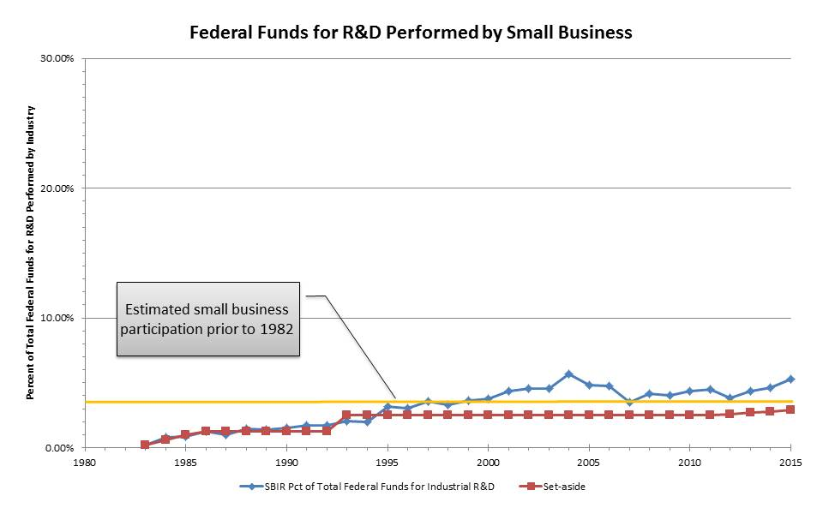

Figure 1. Federal Funds for R&D Performed by Small Business

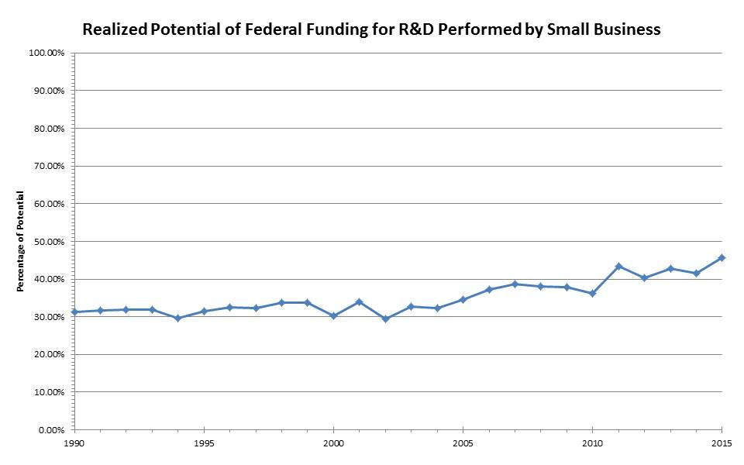

Figure 2. Realized Potential of Federally-Funded R&D Performed by Small Business

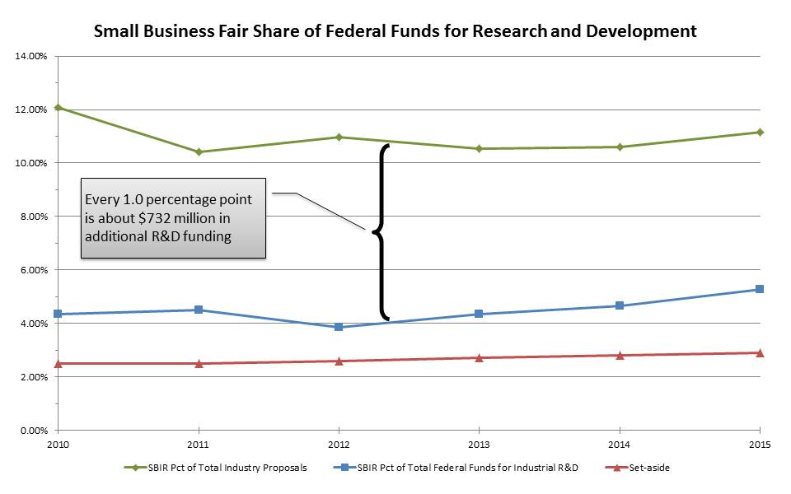

Figure 3. Small Business Fair Share of Federal Funds for Research and Development