Bridging the Delmar Divide: Examining the Meaning of Community
in a Racially Diverse and Upwardly Mobile Neighborhood
Malcolm S. Townes
Saint Louis University

Abstract

Introduction
St. Louis, Missouri has been called one of the most segregated cities in the nation (Freixas & Abbott, 2019). More than 150 years after the end of the Civil War and some 50 years after the end of government sanctioned segregation, the racial and socioeconomic division in the city remains so ingrained that a name has been coined that eloquently captures the essence of the awfully persistent social phenomenon – the “Delmar Divide” (Strasser, 2012).
Delmar Boulevard bisects the city of St. Louis, Missouri into northern and southern regions. It serves as a natural geographic demarcation for resident populations that are very segregated in terms of race, ethnicity, and socioeconomic status.
An area that straddles the Delmar Boulevard is currently the focus of planned redevelopment, which is to be accomplished through an entity operated by representatives of residents living in the redevelopment area along with several institutions with an interest in the project’s success. This presents a unique opportunity to examine several important sociological topics. As this redevelopment unfolds, the neighborhood residents will likely face significant challenges rooted in the concepts of community and diversity.
In this study, we examine several important issues, namely (1) who can be a member of a community, (2) how closely community residents expect other residents to abide by their rules, and (3) how accountable community residents expect to be to each other.
Theoretical and Conceptual Background
Hoekstra & Gerteis (2019) serve as an inspiration for this study and greatly influence its design.
The construct of community is a critical element of this study. There have been numerous efforts to articulate a comprehensive definition of community, none of which have been especially successful (MacGregor, 2010).
Study Setting and Data Collection
The study was conducted in a geographic location whose borders are defined by Page Boulevard on the north, Lindell Boulevard on the south, Vandeventer Avenue on the east, and Newstead Avenue on the west as shown in Figure 1 and Figure 2.
A local resident and community leader served as a key informant for the study. The key informant purposively recruited 40 residents of the study setting to participate in semi-structured interviews. Table 1 provides summary statistics comparing the study participants and the population of the study setting.
Nine graduate students served as interviewers for the study. Each interviewer conducted four (4) interviews.
Analysis and Findings

Discussion

Implications

Limitations and Future Study

Acknowledgements
Ms. Judith Arnold deserves special thanks for acting as our liaison with the community for this study. All errors and omissions are my responsibility alone.

References
Aptekar, S. (2019). The Unbearable Lightness of the Cosmopolitan Canopy: Accomplishment of Diversity at an Urban Farmers Market. City & Community, 18(1), 71-87.
Cataldi, J. (2019). The Commons: Separating Tragedy and Triumph at a City Park. City & Community, 18(1), 88-108.
Strasser, F. (Producer). (2012, March 14). Crossing a St Louis street that divides communities [Documentary video]. United States: BBC News. Retrieved September 15, 2019 from https://www.bbc.com/news/av/magazine-17361995/crossing-a-st-louis-street-that-divides-communities
Elliott, J. R., Korver-Glenn, E., & Bolger, D. (2019). The Successive Nature of City Parks: Making and Remaking Unequal Access Over Time. City & Community, 18(1), 109-127.
Freixas, C., & Abbott, M. (2019). Segregation by design: conversations and calls for action in St. Louis. Springer. https://doi.org/10.1007/978-3-319-72956-5
Hoestrka, E. & Gerteis, J. (2019). The Civic Side of Diversity: Ambivalence and Belonging at the Neighborhood Level. City & Community, 18(1), 195-212.
Lukasiewicz, K., Bahar, O. S., Ali, S., Gopalan, P., Parker, G., & Hawkins, R. (2019). Getting by in New York City: Bonding, Bridging and Linking Capital in Poverty-Impacted Neighborhoods. City & Community, 18(1), 280-301.
MacGregor, L. C. (2010). Habits of the Heartland: Small-Town Life in Modern America. Ithaca, New York: Cornell University Press.
References Not Cited
Hillery, G. A. Jr. (1977). A General Typology of Human Groups. In R. L. Warren (eds). New Perspectives on the American Community (2nd ed.). Chicago, Illinois: Rand McNally College Publishing Company.
McMillan, D. W. & Chavis, D. M. (1986). Sense of Community: A Definition and Theory. Journal of Community Psychology (14), 6-20.

Appendix
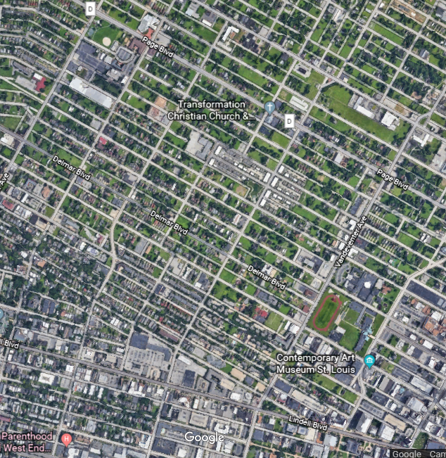
Figure 1. Aerial view of study area from Google Earth

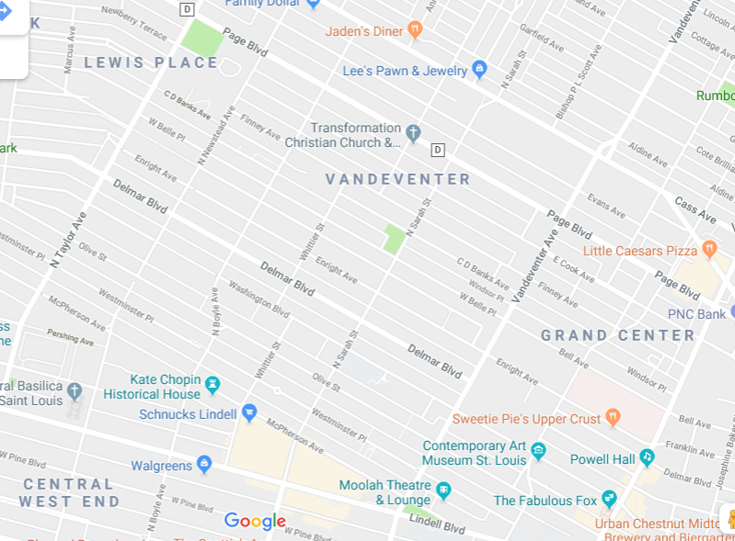
Figure 2. Google map of study area

