An Exploratory Spatial Analysis of Race and Poverty in Springfield, Missouri

Malcolm S. Townes

Saint Louis University

Abstract

[Enter text]

Keywords:

**Introduction**

Race-based segregation has colored the social fabric of the United States since before the founding of the republic. Sociologists have studied the topic extensively and illuminated its effects on various populations. Many of these effects persist to the present day. However, most research appears to have focused on the largest or most prominent cities in the nation such as Chicago, Illinois; Detroit, Michigan; Los Angeles, California; and St. Louis, Missouri. There seems to have been few, if any, spatial studies of race and poverty in Springfield, Missouri.

Located in the southwestern corner of the state of Missouri (Figure 1), the Springfield, Missouri metropolitan statistical area (MSA) is a worthwhile locale to study for several reasons. Springfield, Missouri is the third largest city in the state of Missouri (U.S. Census Bureau, 2018). It is the seat of government for Greene County (“County of Greene,” n.d.). The Springfield Public Schools System is the largest school district in Missouri (Missouri Department of Elementary and Secondary Education, n.d.). Moreover, the city of Springfield, Missouri has played an important role in the development of the current social order for both the state of Missouri and the nation going back to the American Civil War. Examining poverty and race in the Springfield, Missouri area will help expand our overall understanding of these social issues.

As in politics, all social issues are local. It’s likely that various locales across the nation have experienced their own distinct flavor of racial segregation resulting in variations of the social effects that are currently manifested within each region. The unique social and demographic characteristics and history of Springfield, Missouri have likely influenced its current social dynamics. However, most studies of social issues ignore the spatial component. This study seeks to ascertain whether there is evidence of spatial processes associated with poverty and race in Springfield, Missouri.

**Literature Review**

[Enter text]

**Data and Methods**

**Data Sources**

I obtained the data for this analysis from two primary sources. I downloaded shapefiles for the state of Missouri and metropolitan and micropolitan statistical areas (MSAs) for the United States from the TIGER/line shapefile database of the U.S. Census Bureau. I downloaded demographic and social data at the census tract level from SocialExplorer.com in two batches in formats suitable for manipulation in STATA. The first included sex, age, and race. The second comprised educational attainment, household income, median household income, Gini index, poverty, and health insurance (Table 1).

**Data Modifications**

I used STATA to create several interval-ratio variables in two batches (Table 2) using code that was provided by Dr. J. S. Onésiemo Sandoval. As part of the output, the code created Microsoft Excel spreadsheets with the interval-ratio variable data.

I used ESRI ArcMap 10.6.1 to merge the interval-ratio variable with the shapefile for the study area. To begin, I clipped the census tracts for the state of Missouri to the Springfield, Missouri MSA. I then used the Join function to merge each of the Microsoft Excel spreadsheets with the interval-ratio variable data to the shapefile for the Springfield, Missouri MSA using the GEOID and FIPS fields as the unique identifiers to match the data with the correct census tracts.

I inspected the Attribute Table to identify census tracts that should be removed to avoid skewing the analysis results. To do this, I sorted the total population field from low to high and inspected it for census tracts with values that were abnormally low relative to the other census tracts (i.e., census tracts with total populations less than 100 persons). I found no census tracts that warranted removal from the analysis.

As I performed the tasks necessary to modify the data, I periodically saved the results at strategic points to permanent shapefiles in a file geodatabase I created using ArcMap. I did this as a precaution to save time in case I made an error. In such an eventuality, I would not have to repeat the entire data preparation process. I projected the final shapefile to the North American Datum (NAD) 1983 Universal Transverse Mercator (UTM) zone 15 projection coordinate system.

Because administrative boundaries (e.g., census tracts) change over time and generally don’t align with social boundaries, I also used ArcMap to create a shapefile of the study area with a one square kilometer grids rather than census tracts as a point of comparison. I interpolated the total population, total Black population, total Latino population, and total White population at the census tract level to the grid. I then added variables for the percent Black population, percent Latino population, and percent White population to the Attribute Table for the shapefile and calculated them for each grid square. I saved the result as a new shapefile with the NAD 1983 UTM zone 15 projection.

**Analysis and Findings**

I used ESRI ArcMap 10.6.1 and GeoDa to analyze the data. I used ArcMap to create thematic maps of the total population, percent Black population, percent White population, and percent poverty (Figures 2 through 5). The maps suggest that spatial processes are at play. Traditional statistical inference methods assume variables are randomly distributed throughout space. However, the thematic maps appear to show nonrandom distributions of racial populations and poverty throughout the study area.

I used the Measuring Geographic Distributions function in ArcMap to calculate the mean centers and standard deviational ellipses for poverty and the percent Black and percent White populations in the study area (Figures 6 and 7). The means centers of these variables are geographically very close to each other. The standard deviational ellipse for poverty fully encompasses that for the Black population.

I used GeoDa to analyze the global spatial autocorrelation at the census tract level for the variables I intended to use in the analysis. I used the queen method first order for contiguity weights for all calculations. I chose this method because it seemed to best represent the possible social interactions in the study area.

I calculated univariate Moran’s I statistics for all variables (Table 3). Except for the Theil index and no health insurance status, all variables showed a moderate level of spatial autocorrelation at the global level. The Theil index of inequality and no health insurance status exhibited a mild degree of spatial autocorrelation at the global level.

I calculated bivariate Moran’s I statistics for poverty, which I planned to use as the dependent variable, and the percent Black and percent White populations, which I planned to use as two of several independent variables (Tables 4). Percent Black population and percent White population exhibited a mild degree of negative spatial autocorrelation as did the education attainment index and poverty. Poverty and no health insurance status exhibited a moderate level of negative spatial autocorrelation. No health insurance status and percent Black population showed a mild level of positive spatial autocorrelation.

I also used GeoDa to examine univariate Local Indicators of Spatial Association (LISA) for the top three variables that had statistically significant global univariate Moran’s I statistics (Figures 9 through 10). The poverty ratio, education attainment index, and no health insurance status exhibited significant numbers of census tracts with positive spatial autocorrelation that were statistically significant at the 0.05 level or stronger.

Based on these initial results, I created bivariate LISA maps for the percent Black population with poverty and the percent White population with poverty (Figures 10 and 11). Both exhibited 37 census tracts with spatial autocorrelation that was statistically significant at the 0.05 level or stronger. Most of these tracts exhibited positive spatial autocorrelation for percent Black population and poverty but negative spatial autocorrelation for Percent White population and poverty.

Additionally, I calculated global univariate Moran’s I statistics for the percent Black population and percent White population based on grid polygons. I compared these results with those based on census tracts (Table 5). Based on census tracts, the Moran’s I statistics indicated moderate levels of spatial autocorrelation for both variables. Using the grid polygons, the Moran’s I statistics indicated severe levels of spatial autocorrelation for both variables.

**Discussion**

**Policy Implications**

[Enter text]

**Limitations of the Analysis**

[Enter text]

**Possible Extensions**

Second, are there statistically significant associations between poverty, race, and other social indicators when spatial processes are considered in the analysis?

**Conclusion**

[Enter text]

References

*County of Greene*. (n.d.). Greene County website. Retrieved March 15, 2020 from https://greenecountymo.gov/

Missouri Department of Elementary and Secondary Education [MDESE]. (n.d.). *District List* [Data file]. Retrieved March 15, 2020 from https://apps.dese.mo.gov/MCDS/Reports/SSRS_Print.aspx?Reportid=ee8cf509-bf32-455e-b49e-c366a23b37db

U.S. Census Bureau. (2018). *American Community Survey 2018 5-year estimate, Total Population, Table B01003* [Data file]. Retrieved March 15, 2020 from https://data.census.gov/cedsci/table?tid=ACSDT5Y2018.B01003&hidePreview=true&vintage=2018&cid=DP05_0001E&g=0400000US29,29.160000&layer=place&tp=true&moe=false

Appendix A. [Enter Title]











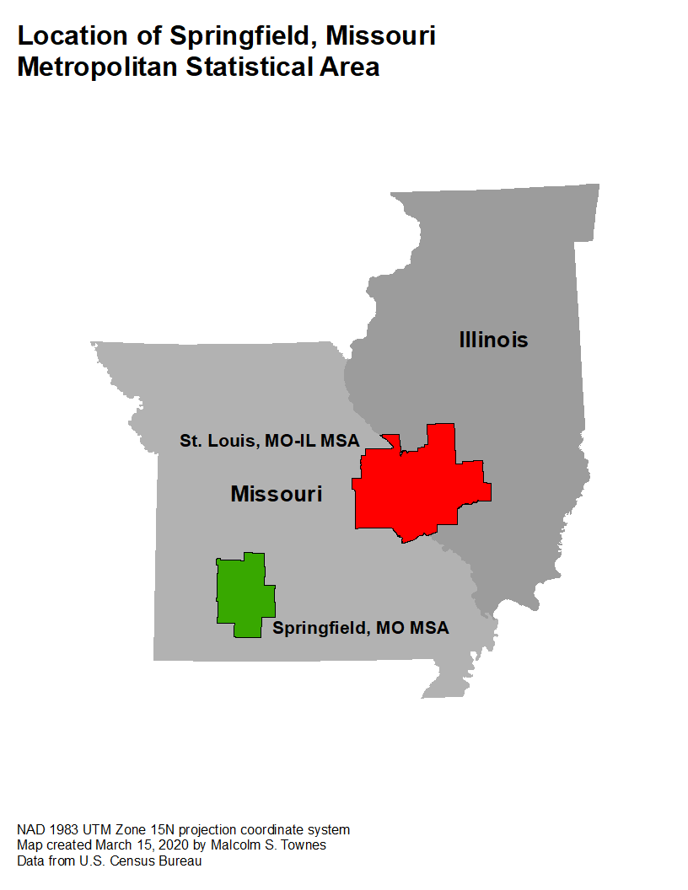

Figure 1. The Springfield, Missouri MSA is in the southwestern corner of the state of Missouri.

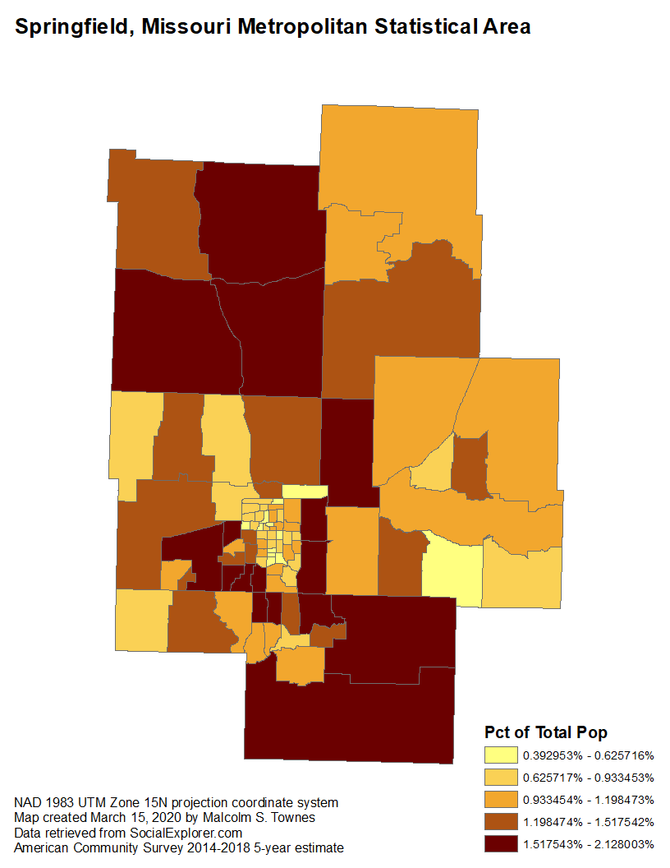

Figure 2.

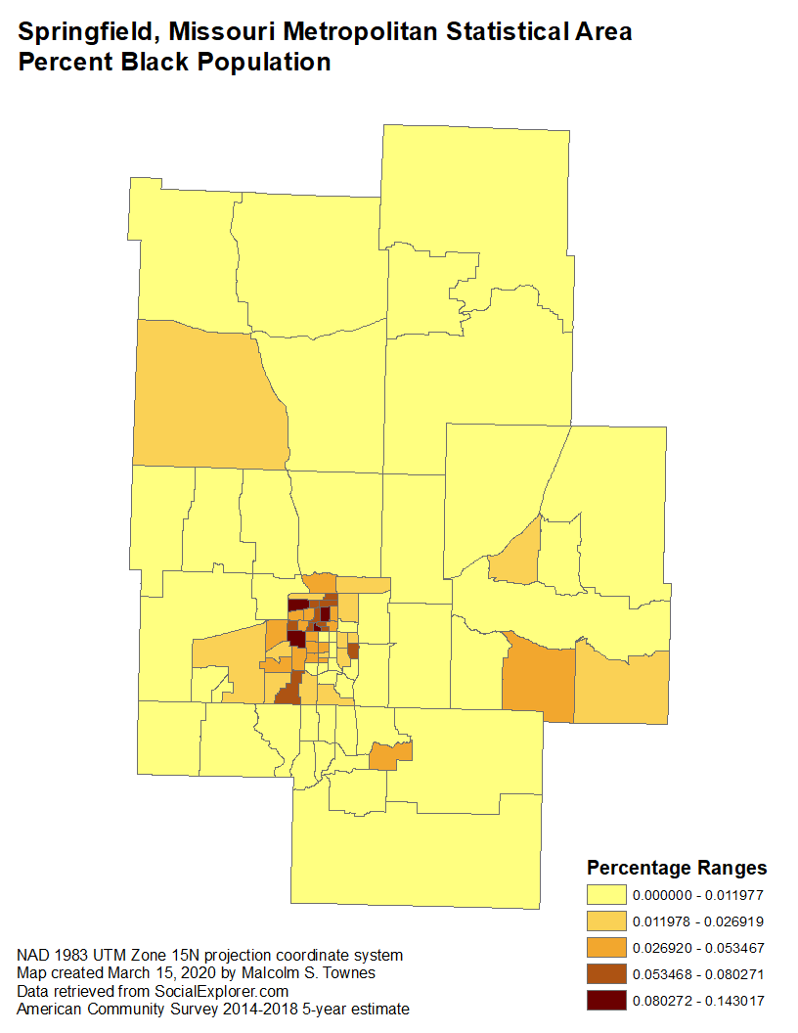

Figure 3.

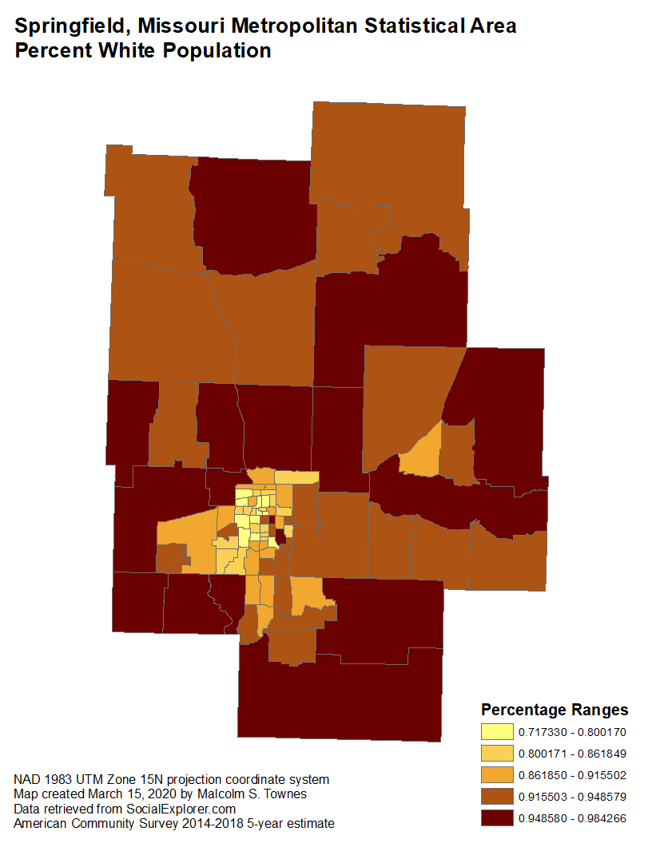

Figure 4.

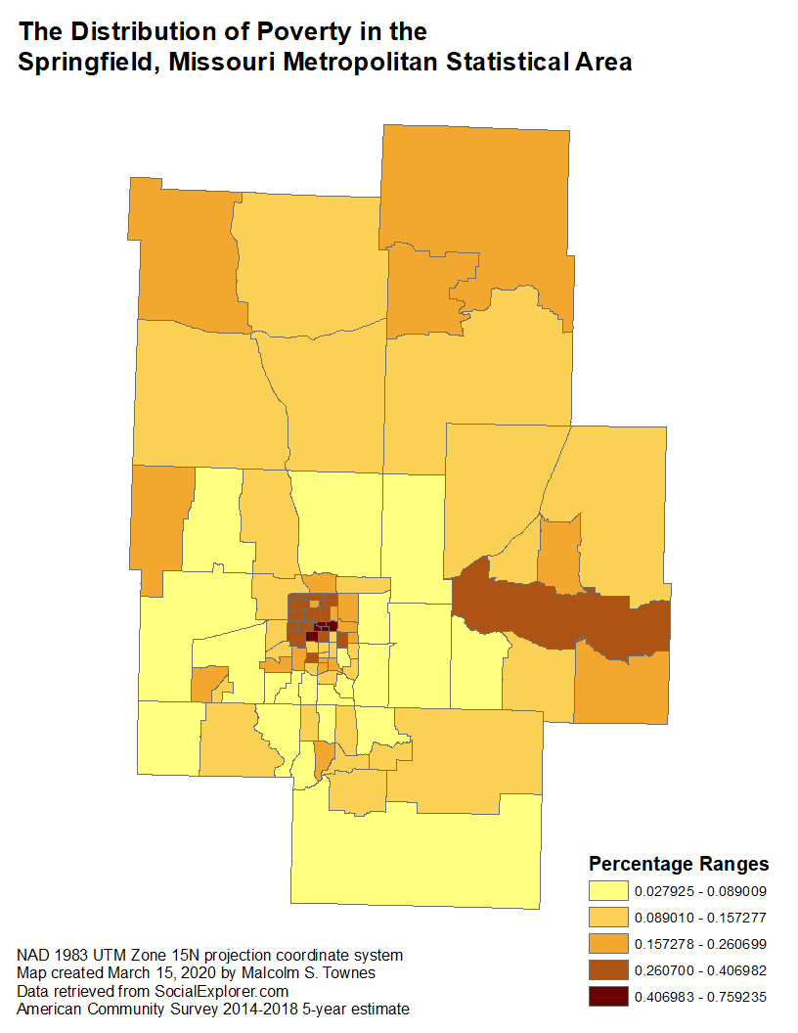

Figure 5.