An Exploratory Spatial Analysis of Race and Poverty in the

Springfield, Missouri Metropolitan Statistical Area

Malcolm S. Townes

Saint Louis University

Abstract

Race-based segregation has colored the social fabric of the United States since before the founding of the republic. There is ample literature that examines the intersection of race, poverty and other social issues. However, most research is at the state and national level or appears to have focused on the largest or most prominent cities in the nation. These studies have generally been aspatial in nature. Moreover, there seems to have been few, if any, spatial studies of the Springfield, Missouri area focused on poverty, race, and other social indicators. This study sought to ascertain whether there is evidence of spatial processes associated with race, poverty, and other social indicators in the Springfield, Missouri metropolitan statistical area. The results of the analysis based on census tracts indicated mild to moderate levels of global and local spatial autocorrelation for all the variables used in the analysis.

Keywords: race; poverty; segregation; spatial analysis; Springfield, Missouri

**Introduction**

Race-based segregation rooted in the practice of slavery has colored the social fabric of the United States since before the founding of the republic. Sociologists have studied the topic extensively and illuminated its effects on various populations. Many of these effects persist to the present day.

Poverty is of particular interest for this study. There is ample literature that examines the intersection of poverty, race, and other social issues. However, most research is at the state and national level or appears to have focused on the largest or most prominent cities in the nation. Moreover, these studies have generally been aspatial in nature. That is, they seem to assume that space does not matter and therefore ignore spatial considerations in the analysis. Moreover, there seems to have been few, if any, spatial studies of the Springfield, Missouri area focused on poverty, race, and other social indicators.

**Motivation for Research**

Located in the southwestern corner of the state of Missouri (Figure 1), the Springfield, Missouri metropolitan statistical area (MSA) is a worthwhile locale to study race and poverty for several reasons. Springfield, Missouri is the third largest city in the state of Missouri (U.S. Census Bureau, 2018). It is the seat of government for Greene County (“County of Greene,” n.d.; Wood, 2011). The Springfield Public Schools System is the largest school district in Missouri (Missouri Department of Elementary and Secondary Education, n.d.). Moreover, the city of Springfield, Missouri has played an important role in the development of the current social order for both the state of Missouri and the nation going back to the American Civil War when both the Confederacy and the Union considered Springfield a strategic location and control over the region seesawed between them (Wood, 2011). As such, examining race and poverty in the Springfield, Missouri area will help expand our overall understanding of these social issues.

Like politics, all social issues are local. However, economic research on poverty has primarily been at the national level. The history and structure of a location greatly influence the social issues and needed mechanism for addressing them (Blank, 2005). Race-based segregation rooted in the historical practice of slavery has had a profound impact on the social order of the United States. It’s likely that various locales across the nation have experienced their own distinct flavor of racial segregation resulting in variations of the social issues, such as poverty, that are currently manifested within each region. There is a need for scholarly research that stresses the role of place in poverty and various other social issues (Blank).

The unique social, demographic, and spatial characteristics and history of the Springfield, Missouri area have likely influenced the social issues the region currently experiences. However, most studies of social issues ignore the spatial component. This study seeks take spatial processes into consideration in the analysis of poverty and race in the Springfield, Missouri metropolitan statistical area.

**Literature Review**

There is ample literature about that focuses on race, poverty, and various social issues (Danziger & Gattschalk, 1987; Gaskin, et al., 2014; Gebhardt, 2014; Madden, 2014; Michner, 2016; Paschall, Gershoff, & Kuhfeld, 2018; Vaughan, A., et al., 2014). However, the analyses tend to be at the national or state level. Moreover, most of the literature seems to assume that local spatial factors do not matter.

The literature about race, poverty, and various social issues in the Springfield, Missouri Metropolitan Statistical Area (MSA) is sparse, if it exists at all. Shur (2012) noted the “relative silence in official narratives about how race, racism, and race relations shaped Springfield and the region” (p. 131).

Harper (2007) examined a series of lynchings and subsequent expulsions of Blacks between 1894 and 1906 in Southwest Missouri which likely influenced the current social characteristics of the Springfield, Missouri MSA to a great degree. As Harper explained, Missouri remained in the Union during the Civil War but was allowed to continue practicing slavery. However, the slave population in Missouri was concentrated along the Missouri river which runs through the central corridor of the state. Greene county, where the city of Springfield is located, was the only county in southwestern Missouri where the number of slaves reached at least 10 percent of the total population. As such, Blacks didn’t become a significant economic factor in the region. This greatly influenced how racial tension manifested itself in southwest Missouri and the Springfield area.

According to Harper (2007), a significant portion of the population in southwest Missouri was sympathetic to the Union and abolitionism. There was considerable violent Confederate guerrilla activity in the region. After the end of the Civil War, former slaves from other regions migrated to the area as did former Confederates. This set the stage for heightened racial tensions. The industrialization and modernization of the region only exacerbated the situation.

There is evidence that Blacks, particularly business people, tried to integrate into the Springfield community between 1880 and 1910 by locating businesses in the main business district and purchasing homes on integrated streets (Shur, 2012). For example, Phelps Street was apparently integrated although residential segregation was common in Springfield; however, more Whites than Blacks resided on the street (Shur, p. 119).

As Harper (2007) further explained, lynchings were a tool used by many communities throughout the South as a form of social control meant to keep the Black population in its place. But they rarely led to expulsions of entire Black populations from the community because Blacks were economically necessary. However, this was not the case in southwest Missouri. Slavery in Missouri was more domestic than economic (Seale, 2014). As such, Black labor was not as economically critical to the southwest region because there was plenty of inexpensive White labor (Harper). Consequently, mobs in southwest Missouri used lynchings as a method to expel Blacks from their communities (Sheppard, 2016) rather than simply as a tool for subordinating the Black population.

In 1880, Blacks made up about 23 percent of the population of Greene County. In 1906, there were a series of lynchings in Springfield so gruesome in nature that they made national headlines (Wood, 2012, p. 90-91). Blacks interpreted these lynchings of their brethren as a clear message that they were not welcomed in the region. They left southwest Missouri in significant numbers (Harper 2007). By 1910, the Black population in Springfield was less than 10 percent (Duran, 2017). Moreover, as Shur (2012) elucidated, Whites generally viewed Blacks through the lens of stereotypes established during slavery. This racism often led Whites to limit Black enterprise in their communities to only businesses that offered personal services to other Blacks. This history has likely had some influence on subsequent and current social dynamics within the Springfield, Missouri region.

**Research Questions**

Given the historical context of Springfield, Missouri and published research findings indicating links between race and poverty, the research question I chose to examine was whether there is a statistically significant association between poverty and race in the Springfield, Missouri metropolitan statistical area (MSA) when controlling for certain factors including potential spatial processes. I tested the following two specific hypotheses:

H1: There is a positive association between poverty ratio and the Black population ratio when controlling for certain factors including potential spatial processes.

H2: The association between poverty ratio and the White population ratio is vectorially opposite the association between poverty ratio and the Black population ratio when controlling for certain factors including potential spatial processes.

Both these hypotheses reflect findings found in the literature as well as generally public perceptions about race and poverty. If sufficient evidence is found to warrant rejecting the null hypothesis in favor of the alternative hypothesis in each case, it would suggest that race-based bias is still a problem in the Springfield, Missouri metropolitan statistical areas.

**Data and Methods**

**Data Sources**

I obtained the data for this analysis from two primary sources. I obtained shapefiles for the state of Missouri and metropolitan and micropolitan statistical areas (MSAs) for the United States from the TIGER/line shapefile database of the U.S. Census Bureau. I obtained demographic and social data at the census tract level from SocialExplorer.com in two batches in formats suitable for manipulation in STATA. The first included sex, age, and race. The second comprised educational attainment, household income, median household income, Gini index, poverty, and health insurance (Table 1).

**Data Modifications**

I used STATA to create several interval-ratio variables (Table 2) using code that was provided by Dr. J. S. Onésiemo Sandoval. As part of the output, the code created Microsoft Excel spreadsheets with the interval-ratio variable data.

I used ESRI ArcMap 10.6.1 to merge the interval-ratio variable with the shapefile for the study area. To begin, I clipped the census tracts for the state of Missouri to the Springfield, Missouri MSA. I then used the Join function to merge each of the Microsoft Excel spreadsheets with the interval-ratio variable data to the shapefile for the Springfield, Missouri MSA using the GEOID and FIPS fields as the unique identifiers to match the data with the correct census tracts.

I inspected the Attribute Table to identify census tracts that should be removed to avoid skewing the analysis results. To do this, I sorted the total population field from low to high and inspected it for census tracts with values that were abnormally low relative to the other census tracts (i.e., census tracts with total populations less than 100 persons). I found no census tracts that warranted removal from the analysis.

As I performed the tasks necessary to modify the data, I periodically saved the results at strategic points to permanent shapefiles in a file geodatabase I created using ArcMap. I did this as a precaution to save time in case I made an error. In such an eventuality, I would not have to repeat the entire data preparation process. I projected the final shapefile to the North American Datum (NAD) 1983 Universal Transverse Mercator (UTM) zone 15N projection coordinate system.

Because administrative boundaries (e.g., census tracts) change over time and generally don’t align with social boundaries, I also used ArcMap to create a shapefile of the study area with a one square kilometer grids rather than census tracts as a point of comparison. I interpolated the total population, total Black population, total Latino population, and total White population at the census tract level to the grids. I then added variables for the percent Black population, percent Latino population, and percent White population to the Attribute Table for the shapefile and calculated them for each grid square. I saved the result as a new shapefile with the NAD 1983 UTM zone 15 projection.

Finally, inspection of the census tract data revealed numerous tracts that had large geographic areas and low populations, which might skew the analysis. To account for this, I created two additional variables to measure population density. The first variable simply used the calculated population density as a ratio variable. The second variable was a dichotomous measure of population density. Census tracts in which the population density was less than or equal to the mean census tract population density minus one-half the standard deviation were coded as 1 to indicate low population density. All remaining census tract were coded as 0 to indicate high population density.

**Analysis and Findings**

I used ESRI ArcMap 10.6.1, GeoDa, GeoDaSpace software to analyze the data using poverty ratio as the dependent variable. I began by exploring whether there was evidence of spatial processes associated with poverty, race, and other social indicators in the Springfield, Missouri metropolitan statistical area. I used ArcMap to create thematic maps of poverty ratio, the total population, percent Black population, and percent White population (Figures 2 through 5). The maps suggested that spatial processes are at play. Traditional statistical inference methods assume variables are randomly distributed throughout space. However, the thematic maps appear to show nonrandom distributions of racial populations and poverty within the study area.

I used the Measuring Geographic Distributions function in ArcMap to calculate the mean centers and standard deviational ellipses at one standard deviation for poverty, percent Black population, and percent White populations in the study area (Figures 6). The means centers of these variables are geographically very close to each other. The standard deviational ellipse for poverty fully encompasses that for the Black population.

I used GeoDa to analyze the spatial autocorrelation at the census tract level for the variables I intended to use in the analysis. I used the queen method first order for contiguity weights for all calculations. I chose this method because it seemed to best represent the possible social interactions in the study area.

I calculated univariate Moran’s I statistics for all potential variables for the analysis (Table 3). Except for the Theil index of inequality and no health insurance status, all variables showed a moderate level of global spatial autocorrelation. The Theil index of inequality and no health insurance status exhibited a mild degree of global spatial autocorrelation.

I calculated bivariate Moran’s I statistics for poverty, which I planned to use as the dependent variable, and the percent Black and percent White populations, which I planned to use as two of several independent variables (Tables 4). Percent Black population and percent White population exhibited a mild degree of negative spatial autocorrelation as did the education attainment index and poverty. Poverty and no health insurance status exhibited a moderate level of negative spatial autocorrelation. No health insurance status and percent Black population showed a mild level of positive spatial autocorrelation.

I also used GeoDa to examine univariate Local Indicators of Spatial Association (LISA) for the top three variables that had statistically significant global univariate Moran’s I statistics (Figures 7 through 9). The poverty ratio, education attainment index, and median household income exhibited significant numbers of census tracts with positive spatial autocorrelation that were statistically significant at the 0.01 level.

Based on these initial results, I created bivariate LISA maps for the percent Black population with poverty and the percent White population with poverty (Figures 10 and 11). Both exhibited 37 census tracts with spatial autocorrelation that was statistically significant at the 0.01 level. Most of these tracts exhibited positive spatial autocorrelation for percent Black population and poverty but negative spatial autocorrelation for Percent White population and poverty.

I examined the percent Black and percent White population based on grid polygons (Figures 12 and 13) as a point of comparison with census tracts because administrative boundaries (e.g., census tracts) change over time and generally don’t align with social boundaries. I calculated global univariate Moran’s I statistics for the percent Black population and percent White population based on grid polygons (Figure 14) and compared these results with those based on census tracts (Table 5). Using census tracts, the Moran’s I statistics indicated moderate levels of global spatial autocorrelation for both variables. Using grid polygons, the Moran’s I statistics indicated severe levels of global spatial autocorrelation for both variables.

This exploratory spatial analysis provided *prima facie* evidence that spatial processes are likely present in the dynamics between race, poverty, and various other social indicators in the Springfield, Missouri metropolitan statistical area. Based on this information, I performed various regression analyses using GeoDa and GeoDaSpace to examine whether there are statistically significant associations between poverty, race, and various other social indicators when accounting for spatial autocorrelation in the analysis. I used poverty ratio as the dependent variable in all regressions.

As a baseline, I calculated a simple ordinary least squares (OLS) regression using the Black population ratio as the only independent variable (Table 1). This model indicated a statistically significant association between poverty ratio and the Black population ratio   
(p ≤ 0.001). The Moran’s I value for the residuals indicated statistically significant low to mild level of spatial autocorrelation (p ≤ 0.001).

I then calculated spatial lag regression models for each independent variable individually (Table 6). In addition to the Black population ratio, the independent variables included the White population ratio, education attainment index, median household income, and population density as a ratio variable. In each case, the independent variable and the spatial lag variable were statistically significant. All single variable models significantly improved the Akaike Information Criterion (AIC) value. The models with median household income and population density demonstrated the greatest improvement in AIC value but the coefficients in each case were very small.

I repeated the process to calculate spatial error models for each independent variable individually (Table 7). The results exhibited the same pattern as the spatial lag simple regression models. In each case, the independent variable and the spatial error variable were statistically significant. All single variable models significantly improved the AIC value. The models with median household income and population density demonstrated the greatest improvement in AIC value but the coefficients in each case were very small. The spatial lag models produced greater improvement in AIC values than the spatial error models in each case except when the education attainment index and population density were the independent variables.

I then performed OLS, spatial lag, and spatial error regression analyses using all the independent variables in the models (Table 8). In each case, the Black population ratio, White population ratio, and education attainment index were no longer significant although the AIC for each model significant improved compared to the baseline regression. The OLS regression produced a multicollinearity condition number significantly greater than 30, which has a rule of thumb is indicative of a high level of multicollinearity among the variables (Anselin, 2005, p. 194; Matthews, 2006). The spatial lag and spatial error variables were not significant.

To isolate and eliminate the source of multicollinearity, I performed another series of OLS regressions with combinations of independent variables. In the first case, I replaced the population density ratio variable with the dichotomous population density variable (Table 9). However, the results still indicated a significant level of multicollinearity.

I performed another two sets of two OLS regressions using all independent variables except the White population ratio (Table 10). In one case set I used the population density ratio variable. In the second case set, I replaced the population density ratio variable with the dichotomous population density variable. In each case set, I determined the Moran’s I value for the residuals based on a queen method first order contingency weight matrix and a max-min distance band weight matrix. The multicollinearity of each model was reduced to a low level in each model. The Black population ratio was only significant (p ≤ 0.01) when the dichotomous population density variable was used. The Moran’s I of the residuals was extremely low and not statistically significant in these two models. The education attainment index was not statistically significant in any of the models.

I prepared another two sets of two OLS regressions using all independent variables except the White population ratio and the education attainment index (Table 11). In one case set I used the population density ratio variable. In the second case set, I again replaced the population density ratio variable with the dichotomous population density variable. In each case set, I determined the Moran’s I value for the residuals based on a queen method first order contingency weight matrix and a max-min distance band weight matrix. The Black population ratio was significant only in the models that used the dichotomous population density variable. Multicollinearity was reduced to its lowest levels in these two models. However, the population density was not statistically significant in these models. Once again, the Moran’s I of the residuals was extremely low and not statistically significant.

I prepared a third group of two sets of two OLS regressions using all independent variable expect the White population ratio and the median household income (Table 12). As before, in one case set I used the population density ratio variable. In the second case set, I replaced the population density ratio variable with the dichotomous population density variable. In each case set, I determined the Moran’s I value for the residuals based on a queen method first order contingency weight matrix and a max-min distance band weight matrix. The results still indicated a low level of multicollinearity. All the variables were statistically significant when the dichotomous population density variable was used. The model that used a queen method first order contingency weight matrix (OLS Modified Model 11) produced a mild level of spatial autocorrelation in the residuals that was statistically significant.

I used OLS Modified Model 11 as the basis for additional spatial regressions (Table 13). I prepared a spatial lag, spatial error, and spatial lag and error regression using a queen method first order contingency weight matrix. In all cases the population density was no longer statistically significant. The spatial lag and spatial error variables were statistically significant in their respective models and the Moran’s I of the residuals was reduced to very low levels that were not statistically significant. The spatial lag model improved the AIC the greatest amount compared to the OLS modified models and the OLS baseline model. However, the improvement was not as much as several of the simple spatial lag and simple spatial error regression models. In the spatial lag and spatial error model, the spatial error variable was not statistically significant.

I performed a final set of spatial regressions on the modified model replacing the Black population ratio with the White population ratio (Table 14). I calculated a second OLS baseline and OLS modified model regression as well as a spatial lag, spatial error, and spatial lag and error regression using a queen method first order contingency weight matrix. In the OLS modified model regression (OLS Modified Model 13), all variables were statistically significant, multicollinearity was low, and the Moran’s I of the residuals indicated a mild level of statistically significant spatial autocorrelation. In the spatial lag model (Spatial Lag Modified Model 2), the lag variable was statistically significant and spatial autocorrelation was removed. However, the coefficient for the White population ratio variable was no longer statistically significant. In the spatial error model (Spatial Error Model 2), the error variable was also statistically significant and the Moran’s I of the residuals was reduced to a very low level that was not statistically significant. But the coefficient for the White population ratio variable was once again no longer statistically significant. The spatial lag model improved the AIC the greatest amount compared to the OLS modified models and the OLS baseline model. In the spatial lag and spatial error model, the neither the spatial lag nor the spatial error variable was not statistically significant.

The results of the analysis provide some insight into the question of whether there is a statistically significant association between poverty and race in the Springfield, Missouri metropolitan statistical area (MSA) when controlling for certain factors including potential spatial processes. Based on the results of the Spatial Lag Modified Model 1 (Table 13), there is a statistically significant association between the poverty ratio and the Black population ratio when controlling for the education attainment index, population density, and spatial autocorrelation. This model was a significant improvement over the OLS baseline and the OLS Modified Model 11 (Table 13). However, the value of the coefficient for the Black population ratio variable was small suggesting that the association is slight and may not be theoretically significant. The coefficient for the education attainment index was statistically significant but much smaller in magnitude than that for the Black population ratio variable. It indicated a negative association with poverty ratio, which is what one would expect.

The simple spatial lag and simple spatial error models suggested that the association between poverty ratio and the White population ratio was vectorially opposite of any association between poverty ratio and the Black population ratio (Table 6; Table 7). However, the results of the Spatial Lag Modified Model 2 (Table 14) suggest that there is no statistically significant association between poverty ratio and the White population ratio when controlling for the education attainment index, the population density, and spatial autocorrelation.

There are several limitations of the analysis presented in this paper. First, the analysis assumed that the relationship between poverty, race, education attainment, and population density were the same across the study area. This assumption may not hold if there is local variation in the data. Second, the analysis only examined data for one point in time. There could be a temporal aspect to associations among the variables.

**Conclusion and Critical Reflection**

This exploratory spatial analysis suggests that any spatial processes that may be present in the dynamics between poverty, race, and education attainment in the Springfield, Missouri metropolitan statistical area are probably mild. When controlling for education attainment, population density, and spatial autocorrelation, the associations between poverty and race appear theoretically insignificant. It appears that race-based bias may not be a significant influence on poverty in the Springfield, Missouri area.

If these results hold up, they raise several intriguing questions. First, was there truly any association between poverty and race in previous decades when controlling for education attainment, population density, and spatial autocorrelation? Assuming there is presently is no significant association between poverty and race in Springfield, Missouri MSA when controlling for these factors, what has enabled the region to accomplish this outcome given the historical context of slavery and race relations in the region? One theory is that the issue of race is not a significant factor in social interactions because one race (Whites) constitutes such a large portion of the population that as a group it isn’t threatened by the presence of other races that make up small portions of the population. Another possibility is that there is not much variability in the economic opportunities in the region. Absent *de juris* racial discrimination, any *de facto* racial discrimination present simply has no means of having an economic impact. Alternatively, a more optimistic theory is that attitudes about race have genuinely change in the region. These questions and theories would make for interesting and insightful future research.

References

Anselin, L. (2005). Exploring spatial data with GeoDa workbook. Urbana, IL: Spatial Analysis Laboratory, Department of Geography, University of Illinois at Urbana-Champaign / Center for Spatially Integrated Social Science. Retrieved April 25, 2020 from http://www.csiss.org/clearinghouse/GeoDa/geodaworkbook.pdf

Blank, R. M. (2005).Poverty, Policy, and Place: How Poverty and Policies to Alleviate Poverty Are Shaped by Local Characteristics. *International Regional Science Review, 28(4)*, 441-464. Retrieved from http://citeseerx.ist.psu.edu/viewdoc/download?doi=10.1.1.204.7485&rep=rep1&type=pdf

*County of Greene*. (n.d.). Greene County website. Retrieved March 15, 2020 from https://greenecountymo.gov/

Danziger, S., & Gattschalk, P. (1987). Continuing black poverty: Earnings inequality, the spatial concentration of poverty, and the underclass. *The American Economic Review*, *77*(2), 211-215. Retrieved from https://www.jstor.org

Duran, Sr., D. C. (2017). *Intentionally diverse: Raising Awareness in the Life360 Church Network of the Mutliethnic community in the Springfield, Missouri metropolitan area* (Unpublished doctoral dissertation). Assemblies of God Theological Seminary, Springfield, MO.

Gaskin, D., Thorpe, R., McGinty, E. E., Bower, K., Rohde, C., Young, J. H., LaVeist, T., & Dubay, L. (2014). Disparities in Diabetes: The Nexus of Race, Poverty, and Place. *American Journal of Public Health, 104(11)*, 2147-2155. doi: 10.2105/AJPH.2013.301420

Gebhardt, M. F. (2014). Race, Segregation, and Choice: Race and Ethnicity in Choice Neighborhoods Initiative Applicant Neighborhoods, 2010-2012. *Cityscape*, 16(3), 93-115. Retrieved from https://pdxscholar.library.pdx.edu/cgi/viewcontent.cgi?article=1251&context=usp_fac

Harper, K. D. (2007). *White man’s heaven: The expulsion of Blacks in southwest Missouri, 1894-1906* (Unpublished master’s thesis). University of Arkansas, Fayetteville, AK.

Madden, J. F. (2014). Changing Racial and Poverty Segregation in Large U.S. Metropolitan Areas, 1970-2009. *International Regional Science Review*, 37(1), 9-36. DOI: 10.1177/0160017612456398

Matthews, S. A. (2006). GeoDa and Spatial Regression Modeling [Lecture]. Center for Spatially Integrated Social Science, Population Research Institute, University of California – Santa Barbara. Retrieved April 25, 2020 from https://ibis.geog.ubc.ca/~brian/workshop/GeoDa_Spatial_Regression.pdf

Michener, J. (2016). Race, Poverty, and the Redistribution of Voting Rights. *Poverty & Public Policy, 8(2)*, 106-128. DOI: http://dx.doi.org/10.1002/pop4.137

Missouri Department of Elementary and Secondary Education [MDESE]. (n.d.). *District List* [Data file]. Retrieved March 15, 2020 from https://apps.dese.mo.gov/MCDS/Reports/SSRS_Print.aspx?Reportid=ee8cf509-bf32-455e-b49e-c366a23b37db

Paschall, K., Gershoff, E., & Kuhfeld, M. (2018). A two-decade examination of historical race/ethnicity disparities in academic achievement by poverty status. *Journal of Youth and Adolescence, 47(6)*, 1164-1177. DOI: http://dx.doi.org/10.1007/s10964-017-0800-7

Seale, K. A. (2012). *Strange Circumstances: The story of slavery and the civil war in Southwest Missouri* (Unpublished master’s thesis). Oklahoma State University, Stillwater, OK.

Sheppard, A. M. (2016). *Lynching in the border states: Press coverage change over time 1901-1942* (Unpublished master’s thesis). Southern Illinois University-Edwardsville, Edwardsville, IL

Shur, R. L. (2012). *Memories of Walter Majors: Searching for African American history in Springfield*. In S. L. McIntyre (Ed.), *Springfield’s urban histories: Essays on the Queen City of the Missouri Ozarks* (pp. 113-137). Moon City Press.

U.S. Census Bureau. (2018). *American Community Survey 2018 5-year estimate, Total Population, Table B01003* [Data file]. Retrieved March 15, 2020 from https://data.census.gov/cedsci/table?tid=ACSDT5Y2018.B01003&hidePreview=true&vintage=2018&cid=DP05_0001E&g=0400000US29,29.160000&layer=place&tp=true&moe=false

Vaughan, A. S., Rosenberg, E., Shouse, R. L., & Sullivan, P. S. (2014). Connecting Race and Place: A County-Level Analysis of White, Black, and Hispanic HIV Prevalence, Poverty, and Level of Urbanization. *American Journal of Public Health, 104(7)*, 77-84. doi: 10.2105/AJPH.2014.301997

Wood, L. (2011). *Civil war Springfield*. Charleston, SC: The History Press.

Wood, L. (2012). *Wicked Springfield Missouri: The seamy side of the queen city*. Charleston, SC: The History Press.

Appendix A. Tables and Figures





























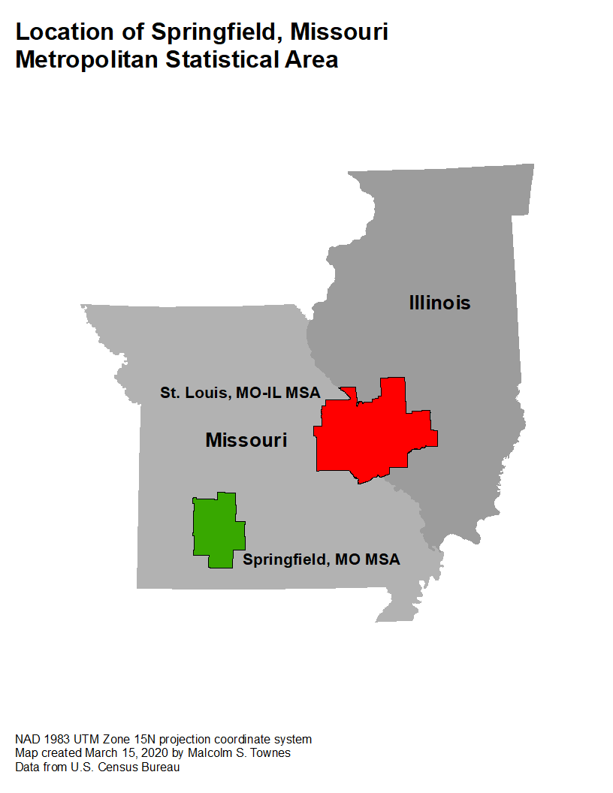

Figure 1. The Springfield, Missouri MSA is in the southwestern corner of the state of Missouri.

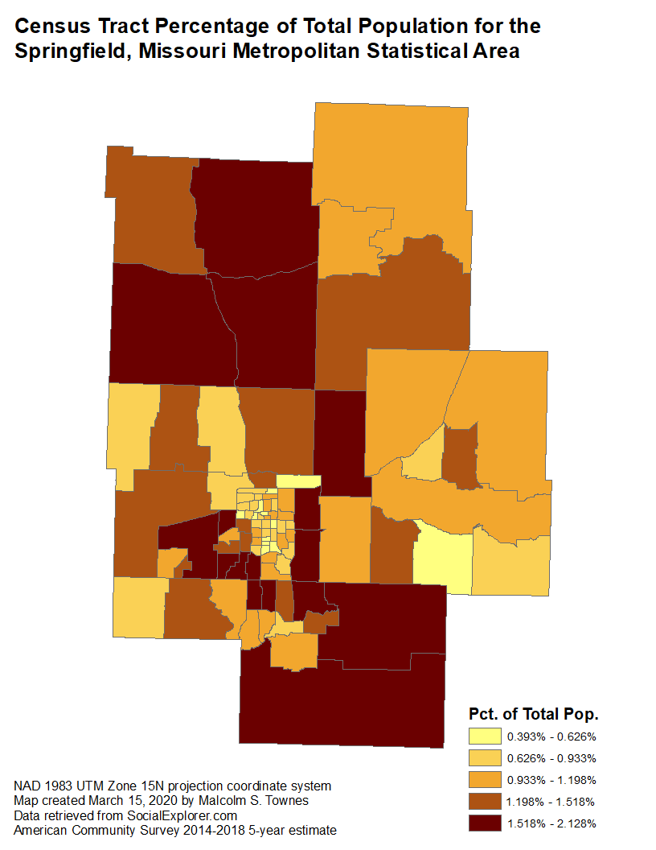

Figure 2. Distribution of population in the Springfield, Missouri Metropolitan Statistical Area.

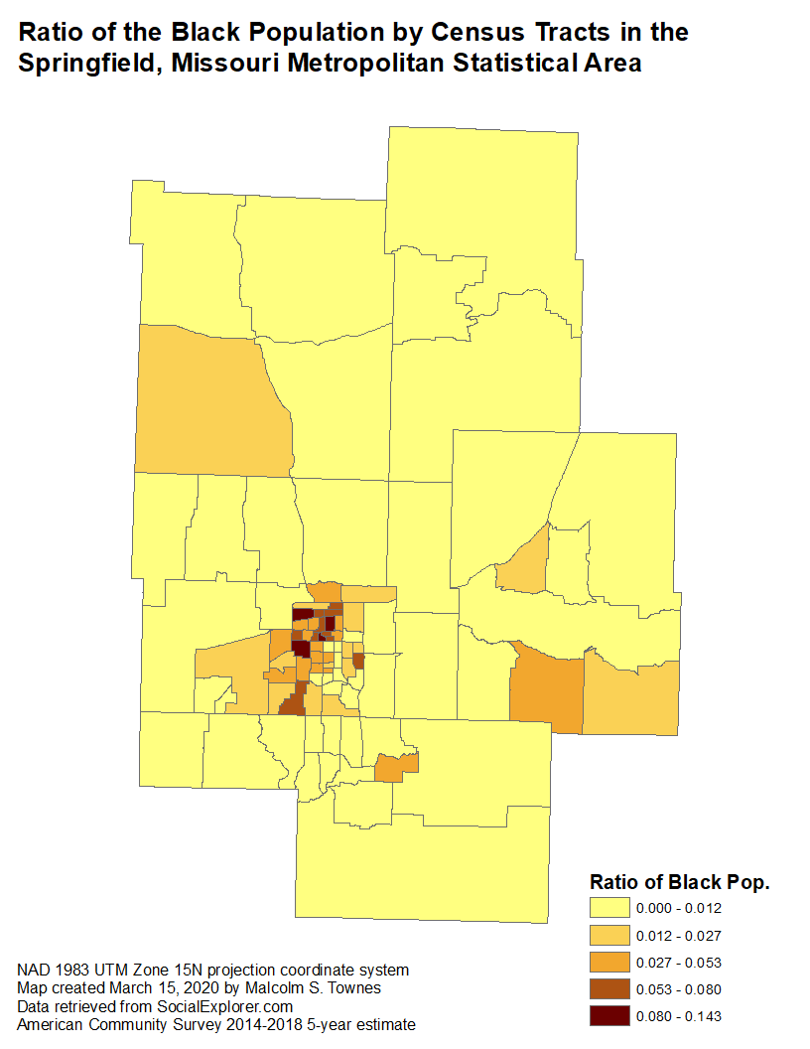

Figure 3. Percent Black population approaches the national average in only four census tracts.

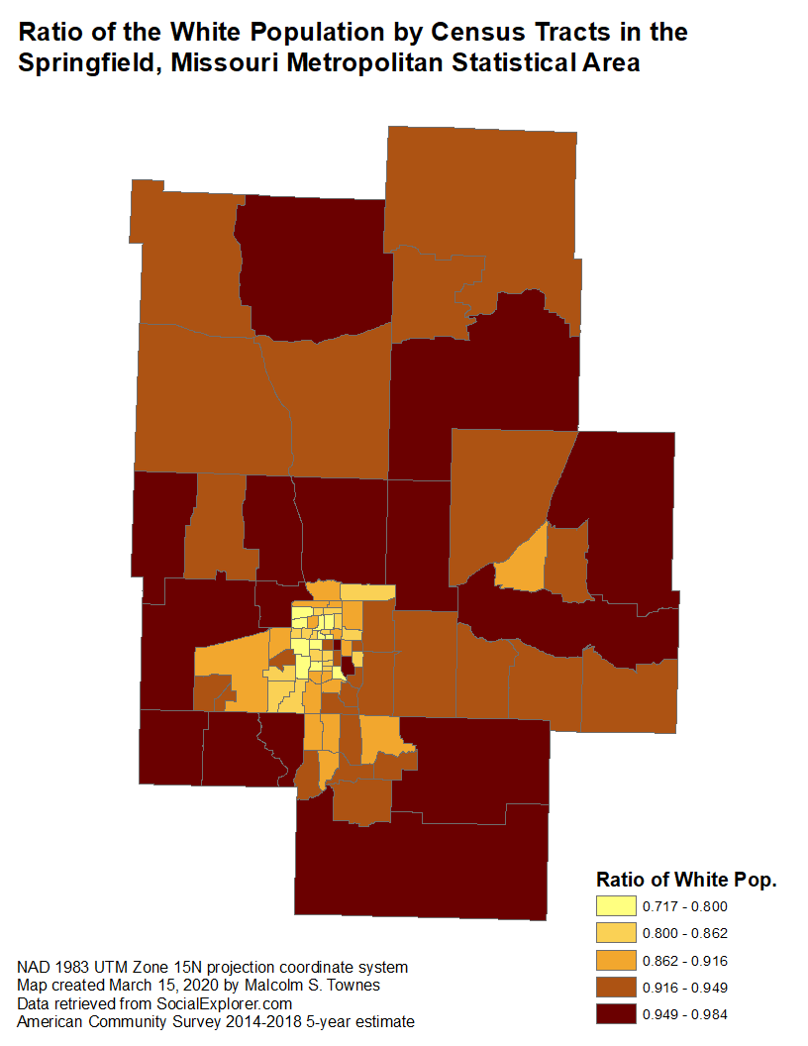

Figure 4. Greater than 85% of the population is White for the vast majority of census tracts.

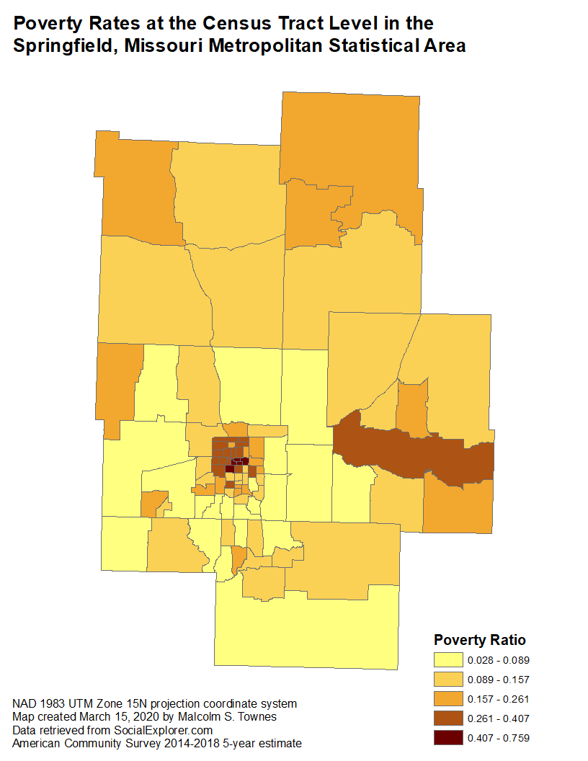

Figure 5. Highest rates of poverty are generally found close to the city of Springfield, Missouri.

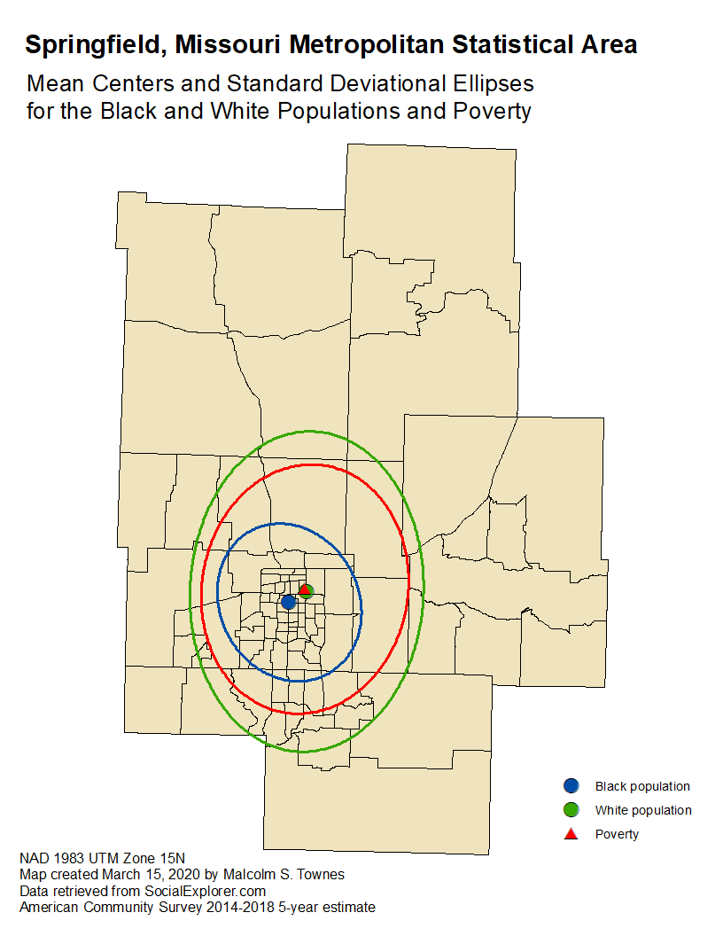

Figure 6. Spatial descriptive statistics for poverty ratio, Black population, and White population.

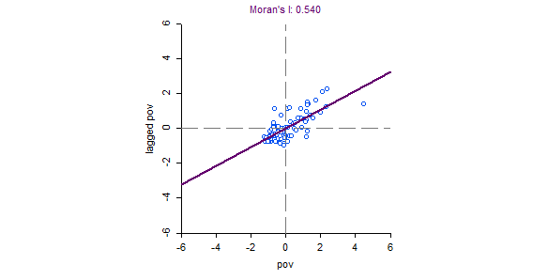

**Poverty Ratio**

**Lagged Poverty Ratio**

(a)

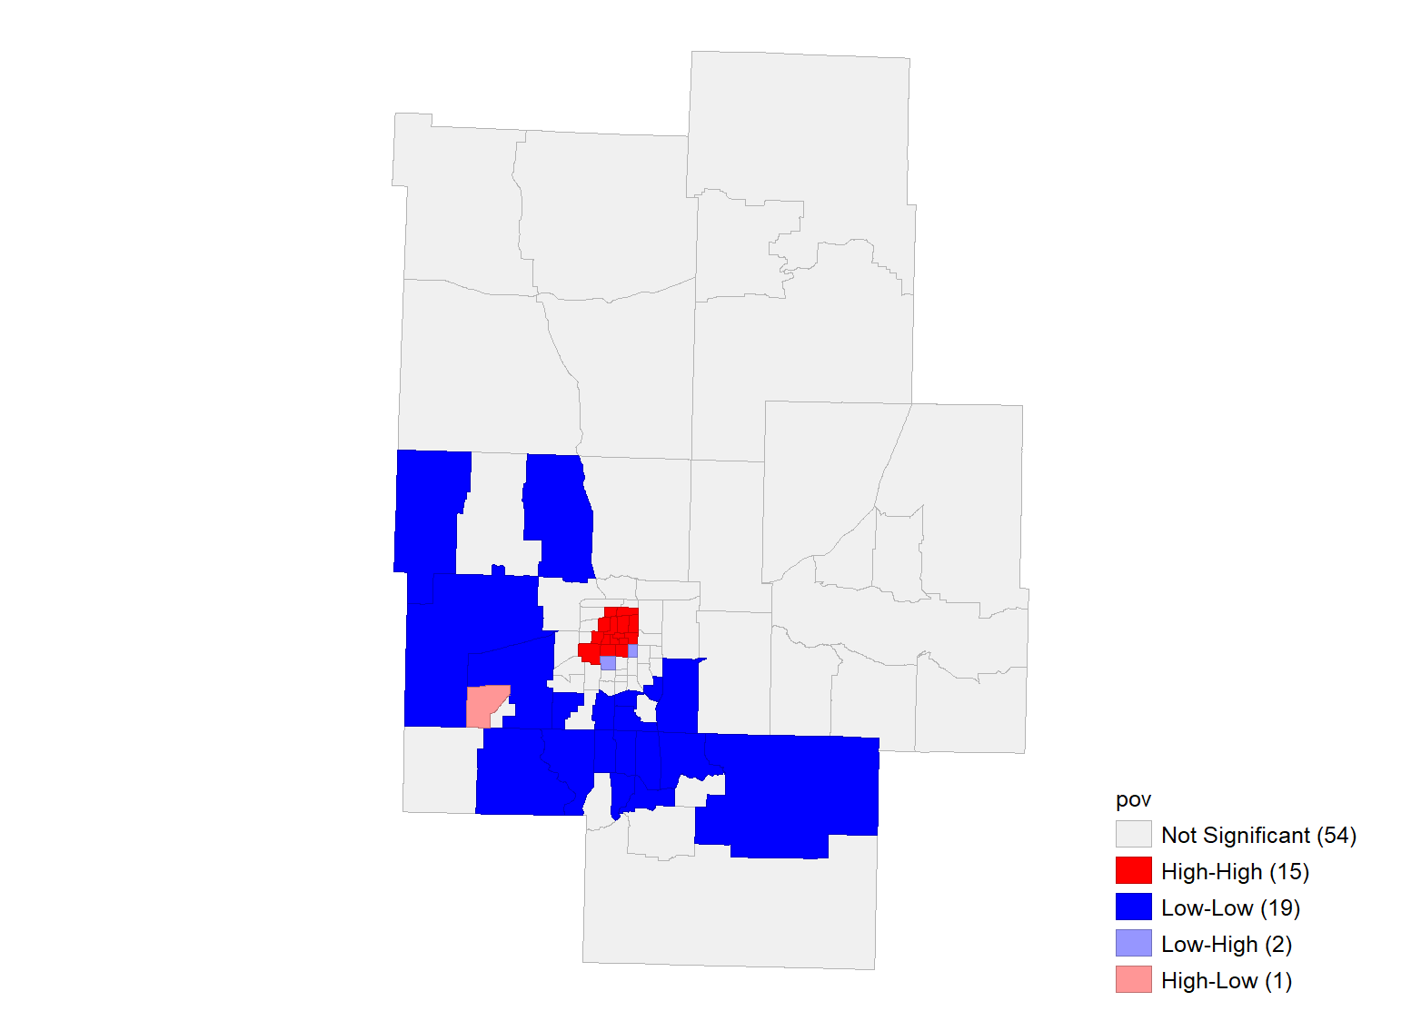 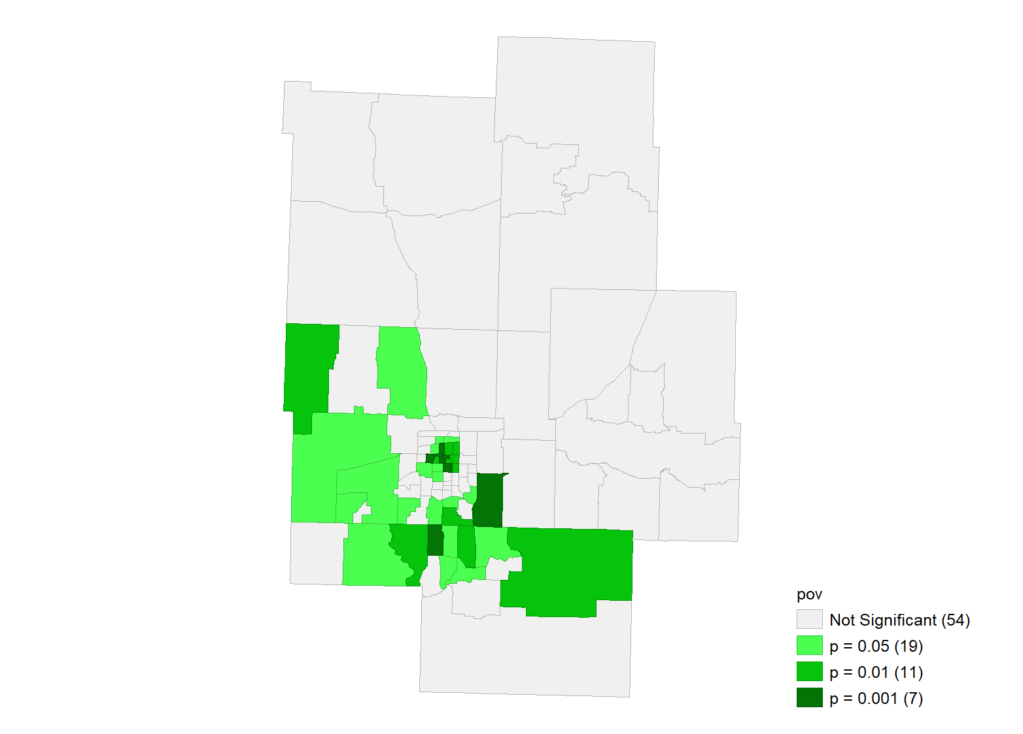

Poverty Ratio

Poverty Ratio

(b) (c)

Figure 7. Global spatial autocorrelation for poverty ratio at the census tract level.

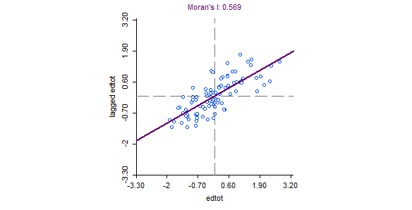

**Lagged Education Attainment Index**

**Education Attainment Index**

(a)

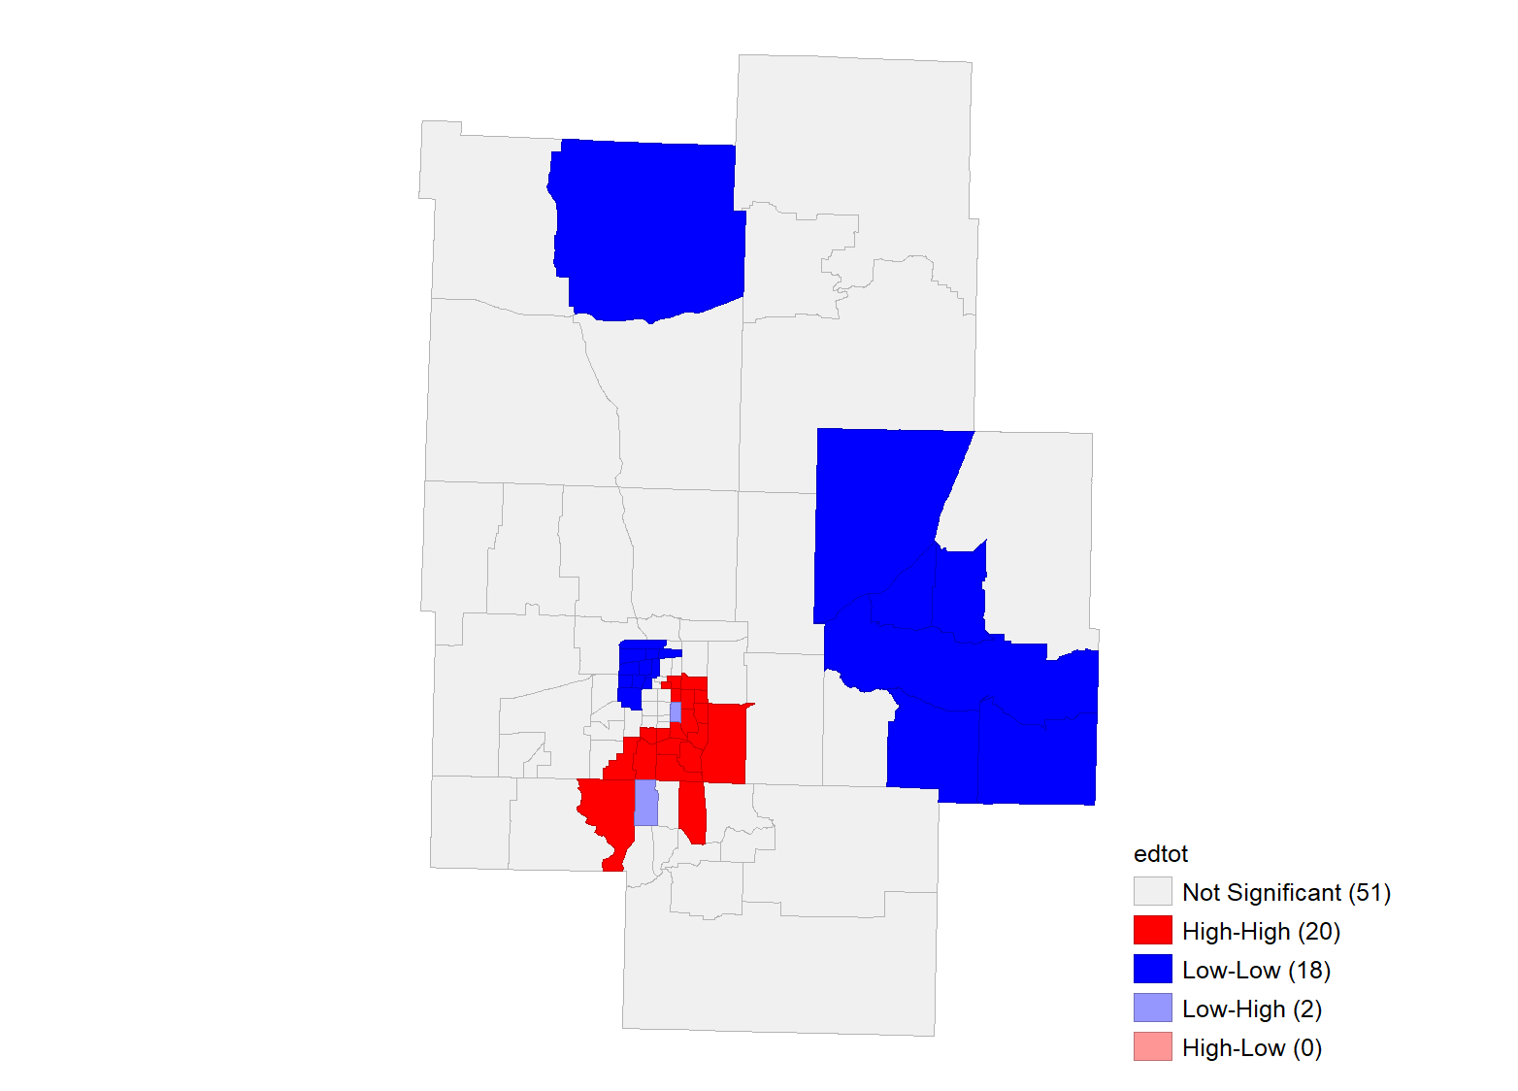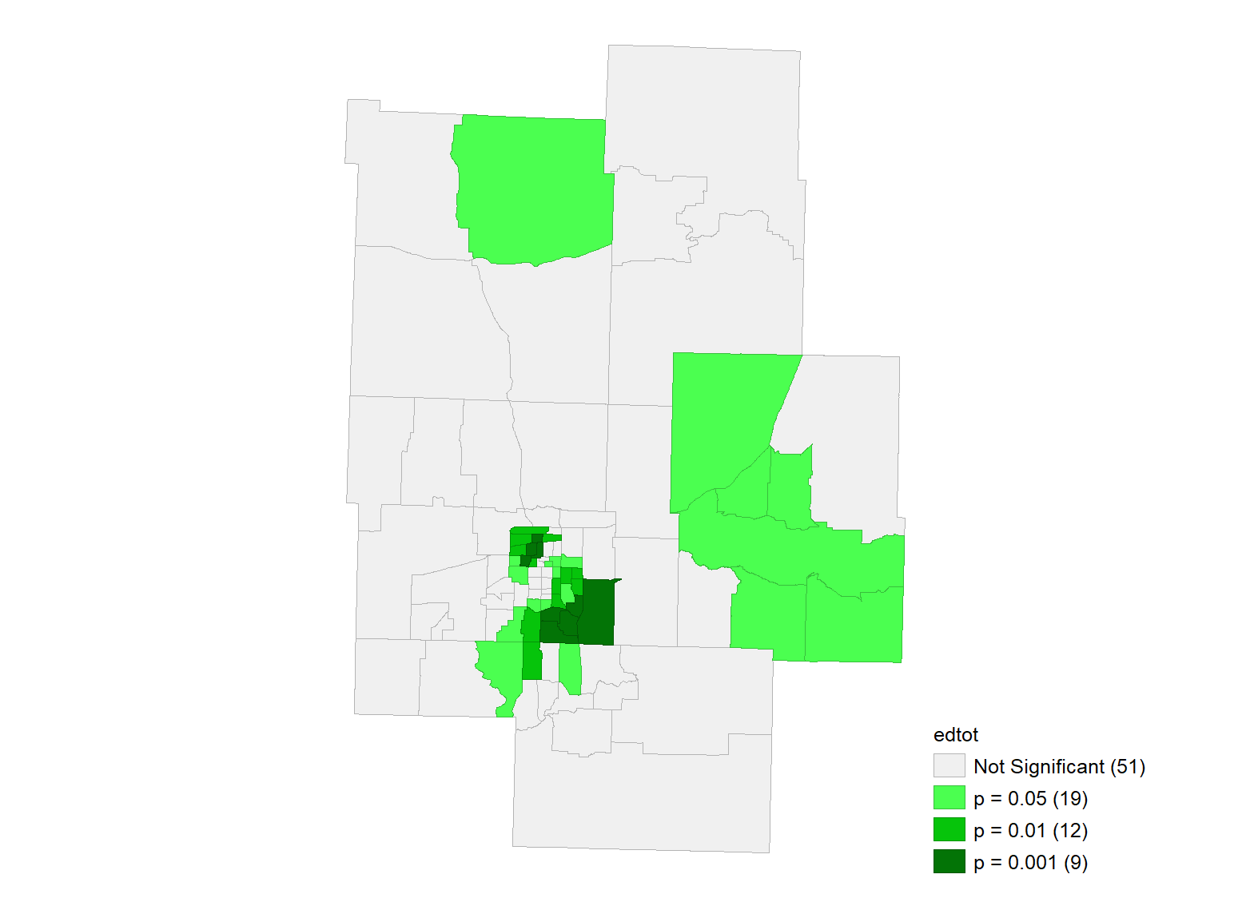

Educ. Attain. Index

Educ. Attain. Index

(b) (c)

Figure 8. Global spatial autocorrelation for education attainment index at the census tract level.

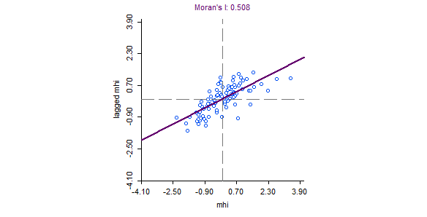

**Lagged Median Household Income**

**Median Household Income**

(a)

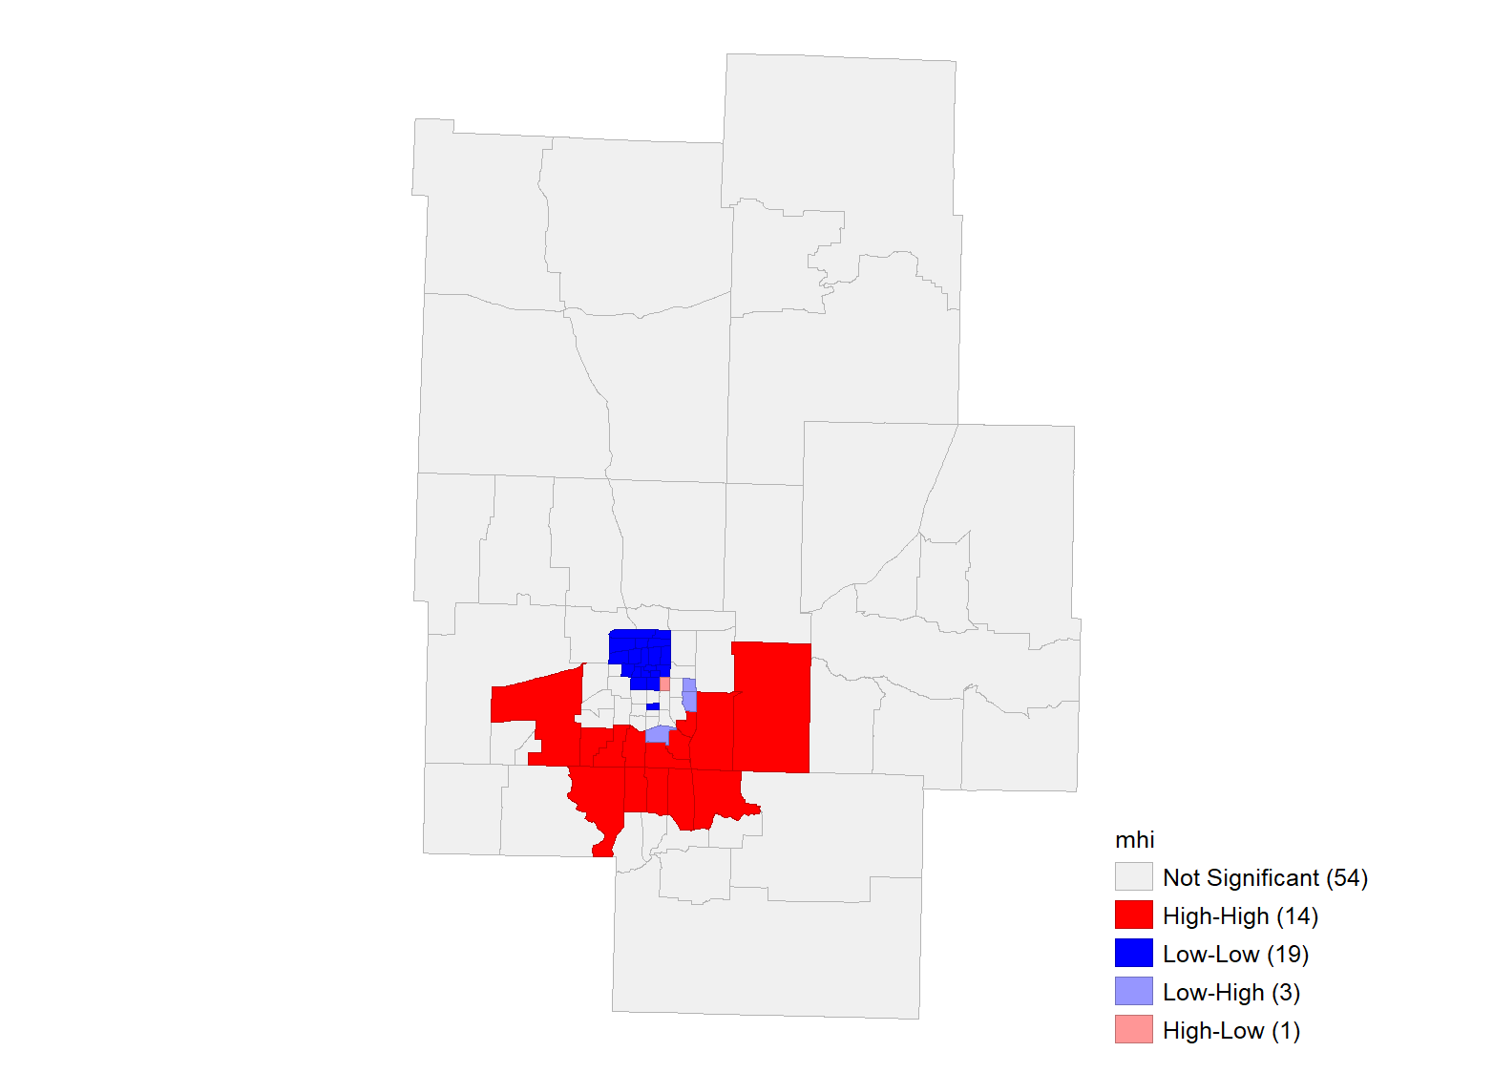 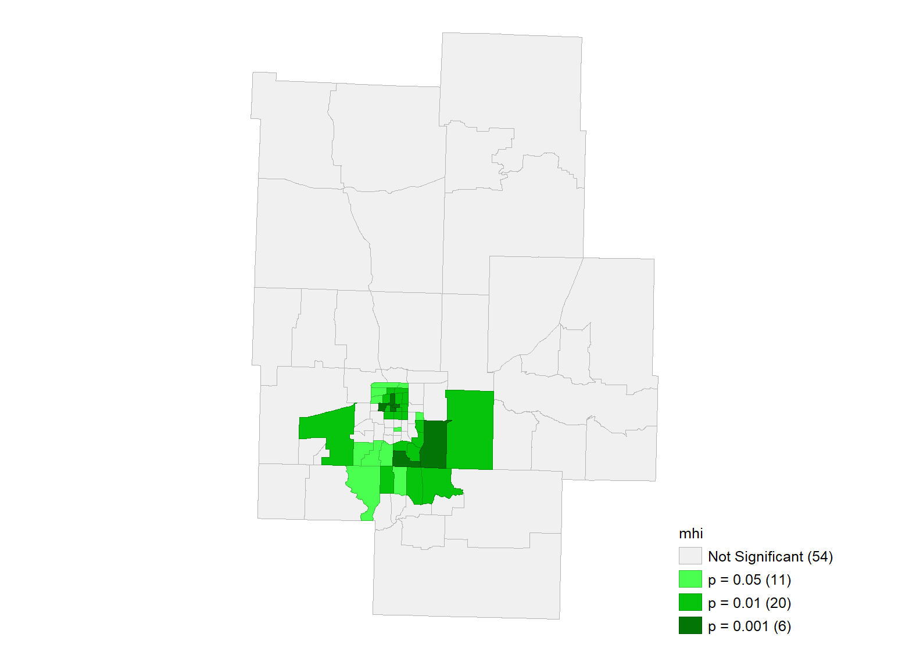

Median Household

Income

Median Household

Income

(b) (c)

Figure 9. Global spatial autocorrelation for mean household income at the census tract level.

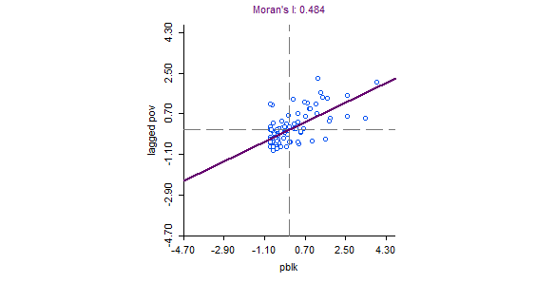

**Lagged Poverty Ratio**

**Black Population Ratio**

(a)

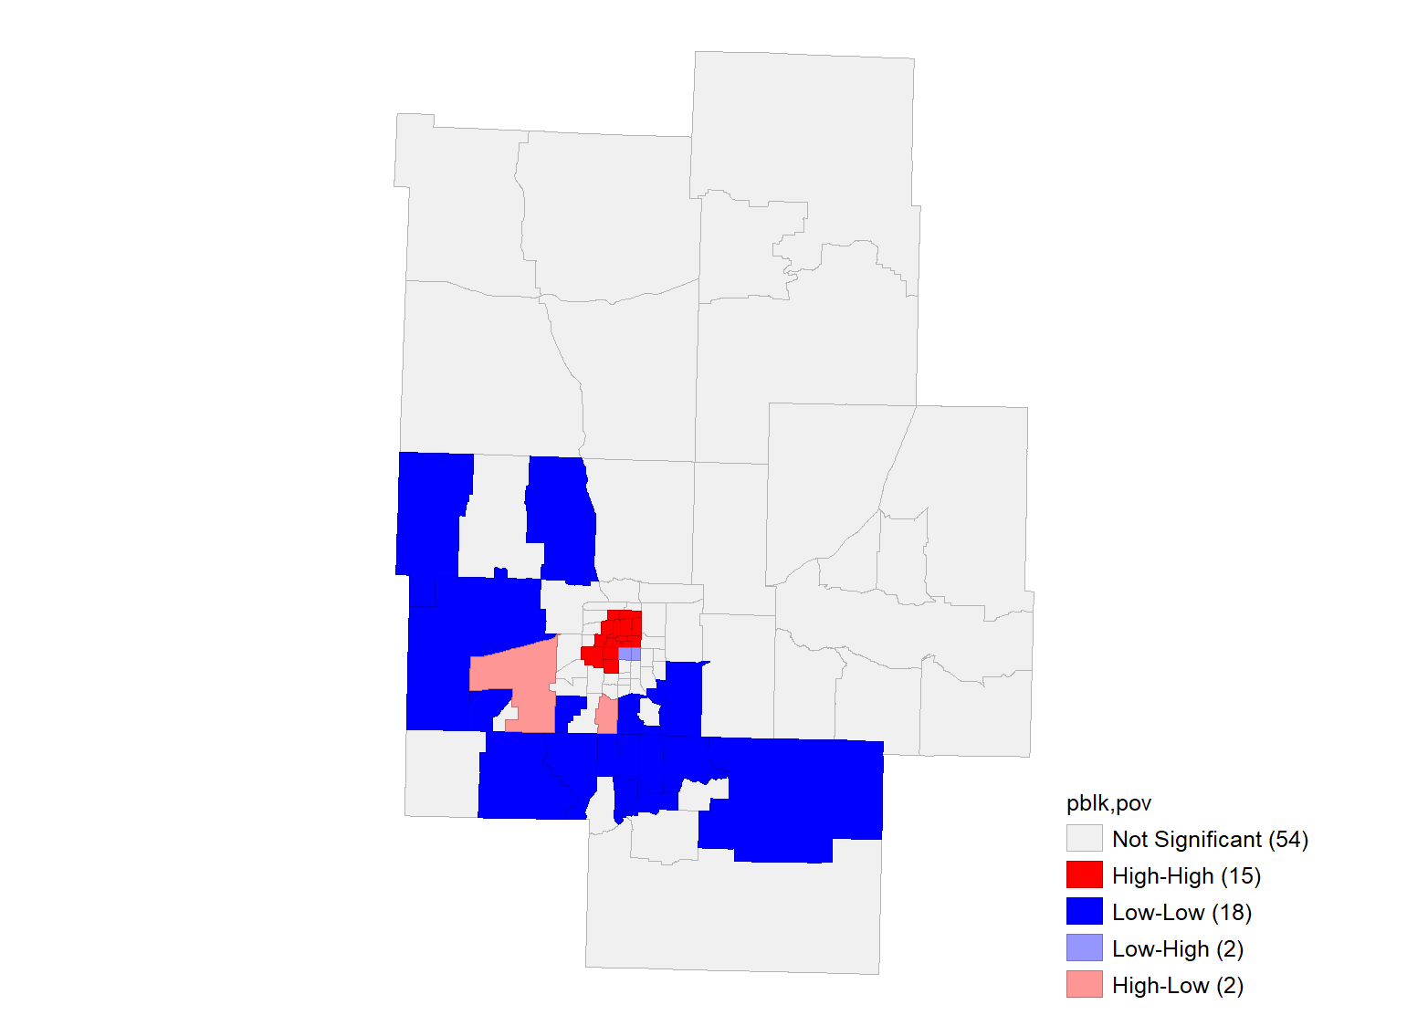 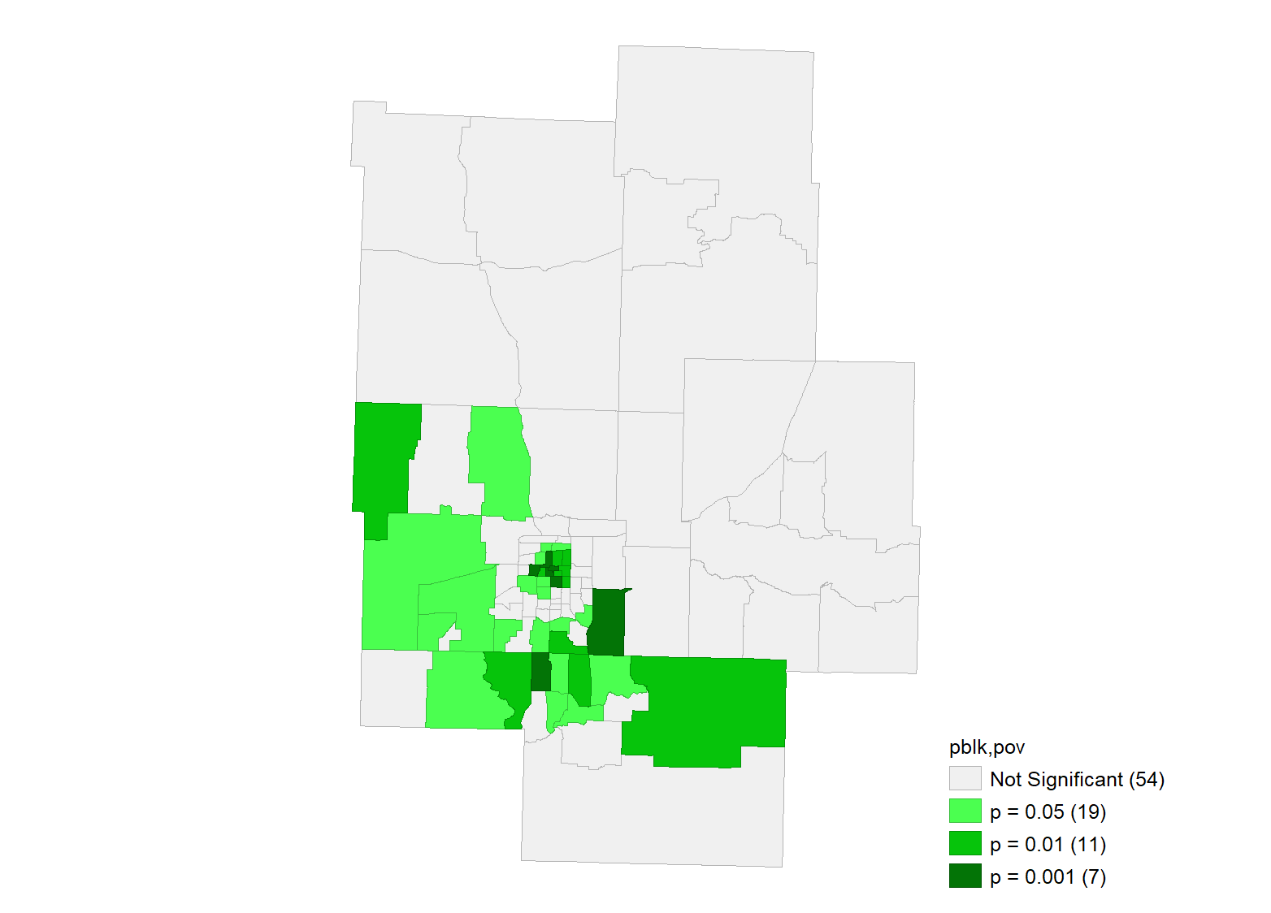

Black Pop. Ratio,

Poverty Ratio

Black Pop. Ratio,

Poverty Ratio

(b) (c)

Figure 10. Spatial autocorrelation found between percent Black population and poverty.

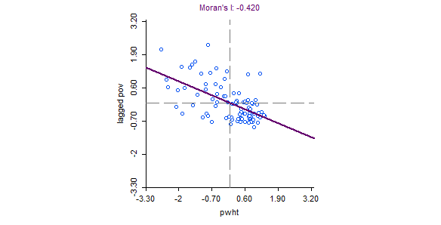

**Lagged Poverty Ratio**

**White Population Ratio**

(a)

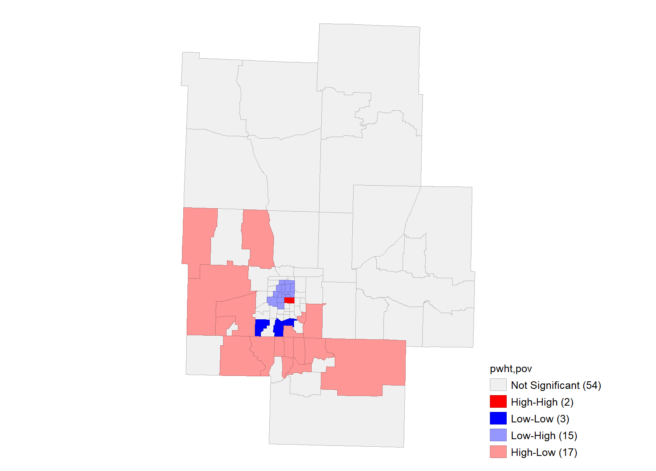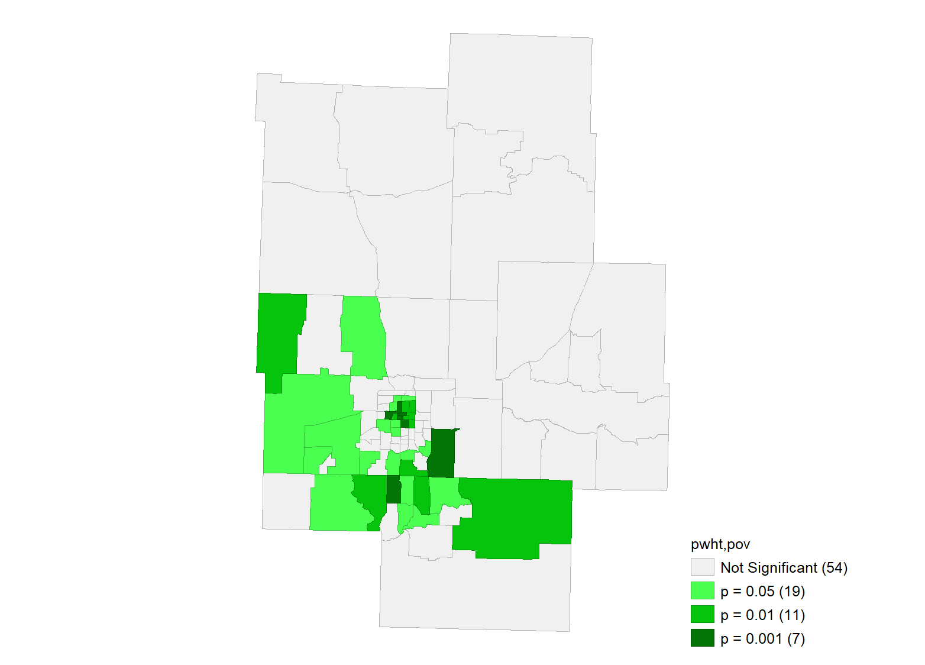

White Pop. Ratio,

Poverty Ratio

White Pop. Ratio,

Poverty Ratio

(b) (c)

Figure 11. Spatial autocorrelation found between percent White population and poverty.

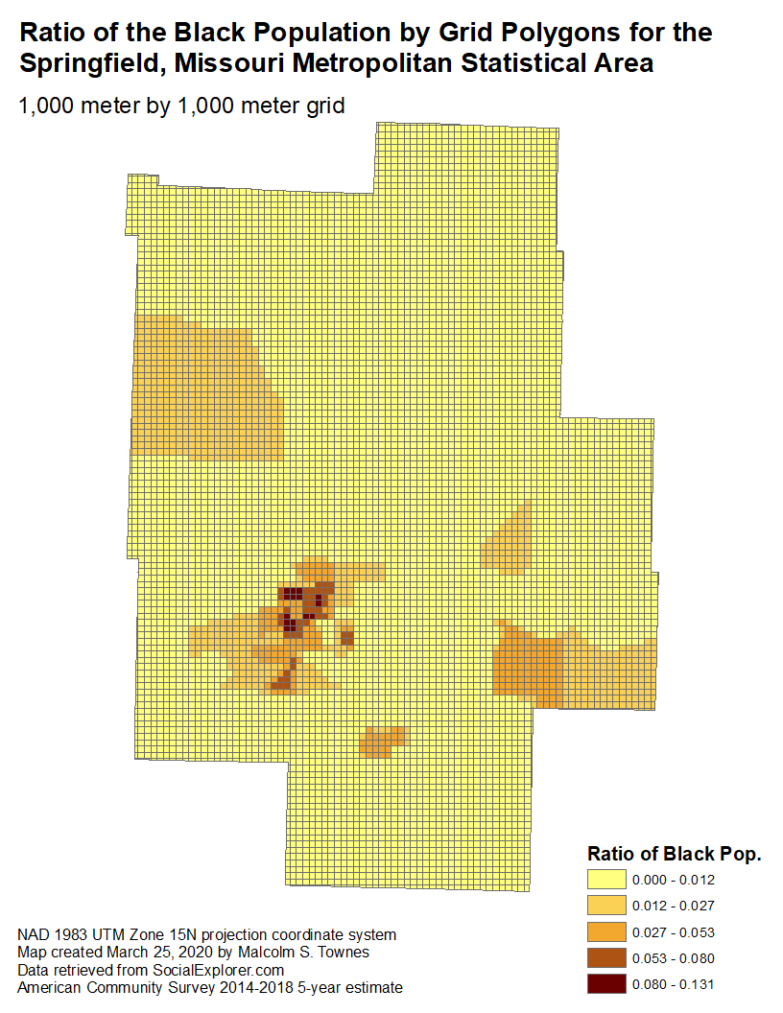

Figure 12. Black population appears concentrated near the city center based on grid polygons.

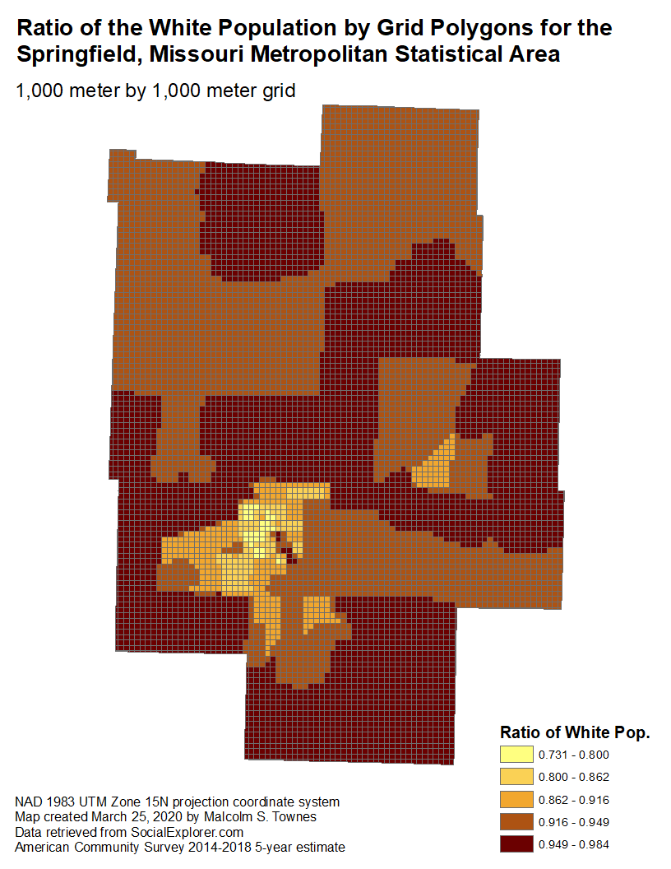

Figure 13. Greater than 91 percent of the population was White for the vast majority of grids.

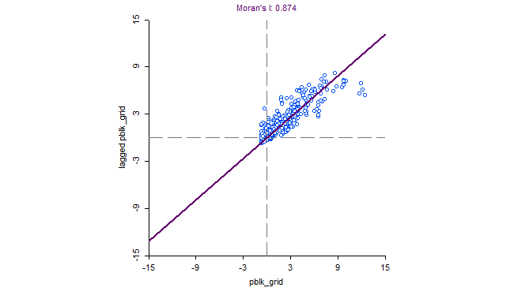

**Lagged Black Population Ratio**

**Black Population Ratio**

(a)

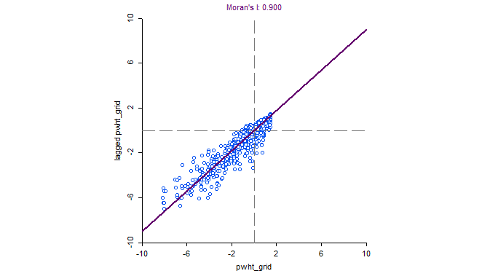

**Lagged White Population Ratio**

**White Population Ratio**

(b)

Figure 14. Grid based Moran’s I indicates severe spatial autocorrelation for both populations.