**A**

**Formative Evaluation of the**

**Vitendo 4 Africa Mentoring Program**

**SOC 5850**

**Program/Policy Evaluation and Needs Assessment**

**Final Report**

**December 2018**

Prepared by Saint Louis University Doctoral and Masters Program Students

(listed in alphabetical order of their surnames):

Daniel Ferris

Jacob Fussell

Melissa Stone

Malcolm Townes

Instructor: Nhial Tutlam, Ph.D.

**Table of Contents**

**Introduction and Background Information** **2**

**Literature Review** **3**

**Methods** **6**

**Results** **7**

**Recommendations** **16**

**References** **19**

[**Appendix A  
Mentor Phone Interview Unique Insights**](#_629v27ipnkyw) **21**

[**Appendix B  
Mentee Focus Group Results**](#_rycybzkjpwb1) **22**

# **Introduction and Background Information**

Vitendo 4 Africa (V4A) is a community-based organization built on bridging the gaps that exist between African Immigrant, primarily Kenyan to this point, and American-born individuals in Saint Louis, Missouri. Some of the services that this program offers include legal services, information awareness of the community, places of worship, and their youth mentorship program. Specifically, the mentorship program provides African youth the opportunity to work with a mentor who currently works in a career field that is similar to the type of career the mentee is interested in pursuing later in life. This opportunity allows for these mentees to be aware of what steps they need to be taking or how to better bolster their applications to college through services provided by Vitendo 4 Africa, such as ACT preparation and their mission trip to Africa (Vitendo).

Congress began supporting legislation in the mid-90s to support structured mentorship programs. These structured programs serve to decrease the risks or disadvantages of certain youth groups. The Department of Justice began their Juvenile Mentoring Program (JUMP) which was one of the first of these programs supported by Congress in 1994 (Fernandez-Alcantara, 2015). This mentorship program as well as others are designed to provide a supplemental guidance role in the child’s life. This role is meant to build upon the relationship the children have with their parents. In other words, this mentoring relationship will help the children to achieve and to solidify the child’s life chances by mitigating the negative effects of environmental factors on youth development (Aschenbrener & Johnson, 2017; Beiswinger, 1985; Grossman & Tierney, 1998). While these types of programs aimed at pairing unrelated adults with youth began in the early 1900s with what is today the Big Brother Big Sister organization (Beiswinger, 1985), the literature on mentoring seems to support the short-term success of reducing youth’s use of drugs and alcohol and youth gang activity as well as improving grades, the long-term outcomes of mentoring programs have not been studied (Fernandez-Alcantara, 2015). Even in the short-term, some studies have shown conflicting results.

There are many opportunities for mentorship programs to receive funding to better aid or equip their program. Even though grants and support do exist, estimated at $500 million in private donations, there has not been any type of research on state or local funding (Walker, 2007). While the amount of private funding seems impressive, it does not compare to many federally funded programs with billion dollar budgets. In addition, this support is contingent on the philanthropy of others. Thus, the evaluation of Vitendo4Africa’s mentorship program that follows may have limitations in implementation of recommendations as funding may play a role, especially considering that the mentorship program is just one aspect of Vitendo4Africa’s mission.

# **Literature Review**

When examining the effects of mentorship programs, it is important to consider what it is that the program seeks to achieve. In other words, reducing a child’s risk of getting involved with drugs, alcohol, or gangs could mean providing these kids with mentors to help them work on getting better grades, mentors to show them the steps to take for certain career fields, or mentors who help them understand the importance of giving back to the community through volunteerism. Each of these examples of mentor roles has certain goals: better GPA, greater connection and social network within a career, and larger amounts of service. Since mentorship programs may have different goals in mind, it is important to recognize Vitendo4Africa’s goal of bridging the gaps between African immigrants and American-born individuals in understanding how to use, to navigate, and to live in the United States. With this mission in mind, the literature helps to guide the research in what has been done before with other mentorship programs.

As V4A is an organization situated in North County, Saint Louis, there are unfortunately many factors that can place youth at risk. In terms of environmental risks, Aschenbrener & Johnson (2017) found that at-risk youth may face poverty, substance abuse, gang activity, teenage pregnancy, dropping out of high school, or a combination of these factors. These risks have both short-term and long-term problems associated with the individual’s life. “Individual costs [to dropping out of high school] include lower earnings, higher likelihood of unemployment, and greater likelihood of health problems” (Tyler & Lofstrom, 2009). These risks can be managed or mitigated by providing youth with mentoring relationships (DuBois et al., 2011). DuBois et al. noted that using mentoring relationships as interventions may come at varying degrees of success. In other words, programs that show more success hinge on to a significant degree on the selection of the type of mentors and mentees the program wishes to facilitate. In addition, successful programs exhibit “care with which mentoring relationships are then established and guided toward activities that are consistent with the goals of the program” (DuBois et al., 2011). With respect to results, research shows increased confidence especially when it comes to educational outcomes and achieves (Aschenbrener & Johnson, 2017; Ching et al., 2009). Improved academics are the goals of many mentorship programs in order to improve youth life chances later on as well as reduce the possibility of the youth dealing with environmental factors (DuBois et al., 2011; Fernandez-Alcantara, 2015; Tyler & Lofstrom, 2009). It is important to note that community-based mentorship programs show more enduring results as school-based programs are inherently linked to the academic calendar, meaning that there are gaps in mentoring when school is out of session (Randolph & Johnson, J. 2008). While mentor role-models can emphasize the importance of education to their mentees, sometimes this may not be the programs goal.

For some programs, the goal is to get mentees more involved in their career path in place of academics. V4A does promote academic success and ACT preparation, but the ultimate goals is to teach the youth how to achieve their life and career goals. Research on college mentoring of African American students shows a negative relationship between mentees and GPA (Brittian, Sy, & Stokes, 2009). Brittian, Sy, and Stokes explain through qualitative analysis of the sample that the African American students were less likely to seek aid such as academic mentoring unless they felt they were already facing issues (2009). That is to say, if the students felt like they were academically achieving their goals, they were less likely to seek out mentorship programs. While their research showed a negative relationship of mentees with GPA, it also showed a positive relationship between mentees and engagement and social networking, which can prove to be more important in career building or acquisition then educational attainment (McNamee & Miller, 2009). The research initially seems contradictory in the sense that the mentees had lower academic performance than non-mentees; however, these individuals self-reported waiting until the issue manifested before seeking out help. In addition, the mentorship program encourages community engagement and social networking as a goal for the mentees (Brittian, Sy, & Stokes, 2009). As mentioned before, mentoring programs can have a variety of different goals, but the key to mentoring success is based on knowing program objectives and aiming to prepare mentees based on activities that lead to the goal (DuBois et al., 2011). In other words, this study that seems to confound the literature actually follows the logic of success in mentorship programs.

Other forms of success in mentorship programs come in the form of reducing or removing mentee stress. Research regarding immigrant youth suggests they may experience a sense of loss from having left their familiar environment, struggle with language differences and academic performance, and endure increased stress or decreased self-esteem (James, 1997). While managing one’s ethnic identity and new American identity can be difficult as an immigrant, there are ways in which mentorship programs can help. Ching et al. found that Asian immigrants often suffer from isolation, issues of poor academic performance (as a result of language barrier), and problems with acculturating; however, mentoring provides a platform for the immigrant students to express themselves, to manage their ethnic identity, and to grow their knowledge of American ways (2009). Students can use mentorship programs as a means to gain social support and a tangible network of peers who can help with group counseling and coping with this drastic life change.

Similarly, Latino youth immigrants have issues with loss, fear, and embarrassment of not understanding a new culture. Immigrants generally find an “inner equilibrium” in their new country; however, the very foundation that children learn and understand life has been changed (Grinberg and Grinberg, 1989). As immigrants cease to belong to their former homeland, the consequences become more acute and potentially long-lasting (Conde, 2002; Grinberg and Grinberg, 1989). Through their research, Gonzalez-Ramos and Sanchez-Nester found that the mentorship evaluated provided mental health support by means of preventing gaps in knowledge (2009). The program provides the Latino youth with the opportunity to express what they feel they are struggling with as well as giving them the chance to see Latino professionals in their career settings (Gonzalez-Ramos & Sanchez-Nester, 2009). In addition to showing youth what possible opportunities are out there, the organization provides events for parents to become involved and gained experience. The parents are also struggling to understand the American ways, so it can be troubling for them to understand the stressors and expectations placed upon their child (Gonzalez-Ramos & Sanchez-Nester, 2009). In this particular mentorship program, the immigrant youth focused on managing their stressors while simultaneously receiving role-models, perspectives from successful immigrants, and parental-support through their better understanding of American stressors for children.

Being an immigrant comes with many environmental and internal challenges that put youth at risk that limit their life chances although research suggests that properly tailored mentorship programs can help to intervene so that immigrant youth can achieve their goals. In order to provide the skills and knowledge necessary to take the steps towards youth success, several aspects must be considered and analyzed, such as the objectives of the program as well as positive externalities not anticipated by program developers. While V4A’s mentorship primarily seeks to provide career building skills and knowledge, “Ideally, friendships will develop in such a way that students feel comfortable in approaching their mentors for help with academic, social and personal concerns” (Vitendo).

# **Methods**

The evaluation of Vitendo4Africa took place over a two-month time period under the direction and guidance of Dr. Nhial Tutlam of Saint Louis University. In order to learn more about the current state of the program, V4A’s mission statement and pertinent documents were shared with the team to aid in forming a series of questions meant for V4A leadership. These initial questions were comprised of survey items from the literature (Rhodes, Reddy, Roffman, & Grossman, 2005) and specific questions pertinent to the program. These questions were then collaboratively edited and organized to produce an adjustable survey.

The initial survey was trialed in a phone interview with V4A leadership to address the objective of the mentorship program and what specific information leadership wished to acquire from a formal assessment and evaluation. The survey was then further developed to include items related to the needs of V4A leadership, allowing for testing to occur during phone interviews with program mentors. As each mentor interview occurred, the survey was restructured to improve flow, remove redundant items, improve the specificity of items that had confused respondents, and add items addressing the concerns of mentors. This resulted in a complete survey that could be administered orally or be used as a template for online administration.

To increase mentor and mentee feedback beyond phone interviews, the completed survey was then transposed into a Qualtrics survey for online administration. Qualtrics is an online survey development tool used throughout industry and research to collect and analyze large quantities of data (Qualtrics, 2018). A team member transferred the original items into a new Qualtrics survey and was able to improve upon the survey via peer review and feedback from the software platform. The resulting final survey included questions for mentees and mentors. The evaluation team prioritized a mobile-friendly design, reasonable length (Qualtrics estimated the average response could be completed in under ten minutes), and asking measurable questions via yes/no and Likert scales with some open-text prompts.

A focus group of mentees (*n* = 15) was conducted with the assessment team during a V4A monthly meeting in November 2018. This meeting included mentees who had been part of the program since the very beginning, those who had joined part way through, and new mentees not yet assigned to a mentor. The focus group interview was conducted in private without any mentors present and lasted for approximately one hour. The session comprised of open discussion of the program and guided questioning following the questionnaire items established previously for mentors and mentees.

**Analyses:** Quantitative data was analyzed by first extracting survey data from Qualtrics to share among all group members. These data were placed into graphs in order to compare responses. Due to the low response rate (*n* = 8) of these survey items, statistical analyses were not applied. However, group members were able to interpret general trends that were supported by qualitative data.

Qualitative data were analyzed for phone interviews conducted with mentors and the in-person group interview with mentees. Initial analyses occurred directly following the interviews as a team to discuss themes, and transcripts and notes were then further analyzed by a team member with experience in qualitative data analysis. The analyses focused on general themes based off a large quantity of similar responses as well as unique insights and experiences of mentees/mentors that may not have reflected the entire group but still provide relevant information for the assessment. These analyses allowed the assessment team to explain why general trends from quantitative data was occurring in the program and give possible insights into problems and solutions.

**Limitations:** Limitations to the methodology of this assessment and evaluation are primarily tied to low response rates and forced binary responses on individual survey items. The low response rate via Qualtrics from both mentors and mentees gives limited information and may not be representative of all members of the program. Similarly, not all mentees at the focus group were able to refer to their experience within the program due to limited time in the program, thus limiting overall findings. As for survey items with forced binary responses, the assessment team had to balance between depth and ability to manageably analyze provided data. Many questionnaire items would improve from in-depth, qualitative responses, but binary (i.e., yes/no) responses were necessary due to the short timeframe of the assessment. Last, a limitation of this assessment comes from the qualitative responses as they may not represent all mentors/mentees.

# **Results**

**Program Logic Model:** Figure 1 shows a program logic model (PLM) for the V4A mentoring program. It depicts a visual representation of how the program is supposed to operate in theory based on information obtained during the evaluation process. While the PLM does not specify linkages or causal relationships among the elements of the model, it does help develop measures of program activities, outputs, and outcomes (McDavid, Huse, & Hawthorn, 2013). It is also useful for rapidly and efficiently communicating the most important aspects of the program to potential stakeholders.

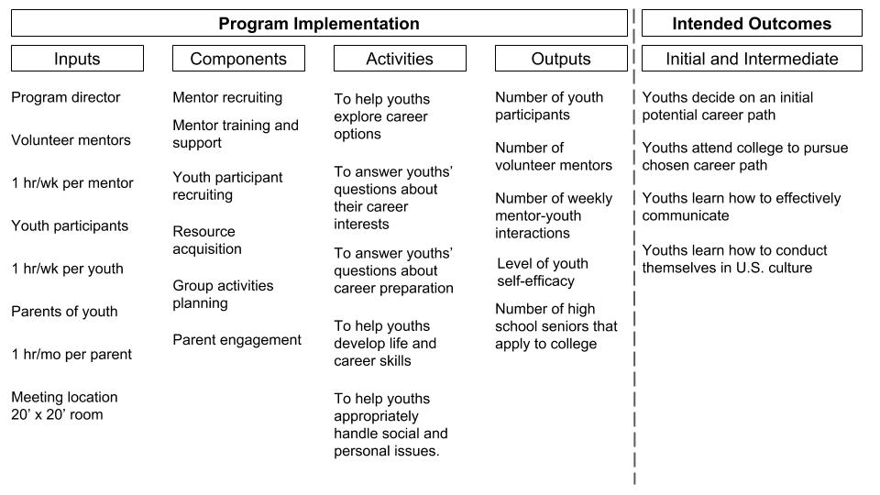

Figure 1. Program Logic Model for V4A Mentoring Program

Inputs are the resources needed to successfully operate the program (McDavid, Huse, & Hawthorn, 2013). The primary inputs for the V4A mentoring program are volunteer mentors, youth participants, and parents and the time they spend performing activities related to the program. A program director is required to manage the program and coordinate activities. We estimate that the amount of time expected of volunteer mentors and youth participants is approximately 1 hour per week and roughly 1 hour per month for the parents of youth participants. We were not able to generate an estimated for the amount of time required of the program director. The importance of the meeting location as a key input seemed to be overlooked or taken for granted by program administrators and participants. The meeting location can affect other various aspects of the program ranging from the attendance and tardiness of participants to the types of activities that can be conducted in the program to the effectiveness of program activities.

Program components are groups of related activities of the program (McDavid, Huse, & Hawthorn, 2013). The primary activities of the V4A program can be grouped into the three basic categories of participant support, resource acquisition, and programmatic. Participant support includes mentor recruiting, training, and support; youth participant recruiting, and parent engagement. Resource acquisition includes tasks related to obtaining the assets needed to successfully operate the program. The programmatic component includes tasks necessary to implement the activities that produce measurable program outputs.

Activities are the tasks that program staff and participants perform that produce measurable program outputs meant to result in the intended outcomes of the program. While successfully implementing the activities of the program is necessary for its success, doing so does not assure success (McDavid, Huse, & Hawthorn, 2013). The current activities of the V4A mentoring program are mostly focused on youth career development. However, they also address the ability of youth participants to deal with social and personal issues, which is also important for career success.

Program outputs are the direct measurable results of program activities (McDavid, Huse, & Hawthorn, 2013). Outputs for the V4A mentoring program include what one might typically expect such as number of youth participants, number of volunteer mentors, number of weekly mentor-youth interactions, and number of high school seniors that apply to college. Level of youth self-efficacy is also included in program outputs, which is something that was alluded to in the evaluation process but was not explicitly stated.

Intended outcomes are the results that the program hopes to achieve (McDavid, Huse, & Hawthorn, 2013). Often intended outcomes are categorized into initial, intermediate, and long-term outcomes. We decided to focus on and consolidate initial and intermediate outcomes to simplify the program logic model and because further detail was unlikely to facilitate implementation of recommendations for improvement. The intended outcomes for the V4A mentoring program relate to youth participants selecting and entering college to pursue a career. However, helping youth participants learn how to effectively communicate and how to conduct themselves in U.S. culture are also important intended outcomes for the program.

It’s important to note that successful program implementation doesn’t necessarily guarantee the intended outcomes will occur because the linkages and causality between program elements aren’t necessarily certain. Moreover, observed outcomes that correspond to intended outcomes can’t necessarily be attributed to the program without sufficient analysis to establish such connections to a reasonable degree of validity (McDavid, Huse, & Hawthorn, 2013).

**Qualtrics Survey Responses:** Survey responses collected through the online Qualtrics platform provided helpful, often complementary insights and context to the mentoring program in three key areas: Mentor and Mentee interaction, program support and coordination, and parent involvement.

In addition, the survey collected general feedback through open text responses on general program experience and feedback. One notable characteristic learned from the survey of mentors and mentees alike is that all respondents but one mentee have never had experience in a formal mentorship program previously. This along with the fact that the program is very early in its development may have driven a greater number of responses that were left blank or selected “unsure” or “neither agree nor disagree.”

Regarding Mentor and Mentee interaction, key findings include that a majority of respondents 1) feel their mentor’s or mentee’s career goals match their own (n=6), strongly agree or agree (n=8) that they feel comfortable communicating with their mentor or mentee. However, there is wide variation between mentor/mentee relationships in frequency and method of communication.

**E-Mail Text Message Social Media Telephone Call**

Never (5) Never (2) Never (4) Never (3)  
 Sometimes (1) Sometimes (1) Sometimes (2) Sometimes (2)

Frequently (3) Frequently (3)

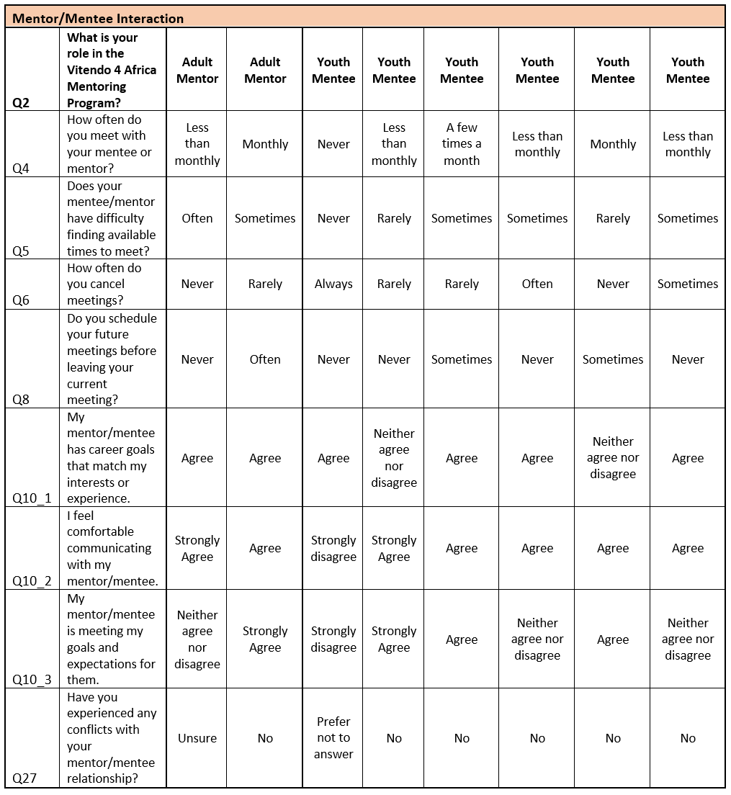

Program coordination and support questions included participation in orientation and the end of year activity (Cardinals baseball game), the role of the program coordinator, and additional evaluations participants completed. Notably, a majority of respondents (n=5) indicated they completed both mid-year and end-of-year evaluations for the program prior to this survey. Only one mentee, however, was aware of any findings from the previous evaluations.

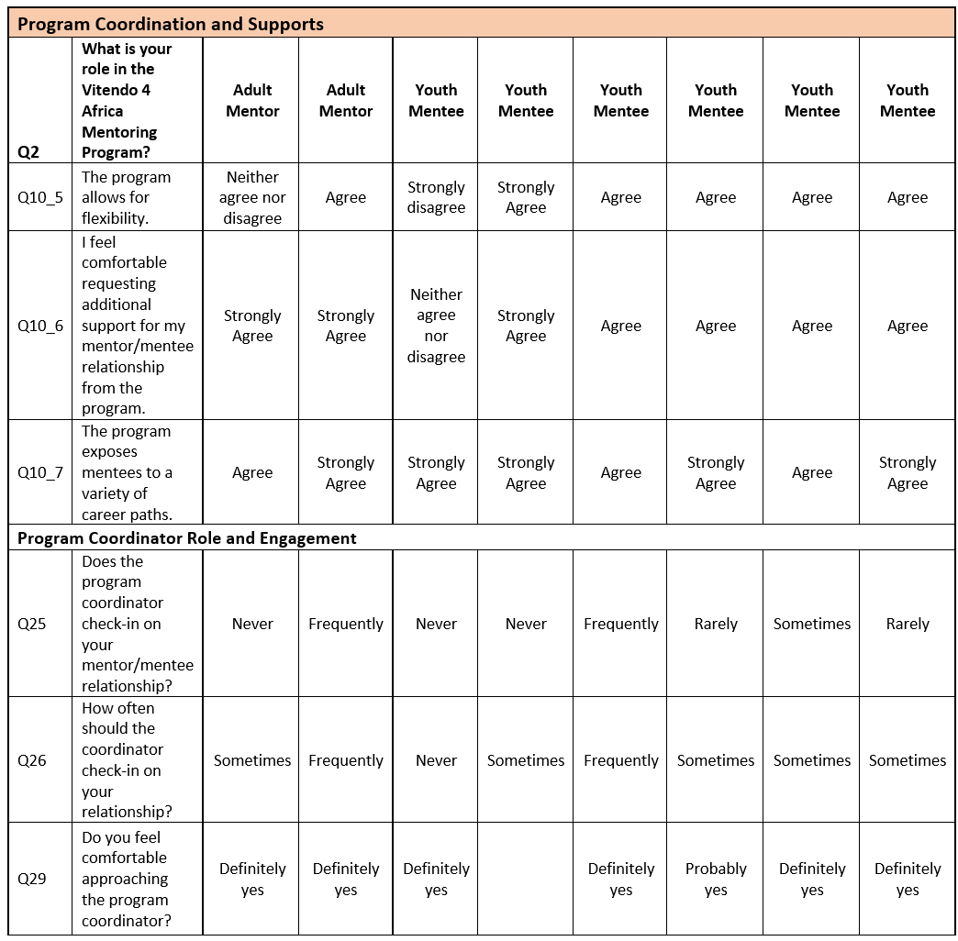

Responses on the general program coordination and support suggested that there is great comfortability for both mentors and mentees asking for support, the program allows for flexibility, and the program is successfully exposing mentees to a variety of career paths. One mentor and three mentees indicated they would prefer more frequent check-ins from the program coordination, one mentor and three mentees indicated the current amount of engagement with the program coordinator is their ideal amount.

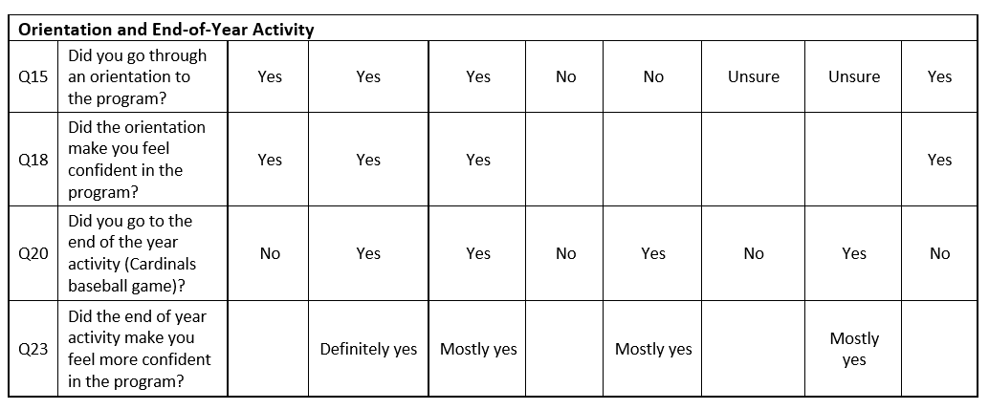  
 Early interviews with the mentorship program coordinator mentors informed the evaluation team’s approach for including questions around parent involvement. Youth mentee respondents unanimously agreed that they would prefer their mentors have ‘some interaction’ with their parents[1]. Currently, mentees reported their mentors “never” interacting with their parents (n=2) or “sometimes” interacting with their parents (n=3).

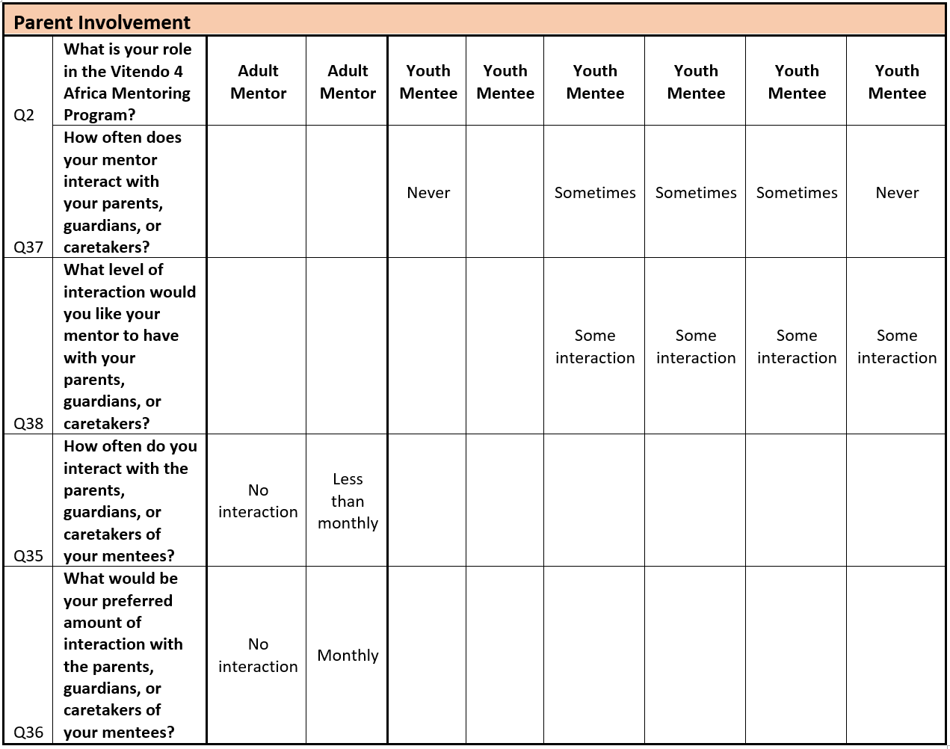

Finally, the survey captured responses as to why participants continue in the program and what they might improve or change. Regarding their program participation, reflections from mentees ranged from “Because I am told to” to the supports that they receive academically and socially. All three responses received from mentees regarding what they would change or improve indicated a desire for more engagement and more frequent interaction with mentors.

**Mentor and Mentee Interview Responses:** Qualitative analyses were conducted for both the mentor phone interviews and in-person focus group conducted between the mentees and assessment team. Mentor phone interviews revealed several general trends, most of which being positive from mentors who felt like they were making a difference in the program’s youth. They expressed general confidence in program, noting that V4A provides proper guidance and tools to ensure success for their mentees. Most mentors had 2-3 mentees with whom they met with about once per month. They noted wanting to see greater representation from jobs outside of white collar professions and future program expansion, and they expressed a need for more parental involvement or education of parents. Commonly expressed improvements to the program included greater feedback to all mentors and mentees, improved communication throughout the program, and adding more non-structured activities into the program.

Unique insights provided by mentor interviews focused on parental involvement, their meetings with mentees, the rapport they have with their mentees, and possible improvements to the program. These individual insights can be reviewed in Appendix A.

General trends during the mentee focus group were also positive but also expressed specific needs of the mentees to allow for better functioning of the program. The mentees expressed that the program is effective at creating professional contact and preparing them for college. The program has also given them perspectives on life beyond school and given them insight about future directions for jobs. They expressed satisfaction with the mentor-mentee match, noting that there is fairly close match between professional interests. Unlike what was mentioned in mentor interviews, the mentees said that they were meeting with their mentors only once per month at the very most and that meetings were more likely occurring only once every 2-3 months.

The mentees had specific wishes for the program that were expressed during the focus group. They wished for better communication with all mentors, increased frequency of meetings with their mentor (i.e., roughly twice per month), and greater monthly meeting attendance, including mentors. Also expressed by mentees was for more meetings to be social gatherings to help them feel closer to their mentors, as it has been difficult for mentees to feel close to their mentors due to the large age difference between them and events that remain only professionally focused. When asked what type of social gatherings they would prefer, they mentioned liking barbeques, going to the park, playing games, bowling, and sporting events.

A specific need discussed during the focus group was for an organized transportation system to give mentees rides to meetings and events. Many mentees noted not having consistent transportation, causing them to miss monthly meetings and events. Reasons for a lack of transportation included working parents, being too young to drive, not having enough cars in the family, and not having adequate public transportation to the meeting location. They expressed wanting to have a system in place to be able to contact one another when someone needs a ride as well as when someone has extra room in their car to be able to pick someone up.

Last, mentees frequently requested access to shadowing jobs outside of those typically displayed to them within the program (e.g., not just medicine, law, and engineering), and they requested their input concerning parental involvement in the program. Concerning their parents’ involvement, they specifically wanted their parents to receive outside informational meetings about the college application process. They also wanted to have a combined parent-mentor-mentee meeting once every 3-4 months, but they requested that parents not be made a part of the regular monthly meetings each month so that the mentees can have a place to comfortably speak with mentors without censoring themselves.

These findings are summarized in Appendix B.

# **Recommendations**

The evaluation generated the following five (5) specific recommendations for improving the V4A mentoring program:

1. **Have mentors and youth participants use the Fast Friends (FF) Procedure to establish trust and build rapport.**  
   The success of mentorship significantly depends on the nature of the relationship between mentor and protégé. Youth participants indicated that whether or not they opened up to mentors depended on their comfort level with mentors and their belief that mentors would maintain confidences. Results of the evaluation suggest that establishing the requisite level of trust may be an issue with some mentor-youth pairs. The FF Procedure is an approach for quickly establishing trust and building deep relationships. It is based on the gradual mutual disclosure of increasingly personal information between individuals (Aron, Melinat, Aron, Vallone, & Bator, 1997; University of California-Berkley, n.d.).
2. **Establish positive and negative incentives and provide support resources to encourage consistent attendance and on-time arrival for program events and activities.**  
   Both mentors and youths indicated that people arriving late to programs and events was a significant issue. More than half of the youths arrived to the focus group session for the evaluation study more than 10 minutes after the designated start time. Youths indicated that consistent transportation was often an impediment that prevented many of their peers from participating in the program. Youths also indicated that mentors canceling meetings because of other obligations was a regular occurrence. Notably, 5 of 8 survey respondents report that they didn’t schedule future meetings with their mentor before leaving the current meeting.
3. **Encourage and facilitate appropriate parental involvement by planning and scheduling quarterly activities that specifically involve the parents of youth participants.**  
   Both mentors and youths indicated a desire for parental involvement greater than current levels. Most youths indicated they were fine with mentors interacting with their parents but would be uncomfortable with parental involvement in all program activities. Youths also cited work schedules and general fatigue as the primary impediments preventing many parents from being more regularly involved with the program. Suggestions for implementing this recommendation include:
   1. conducting non-career focused social activities that include parents,
   2. having mentors provide mentorship to parents also, and
   3. providing parents with suggestions for activities to do and topics to discuss with their children at their convenience.
4. **Consider expanding participation for some aspects of the program beyond the Kenyan immigrant community.**  
   Youths indicated that the program’s exclusive focus on attracting program participants from Kenyan immigrant community was a limitation. Exclusive focus on participants from the Kenyan immigrant community limits the pool of potential resources for the program. Suggestions for implementing this recommendation include:
   1. recruiting mentors from outside the Kenyan immigrant community,
   2. partnering with other mentor programs for specific activities, and
   3. partnering with other service-oriented programs in the St. Louis community.
5. **Consider relocating the primary group meeting location to a larger, more conveniently located facility.**  
   The conference room in the 7220 N. Lindbergh location has limitations. It can only comfortably accommodate 10 to 12 people. The room arrangement is not particularly conducive to some types of activities. Moreover, individuals that are unable to sit at the conference table are likely to become de facto observers rather than active participants. Also, the location itself is somewhat isolated. Relocating to a more convenient location may help alleviate the transportation issue that some youth participants encounter and could help increase the visibility of the program in the community, which might help with recruiting participants and mentors. Suggestions for implementing this recommendation include:
   1. Relocating activities to a nearby branch of the St. Louis County Library System, such as the Florissant Valley Branch or the Prairie Commons Branch.

# **References**

Aron, A., Melinat, E., Aron, E. N., Vallone, R. D., & Bator, R. J. (1997). The Experimental

Generation of Interpersonal Closeness: A Procedure and Some Preliminary Findings. *Personality and Social Psychology Bulletin*, (4), 363. Retrieved from http://ezp.slu.edu/login?url=http://search.ebscohost .com/login.aspx?direct=true&db=edsbl&AN=RN023285782&site=eds-live.

Aschenbrener, C., & Johnson, S. (2017). Educationally-Based, Culturally-Sensitive, Theory-Driven Mentorship Intervention with At-risk Native American Youth in South Dakota: A Narrative Review. *Journal of Child & Family Studies, 26*(1), 14-27. doi:10.1007/s10826-016-0537-z

Beiswinger, G. L. (1985). *One to one: The story of the Big Brothers/Big Sisters movement in America.* Philadelphia: Big Brothers/Big Sisters of America.

Brittian, A. S., Sy, S. R., & Stokes, J. E. (2009). Mentoring: Implications for African American College Students. *Western Journal of Black Studies, 33*(2), 87-97.

Ching, A. M., Yeh, C. J., Siu, W. Y., Wu, K. A., & Okubo, Y. (2009). Evaluation of a School-based Internship Program for Chinese Immigrant Adolescents in the United States. *Adolescence, 44*(175), 601-620.

Conde, Y. (2002). *Operation Pedro Pan: The Untold Exodus of 14,048 Cuban Children.* Routledge.

DuBois, D. L., Portillo, N., Rhodes, J. E., Silverthorn, N., & Valentine, J. C. (2011). How effective are mentoring programs for youth? A systematic assessment of the evidence. *Psychological Science in the Public Interest*, *12*(2), 57-91.

Gonzalez-Ramos, G., & Sanchez-Nester, M. (2001). Responding to immigrant children's mental health needs in the schools: Project Mi Tierra/My Country. *Children & Schools*, *23*(1), 49-62.

Grossman, J. B., & Tierney, J. P. (1998). Does mentoring work? An impact study of the Big Brothers Big Sisters program. *Evaluation review*, *22*(3), 403-426.

Fernandes-Alcantara, A. L. (2015). Vulnerable Youth: Federal mentoring programs and issues.

James, D. C. (1997). Coping with a new society: The unique psychosocial problems of immigrant youth. *Journal of School Health*, 67(3), 98-102

McNamee, S. J., & Miller, R. K. (2009). *The meritocracy myth*. Rowman & Littlefield.

Qualtrics. (2018). Original research from qualtrics. Retrieved from https://www.qualtrics.com/research-center/

Randolph, K. A., & Johnson, J. L. (2008). School-based mentoring programs: A review of the research. *Children & Schools*, *30*(3), 177-185.

Rhodes, J., Reddy, R., Roffman, J., & Grossman, J. (2005). Promoting successful youth mentoring relationships: A preliminary screening questionnaire. *Journal of Primary Prevention* 26: 147-168.

Tyler, J. H., & Lofstrom, M. (2009). Finishing high school: Alternative pathways and dropout recovery. *The future of children*, 77-103

University of California - Berkeley. (n.d.) Fast Friends procedure full protocol used in *Page-Gould, Mendoza-Denton, & Tropp* (2008). Retrieved from https://rascl.berkeley.edu/tools.html.

Vitendo 4 Africa Mentoring Program. *V4A Revised March 29, 2017.*

Walker, G. (2007). Mentoring, policy, and politics. *Philadelphia: Public/Private Ventures.*

# **Appendix A Mentor Phone Interview Unique Insights**

*Note.* These insights reflect individual opinions expressed by mentors during phone interviews and may not be representative of general trends and themes of other mentors. These responses are meant to provide further detail into mentor thoughts about pertinent subjects in the V4A program.

Concerning Parental Involvement:

* Would like to see parents involved from the beginning and at more meetings
* Would be wary of parents giving conflicting information from mentors and would want parents to receive education or informational sessions
* Would like parents to receive information about college application process

Meeting with Mentees:

* Meetings occur once per month at most and are arranged via text when convenient; usually occur in conjunction with planned monthly meeting and are professional
* Often see one another at same church
* Meetings occur frequently and also include personal phone calls and texts almost daily to maintain contact beyond just professional ties

Rapport with Mentees:

* Difficult building rapport due to age difference
* Takes daily contact to build rapport, but it is possible

Improvement to the Program:

* Create an app for all mentors, mentees, and parents to access and communicate with one another
* Better feedback
* More diverse mentees from other immigrant communities
* Expand program to other Kenyan diasporas across US
* Get mentors from outside of white collar professions
* Add less structured activities that don’t just focus on professionalism
* Add 1-2 good workshops each year for mentees and parents
* Improve participation from parents
* Get participants excited about the outcomes

# **Appendix B Mentee Focus Group Results**

Transportation

* Need better transportation system for mentees who need rides to meetings and events
* Mentees often lack transportation due to insufficient public transportation near meeting place, parents working during monthly meetings, not enough cars in the family, and mentees being too young to drive

Parental Involvement

* Want parents to receive informational meetings concerning the college application process
* Want combined parent-mentor-mentee meeting once every 3-4 months
* Do not want parents at every meeting with mentors, as they want a safe, comfortable place to have conversations with their mentors where they do not need to censor themselves

Increased Mentor Contact

* Mentees often only see mentor once per month at most (sometimes only once every 2-3 months)
* Would like to increase meeting amount to 1-2 times per month
* Would like to have increased communication with mentor
* Would like to have better monthly meeting attendance, especially from mentors

Social Gatherings/Events

* Would like to build relationships and bridge the age differences between mentors and mentees
* Mentees requested social events such as barbeques, going to parks, playing games, bowling, and sporting events similar to the Cardinal’s game occurring at the end of the year event

Job Shadowing of Non-Traditional Jobs

* Mentees requested access to shadowing jobs outside of those typically seen in program (e.g., medicine, law, engineering)
* Expressed enthusiasm for business and entrepreneurial events (i.e., martial arts event)

1. Survey questions asked about interaction between mentors with mentee parents, guardians, or caretakers. For brevity, the report refers to all as ‘parents.’