A Path Analysis Model to Investigate the Drivers of Technology Transfer Outcomes

as Measured by the Number of Citations Received by Patents

Malcolm S. Townes

Saint Louis University

**Abstract**

Technology transfer is the transition of technology or intellectual property from one person or entity to another person or entity. Improving the transfer of technology derived from federally funded research and development (R&D) to the private sector is a priority for the public policy of the United States of America (OMB, 2018). University technology transfer (UTT) is a subcategory of the broader technology transfer field. It focuses on the transfer of technology derived from research conducted at universities to the private sector. Identifying the drivers of successful UTT and improving methods to evaluate technology transfer efforts is an important topic for study. There are several potential benefits to developing predictive models describing UTT and understanding the factors associated with successful UTT. Such knowledge would be useful for managing technological innovation and efficiently identifying high potential technologies for further development (Choi, Jang, Jun & Park, 2015). This study uses path analysis to pursue investigate the potential drivers of the technology transfer process in an effort to assess whether the number of citations received by a patent is a useful and feasible measure of technology transfer outcomes. Insights from the broader field of technology transfer should be applicable to the narrower field of UTT.

Keywords: technology transfer, university technology transfer, technology commercialization, federally funded research and development, patents, patent citations, path analysis

**Introduction**

This study continues the investigation of how technology transfer success can be defined and measured that I began on Assignments 01 and 02 for SOC 6100 in the Fall 2018 semester. Specifically, I conducted a path analysis to evaluate direct and indirect dependencies among various patent citation data variables in an effort to better understand the drivers of technology transfer outcomes. As in the previous analyses, I used patents issued by the United States Patent and Trademark Office (USPTO) as a proxy for a unit of technology and the number of citations a given U.S. patent receives from other U.S. patents as a measure of technology transfer.

**Data and Methods**

**Data Sources**

This study uses a subset of patent data obtained from the National Bureau of Economic Research (NBER) website. The source data contains both original and constructed variables. The data file included all utility patents granted in the U.S. from January 1, 1963 to December 30, 1999 listed in the Technology Assessment and Forecast (TAF) database of the USPTO. The source file contained data on 2,923,922 patents across 23 variables.

Table 1 details the source data original United States Patent and Trademark (USPTO) variables and explanations of their meanings. PATENT indicates the number assigned to the allowed patent by the USPTO. GYEAR is the year the USPTO allowed the patent. GDATE is the number of weeks elapsed since January 1, 1960 to the date the USPTO allowed the patent. APPYEAR is the year the patent application was submitted to the USPTO. COUNTRY is the country of citizenship for the first inventor listed on the patent application. POSTATE is the state of residency for the first inventor listed on the patent application. ASSIGNEE indicates to whom the patent is assigned as is unique to each assignee. ASSCODE indicates the type of assignee. CLAIMS is the number of independent and dependent claims listed on the patent. NCLASS indicates a broad classification for the patent.

Table 1

Source Data Original USPTO Variables

| Variable | Variable Type | Extended Name | Description |
| --- | --- | --- | --- |
| PATENT | Numeric | Patent Number | The number assigned to the allowed patent by the USPTO. |
| GYEAR | Numeric | Grant Year | The year the USPTO allowed the patent. |
| GDATE | Numeric | Grant Date | The date the USPTO allowed the patent expressed in terms of the number of weeks elapsed since  January 1, 1960. |
| APPYEAR | Numeric | Application Year | The year the patent application was submitted to the USPTO. |
| COUNTRY | Character | Country of First Inventor | The country of citizenship for the first inventor listed on the patent application. |
| POSTATE | Character | State of First Inventor (US) | The state of residency for the first inventor listed on the patent application if the country of citizenship is the United States of America. |
| ASSIGNEE | Numeric | Assignee Identifier | Unique identifier for the assignee of the patent. |
| ASSCODE | Numeric | Assignee Code | A one character code categorizing the type of assignee. |
| CLAIMS | Numeric | Number of Claims | Number of independent and dependent claims on the patent. |
| NCLASS | Numeric | Main Patent Class | A code that categorizes the patent into one of several broad classifications. |

Table 2 provides information about the source data constructed variables and explanations of their meanings. CAT is a higher-level classification of the main patent class. SUBCAT is a sub-category of the main patent class. CMADE indicates the number of citations made by the patent. CRECEIVE indicates the number of citations in other patents that reference the patent. RATIOCIT is the ratio of the number of citations made by all patents granted since 1963 to the total number of citations made by the patent. GENERAL is a measure of how broad the influence of a patent spans across fields. ORIGINAL is a measure of the originality of the patent. FWDAPLAG measures forward citations lag. BCKGTLAG measures backward citations lag. SELFCTUB is the upper bound for the measure of the share of citations the patent makes to other patents assigned to the same assignee (i.e., self-citations made). SELFCTLB is the lower bound for the measure of the share of citations the patent makes to other patents assigned to the same assignee. SECUPBD is the upper bound for the share of citations the patent receives from other patents assigned to the same assignee (i.e., self-citations received). SECDLWBD is the lower bound for the share of citations the patent receives from other patents assigned to the same assignee.

Table 2

Source Data Constructed Variables

| Variable | Variable Type | Extended Name | Description |
| --- | --- | --- | --- |
| CAT | Numeric | Technological Category | A higher-level classification of the Main Patent Class. |
| SUBCAT | Numeric | Technological Sub-category | The sub-category of the primary technological category to which the patent is assigned. |
| CMADE | Numeric | Number of Citations Made | The number of citations made by the patent. |
| CRECEIVE | Numeric | No. of Citations Received | The number of citations in other patents that reference the patent. |
| RATIOCIT | Numeric | Percent of Citations Made to Patents Granted Since 1963 | The ratio of the number of citations made by all patents granted since 1963 to the total number of citations made by the particular patent. |
| GENERAL | Numeric | Measure of Generality | A measure of how broad the influence of a patent spans across fields as determined by the number of different fields of all patents that cite the patent of interest.  Calculated as the following:  Generalityi = 1 - $\sum_{j}^{n_{i}}{s_{ij}^{2}}$, where *sij* denotes the percentage of citations received by patent *i* that belong to patent class *j*, out of *ni* patent classes. |
| ORIGINAL | Numeric | Measure of Originality | A measure of the originality of a patent as determined by the number of different fields for all patents cited by the patent of interest.  Calculated as the following:  Originalityi = 1 - $\sum_{j}^{n_{i}}{s_{ij}^{2}}$, where *sij* denotes the percentage of citations made by patent *i* that belong to patent class *j*, out of *ni* patent classes. |
| FWDAPLAG | Numeric | Mean Forward Citation Lag | The mean time difference between the application or grant date of the patent and that of the other patents citing this patent. |
| BCKGTLAG | Numeric | Mean Backward Citation Lag | The mean time difference between the application or grant date of the patent and that of the patents it cites. |
| SELFCTUB | Numeric | Share of Self-Citations Made – Upper Bound | The number of citations made by the patent to other patents with the same assignee divided by the total number of citations made by all patents with assignee codes. |
| SELFCTLB | Numeric | Share of Self-Citations Made – Lower Bound | The number of citations made by the patent to other patents with the same assignee divided by the total number of citations made by all patents. |
| SECUPBD | Numeric | Share of Self-Citations Received – Upper Bound | The number of citations received by the patent from other patents with the same assignee divided by the total number of citations received by all patents with assignee codes. |
| SECDLWBD | Numeric | Share of Self-Citations Received – Lower Bound | The number of citations received by the patent from other patents with the same assignee divided by the total number of citations received by all patents. |

I only used the GYEAR, CLAIMS, CRECEIVE, RATIOCIT, GENERAL, and ORIGINAL variables in the path analysis.

**Data Selection and Modification**

Based on the results of my previous analyses, I made several modifications to the data and incorporated several previous observations into the initial theoretical path analysis model. I removed the following variables because of high multicollinearity with other variables: APPYEAR, BCKGTLAG, FWDAPLAG, SELFCTLB, and SECDLWBD. Based on a scatter plot of the CRECEIVE variable against the CLAIMS variable, I removed observations with CLAIMS greater than 90 claims and CRECEIVE greater than 40 citations received as outliers. This resulted in 42 outlier observations being removed from the analysis for a final sample count of 1,958 observations. Additionally, I created a new variable (CRECEIVEln) using the Transform > Compute Variable function of SPSS Statistics 25. The CRECEIVEln variable is the natural logarithm transformation of the CRECEIVE variable. I decided to perform a transformation on the CRECEIVE variable because the data was skewed to the right (i.e., positively skewed) based on a visual inspection of a histogram. I chose a natural logarithm transformation because it appeared to bring out potential linear relationships between the CRECEIVE variable and primary independent variable (IV) of interest (CLAIMS)better than other transformations that I considered, which included base 10 logarithm and reciprocal transformations. The CRECEIVEln variable is what I used as the dependent variable (DV) in the analysis.

**Theoretical Model**

Figure 1 shows the theoretical path model that I developed from logical consideration of the relationships among the variables.



Figure 1. Logically Derived Theoretical Path Model

The theoretical path model uses the CRECEIVEln variable as the final DV of interest. Sub-model 1 uses GENERAL as the DV and ORIGINAL as the IV. It is likely that the originality of a patent will influence whether or not it will find broad applicability. The more original the patent the more likely that other innovators other varied fields will develop applications in their various areas of focus. Patents that rank low in originality are likely to be specific or specialized to a narrower range of applications within closely related fields.

Sub-model 2 uses CLAIMS as the DV and ORIGINAL, GENERAL, GYEAR, and RATIOCIT as the IVs. The claims of a patent define the scope of the subject that it asserts to be novel, nonobvious, and useful. Patents that rank higher in originality are likely to generate more claims because they stake out new innovation territory. Patents the rank higher in generality are likely to generate more claims because the scope of their applicability. I theorize that as the patents in general are likely to have more claims as the grant year increases because of the temporal nature of advances in sciences and the cumulative effects of scientific knowledge. I suspect that as the ratio of the number of citations made by all patents granted since 1963 to the total number of citations made by a particular patent increases will be associated with increases in the number of claims for a patent because of the general increase in scientific knowledge due to network effects.

Sub-model 3 uses CRECEIVEln as the DV and ORIGINAL, GENERAL, CLAIMS, GYEAR, and RATIOCIT as the IVs. Previous analysis indicated an inverse relationship between the originality of a patent and the number of citations it received. This may be because the full capabilities of highly original patents are less readily apparent than patents that rank lower on originality. Patents that rank high in generality probably receive higher numbers of citations because the broader scope of their applicability creates more opportunities to be cited. Likewise, patents that have more claims probably have more opportunities to be cited than patents with fewer claims. In general, patents are likely to receive more citations over time because scientific knowledge accumulates and spreads over time. I suspect that as the ratio of the number of citations made by all patents granted since 1963 to the total number of citations made by a particular patent increases will likely be associated with increases in the number of citations a patent receives because of network effects.

**Analysis**

I used IBM SPSS Statistics 25 to analyze the theoretical path model. I used the Analyze > Regression > Linear function to prepare regression analyses for each sub-model. The options I selected included model fit, R square change, part and partial correlations, and collinearity diagnostics for the regression statistics; estimates, a confidence level of 95 percent, and covariance matrix for the regression coefficients; and Durbin-Watson, casewise diagnostics for outliers beyond 3 standard deviations for the residuals. For each model I used the enter method. The complete SPSS Statistics 25 output file for the analysis is shown in Appendix A.

**Results and Findings**

Figure 2 shows theoretical path model with standardized coefficients and p-values from the various regression analyses.



Figure 2. Path Model with Standardized Coefficients and P-Values

Figure 3 shows the final path model with standardized coefficients and p-values. I removed the RATIOCIT variable from the final model because it was not significant at least at the 0.05 level. However, the p-value was 0.055 which is just above the threshold for significance.



Figure 3. Final Path Model with Standardized Coefficients and P-Values

Table 1 summarizes the direct, indirect, and total effects for the final path model.

Table 1

Path Model Direct and Indirect Effects



**Discussion**

**Policy Implications**

There are several possible policy implications of this study. The analysis provides insight into a topic that is of considerable interest to policymakers. It provides information to help policymakers identify possible factors that should be considered when forming public policy regarding technology transfer. As such, this study may help point policymakers in the right direction.

**Limitations of the Analysis**

As with any research project or study, this analysis has limitations. Since this analysis was focused on patent data for a five year period from 1995 to 1999, findings based on the data may not be relevant to time frames before or after this period. Additionally, there is a truncation effect in the data. Patents issued in the earliest part of the study period have the potential of receiving citations from patents over a longer period than patents issued in the latter part of the study period. This could potentially be contributing to the skewness observed in the sample distribution.

**Future Study**

There are several opportunities to improve upon and extend the analysis presented in this paper. To begin, it might prove useful to secure more recent data and to examine a subset of data with at least 10 years of subsequent data to minimize truncation effects. By merging the data with data containing information about patent assignees, it should be possible to further subset the patent data specifically for university technologies. It might also be useful to subset the data by category and subcategory of the patent since these variables are nominal and could not be directly included in the regression. Finally, comparing an analysis of various baseline path analysis models could result in a more optimized final path analysis model.

**Conclusion**

In this paper, I have continued to explore an alternative conceptualization of technology transfer and an approach to measuring technology transfer based on patent citations received. Using patent data, I conducted a path analysis using a variable measuring patent citations received as the dependent variable and measures of the patent’s originality, generality, claims, grant year, and citations ratio as independent variables. The path analysis model that I developed provided evidence that the generality of a patent is the overwhelming driver both direct and indirect effects on the number of citations the patent receives.

Finally, I identify potential policy implications for studying this topic. It provides information to help policymakers identify factors that they should potentially consider when forming public policy regarding technology transfer. As such, this study may help policymakers craft public policy that increases the amount of federally-funded research that is transfer to the marketplace to benefit the public interest.

References

Choi, J., Jang, D., Jun, S., & Park, S. (2015). A Predictive Model of Technology Transfer Using Patent Analysis. *Sustainability* (2071-1050), 7(12), 16175

Hall, B. H., Jaffe, A. B. and Trajtenberg, M. (2001). "The NBER Patent Citation Data File: Lessons, Insights and Methodological Tools." *NBER Working Paper 8498*. Retrieved from http://www.nber.org/patents/

National Bureau of Economic Research. (2018). Patent data, including constructed variables [data file]. Retrieved from http://www.nber.org/patents/

Office of Management and Budget [OMB]. (2018). *The President's Management Agenda*. Retrieved from https://www.whitehouse.gov/wp-content/uploads/2018/03/Presidents-Management-Agenda.pdf

Appendix A. IBM Statistics SPSS 25 Output

**Frequencies**

|  |  |  |
| --- | --- | --- |
| **Notes** | | |
| Output Created | | 28-OCT-2018 16:39:40 |
| Comments | |  |
| Input | Data | D:\SOC6100\Assignments\Assignment03\Data\DataClean\Townes_SOC6100_Assignment03_Data.sav |
| Active Dataset | DataSet1 |
| Filter | <none> |
| Weight | <none> |
| Split File | <none> |
| N of Rows in Working Data File | 2000 |
| Missing Value Handling | Definition of Missing | User-defined missing values are treated as missing. |
| Cases Used | Statistics are based on all cases with valid data. |
| Syntax | | FREQUENCIES VARIABLES=CRECEIVE CRECEIVEln CRECEIVElog10 CRECEIVErecip  /STATISTICS=STDDEV RANGE MINIMUM MAXIMUM SEMEAN MEAN MEDIAN SKEWNESS SESKEW KURTOSIS SEKURT  /HISTOGRAM NORMAL  /ORDER=ANALYSIS. |
| Resources | Processor Time | 00:00:07.36 |
| Elapsed Time | 00:00:03.49 |

[DataSet1] D:\SOC6100\Assignments\Assignment03\Data\DataClean\Townes_SOC6100_Assignment03_Data.sav

|  |  |  |  |  |  |
| --- | --- | --- | --- | --- | --- |
| **Statistics** | | | | | |
|  | | CRECEIVE | CRECEIVEln | CRECEIVElog10 | CRECEIVErecip |
| N | Valid | 2000 | 2000 | 2000 | 2000 |
| Missing | 0 | 0 | 0 | 0 |
| Mean | | 3.18 | .7788 | .3382 | .589921152058347 |
| Std. Error of Mean | | .096 | .01770 | .00769 | .007877009960755 |
| Median | | 2.00 | .6931 | .3010 | .500000000000000 |
| Std. Deviation | | 4.309 | .79147 | .34373 | .352270594633808 |
| Skewness | | 10.292 | .797 | .797 | .095 |
| Std. Error of Skewness | | .055 | .055 | .055 | .055 |
| Kurtosis | | 214.022 | .090 | .090 | -1.630 |
| Std. Error of Kurtosis | | .109 | .109 | .109 | .109 |
| Range | | 111 | 4.72 | 2.05 | .99107142857142860 |
| Minimum | | 1 | .00 | .00 | .00892857142857143 |
| Maximum | | 112 | 4.72 | 2.05 | 1.00000000000000000 |

**Frequency Table**

|  |  |  |  |  |  |
| --- | --- | --- | --- | --- | --- |
| **CRECEIVE** | | | | | |
|  | | Frequency | Percent | Valid Percent | Cumulative Percent |
| Valid | 1 | 791 | 39.6 | 39.6 | 39.6 |
| 2 | 433 | 21.7 | 21.7 | 61.2 |
| 3 | 243 | 12.2 | 12.2 | 73.4 |
| 4 | 146 | 7.3 | 7.3 | 80.7 |
| 5 | 105 | 5.3 | 5.3 | 85.9 |
| 6 | 75 | 3.8 | 3.8 | 89.6 |
| 7 | 46 | 2.3 | 2.3 | 92.0 |
| 8 | 36 | 1.8 | 1.8 | 93.8 |
| 9 | 26 | 1.3 | 1.3 | 95.1 |
| 10 | 22 | 1.1 | 1.1 | 96.2 |
| 11 | 14 | .7 | .7 | 96.9 |
| 12 | 10 | .5 | .5 | 97.4 |
| 13 | 9 | .4 | .4 | 97.8 |
| 14 | 10 | .5 | .5 | 98.3 |
| 15 | 4 | .2 | .2 | 98.5 |
| 16 | 4 | .2 | .2 | 98.7 |
| 17 | 5 | .3 | .3 | 99.0 |
| 18 | 5 | .3 | .3 | 99.2 |
| 20 | 1 | .1 | .1 | 99.3 |
| 21 | 2 | .1 | .1 | 99.4 |
| 22 | 1 | .1 | .1 | 99.4 |
| 23 | 2 | .1 | .1 | 99.5 |
| 25 | 1 | .1 | .1 | 99.6 |
| 26 | 2 | .1 | .1 | 99.7 |
| 30 | 1 | .1 | .1 | 99.7 |
| 31 | 1 | .1 | .1 | 99.8 |
| 32 | 1 | .1 | .1 | 99.8 |
| 33 | 1 | .1 | .1 | 99.9 |
| 38 | 1 | .1 | .1 | 99.9 |
| 42 | 1 | .1 | .1 | 100.0 |
| 112 | 1 | .1 | .1 | 100.0 |
| Total | 2000 | 100.0 | 100.0 |  |

|  |  |  |  |  |  |
| --- | --- | --- | --- | --- | --- |
| **CRECEIVEln** | | | | | |
|  | | Frequency | Percent | Valid Percent | Cumulative Percent |
| Valid | .00 | 791 | 39.6 | 39.6 | 39.6 |
| .69 | 433 | 21.7 | 21.7 | 61.2 |
| 1.10 | 243 | 12.2 | 12.2 | 73.4 |
| 1.39 | 146 | 7.3 | 7.3 | 80.7 |
| 1.61 | 105 | 5.3 | 5.3 | 85.9 |
| 1.79 | 75 | 3.8 | 3.8 | 89.6 |
| 1.95 | 46 | 2.3 | 2.3 | 92.0 |
| 2.08 | 36 | 1.8 | 1.8 | 93.8 |
| 2.20 | 26 | 1.3 | 1.3 | 95.1 |
| 2.30 | 22 | 1.1 | 1.1 | 96.2 |
| 2.40 | 14 | .7 | .7 | 96.9 |
| 2.48 | 10 | .5 | .5 | 97.4 |
| 2.56 | 9 | .4 | .4 | 97.8 |
| 2.64 | 10 | .5 | .5 | 98.3 |
| 2.71 | 4 | .2 | .2 | 98.5 |
| 2.77 | 4 | .2 | .2 | 98.7 |
| 2.83 | 5 | .3 | .3 | 99.0 |
| 2.89 | 5 | .3 | .3 | 99.2 |
| 3.00 | 1 | .1 | .1 | 99.3 |
| 3.04 | 2 | .1 | .1 | 99.4 |
| 3.09 | 1 | .1 | .1 | 99.4 |
| 3.14 | 2 | .1 | .1 | 99.5 |
| 3.22 | 1 | .1 | .1 | 99.6 |
| 3.26 | 2 | .1 | .1 | 99.7 |
| 3.40 | 1 | .1 | .1 | 99.7 |
| 3.43 | 1 | .1 | .1 | 99.8 |
| 3.47 | 1 | .1 | .1 | 99.8 |
| 3.50 | 1 | .1 | .1 | 99.9 |
| 3.64 | 1 | .1 | .1 | 99.9 |
| 3.74 | 1 | .1 | .1 | 100.0 |
| 4.72 | 1 | .1 | .1 | 100.0 |
| Total | 2000 | 100.0 | 100.0 |  |

|  |  |  |  |  |  |
| --- | --- | --- | --- | --- | --- |
| **CRECEIVElog10** | | | | | |
|  | | Frequency | Percent | Valid Percent | Cumulative Percent |
| Valid | .00 | 791 | 39.6 | 39.6 | 39.6 |
| .30 | 433 | 21.7 | 21.7 | 61.2 |
| .48 | 243 | 12.2 | 12.2 | 73.4 |
| .60 | 146 | 7.3 | 7.3 | 80.7 |
| .70 | 105 | 5.3 | 5.3 | 85.9 |
| .78 | 75 | 3.8 | 3.8 | 89.6 |
| .85 | 46 | 2.3 | 2.3 | 92.0 |
| .90 | 36 | 1.8 | 1.8 | 93.8 |
| .95 | 26 | 1.3 | 1.3 | 95.1 |
| 1.00 | 22 | 1.1 | 1.1 | 96.2 |
| 1.04 | 14 | .7 | .7 | 96.9 |
| 1.08 | 10 | .5 | .5 | 97.4 |
| 1.11 | 9 | .4 | .4 | 97.8 |
| 1.15 | 10 | .5 | .5 | 98.3 |
| 1.18 | 4 | .2 | .2 | 98.5 |
| 1.20 | 4 | .2 | .2 | 98.7 |
| 1.23 | 5 | .3 | .3 | 99.0 |
| 1.26 | 5 | .3 | .3 | 99.2 |
| 1.30 | 1 | .1 | .1 | 99.3 |
| 1.32 | 2 | .1 | .1 | 99.4 |
| 1.34 | 1 | .1 | .1 | 99.4 |
| 1.36 | 2 | .1 | .1 | 99.5 |
| 1.40 | 1 | .1 | .1 | 99.6 |
| 1.41 | 2 | .1 | .1 | 99.7 |
| 1.48 | 1 | .1 | .1 | 99.7 |
| 1.49 | 1 | .1 | .1 | 99.8 |
| 1.51 | 1 | .1 | .1 | 99.8 |
| 1.52 | 1 | .1 | .1 | 99.9 |
| 1.58 | 1 | .1 | .1 | 99.9 |
| 1.62 | 1 | .1 | .1 | 100.0 |
| 2.05 | 1 | .1 | .1 | 100.0 |
| Total | 2000 | 100.0 | 100.0 |  |

|  |  |  |  |  |  |
| --- | --- | --- | --- | --- | --- |
| **CRECEIVErecip** | | | | | |
|  | | Frequency | Percent | Valid Percent | Cumulative Percent |
| Valid | .00892857142857143 | 1 | .1 | .1 | .1 |
| .02380952380952380 | 1 | .1 | .1 | .1 |
| .02631578947368420 | 1 | .1 | .1 | .2 |
| .03030303030303030 | 1 | .1 | .1 | .2 |
| .03125000000000000 | 1 | .1 | .1 | .3 |
| .03225806451612900 | 1 | .1 | .1 | .3 |
| .03333333333333330 | 1 | .1 | .1 | .4 |
| .03846153846153850 | 2 | .1 | .1 | .4 |
| .04000000000000000 | 1 | .1 | .1 | .5 |
| .04347826086956520 | 2 | .1 | .1 | .6 |
| .04545454545454550 | 1 | .1 | .1 | .7 |
| .04761904761904760 | 2 | .1 | .1 | .8 |
| .05000000000000000 | 1 | .1 | .1 | .8 |
| .05555555555555560 | 5 | .3 | .3 | 1.1 |
| .05882352941176470 | 5 | .3 | .3 | 1.3 |
| .06250000000000000 | 4 | .2 | .2 | 1.5 |
| .06666666666666670 | 4 | .2 | .2 | 1.7 |
| .07142857142857140 | 10 | .5 | .5 | 2.2 |
| .07692307692307690 | 9 | .4 | .4 | 2.7 |
| .08333333333333330 | 10 | .5 | .5 | 3.2 |
| .09090909090909090 | 14 | .7 | .7 | 3.9 |
| .10000000000000000 | 22 | 1.1 | 1.1 | 5.0 |
| .11111111111111100 | 26 | 1.3 | 1.3 | 6.3 |
| .12500000000000000 | 36 | 1.8 | 1.8 | 8.1 |
| .14285714285714300 | 46 | 2.3 | 2.3 | 10.4 |
| .16666666666666700 | 75 | 3.8 | 3.8 | 14.1 |
| .20000000000000000 | 105 | 5.3 | 5.3 | 19.4 |
| .25000000000000000 | 146 | 7.3 | 7.3 | 26.7 |
| .33333333333333300 | 243 | 12.2 | 12.2 | 38.8 |
| .50000000000000000 | 433 | 21.7 | 21.7 | 60.5 |
| 1.00000000000000000 | 791 | 39.6 | 39.6 | 100.0 |
| Total | 2000 | 100.0 | 100.0 |  |

**Histogram**

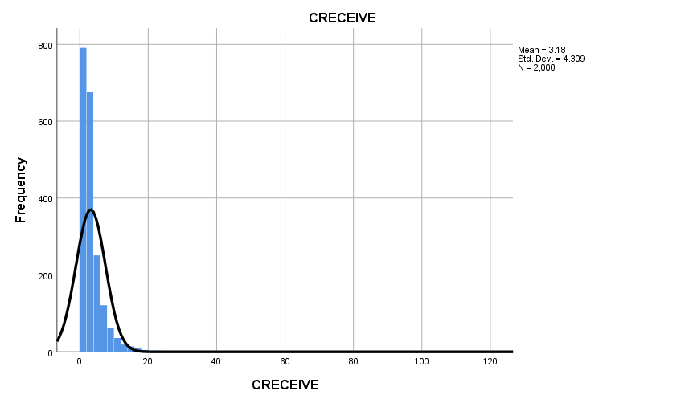

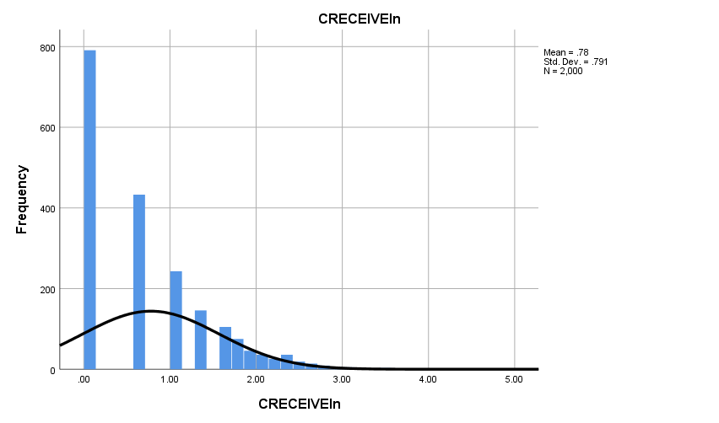

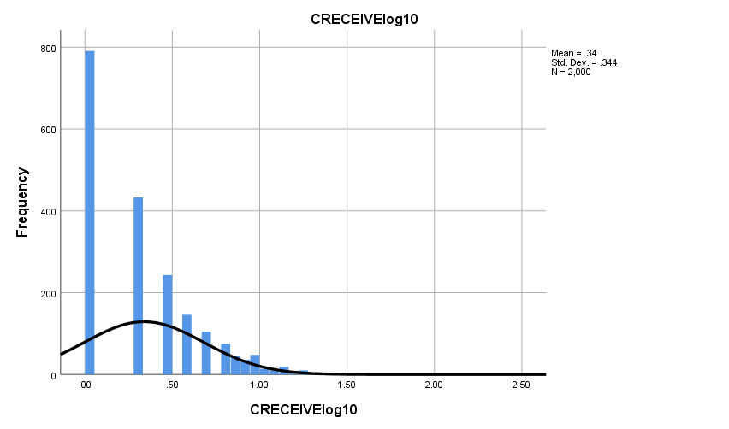

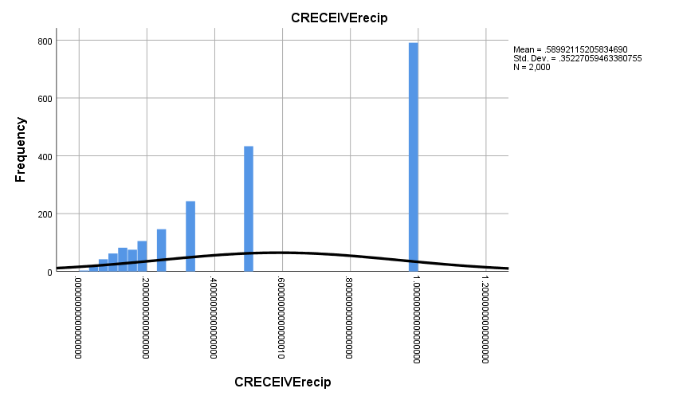

**Graph**

|  |  |  |
| --- | --- | --- |
| **Notes** | | |
| Output Created | | 28-OCT-2018 16:50:51 |
| Comments | |  |
| Input | Data | D:\SOC6100\Assignments\Assignment03\Data\DataClean\Townes_SOC6100_Assignment03_Data.sav |
| Active Dataset | DataSet1 |
| Filter | <none> |
| Weight | <none> |
| Split File | <none> |
| N of Rows in Working Data File | 2000 |
| Syntax | | GRAPH  /SCATTERPLOT(BIVAR)=CLAIMS WITH CRECEIVE  /MISSING=LISTWISE  /TITLE='Scatter Plot of CRECEIVE by CLAIMS'  /FOOTNOTE='All observations included'. |
| Resources | Processor Time | 00:00:01.69 |
| Elapsed Time | 00:00:00.88 |

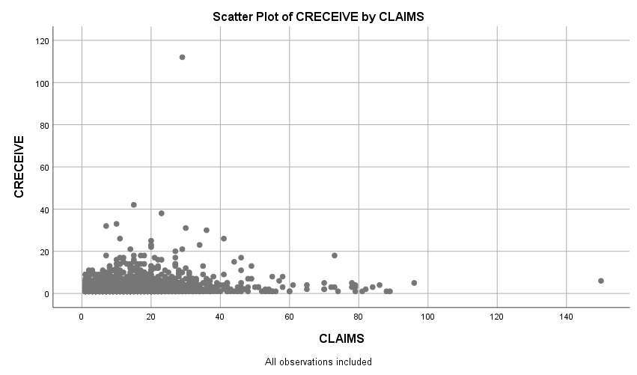

**Graph**

|  |  |  |
| --- | --- | --- |
| **Notes** | | |
| Output Created | | 28-OCT-2018 16:52:07 |
| Comments | |  |
| Input | Data | D:\SOC6100\Assignments\Assignment03\Data\DataClean\Townes_SOC6100_Assignment03_Data.sav |
| Active Dataset | DataSet1 |
| Filter | <none> |
| Weight | <none> |
| Split File | <none> |
| N of Rows in Working Data File | 2000 |
| Syntax | | GRAPH  /SCATTERPLOT(BIVAR)=CLAIMS WITH CRECEIVEln  /MISSING=LISTWISE  /TITLE='Scatter Plot of CRECEIVEln by CLAIMS'  /FOOTNOTE='All observations included'. |
| Resources | Processor Time | 00:00:00.97 |
| Elapsed Time | 00:00:00.70 |

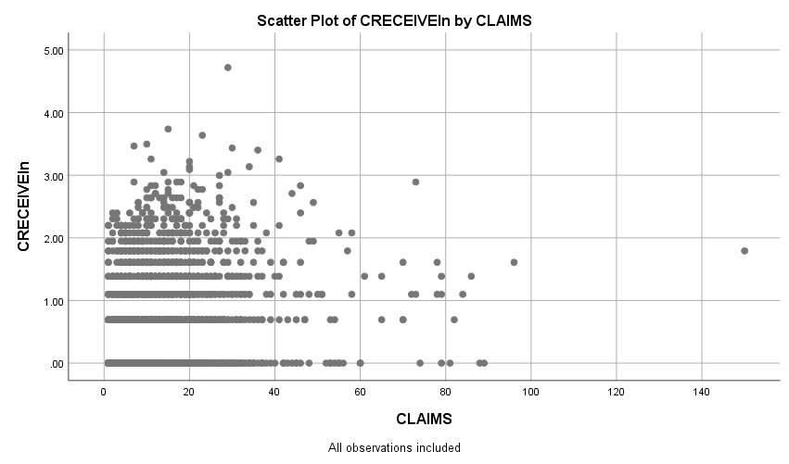

**Graph**

|  |  |  |
| --- | --- | --- |
| **Notes** | | |
| Output Created | | 28-OCT-2018 16:52:57 |
| Comments | |  |
| Input | Data | D:\SOC6100\Assignments\Assignment03\Data\DataClean\Townes_SOC6100_Assignment03_Data.sav |
| Active Dataset | DataSet1 |
| Filter | <none> |
| Weight | <none> |
| Split File | <none> |
| N of Rows in Working Data File | 2000 |
| Syntax | | GRAPH  /SCATTERPLOT(BIVAR)=CLAIMS WITH CRECEIVElog10  /MISSING=LISTWISE  /TITLE='Scatter Plot of CRECEIVElog10 by CLAIMS'  /FOOTNOTE='All observations included'. |
| Resources | Processor Time | 00:00:01.19 |
| Elapsed Time | 00:00:00.60 |

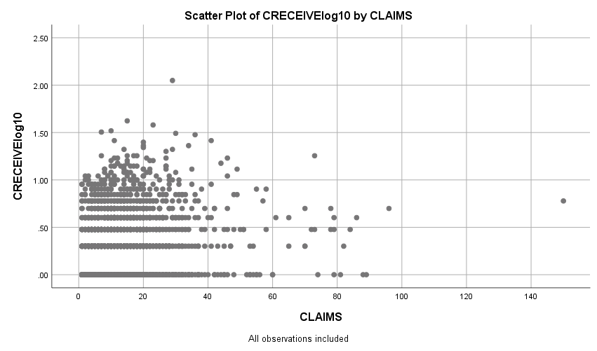

**Graph**

|  |  |  |
| --- | --- | --- |
| **Notes** | | |
| Output Created | | 28-OCT-2018 16:53:51 |
| Comments | |  |
| Input | Data | D:\SOC6100\Assignments\Assignment03\Data\DataClean\Townes_SOC6100_Assignment03_Data.sav |
| Active Dataset | DataSet1 |
| Filter | <none> |
| Weight | <none> |
| Split File | <none> |
| N of Rows in Working Data File | 2000 |
| Syntax | | GRAPH  /SCATTERPLOT(BIVAR)=CLAIMS WITH CRECEIVErecip  /MISSING=LISTWISE  /TITLE='Scatter Plot of CRECEIVErecip by CLAIMS'  /FOOTNOTE='All observations included'. |
| Resources | Processor Time | 00:00:01.11 |
| Elapsed Time | 00:00:00.59 |

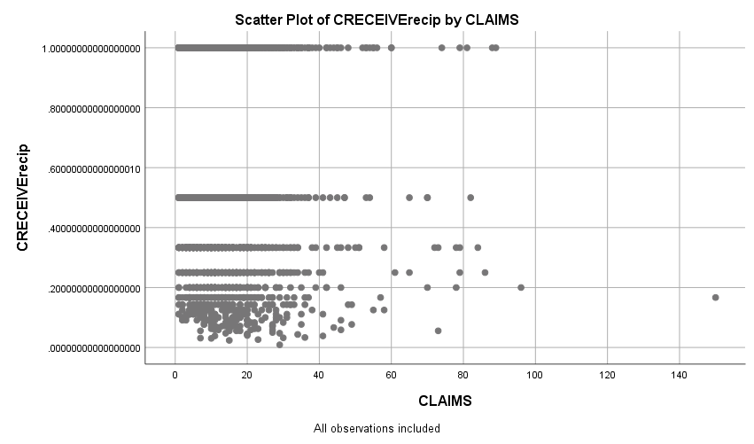

**Regression**

|  |  |  |
| --- | --- | --- |
| **Notes** | | |
| Output Created | | 28-OCT-2018 19:27:42 |
| Comments | |  |
| Input | Data | D:\SOC6100\Assignments\Assignment03\Data\DataClean\Townes_SOC6100_Assignment03_Data.sav |
| Active Dataset | DataSet1 |
| Filter | CRECEIVE < 40 AND CLAIMS < 90 (FILTER) |
| Weight | <none> |
| Split File | <none> |
| N of Rows in Working Data File | 1996 |
| Missing Value Handling | Definition of Missing | User-defined missing values are treated as missing. |
| Cases Used | Statistics are based on cases with no missing values for any variable used. |
| Syntax | | REGRESSION  /DESCRIPTIVES MEAN STDDEV CORR SIG N  /MISSING LISTWISE  /STATISTICS COEFF OUTS CI(95) BCOV R ANOVA COLLIN TOL CHANGE ZPP  /CRITERIA=PIN(.05) POUT(.10)  /NOORIGIN  /DEPENDENT GENERAL  /METHOD=ENTER ORIGINAL  /SCATTERPLOT=(*ZRESID ,*ZPRED)  /RESIDUALS DURBIN HISTOGRAM(ZRESID) NORMPROB(ZRESID)  /CASEWISE PLOT(ZRESID) OUTLIERS(3). |
| Resources | Processor Time | 00:00:08.63 |
| Elapsed Time | 00:00:04.53 |
| Memory Required | 3488 bytes |
| Additional Memory Required for Residual Plots | 680 bytes |

[DataSet1] D:\SOC6100\Assignments\Assignment03\Data\DataClean\Townes_SOC6100_Assignment03_Data.sav

|  |  |  |  |
| --- | --- | --- | --- |
| **Descriptive Statistics** | | | |
|  | Mean | Std. Deviation | N |
| GENERAL | .194597 | .2589553 | 1958 |
| ORIGINAL | .398282 | .2739932 | 1958 |

|  |  |  |  |
| --- | --- | --- | --- |
| **Correlations** | | | |
|  | | GENERAL | ORIGINAL |
| Pearson Correlation | GENERAL | 1.000 | .169 |
| ORIGINAL | .169 | 1.000 |
| Sig. (1-tailed) | GENERAL | . | .000 |
| ORIGINAL | .000 | . |
| N | GENERAL | 1958 | 1958 |
| ORIGINAL | 1958 | 1958 |

|  |  |  |  |
| --- | --- | --- | --- |
| **Variables Entered/Removeda** | | | |
| Model | Variables Entered | Variables Removed | Method |
| 1 | ORIGINALb | . | Enter |

|  |
| --- |
| a. Dependent Variable: GENERAL |
| b. All requested variables entered. |

|  |  |  |  |  |  |  |  |
| --- | --- | --- | --- | --- | --- | --- | --- |
| **Model Summaryb** | | | | | | | |
| Model | R | R Square | Adjusted R Square | Std. Error of the Estimate | Change Statistics | | |
| R Square Change | F Change | df1 |
| 1 | .169a | .029 | .028 | .2552980 | .029 | 57.473 | 1 |

|  |  |  |  |
| --- | --- | --- | --- |
| **Model Summaryb** | | | |
| Model | Change Statistics | | |
| df2 | Sig. F Change |  |
| 1 | 1956 | .000 | 2.053 |

|  |
| --- |
| a. Predictors: (Constant), ORIGINAL |
| b. Dependent Variable: GENERAL |

|  |  |  |  |  |  |  |
| --- | --- | --- | --- | --- | --- | --- |
| **ANOVAa** | | | | | | |
| Model | | Sum of Squares | df | Mean Square | F | Sig. |
| 1 | Regression | 3.746 | 1 | 3.746 | 57.473 | .000b |
| Residual | 127.486 | 1956 | .065 |  |  |
| Total | 131.232 | 1957 |  |  |  |

|  |
| --- |
| a. Dependent Variable: GENERAL |
| b. Predictors: (Constant), ORIGINAL |

|  |  |  |  |  |  |  |
| --- | --- | --- | --- | --- | --- | --- |
| **Coefficientsa** | | | | | | |
| Model | | Unstandardized Coefficients | | Standardized Coefficients | t | Sig. |
| B | Std. Error | Beta |
| 1 | (Constant) | .131 | .010 |  | 12.867 | .000 |
| ORIGINAL | .160 | .021 | .169 | 7.581 | .000 |

|  |  |  |  |  |  |  |  |
| --- | --- | --- | --- | --- | --- | --- | --- |
| **Coefficientsa** | | | | | | | |
| Model | | 95.0% Confidence Interval for B | | Correlations | | | Collinearity Statistics |
| Lower Bound | Upper Bound | Zero-order | Partial | Part | Tolerance |
| 1 | (Constant) | .111 | .151 |  |  |  |  |
| ORIGINAL | .118 | .201 | .169 | .169 | .169 | 1.000 |

|  |  |  |
| --- | --- | --- |
| **Coefficientsa** | | |
| Model | | Collinearity Statistics |
| VIF |
| 1 | (Constant) |  |
| ORIGINAL | 1.000 |

|  |
| --- |
| a. Dependent Variable: GENERAL |

|  |  |  |  |
| --- | --- | --- | --- |
| **Coefficient Correlationsa** | | | |
| Model | | | ORIGINAL |
| 1 | Correlations | ORIGINAL | 1.000 |
| Covariances | ORIGINAL | .000 |

|  |
| --- |
| a. Dependent Variable: GENERAL |

|  |  |  |  |  |  |
| --- | --- | --- | --- | --- | --- |
| **Collinearity Diagnosticsa** | | | | | |
| Model | Dimension | Eigenvalue | Condition Index | Variance Proportions | |
| (Constant) | ORIGINAL |
| 1 | 1 | 1.824 | 1.000 | .09 | .09 |
| 2 | .176 | 3.219 | .91 | .91 |

|  |
| --- |
| a. Dependent Variable: GENERAL |

|  |  |  |  |  |  |
| --- | --- | --- | --- | --- | --- |
| **Residuals Statisticsa** | | | | | |
|  | Minimum | Maximum | Mean | Std. Deviation | N |
| Predicted Value | .131001 | .273656 | .194597 | .0437504 | 1958 |
| Residual | -.2711814 | .7331990 | .0000000 | .2552328 | 1958 |
| Std. Predicted Value | -1.454 | 1.807 | .000 | 1.000 | 1958 |
| Std. Residual | -1.062 | 2.872 | .000 | 1.000 | 1958 |

|  |
| --- |
| a. Dependent Variable: GENERAL |

**Charts**

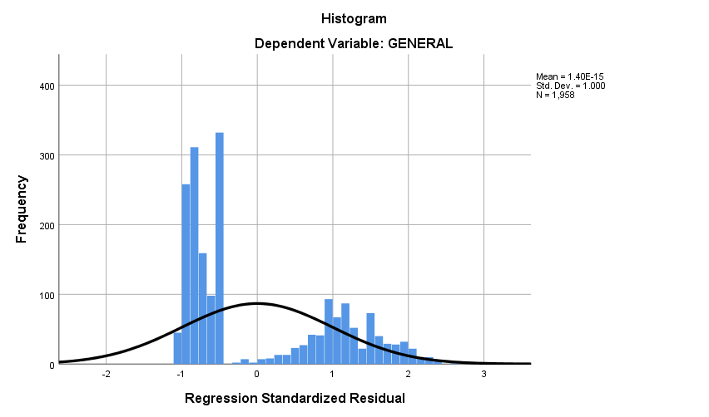

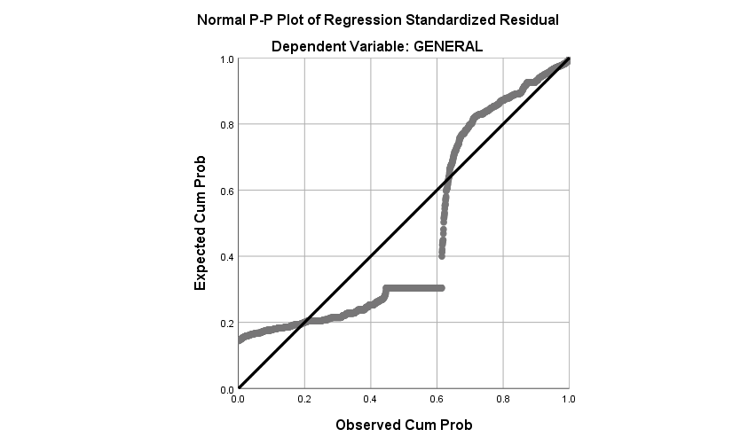

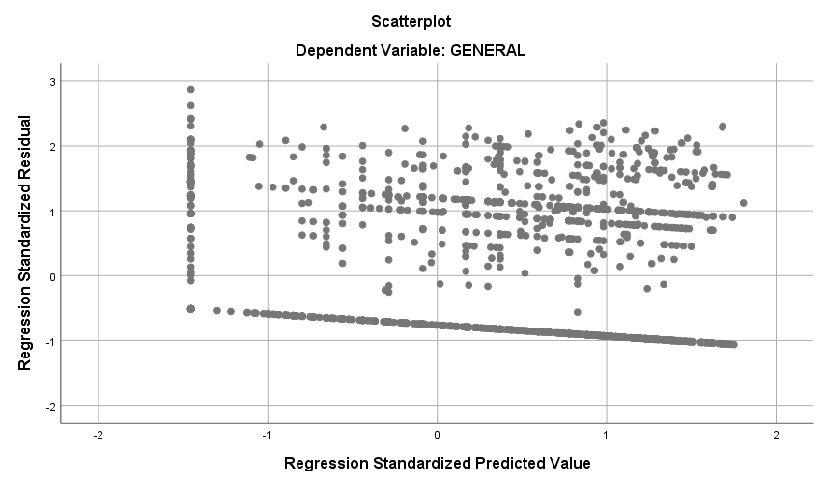

**Regression**

|  |  |  |
| --- | --- | --- |
| **Notes** | | |
| Output Created | | 28-OCT-2018 19:32:32 |
| Comments | |  |
| Input | Data | D:\SOC6100\Assignments\Assignment03\Data\DataClean\Townes_SOC6100_Assignment03_Data.sav |
| Active Dataset | DataSet1 |
| Filter | CRECEIVE < 40 AND CLAIMS < 90 (FILTER) |
| Weight | <none> |
| Split File | <none> |
| N of Rows in Working Data File | 1996 |
| Missing Value Handling | Definition of Missing | User-defined missing values are treated as missing. |
| Cases Used | Statistics are based on cases with no missing values for any variable used. |
| Syntax | | REGRESSION  /DESCRIPTIVES MEAN STDDEV CORR SIG N  /MISSING LISTWISE  /STATISTICS COEFF OUTS CI(95) BCOV R ANOVA COLLIN TOL CHANGE ZPP  /CRITERIA=PIN(.05) POUT(.10)  /NOORIGIN  /DEPENDENT CLAIMS  /METHOD=ENTER ORIGINAL GENERAL GYEAR RATIOCIT  /SCATTERPLOT=(*ZRESID ,*ZPRED)  /RESIDUALS DURBIN HISTOGRAM(ZRESID) NORMPROB(ZRESID)  /CASEWISE PLOT(ZRESID) OUTLIERS(3). |
| Resources | Processor Time | 00:00:02.46 |
| Elapsed Time | 00:00:01.57 |
| Memory Required | 5072 bytes |
| Additional Memory Required for Residual Plots | 632 bytes |

|  |  |  |  |
| --- | --- | --- | --- |
| **Descriptive Statistics** | | | |
|  | Mean | Std. Deviation | N |
| CLAIMS | 14.97 | 11.689 | 1958 |
| ORIGINAL | .398282 | .2739932 | 1958 |
| GENERAL | .194597 | .2589553 | 1958 |
| GYEAR | 1996.27 | 1.075 | 1958 |
| RATIOCIT | .939529 | .1404329 | 1958 |

|  |  |  |  |  |  |  |
| --- | --- | --- | --- | --- | --- | --- |
| **Correlations** | | | | | | |
|  | | CLAIMS | ORIGINAL | GENERAL | GYEAR | RATIOCIT |
| Pearson Correlation | CLAIMS | 1.000 | .101 | .056 | .039 | .054 |
| ORIGINAL | .101 | 1.000 | .169 | .017 | .052 |
| GENERAL | .056 | .169 | 1.000 | -.238 | .043 |
| GYEAR | .039 | .017 | -.238 | 1.000 | .083 |
| RATIOCIT | .054 | .052 | .043 | .083 | 1.000 |
| Sig. (1-tailed) | CLAIMS | . | .000 | .006 | .042 | .008 |
| ORIGINAL | .000 | . | .000 | .225 | .011 |
| GENERAL | .006 | .000 | . | .000 | .028 |
| GYEAR | .042 | .225 | .000 | . | .000 |
| RATIOCIT | .008 | .011 | .028 | .000 | . |
| N | CLAIMS | 1958 | 1958 | 1958 | 1958 | 1958 |
| ORIGINAL | 1958 | 1958 | 1958 | 1958 | 1958 |
| GENERAL | 1958 | 1958 | 1958 | 1958 | 1958 |
| GYEAR | 1958 | 1958 | 1958 | 1958 | 1958 |
| RATIOCIT | 1958 | 1958 | 1958 | 1958 | 1958 |

|  |  |  |  |
| --- | --- | --- | --- |
| **Variables Entered/Removeda** | | | |
| Model | Variables Entered | Variables Removed | Method |
| 1 | RATIOCIT, GENERAL, ORIGINAL, GYEARb | . | Enter |

|  |
| --- |
| a. Dependent Variable: CLAIMS |
| b. All requested variables entered. |

|  |  |  |  |  |  |  |  |
| --- | --- | --- | --- | --- | --- | --- | --- |
| **Model Summaryb** | | | | | | | |
| Model | R | R Square | Adjusted R Square | Std. Error of the Estimate | Change Statistics | | |
| R Square Change | F Change | df1 |
| 1 | .127a | .016 | .014 | 11.607 | .016 | 7.952 | 4 |

|  |  |  |  |
| --- | --- | --- | --- |
| **Model Summaryb** | | | |
| Model | Change Statistics | | |
| df2 | Sig. F Change |  |
| 1 | 1953 | .000 | 1.966 |

|  |
| --- |
| a. Predictors: (Constant), RATIOCIT, GENERAL, ORIGINAL, GYEAR |
| b. Dependent Variable: CLAIMS |

|  |  |  |  |  |  |  |
| --- | --- | --- | --- | --- | --- | --- |
| **ANOVAa** | | | | | | |
| Model | | Sum of Squares | df | Mean Square | F | Sig. |
| 1 | Regression | 4285.217 | 4 | 1071.304 | 7.952 | .000b |
| Residual | 263126.455 | 1953 | 134.729 |  |  |
| Total | 267411.672 | 1957 |  |  |  |

|  |
| --- |
| a. Dependent Variable: CLAIMS |
| b. Predictors: (Constant), RATIOCIT, GENERAL, ORIGINAL, GYEAR |

|  |  |  |  |  |  |  |
| --- | --- | --- | --- | --- | --- | --- |
| **Coefficientsa** | | | | | | |
| Model | | Unstandardized Coefficients | | Standardized Coefficients | t | Sig. |
| B | Std. Error | Beta |
| 1 | (Constant) | -986.372 | 504.599 |  | -1.955 | .051 |
| ORIGINAL | 3.820 | .974 | .090 | 3.921 | .000 |
| GENERAL | 2.274 | 1.062 | .050 | 2.142 | .032 |
| GYEAR | .499 | .253 | .046 | 1.973 | .049 |
| RATIOCIT | 3.608 | 1.880 | .043 | 1.919 | .055 |

|  |  |  |  |  |  |  |  |
| --- | --- | --- | --- | --- | --- | --- | --- |
| **Coefficientsa** | | | | | | | |
| Model | | 95.0% Confidence Interval for B | | Correlations | | | Collinearity Statistics |
| Lower Bound | Upper Bound | Zero-order | Partial | Part | Tolerance |
| 1 | (Constant) | -1975.981 | 3.237 |  |  |  |  |
| ORIGINAL | 1.909 | 5.730 | .101 | .088 | .088 | .966 |
| GENERAL | .192 | 4.357 | .056 | .048 | .048 | .911 |
| GYEAR | .003 | .995 | .039 | .045 | .044 | .932 |
| RATIOCIT | -.080 | 7.296 | .054 | .043 | .043 | .987 |

|  |  |  |
| --- | --- | --- |
| **Coefficientsa** | | |
| Model | | Collinearity Statistics |
| VIF |
| 1 | (Constant) |  |
| ORIGINAL | 1.035 |
| GENERAL | 1.098 |
| GYEAR | 1.073 |
| RATIOCIT | 1.013 |

|  |
| --- |
| a. Dependent Variable: CLAIMS |

|  |  |  |  |  |  |  |
| --- | --- | --- | --- | --- | --- | --- |
| **Coefficient Correlationsa** | | | | | | |
| Model | | | RATIOCIT | GENERAL | ORIGINAL | GYEAR |
| 1 | Correlations | RATIOCIT | 1.000 | -.057 | -.040 | -.094 |
| GENERAL | -.057 | 1.000 | -.175 | .248 |
| ORIGINAL | -.040 | -.175 | 1.000 | -.056 |
| GYEAR | -.094 | .248 | -.056 | 1.000 |
| Covariances | RATIOCIT | 3.536 | -.113 | -.073 | -.044 |
| GENERAL | -.113 | 1.128 | -.181 | .067 |
| ORIGINAL | -.073 | -.181 | .949 | -.014 |
| GYEAR | -.044 | .067 | -.014 | .064 |

|  |
| --- |
| a. Dependent Variable: CLAIMS |

|  |  |  |  |  |  |  |  |
| --- | --- | --- | --- | --- | --- | --- | --- |
| **Collinearity Diagnosticsa** | | | | | | | |
| Model | Dimension | Eigenvalue | Condition Index | Variance Proportions | | | |
| (Constant) | ORIGINAL | GENERAL | GYEAR |
| 1 | 1 | 4.172 | 1.000 | .00 | .01 | .02 | .00 |
| 2 | .558 | 2.734 | .00 | .00 | .91 | .00 |
| 3 | .255 | 4.048 | .00 | .98 | .01 | .00 |
| 4 | .015 | 16.893 | .00 | .00 | .00 | .00 |
| 5 | 1.351E-7 | 5557.627 | 1.00 | .00 | .06 | 1.00 |

|  |  |  |
| --- | --- | --- |
| **Collinearity Diagnosticsa** | | |
| Model | Dimension | Variance Proportions |
| RATIOCIT |
| 1 | 1 | .00 |
| 2 | .00 |
| 3 | .01 |
| 4 | .98 |
| 5 | .01 |

|  |
| --- |
| a. Dependent Variable: CLAIMS |

|  |  |  |  |  |
| --- | --- | --- | --- | --- |
| **Casewise Diagnosticsa** | | | | |
| Case Number | Std. Residual | CLAIMS | Predicted Value | Residual |
| 33 | 5.444 | 79 | 15.81 | 63.192 |
| 102 | 6.496 | 88 | 12.60 | 75.404 |
| 114 | 4.478 | 70 | 18.02 | 51.981 |
| 117 | 3.576 | 57 | 15.49 | 41.510 |
| 149 | 4.972 | 72 | 14.29 | 57.707 |
| 187 | 3.016 | 53 | 17.99 | 35.012 |
| 255 | 5.088 | 73 | 13.94 | 59.061 |
| 290 | 4.781 | 70 | 14.51 | 55.490 |
| 382 | 4.097 | 61 | 13.45 | 47.551 |
| 501 | 3.060 | 49 | 13.49 | 35.515 |
| 515 | 3.909 | 60 | 14.63 | 45.375 |
| 541 | 4.146 | 65 | 16.87 | 48.128 |
| 605 | 4.999 | 74 | 15.98 | 58.019 |
| 668 | 3.610 | 56 | 14.09 | 41.907 |
| 766 | 3.054 | 52 | 16.55 | 35.445 |
| 794 | 3.606 | 58 | 16.14 | 41.857 |
| 860 | 3.771 | 60 | 16.23 | 43.768 |
| 868 | 5.362 | 79 | 16.77 | 62.233 |
| 951 | 4.127 | 65 | 17.10 | 47.903 |
| 1010 | 3.075 | 51 | 15.30 | 35.696 |
| 1024 | 5.912 | 84 | 15.38 | 68.617 |
| 1029 | 3.382 | 54 | 14.74 | 39.258 |
| 1128 | 5.289 | 79 | 17.60 | 61.395 |
| 1160 | 5.807 | 81 | 13.59 | 67.406 |
| 1210 | 3.789 | 58 | 14.02 | 43.981 |
| 1248 | 4.772 | 73 | 17.61 | 55.390 |
| 1272 | 3.367 | 55 | 15.92 | 39.084 |
| 1336 | 3.439 | 55 | 15.08 | 39.916 |
| 1381 | 6.375 | 89 | 15.00 | 73.995 |
| 1451 | 3.266 | 51 | 13.09 | 37.905 |
| 1461 | 3.375 | 54 | 14.83 | 39.174 |
| 1480 | 5.592 | 78 | 13.09 | 64.905 |
| 1507 | 5.635 | 82 | 16.60 | 65.402 |
| 1557 | 3.104 | 53 | 16.97 | 36.029 |
| 1655 | 5.537 | 78 | 13.73 | 64.274 |
| 1671 | 3.438 | 53 | 13.09 | 39.905 |
| 1774 | 5.883 | 86 | 17.72 | 68.280 |
| 1884 | 3.488 | 55 | 14.51 | 40.492 |
| 1991 | 4.615 | 70 | 16.43 | 53.565 |

|  |
| --- |
| a. Dependent Variable: CLAIMS |

|  |  |  |  |  |  |
| --- | --- | --- | --- | --- | --- |
| **Residuals Statisticsa** | | | | | |
|  | Minimum | Maximum | Mean | Std. Deviation | N |
| Predicted Value | 9.27 | 18.51 | 14.97 | 1.480 | 1958 |
| Residual | -16.660 | 75.404 | .000 | 11.595 | 1958 |
| Std. Predicted Value | -3.858 | 2.388 | .000 | 1.000 | 1958 |
| Std. Residual | -1.435 | 6.496 | .000 | .999 | 1958 |

|  |
| --- |
| a. Dependent Variable: CLAIMS |

**Charts**

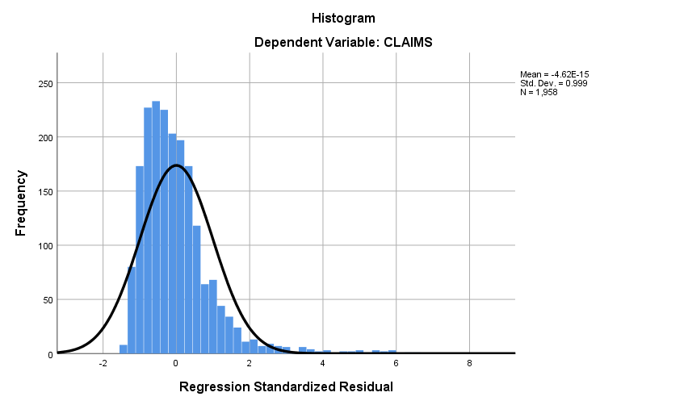

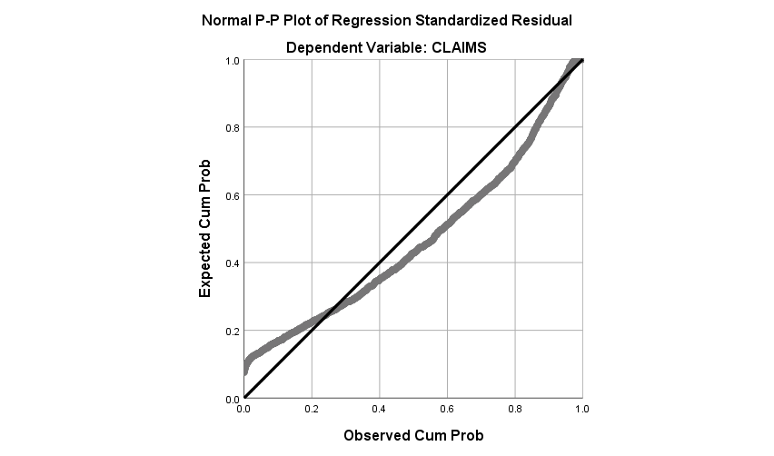

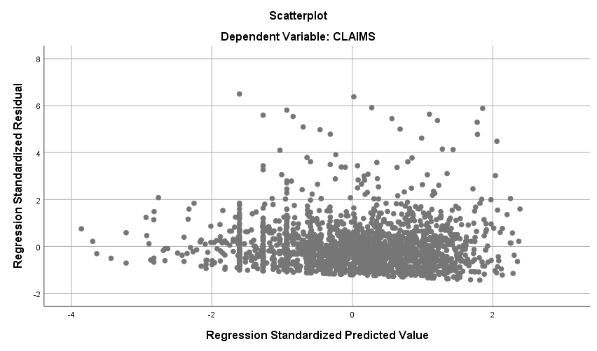

**Regression**

|  |  |  |
| --- | --- | --- |
| **Notes** | | |
| Output Created | | 28-OCT-2018 19:34:32 |
| Comments | |  |
| Input | Data | D:\SOC6100\Assignments\Assignment03\Data\DataClean\Townes_SOC6100_Assignment03_Data.sav |
| Active Dataset | DataSet1 |
| Filter | CRECEIVE < 40 AND CLAIMS < 90 (FILTER) |
| Weight | <none> |
| Split File | <none> |
| N of Rows in Working Data File | 1996 |
| Missing Value Handling | Definition of Missing | User-defined missing values are treated as missing. |
| Cases Used | Statistics are based on cases with no missing values for any variable used. |
| Syntax | | REGRESSION  /DESCRIPTIVES MEAN STDDEV CORR SIG N  /MISSING LISTWISE  /STATISTICS COEFF OUTS CI(95) BCOV R ANOVA COLLIN TOL CHANGE ZPP  /CRITERIA=PIN(.05) POUT(.10)  /NOORIGIN  /DEPENDENT CRECEIVEln  /METHOD=ENTER ORIGINAL GENERAL GYEAR RATIOCIT CLAIMS  /SCATTERPLOT=(*ZRESID ,*ZPRED)  /RESIDUALS DURBIN HISTOGRAM(ZRESID) NORMPROB(ZRESID)  /CASEWISE PLOT(ZRESID) OUTLIERS(3). |
| Resources | Processor Time | 00:00:01.95 |
| Elapsed Time | 00:00:01.54 |
| Memory Required | 5728 bytes |
| Additional Memory Required for Residual Plots | 616 bytes |

|  |  |  |  |
| --- | --- | --- | --- |
| **Descriptive Statistics** | | | |
|  | Mean | Std. Deviation | N |
| CRECEIVEln | .7773 | .78494 | 1958 |
| ORIGINAL | .398282 | .2739932 | 1958 |
| GENERAL | .194597 | .2589553 | 1958 |
| GYEAR | 1996.27 | 1.075 | 1958 |
| RATIOCIT | .939529 | .1404329 | 1958 |
| CLAIMS | 14.97 | 11.689 | 1958 |

|  |  |  |  |  |  |  |
| --- | --- | --- | --- | --- | --- | --- |
| **Correlations** | | | | | | |
|  | | CRECEIVEln | ORIGINAL | GENERAL | GYEAR | RATIOCIT |
| Pearson Correlation | CRECEIVEln | 1.000 | .019 | .612 | -.339 | .098 |
| ORIGINAL | .019 | 1.000 | .169 | .017 | .052 |
| GENERAL | .612 | .169 | 1.000 | -.238 | .043 |
| GYEAR | -.339 | .017 | -.238 | 1.000 | .083 |
| RATIOCIT | .098 | .052 | .043 | .083 | 1.000 |
| CLAIMS | .083 | .101 | .056 | .039 | .054 |
| Sig. (1-tailed) | CRECEIVEln | . | .204 | .000 | .000 | .000 |
| ORIGINAL | .204 | . | .000 | .225 | .011 |
| GENERAL | .000 | .000 | . | .000 | .028 |
| GYEAR | .000 | .225 | .000 | . | .000 |
| RATIOCIT | .000 | .011 | .028 | .000 | . |
| CLAIMS | .000 | .000 | .006 | .042 | .008 |
| N | CRECEIVEln | 1958 | 1958 | 1958 | 1958 | 1958 |
| ORIGINAL | 1958 | 1958 | 1958 | 1958 | 1958 |
| GENERAL | 1958 | 1958 | 1958 | 1958 | 1958 |
| GYEAR | 1958 | 1958 | 1958 | 1958 | 1958 |
| RATIOCIT | 1958 | 1958 | 1958 | 1958 | 1958 |
| CLAIMS | 1958 | 1958 | 1958 | 1958 | 1958 |

|  |  |  |
| --- | --- | --- |
| **Correlations** | | |
|  | | CLAIMS |
| Pearson Correlation | CRECEIVEln | .083 |
| ORIGINAL | .101 |
| GENERAL | .056 |
| GYEAR | .039 |
| RATIOCIT | .054 |
| CLAIMS | 1.000 |
| Sig. (1-tailed) | CRECEIVEln | .000 |
| ORIGINAL | .000 |
| GENERAL | .006 |
| GYEAR | .042 |
| RATIOCIT | .008 |
| CLAIMS | . |
| N | CRECEIVEln | 1958 |
| ORIGINAL | 1958 |
| GENERAL | 1958 |
| GYEAR | 1958 |
| RATIOCIT | 1958 |
| CLAIMS | 1958 |

|  |  |  |  |
| --- | --- | --- | --- |
| **Variables Entered/Removeda** | | | |
| Model | Variables Entered | Variables Removed | Method |
| 1 | CLAIMS, GYEAR, RATIOCIT, ORIGINAL, GENERALb | . | Enter |

|  |
| --- |
| a. Dependent Variable: CRECEIVEln |
| b. All requested variables entered. |

|  |  |  |  |  |  |  |  |
| --- | --- | --- | --- | --- | --- | --- | --- |
| **Model Summaryb** | | | | | | | |
| Model | R | R Square | Adjusted R Square | Std. Error of the Estimate | Change Statistics | | |
| R Square Change | F Change | df1 |
| 1 | .658a | .433 | .432 | .59178 | .433 | 298.204 | 5 |

|  |  |  |  |
| --- | --- | --- | --- |
| **Model Summaryb** | | | |
| Model | Change Statistics | | |
| df2 | Sig. F Change |  |
| 1 | 1952 | .000 | 2.008 |

|  |
| --- |
| a. Predictors: (Constant), CLAIMS, GYEAR, RATIOCIT, ORIGINAL, GENERAL |
| b. Dependent Variable: CRECEIVEln |

|  |  |  |  |  |  |  |
| --- | --- | --- | --- | --- | --- | --- |
| **ANOVAa** | | | | | | |
| Model | | Sum of Squares | df | Mean Square | F | Sig. |
| 1 | Regression | 522.161 | 5 | 104.432 | 298.204 | .000b |
| Residual | 683.599 | 1952 | .350 |  |  |
| Total | 1205.759 | 1957 |  |  |  |

|  |
| --- |
| a. Dependent Variable: CRECEIVEln |
| b. Predictors: (Constant), CLAIMS, GYEAR, RATIOCIT, ORIGINAL, GENERAL |

|  |  |  |  |  |  |  |
| --- | --- | --- | --- | --- | --- | --- |
| **Coefficientsa** | | | | | | |
| Model | | Unstandardized Coefficients | | Standardized Coefficients | t | Sig. |
| B | Std. Error | Beta |
| 1 | (Constant) | 310.279 | 25.751 |  | 12.049 | .000 |
| ORIGINAL | -.243 | .050 | -.085 | -4.874 | .000 |
| GENERAL | 1.723 | .054 | .569 | 31.794 | .000 |
| GYEAR | -.155 | .013 | -.213 | -12.046 | .000 |
| RATIOCIT | .516 | .096 | .092 | 5.382 | .000 |
| CLAIMS | .004 | .001 | .063 | 3.650 | .000 |

|  |  |  |  |  |  |  |  |
| --- | --- | --- | --- | --- | --- | --- | --- |
| **Coefficientsa** | | | | | | | |
| Model | | 95.0% Confidence Interval for B | | Correlations | | | Collinearity Statistics |
| Lower Bound | Upper Bound | Zero-order | Partial | Part | Tolerance |
| 1 | (Constant) | 259.776 | 360.782 |  |  |  |  |
| ORIGINAL | -.341 | -.145 | .019 | -.110 | -.083 | .959 |
| GENERAL | 1.617 | 1.830 | .612 | .584 | .542 | .908 |
| GYEAR | -.181 | -.130 | -.339 | -.263 | -.205 | .930 |
| RATIOCIT | .328 | .705 | .098 | .121 | .092 | .986 |
| CLAIMS | .002 | .006 | .083 | .082 | .062 | .984 |

|  |  |  |
| --- | --- | --- |
| **Coefficientsa** | | |
| Model | | Collinearity Statistics |
| VIF |
| 1 | (Constant) |  |
| ORIGINAL | 1.043 |
| GENERAL | 1.101 |
| GYEAR | 1.075 |
| RATIOCIT | 1.015 |
| CLAIMS | 1.016 |

|  |
| --- |
| a. Dependent Variable: CRECEIVEln |

|  |  |  |  |  |  |  |  |
| --- | --- | --- | --- | --- | --- | --- | --- |
| **Coefficient Correlationsa** | | | | | | | |
| Model | | | CLAIMS | GYEAR | RATIOCIT | ORIGINAL | GENERAL |
| 1 | Correlations | CLAIMS | 1.000 | -.045 | -.043 | -.088 | -.048 |
| GYEAR | -.045 | 1.000 | -.091 | -.052 | .250 |
| RATIOCIT | -.043 | -.091 | 1.000 | -.036 | -.055 |
| ORIGINAL | -.088 | -.052 | -.036 | 1.000 | -.170 |
| GENERAL | -.048 | .250 | -.055 | -.170 | 1.000 |
| Covariances | CLAIMS | 1.331E-6 | -6.640E-7 | -4.802E-6 | -5.084E-6 | -3.027E-6 |
| GYEAR | -6.640E-7 | .000 | .000 | -3.315E-5 | .000 |
| RATIOCIT | -4.802E-6 | .000 | .009 | .000 | .000 |
| ORIGINAL | -5.084E-6 | -3.315E-5 | .000 | .002 | .000 |
| GENERAL | -3.027E-6 | .000 | .000 | .000 | .003 |

|  |
| --- |
| a. Dependent Variable: CRECEIVEln |

|  |  |  |  |  |  |  |  |
| --- | --- | --- | --- | --- | --- | --- | --- |
| **Collinearity Diagnosticsa** | | | | | | | |
| Model | Dimension | Eigenvalue | Condition Index | Variance Proportions | | | |
| (Constant) | ORIGINAL | GENERAL | GYEAR |
| 1 | 1 | 4.843 | 1.000 | .00 | .01 | .01 | .00 |
| 2 | .574 | 2.905 | .00 | .00 | .89 | .00 |
| 3 | .321 | 3.886 | .00 | .18 | .03 | .00 |
| 4 | .248 | 4.415 | .00 | .80 | .01 | .00 |
| 5 | .015 | 18.199 | .00 | .00 | .00 | .00 |
| 6 | 1.348E-7 | 5993.179 | 1.00 | .00 | .06 | 1.00 |

|  |  |  |  |
| --- | --- | --- | --- |
| **Collinearity Diagnosticsa** | | | |
| Model | Dimension | Variance Proportions | |
| RATIOCIT | CLAIMS |
| 1 | 1 | .00 | .01 |
| 2 | .00 | .03 |
| 3 | .00 | .85 |
| 4 | .01 | .10 |
| 5 | .98 | .00 |
| 6 | .01 | .00 |

|  |
| --- |
| a. Dependent Variable: CRECEIVEln |

|  |  |  |  |  |
| --- | --- | --- | --- | --- |
| **Casewise Diagnosticsa** | | | | |
| Case Number | Std. Residual | CRECEIVEln | Predicted Value | Residual |
| 159 | 3.367 | 2.20 | .2046 | 1.99260 |
| 198 | 3.034 | 2.48 | .6894 | 1.79550 |
| 243 | 3.559 | 3.14 | 1.0295 | 2.10601 |
| 269 | 3.441 | 2.64 | .6028 | 2.03628 |
| 446 | 3.513 | 3.22 | 1.1397 | 2.07915 |
| 457 | 4.068 | 3.43 | 1.0264 | 2.40757 |
| 776 | 3.046 | 2.71 | .9052 | 1.80282 |
| 832 | 3.199 | 2.64 | .7461 | 1.89295 |
| 859 | 3.632 | 2.56 | .4157 | 2.14925 |
| 879 | 3.013 | 3.26 | 1.4748 | 1.78326 |
| 1058 | 3.130 | 1.95 | .0934 | 1.85254 |
| 1063 | 4.125 | 3.64 | 1.1964 | 2.44122 |
| 1116 | 3.895 | 3.09 | .7859 | 2.30512 |
| 1220 | 3.375 | 3.50 | 1.4990 | 1.99752 |
| 1347 | 3.126 | 2.83 | .9832 | 1.85002 |
| 1379 | 3.251 | 2.48 | .5613 | 1.92362 |
| 1680 | 3.815 | 3.26 | 1.0002 | 2.25791 |
| 1744 | 3.179 | 2.77 | .8914 | 1.88122 |

|  |
| --- |
| a. Dependent Variable: CRECEIVEln |

|  |  |  |  |  |  |
| --- | --- | --- | --- | --- | --- |
| **Residuals Statisticsa** | | | | | |
|  | Minimum | Maximum | Mean | Std. Deviation | N |
| Predicted Value | -.1505 | 2.1346 | .7773 | .51654 | 1958 |
| Residual | -1.07455 | 2.44122 | .00000 | .59102 | 1958 |
| Std. Predicted Value | -1.796 | 2.628 | .000 | 1.000 | 1958 |
| Std. Residual | -1.816 | 4.125 | .000 | .999 | 1958 |

|  |
| --- |
| a. Dependent Variable: CRECEIVEln |

**Charts**

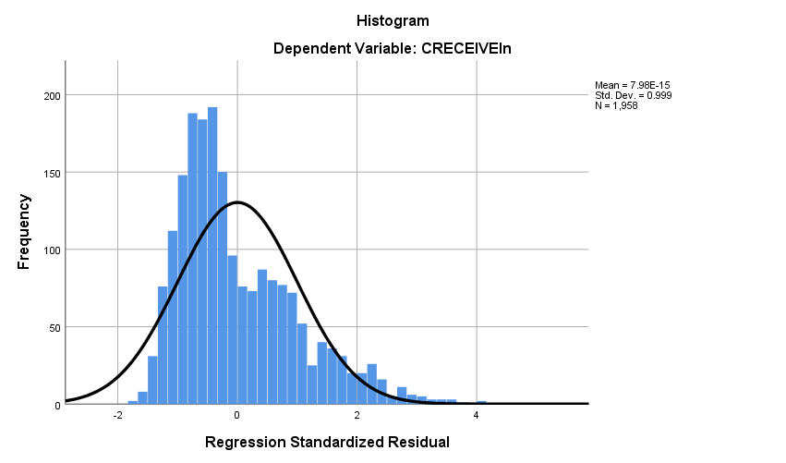

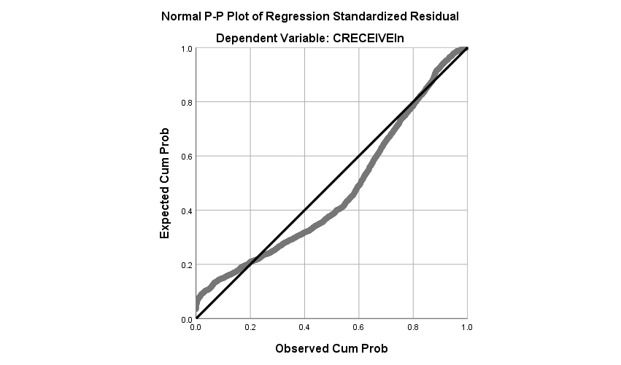

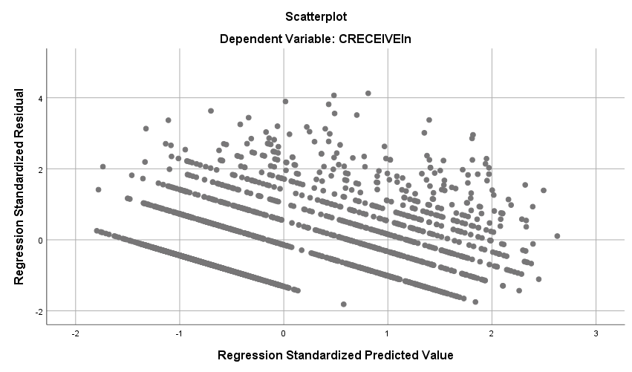

**Regression**

|  |  |  |
| --- | --- | --- |
| **Notes** | | |
| Output Created | | 30-OCT-2018 18:57:59 |
| Comments | |  |
| Input | Data | D:\SOC6100\Assignments\Assignment03\Data\DataClean\Townes_SOC6100_Assignment03_Data.sav |
| Active Dataset | DataSet1 |
| Filter | CRECEIVE<40 AND CLAIMS<90 (FILTER) |
| Weight | <none> |
| Split File | <none> |
| N of Rows in Working Data File | 1996 |
| Missing Value Handling | Definition of Missing | User-defined missing values are treated as missing. |
| Cases Used | Statistics are based on cases with no missing values for any variable used. |
| Syntax | | REGRESSION  /DESCRIPTIVES MEAN STDDEV CORR SIG N  /MISSING LISTWISE  /STATISTICS COEFF OUTS CI(95) BCOV R ANOVA COLLIN TOL CHANGE ZPP  /CRITERIA=PIN(.05) POUT(.10)  /NOORIGIN  /DEPENDENT CLAIMS  /METHOD=ENTER GENERAL GYEAR ORIGINAL  /SCATTERPLOT=(*ZRESID ,*ZPRED)  /RESIDUALS DURBIN HISTOGRAM(ZRESID) NORMPROB(ZRESID)  /CASEWISE PLOT(ZRESID) OUTLIERS(3). |
| Resources | Processor Time | 00:00:04.10 |
| Elapsed Time | 00:00:01.87 |
| Memory Required | 4480 bytes |
| Additional Memory Required for Residual Plots | 648 bytes |

|  |  |  |  |
| --- | --- | --- | --- |
| **Descriptive Statistics** | | | |
|  | Mean | Std. Deviation | N |
| CLAIMS | 14.97 | 11.689 | 1958 |
| GENERAL | .194597 | .2589553 | 1958 |
| GYEAR | 1996.27 | 1.075 | 1958 |
| ORIGINAL | .398282 | .2739932 | 1958 |

|  |  |  |  |  |  |
| --- | --- | --- | --- | --- | --- |
| **Correlations** | | | | | |
|  | | CLAIMS | GENERAL | GYEAR | ORIGINAL |
| Pearson Correlation | CLAIMS | 1.000 | .056 | .039 | .101 |
| GENERAL | .056 | 1.000 | -.238 | .169 |
| GYEAR | .039 | -.238 | 1.000 | .017 |
| ORIGINAL | .101 | .169 | .017 | 1.000 |
| Sig. (1-tailed) | CLAIMS | . | .006 | .042 | .000 |
| GENERAL | .006 | . | .000 | .000 |
| GYEAR | .042 | .000 | . | .225 |
| ORIGINAL | .000 | .000 | .225 | . |
| N | CLAIMS | 1958 | 1958 | 1958 | 1958 |
| GENERAL | 1958 | 1958 | 1958 | 1958 |
| GYEAR | 1958 | 1958 | 1958 | 1958 |
| ORIGINAL | 1958 | 1958 | 1958 | 1958 |

|  |  |  |  |
| --- | --- | --- | --- |
| **Variables Entered/Removeda** | | | |
| Model | Variables Entered | Variables Removed | Method |
| 1 | ORIGINAL, GYEAR, GENERALb | . | Enter |

|  |
| --- |
| a. Dependent Variable: CLAIMS |
| b. All requested variables entered. |

|  |  |  |  |  |  |  |  |
| --- | --- | --- | --- | --- | --- | --- | --- |
| **Model Summaryb** | | | | | | | |
| Model | R | R Square | Adjusted R Square | Std. Error of the Estimate | Change Statistics | | |
| R Square Change | F Change | df1 |
| 1 | .119a | .014 | .013 | 11.615 | .014 | 9.362 | 3 |

|  |  |  |  |
| --- | --- | --- | --- |
| **Model Summaryb** | | | |
| Model | Change Statistics | | |
| df2 | Sig. F Change |  |
| 1 | 1954 | .000 | 1.963 |

|  |
| --- |
| a. Predictors: (Constant), ORIGINAL, GYEAR, GENERAL |
| b. Dependent Variable: CLAIMS |

|  |  |  |  |  |  |  |
| --- | --- | --- | --- | --- | --- | --- |
| **ANOVAa** | | | | | | |
| Model | | Sum of Squares | df | Mean Square | F | Sig. |
| 1 | Regression | 3789.155 | 3 | 1263.052 | 9.362 | .000b |
| Residual | 263622.516 | 1954 | 134.914 |  |  |
| Total | 267411.672 | 1957 |  |  |  |

|  |
| --- |
| a. Dependent Variable: CLAIMS |
| b. Predictors: (Constant), ORIGINAL, GYEAR, GENERAL |

|  |  |  |  |  |  |  |
| --- | --- | --- | --- | --- | --- | --- |
| **Coefficientsa** | | | | | | |
| Model | | Unstandardized Coefficients | | Standardized Coefficients | t | Sig. |
| B | Std. Error | Beta |
| 1 | (Constant) | -1073.630 | 502.890 |  | -2.135 | .033 |
| GENERAL | 2.390 | 1.061 | .053 | 2.253 | .024 |
| GYEAR | .544 | .252 | .050 | 2.161 | .031 |
| ORIGINAL | 3.894 | .974 | .091 | 3.998 | .000 |

|  |  |  |  |  |  |  |  |
| --- | --- | --- | --- | --- | --- | --- | --- |
| **Coefficientsa** | | | | | | | |
| Model | | 95.0% Confidence Interval for B | | Correlations | | | Collinearity Statistics |
| Lower Bound | Upper Bound | Zero-order | Partial | Part | Tolerance |
| 1 | (Constant) | -2059.888 | -87.372 |  |  |  |  |
| GENERAL | .310 | 4.471 | .056 | .051 | .051 | .913 |
| GYEAR | .050 | 1.038 | .039 | .049 | .049 | .940 |
| ORIGINAL | 1.984 | 5.805 | .101 | .090 | .090 | .968 |

|  |  |  |
| --- | --- | --- |
| **Coefficientsa** | | |
| Model | | Collinearity Statistics |
| VIF |
| 1 | (Constant) |  |
| GENERAL | 1.095 |
| GYEAR | 1.064 |
| ORIGINAL | 1.033 |

|  |
| --- |
| a. Dependent Variable: CLAIMS |

|  |  |  |  |  |  |
| --- | --- | --- | --- | --- | --- |
| **Coefficient Correlationsa** | | | | | |
| Model | | | ORIGINAL | GYEAR | GENERAL |
| 1 | Correlations | ORIGINAL | 1.000 | -.060 | -.178 |
| GYEAR | -.060 | 1.000 | .244 |
| GENERAL | -.178 | .244 | 1.000 |
| Covariances | ORIGINAL | .949 | -.015 | -.184 |
| GYEAR | -.015 | .063 | .065 |
| GENERAL | -.184 | .065 | 1.125 |

|  |
| --- |
| a. Dependent Variable: CLAIMS |

|  |  |  |  |  |  |  |  |
| --- | --- | --- | --- | --- | --- | --- | --- |
| **Collinearity Diagnosticsa** | | | | | | | |
| Model | Dimension | Eigenvalue | Condition Index | Variance Proportions | | | |
| (Constant) | GENERAL | GYEAR | ORIGINAL |
| 1 | 1 | 3.237 | 1.000 | .00 | .03 | .00 | .02 |
| 2 | .531 | 2.468 | .00 | .91 | .00 | .02 |
| 3 | .232 | 3.737 | .00 | .00 | .00 | .95 |
| 4 | 1.362E-7 | 4874.267 | 1.00 | .06 | 1.00 | .00 |

|  |
| --- |
| a. Dependent Variable: CLAIMS |

|  |  |  |  |  |
| --- | --- | --- | --- | --- |
| **Casewise Diagnosticsa** | | | | |
| Case Number | Std. Residual | CLAIMS | Predicted Value | Residual |
| 33 | 5.454 | 79 | 15.65 | 63.351 |
| 102 | 6.520 | 88 | 12.27 | 75.732 |
| 114 | 4.485 | 70 | 17.90 | 52.096 |
| 117 | 3.466 | 57 | 16.75 | 40.253 |
| 149 | 4.994 | 72 | 14.00 | 58.002 |
| 187 | 3.021 | 53 | 17.91 | 35.092 |
| 255 | 4.983 | 73 | 15.12 | 57.880 |
| 290 | 4.797 | 70 | 14.28 | 55.722 |
| 382 | 4.118 | 61 | 13.16 | 47.836 |
| 501 | 3.081 | 49 | 13.21 | 35.789 |
| 515 | 3.931 | 60 | 14.34 | 45.663 |
| 541 | 4.158 | 65 | 16.70 | 48.301 |
| 605 | 5.011 | 74 | 15.79 | 58.210 |
| 668 | 3.624 | 56 | 13.90 | 42.099 |
| 766 | 3.064 | 52 | 16.41 | 35.589 |
| 794 | 3.617 | 58 | 15.99 | 42.008 |
| 860 | 3.781 | 60 | 16.08 | 43.918 |
| 868 | 5.375 | 79 | 16.57 | 62.434 |
| 951 | 4.136 | 65 | 16.96 | 48.045 |
| 1010 | 3.094 | 51 | 15.06 | 35.939 |
| 1024 | 5.913 | 84 | 15.32 | 68.684 |
| 1029 | 3.404 | 54 | 14.46 | 39.544 |
| 1128 | 5.297 | 79 | 17.48 | 61.522 |
| 1160 | 5.824 | 81 | 13.36 | 67.644 |
| 1210 | 3.807 | 58 | 13.78 | 44.217 |
| 1248 | 4.764 | 73 | 17.67 | 55.331 |
| 1272 | 3.374 | 55 | 15.81 | 39.186 |
| 1336 | 3.457 | 55 | 14.84 | 40.160 |
| 1381 | 6.392 | 89 | 14.76 | 74.241 |
| 1451 | 3.288 | 51 | 12.81 | 38.188 |
| 1461 | 3.367 | 54 | 14.89 | 39.106 |
| 1480 | 5.612 | 78 | 12.81 | 65.188 |
| 1507 | 5.649 | 82 | 16.38 | 65.616 |
| 1557 | 3.114 | 53 | 16.84 | 36.165 |
| 1655 | 5.557 | 78 | 13.46 | 64.544 |
| 1671 | 3.460 | 53 | 12.81 | 40.188 |
| 1774 | 5.887 | 86 | 17.63 | 68.374 |
| 1884 | 3.418 | 55 | 15.30 | 39.696 |
| 1991 | 4.627 | 70 | 16.25 | 53.747 |
| 1994 | 3.018 | 50 | 14.95 | 35.055 |

|  |
| --- |
| a. Dependent Variable: CLAIMS |

|  |  |  |  |  |  |
| --- | --- | --- | --- | --- | --- |
| **Residuals Statisticsa** | | | | | |
|  | Minimum | Maximum | Mean | Std. Deviation | N |
| Predicted Value | 12.27 | 18.45 | 14.97 | 1.391 | 1958 |
| Residual | -16.534 | 75.732 | .000 | 11.606 | 1958 |
| Std. Predicted Value | -1.945 | 2.498 | .000 | 1.000 | 1958 |
| Std. Residual | -1.423 | 6.520 | .000 | .999 | 1958 |

|  |
| --- |
| a. Dependent Variable: CLAIMS |

**Charts**

