Frequencies

Notes
Output Created |  | 20-SEP-2018 10:36:53
Comments
Input | Data | D:\SOC6100\Assignments\Assignment01\Results\Results1995to1999\Townes_SOC6100_Assignment01_Data_Sample.sav
Input | Active Dataset | DataSet1
Input | Filter | <none>
Input | Weight | <none>
Input | Split File | <none>
Input | N of Rows in Working Data File | 2000
Missing Value Handling | Definition of Missing | User-defined missing values are treated as missing.
Missing Value Handling | Cases Used | Statistics are based on all cases with valid data.
Syntax |  | FREQUENCIES VARIABLES=CRECEIVE  /STATISTICS=STDDEV VARIANCE RANGE MINIMUM MAXIMUM SEMEAN MEAN MEDIAN MODE SKEWNESS SESKEW  KURTOSIS SEKURT  /HISTOGRAM NORMAL  /ORDER=ANALYSIS.
Resources | Processor Time | 00:00:03.32
Resources | Elapsed Time | 00:00:01.47

[DataSet1] D:\SOC6100\Assignments\Assignment01\Results\Results1995to1999\Townes_SOC6100_Assignment01_Data_Sample.sav

Statistics
CRECEIVE
N | Valid | 2000
N | Missing | 0
Mean |  | 3.18
Std. Error of Mean |  | .096
Median |  | 2.00
Mode |  | 1
Std. Deviation |  | 4.309
Variance |  | 18.567
Skewness |  | 10.292
Std. Error of Skewness |  | .055
Kurtosis |  | 214.022
Std. Error of Kurtosis |  | .109
Range |  | 111
Minimum |  | 1
Maximum |  | 112

CRECEIVE
 |  | Frequency | Percent | Valid Percent | Cumulative Percent
Valid | 1 | 791 | 39.6 | 39.6 | 39.6
Valid | 2 | 433 | 21.7 | 21.7 | 61.2
Valid | 3 | 243 | 12.2 | 12.2 | 73.4
Valid | 4 | 146 | 7.3 | 7.3 | 80.7
Valid | 5 | 105 | 5.3 | 5.3 | 85.9
Valid | 6 | 75 | 3.8 | 3.8 | 89.6
Valid | 7 | 46 | 2.3 | 2.3 | 92.0
Valid | 8 | 36 | 1.8 | 1.8 | 93.8
Valid | 9 | 26 | 1.3 | 1.3 | 95.1
Valid | 10 | 22 | 1.1 | 1.1 | 96.2
Valid | 11 | 14 | .7 | .7 | 96.9
Valid | 12 | 10 | .5 | .5 | 97.4
Valid | 13 | 9 | .4 | .4 | 97.8
Valid | 14 | 10 | .5 | .5 | 98.3
Valid | 15 | 4 | .2 | .2 | 98.5
Valid | 16 | 4 | .2 | .2 | 98.7
Valid | 17 | 5 | .3 | .3 | 99.0
Valid | 18 | 5 | .3 | .3 | 99.2
Valid | 20 | 1 | .1 | .1 | 99.3
Valid | 21 | 2 | .1 | .1 | 99.4
Valid | 22 | 1 | .1 | .1 | 99.4
Valid | 23 | 2 | .1 | .1 | 99.5
Valid | 25 | 1 | .1 | .1 | 99.6
Valid | 26 | 2 | .1 | .1 | 99.7
Valid | 30 | 1 | .1 | .1 | 99.7
Valid | 31 | 1 | .1 | .1 | 99.8
Valid | 32 | 1 | .1 | .1 | 99.8
Valid | 33 | 1 | .1 | .1 | 99.9
Valid | 38 | 1 | .1 | .1 | 99.9
Valid | 42 | 1 | .1 | .1 | 100.0
Valid | 112 | 1 | .1 | .1 | 100.0
Valid | Total | 2000 | 100.0 | 100.0

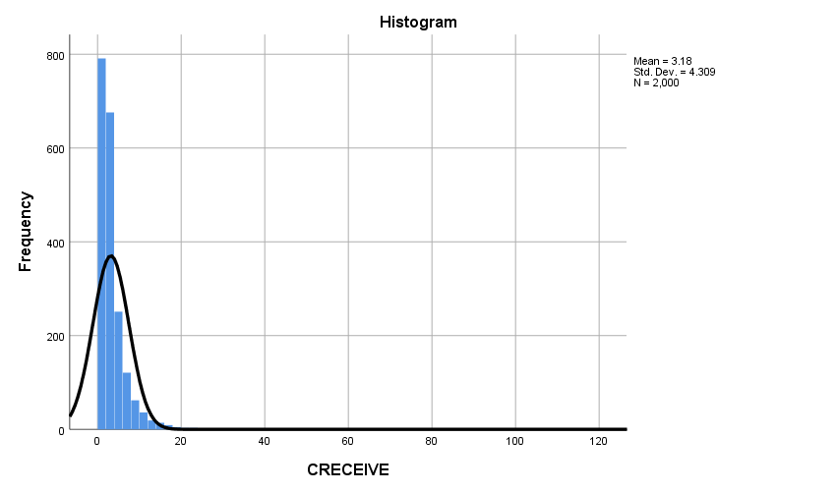

GGraph

Notes
Output Created |  | 20-SEP-2018 10:39:40
Comments
Input | Data | D:\SOC6100\Assignments\Assignment01\Results\Results1995to1999\Townes_SOC6100_Assignment01_Data_Sample.sav
Input | Active Dataset | DataSet1
Input | Filter | <none>
Input | Weight | <none>
Input | Split File | <none>
Input | N of Rows in Working Data File | 2000
Syntax |  | GGRAPH  /GRAPHDATASET NAME="graphdataset" VARIABLES=CLAIMS CRECEIVE MISSING=LISTWISE REPORTMISSING=NO  /GRAPHSPEC SOURCE=INLINE  /FITLINE TOTAL=NO.  BEGIN GPL  SOURCE: s=userSource(id("graphdataset"))  DATA: CLAIMS=col(source(s), name("CLAIMS"))  DATA: CRECEIVE=col(source(s), name("CRECEIVE"))  GUIDE: axis(dim(1), label("CLAIMS"))  GUIDE: axis(dim(2), label("CRECEIVE"))  GUIDE: text.title(label("Simple Scatter of CRECEIVE by CLAIMS"))  ELEMENT: point(position(CLAIMS*CRECEIVE))  END GPL.
Resources | Processor Time | 00:00:00.87
Resources | Elapsed Time | 00:00:00.45

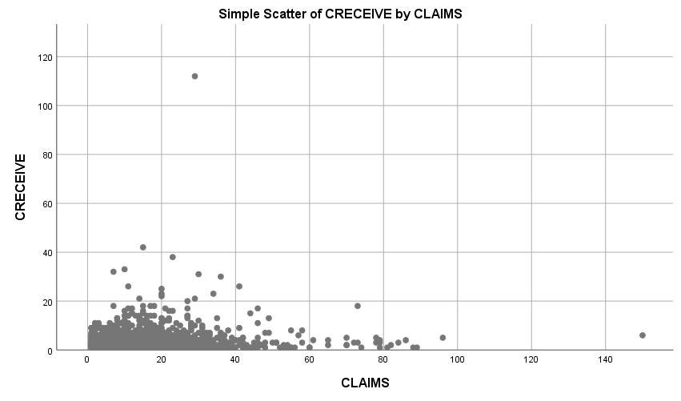

Regression

Notes
Output Created |  | 19-SEP-2018 20:40:56
Comments
Input | Data | D:\SOC6100\Assignments\Assignment01\Results\Results1995to1999\Townes_SOC6100_Assignment01_Data_Sample.sav
Input | Active Dataset | DataSet1
Input | Filter | <none>
Input | Weight | <none>
Input | Split File | <none>
Input | N of Rows in Working Data File | 2000
Missing Value Handling | Definition of Missing | User-defined missing values are treated as missing.
Missing Value Handling | Cases Used | Statistics are based on cases with no missing values for any variable used.
Syntax |  | REGRESSION  /MISSING LISTWISE  /STATISTICS COEFF OUTS CI(95) BCOV R ANOVA COLLIN TOL CHANGE ZPP  /CRITERIA=PIN(.05) POUT(.10)  /NOORIGIN  /DEPENDENT CRECEIVE  /METHOD=ENTER APPYEAR BCKGTLAG CLAIMS FWDAPLAG GENERAL GYEAR ORIGINAL SECDLWBD SECDUPBD SELFCTLB  SELFCTUB  /RESIDUALS DURBIN  /CASEWISE PLOT(ZRESID) OUTLIERS(3).
Resources | Processor Time | 00:00:00.02
Resources | Elapsed Time | 00:00:00.01
Resources | Memory Required | 10800 bytes
Resources | Additional Memory Required for Residual Plots | 0 bytes

Variables Entered/Removedª
Model | Variables Entered | Variables Removed | Method
1 | SELFCTUB, CLAIMS, GYEAR, ORIGINAL, BCKGTLAG, SECDUPBD, GENERAL, FWDAPLAG, APPYEAR, SELFCTLB, SECDLWBD^{b} | . | Enter

a. Dependent Variable: CRECEIVE
b. All requested variables entered.

Model Summary^{b}
Model | R | R Square | Adjusted R Square | Std. Error of the Estimate | Change Statistics
 |  |  |  |  | R Square Change | F Change | df1
1 | .443ª | .196 | .191 | 4.098 | .196 | 36.647 | 11

Model Summary^{b}
Model | Change Statistics
Model | df2 | Sig. F Change
1 | 1655 | .000 | 1.970

a. Predictors: (Constant), SELFCTUB, CLAIMS, GYEAR, ORIGINAL, BCKGTLAG, SECDUPBD, GENERAL, FWDAPLAG, APPYEAR, SELFCTLB, SECDLWBD
b. Dependent Variable: CRECEIVE

ANOVAª
Model |  | Sum of Squares | df | Mean Square | F | Sig.
1 | Regression | 6769.213 | 11 | 615.383 | 36.647 | .000^{b}
1 | Residual | 27790.817 | 1655 | 16.792
1 | Total | 34560.030 | 1666

a. Dependent Variable: CRECEIVE
b. Predictors: (Constant), SELFCTUB, CLAIMS, GYEAR, ORIGINAL, BCKGTLAG, SECDUPBD, GENERAL, FWDAPLAG, APPYEAR, SELFCTLB, SECDLWBD

Coefficientsª
Model |  | Unstandardized Coefficients |  | Standardized Coefficients | t | Sig.
 |  | B | Std. Error | Beta | t | Sig.
1 | (Constant) | 1509.628 | 254.147 |  | 5.940 | .000
1 | APPYEAR | -.281 | .167 | -.078 | -1.683 | .092
1 | BCKGTLAG | -.064 | .013 | -.114 | -4.805 | .000
1 | CLAIMS | .027 | .008 | .074 | 3.319 | .001
1 | FWDAPLAG | -.034 | .141 | -.008 | -.244 | .807
1 | GENERAL | 5.826 | .408 | .336 | 14.264 | .000
1 | GYEAR | -.474 | .147 | -.112 | -3.232 | .001
1 | ORIGINAL | -1.001 | .374 | -.061 | -2.676 | .008
1 | SECDLWBD | -3.184 | 2.330 | -.234 | -1.367 | .172
1 | SECDUPBD | 3.049 | 2.274 | .229 | 1.341 | .180
1 | SELFCTLB | -1.653 | 2.138 | -.078 | -.773 | .440
1 | SELFCTUB | 1.188 | 1.968 | .060 | .604 | .546

Coefficientsª
Model |  | 95.0% Confidence Interval for B |  | Correlations |  |  | Collinearity Statistics
 |  | Lower Bound | Upper Bound | Zero-order | Partial | Part | Tolerance
1 | (Constant) | 1011.146 | 2008.111
1 | APPYEAR | -.608 | .046 | -.239 | -.041 | -.037 | .226
1 | BCKGTLAG | -.091 | -.038 | -.124 | -.117 | -.106 | .865
1 | CLAIMS | .011 | .043 | .090 | .081 | .073 | .976
1 | FWDAPLAG | -.311 | .242 | .143 | -.006 | -.005 | .409
1 | GENERAL | 5.024 | 6.627 | .385 | .331 | .314 | .877
1 | GYEAR | -.762 | -.187 | -.243 | -.079 | -.071 | .406
1 | ORIGINAL | -1.735 | -.267 | .007 | -.066 | -.059 | .938
1 | SECDLWBD | -7.753 | 1.385 | -.039 | -.034 | -.030 | .017
1 | SECDUPBD | -1.411 | 7.509 | -.033 | .033 | .030 | .017
1 | SELFCTLB | -5.847 | 2.541 | -.007 | -.019 | -.017 | .048
1 | SELFCTUB | -2.672 | 5.047 | -.010 | .015 | .013 | .049

Coefficientsª
Model |  | Collinearity Statistics
 |  | VIF
1 | (Constant)
1 | APPYEAR | 4.417
1 | BCKGTLAG | 1.157
1 | CLAIMS | 1.025
1 | FWDAPLAG | 2.447
1 | GENERAL | 1.140
1 | GYEAR | 2.461
1 | ORIGINAL | 1.066
1 | SECDLWBD | 60.138
1 | SECDUPBD | 59.861
1 | SELFCTLB | 21.015
1 | SELFCTUB | 20.547

a. Dependent Variable: CRECEIVE

Coefficient Correlationsª
Model |  |  | SELFCTUB | CLAIMS | GYEAR | ORIGINAL | BCKGTLAG
1 | Correlations | SELFCTUB | 1.000 | .013 | -.021 | .011 | -.257
1 | Correlations | CLAIMS | .013 | 1.000 | -.089 | -.088 | .003
1 | Correlations | GYEAR | -.021 | -.089 | 1.000 | -.091 | .072
1 | Correlations | ORIGINAL | .011 | -.088 | -.091 | 1.000 | -.080
1 | Correlations | BCKGTLAG | -.257 | .003 | .072 | -.080 | 1.000
1 | Correlations | SECDUPBD | -.038 | -.031 | .053 | .029 | -.102
1 | Correlations | GENERAL | -.019 | -.043 | .095 | -.194 | .114
1 | Correlations | FWDAPLAG | .005 | -.012 | -.237 | .019 | -.101
1 | Correlations | APPYEAR | .009 | .057 | -.677 | .057 | -.064
1 | Correlations | SELFCTLB | -.974 | -.014 | .033 | -.003 | .288
1 | Correlations | SECDLWBD | .038 | .030 | -.051 | -.028 | .100
1 | Covariances | SELFCTUB | 3.872 | .000 | -.006 | .008 | -.007
1 | Covariances | CLAIMS | .000 | 6.632E-5 | .000 | .000 | 3.690E-7
1 | Covariances | GYEAR | -.006 | .000 | .022 | -.005 | .000
1 | Covariances | ORIGINAL | .008 | .000 | -.005 | .140 | .000
1 | Covariances | BCKGTLAG | -.007 | 3.690E-7 | .000 | .000 | .000
1 | Covariances | SECDUPBD | -.171 | -.001 | .018 | .024 | -.003
1 | Covariances | GENERAL | -.015 | .000 | .006 | -.030 | .001
1 | Covariances | FWDAPLAG | .001 | -1.401E-5 | -.005 | .001 | .000
1 | Covariances | APPYEAR | .003 | 7.754E-5 | -.017 | .004 | .000
1 | Covariances | SELFCTLB | -4.097 | .000 | .010 | -.003 | .008
1 | Covariances | SECDLWBD | .176 | .001 | -.017 | -.025 | .003

Coefficient Correlationsª
Model |  |  | SECDUPBD | GENERAL | FWDAPLAG | APPYEAR
1 | Correlations | SELFCTUB | -.038 | -.019 | .005 | .009
1 | Correlations | CLAIMS | -.031 | -.043 | -.012 | .057
1 | Correlations | GYEAR | .053 | .095 | -.237 | -.677
1 | Correlations | ORIGINAL | .029 | -.194 | .019 | .057
1 | Correlations | BCKGTLAG | -.102 | .114 | -.101 | -.064
1 | Correlations | SECDUPBD | 1.000 | -.023 | -.037 | -.013
1 | Correlations | GENERAL | -.023 | 1.000 | .041 | .093
1 | Correlations | FWDAPLAG | -.037 | .041 | 1.000 | .688
1 | Correlations | APPYEAR | -.013 | .093 | .688 | 1.000
1 | Correlations | SELFCTLB | .041 | .023 | -.008 | -.017
1 | Correlations | SECDLWBD | -.991 | .028 | .042 | .010
1 | Covariances | SELFCTUB | -.171 | -.015 | .001 | .003
1 | Covariances | CLAIMS | -.001 | .000 | -1.401E-5 | 7.754E-5
1 | Covariances | GYEAR | .018 | .006 | -.005 | -.017
1 | Covariances | ORIGINAL | .024 | -.030 | .001 | .004
1 | Covariances | BCKGTLAG | -.003 | .001 | .000 | .000
1 | Covariances | SECDUPBD | 5.170 | -.022 | -.012 | -.005
1 | Covariances | GENERAL | -.022 | .167 | .002 | .006
1 | Covariances | FWDAPLAG | -.012 | .002 | .020 | .016
1 | Covariances | APPYEAR | -.005 | .006 | .016 | .028
1 | Covariances | SELFCTLB | .201 | .020 | -.003 | -.006
1 | Covariances | SECDLWBD | -5.250 | .027 | .014 | .004

Coefficient Correlationsª
Model |  |  | SELFCTLB | SECDLWBD
1 | Correlations | SELFCTUB | -.974 | .038
1 | Correlations | CLAIMS | -.014 | .030
1 | Correlations | GYEAR | .033 | -.051
1 | Correlations | ORIGINAL | -.003 | -.028
1 | Correlations | BCKGTLAG | .288 | .100
1 | Correlations | SECDUPBD | .041 | -.991
1 | Correlations | GENERAL | .023 | .028
1 | Correlations | FWDAPLAG | -.008 | .042
1 | Correlations | APPYEAR | -.017 | .010
1 | Correlations | SELFCTLB | 1.000 | -.048
1 | Correlations | SECDLWBD | -.048 | 1.000
1 | Covariances | SELFCTUB | -4.097 | .176
1 | Covariances | CLAIMS | .000 | .001
1 | Covariances | GYEAR | .010 | -.017
1 | Covariances | ORIGINAL | -.003 | -.025
1 | Covariances | BCKGTLAG | .008 | .003
1 | Covariances | SECDUPBD | .201 | -5.250
1 | Covariances | GENERAL | .020 | .027
1 | Covariances | FWDAPLAG | -.003 | .014
1 | Covariances | APPYEAR | -.006 | .004
1 | Covariances | SELFCTLB | 4.571 | -.237
1 | Covariances | SECDLWBD | -.237 | 5.427

a. Dependent Variable: CRECEIVE

Collinearity Diagnosticsª
Model | Dimension | Eigenvalue | Condition Index | Variance Proportions
 |  |  |  | (Constant) | APPYEAR | BCKGTLAG | CLAIMS
1 | 1 | 7.500 | 1.000 | .00 | .00 | .00 | .00
1 | 2 | 1.607 | 2.161 | .00 | .00 | .01 | .01
1 | 3 | 1.189 | 2.512 | .00 | .00 | .00 | .00
1 | 4 | .598 | 3.540 | .00 | .00 | .08 | .00
1 | 5 | .380 | 4.444 | .00 | .00 | .23 | .70
1 | 6 | .290 | 5.083 | .00 | .00 | .14 | .12
1 | 7 | .259 | 5.381 | .00 | .00 | .42 | .13
1 | 8 | .153 | 7.009 | .00 | .00 | .01 | .02
1 | 9 | .018 | 20.291 | .00 | .00 | .09 | .00
1 | 10 | .006 | 34.531 | .00 | .00 | .01 | .00
1 | 11 | 1.112E-7 | 8214.054 | .86 | .03 | .00 | .00
1 | 12 | 5.913E-8 | 11262.073 | .14 | .97 | .00 | .00

Collinearity Diagnosticsª
Model | Dimension | Variance Proportions
Model | Dimension | FWDAPLAG | GENERAL | GYEAR | ORIGINAL | SECDLWBD | SECDUPBD
1 | 1 | .00 | .00 | .00 | .00 | .00 | .00
1 | 2 | .00 | .01 | .00 | .01 | .00 | .00
1 | 3 | .00 | .00 | .00 | .00 | .00 | .00
1 | 4 | .00 | .74 | .00 | .00 | .00 | .00
1 | 5 | .00 | .04 | .00 | .00 | .00 | .00
1 | 6 | .01 | .10 | .00 | .76 | .00 | .00
1 | 7 | .10 | .04 | .00 | .12 | .00 | .00
1 | 8 | .32 | .01 | .00 | .10 | .00 | .00
1 | 9 | .00 | .00 | .00 | .00 | .00 | .00
1 | 10 | .00 | .00 | .00 | .00 | .99 | .99
1 | 11 | .18 | .05 | .37 | .00 | .00 | .00
1 | 12 | .39 | .00 | .63 | .00 | .00 | .00

Collinearity Diagnosticsª
Model | Dimension | Variance Proportions
Model | Dimension | SELFCTLB | SELFCTUB
1 | 1 | .00 | .00
1 | 2 | .00 | .00
1 | 3 | .01 | .01
1 | 4 | .00 | .00
1 | 5 | .00 | .00
1 | 6 | .00 | .00
1 | 7 | .00 | .00
1 | 8 | .00 | .00
1 | 9 | .98 | .98
1 | 10 | .00 | .00
1 | 11 | .00 | .00
1 | 12 | .00 | .00

a. Dependent Variable: CRECEIVE

Casewise Diagnosticsª
Case Number | Std. Residual | CRECEIVE | Predicted Value | Residual
30 | 3.911 | 23 | 6.98 | 16.024
153 | 6.131 | 32 | 6.88 | 25.125
202 | 8.840 | 42 | 5.78 | 36.224
230 | 25.144 | 112 | 8.96 | 103.036
243 | 4.366 | 23 | 5.11 | 17.892
405 | 3.015 | 18 | 5.65 | 12.355
446 | 4.977 | 25 | 4.61 | 20.393
457 | 6.329 | 31 | 5.07 | 25.934
585 | 3.081 | 20 | 7.37 | 12.626
759 | 3.309 | 21 | 7.44 | 13.560
879 | 4.839 | 26 | 6.17 | 19.830
1063 | 8.040 | 38 | 5.05 | 32.947
1116 | 4.651 | 22 | 2.94 | 19.059
1220 | 6.530 | 33 | 6.24 | 26.759
1680 | 5.189 | 26 | 4.74 | 21.264
1786 | 3.470 | 21 | 6.78 | 14.219

a. Dependent Variable: CRECEIVE

Residuals Statisticsª
 | Minimum | Maximum | Mean | Std. Deviation | N
Predicted Value | -2.11 | 9.70 | 3.30 | 2.016 | 1667
Residual | -5.320 | 103.036 | .000 | 4.084 | 1667
Std. Predicted Value | -2.682 | 3.175 | .000 | 1.000 | 1667
Std. Residual | -1.298 | 25.144 | .000 | .997 | 1667

a. Dependent Variable: CRECEIVE

