Frequencies

Notes
Output Created |  | 28-OCT-2018 16:39:40
Comments
Input | Data | D:\SOC6100\Assignments\Assignment03\Data\DataClean\Townes_SOC6100_Assignment03_Data.sav
Input | Active Dataset | DataSet1
Input | Filter | <none>
Input | Weight | <none>
Input | Split File | <none>
Input | N of Rows in Working Data File | 2000
Missing Value Handling | Definition of Missing | User-defined missing values are treated as missing.
Missing Value Handling | Cases Used | Statistics are based on all cases with valid data.
Syntax |  | FREQUENCIES VARIABLES=CRECEIVE CRECEIVEln CRECEIVElog10 CRECEIVErecip  /STATISTICS=STDDEV RANGE MINIMUM MAXIMUM SEMEAN MEAN MEDIAN SKEWNESS SESKEW KURTOSIS SEKURT  /HISTOGRAM NORMAL  /ORDER=ANALYSIS.
Resources | Processor Time | 00:00:07.36
Resources | Elapsed Time | 00:00:03.49

[DataSet1] D:\SOC6100\Assignments\Assignment03\Data\DataClean\Townes_SOC6100_Assignment03_Data.sav

Statistics
 |  | CRECEIVE | CRECEIVEln | CRECEIVElog10 | CRECEIVErecip
N | Valid | 2000 | 2000 | 2000 | 2000
N | Missing | 0 | 0 | 0 | 0
Mean |  | 3.18 | .7788 | .3382 | .589921152058347
Std. Error of Mean |  | .096 | .01770 | .00769 | .007877009960755
Median |  | 2.00 | .6931 | .3010 | .500000000000000
Std. Deviation |  | 4.309 | .79147 | .34373 | .352270594633808
Skewness |  | 10.292 | .797 | .797 | .095
Std. Error of Skewness |  | .055 | .055 | .055 | .055
Kurtosis |  | 214.022 | .090 | .090 | -1.630
Std. Error of Kurtosis |  | .109 | .109 | .109 | .109
Range |  | 111 | 4.72 | 2.05 | .99107142857142860
Minimum |  | 1 | .00 | .00 | .00892857142857143
Maximum |  | 112 | 4.72 | 2.05 | 1.00000000000000000

Frequency Table

CRECEIVE
 |  | Frequency | Percent | Valid Percent | Cumulative Percent
Valid | 1 | 791 | 39.6 | 39.6 | 39.6
Valid | 2 | 433 | 21.7 | 21.7 | 61.2
Valid | 3 | 243 | 12.2 | 12.2 | 73.4
Valid | 4 | 146 | 7.3 | 7.3 | 80.7
Valid | 5 | 105 | 5.3 | 5.3 | 85.9
Valid | 6 | 75 | 3.8 | 3.8 | 89.6
Valid | 7 | 46 | 2.3 | 2.3 | 92.0
Valid | 8 | 36 | 1.8 | 1.8 | 93.8
Valid | 9 | 26 | 1.3 | 1.3 | 95.1
Valid | 10 | 22 | 1.1 | 1.1 | 96.2
Valid | 11 | 14 | .7 | .7 | 96.9
Valid | 12 | 10 | .5 | .5 | 97.4
Valid | 13 | 9 | .4 | .4 | 97.8
Valid | 14 | 10 | .5 | .5 | 98.3
Valid | 15 | 4 | .2 | .2 | 98.5
Valid | 16 | 4 | .2 | .2 | 98.7
Valid | 17 | 5 | .3 | .3 | 99.0
Valid | 18 | 5 | .3 | .3 | 99.2
Valid | 20 | 1 | .1 | .1 | 99.3
Valid | 21 | 2 | .1 | .1 | 99.4
Valid | 22 | 1 | .1 | .1 | 99.4
Valid | 23 | 2 | .1 | .1 | 99.5
Valid | 25 | 1 | .1 | .1 | 99.6
Valid | 26 | 2 | .1 | .1 | 99.7
Valid | 30 | 1 | .1 | .1 | 99.7
Valid | 31 | 1 | .1 | .1 | 99.8
Valid | 32 | 1 | .1 | .1 | 99.8
Valid | 33 | 1 | .1 | .1 | 99.9
Valid | 38 | 1 | .1 | .1 | 99.9
Valid | 42 | 1 | .1 | .1 | 100.0
Valid | 112 | 1 | .1 | .1 | 100.0
Valid | Total | 2000 | 100.0 | 100.0

CRECEIVEln
 |  | Frequency | Percent | Valid Percent | Cumulative Percent
Valid | .00 | 791 | 39.6 | 39.6 | 39.6
Valid | .69 | 433 | 21.7 | 21.7 | 61.2
Valid | 1.10 | 243 | 12.2 | 12.2 | 73.4
Valid | 1.39 | 146 | 7.3 | 7.3 | 80.7
Valid | 1.61 | 105 | 5.3 | 5.3 | 85.9
Valid | 1.79 | 75 | 3.8 | 3.8 | 89.6
Valid | 1.95 | 46 | 2.3 | 2.3 | 92.0
Valid | 2.08 | 36 | 1.8 | 1.8 | 93.8
Valid | 2.20 | 26 | 1.3 | 1.3 | 95.1
Valid | 2.30 | 22 | 1.1 | 1.1 | 96.2
Valid | 2.40 | 14 | .7 | .7 | 96.9
Valid | 2.48 | 10 | .5 | .5 | 97.4
Valid | 2.56 | 9 | .4 | .4 | 97.8
Valid | 2.64 | 10 | .5 | .5 | 98.3
Valid | 2.71 | 4 | .2 | .2 | 98.5
Valid | 2.77 | 4 | .2 | .2 | 98.7
Valid | 2.83 | 5 | .3 | .3 | 99.0
Valid | 2.89 | 5 | .3 | .3 | 99.2
Valid | 3.00 | 1 | .1 | .1 | 99.3
Valid | 3.04 | 2 | .1 | .1 | 99.4
Valid | 3.09 | 1 | .1 | .1 | 99.4
Valid | 3.14 | 2 | .1 | .1 | 99.5
Valid | 3.22 | 1 | .1 | .1 | 99.6
Valid | 3.26 | 2 | .1 | .1 | 99.7
Valid | 3.40 | 1 | .1 | .1 | 99.7
Valid | 3.43 | 1 | .1 | .1 | 99.8
Valid | 3.47 | 1 | .1 | .1 | 99.8
Valid | 3.50 | 1 | .1 | .1 | 99.9
Valid | 3.64 | 1 | .1 | .1 | 99.9
Valid | 3.74 | 1 | .1 | .1 | 100.0
Valid | 4.72 | 1 | .1 | .1 | 100.0
Valid | Total | 2000 | 100.0 | 100.0

CRECEIVElog10
 |  | Frequency | Percent | Valid Percent | Cumulative Percent
Valid | .00 | 791 | 39.6 | 39.6 | 39.6
Valid | .30 | 433 | 21.7 | 21.7 | 61.2
Valid | .48 | 243 | 12.2 | 12.2 | 73.4
Valid | .60 | 146 | 7.3 | 7.3 | 80.7
Valid | .70 | 105 | 5.3 | 5.3 | 85.9
Valid | .78 | 75 | 3.8 | 3.8 | 89.6
Valid | .85 | 46 | 2.3 | 2.3 | 92.0
Valid | .90 | 36 | 1.8 | 1.8 | 93.8
Valid | .95 | 26 | 1.3 | 1.3 | 95.1
Valid | 1.00 | 22 | 1.1 | 1.1 | 96.2
Valid | 1.04 | 14 | .7 | .7 | 96.9
Valid | 1.08 | 10 | .5 | .5 | 97.4
Valid | 1.11 | 9 | .4 | .4 | 97.8
Valid | 1.15 | 10 | .5 | .5 | 98.3
Valid | 1.18 | 4 | .2 | .2 | 98.5
Valid | 1.20 | 4 | .2 | .2 | 98.7
Valid | 1.23 | 5 | .3 | .3 | 99.0
Valid | 1.26 | 5 | .3 | .3 | 99.2
Valid | 1.30 | 1 | .1 | .1 | 99.3
Valid | 1.32 | 2 | .1 | .1 | 99.4
Valid | 1.34 | 1 | .1 | .1 | 99.4
Valid | 1.36 | 2 | .1 | .1 | 99.5
Valid | 1.40 | 1 | .1 | .1 | 99.6
Valid | 1.41 | 2 | .1 | .1 | 99.7
Valid | 1.48 | 1 | .1 | .1 | 99.7
Valid | 1.49 | 1 | .1 | .1 | 99.8
Valid | 1.51 | 1 | .1 | .1 | 99.8
Valid | 1.52 | 1 | .1 | .1 | 99.9
Valid | 1.58 | 1 | .1 | .1 | 99.9
Valid | 1.62 | 1 | .1 | .1 | 100.0
Valid | 2.05 | 1 | .1 | .1 | 100.0
Valid | Total | 2000 | 100.0 | 100.0

CRECEIVErecip
 |  | Frequency | Percent | Valid Percent | Cumulative Percent
Valid | .00892857142857143 | 1 | .1 | .1 | .1
Valid | .02380952380952380 | 1 | .1 | .1 | .1
Valid | .02631578947368420 | 1 | .1 | .1 | .2
Valid | .03030303030303030 | 1 | .1 | .1 | .2
Valid | .03125000000000000 | 1 | .1 | .1 | .3
Valid | .03225806451612900 | 1 | .1 | .1 | .3
Valid | .03333333333333330 | 1 | .1 | .1 | .4
Valid | .03846153846153850 | 2 | .1 | .1 | .4
Valid | .04000000000000000 | 1 | .1 | .1 | .5
Valid | .04347826086956520 | 2 | .1 | .1 | .6
Valid | .04545454545454550 | 1 | .1 | .1 | .7
Valid | .04761904761904760 | 2 | .1 | .1 | .8
Valid | .05000000000000000 | 1 | .1 | .1 | .8
Valid | .05555555555555560 | 5 | .3 | .3 | 1.1
Valid | .05882352941176470 | 5 | .3 | .3 | 1.3
Valid | .06250000000000000 | 4 | .2 | .2 | 1.5
Valid | .06666666666666670 | 4 | .2 | .2 | 1.7
Valid | .07142857142857140 | 10 | .5 | .5 | 2.2
Valid | .07692307692307690 | 9 | .4 | .4 | 2.7
Valid | .08333333333333330 | 10 | .5 | .5 | 3.2
Valid | .09090909090909090 | 14 | .7 | .7 | 3.9
Valid | .10000000000000000 | 22 | 1.1 | 1.1 | 5.0
Valid | .11111111111111100 | 26 | 1.3 | 1.3 | 6.3
Valid | .12500000000000000 | 36 | 1.8 | 1.8 | 8.1
Valid | .14285714285714300 | 46 | 2.3 | 2.3 | 10.4
Valid | .16666666666666700 | 75 | 3.8 | 3.8 | 14.1
Valid | .20000000000000000 | 105 | 5.3 | 5.3 | 19.4
Valid | .25000000000000000 | 146 | 7.3 | 7.3 | 26.7
Valid | .33333333333333300 | 243 | 12.2 | 12.2 | 38.8
Valid | .50000000000000000 | 433 | 21.7 | 21.7 | 60.5
Valid | 1.00000000000000000 | 791 | 39.6 | 39.6 | 100.0
Valid | Total | 2000 | 100.0 | 100.0

Histogram

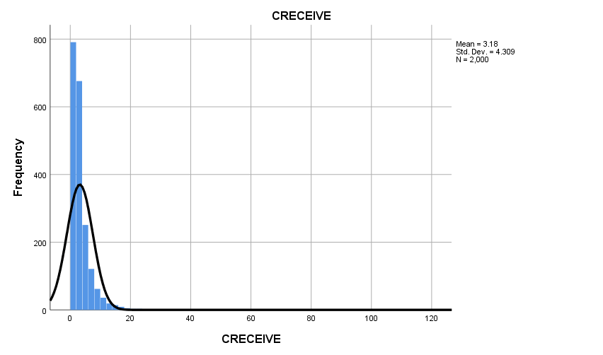

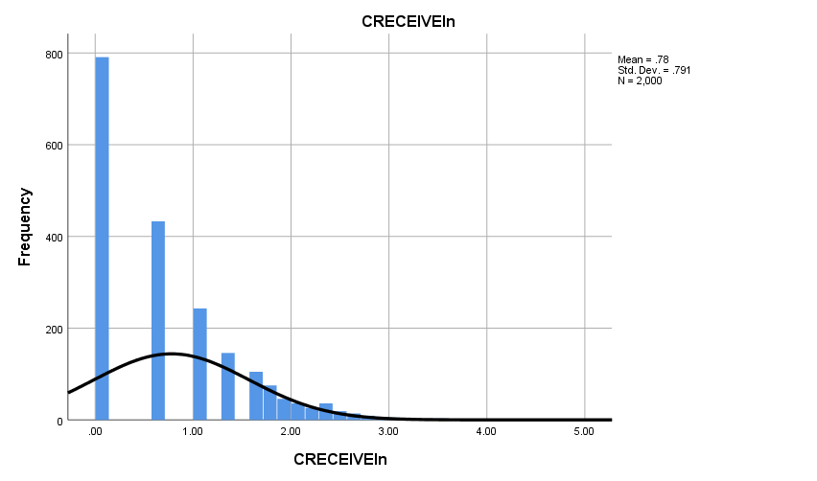

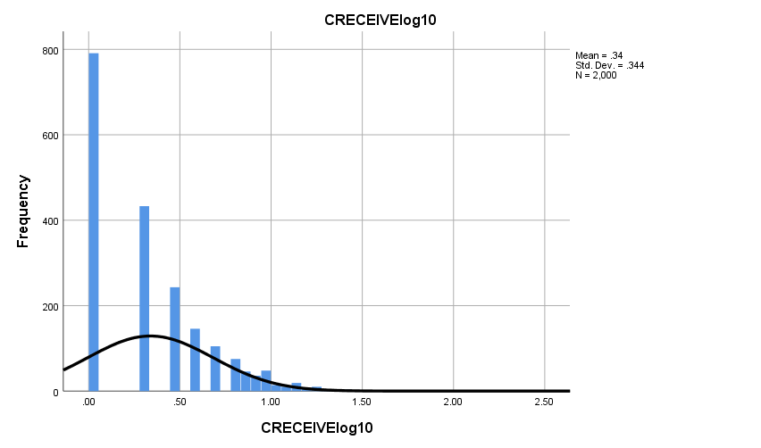

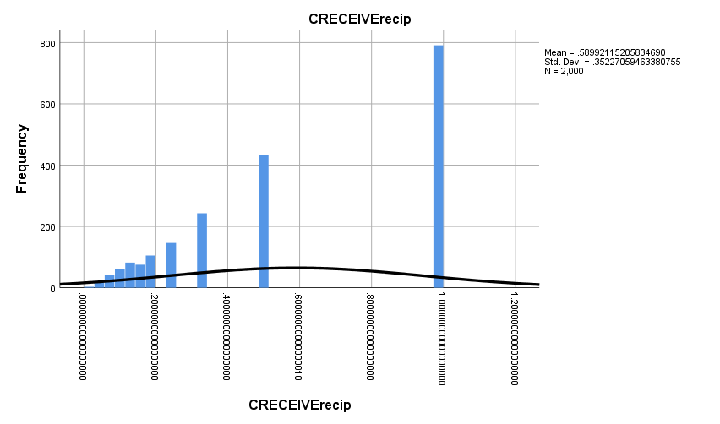

Graph

Notes
Output Created |  | 28-OCT-2018 16:50:51
Comments
Input | Data | D:\SOC6100\Assignments\Assignment03\Data\DataClean\Townes_SOC6100_Assignment03_Data.sav
Input | Active Dataset | DataSet1
Input | Filter | <none>
Input | Weight | <none>
Input | Split File | <none>
Input | N of Rows in Working Data File | 2000
Syntax |  | GRAPH  /SCATTERPLOT(BIVAR)=CLAIMS WITH CRECEIVE  /MISSING=LISTWISE  /TITLE='Scatter Plot of CRECEIVE by CLAIMS'  /FOOTNOTE='All observations included'.
Resources | Processor Time | 00:00:01.69
Resources | Elapsed Time | 00:00:00.88

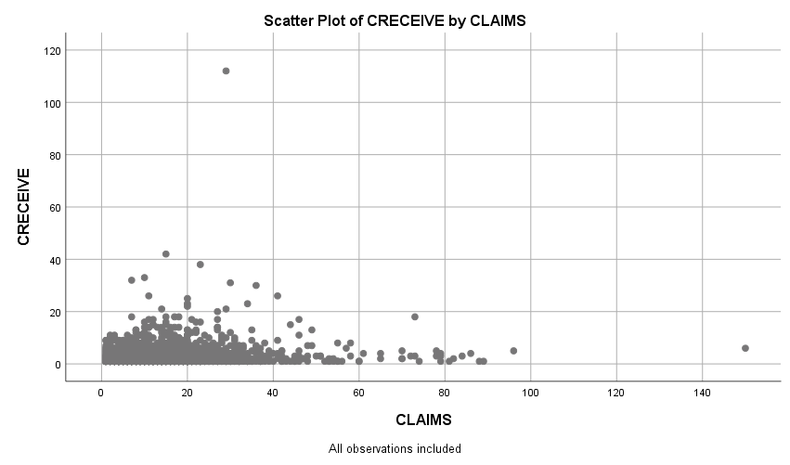

Graph

Notes
Output Created |  | 28-OCT-2018 16:52:07
Comments
Input | Data | D:\SOC6100\Assignments\Assignment03\Data\DataClean\Townes_SOC6100_Assignment03_Data.sav
Input | Active Dataset | DataSet1
Input | Filter | <none>
Input | Weight | <none>
Input | Split File | <none>
Input | N of Rows in Working Data File | 2000
Syntax |  | GRAPH  /SCATTERPLOT(BIVAR)=CLAIMS WITH CRECEIVEln  /MISSING=LISTWISE  /TITLE='Scatter Plot of CRECEIVEln by CLAIMS'  /FOOTNOTE='All observations included'.
Resources | Processor Time | 00:00:00.97
Resources | Elapsed Time | 00:00:00.70

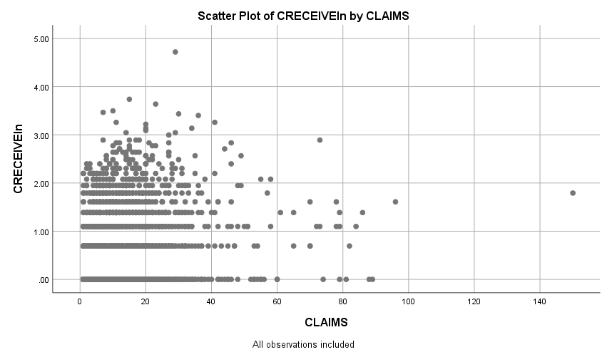

Graph

Notes
Output Created |  | 28-OCT-2018 16:52:57
Comments
Input | Data | D:\SOC6100\Assignments\Assignment03\Data\DataClean\Townes_SOC6100_Assignment03_Data.sav
Input | Active Dataset | DataSet1
Input | Filter | <none>
Input | Weight | <none>
Input | Split File | <none>
Input | N of Rows in Working Data File | 2000
Syntax |  | GRAPH  /SCATTERPLOT(BIVAR)=CLAIMS WITH CRECEIVElog10  /MISSING=LISTWISE  /TITLE='Scatter Plot of CRECEIVElog10 by CLAIMS'  /FOOTNOTE='All observations included'.
Resources | Processor Time | 00:00:01.19
Resources | Elapsed Time | 00:00:00.60

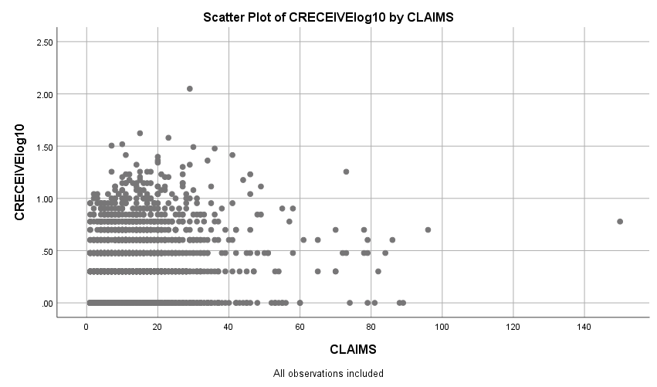

Graph

Notes
Output Created |  | 28-OCT-2018 16:53:51
Comments
Input | Data | D:\SOC6100\Assignments\Assignment03\Data\DataClean\Townes_SOC6100_Assignment03_Data.sav
Input | Active Dataset | DataSet1
Input | Filter | <none>
Input | Weight | <none>
Input | Split File | <none>
Input | N of Rows in Working Data File | 2000
Syntax |  | GRAPH  /SCATTERPLOT(BIVAR)=CLAIMS WITH CRECEIVErecip  /MISSING=LISTWISE  /TITLE='Scatter Plot of CRECEIVErecip by CLAIMS'  /FOOTNOTE='All observations included'.
Resources | Processor Time | 00:00:01.11
Resources | Elapsed Time | 00:00:00.59

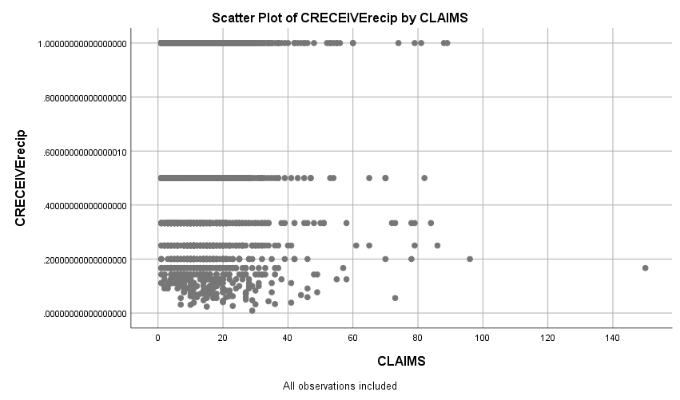

Regression

Notes
Output Created |  | 28-OCT-2018 19:27:42
Comments
Input | Data | D:\SOC6100\Assignments\Assignment03\Data\DataClean\Townes_SOC6100_Assignment03_Data.sav
Input | Active Dataset | DataSet1
Input | Filter | CRECEIVE < 40 AND CLAIMS < 90 (FILTER)
Input | Weight | <none>
Input | Split File | <none>
Input | N of Rows in Working Data File | 1996
Missing Value Handling | Definition of Missing | User-defined missing values are treated as missing.
Missing Value Handling | Cases Used | Statistics are based on cases with no missing values for any variable used.
Syntax |  | REGRESSION  /DESCRIPTIVES MEAN STDDEV CORR SIG N  /MISSING LISTWISE  /STATISTICS COEFF OUTS CI(95) BCOV R ANOVA COLLIN TOL CHANGE ZPP  /CRITERIA=PIN(.05) POUT(.10)  /NOORIGIN  /DEPENDENT GENERAL  /METHOD=ENTER ORIGINAL  /SCATTERPLOT=(*ZRESID ,*ZPRED)  /RESIDUALS DURBIN HISTOGRAM(ZRESID) NORMPROB(ZRESID)  /CASEWISE PLOT(ZRESID) OUTLIERS(3).
Resources | Processor Time | 00:00:08.63
Resources | Elapsed Time | 00:00:04.53
Resources | Memory Required | 3488 bytes
Resources | Additional Memory Required for Residual Plots | 680 bytes

[DataSet1] D:\SOC6100\Assignments\Assignment03\Data\DataClean\Townes_SOC6100_Assignment03_Data.sav

Descriptive Statistics
 | Mean | Std. Deviation | N
GENERAL | .194597 | .2589553 | 1958
ORIGINAL | .398282 | .2739932 | 1958

Correlations
 |  | GENERAL | ORIGINAL
Pearson Correlation | GENERAL | 1.000 | .169
Pearson Correlation | ORIGINAL | .169 | 1.000
Sig. (1-tailed) | GENERAL | . | .000
Sig. (1-tailed) | ORIGINAL | .000 | .
N | GENERAL | 1958 | 1958
N | ORIGINAL | 1958 | 1958

Variables Entered/Removedª
Model | Variables Entered | Variables Removed | Method
1 | ORIGINAL^{b} | . | Enter

a. Dependent Variable: GENERAL
b. All requested variables entered.

Model Summary^{b}
Model | R | R Square | Adjusted R Square | Std. Error of the Estimate | Change Statistics
 |  |  |  |  | R Square Change | F Change | df1
1 | .169ª | .029 | .028 | .2552980 | .029 | 57.473 | 1

Model Summary^{b}
Model | Change Statistics
Model | df2 | Sig. F Change
1 | 1956 | .000 | 2.053

a. Predictors: (Constant), ORIGINAL
b. Dependent Variable: GENERAL

ANOVAª
Model |  | Sum of Squares | df | Mean Square | F | Sig.
1 | Regression | 3.746 | 1 | 3.746 | 57.473 | .000^{b}
1 | Residual | 127.486 | 1956 | .065
1 | Total | 131.232 | 1957

a. Dependent Variable: GENERAL
b. Predictors: (Constant), ORIGINAL

Coefficientsª
Model |  | Unstandardized Coefficients |  | Standardized Coefficients | t | Sig.
 |  | B | Std. Error | Beta | t | Sig.
1 | (Constant) | .131 | .010 |  | 12.867 | .000
1 | ORIGINAL | .160 | .021 | .169 | 7.581 | .000

Coefficientsª
Model |  | 95.0% Confidence Interval for B |  | Correlations |  |  | Collinearity Statistics
 |  | Lower Bound | Upper Bound | Zero-order | Partial | Part | Tolerance
1 | (Constant) | .111 | .151
1 | ORIGINAL | .118 | .201 | .169 | .169 | .169 | 1.000

Coefficientsª
Model |  | Collinearity Statistics
 |  | VIF
1 | (Constant)
1 | ORIGINAL | 1.000

a. Dependent Variable: GENERAL

Coefficient Correlationsª
Model |  |  | ORIGINAL
1 | Correlations | ORIGINAL | 1.000
1 | Covariances | ORIGINAL | .000

a. Dependent Variable: GENERAL

Collinearity Diagnosticsª
Model | Dimension | Eigenvalue | Condition Index | Variance Proportions
 |  |  |  | (Constant) | ORIGINAL
1 | 1 | 1.824 | 1.000 | .09 | .09
1 | 2 | .176 | 3.219 | .91 | .91

a. Dependent Variable: GENERAL

Residuals Statisticsª
 | Minimum | Maximum | Mean | Std. Deviation | N
Predicted Value | .131001 | .273656 | .194597 | .0437504 | 1958
Residual | -.2711814 | .7331990 | .0000000 | .2552328 | 1958
Std. Predicted Value | -1.454 | 1.807 | .000 | 1.000 | 1958
Std. Residual | -1.062 | 2.872 | .000 | 1.000 | 1958

a. Dependent Variable: GENERAL

Charts

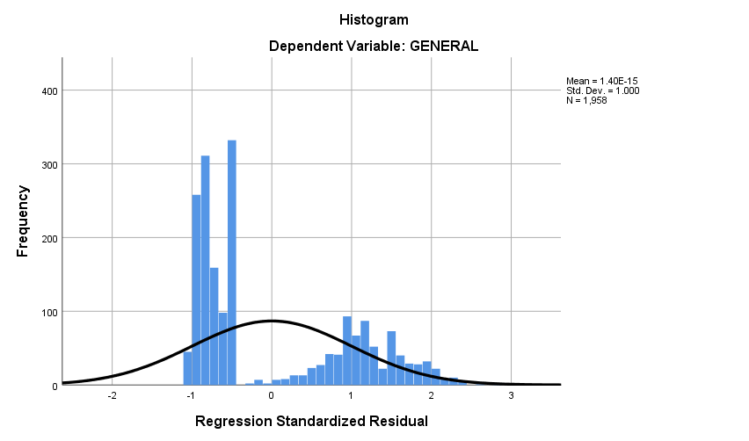

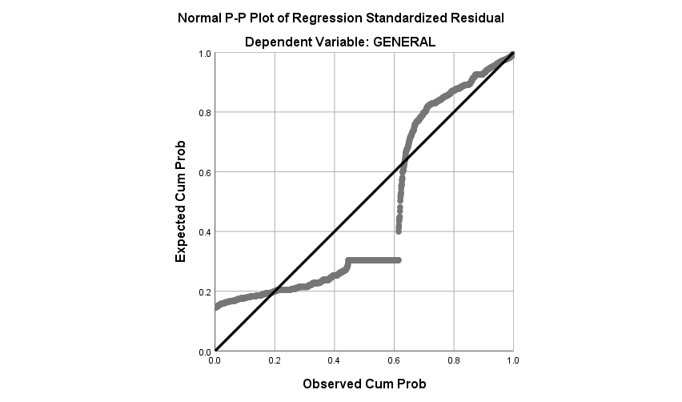

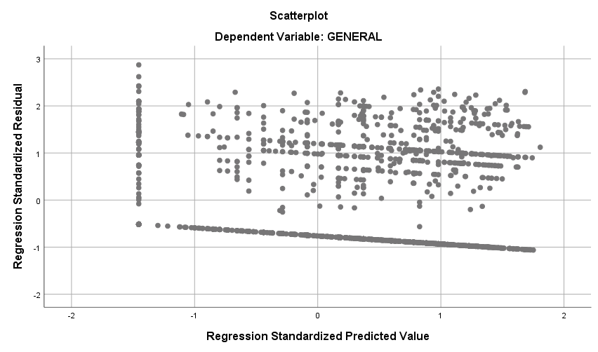

Regression

Notes
Output Created |  | 28-OCT-2018 19:32:32
Comments
Input | Data | D:\SOC6100\Assignments\Assignment03\Data\DataClean\Townes_SOC6100_Assignment03_Data.sav
Input | Active Dataset | DataSet1
Input | Filter | CRECEIVE < 40 AND CLAIMS < 90 (FILTER)
Input | Weight | <none>
Input | Split File | <none>
Input | N of Rows in Working Data File | 1996
Missing Value Handling | Definition of Missing | User-defined missing values are treated as missing.
Missing Value Handling | Cases Used | Statistics are based on cases with no missing values for any variable used.
Syntax |  | REGRESSION  /DESCRIPTIVES MEAN STDDEV CORR SIG N  /MISSING LISTWISE  /STATISTICS COEFF OUTS CI(95) BCOV R ANOVA COLLIN TOL CHANGE ZPP  /CRITERIA=PIN(.05) POUT(.10)  /NOORIGIN  /DEPENDENT CLAIMS  /METHOD=ENTER ORIGINAL GENERAL GYEAR RATIOCIT  /SCATTERPLOT=(*ZRESID ,*ZPRED)  /RESIDUALS DURBIN HISTOGRAM(ZRESID) NORMPROB(ZRESID)  /CASEWISE PLOT(ZRESID) OUTLIERS(3).
Resources | Processor Time | 00:00:02.46
Resources | Elapsed Time | 00:00:01.57
Resources | Memory Required | 5072 bytes
Resources | Additional Memory Required for Residual Plots | 632 bytes

Descriptive Statistics
 | Mean | Std. Deviation | N
CLAIMS | 14.97 | 11.689 | 1958
ORIGINAL | .398282 | .2739932 | 1958
GENERAL | .194597 | .2589553 | 1958
GYEAR | 1996.27 | 1.075 | 1958
RATIOCIT | .939529 | .1404329 | 1958

Correlations
 |  | CLAIMS | ORIGINAL | GENERAL | GYEAR | RATIOCIT
Pearson Correlation | CLAIMS | 1.000 | .101 | .056 | .039 | .054
Pearson Correlation | ORIGINAL | .101 | 1.000 | .169 | .017 | .052
Pearson Correlation | GENERAL | .056 | .169 | 1.000 | -.238 | .043
Pearson Correlation | GYEAR | .039 | .017 | -.238 | 1.000 | .083
Pearson Correlation | RATIOCIT | .054 | .052 | .043 | .083 | 1.000
Sig. (1-tailed) | CLAIMS | . | .000 | .006 | .042 | .008
Sig. (1-tailed) | ORIGINAL | .000 | . | .000 | .225 | .011
Sig. (1-tailed) | GENERAL | .006 | .000 | . | .000 | .028
Sig. (1-tailed) | GYEAR | .042 | .225 | .000 | . | .000
Sig. (1-tailed) | RATIOCIT | .008 | .011 | .028 | .000 | .
N | CLAIMS | 1958 | 1958 | 1958 | 1958 | 1958
N | ORIGINAL | 1958 | 1958 | 1958 | 1958 | 1958
N | GENERAL | 1958 | 1958 | 1958 | 1958 | 1958
N | GYEAR | 1958 | 1958 | 1958 | 1958 | 1958
N | RATIOCIT | 1958 | 1958 | 1958 | 1958 | 1958

Variables Entered/Removedª
Model | Variables Entered | Variables Removed | Method
1 | RATIOCIT, GENERAL, ORIGINAL, GYEAR^{b} | . | Enter

a. Dependent Variable: CLAIMS
b. All requested variables entered.

Model Summary^{b}
Model | R | R Square | Adjusted R Square | Std. Error of the Estimate | Change Statistics
 |  |  |  |  | R Square Change | F Change | df1
1 | .127ª | .016 | .014 | 11.607 | .016 | 7.952 | 4

Model Summary^{b}
Model | Change Statistics
Model | df2 | Sig. F Change
1 | 1953 | .000 | 1.966

a. Predictors: (Constant), RATIOCIT, GENERAL, ORIGINAL, GYEAR
b. Dependent Variable: CLAIMS

ANOVAª
Model |  | Sum of Squares | df | Mean Square | F | Sig.
1 | Regression | 4285.217 | 4 | 1071.304 | 7.952 | .000^{b}
1 | Residual | 263126.455 | 1953 | 134.729
1 | Total | 267411.672 | 1957

a. Dependent Variable: CLAIMS
b. Predictors: (Constant), RATIOCIT, GENERAL, ORIGINAL, GYEAR

Coefficientsª
Model |  | Unstandardized Coefficients |  | Standardized Coefficients | t | Sig.
 |  | B | Std. Error | Beta | t | Sig.
1 | (Constant) | -986.372 | 504.599 |  | -1.955 | .051
1 | ORIGINAL | 3.820 | .974 | .090 | 3.921 | .000
1 | GENERAL | 2.274 | 1.062 | .050 | 2.142 | .032
1 | GYEAR | .499 | .253 | .046 | 1.973 | .049
1 | RATIOCIT | 3.608 | 1.880 | .043 | 1.919 | .055

Coefficientsª
Model |  | 95.0% Confidence Interval for B |  | Correlations |  |  | Collinearity Statistics
 |  | Lower Bound | Upper Bound | Zero-order | Partial | Part | Tolerance
1 | (Constant) | -1975.981 | 3.237
1 | ORIGINAL | 1.909 | 5.730 | .101 | .088 | .088 | .966
1 | GENERAL | .192 | 4.357 | .056 | .048 | .048 | .911
1 | GYEAR | .003 | .995 | .039 | .045 | .044 | .932
1 | RATIOCIT | -.080 | 7.296 | .054 | .043 | .043 | .987

Coefficientsª
Model |  | Collinearity Statistics
 |  | VIF
1 | (Constant)
1 | ORIGINAL | 1.035
1 | GENERAL | 1.098
1 | GYEAR | 1.073
1 | RATIOCIT | 1.013

a. Dependent Variable: CLAIMS

Coefficient Correlationsª
Model |  |  | RATIOCIT | GENERAL | ORIGINAL | GYEAR
1 | Correlations | RATIOCIT | 1.000 | -.057 | -.040 | -.094
1 | Correlations | GENERAL | -.057 | 1.000 | -.175 | .248
1 | Correlations | ORIGINAL | -.040 | -.175 | 1.000 | -.056
1 | Correlations | GYEAR | -.094 | .248 | -.056 | 1.000
1 | Covariances | RATIOCIT | 3.536 | -.113 | -.073 | -.044
1 | Covariances | GENERAL | -.113 | 1.128 | -.181 | .067
1 | Covariances | ORIGINAL | -.073 | -.181 | .949 | -.014
1 | Covariances | GYEAR | -.044 | .067 | -.014 | .064

a. Dependent Variable: CLAIMS

Collinearity Diagnosticsª
Model | Dimension | Eigenvalue | Condition Index | Variance Proportions
 |  |  |  | (Constant) | ORIGINAL | GENERAL | GYEAR
1 | 1 | 4.172 | 1.000 | .00 | .01 | .02 | .00
1 | 2 | .558 | 2.734 | .00 | .00 | .91 | .00
1 | 3 | .255 | 4.048 | .00 | .98 | .01 | .00
1 | 4 | .015 | 16.893 | .00 | .00 | .00 | .00
1 | 5 | 1.351E-7 | 5557.627 | 1.00 | .00 | .06 | 1.00

Collinearity Diagnosticsª
Model | Dimension | Variance Proportions
Model | Dimension | RATIOCIT
1 | 1 | .00
1 | 2 | .00
1 | 3 | .01
1 | 4 | .98
1 | 5 | .01

a. Dependent Variable: CLAIMS

Casewise Diagnosticsª
Case Number | Std. Residual | CLAIMS | Predicted Value | Residual
33 | 5.444 | 79 | 15.81 | 63.192
102 | 6.496 | 88 | 12.60 | 75.404
114 | 4.478 | 70 | 18.02 | 51.981
117 | 3.576 | 57 | 15.49 | 41.510
149 | 4.972 | 72 | 14.29 | 57.707
187 | 3.016 | 53 | 17.99 | 35.012
255 | 5.088 | 73 | 13.94 | 59.061
290 | 4.781 | 70 | 14.51 | 55.490
382 | 4.097 | 61 | 13.45 | 47.551
501 | 3.060 | 49 | 13.49 | 35.515
515 | 3.909 | 60 | 14.63 | 45.375
541 | 4.146 | 65 | 16.87 | 48.128
605 | 4.999 | 74 | 15.98 | 58.019
668 | 3.610 | 56 | 14.09 | 41.907
766 | 3.054 | 52 | 16.55 | 35.445
794 | 3.606 | 58 | 16.14 | 41.857
860 | 3.771 | 60 | 16.23 | 43.768
868 | 5.362 | 79 | 16.77 | 62.233
951 | 4.127 | 65 | 17.10 | 47.903
1010 | 3.075 | 51 | 15.30 | 35.696
1024 | 5.912 | 84 | 15.38 | 68.617
1029 | 3.382 | 54 | 14.74 | 39.258
1128 | 5.289 | 79 | 17.60 | 61.395
1160 | 5.807 | 81 | 13.59 | 67.406
1210 | 3.789 | 58 | 14.02 | 43.981
1248 | 4.772 | 73 | 17.61 | 55.390
1272 | 3.367 | 55 | 15.92 | 39.084
1336 | 3.439 | 55 | 15.08 | 39.916
1381 | 6.375 | 89 | 15.00 | 73.995
1451 | 3.266 | 51 | 13.09 | 37.905
1461 | 3.375 | 54 | 14.83 | 39.174
1480 | 5.592 | 78 | 13.09 | 64.905
1507 | 5.635 | 82 | 16.60 | 65.402
1557 | 3.104 | 53 | 16.97 | 36.029
1655 | 5.537 | 78 | 13.73 | 64.274
1671 | 3.438 | 53 | 13.09 | 39.905
1774 | 5.883 | 86 | 17.72 | 68.280
1884 | 3.488 | 55 | 14.51 | 40.492
1991 | 4.615 | 70 | 16.43 | 53.565

a. Dependent Variable: CLAIMS

Residuals Statisticsª
 | Minimum | Maximum | Mean | Std. Deviation | N
Predicted Value | 9.27 | 18.51 | 14.97 | 1.480 | 1958
Residual | -16.660 | 75.404 | .000 | 11.595 | 1958
Std. Predicted Value | -3.858 | 2.388 | .000 | 1.000 | 1958
Std. Residual | -1.435 | 6.496 | .000 | .999 | 1958

a. Dependent Variable: CLAIMS

Charts

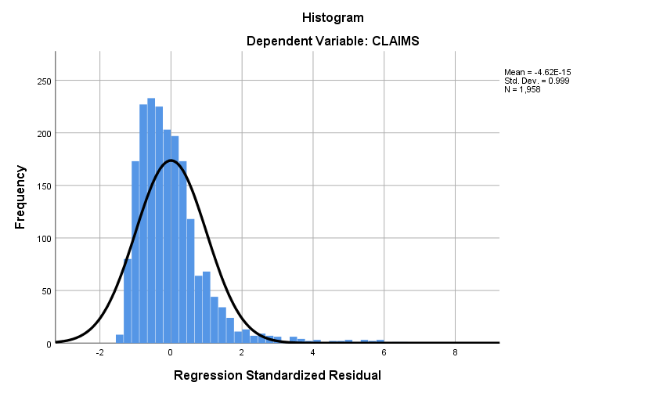

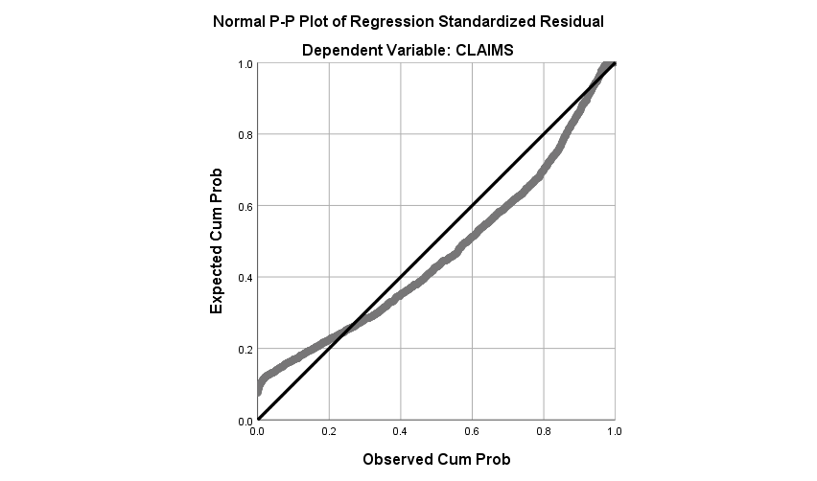

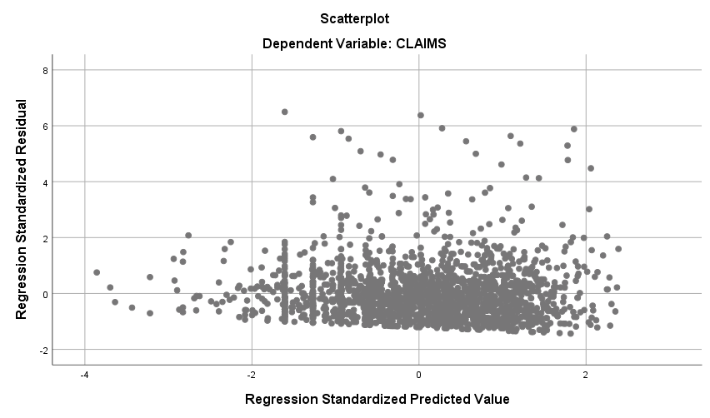

Regression

Notes
Output Created |  | 28-OCT-2018 19:34:32
Comments
Input | Data | D:\SOC6100\Assignments\Assignment03\Data\DataClean\Townes_SOC6100_Assignment03_Data.sav
Input | Active Dataset | DataSet1
Input | Filter | CRECEIVE < 40 AND CLAIMS < 90 (FILTER)
Input | Weight | <none>
Input | Split File | <none>
Input | N of Rows in Working Data File | 1996
Missing Value Handling | Definition of Missing | User-defined missing values are treated as missing.
Missing Value Handling | Cases Used | Statistics are based on cases with no missing values for any variable used.
Syntax |  | REGRESSION  /DESCRIPTIVES MEAN STDDEV CORR SIG N  /MISSING LISTWISE  /STATISTICS COEFF OUTS CI(95) BCOV R ANOVA COLLIN TOL CHANGE ZPP  /CRITERIA=PIN(.05) POUT(.10)  /NOORIGIN  /DEPENDENT CRECEIVEln  /METHOD=ENTER ORIGINAL GENERAL GYEAR RATIOCIT CLAIMS  /SCATTERPLOT=(*ZRESID ,*ZPRED)  /RESIDUALS DURBIN HISTOGRAM(ZRESID) NORMPROB(ZRESID)  /CASEWISE PLOT(ZRESID) OUTLIERS(3).
Resources | Processor Time | 00:00:01.95
Resources | Elapsed Time | 00:00:01.54
Resources | Memory Required | 5728 bytes
Resources | Additional Memory Required for Residual Plots | 616 bytes

Descriptive Statistics
 | Mean | Std. Deviation | N
CRECEIVEln | .7773 | .78494 | 1958
ORIGINAL | .398282 | .2739932 | 1958
GENERAL | .194597 | .2589553 | 1958
GYEAR | 1996.27 | 1.075 | 1958
RATIOCIT | .939529 | .1404329 | 1958
CLAIMS | 14.97 | 11.689 | 1958

Correlations
 |  | CRECEIVEln | ORIGINAL | GENERAL | GYEAR | RATIOCIT
Pearson Correlation | CRECEIVEln | 1.000 | .019 | .612 | -.339 | .098
Pearson Correlation | ORIGINAL | .019 | 1.000 | .169 | .017 | .052
Pearson Correlation | GENERAL | .612 | .169 | 1.000 | -.238 | .043
Pearson Correlation | GYEAR | -.339 | .017 | -.238 | 1.000 | .083
Pearson Correlation | RATIOCIT | .098 | .052 | .043 | .083 | 1.000
Pearson Correlation | CLAIMS | .083 | .101 | .056 | .039 | .054
Sig. (1-tailed) | CRECEIVEln | . | .204 | .000 | .000 | .000
Sig. (1-tailed) | ORIGINAL | .204 | . | .000 | .225 | .011
Sig. (1-tailed) | GENERAL | .000 | .000 | . | .000 | .028
Sig. (1-tailed) | GYEAR | .000 | .225 | .000 | . | .000
Sig. (1-tailed) | RATIOCIT | .000 | .011 | .028 | .000 | .
Sig. (1-tailed) | CLAIMS | .000 | .000 | .006 | .042 | .008
N | CRECEIVEln | 1958 | 1958 | 1958 | 1958 | 1958
N | ORIGINAL | 1958 | 1958 | 1958 | 1958 | 1958
N | GENERAL | 1958 | 1958 | 1958 | 1958 | 1958
N | GYEAR | 1958 | 1958 | 1958 | 1958 | 1958
N | RATIOCIT | 1958 | 1958 | 1958 | 1958 | 1958
N | CLAIMS | 1958 | 1958 | 1958 | 1958 | 1958

Correlations
 |  | CLAIMS
Pearson Correlation | CRECEIVEln | .083
Pearson Correlation | ORIGINAL | .101
Pearson Correlation | GENERAL | .056
Pearson Correlation | GYEAR | .039
Pearson Correlation | RATIOCIT | .054
Pearson Correlation | CLAIMS | 1.000
Sig. (1-tailed) | CRECEIVEln | .000
Sig. (1-tailed) | ORIGINAL | .000
Sig. (1-tailed) | GENERAL | .006
Sig. (1-tailed) | GYEAR | .042
Sig. (1-tailed) | RATIOCIT | .008
Sig. (1-tailed) | CLAIMS | .
N | CRECEIVEln | 1958
N | ORIGINAL | 1958
N | GENERAL | 1958
N | GYEAR | 1958
N | RATIOCIT | 1958
N | CLAIMS | 1958

Variables Entered/Removedª
Model | Variables Entered | Variables Removed | Method
1 | CLAIMS, GYEAR, RATIOCIT, ORIGINAL, GENERAL^{b} | . | Enter

a. Dependent Variable: CRECEIVEln
b. All requested variables entered.

Model Summary^{b}
Model | R | R Square | Adjusted R Square | Std. Error of the Estimate | Change Statistics
 |  |  |  |  | R Square Change | F Change | df1
1 | .658ª | .433 | .432 | .59178 | .433 | 298.204 | 5

Model Summary^{b}
Model | Change Statistics
Model | df2 | Sig. F Change
1 | 1952 | .000 | 2.008

a. Predictors: (Constant), CLAIMS, GYEAR, RATIOCIT, ORIGINAL, GENERAL
b. Dependent Variable: CRECEIVEln

ANOVAª
Model |  | Sum of Squares | df | Mean Square | F | Sig.
1 | Regression | 522.161 | 5 | 104.432 | 298.204 | .000^{b}
1 | Residual | 683.599 | 1952 | .350
1 | Total | 1205.759 | 1957

a. Dependent Variable: CRECEIVEln
b. Predictors: (Constant), CLAIMS, GYEAR, RATIOCIT, ORIGINAL, GENERAL

Coefficientsª
Model |  | Unstandardized Coefficients |  | Standardized Coefficients | t | Sig.
 |  | B | Std. Error | Beta | t | Sig.
1 | (Constant) | 310.279 | 25.751 |  | 12.049 | .000
1 | ORIGINAL | -.243 | .050 | -.085 | -4.874 | .000
1 | GENERAL | 1.723 | .054 | .569 | 31.794 | .000
1 | GYEAR | -.155 | .013 | -.213 | -12.046 | .000
1 | RATIOCIT | .516 | .096 | .092 | 5.382 | .000
1 | CLAIMS | .004 | .001 | .063 | 3.650 | .000

Coefficientsª
Model |  | 95.0% Confidence Interval for B |  | Correlations |  |  | Collinearity Statistics
 |  | Lower Bound | Upper Bound | Zero-order | Partial | Part | Tolerance
1 | (Constant) | 259.776 | 360.782
1 | ORIGINAL | -.341 | -.145 | .019 | -.110 | -.083 | .959
1 | GENERAL | 1.617 | 1.830 | .612 | .584 | .542 | .908
1 | GYEAR | -.181 | -.130 | -.339 | -.263 | -.205 | .930
1 | RATIOCIT | .328 | .705 | .098 | .121 | .092 | .986
1 | CLAIMS | .002 | .006 | .083 | .082 | .062 | .984

Coefficientsª
Model |  | Collinearity Statistics
 |  | VIF
1 | (Constant)
1 | ORIGINAL | 1.043
1 | GENERAL | 1.101
1 | GYEAR | 1.075
1 | RATIOCIT | 1.015
1 | CLAIMS | 1.016

a. Dependent Variable: CRECEIVEln

Coefficient Correlationsª
Model |  |  | CLAIMS | GYEAR | RATIOCIT | ORIGINAL | GENERAL
1 | Correlations | CLAIMS | 1.000 | -.045 | -.043 | -.088 | -.048
1 | Correlations | GYEAR | -.045 | 1.000 | -.091 | -.052 | .250
1 | Correlations | RATIOCIT | -.043 | -.091 | 1.000 | -.036 | -.055
1 | Correlations | ORIGINAL | -.088 | -.052 | -.036 | 1.000 | -.170
1 | Correlations | GENERAL | -.048 | .250 | -.055 | -.170 | 1.000
1 | Covariances | CLAIMS | 1.331E-6 | -6.640E-7 | -4.802E-6 | -5.084E-6 | -3.027E-6
1 | Covariances | GYEAR | -6.640E-7 | .000 | .000 | -3.315E-5 | .000
1 | Covariances | RATIOCIT | -4.802E-6 | .000 | .009 | .000 | .000
1 | Covariances | ORIGINAL | -5.084E-6 | -3.315E-5 | .000 | .002 | .000
1 | Covariances | GENERAL | -3.027E-6 | .000 | .000 | .000 | .003

a. Dependent Variable: CRECEIVEln

Collinearity Diagnosticsª
Model | Dimension | Eigenvalue | Condition Index | Variance Proportions
 |  |  |  | (Constant) | ORIGINAL | GENERAL | GYEAR
1 | 1 | 4.843 | 1.000 | .00 | .01 | .01 | .00
1 | 2 | .574 | 2.905 | .00 | .00 | .89 | .00
1 | 3 | .321 | 3.886 | .00 | .18 | .03 | .00
1 | 4 | .248 | 4.415 | .00 | .80 | .01 | .00
1 | 5 | .015 | 18.199 | .00 | .00 | .00 | .00
1 | 6 | 1.348E-7 | 5993.179 | 1.00 | .00 | .06 | 1.00

Collinearity Diagnosticsª
Model | Dimension | Variance Proportions
Model | Dimension | RATIOCIT | CLAIMS
1 | 1 | .00 | .01
1 | 2 | .00 | .03
1 | 3 | .00 | .85
1 | 4 | .01 | .10
1 | 5 | .98 | .00
1 | 6 | .01 | .00

a. Dependent Variable: CRECEIVEln

Casewise Diagnosticsª
Case Number | Std. Residual | CRECEIVEln | Predicted Value | Residual
159 | 3.367 | 2.20 | .2046 | 1.99260
198 | 3.034 | 2.48 | .6894 | 1.79550
243 | 3.559 | 3.14 | 1.0295 | 2.10601
269 | 3.441 | 2.64 | .6028 | 2.03628
446 | 3.513 | 3.22 | 1.1397 | 2.07915
457 | 4.068 | 3.43 | 1.0264 | 2.40757
776 | 3.046 | 2.71 | .9052 | 1.80282
832 | 3.199 | 2.64 | .7461 | 1.89295
859 | 3.632 | 2.56 | .4157 | 2.14925
879 | 3.013 | 3.26 | 1.4748 | 1.78326
1058 | 3.130 | 1.95 | .0934 | 1.85254
1063 | 4.125 | 3.64 | 1.1964 | 2.44122
1116 | 3.895 | 3.09 | .7859 | 2.30512
1220 | 3.375 | 3.50 | 1.4990 | 1.99752
1347 | 3.126 | 2.83 | .9832 | 1.85002
1379 | 3.251 | 2.48 | .5613 | 1.92362
1680 | 3.815 | 3.26 | 1.0002 | 2.25791
1744 | 3.179 | 2.77 | .8914 | 1.88122

a. Dependent Variable: CRECEIVEln

Residuals Statisticsª
 | Minimum | Maximum | Mean | Std. Deviation | N
Predicted Value | -.1505 | 2.1346 | .7773 | .51654 | 1958
Residual | -1.07455 | 2.44122 | .00000 | .59102 | 1958
Std. Predicted Value | -1.796 | 2.628 | .000 | 1.000 | 1958
Std. Residual | -1.816 | 4.125 | .000 | .999 | 1958

a. Dependent Variable: CRECEIVEln

Charts

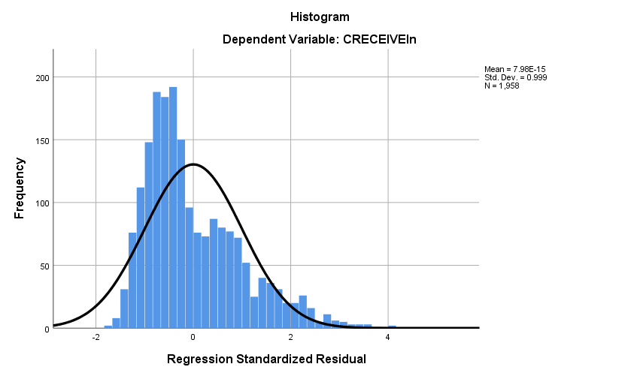

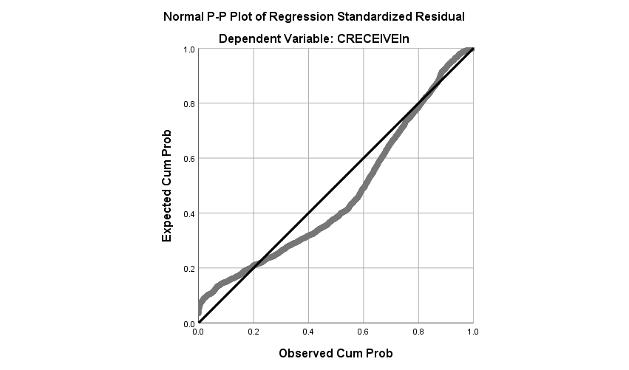

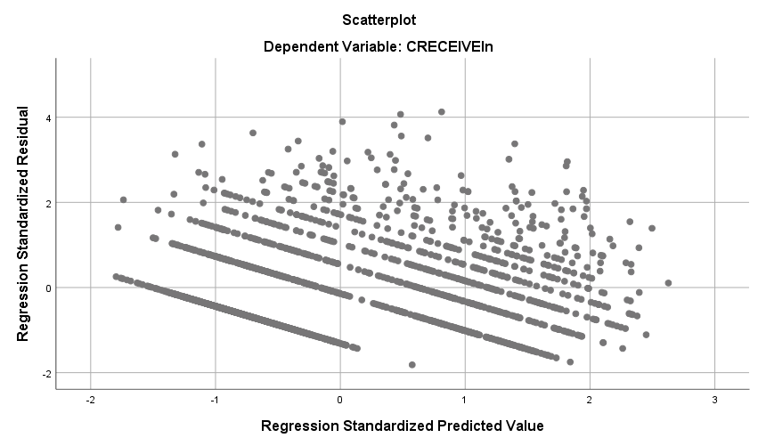

Regression

Notes
Output Created |  | 30-OCT-2018 18:57:59
Comments
Input | Data | D:\SOC6100\Assignments\Assignment03\Data\DataClean\Townes_SOC6100_Assignment03_Data.sav
Input | Active Dataset | DataSet1
Input | Filter | CRECEIVE<40 AND CLAIMS<90 (FILTER)
Input | Weight | <none>
Input | Split File | <none>
Input | N of Rows in Working Data File | 1996
Missing Value Handling | Definition of Missing | User-defined missing values are treated as missing.
Missing Value Handling | Cases Used | Statistics are based on cases with no missing values for any variable used.
Syntax |  | REGRESSION  /DESCRIPTIVES MEAN STDDEV CORR SIG N  /MISSING LISTWISE  /STATISTICS COEFF OUTS CI(95) BCOV R ANOVA COLLIN TOL CHANGE ZPP  /CRITERIA=PIN(.05) POUT(.10)  /NOORIGIN  /DEPENDENT CLAIMS  /METHOD=ENTER GENERAL GYEAR ORIGINAL  /SCATTERPLOT=(*ZRESID ,*ZPRED)  /RESIDUALS DURBIN HISTOGRAM(ZRESID) NORMPROB(ZRESID)  /CASEWISE PLOT(ZRESID) OUTLIERS(3).
Resources | Processor Time | 00:00:04.10
Resources | Elapsed Time | 00:00:01.87
Resources | Memory Required | 4480 bytes
Resources | Additional Memory Required for Residual Plots | 648 bytes

Descriptive Statistics
 | Mean | Std. Deviation | N
CLAIMS | 14.97 | 11.689 | 1958
GENERAL | .194597 | .2589553 | 1958
GYEAR | 1996.27 | 1.075 | 1958
ORIGINAL | .398282 | .2739932 | 1958

Correlations
 |  | CLAIMS | GENERAL | GYEAR | ORIGINAL
Pearson Correlation | CLAIMS | 1.000 | .056 | .039 | .101
Pearson Correlation | GENERAL | .056 | 1.000 | -.238 | .169
Pearson Correlation | GYEAR | .039 | -.238 | 1.000 | .017
Pearson Correlation | ORIGINAL | .101 | .169 | .017 | 1.000
Sig. (1-tailed) | CLAIMS | . | .006 | .042 | .000
Sig. (1-tailed) | GENERAL | .006 | . | .000 | .000
Sig. (1-tailed) | GYEAR | .042 | .000 | . | .225
Sig. (1-tailed) | ORIGINAL | .000 | .000 | .225 | .
N | CLAIMS | 1958 | 1958 | 1958 | 1958
N | GENERAL | 1958 | 1958 | 1958 | 1958
N | GYEAR | 1958 | 1958 | 1958 | 1958
N | ORIGINAL | 1958 | 1958 | 1958 | 1958

Variables Entered/Removedª
Model | Variables Entered | Variables Removed | Method
1 | ORIGINAL, GYEAR, GENERAL^{b} | . | Enter

a. Dependent Variable: CLAIMS
b. All requested variables entered.

Model Summary^{b}
Model | R | R Square | Adjusted R Square | Std. Error of the Estimate | Change Statistics
 |  |  |  |  | R Square Change | F Change | df1
1 | .119ª | .014 | .013 | 11.615 | .014 | 9.362 | 3

Model Summary^{b}
Model | Change Statistics
Model | df2 | Sig. F Change
1 | 1954 | .000 | 1.963

a. Predictors: (Constant), ORIGINAL, GYEAR, GENERAL
b. Dependent Variable: CLAIMS

ANOVAª
Model |  | Sum of Squares | df | Mean Square | F | Sig.
1 | Regression | 3789.155 | 3 | 1263.052 | 9.362 | .000^{b}
1 | Residual | 263622.516 | 1954 | 134.914
1 | Total | 267411.672 | 1957

a. Dependent Variable: CLAIMS
b. Predictors: (Constant), ORIGINAL, GYEAR, GENERAL

Coefficientsª
Model |  | Unstandardized Coefficients |  | Standardized Coefficients | t | Sig.
 |  | B | Std. Error | Beta | t | Sig.
1 | (Constant) | -1073.630 | 502.890 |  | -2.135 | .033
1 | GENERAL | 2.390 | 1.061 | .053 | 2.253 | .024
1 | GYEAR | .544 | .252 | .050 | 2.161 | .031
1 | ORIGINAL | 3.894 | .974 | .091 | 3.998 | .000

Coefficientsª
Model |  | 95.0% Confidence Interval for B |  | Correlations |  |  | Collinearity Statistics
 |  | Lower Bound | Upper Bound | Zero-order | Partial | Part | Tolerance
1 | (Constant) | -2059.888 | -87.372
1 | GENERAL | .310 | 4.471 | .056 | .051 | .051 | .913
1 | GYEAR | .050 | 1.038 | .039 | .049 | .049 | .940
1 | ORIGINAL | 1.984 | 5.805 | .101 | .090 | .090 | .968

Coefficientsª
Model |  | Collinearity Statistics
 |  | VIF
1 | (Constant)
1 | GENERAL | 1.095
1 | GYEAR | 1.064
1 | ORIGINAL | 1.033

a. Dependent Variable: CLAIMS

Coefficient Correlationsª
Model |  |  | ORIGINAL | GYEAR | GENERAL
1 | Correlations | ORIGINAL | 1.000 | -.060 | -.178
1 | Correlations | GYEAR | -.060 | 1.000 | .244
1 | Correlations | GENERAL | -.178 | .244 | 1.000
1 | Covariances | ORIGINAL | .949 | -.015 | -.184
1 | Covariances | GYEAR | -.015 | .063 | .065
1 | Covariances | GENERAL | -.184 | .065 | 1.125

a. Dependent Variable: CLAIMS

Collinearity Diagnosticsª
Model | Dimension | Eigenvalue | Condition Index | Variance Proportions
 |  |  |  | (Constant) | GENERAL | GYEAR | ORIGINAL
1 | 1 | 3.237 | 1.000 | .00 | .03 | .00 | .02
1 | 2 | .531 | 2.468 | .00 | .91 | .00 | .02
1 | 3 | .232 | 3.737 | .00 | .00 | .00 | .95
1 | 4 | 1.362E-7 | 4874.267 | 1.00 | .06 | 1.00 | .00

a. Dependent Variable: CLAIMS

Casewise Diagnosticsª
Case Number | Std. Residual | CLAIMS | Predicted Value | Residual
33 | 5.454 | 79 | 15.65 | 63.351
102 | 6.520 | 88 | 12.27 | 75.732
114 | 4.485 | 70 | 17.90 | 52.096
117 | 3.466 | 57 | 16.75 | 40.253
149 | 4.994 | 72 | 14.00 | 58.002
187 | 3.021 | 53 | 17.91 | 35.092
255 | 4.983 | 73 | 15.12 | 57.880
290 | 4.797 | 70 | 14.28 | 55.722
382 | 4.118 | 61 | 13.16 | 47.836
501 | 3.081 | 49 | 13.21 | 35.789
515 | 3.931 | 60 | 14.34 | 45.663
541 | 4.158 | 65 | 16.70 | 48.301
605 | 5.011 | 74 | 15.79 | 58.210
668 | 3.624 | 56 | 13.90 | 42.099
766 | 3.064 | 52 | 16.41 | 35.589
794 | 3.617 | 58 | 15.99 | 42.008
860 | 3.781 | 60 | 16.08 | 43.918
868 | 5.375 | 79 | 16.57 | 62.434
951 | 4.136 | 65 | 16.96 | 48.045
1010 | 3.094 | 51 | 15.06 | 35.939
1024 | 5.913 | 84 | 15.32 | 68.684
1029 | 3.404 | 54 | 14.46 | 39.544
1128 | 5.297 | 79 | 17.48 | 61.522
1160 | 5.824 | 81 | 13.36 | 67.644
1210 | 3.807 | 58 | 13.78 | 44.217
1248 | 4.764 | 73 | 17.67 | 55.331
1272 | 3.374 | 55 | 15.81 | 39.186
1336 | 3.457 | 55 | 14.84 | 40.160
1381 | 6.392 | 89 | 14.76 | 74.241
1451 | 3.288 | 51 | 12.81 | 38.188
1461 | 3.367 | 54 | 14.89 | 39.106
1480 | 5.612 | 78 | 12.81 | 65.188
1507 | 5.649 | 82 | 16.38 | 65.616
1557 | 3.114 | 53 | 16.84 | 36.165
1655 | 5.557 | 78 | 13.46 | 64.544
1671 | 3.460 | 53 | 12.81 | 40.188
1774 | 5.887 | 86 | 17.63 | 68.374
1884 | 3.418 | 55 | 15.30 | 39.696
1991 | 4.627 | 70 | 16.25 | 53.747
1994 | 3.018 | 50 | 14.95 | 35.055

a. Dependent Variable: CLAIMS

Residuals Statisticsª
 | Minimum | Maximum | Mean | Std. Deviation | N
Predicted Value | 12.27 | 18.45 | 14.97 | 1.391 | 1958
Residual | -16.534 | 75.732 | .000 | 11.606 | 1958
Std. Predicted Value | -1.945 | 2.498 | .000 | 1.000 | 1958
Std. Residual | -1.423 | 6.520 | .000 | .999 | 1958

a. Dependent Variable: CLAIMS

Charts

