**Biography**

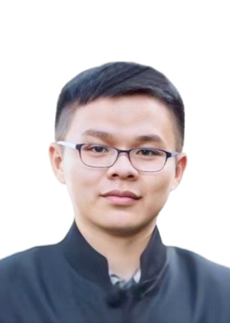

**Yifan Li** received the Ph. D. degree from Hunan University, Changsha, China, in 2023. He is currently a postdoctor with the College of Computer Science and Technology, Zhejiang University of Technology, China. His research interests include spatiotemporal data mining and anomaly detection.

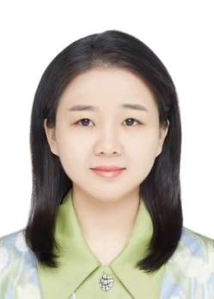

**Mengjue Wang** was born in Zhejiang, China, 1992. She received the BS and MS degrees from Guangxi Medical University in 2019. She is currently a doctor in Xixi Hospital of Hangzhou. Her current research interests include ECG diagnosis and parasite infection.

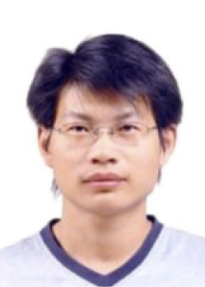

**Mingxiang Guan** received the B.S. degree in electronic engineering, and the M.S. and Ph.D. degrees in information and communication engineering from the Harbin Institute of Technology, in 2002, 2004, and 2008, respectively. He is currently a Full-Time Professor with the School of Electronic Communication Technology, Shenzhen Institute of Information Technology, Shenzhen, China. His main interests include wireless communications, resource allocation, HAPS-based communications and networking, and HAPS-based 5G.

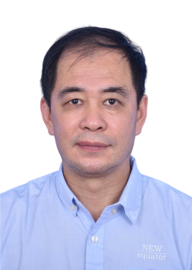

**Chen Lu** is a professor-level senior engineer at Shenzhen Institute of Information Technology. He has previously served as a Ph.D. candidate and associate professor at Xi'an Jiaotong University, a teaching assistant at Xidian University, and a lecturer at the Armed Police Engineering University.

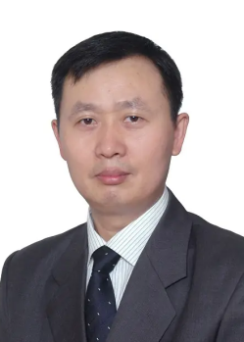

**Zhiyong Li** received the MSc degree in system engineering from the National University of Defense Technology, Changsha, China, in 1996, and the PhD degree in control theory and control engineering from Hunan Uni- versity, Changsha, China, in 2004. In 2004, he joined the College of Computer Science and Electronic Engineering, Hunan University, China, where he is currently a full professor. He has published more than 100 papers in international journals and conferences. His research interests include intelligent perception and autonomous moving body, machine learning and industrial big data, and intelligent optimization algorithms with applications. He is a member of China Computer Federation (CCF) and Chinese Association for Artificial Intelligence (CAAI).



**Tieming Chen** received the Ph.D. degree in computer software and theory from BeiHang University, Beijing, China, in 2011. He is now a professor with the College of Geoinformatics, Zhejiang University of Technology, Hangzhou, China. He is also a member of IEEE and ACM. His research interests include cyberspace security and artificial intelligence.