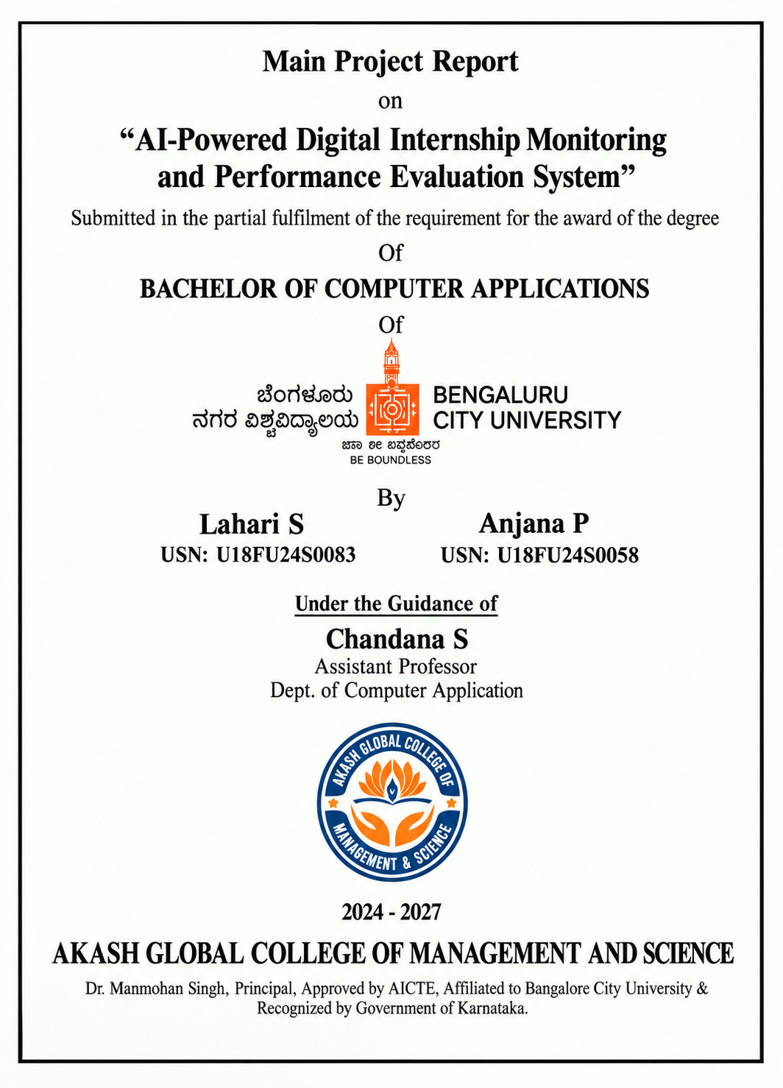
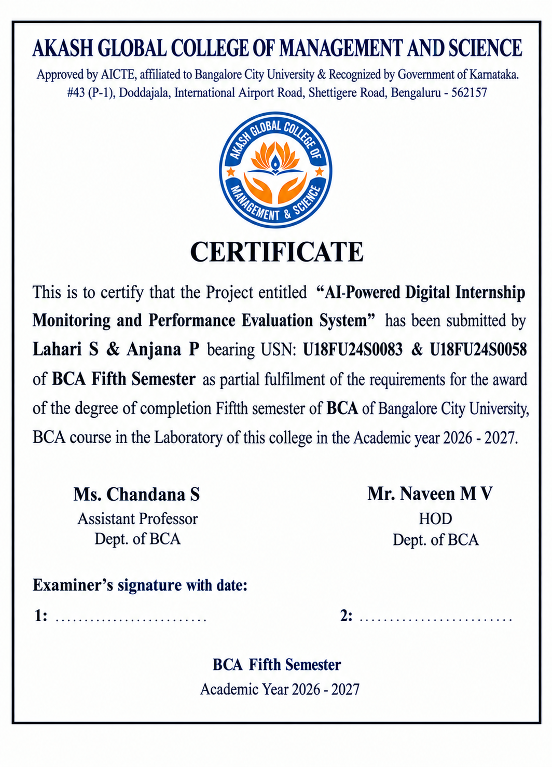

PROJECT TITLE

Powered AI Digital Internship Monitoring and Performance Evaluation System

1.1 ABSTRACT
The AI-Powered Digital Internship Monitoring and Performance Evaluation System is a proposed web-based platform designed to digitally monitor internship activities and evaluate student performance in a structured manner. The system provides a centralized environment where students can record internship activities, tasks, progress and learning outcomes, while guides or administrators can monitor submissions and assess performance. Artificial Intelligence can be used to support analysis of internship records and generate meaningful performance insights. The proposed system aims to reduce manual monitoring, improve transparency, maintain organized internship records, and help students and faculty understand progress and areas for improvement.

2.1 INTRODUCTION
Internships provide students with practical exposure and help them connect academic learning with real-world work. However, monitoring internship activities and evaluating student performance can become difficult when records are maintained manually through documents, messages, spreadsheets, or disconnected systems. The proposed AI-Powered Digital Internship Monitoring and Performance Evaluation System addresses this issue by providing a centralized digital platform for internship management. Students can maintain their internship details and submit activity updates, while faculty or authorized guides can review progress and evaluate performance. AI-supported analysis can assist in identifying patterns in submitted information and presenting useful performance feedback.

3.1 OBJECTIVE AND SCOPE

3.1.1 Objectives
- To provide a centralized digital platform for managing internship activities.
- To allow students to record and submit internship tasks, progress and learning outcomes.
- To enable faculty/guides to monitor student internship progress.
- To provide structured performance evaluation based on defined criteria.
- To use AI-supported analysis for generating performance insights and feedback.
- To maintain organized digital internship records for future reference.

3.1.2 Scope
The system covers student registration/login, internship details, activity or task submission, progress monitoring, guide review, performance evaluation, feedback, reports and AI-supported performance analysis. The proposed system is intended for academic internship monitoring and can be adapted for colleges, departments and internship coordinators.

4.1 METHODOLOGY / SYSTEM DESIGN
The proposed system follows a modular web-application approach. Students and authorized faculty members access the system through role-based login. Students enter internship information and periodically submit task/activity details. Faculty or guides review the submitted records, provide feedback and evaluate performance using defined parameters. The application stores the information in a database and presents progress through dashboards and reports. An AI component can analyze available internship records and evaluation data to identify performance trends, summarize progress and support personalized feedback.

4.1.1 Major Modules
- Student Registration and Login
- Internship Profile and Details Management
- Daily/Weekly Activity and Task Submission
- Document/Report Submission
- Faculty/Guide Monitoring Dashboard
- Performance Evaluation and Feedback
- AI-Based Performance Analysis
- Progress Reports and Notifications
- Admin/Coordinator Management

4.1.2 Basic Workflow
Student Login → Internship Details → Activity/Task Submission → Faculty Review → Performance Evaluation → AI-Based Analysis → Feedback and Reports.

5.1 HARDWARE AND SOFTWARE REQUIREMENTS

5.1.1 Hardware Requirements
- Computer/Laptop with a suitable processor
- Minimum 4 GB RAM (8 GB recommended)
- Sufficient storage for software and project files
- Internet connection for web-based access and deployment

5.1.2 Software Requirements
- Operating System: Windows/Linux/macOS
- Front End: HTML, CSS, JavaScript
- Back End: Python with Django/Flask or another suitable web framework
- Database: MySQL/SQLite or another suitable relational database
- AI/ML: Python-based AI/ML libraries as required
- IDE/Editor: Visual Studio Code or equivalent
- Web Browser: Google Chrome, Mozilla Firefox or Microsoft Edge

6.1 PROJECT DESCRIPTION
The proposed system acts as a digital bridge between students, internship guides and academic coordinators. A student can create an internship profile, enter organization and internship details, and submit regular activities or task reports. The guide can view submissions, verify progress, provide comments and record evaluation scores. The system can maintain attendance/progress indicators, submission history and evaluation records in an organized database. An AI-supported module can analyze the collected information and provide summaries or performance insights to assist faculty in evaluation. Dashboards and reports can make the student's internship progress easier to understand and manage. The system therefore aims to make internship monitoring more systematic, transparent and less dependent on manual record keeping.

7.1 CONCLUSION
The AI-Powered Digital Internship Monitoring and Performance Evaluation System provides a structured approach to managing and monitoring student internships. By combining digital activity tracking, guide evaluation, feedback and AI-supported analysis, the proposed system can reduce manual effort and improve the organization of internship information. It can also help students understand their progress and help faculty maintain consistent records and evaluation.

8.1 FUTURE SCOPE AND APPLICATION
The system can be extended with mobile application support, automated report generation, advanced AI-based feedback, resume/skill mapping, internship recommendation, sentiment analysis of feedback, automated alerts, organization/employer access, certificate management, analytics dashboards and integration with college placement or learning-management systems. It can be applied in colleges and universities to manage academic internships across different departments and programs.

9.1 REFERENCE
- Documentation and learning resources for HTML, CSS and JavaScript.
- Python and web-framework documentation for application development.
- MySQL/SQLite documentation for database management.
- Standard learning resources on Artificial Intelligence and Machine Learning concepts.
5.The project synopsis format supplied by Akash Global College of Management and Science.

