**2.  
3.**

**  
4.**

**5.**

**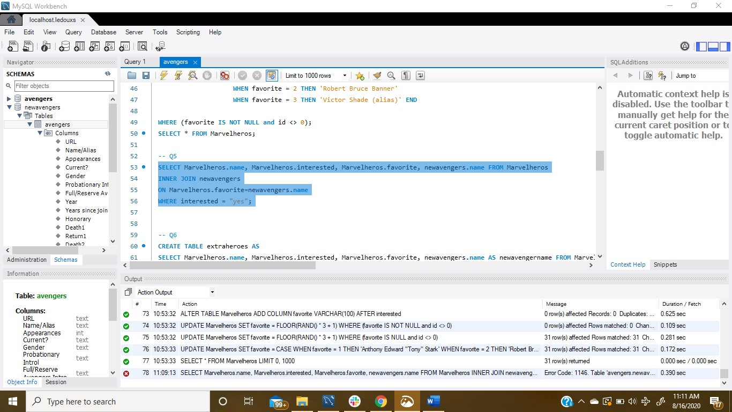  
6.**

**  
  
10.**

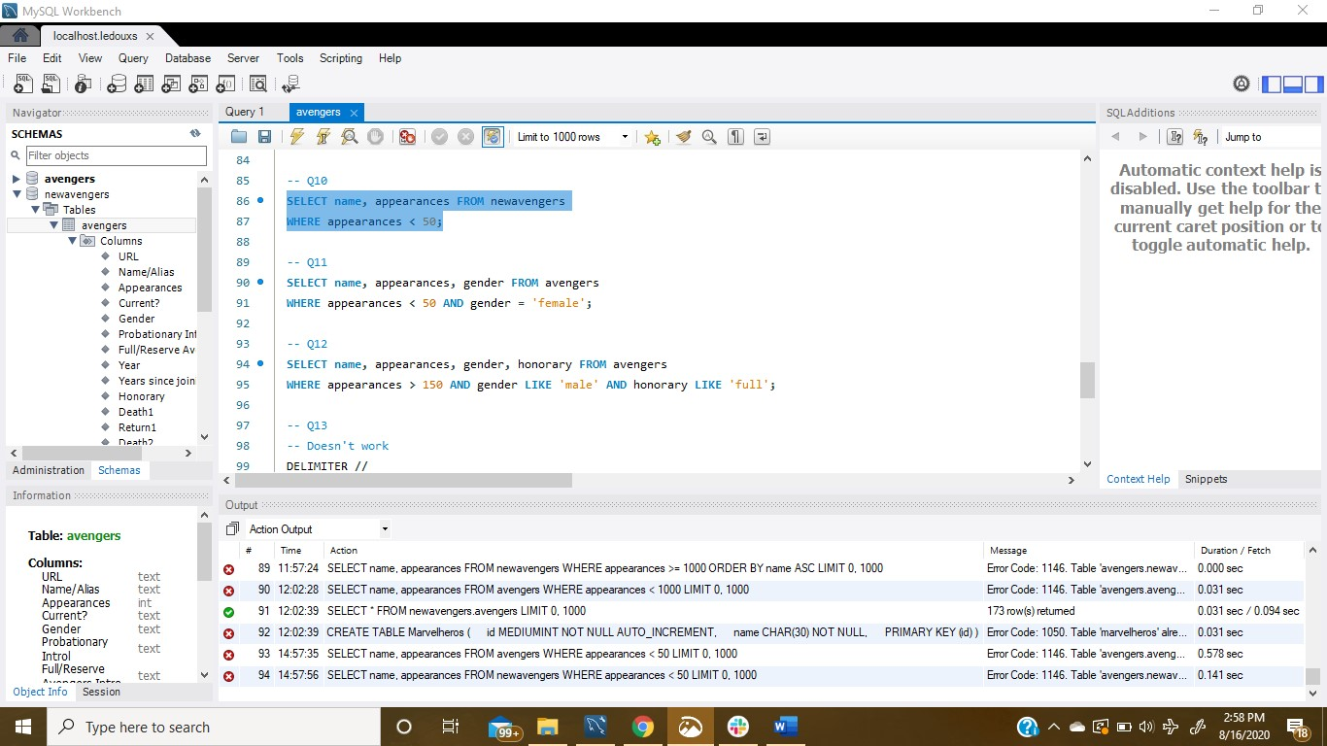

**All of the answers for the questions written out;  
  
SELECT * FROM newavengers.avengers;**

**-- Q2**

**CREATE TABLE Marvelheros (**

**id MEDIUMINT NOT NULL AUTO_INCREMENT,**

**name CHAR(30) NOT NULL,**

**PRIMARY KEY (id)**

**);**

**INSERT INTO Marvelheros (name) VALUES**

**('Spiderman'),('deadpool'),('black panther'),**

**('Jessica Jones'),('Ant-man'),('Luke Cage'),**

**('Captain Marvel'),('Wolverine'),('Rocket'),**

**('Groot'),('Invisible Girl'),('civ1'),**

**('civ2'),('civ3'),('civ4'),**

**('civ5'),('civ6'),('civ7'),**

**('civ8'),('civ9'),('civ10'),**

**('civ11'),('civ12'),('civ13'),**

**('civ14'),('civ15'),('civ16'),**

**('civ17'),('civ18'),('civ19'),('civ20');**

**SELECT * FROM Marvelheros;**

**-- Q3**

**ALTER TABLE Marvelheros**

**ADD COLUMN interested VARCHAR(15) AFTER name;**

**-- NOTE: values were originally NULL, but figuring out how to get the yes/no value lead to them no longer being NULL.**

**UPDATE Marvelheros**

**SET interested = CASE WHEN interested < 0.5 THEN 'yes' ELSE 'no' end WHERE (interested IS NOT NULL and id <> 0);**

**SELECT * FROM Marvelheros;**

**-- Q4**

**ALTER TABLE Marvelheros**

**ADD COLUMN favorite VARCHAR(100) AFTER interested;**

**-- For reseting favorite to numbers during experimentation**

**UPDATE Marvelheros**

**SET favorite = FLOOR(RAND() * 3 + 1) WHERE (favorite IS NOT NULL and id <> 0);**

**-- For reseting favorite to numbers during experimentation**

**UPDATE Marvelheros**

**SET favorite = FLOOR(RAND() * 3 + 1) WHERE (favorite IS NULL and id <> 0);**

**UPDATE Marvelheros**

**SET favorite = CASE WHEN favorite = 1 THEN 'Anthony Edward "Tony" Stark'**

**WHEN favorite = 2 THEN 'Robert Bruce Banner'**

**WHEN favorite = 3 THEN 'Victor Shade (alias)' END**

**WHERE (favorite IS NOT NULL and id <> 0);**

**SELECT * FROM Marvelheros;**

**-- Q5**

**SELECT Marvelheros.name, Marvelheros.interested, Marvelheros.favorite, newavengers.name FROM Marvelheros**

**INNER JOIN newavengers**

**ON Marvelheros.favorite=newavengers.name**

**WHERE interested = "yes";**

**-- Q6**

**CREATE TABLE extraheroes AS**

**SELECT Marvelheros.name, Marvelheros.interested, Marvelheros.favorite, newavengers.name AS newavengername FROM Marvelheros**

**INNER JOIN newavengers**

**ON Marvelheros.favorite=newavengers.name**

**WHERE interested = "yes";**

**SELECT * FROM extraheroes;**

**-- Q7**

**SELECT name, appearances FROM newavengers**

**WHERE appearances >= 1000**

**ORDER BY name ASC;**

**-- Q8**

**SELECT name, appearances FROM newavengers**

**WHERE appearances < 1000;**

**-- Q9**

**SELECT name, appearances FROM avengers**

**WHERE appearances < 500;**

**-- Q10**

**SELECT name, appearances FROM avengers**

**WHERE appearances < 50;**

**-- Q11**

**SELECT name, appearances, gender FROM avengers**

**WHERE appearances < 50 AND gender = 'female';**

**-- Q12**

**SELECT name, appearances, gender, honorary FROM avengers**

**WHERE appearances > 150 AND gender LIKE 'male' AND honorary LIKE 'full';**

**-- Q13**

**-- Doesn't work**

**DELIMITER //**

**CREATE FUNCTION newhero(item VARCHAR(100)) RETURNS VARCHAR(100) DETERMINISTIC**

**BEGIN**

**DECLARE herostatus VARCHAR(100);**

**SELECT if(extraheroes.favorite = "Victor Shade (alias)", extraheroes.name) FROM extraheroes INTO herostatus;**

**RETURN herostatus;**

**END**

**//**

**delimiter ;**

**SELECT * FROM Marvelheros**

**SELECT name FROM extraheros**

**-- Q14**

**DELIMITER //**

**CREATE FUNCTION totalrecords () RETURNS INT DETERMINISTIC**

**BEGIN**

**DECLARE total INT;**

**SELECT DISTINCT count(*) FROM newavengers INTO total;**

**RETURN total;**

**END**

**//**

**delimiter ;**

**SELECT DISTINCT totalRecords() AS total FROM newavengers;**