Are smarter brains more efficient? An investigation of the relationship between intelligence and the alpha parameter of the Levy-Flight Model

Sven Lesche1

1 Ruprecht-Karls-University Heidelberg

Author note

Author Notes go here.

Correspondence concerning this article should be addressed to Sven Lesche, Kurfürsten-Anlage 57. E-mail: [sven.lesche@stud.uni-heidelberg.de](mailto:sven.lesche@stud.uni-heidelberg.de)

Are smarter brains more efficient? An investigation of the relationship between intelligence and the alpha parameter of the Levy-Flight Model

# Introduction

Intelligence is one of the most researched constructs in psychology, playing a crucial role in predicting success in education, job performance, and overall well-being. Understanding the cognitive processes that underpin intelligence has been the focus of decades of research. One of the most robust findings in this area is the relationship between measures of mental speed and intelligence, with faster cognitive processing often associated with higher intelligence.

In a review of 172 studies, Sheppard and Vernon (2008) reported an average correlation of between various mental speed measures and various intelligence measures. Most studies investigating the relationship between intelligence and mental speed use elementary cognitive tasks (ECTs) to obtain a measure of mental speed. ECTs are simple tasks with very low cognitive demands. For example, participants have to respond by key-press in which of two squares a stimulus has appeared. This limits the role of individual differences in strategy and allows researchers to obtain a pure measure of mental speed.

Mental speed is assessed at different levels: behaviorally, through psychophysiological measures, or via cognitive models. Researchers find robust negative correlations between intelligence and both mean response time and variability of response time (Doebler & Scheffler, 2016; Jensen, 2006). More intelligent individuals tend to have lower mean response times and lower variability in response times. Using EEG measures, Schubert et al. (2017) found that the latency of event-related potentials are able to explain 80% of the variance in intelligence. In cognitive models, evidence accumulation models like the drift-diffusion model (DDM) (**ratcliff2007diffusion?**) are employed to obtain model parameters of mental speed.

The DDM assumes that participants steadily accumulate evidence during a trial. Once they have accumulated enough evidence pointing towards a response, a decision and subsequent reaction is made. The model attempts to fit the empirical distribution of response times and accuracies by optimizing several different parameters. First, response time is separated into decision time, where the noisy evidence accumulation process takes place, and non-decision time . Non-decision time incorporates processes such as stimulus encoding and motor processes. Decision time is further controlled by three main parameters: (1) the boundary separation describes the distance between decision boundaries and represents the amount of evidence required to reach a decision, (2) the mean drift rate is the average rate at which evidence is accumulated and (3) the mean starting point *z* represents the average point at which the evidence accumulation process begins and can account for an a-priori bias towards one of the two-choice alternatives.

Further parameters of across-trial variability can be added to reflect changes in diffusion model parameters over time. Variability of the starting point *sz* accounts for differences in a-priori bias towards one response alternative across trials (**laming1968?**; **ratcliff1998?**). Variability of drift rate reflects changes in drift rate across trials and allows the model to account for systematic differences between trials, such as error responses being systematically faster than correct responses (**ratcliff1978?**; **ratcliff1998?**). Finally, variability of non-decision time *st* reflects fluctuations in the duration of encoding or motor-execution processes across trials.

Of these parameters, drift rate has so far shown the most robust correlation to intelligence [citations]. Other parameters have shown…

The DDM makes the assumption that noise is … This means that large jumps are unlikely… Recently, (**LEVY?**) introduced a new version taht includes alpha… This is able to account for fast errors and fits data better (**LEVY?**).

From a variability perspective, you would expect alpha to correlate psotively with intelligence. This is inefficient jumping hypothesis. However, you could also argue that… “effecient jumping” here, the noise is used efficienlty.

This study focuses on determining this issue. We will use data from Schubert et al. (2017) and fit the levy flight model. Then investigate …

Because Schubert et al. (2016), we will fit this to multiple tasks and conditions and obtain a latent factor over alpha to account for measurement error. Then, we will check the correlation with intelligence.

Positive correlations would mean… Negative correlations would mean…

# Methods

## Participants

The data I analyse here was published in Schubert et al. (2017). The original study consisted of three measurement occasions and included EEG measurements in the first and last measurement occasion. The present analysis focuses on the behavioral data collected during the first two measurement occasions. The sample consists of N = 122 (72 female, ) participants. All of the participants had normal or corrected to normal vision, no history of mental illness, provided informed consent, and received 100€ for their participation.

## Materials

I will focus on behavioral data from the Hick, Sternberg, and Posner Tasks. Detailed information can be found in the original publication (Schubert et al., 2017).

Intelligence was measured using a computer-adapted version of Raven’s Advanced Progressive Matrices (APM) (Raven, 1981) and the Berlin Intelligence Structure Test (BIS) (Jäger et al., 1997).

## Procedure

The first two measurement occasions were spaced approximately four months apart. The Hick, Sternberg, and Posner Tasks were administered at the first measurement occasion in the same order for all participants. The APM and BIS were administered at the second measurement occasion.

## Analysis

### Levy-Flight Model.

I estimated the parameters of the Levy-Flight model using BayesFlow (Radev et al., 2020). I used accuracy coding, with the upper boundary representing a correct response and the lower boundary representing an incorrect response. Hence, I fixed the start point to 0.5. I allowed drift rate , boundary separation , non-decision time , variability in the non-decision time and to vary between tasks and conditions.

To train the neural approximator, I employed the following priors:

I simulated 200,000 datasets and then trained the model for 150 epochs. After training, I investigated the computational faithfulness of the neural network by using simulation-based calibration (Talts et al., 2018). I investigated the bias of the posterior distributions after applying the amortized inference network on newly simulated data. Furthermore, I investigated the ability of the model to recover true generating parameters by comparing the posterior mean to the true parameters used in simulation.

### Structural Equation Model.

I used structural equation modelling to evaluate the correlation between a latent first order factors of the alpha parameter over all tasks and a g factor over all intelligence measures. In addition to the first order factor over all tasks and conditions, I included task-specific method factors. Intelligence was defined as a first order factor over all sub-tests of the BIS as well as the APM. I then investigated the relationship between latent the latent factors alpha and g.

# Results

Model estimation was done in Python 3.11 with Bayesflow version 1.1.6 (Radev et al., 2020). Data analysis was done in R [Version 4.3.2; R Core Team (2023)][1].

I excluded all response times which deviated more than 3 standard deviations from the mean response time for a given participant in a given condition. This removed 1.33 % of the data in the Hick task, 1.59 % of the data in the Posner task, and 1.68 % of the data in the Sternberg task. No further data-pruning was applied.

## Levy Flight Model estimation

The inference net showed no sign of bias in posterior estimation (see Figure 1). It also displayed acceptable recovery of true generating parameters (see Figure 2).

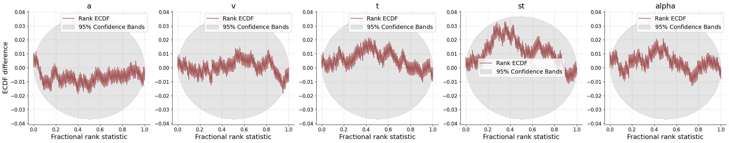

Figure 1: Empirical Cumulative Density Functions of Rank Statistics

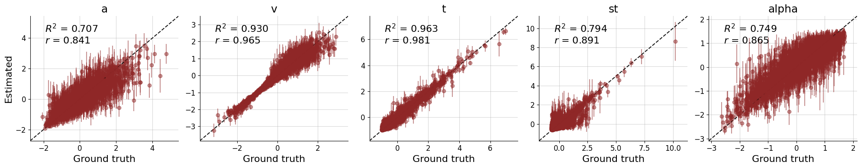

Figure 2: Recovery of true model parameters

## Relationship of alpha and g

On a bivariate level, alpha displayed consistently negative correlations with all cognitive performance measures (see Figure 3). Averaged over tasks and conditions, alpha showed a correlation with performance in the APM of -0.18 and -0.16 in the BIS.

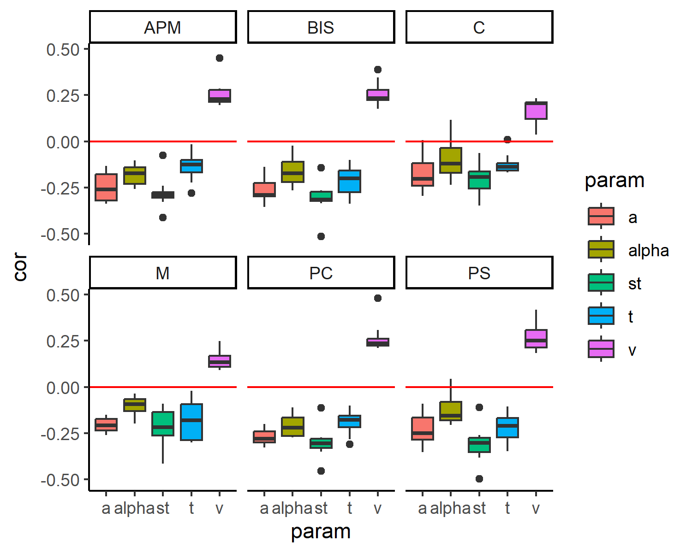

Figure 3: Bivariate Correlation between parameters and cognitive performance

## SEM

The measurement model with method factors for all three tasks failed to fit. This full model always estimated the variance of one of the method factors to be negative. I therefore excluded one of the method factors from the model (Steyer et al., 1999) and only retained a factor for the Sternberg and Posner Task.

The model showed acceptable fit = 140.16, p < .001, CFI = 0.89, RMSEA = 0.08 and can be seen in Figure 4. On a latent level alpha and g correlated to .

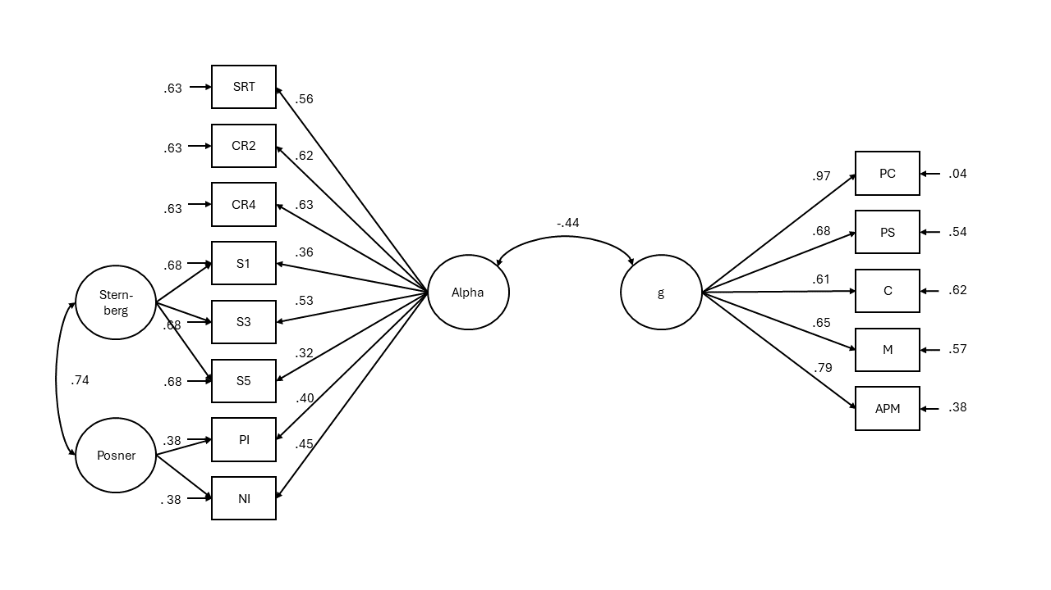

Figure 4: Structural Equation Model of Alpha and Intelligence

# Discussion

Low correlations, but negative direction. Need to extend this to more difficult tasks. (Sternberg may already be a difficult task)

We used the SEM to measure trait alpha across tasks, as recommended in Schubert et al. (2016)

This is in contrast to the findings that less variable results are found in more intelligent individuals maybe in the ongoing variability discussion

You could talk about relationship of alpha and mean rt / sd_rt.

# References

Aust, F., & Barth, M. (2023). *papaja: Prepare reproducible APA journal articles with R Markdown*. <https://github.com/crsh/papaja>

Doebler, P., & Scheffler, B. (2016). The relationship of choice reaction time variability and intelligence: A meta-analysis. *Learning and Individual Differences*, *52*, 157–166.

Jäger, A. O., Süß, H.-M., & Beauducel, A. (1997). *Berliner Intelligenzstruktur-Test: BIS-Test*.

Jensen, A. R. (2006). *Clocking the mind: Mental chronometry and individual differences*. Elsevier.

R Core Team. (2023). *R: A language and environment for statistical computing*. R Foundation for Statistical Computing. <https://www.R-project.org/>

Radev, S. T., Mertens, U. K., Voss, A., Ardizzone, L., & Köthe, U. (2020). BayesFlow: Learning complex stochastic models with invertible neural networks. *IEEE Transactions on Neural Networks and Learning Systems*, *33*(4), 1452–1466.

Raven, J. (1981). Manual for Raven’s progressive matrices and Mill Hill vocabulary scales. *(No Title)*.

Rosseel, Y. (2012). lavaan: An R package for structural equation modeling. *Journal of Statistical Software*, *48*(2), 1–36. <https://doi.org/10.18637/jss.v048.i02>

Schubert, A.-L., Frischkorn, G. T., Hagemann, D., & Voss, A. (2016). Trait characteristics of diffusion model parameters. *Journal of Intelligence*, *4*(3), 7.

Schubert, A.-L., Hagemann, D., & Frischkorn, G. T. (2017). Is general intelligence little more than the speed of higher-order processing? *Journal of Experimental Psychology: General*, *146*(10), 1498–1512. <https://doi.org/10.1037/xge0000325.supp>

Sheppard, L. D., & Vernon, P. A. (2008). Intelligence and speed of information-processing: A review of 50 years of research. *Personality and Individual Differences*, *44*(3), 535–551.

Steyer, R., Schmitt, M., & Eid, M. (1999). Latent state–trait theory and research in personality and individual differences. *European Journal of Personality*, *13*(5), 389–408.

Talts, S., Betancourt, M., Simpson, D., Vehtari, A., & Gelman, A. (2018). Validating Bayesian inference algorithms with simulation-based calibration. *arXiv Preprint arXiv:1804.06788*.

Wickham, H., Averick, M., Bryan, J., Chang, W., McGowan, L. D., François, R., Grolemund, G., Hayes, A., Henry, L., Hester, J., Kuhn, M., Pedersen, T. L., Miller, E., Bache, S. M., Müller, K., Ooms, J., Robinson, D., Seidel, D. P., Spinu, V., … Yutani, H. (2019). Welcome to the tidyverse. *Journal of Open Source Software*, *4*(43), 1686. <https://doi.org/10.21105/joss.01686>

1. We, furthermore, used the R-packages *lavaan* (Version 0.6.18; Rosseel, 2012), *papaja* (Version 0.1.2; Aust & Barth, 2023), and *tidyverse* (Version 2.0.0; Wickham et al., 2019).