NS Lab 4 Answer Sheet
NS3 simulator - TCP Performance Monitoring
Student Name: Sander
Student Surname: In 't Veld
Student Number: 10277935

Chariklis Pittaras (c.pittaras@uva.nl)
Karel van der Veldt (karel.vd.veldt@uva.nl)
Koen Koning (koen.koning@gmail.com)
Lab date: Sep 19 & 23 2013
Hand-in time (submit to blackboard) by Sep 30, 2013 13:00CEST
Total points: 20 pts
Please provide your answer in the appropriate space for each question

Task 1 – Throughput of TCP client-server connection
- See the text files output-task1-64-16k.txt, output-task1-96-16k.txt and output-task1-128-16k.txt.
Latency | Measured Throughput | Calculated Throughput | Calculation
64ms | 1.03Mbps | 1.02 Mbps | (16384 * 8 / 10^6) / (0,064 * 2)
96ms | 0.68 Mbps | 0.68 Mbps | (16384 * 8 / 10^6) / (0,096 * 2)
128ms | 0.51 Mbps | 0.51 Mbps | (16384 * 8 / 10^6) / (0,128 * 2)
Here, an Mbit is (apparently) a million bits, as opposed to a 1024^2 bits.
- Yes, it inversely affects throughput. The TCP client waits to submit more than RWIN bytes until it receives an ACK; the client has to wait longer if the latency is bigger.

- Optimal RWIN value: 51200 bytes
Calculation: ((3.2 * 10^ 6) * (0.064 * 2)) / 8
- 3.10 Mbps. See output-task1-optimal.txt.

Task 2 – Monitoring TCP congestion window
1. From 1s to 1.5s, we have the slow start phase where cwnd grows exponentially. After that, TCP enters the congestion avoidance phase where cwnd grows much more slowly. See cwnd-part1.log and cwnd-part1.png (Figure 1).
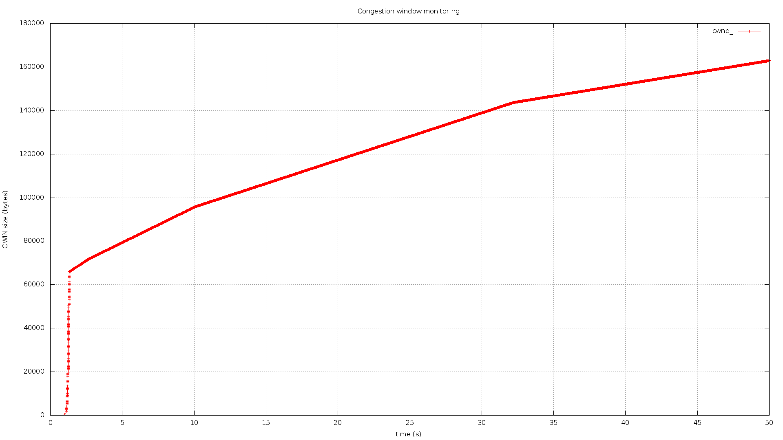
Figure 1: Tahoe – droptail queue = 100

2.a.

Figure 2: Tahoe, droptail queue = 40

2.b
Figure 3: Tahoe, droptail queue = 40 (from 1 until 1.85 secs)

State changes, Tahoe – from 1 until 1.85 secs
Time (sec, accuracy 3 decimal) | cwnd (bytes) | New state
1.000 | 1 | (initial state)

2.c

Figure 4: Tahoe, droptail queue = 40 (from 4 until 6 secs)

State changes, Tahoe – from 4 until 6 secs
Time (sec, accuracy 3 decimal) | cwnd (bytes) | New state
4.000 |  | (initial state)

3.a
Figure 5: Reno, droptail queue = 40

3.b

Figure 6: Reno, droptail queue = 40 (from 4 until 6 secs)

State changes, Reno – from 4 until 6 secs
Time (sec, accuracy 3 decimal) | Current cwnd (bytes) | New cwnd (bytes) | New state | Event
4.000 |  | --- | (initial state) | ---

Submission
You have to submit:
- Your answers to all the questions. Use this provided answer sheet for you answers and graphs. Provide your answers in the appropriate answer field for each question
- The source codes of the two tasks.
- The graphs and the produced data.
Attention: You have to submit one PDF file that contains all the answers and graphs; the name of the file should be lab4-<lastname_firstletter>.pdf (example: lab1-vanderveldt_k.pdf, or lab1-pittaras_c.pdf). Additionally you have to submit one zip (or rar) file containing the source codes, the graphs and the data. The name of the file should be: lab4-source-<lastname_firstletter>.zip
Any other kind of submission will not be taken into account. You must also put your full name and your student number at the top of the answer sheet.

