**CACIE Tool #NN** – **SRC2STOMP Tool**

**Version** **1.0**

**QA**: **QA**

# Description and Purpose

The SRC2STOMP tool combines the site spatial information with the corresponding inventory and creates a STOMP-readable source card file containing grid cell definitions of fluxes (solute and/or liquid) for the model simulation.

Assigning solute and volumetric fluxes depends on the sites’ corresponding area. The SRC2STOMP tool will select STOMP grid cells to approximate each site’s respective footprint except in the case of ancillary equipment sites. Ancillary equipment site areas are honored, less the area covered by sites inside the ancillary equipment site area. Site areas are “approximated” based on the STOMP grid resolution.

# Functional Requirements

The following are the functional requirements (FR) of the SRC2STOMP tool:

FR-1: Sites are included if they are (partly) located in either the buffer or source zone of a vadose zone model (as specified in the control file).

FR-2: STOMP grid cells are selected for each site to best match the actual area of the site (except for ancillary equipment sites) based on spatial information obtained from the site geometry CSV file.

FR-3: STOMP grid cells that are (partly) located in an ancillary equipment site and another site are not assigned to the ancillary equipment site. After removing these cells, all remaining cells will be assigned to any ancillary equipment site(s) they intersect with or remain unassigned if they don’t intersect with any sites.

FR-4: Select STOMP grid cells based on their overlapping area with the site by selecting cells in descending order of total overlapping area until adding another cell diverges from the actual site area (obtained from the site geometry CSV file).

FR-5: Cells that share the same coincident area of the site (i.e. equal areas of overlap between cells and site) are sorted by their distance from the site centroid. Cells closer to the centroid take precedence over other cells.

FR-6: In the STOMP source card comment block, identify the site name corresponding to the sources listed below the site comment block.

FR-7: In the STOMP source card comment blocks, identify the waste stream type (liquid or solid) of the corresponding sources listed below the site comment block.

FR-8: Inventory associated with sites that partially overlap the buffer or source zone are scaled using the ratio of the site area in the buffer/source zone(s) to the total site area.

FR-9: Inventory is assigned as a rate over the selected cells. Rates are calculated by dividing the inventory per time period by the number of cells selected.

FR-10: Liquid inventory releases are treated as discrete events in time where each recorded year and associated inventory is assumed to be uniformly distributed from January 1st through December 31st of the corresponding year.

FR-11: Solid release inventory is considered a continuous timeseries starting/ending on January 1st of the years recorded.

FR-12: Liquid inventory is written to the STOMP source cards as a “Volumetric Aqueous” type source for liquids and, if the liquids contain analytes, one or more “Solute” type source(s).

FR-13: Solid release inventory is written to the STOMP source card as a single “Solute” type source per site comment block.

FR-14: No solid release inventory is included if the “No Solid” option is specified in the control card (line 7).

FR-15: An output file with the file extension “.card” is created, containing STOMP-formatted text corresponding with all other functional requirements described.

FR-16: Only analytes specified by the user in the control file are included in the output file if inventory is present. Water inventory is always included (where present).

# Software Requirements Specifications

The Perl programming language was used to develop this script. The Perl v5.18.2 interpreter was used in conjunction with the following libraries:

* Data
* Math/Geometry
* Math/Polygon

# Software Design Description

Arguments:

The tool is executed from the command line in a Linux terminal in the following manner:

$ perl ca-src2stomp.pl control_file.ctl

Where:

* “ca-src2stomp.pl” is the file name of the tool and
* “control_file.ctl” is a text file (name can be changed) specifying the inputs and options used by the tool

Input Files:

The “control_file.txt” file is the only argument required by the SRC2STOMP tool. Its contents are as follows (line-by-line):

* Path (relative or absolute) to the STOMP grid vertices file (“*.sij”)
  + File format must match the format generated by the CAST tool
* Path (relative or absolute) to the STOMP grid topmost active layer file (“.top”)
  + File format must match that generated by the CAST tool
* Path (relative or absolute) to the source and buffer zones definition file (containing coordinates for the source and buffer zones for each model)
* The matching key or text for the corresponding model and source zone being modeled (e.g. “afarms_source_zone” excluding the quotation marks)
  + The first row is a header row (ignored)
  + Model zones are listed in the first column, only one instance of the zone name is given per group of vertices belonging to the zone
  + The second column consists of the vertices belonging to each model zone as an array (listed as rows in the same column)
* The sites geometry file, which is a CSV-formatted file containing the vertices of the site boundary footprints
  + The first row is a header row (ignored)
  + Waste site names will appear in the first column, only one instance of the site name is given per group of vertices belonging to the site
  + The second column consists of the vertices belonging to each waste site as an array (listed as rows in the same column)
* Path to the preprocessed inventory file which has 13 header rows, 11 of which are comments. The 13th row is a listing of the units for each column. The 12th header row contains the following column names (corresponding to each subsequent row):
  + Inventory Module
  + SIMV2 site name
  + CA site name
  + Source Type
  + Volume [m3]
  + Discharge/decay-corrected year
  + C-14
  + Cl-36
  + H-3
  + I-129
  + Np-237
  + Re-187
  + Sr-90
  + Tc-99
  + U-232
  + U-233
  + U-234
  + U-235
  + U-236
  + U-238
  + Th-230
  + Ra-226
  + U
  + Cr
  + NO3
  + CN
* Flag whether to include “Solid[s]” or “No Solid[s]”
* Flag whether to limit to area-conservative representations of sites (only “Limited” is available)
* Base name of output files
* Number of inventory types to include (positive integer value)
* Name(s) of constituents to be included, must match up with the column heading in the preprocessed inventory file (listed/described above). The number of constituents must match with the number specified in the previous line. Each constituent should be separated by a newline character (only one constituent per line)

Output Files:

The output file of interest is the <base file name>.card which is a STOMP-formatted source card including inventory release information for the sites and analytes included (specified in the control file and associated input files).

Other outputs are extraneous and will not be qualified but serve as meta files for the tool execution. These auxiliary outputs include a log file, 2 cumulative summary tables, a list of input sources, and a list of sites included in the source card.

Tool Runner:

The following is the shell script configuration that will be passed as an argument to the Tool Runner for qualified runs:

{directory path to repository}\tools\ca-src2stomp\ca-src2stomp.pl “$CONTROL_FILE”

The shell script variable (indicated by the “$”) will be set in the shell script with the path to the control file (refer to the section of this document describing “Input Files”).

Code Review:

Jacob Fullerton performed a code review. No impacts to other repository tools or library dependencies were identified for the SRC2STOMP tool.

# Requirements Traceability Matrix

The requirements traceability matrix for the SRC2STOMP tool is presented in Table 1.

| Table  Requirements Traceability Matrix | | |
| --- | --- | --- |
| **Functional Requirement ID** | **Acceptance Test ID** | **Test Case** |
| QA Level | CACIE- SRC2STOMP-IT-1 | Installation Test |
| FR-1 | CACIE- SRC2STOMP-AT-1 | Run the SRC2STOMP tool for the source area, excluding solids and including no analytes (will always include water). |
| FR-2 | CACIE- SRC2STOMP-AT-1 | Run the SRC2STOMP tool for the source area, excluding solids and including no analytes (will always include water). |
| FR-3 | CACIE- SRC2STOMP-AT-2 | Run the SRC2STOMP tool for the source area, including solids and 2 analytes: C-14, and Ra-226. |
| FR-4 | CACIE- SRC2STOMP-AT-1 | Run the SRC2STOMP tool for the source area, excluding solids and including no analytes (will always include water). |
| FR-5 | CACIE- SRC2STOMP-AT-1 | Run the SRC2STOMP tool for the source area, excluding solids and including no analytes (will always include water). |
| FR-6 | CACIE- SRC2STOMP-AT-1 | Run the SRC2STOMP tool for the source area, excluding solids and including no analytes (will always include water). |
| FR-7 | CACIE- SRC2STOMP-AT-2 | Run the SRC2STOMP tool for the source area, including solids and 2 analytes: C-14, and Ra-226. |
| FR-8 | CACIE- SRC2STOMP-AT-1 | Run the SRC2STOMP tool for the source area, excluding solids and including no analytes (will always include water). |
| FR-9 | CACIE- SRC2STOMP-AT-2 | Run the SRC2STOMP tool for the source area, including solids and 2 analytes: C-14, and Ra-226. |
| FR-10 | CACIE- SRC2STOMP-AT-2 | Run the SRC2STOMP tool for the source area, including solids and 2 analytes: C-14, and Ra-226. |
| FR-11 | CACIE- SRC2STOMP-AT-2 | Run the SRC2STOMP tool for the source area, including solids and 2 analytes: C-14, and Ra-226. |
| FR-12 | CACIE- SRC2STOMP-AT-1  &  CACIE- SRC2STOMP-AT-2 | Run both tests to corroborate that the tool will only output “Solute” where other analytes are specified. If no analytes are included then only “Aqueous Volumetric” should be written to the output card. |
| FR-13 | CACIE- SRC2STOMP-AT-2 | Run the SRC2STOMP tool for the source area, including solids and 2 analytes: C-14, and Ra-226. |
| FR-14 | CACIE- SRC2STOMP-AT-3 | Run the SRC2STOMP tool for the buffer area, excluding solids and do not specify any analytes to include in the output. |
| FR-15 | CACIE- SRC2STOMP-AT-1 | Run the SRC2STOMP tool for the source area, excluding solids and including no analytes (will always include water). |
| FR-16 | CACIE- SRC2STOMP-AT-2 | Run the SRC2STOMP tool for the source area, including solids and 2 analytes: C-14, and Ra-226. |

# Installation Test Plan and Acceptance Test Plan Cases

The installation test plan for SRC2STOMP is presented in Table 2 and the acceptance test plan cases for SRC2STOMP are presented in Table 3 through Table 6.

| Table  **SRC2STOMP Installation Test Plan** | | | |
| --- | --- | --- | --- |
| **SRC2STOMP Installation Testing**  **CACIE-SRC2STOMP – IT-1** | | **Date:** | |
| **Tool Runner Log File Location for this test:** | | **Test Performed By: [FIRST & LAST NAME]** | |
| **Testing Directory:** | | | |
| **Test Step** | **Test Instruction** | **Expected Result** | **Test Result  (Pass/Fail)** |
| Tools Code Repository Directory: | | | |
| Navigate to the testing directory | | | |
| 1 | Invoke Tool runner and test the tool using ***runner_run_IT-1_ SRC2STOMP.sh*** as follows: Open a Linux terminal and after navigating to the appropriate directory indicated  *./runner_run_IT-1_SRC2STOMP.sh* | | |
| 2 | Verify Tool Runner and tool is invoked and executed. | Open ./IT-1/runner_run_IT-1_SRC2STOMP_log.txt and look for a line that states the following: “Can't open not_a_file file No such file or directory”  (Do not include the quotes in your search) |  |

| Table  **SRC2STOMP Acceptance Test Plan Case 1** | | | |
| --- | --- | --- | --- |
| **SRC2STOMP Acceptance Testing**  **CACIE-SRC2STOMP – AT-1** | | **Date:** | |
| **Tool Runner Log File Location for this test:**  **\\olive\backups\CAVE\CA-CIE-Tools-TestEnv\src2stomp** | | **Test Performed By: [FIRST & LAST NAME]** | |
| **Testing Directory: \\olive\backups\CAVE\CA-CIE-Tools-TestEnv\src2stomp** | | | |
| **Test Step** | **Test Instruction** | **Expected Result** | **Test Result  (Pass/Fail)** |
| Navigate to the Testing Directory | | | |
| 1 | Invoke Tool runner and execute the tool using ***runner_run_AT-1_ SRC2STOMP.sh***. Open a Linux terminal and after navigating to the appropriate directory indicated and execute the following command: *./runner_run_AT-1_SRC2STOMP.sh* | | |
| 2 | A new folder called “AT-1” should have been created. Navigate inside of that directory and verify that a file called ***source-aq.card*** was created. | A file entitled “source-aq.card” should be present in the folder indicated. This satisfies the following FR:  FR-15 |  |
| 3 | Navigate to the “AT-1” directory and open the ***source-aq.card*** in a text editor of your choice | | |
| 4 | Verify that the following phrases are in the file (ordering is not important):   * “# Site = Liquid/Solid_1” * “# Site = Liquid_1” * “# Site = Liquid_2” | The phrases specified in quotations should all be present in the file. This satisfies the following FR:  FR-6 |  |
| 5 | Verify that the following cells were selected for the corresponding sites:   |  |  | | --- | --- | | **Site** | **Node (I, J)** | | Liquid/Solid_1  (see Figure 1) | 31, 25 | | 32, 25 | | Liquid_1  (see Figure 2) | 35, 31 | | 36, 31 | | 37, 31 | | 35, 32 | | 36, 32 | | 37, 32 | | 35, 33 | | 36, 33 | | 37, 33 | | Liquid_2  (see Figure 3) | *(49, 31)  *(49, 33) | | 50, 31 | | 49, 32 | | 50, 32 | | 50, 33 | | * - These cells are interchangeable, but only one of the two should be selected at any given time | | | Find each site in its corresponding comment block. Look immediately below the comment block to find the line(s) that start with the phrase “Aqueous Volumetric“ and look at the cells assigned. The way to read this is the following:  Aqueous Volumetric, [start-i], [end-i], [start-j], [end-j], [start-k], [end-k], [no. conditions to follow]  Satisfies the following FR’s:  FR-1, FR-4, and FR-5 |  |
| 6 | Each cell of the STOMP grid is a 10m x 10m cell. Verify that the number of cells selected corresponds with the area of each site:   |  |  |  |  | | --- | --- | --- | --- | | **Site** | **Total Area [m2]** | **Area in Source Zone [m2]** | **Expected No. of Cells** | | Liquid/Solid_1 | 200 | 200 | 2 | | Liquid_1 | 900 | 900 | 9 | | Liquid_2 | 900 | 450 | 5 | | Verify that each site has the appropriate number of cells selected.  Satisfies the following FR:  FR-2 |  |
| 7 | The total volume of water associated with the Liquid_2 site is 2,220 m^3. However, because Liquid_2 only overlaps the selected model zone with half of its total area, only half of the total water inventory should be represented in the source card.  This means that for this source card, a total of 1,110 m^3 should be specified for the Liquid_2 site for this source card. | | |
| 8 | Calculate the total volume of water assigned to Liquid_2 in the source card by multiplying the rate by the time elapsed by the number of cells (should be 5 cells, as determined in step 6). | A total volume of 1,110 m^3 of water should be calculated from the source card for Liquid_2. This satisfies the following FR:  FR-8 |  |
| 9 | Verify that the word “Solute” is not present in the ***source-aq.card*** file. | If the word “Solute” is not present, this corroborates that if only water is supplied (no other analytes), only “Volumetric Aqueous” is written to the output. This partially satisfies the following FR:  FR-12 |  |

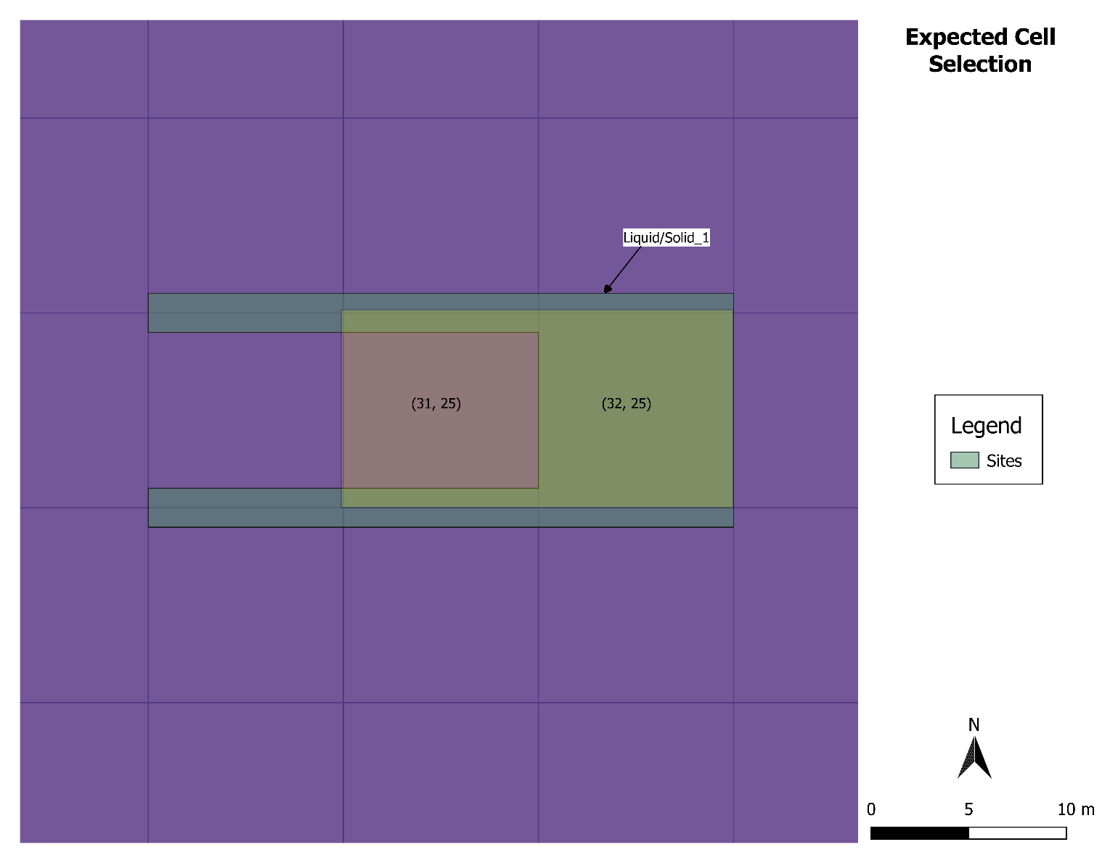

Figure . Expected Cell Selection (Yellow w/ Cell ID’s) for Liquid/Solid_1 Site

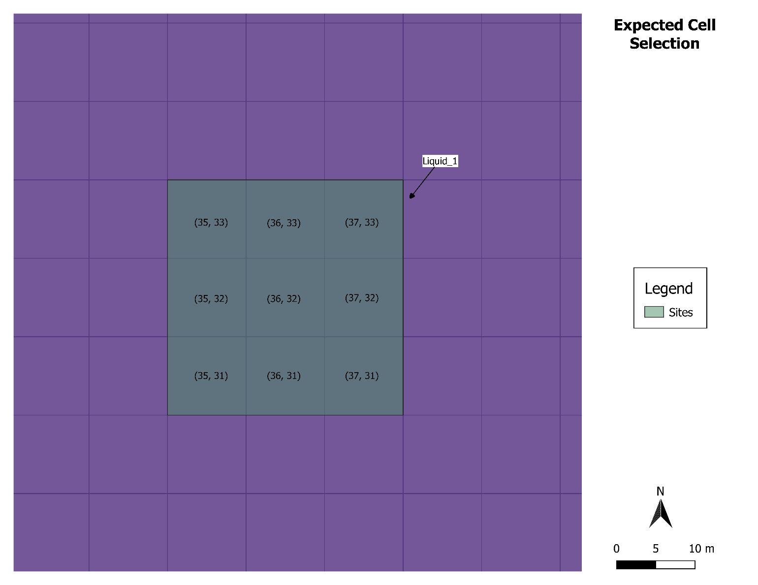

Figure . Expected Cell Selection for Liquid_1 Site

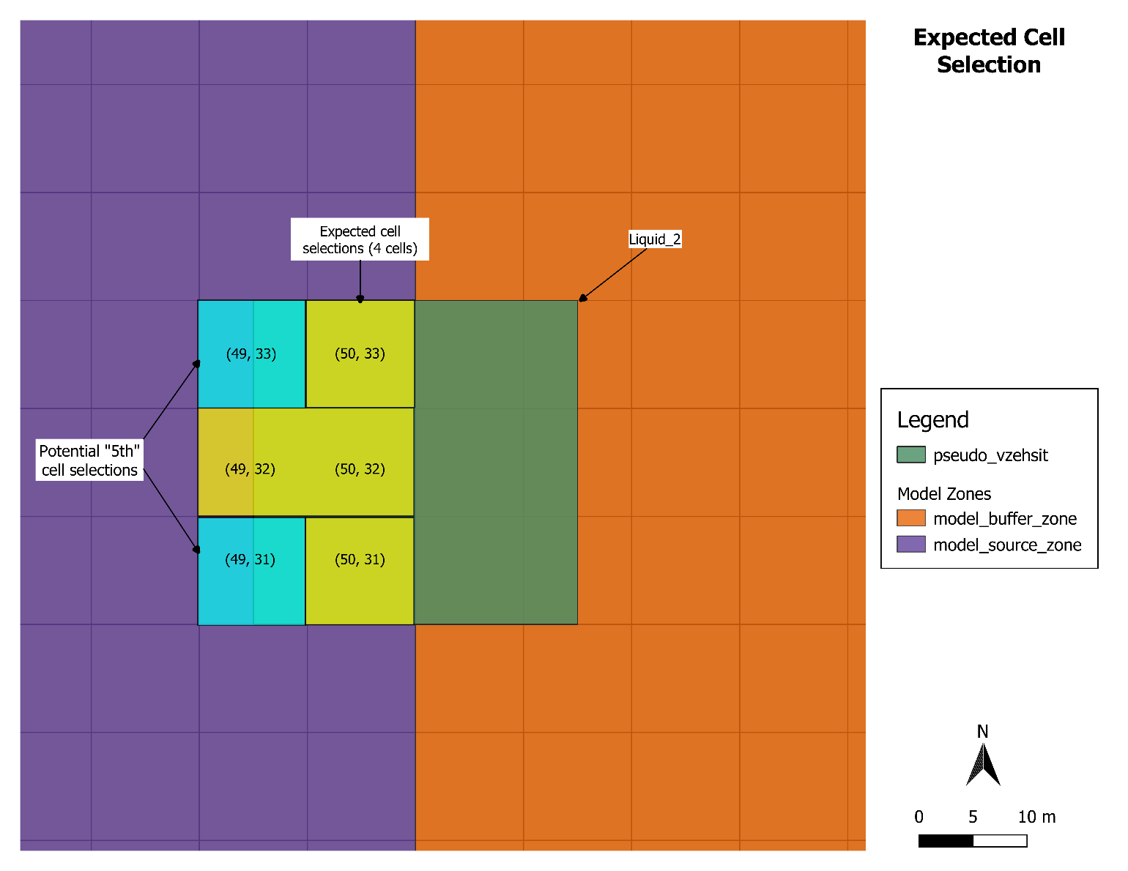

Figure . Expected Cell Selections for Liquid_2 Site

| Table  **SRC2STOMP Acceptance Test Plan Case 2** | | | |
| --- | --- | --- | --- |
| **SRC2STOMP Acceptance Testing**  **CACIE-SRC2STOMP – AT-2** | | **Date:** | |
| **Tool Runner Log File Location for this test:**  **\\olive\backups\CAVE\CA-CIE-Tools-TestEnv\src2stomp** | | **Test Performed By: [FIRST & LAST NAME]** | |
| **Testing Directory: \\olive\backups\CAVE\CA-CIE-Tools-TestEnv\src2stomp** | | | |
| **Test Step** | **Test Instruction** | **Expected Result** | **Test Result  (Pass/Fail)** |
| Navigate to the Testing Directory | | | |
| 1 | Invoke Tool runner and execute the tool using ***runner_run_AT-2_SRC2STOMP.sh*** | | |
| 2 | A new folder called “AT-2” should have been created. Navigate inside of that directory and open the file called ***source-inv-src.card*** in a preferred text editor. | | |
| 3 | Look through the comments of the ***sourc-inv-src.card*** and verify that the following sites are present with a line (2 lines below the site name) stating whether the site is a “non-liquid site = solid release series” or a “liquid site = liquid”:   |  |  | | --- | --- | | **Site** | **Type\*** | | Liquid_1 | liquid site = liquid | | Liquid_2 | liquid site = liquid | | Solid_4 | non-liquid site = solid release series | | Solid_5 | non-liquid site = solid release series | | ANC_1 | non-liquid site = solid release series | | Liquid/Solid_1 | liquid site = liquid | | non-liquid site = solid release series | | * - Specified 2 lines below site name | | | The “Liquid/Solid_1” site has a special status as it should be mentioned twice: once as a liquid site, and again as a solid site. If all sites match up as specified in the table provided in the test instruction, this will satisfy the following FR:  FR-7 |  |
| 4 | The total number of cells that should be selected for the ANC_1 site should add up to 214 (total area of 21,400 m^2). To verify the cell selection, you will need to read each line of the source card for an analyte (belonging to the ancillary equipment site) and tally up the count.  The best way to do this is to search for the ANC_1 site, then read each line for a single analyte (e.g. C-14) and count the number of cells. The phrase to search on (remember to do this only for the ANC_1 site) is “Solute, C-14,” (using the phrase inside quotation marks). A full listing of the expected cells is included in Table 5 along with a visual in Figure 4. | There should be 214 cells in total for the ancillary site, totaling 21,400 m^2 in area. If only the 214 cells shown in Table 5 are included in the source card, this will satisfy the following FR:  FR-3 |  |
| 5 | Navigate to ./data_files and open ***pseudo_inventory.csv*** in either a text editor or Excel. Search for site “Solid_5” and focus on the “C-14” analyte. Pick the value for 2080 (should be 5 Ci). Divide by the number of cells for “Solid_5” to determine the amount that should be written to the source card (should be 5.55556E-01).  After obtaining the expected value for year 2080 from the ***pseudo_inventory.csv*** file, read in the ***source-inv.card*** file to find the “C-14” solute release for site “Solid_5”. | For year 2080, the release written for the C-14 solute for site “Solid_5” should be 5.55556e-01.  Using the same process described for “Solid_5”, C-14, for the year 2080, verify at least one other site for a liquid release for a different year and a different analyte (water or Ra-226).  This check satisfies the following FR:  FR-9 |  |
| 6 | Navigate to the ./AT-2 directory and open the ***source_inv.ctl*** file in a text editor. Verify that lines 11 and 12 have “C-14” and “Ra-226”, respectively. This file is what was used as input to the SRC2STOMP tool. Verify that only the following analytes are present in the ***source-inv.card*** file:   * C-14 * Ra-226 * Water (written as “Volumetric Aqueous” in the source card) | Only the indicated analytes should be present in the source card. If true, this satisfies the following FR:  FR-16 |  |
| 7 | With ***source-inv.card*** open, verify that all liquid sites include release types: “Volumetric Aqueous” and “Solute”. This should include Liquid_1, Liquid_2, and one instance of Liquid/Solid_1. For each site, there should only be one “block” of “Volumetric Aqueous” type releases and 2 “blocks” specifying “Solute” type releases.  A “block” in this context refers to a group of consecutive lines in the text file. These consecutive lines are identified by the STOMP notation as follows (see highlighted portions for relevant values):  For water:  Aqueous Volumetric, [start-i], [end-i], [start-j], [end-j], [start-k], [end-k], [no. conditions to follow]  For any other analyte:  Solute, [analyte], [start-i], [end-i], [start-j], [end-j], [start-k], [end-k], [no. conditions to follow] | All “liquid” release type sites should have sources defined as “Aqueous Volumetric” and “Solute” types. This, in conjunction with Acceptance Test 1, satisfies the following FR:  FR-12 |  |
| 8 | With ***source-inv.card*** open, verify that all solid sites only use the “Solute” type option for specifying releases. The site list includes Solid_4, Solid_5, ANC_1, and one instance of Liquid/Solid_1. Refer to step 7 for help with reading the STOMP source card.  No solid site should have “Aqueous Volumetric” as a release type. | All “solid” release type sites should only have “Solute” type releases specified in the source card. This satisfies the following FR:  FR-13 |  |
| 9 | Verify the total inventory assigned to the source card produced by choosing at least one of the alternatives: 1) execute the checking script (provided) and read the totals in comparison with the ***pseudo_inventory_summary.csv*** file in the ./data_files folder or 2) sum up the inventory manually reading the ***source-inv.card***  Either method is acceptable, the end goal of the check is to make sure that for each site and analyte (including water) the total inventory matches up with the expected total (found in ***pseudo_inventory_summary.csv***).  For method 1, in a Linux terminal, navigate to ./AT-2 and type the following command: *./run_src2stomp_check_AT-2.sh*. This action should create 4 new files:   1. ***model_fraction_summary.txt*** 2. ***source-inv_compare_areas.dat*** 3. ***source-inv_compare_list.dat*** 4. ***source-inv_compare_sum.dat***   Open the ***source-inv_compare_sum.dat*** file in a text editor of your choosing. In another window/view, also open the ***pseudo_inventory_summary.csv*** file. Verify that for each waste site the totals all match up exactly. Take note that sites Solid_4 and Liquid_2 match up with the total inventory even though they only partially overlap with the source area. The checking tool takes this into account and divides the real total by the fraction of overlap to obtain the total amount that would be expected if the whole site were present. For a more granular listing, please refer to the ***source-inv_compare_list.dat*** for these two sites (you will have to perform the summations yourself, using the “Total” column, not the “Adj_Total”.  If you opt to perform the summations manually (method 2), please refer to step 8 in Acceptance Test 1 (Table 3) for further instructions on how to perform the summation. | Using either method outlined in the instructions, each waste site and each analyte should come out with the expected total inventory presented in the ***pseudo_inventory_summary.csv*** file found in the ./data_files directory. This will satisfy the following FR’s:  FR-10, FR-11 |  |

| Table . Expected Cell Selection for Ancillary Site | | | | | | | | | | |
| --- | --- | --- | --- | --- | --- | --- | --- | --- | --- | --- |
| 25,21 | 29,23 | 30,31 | 30,27 | 33,23 | 25,15 | 30,18 | 33,33 | 39,29 | 35,29 | 39,30 |
| 26,21 | 30,23 | 31,31 | 31,27 | 33,24 | 26,15 | 31,18 | 32,34 | 39,31 | 36,29 | 33,26 |
| 27,21 | 31,23 | 32,31 | 32,27 | 33,25 | 27,15 | 23,19 | 33,34 | 38,29 | 37,29 | 33,27 |
| 28,21 | 32,23 | 31,32 | 28,28 | 33,30 | 28,15 | 24,19 | 33,35 | 38,30 | 35,30 | 33,28 |
| 29,21 | 25,24 | 32,32 | 29,28 | 33,31 | 29,15 | 25,19 | 34,21 | 35,23 | 36,30 | 33,29 |
| 30,21 | 26,24 | 31,33 | 30,28 | 33,32 | 23,16 | 26,19 | 34,22 | 35,24 | 37,30 | 25,25 |
| 31,21 | 27,24 | 27,26 | 31,28 | 32,33 | 27,16 | 27,19 | 34,23 | 36,24 | 38,31 | 29,30 |
| 32,21 | 28,24 | 28,26 | 32,28 | 22,15 | 28,16 | 28,19 | 34,24 | 35,25 | 38,32 | 26,26 |
| 25,22 | 29,24 | 29,26 | 30,20 | 22,16 | 29,16 | 29,19 | 34,25 | 36,25 | 39,32 | 27,13 |
| 26,22 | 30,24 | 30,26 | 24,20 | 22,17 | 30,16 | 30,19 | 34,26 | 35,26 | 38,33 | 28,13 |
| 27,22 | 31,24 | 31,26 | 25,20 | 22,18 | 23,17 | 31,19 | 34,27 | 36,26 | 39,33 | 37,25 |
| 28,22 | 32,24 | 32,26 | 26,20 | 22,19 | 27,17 | 32,19 | 34,28 | 37,26 | 35,34 | 40,29 |
| 29,22 | 26,25 | 28,29 | 27,20 | 23,14 | 28,17 | 22,20 | 34,29 | 35,27 | 36,34 | 40,30 |
| 30,22 | 27,25 | 29,29 | 28,20 | 24,14 | 29,17 | 23,20 | 34,30 | 36,27 | 37,34 | 34,36 |
| 31,22 | 28,25 | 30,29 | 29,20 | 25,14 | 30,17 | 31,20 | 34,31 | 37,27 | 38,34 |  |
| 32,22 | 29,25 | 31,29 | 24,21 | 26,14 | 31,17 | 32,20 | 34,32 | 38,27 | 39,34 |  |
| 25,23 | 30,25 | 32,29 | 33,21 | 27,14 | 23,18 | 33,20 | 34,33 | 35,28 | 35,35 |  |
| 26,23 | 30,30 | 27,27 | 24,22 | 28,14 | 27,18 | 22,21 | 34,34 | 36,28 | 36,35 |  |
| 27,23 | 31,30 | 28,27 | 33,22 | 23,15 | 28,18 | 23,21 | 34,35 | 37,28 | 37,35 |  |
| 28,23 | 32,30 | 29,27 | 24,23 | 24,15 | 29,18 | 23,22 | 39,28 | 38,28 | 38,35 |  |

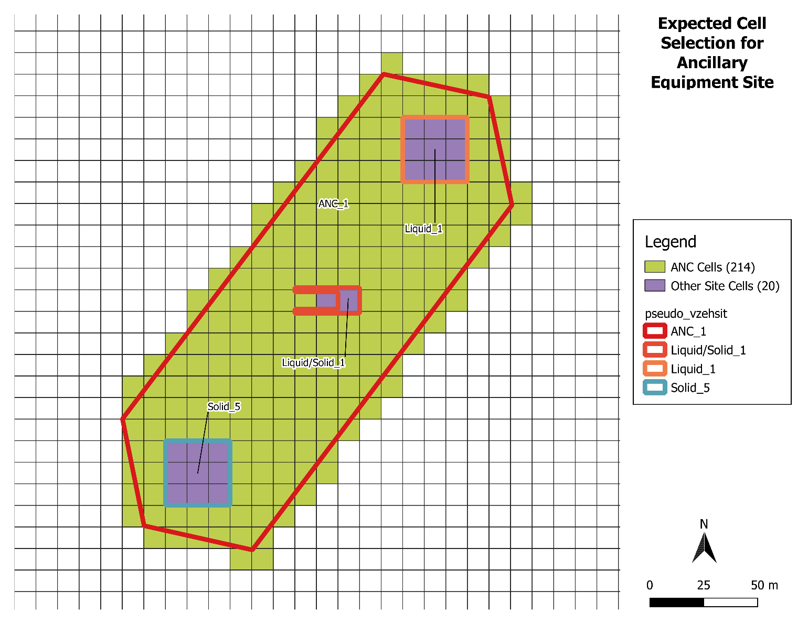

Figure . Expected Cell Selection for Ancillary Site

| Table  **SRC2STOMP Acceptance Test Plan Case 3** | | | |
| --- | --- | --- | --- |
| **SRC2STOMP Acceptance Testing**  **CACIE-SRC2STOMP – AT-3** | | **Date:** | |
| **Tool Runner Log File Location for this test:**  **\\olive\backups\CAVE\CA-CIE-Tools-TestEnv\src2stomp** | | **Test Performed By: [FIRST & LAST NAME]** | |
| **Testing Directory: \\olive\backups\CAVE\CA-CIE-Tools-TestEnv\src2stomp** | | | |
| **Test Step** | **Test Instruction** | **Expected Result** | **Test Result  (Pass/Fail)** |
| Navigate to the Testing Directory | | | |
| 1 | Invoke Tool runner and execute the tool using ***runner_run_AT-3_ SRC2STOMP.sh***. Open a Linux terminal and after navigating to the appropriate directory indicated and execute the following command: *./runner_run_AT-3_SRC2STOMP.sh* | | |
| 2 | A new folder called “AT-3” should have been created. Navigate inside of that directory and verify that a file called ***buffer-aq.card*** was created. Open the ***buffer-aq.card*** file in a text editor. | | |
| 3 | In the ./AT-3 directory, open the ***buffer_aq.ctl*** and verify that line 7 has the phrase “No Solid”. This indicates to the SRC2STOMP tool that no solid sites should be included | | |
| 4 | Verify that no solid sites were included. The only sites that should be present are Liquid_2, Liquid_3, and Liquid_4. | If no solid sites are present, this satisfies the following FR:  FR-14 |  |

# Acceptance Test Report

To complete the Acceptance Testing use Appendix A. The two test cases are described as follows:

* Acceptance Test 1 is in Table A-1. It is successful and qualified to use
  + Excel program was used to verify the steps listed in Table A-1 Test Step 8. The file Table_A-1_A-2_check.xlsx located in the testing directory \\olive\backups\CAVE\CA-CIE-Tools-TestEnv\src2stomp
* Acceptance Test 2 is in Table A-2. It is successful and qualified to use
  + Excel program was used to verify the steps listed in Table A-2 Test Step 4. The file Table_A-1_A-2_check.xlsx located in the testing directory \\olive\backups\CAVE\CA-CIE-Tools-TestEnv\src2stomp
  + Method 1 was used to complete the Test Step 9
* Acceptance Test 3 is in Table A-3. It is successful and qualified to use

Details of these tests, when they were conducted, by whom, and if they Passed or Failed are in each table of Appendix A.

# User Guide

Prepare a control file as input to the tool (refer to the software design section for guidance on how to properly construct the control file). With the control file created, execute the tool as follows:

perl <path/to/tool>ca-src2stomp.pl <control/file/path>

# Tool Versions

This section details changes incorporated into each version of the **SRC2STOMP** tool.

* 1.0 – Tool was developed.

# Appendix

**Completed Acceptance Test Cases**

**Tool Runner Log**

###Executing src2stomp ./data_files/source_aq.ctl##

INFO--04/16/2020 04:28:03 PM--Starting CA-CIE Tool Runner. Logging to "./AT-1/runner_run_AT-1_SRC2STOMP_log.txt"

INFO--04/16/2020 04:28:03 PM--Code Version: 727623de1f3d79995732bc05543096a894b75e69 2.9: /opt/tools/pylib/runner/runner.py<--1bcfd6779e9cbdb82673405873a8e5e81514ae27

INFO--04/16/2020 04:28:03 PM--Code Version: fbbbdb45ff7f31f6abb25bbca4415867dbe521e6 Local repo SHA-1 has does not correspond to a remote repo release version: /home/pallena/CAVE/CA-CIE-Tools-TestRepos/src2stomp/tools/ca-src2stomp/ca-src2stomp.pl<--9b639696c8a5f24dd9042ad97900681e723e6cdd

INFO--04/16/2020 04:28:03 PM--QA Status: QUALIFIED : /opt/tools/pylib/runner/runner.py

INFO--04/16/2020 04:28:03 PM--QA Status: TEST : /home/pallena/CAVE/CA-CIE-Tools-TestRepos/src2stomp/tools/ca-src2stomp/ca-src2stomp.pl

INFO--04/16/2020 04:28:03 PM--Invoking Command:"perl" with Arguments:"/home/pallena/CAVE/CA-CIE-Tools-TestRepos/src2stomp/tools/ca-src2stomp/ca-src2stomp.pl ./data_files/source_aq.ctl"

INFO--04/16/2020 04:28:03 PM--Username:pallena Computer:olive Platform:Linux 4.4.0-38-generic #57~14.04.1-Ubuntu SMP Tue Sep 6 17:20:43 UTC 2016

NSX NSY = 61 51

NX NY = 60 50

Before sort ... After sort

Before sort ... After sort

Before sort ... After sort

Before sort ... After sort

Before sort ... After sort

Procsessing ANC = ANC_1, #nodes = 234

Done Procsessing ANC = ANC_1, #nodes = 214

NTRAD = 20, Inventory Module,SIMV2 site name,CA site name,Source Type,Volume [m3],Discharge/decay-corrected year,C-14,Cl-36,H-3,I-129,Np-237,Re-187,Sr-90,Tc-99,U-232,U-233,U-234,U-235,U-236,U-238,Th-230,Ra-226,U,Cr,NO3,CN

We've got duplicate years for a waste site: SOLID_1, 2050

We've got duplicate years for a waste site: SOLID_1, 2100

We've got duplicate years for a waste site: SOLID_2, 2050

We've got duplicate years for a waste site: SOLID_2, 2100

We've got duplicate years for a waste site: SOLID_3, 2050

We've got duplicate years for a waste site: SOLID_3, 2100

We've got duplicate years for a waste site: SOLID_4, 2050

We've got duplicate years for a waste site: SOLID_4, 2100

We've got duplicate years for a waste site: SOLID_5, 2050

We've got duplicate years for a waste site: SOLID_5, 2100

We've got duplicate years for a waste site: ANC_1, 2050

We've got duplicate years for a waste site: ANC_1, 2100

Starting CA-CIE Tool Runner. Logging to "./AT-1/runner_run_AT-1_SRC2STOMP_log.txt"

###Finished Process###

| Table A-1 **SRC2STOMP Acceptance Test Plan Case 1** | | | |
| --- | --- | --- | --- |
| **SRC2STOMP Acceptance Testing**  **CACIE-SRC2STOMP – AT-1** | | **Date: 04-16-2020** | |
| **Tool Runner Log File Location for this test:**  **\\olive\backups\CAVE\CA-CIE-Tools-TestEnv\src2stomp** | | **Test Performed By: Praveena Allena** | |
| **Testing Directory: \\olive\backups\CAVE\CA-CIE-Tools-TestEnv\src2stomp** | | | |
| **Test Step** | **Test Instruction** | **Expected Result** | **Test Result  (Pass/Fail)** |
| Navigate to the Testing Directory | | | |
| 1 | Invoke Tool runner and execute the tool using ***runner_run_AT-1_ SRC2STOMP.sh***. Open a Linux terminal and after navigating to the appropriate directory indicated and execute the following command: *./runner_run_AT-1_SRC2STOMP.sh* | | |
| 2 | A new folder called “AT-1” should have been created. Navigate inside of that directory and verify that a file called ***source-aq.card*** was created. | A file entitled “source-aq.card” should be present in the folder indicated. This satisfies the following FR:  FR-15 | Pass |
| 3 | Navigate to the “AT-1” directory and open the ***source-aq.card*** in a text editor of your choice | | |
| 4 | Verify that the following phrases are in the file (ordering is not important):   * “# Site = Liquid/Solid_1” * “# Site = Liquid_1” * “# Site = Liquid_2” | The phrases specified in quotations should all be present in the file. This satisfies the following FR:  FR-6 | Pass |
| 5 | Verify that the following cells were selected for the corresponding sites:   |  |  | | --- | --- | | **Site** | **Node (I, J)** | | Liquid/Solid_1  (see Figure 1) | 31, 25 | | 32, 25 | | Liquid_1  (see Figure 2) | 35, 31 | | 36, 31 | | 37, 31 | | 35, 32 | | 36, 32 | | 37, 32 | | 35, 33 | | 36, 33 | | 37, 33 | | Liquid_2  (see Figure 3) | *(49, 31)  *(49, 33) | | 50, 31 | | 49, 32 | | 50, 32 | | 50, 33 | | * - These cells are interchangeable, but only one of the two should be selected at any given time | | | Find each site in its corresponding comment block. Look immediately below the comment block to find the line(s) that start with the phrase “Aqueous Volumetric“ and look at the cells assigned. The way to read this is the following:  Aqueous Volumetric, [start-i], [end-i], [start-j], [end-j], [start-k], [end-k], [no. conditions to follow]  Satisfies the following FR’s:  FR-1, FR-4, and FR-5 | Pass |
| 6 | Each cell of the STOMP grid is a 10m x 10m cell. Verify that the number of cells selected corresponds with the area of each site:   |  |  |  |  | | --- | --- | --- | --- | | **Site** | **Total Area [m2]** | **Area in Source Zone [m2]** | **Expected No. of Cells** | | Liquid/Solid_1 | 200 | 200 | 2 | | Liquid_1 | 900 | 900 | 9 | | Liquid_2 | 900 | 450 | 5 | | Verify that each site has the appropriate number of cells selected.  Satisfies the following FR:  FR-2 | Pass |
| 7 | The total volume of water associated with the Liquid_2 site is 2,220 m^3. However, because Liquid_2 only overlaps the selected model zone with half of its total area, only half of the total water inventory should be represented in the source card.  This means that for this source card, a total of 1,110 m^3 should be specified for the Liquid_2 site for this source card. | | |
| 8 | Calculate the total volume of water assigned to Liquid_2 in the source card by multiplying the rate by the time elapsed by the number of cells (should be 5 cells, as determined in step 6). | A total volume of 1,110 m^3 of water should be calculated from the source card for Liquid_2. This satisfies the following FR:  FR-8 | Pass |
| 9 | Verify that the word “Solute” is not present in the ***source-aq.card*** file. | If the word “Solute” is not present, this corroborates that if only water is supplied (no other analytes), only “Volumetric Aqueous” is written to the output. This partially satisfies the following FR:  FR-12 | Pass |

**Testing Process Description**

The SRC2STOMP tool may be checked using another pair of scripts. These scripts are used to verify FR-10 and FR-11. One script is a Python script, written in Python v3.6 using a library called “GeoPandas” version 0.4.1. This Python script takes 2 shapefiles representing the model zones (source and buffer) and the sites and intersects the two to determine overlapping areas and associated fractions. A second program written in FORTRAN will read the source card, parse it, read the output from the Python script for the site area fractions (with reference to the model zones), and produce a set of comparison files. These comparison files include a list of sources, waste sites, areas, and a summary of the total inventory per waste site. These values can then be used to verify that the right amount of inventory was assigned to each waste site (for each analyte).

**Tool Runner Log**

###Executing src2stomp ./data_files/source_inv.ctl##

INFO--04/16/2020 04:09:07 PM--Starting CA-CIE Tool Runner. Logging to "./AT-2/runner_run_AT-2_SRC2STOMP_log.txt"

INFO--04/16/2020 04:09:07 PM--Code Version: 727623de1f3d79995732bc05543096a894b75e69 2.9: /opt/tools/pylib/runner/runner.py<--1bcfd6779e9cbdb82673405873a8e5e81514ae27

INFO--04/16/2020 04:09:07 PM--Code Version: fbbbdb45ff7f31f6abb25bbca4415867dbe521e6 Local repo SHA-1 has does not correspond to a remote repo release version: /home/pallena/CAVE/CA-CIE-Tools-TestRepos/src2stomp/tools/ca-src2stomp/ca-src2stomp.pl<--9b639696c8a5f24dd9042ad97900681e723e6cdd

INFO--04/16/2020 04:09:07 PM--QA Status: QUALIFIED : /opt/tools/pylib/runner/runner.py

INFO--04/16/2020 04:09:07 PM--QA Status: TEST : /home/pallena/CAVE/CA-CIE-Tools-TestRepos/src2stomp/tools/ca-src2stomp/ca-src2stomp.pl

INFO--04/16/2020 04:09:07 PM--Invoking Command:"perl" with Arguments:"/home/pallena/CAVE/CA-CIE-Tools-TestRepos/src2stomp/tools/ca-src2stomp/ca-src2stomp.pl ./data_files/source_inv.ctl"

INFO--04/16/2020 04:09:07 PM--Username:pallena Computer:olive Platform:Linux 4.4.0-38-generic #57~14.04.1-Ubuntu SMP Tue Sep 6 17:20:43 UTC 2016

NSX NSY = 61 51

NX NY = 60 50

Before sort ... After sort

Before sort ... After sort

Before sort ... After sort

Before sort ... After sort

Before sort ... After sort

Procsessing ANC = ANC_1, #nodes = 234

Done Procsessing ANC = ANC_1, #nodes = 214

NTRAD = 20, Inventory Module,SIMV2 site name,CA site name,Source Type,Volume [m3],Discharge/decay-corrected year,C-14,Cl-36,H-3,I-129,Np-237,Re-187,Sr-90,Tc-99,U-232,U-233,U-234,U-235,U-236,U-238,Th-230,Ra-226,U,Cr,NO3,CN

SIM2 Name=C-14, SIM2 Unit=Ci, SIM2 Column=6

SIM2 Name=Ra-226, SIM2 Unit=Ci, SIM2 Column=21

We've got duplicate years for a waste site: SOLID_1, 2050

We've got duplicate years for a waste site: SOLID_1, 2100

SOLID_1 duplicate years at 2100, 0.01, 2100, 5, -no existing solute for 1 Ra-226 at that year, appending (check date sequence)

We've got duplicate years for a waste site: SOLID_2, 2050

We've got duplicate years for a waste site: SOLID_2, 2100

SOLID_2 duplicate years at 2100, 0.02, 2100, 5, -no existing solute for 1 Ra-226 at that year, appending (check date sequence)

We've got duplicate years for a waste site: SOLID_3, 2050

We've got duplicate years for a waste site: SOLID_3, 2100

SOLID_3 duplicate years at 2100, 0.03, 2100, 5, -no existing solute for 1 Ra-226 at that year, appending (check date sequence)

We've got duplicate years for a waste site: SOLID_4, 2050

We've got duplicate years for a waste site: SOLID_4, 2100

SOLID_4 duplicate years at 2100, 0.04, 2100, 5, -no existing solute for 1 Ra-226 at that year, appending (check date sequence)

We've got duplicate years for a waste site: SOLID_5, 2050

We've got duplicate years for a waste site: SOLID_5, 2100

SOLID_5 duplicate years at 2100, 0.05, 2100, 5, -no existing solute for 1 Ra-226 at that year, appending (check date sequence)

We've got duplicate years for a waste site: ANC_1, 2050

We've got duplicate years for a waste site: ANC_1, 2100

ANC_1 duplicate years at 2100, 0.0011, 2100, 5, -no existing solute for 1 Ra-226 at that year, appending (check date sequence)

Starting CA-CIE Tool Runner. Logging to "./AT-2/runner_run_AT-2_SRC2STOMP_log.txt"

###Finished Process###

| Table A-2 **SRC2STOMP Acceptance Test Plan Case 2** | | | |
| --- | --- | --- | --- |
| **SRC2STOMP Acceptance Testing**  **CACIE-SRC2STOMP – AT-2** | | **Date: 04-16-2020** | |
| **Tool Runner Log File Location for this test:**  **\\olive\backups\CAVE\CA-CIE-Tools-TestEnv\src2stomp** | | **Test Performed By: Praveena Allena** | |
| **Testing Directory: \\olive\backups\CAVE\CA-CIE-Tools-TestEnv\src2stomp** | | | |
| **Test Step** | **Test Instruction** | **Expected Result** | **Test Result  (Pass/Fail)** |
| Navigate to the Testing Directory | | | |
| 1 | Invoke Tool runner and execute the tool using ***runner_run_AT-2_SRC2STOMP.sh*** | | |
| 2 | A new folder called “AT-2” should have been created. Navigate inside of that directory and open the file called ***source-inv-src.card*** in a preferred text editor. | | |
| 3 | Look through the comments of the ***sourc-inv-src.card*** and verify that the following sites are present with a line (2 lines below the site name) stating whether the site is a “non-liquid site = solid release series” or a “liquid site = liquid”:   |  |  | | --- | --- | | **Site** | **Type\*** | | Liquid_1 | liquid site = liquid | | Liquid_2 | liquid site = liquid | | Solid_4 | non-liquid site = solid release series | | Solid_5 | non-liquid site = solid release series | | ANC_1 | non-liquid site = solid release series | | Liquid/Solid_1 | liquid site = liquid | | non-liquid site = solid release series | | * - Specified 2 lines below site name | | | The “Liquid/Solid_1” site has a special status as it should be mentioned twice: once as a liquid site, and again as a solid site. If all sites match up as specified in the table provided in the test instruction, this will satisfy the following FR:  FR-7 | Pass |
| 4 | The total number of cells that should be selected for the ANC_1 site should add up to 214 (total area of 21,400 m^2). To verify the cell selection, you will need to read each line of the source card for an analyte (belonging to the ancillary equipment site) and tally up the count.  The best way to do this is to search for the ANC_1 site, then read each line for a single analyte (e.g. C-14) and count the number of cells. The phrase to search on (remember to do this only for the ANC_1 site) is “Solute, C-14,” (using the phrase inside quotation marks). A full listing of the expected cells is included in Table 5 along with a visual in Figure 4. | There should be 214 cells in total for the ancillary site, totaling 21,400 m^2 in area. If only the 214 cells shown in Table 5 are included in the source card, this will satisfy the following FR:  FR-3 | Pass |
| 5 | Navigate to ./data_files and open ***pseudo_inventory.csv*** in either a text editor or Excel. Search for site “Solid_5” and focus on the “C-14” analyte. Pick the value for 2080 (should be 5 Ci). Divide by the number of cells for “Solid_5” to determine the amount that should be written to the source card (should be 5.55556E-01).  After obtaining the expected value for year 2080 from the ***pseudo_inventory.csv*** file, read in the ***source-inv.card*** file to find the “C-14” solute release for site “Solid_5”. | For year 2080, the release written for the C-14 solute for site “Solid_5” should be 5.55556e-01.  Using the same process described for “Solid_5”, C-14, for the year 2080, verify at least one other site for a liquid release for a different year and a different analyte (water or Ra-226).  This check satisfies the following FR:  FR-9 | Pass (checked Solid_4, Ra-226, Yr 2075) |
| 6 | Navigate to the ./AT-2 directory and open the ***source_inv.ctl*** file in a text editor. Verify that lines 11 and 12 have “C-14” and “Ra-226”, respectively. This file is what was used as input to the SRC2STOMP tool. Verify that only the following analytes are present in the ***source-inv.card*** file:   * C-14 * Ra-226 * Water (written as “Volumetric Aqueous” in the source card) | Only the indicated analytes should be present in the source card. If true, this satisfies the following FR:  FR-16 | Pass |
| 7 | With ***source-inv.card*** open, verify that all liquid sites include release types: “Volumetric Aqueous” and “Solute”. This should include Liquid_1, Liquid_2, and one instance of Liquid/Solid_1. For each site, there should only be one “block” of “Volumetric Aqueous” type releases and 2 “blocks” specifying “Solute” type releases.  A “block” in this context refers to a group of consecutive lines in the text file. These consecutive lines are identified by the STOMP notation as follows (see highlighted portions for relevant values):  For water:  Aqueous Volumetric, [start-i], [end-i], [start-j], [end-j], [start-k], [end-k], [no. conditions to follow]  For any other analyte:  Solute, [analyte], [start-i], [end-i], [start-j], [end-j], [start-k], [end-k], [no. conditions to follow] | All “liquid” release type sites should have sources defined as “Aqueous Volumetric” and “Solute” types. This, in conjunction with Acceptance Test 1, satisfies the following FR:  FR-12 | Pass |
| 8 | With ***source-inv.card*** open, verify that all solid sites only use the “Solute” type option for specifying releases. The site list includes Solid_4, Solid_5, ANC_1, and one instance of Liquid/Solid_1. Refer to step 7 for help with reading the STOMP source card.  No solid site should have “Aqueous Volumetric” as a release type. | All “solid” release type sites should only have “Solute” type releases specified in the source card. This satisfies the following FR:  FR-13 | Pass |
| 9 | Verify the total inventory assigned to the source card produced by choosing at least one of the alternatives: 1) execute the checking script (provided) and read the totals in comparison with the ***pseudo_inventory_summary.csv*** file in the ./data_files folder or 2) sum up the inventory manually reading the ***source-inv.card***  Either method is acceptable, the end goal of the check is to make sure that for each site and analyte (including water) the total inventory matches up with the expected total (found in ***pseudo_inventory_summary.csv***).  For method 1, in a Linux terminal, navigate to ./AT-2 and type the following command: *./run_src2stomp_check_AT-2.sh*. This action should create 4 new files:   1. ***model_fraction_summary.txt*** 2. ***source-inv_compare_areas.dat*** 3. ***source-inv_compare_list.dat*** 4. ***source-inv_compare_sum.dat***   Open the ***source-inv_compare_sum.dat*** file in a text editor of your choosing. In another window/view, also open the ***pseudo_inventory_summary.csv*** file. Verify that for each waste site the totals all match up exactly. Take note that sites Solid_4 and Liquid_2 match up with the total inventory even though they only partially overlap with the source area. The checking tool takes this into account and divides the real total by the fraction of overlap to obtain the total amount that would be expected if the whole site were present. For a more granular listing, please refer to the ***source-inv_compare_list.dat*** for these two sites (you will have to perform the summations yourself, using the “Total” column, not the “Adj_Total”.  If you opt to perform the summations manually (method 2), please refer to step 8 in Acceptance Test 1 (Table 3) for further instructions on how to perform the summation. | Using either method outlined in the instructions, each waste site and each analyte should come out with the expected total inventory presented in the ***pseudo_inventory_summary.csv*** file found in the ./data_files directory. This will satisfy the following FR’s:  FR-10, FR-11 | Pass (used Method 1) |

**Tool Runner Log**

###Executing src2stomp ./data_files/buffer_aq.ctl##

INFO--04/16/2020 04:40:53 PM--Starting CA-CIE Tool Runner. Logging to "./AT-3/runner_run_AT-3_SRC2STOMP_log.txt"

INFO--04/16/2020 04:40:53 PM--Code Version: 727623de1f3d79995732bc05543096a894b75e69 2.9: /opt/tools/pylib/runner/runner.py<--1bcfd6779e9cbdb82673405873a8e5e81514ae27

INFO--04/16/2020 04:40:53 PM--Code Version: fbbbdb45ff7f31f6abb25bbca4415867dbe521e6 Local repo SHA-1 has does not correspond to a remote repo release version: /home/pallena/CAVE/CA-CIE-Tools-TestRepos/src2stomp/tools/ca-src2stomp/ca-src2stomp.pl<--9b639696c8a5f24dd9042ad97900681e723e6cdd

INFO--04/16/2020 04:40:53 PM--QA Status: QUALIFIED : /opt/tools/pylib/runner/runner.py

INFO--04/16/2020 04:40:53 PM--QA Status: TEST : /home/pallena/CAVE/CA-CIE-Tools-TestRepos/src2stomp/tools/ca-src2stomp/ca-src2stomp.pl

INFO--04/16/2020 04:40:53 PM--Invoking Command:"perl" with Arguments:"/home/pallena/CAVE/CA-CIE-Tools-TestRepos/src2stomp/tools/ca-src2stomp/ca-src2stomp.pl ./data_files/buffer_aq.ctl"

INFO--04/16/2020 04:40:53 PM--Username:pallena Computer:olive Platform:Linux 4.4.0-38-generic #57~14.04.1-Ubuntu SMP Tue Sep 6 17:20:43 UTC 2016

NSX NSY = 61 51

NX NY = 60 50

Before sort ... After sort

Before sort ... After sort

Before sort ... After sort

Before sort ... After sort

Before sort ... After sort

Before sort ... After sort

NTRAD = 20, Inventory Module,SIMV2 site name,CA site name,Source Type,Volume [m3],Discharge/decay-corrected year,C-14,Cl-36,H-3,I-129,Np-237,Re-187,Sr-90,Tc-99,U-232,U-233,U-234,U-235,U-236,U-238,Th-230,Ra-226,U,Cr,NO3,CN

We've got duplicate years for a waste site: SOLID_1, 2050

We've got duplicate years for a waste site: SOLID_1, 2100

We've got duplicate years for a waste site: SOLID_2, 2050

We've got duplicate years for a waste site: SOLID_2, 2100

We've got duplicate years for a waste site: SOLID_3, 2050

We've got duplicate years for a waste site: SOLID_3, 2100

We've got duplicate years for a waste site: SOLID_4, 2050

We've got duplicate years for a waste site: SOLID_4, 2100

We've got duplicate years for a waste site: SOLID_5, 2050

We've got duplicate years for a waste site: SOLID_5, 2100

We've got duplicate years for a waste site: ANC_1, 2050

We've got duplicate years for a waste site: ANC_1, 2100

Starting CA-CIE Tool Runner. Logging to "./AT-3/runner_run_AT-3_SRC2STOMP_log.txt"

###Finished Process###

| Table A-3 **SRC2STOMP Acceptance Test Plan Case 3** | | | |
| --- | --- | --- | --- |
| **SRC2STOMP Acceptance Testing**  **CACIE-SRC2STOMP – AT-3** | | **Date:04-16-2020** | |
| **Tool Runner Log File Location for this test:**  **\\olive\backups\CAVE\CA-CIE-Tools-TestEnv\src2stomp** | | **Test Performed By: Praveena Allena** | |
| **Testing Directory: \\olive\backups\CAVE\CA-CIE-Tools-TestEnv\src2stomp** | | | |
| **Test Step** | **Test Instruction** | **Expected Result** | **Test Result  (Pass/Fail)** |
| Navigate to the Testing Directory | | | |
| 1 | Invoke Tool runner and execute the tool using ***runner_run_AT-3_ SRC2STOMP.sh***. Open a Linux terminal and after navigating to the appropriate directory indicated and execute the following command: *./runner_run_AT-3_SRC2STOMP.sh* | | |
| 2 | A new folder called “AT-3” should have been created. Navigate inside of that directory and verify that a file called ***buffer-aq.card*** was created. Open the ***buffer-aq.card*** file in a text editor. | | |
| 3 | In the ./AT-3 directory, open the ***buffer_aq.ctl*** and verify that line 7 has the phrase “No Solid”. This indicates to the SRC2STOMP tool that no solid sites should be included | | |
| 4 | Verify that no solid sites were included. The only sites that should be present are Liquid_2, Liquid_3, and Liquid_4. | If no solid sites are present, this satisfies the following FR:  FR-14 | Pass |

# Appendix

**Completed Installation Test**

| Table B-1  **SRC2STOMP Installation Test Plan** | | | |
| --- | --- | --- | --- |
| **SRC2STOMP Installation Testing**  **CACIE-SRC2STOMP – IT-1** | | **Date:** | |
| **Tool Runner Log File Location for this test:** | | **Test Performed By: [FIRST & LAST NAME]** | |
| **Testing Directory:** | | | |
| **Test Step** | **Test Instruction** | **Expected Result** | **Test Result  (Pass/Fail)** |
| Tools Code Repository Directory: | | | |
| Navigate to the testing directory | | | |
| 1 | Invoke Tool runner and test the tool using ***runner_run_IT-1_ SRC2STOMP.sh*** as follows: Open a Linux terminal and after navigating to the appropriate directory indicated  *./runner_run_IT-1_SRC2STOMP.sh* | | |
| 2 | Verify Tool Runner and tool is invoked and executed. | Open ./IT-1/runner_run_IT-1_SRC2STOMP_log.txt and look for a line that states the following: “Can't open not_a_file file No such file or directory”  (Do not include the quotes in your search) |  |