**CACIE Tool #03** – ***Handprinter Tool (handprint.py)***

**Version** **1.0**

**QA**: **QA**

1. **Description and Purpose**

The Handprinter tool is a batch processor that processes a collection of files and folders by invoking the Fingerprinter tool on each one. An input file lists the collection of files and folders to fingerprint and optional filenames for the fingerprint. The Handprinter tool creates one fingerprint file for each item in the input file and stores the results in the target directory (default is current directory).

1. **Functional Requirements**

The following are the functional requirements of the Handprinter tool.

FR-1: Parse the files and/or folder listed in the input file.

FR-2: Invoke the Fingerprinter tool for each file and/or folder listed in the input file.

FR-3: Save fingerprint file to an optional filename as specified in the input file.

1. **Software Requirements Specifications**

The following documents the software requirements for the Handprinter tool.

Python 3.5

Python Standard Libraries:  
os  
sys  
argparse

Modules:  
.\fingerprint.py

1. **Software Design Description**

The following is a brief description of the required arguments and the output generated by the Handprinter tool:

Positional Arguments:

* inputfile: Path to a file containing the items to process through the Fingerprinter tool. Each line should contain at least a path, and optionally a filename. Blank lines or those starting with a '#' are ignored. The path (separated by forward slashes) specifies the path to a file or folder to fingerprint. The optional filename specifies the name of the fingerprint file that is generated for the specified path.

Optional Arguments:

* -h, --help
* --outdir OUTDIR: Path to the folder where you want to store the Fingerprinter tool output. Defaults to the current directory.
* --sep, SEP: the type of character that separates columns in the input file. Defaults to a comma (,); specify a tab or a space delimiter as ‘s’

Shell file configuration:

python [directory path]/pylib/handprint/handprint.py [optional arguments—see above] inputfile

An independent code walkthrough was performed by Neil Powers on 11/22/2019. The Handprinter tool includes the module fingerprint.py; however, the Handprinter tool functions as a batch processer to invoke the fingerprint.py module itself. It does not include code with direct calls to the functions in fingerprint.py.

1. **Requirements Traceability Matrix**

The requirements traceability matrix for the Handprinter tool is presented in Table 1.

| **Table 1. Handprinter Tool Requirements Traceability Matrix** | | |
| --- | --- | --- |
| **Functional Requirement ID** | **Acceptance Test ID** | **Test Case** |
| QA Level | CACIE-handprint.py-IT -1 | Installation Test |
| FR-1 FR-2 | CACIE-handprint.py-TC-1 | Fingerprint files and/or directories listed in an input file |
| FR-3 | CACIE-handprint.py-TC-2 | Save fingerprint file(s) to fingerprint-optional_filename.txt (NOTE: optional_filename is specified in input file) |

1. **Test Plan and Cases**

The installation test plan for the Handprinter tool is presented in Table 2 and the acceptance test plan test cases are presented in Table 3 and Table 4.

| **Table 2. Handprinter Tool Installation Test Plan** | | | | |
| --- | --- | --- | --- | --- |
| **Handprinter Installation Testing**  **CACIE-handprint.py – IT-1** | | **Date:** | | |
| **Tool Runner File Location for this test:** | | **Test Performed By: [FIRST & LAST NAME]** | | |
| **Testing Directory:** | | | | |
| **TEST ID** | **Test Case** | | | **Test Result  (Pass/Fail)** |
| *Note [Testing_Directory] in acceptance test report* | | | | |
| *Navigate to [Testing Directory]\CA-CIE-Tools-Testing (code repository)* | | | | |
| *Verify git branch and repository status by entering the following at the command line:*  *git branch (verify branch is “development”)*  *git pull*  *git status*  *git log -1*  *Note first 6 characters of git SHA-1 hash tag in acceptance test report* | | | | |
| CACIE-handprint.py-IT-1 | *Linux platform:*  *In a Linux command window:*  *Navigate to [Testing_Directory]\handprint_test* | | | |
| *Invoke Tool Runner and Handprint tool using handprint.py_IT-1_windows.sh by entering the following at the command line:./handprint_ITC-1_linux.sh* | | | |
| Verify Tool Runner is invoked and executes | |  | |
| Verify Handprinter tool executes | |  | |
| *Windows platform:*  *In a Windows command window:*  *Navigate to [Testing_Directory]\handprint_test* | | | |
| *Invoke Tool Runner and Handprint tool using handprint.py_IT-1_windows.sh by entering the following at the command line:./handprint_ITC-1_windows.sh* | | | |
| Verify Tool Runner is invoked and executes | | |  |
| Verify Handprinter tool executes | | |  |

| **Table 3. Handprinter Tool Acceptance Test Plan Test Case 1** | | | |
| --- | --- | --- | --- |
| **Handprinter Acceptance Testing**  **CACIE-handprint.py – TC-1** | | **Date:** | |
| **Tool Runner File Location for this test:** | | **Test Performed By: [FIRST & LAST NAME]** | |
| **Testing Directory:** | | | |
| **TEST ID** | **Test Case** | | **Test Result  (Pass/Fail)** |
| CACIE-handprint.py-TC-1 | *Navigate to the [Testing_Directory]\handprint_test* | | |
| *Enter the following command:*  *./handprint.py-TC-1.sh* | | |
| Verify that the fingerprints outputted to *[Testing_Directory]\ATC-1 correspond to the collection of files and directories listed in the input file ATC-1_input.txt* | |  |

| **Table 4. Handprinter Tool Acceptance Test Plan Test Case 2** | | | |
| --- | --- | --- | --- |
| **Handprinter Acceptance Testing**  **CACIE-handprint.py – TC-2** | | **Date:** | |
| **Tool Runner File Location for this test:** | | **Test Performed By: [FIRST & LAST NAME]** | |
| **Testing Directory:** | | | |
| **TEST ID** | **Test Case** | | **Test Result  (Pass/Fail)** |
| CACIE-handprint.py-TC-2 | *Navigate to the [Testing_Directory]\handprint_test* | | |
| *Enter the following command:*  *./handprint.py-TC-2.sh* | | |
| Verify that the fingerprints outputted to [Testing_Directory]\ATC-2 correspond to the collection of files and directories and the optional filenames listed in the input file ATC-2_input.txt | |  |

1. **Acceptance Test Report**

Acceptance testing of the Handprinter tool was performed by Neira Mondragon and in accordance with the test plan documented in Section 6. The acceptance testing was performed in the following directory:

\\olive\backups\CAVE\CA-CIE-Tools-TestEnv \handprint_test

The Handprinter tool met the functional requirements documented in Section 2. Verification of the tool’s functionality is documented in Table A-1 through Table A-3 and the tool runner and test logs are included in Appendix A. There were no incidents requiring resolution and accordingly, there are no unresolved incidents.

1. **User Guide**

The Handprinter tool can be invoked from the command line using the arguments as specified in Section 4 (Software Design) and the arguments for the invoked tool. The Handprinter tool can also be invoked using the Tool Runner tool.

1. **Tool Versions**

This section details changes incorporated into each version of the Fingerprinter tool.

• 1.0 – Tool was developed.

**Appendix A**

**Acceptance Testing Logs**

**Tool Runner Log—Linux**

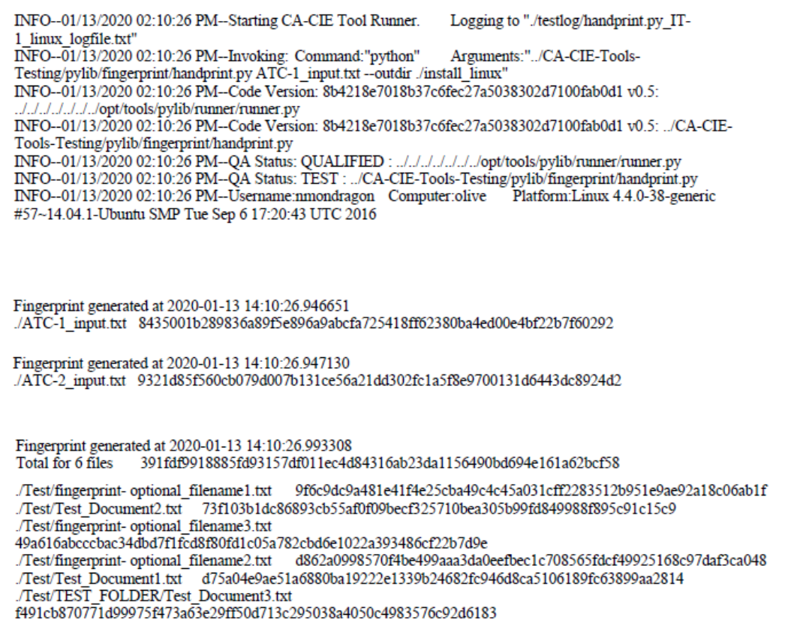

**Tool Runner Log—Windows**

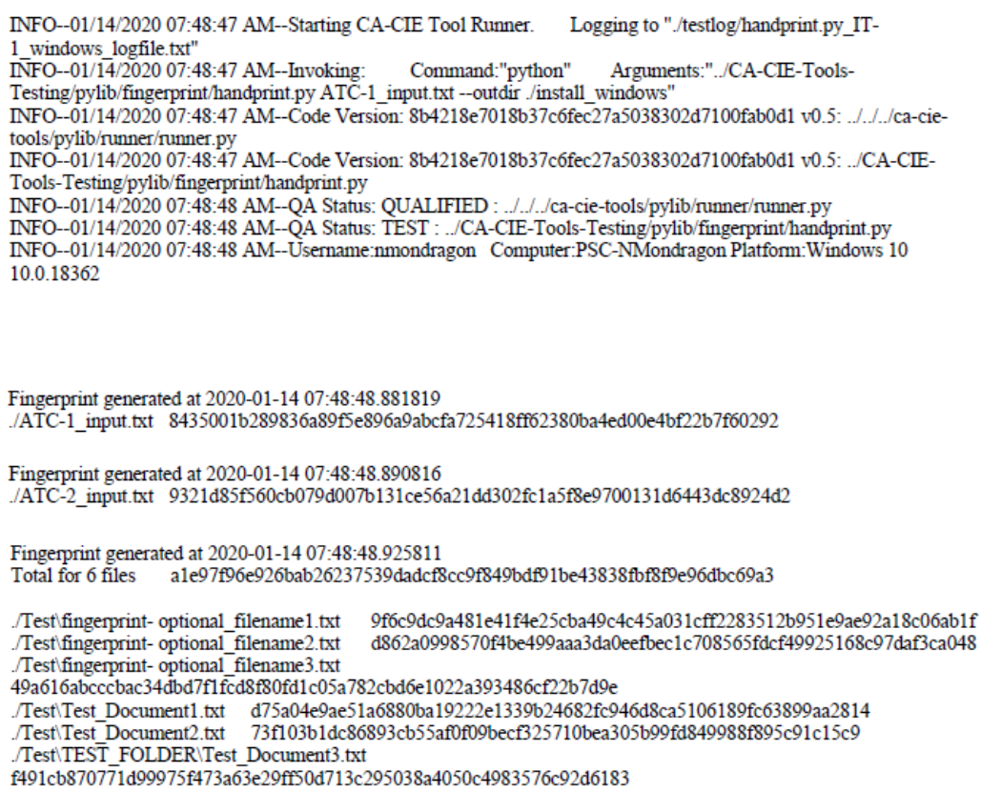

| **Table A-1. Handprinter Tool Installation Test Plan** | | | | |
| --- | --- | --- | --- | --- |
| **Handprinter Installation Testing**  **CACIE-handprint.py – IT-1** | | **Date:01/13/2020 (linux)  01/14/2020 (windows)** | | |
| **Tool Runner File Location for this test:**  **\olive\backups\CAVE\CA-CIE-Tools-TestEnv\handprint_test\testlog\handprint.py_IT-1_linux_logfile.txt  \olive\backups\CAVE\CA-CIE-Tools-TestEnv\handprint_test\testlog\handprint.py_IT-1_windows_logfile.txt** | | **Test Performed By:** **Neira Mondragon** | | |
| **Testing Directory:** **\olive\backups\CAVE\CA-CIE-Tools-TestEnv\handprint_test** | | | | |
| **TEST ID** | **Test Case** | | | **Test Result  (Pass/Fail)** |
| *Note [Testing_Directory]* \\olive\backups\CAVE\CA-CIE-Tools-TestEnv\handprint_test  *in acceptance test report* | | | | |
| *Navigate to [Testing Directory]\CA-CIE-Tools-Testing (code repository)* | | | | |
| *Verify git branch and repository status by entering the following at the command line:*  *git branch (verify branch is “development”)*    *git pull* *Note first 6 characters of git SHA-1 hash tag in acceptance test report*  *8b4218* | | | | |
| CACIE-handprint.py-IT-1 | *Linux platform:*  *In a Linux command window:*  *Navigate to [Testing_Directory]\handprint_test* | | | |
| *Invoke Tool Runner and Handprint tool using handprint.py_IT-1_windows.sh by entering the following at the command line:./handprint_IT-1_linux.sh* | | | |
| Verify Tool Runner is invoked and executes | | Pass | |
| Verify Handprinter tool executes | | Pass | |
| *Windows platform:*  *Opened Anaconda Powershell Prompt 🡪 since on my computer has Y drive mapped to olive/backups, I entered:*  *Y:*  *Cd .\CAVE\CA-CIE-Tools-TestEnv\handprint_test*  *In a Windows command window:*  *Navigate to [Testing_Directory]\handprint_test* | | | |
| *Invoke Tool Runner and Handprint tool using handprint.py_IT-1_windows.bat by entering the following at the command line:.\handprint_IT-1_windows.bat*  *Originally received an error when I entered “.\handprint_IT-1_windows.sh” (the file just opened in notepad). I changed the type of file in the directory and then ran the following “.\handprint.py_IT-1_windows.bat”* | | | |
| Verify Tool Runner is invoked and executes | | | Pass |
| Verify Handprinter tool executes | | | Pass |

**Tool Runner Log**

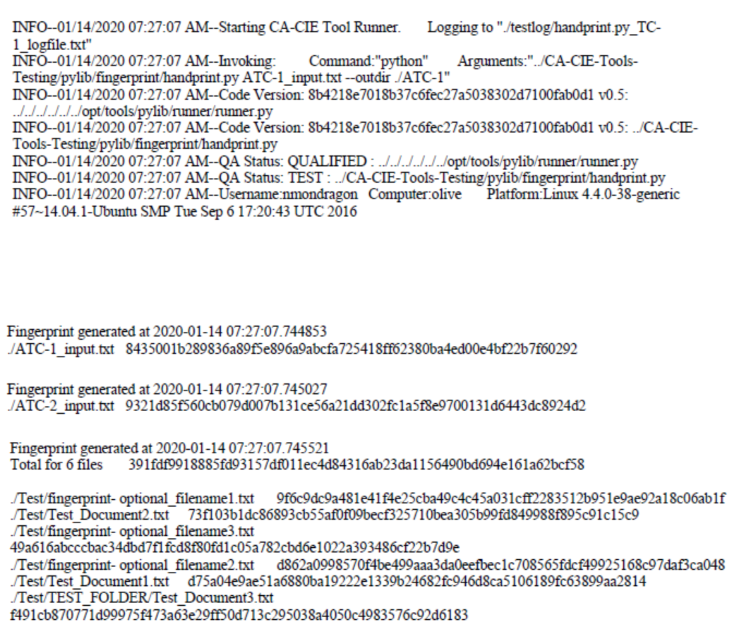

| **Table A-2. Handprinter Tool Acceptance Test Plan Case 1** | | | |
| --- | --- | --- | --- |
| **Handprinter Acceptance Testing**  **CACIE-handprint.py – TC-1** | | **Date: 01/14/2020** | |
| **Tool Runner File Location for this test: \olive\backups\CAVE\CA-CIE-Tools-TestEnv\handprint_test\testlog\handprint.py_TC-1_logfile.txt** | | **Test Performed By: Neira Mondragon** | |
| **Testing Directory: \olive\backups\CAVE\CA-CIE-Tools-TestEnv\handprint_test** | | | |
| CACIE-handprint.py-TC-1 | *Navigate to the [Testing_Directory]\handprint_test* | | |
| *Enter the following command:*  *./handprint.py_TC-1.sh* | | |
| Verify that the fingerprints outputted to *[Testing_Directory]\ATC-1 folder correspond to the collection of files and directories listed in the input file ATC-1_input.txt* in [Testing_Directory]  A screenshot of a cell phone  Description automatically generated | | Pass |

**Tool Runner Log**

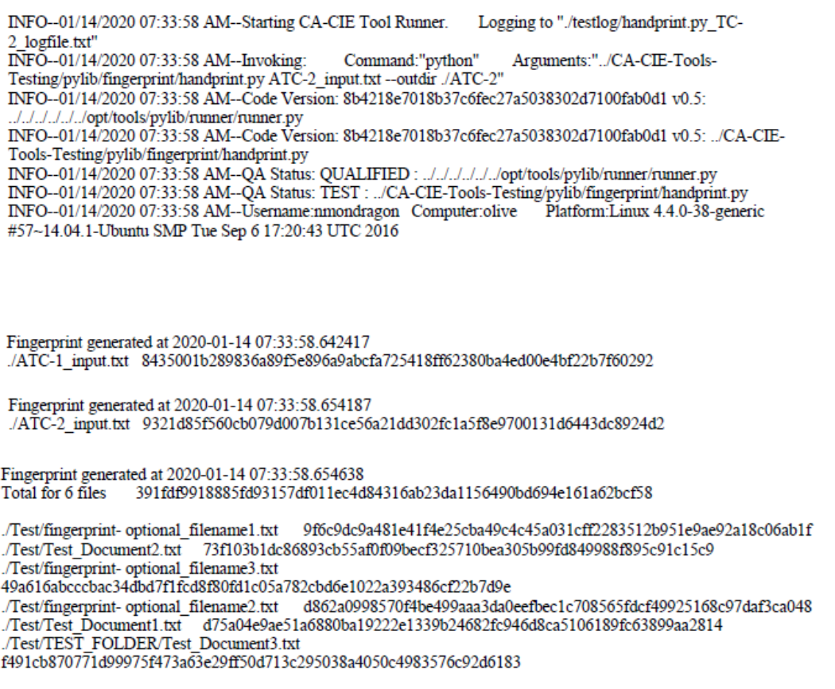

| **Table A-3. Handprinter Tool Acceptance Test Plan Case 2** | | | |
| --- | --- | --- | --- |
| **Handprinter Acceptance Testing**  **CACIE-handprint.py – TC-2** | | **Date: 01/14/2020** | |
| **Tool Runner File Location for this test: \olive\backups\CAVE\CA-CIE-Tools-TestEnv\handprint_test\testlog\handprint.py_TC-2_logfile.txt** | | **Test Performed By: Neira Mondragon** | |
| **Testing Directory:** **\olive\backups\CAVE\CA-CIE-Tools-TestEnv\handprint_test** | | | |
| CACIE-handprint.py-TC-2 | *Navigate to the [Testing_Directory]\handprint_test* | | |
| *Enter the following command:*  *./handprint.py_TC-2.sh* | | |
| Verify that the fingerprints outputted to [Testing_Directory]\ATC-2 correspond to the collection of files and directories and the optional filenames listed in the input file ATC-2_input.txt  A screenshot of a cell phone  Description automatically generated | | Pass |

**Appendix B**

**Installation Test Plan**

**Tool Runner Log—Windows**

INFO--01/16/2020 02:33:13 PM--Starting CA-CIE Tool Runner. Logging to "./testlog/CACIETools_v1.0_installtest_logfile.txt"

INFO--01/16/2020 02:33:13 PM--Invoking: Command:"python" Arguments:"S:/PSC/!HANFORD/ICF/CA-CIE-Tools/CA-CIE-Tools/pylib/fingerprint/handprint.py ATC-1_input.txt --outdir ./testlog"

INFO--01/16/2020 02:33:14 PM--Code Version: 53308176b389f2fa9adf86a01da71851b3b09d5d v1.0: S:/PSC/!HANFORD/ICF/CA-CIE-Tools/CA-CIE-Tools/pylib/runner/runner.py

INFO--01/16/2020 02:33:14 PM--Code Version: 53308176b389f2fa9adf86a01da71851b3b09d5d v1.0: S:/PSC/!HANFORD/ICF/CA-CIE-Tools/CA-CIE-Tools/pylib/fingerprint/handprint.py

INFO--01/16/2020 02:33:16 PM--QA Status: QUALIFIED : S:/PSC/!HANFORD/ICF/CA-CIE-Tools/CA-CIE-Tools/pylib/runner/runner.py

INFO--01/16/2020 02:33:17 PM--QA Status: QUALIFIED : S:/PSC/!HANFORD/ICF/CA-CIE-Tools/CA-CIE-Tools/pylib/fingerprint/handprint.py

INFO--01/16/2020 02:33:17 PM--Username:rdockter Computer:PSC-Polonium Platform:Windows 10 10.0.18362

**Tool Runner Log—Linux**

INFO--01/16/2020 02:50:31 PM--Starting CA-CIE Tool Runner. Logging to "./testlog/CACIETools_v1.0_installtest_logfile.txt"

INFO--01/16/2020 02:50:31 PM--Invoking: Command:"python" Arguments:"../../../../../../opt/tools/pylib/fingerprint/handprint.py ATC-1_input.txt --outdir ./testlog"

INFO--01/16/2020 02:50:31 PM--Code Version: 53308176b389f2fa9adf86a01da71851b3b09d5d v1.0: ../../../../../../opt/tools/pylib/runner/runner.py

INFO--01/16/2020 02:50:31 PM--Code Version: 53308176b389f2fa9adf86a01da71851b3b09d5d v1.0: ../../../../../../opt/tools/pylib/fingerprint/handprint.py

INFO--01/16/2020 02:50:32 PM--QA Status: QUALIFIED : ../../../../../../opt/tools/pylib/runner/runner.py

INFO--01/16/2020 02:50:32 PM--QA Status: QUALIFIED : ../../../../../../opt/tools/pylib/fingerprint/handprint.py

INFO--01/16/2020 02:50:32 PM--Username:rdockter Computer:olive Platform:Linux 4.4.0-38-generic #57~14.04.1-Ubuntu SMP Tue Sep 6 17:20:43 UTC 2016

| **Table 2. Handprinter Tool Installation Test Plan** | | | | |
| --- | --- | --- | --- | --- |
| **Handprinter Installation Testing**  **CACIE-handprint.py – IT-1** | | **Date: 01/16/2020** | | |
| **Tool Runner File Location for this test:**  **OLIVE\\CAVE\CA-CIE-Tools-TestEnv\CA-CIE-Tools_v1.0_install_tests\testlog\CACIETools_v1.0_installtest_logfile.txt** | | **Test Performed By: Randy Dockter** | | |
| **Testing Directory: OLIVE\\CAVE\CA-CIE-Tools-TestEnv\CA-CIE-Tools_v1.0_install_tests\** | | | | |
| **TEST ID** | **Test Case** | | | **Test Result  (Pass/Fail)** |
| *Note [Testing_Directory] in acceptance test report* | | | | |
| CACIE-handprint.py-IT-1 | *Linux platform:*  *In a Linux command window:*  *Navigate to [Testing_Directory]\handprint_test* | | | |
| *Invoke Tool Runner and Handprint tool using handprint.py_IT-1_windows.sh by entering the following at the command line:./handprint_ITC-1_linux.sh* | | | |
| Verify Tool Runner is invoked and executes | | PASS | |
| Verify Handprinter tool executes | | PASS | |
| *Windows platform:*  *In a Windows command window:*  *Navigate to [Testing_Directory]\handprint_test* | | | |
| *Invoke Tool Runner and Handprint tool using handprint.py_IT-1_windows.sh by entering the following at the command line:./handprint_ITC-1_windows.sh* | | | |
| Verify Tool Runner is invoked and executes | | | PASS |
| Verify Handprinter tool executes | | | PASS |

**Appendix C**

**QA Checklist**

