Micro Project 4: Use of NS3

**First of all we need to launch the first.cc to simulate a traffic between devices using the same network:**

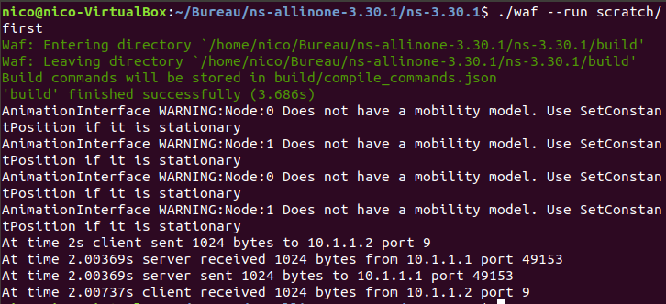

Configuration :



Traffic between two devices: 10.1.1.1 and 10.1.1.2 :

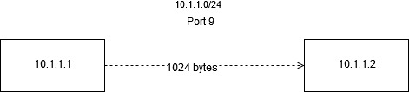

Netanim is a tool to obtain graphic interfaces while simulating with NS3. First of all we need to initialize two nodes on the interface, then, after the simulation, we will obtain a xml file with the configuration of each node.

