LAB Assignment 1
Shashank Mishra
1024170033

CODE:
#include <iostream>
using namespace std;

int BinarySearch(int arr[], int n, int target) {
int l, h, mid;
l = 0;
h = n - 1;

while (l < h) {
mid = l + (h - l) / 2;

if (arr[mid] == target)
return target;
else if (arr[mid] < target)
l = mid + 1;
else
h = mid - 1;
}

return -1;
}

int main() {
int arr[] = {2, 5, 8, 12, 16, 23, 38, 56, 72, 91};
int n = sizeof(arr) / sizeof(arr[0]);

int a = BinarySearch(arr, n, 23);

if (a == -1)
cout << "Target not Found" << endl;
else
cout << "Target Found" << endl;

return 0;
}
OUTPUT:
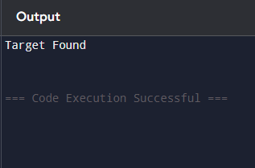

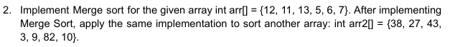
CODE:
#include <iostream>
using namespace std;

void merge(int arr[], int left, int mid, int right) {
int n1 = mid - left + 1;
int n2 = right - mid;

int L[n1], R[n2];

for (int i = 0; i < n1; i++)
L[i] = arr[left + i];

for (int j = 0; j < n2; j++)
R[j] = arr[mid + 1 + j];

int i = 0, j = 0, k = left;

while (i < n1 && j < n2) {
if (L[i] <= R[j])
arr[k++] = L[i++];
else
arr[k++] = R[j++];
}

while (i < n1)
arr[k++] = L[i++];

while (j < n2)
arr[k++] = R[j++];
}

void mergeSort(int arr[], int left, int right) {
if (left >= right)
return;

int mid = left + (right - left) / 2;

mergeSort(arr, left, mid);
mergeSort(arr, mid + 1, right);
merge(arr, left, mid, right);
}

int main() {
int arr1[] = {12, 11, 13, 5, 6, 7};
int n = sizeof(arr1) / sizeof(arr1[0]);

mergeSort(arr1, 0, n - 1);

for (int i = 0; i < n; i++)
cout << arr1[i] << " ";

cout << endl;

int arr2[] = {38, 27, 43, 3, 9, 82, 10};
int a = sizeof(arr2) / sizeof(arr2[0]);

mergeSort(arr2, 0, a - 1);

for (int i = 0; i < a; i++)
cout << arr2[i] << " ";

return 0;
}
OUTPUT:
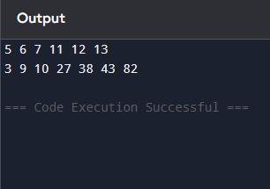

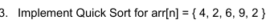
CODE:
#include <iostream>
using namespace std;

void swap(int &a, int &b) {
int temp = a;
a = b;
b = temp;
}

int partition(int A[], int l, int h) {
int pivot = A[h];
int i = l - 1;

for (int j = l; j < h; j++) {
if (A[j] <= pivot) {
i++;
swap(A[i], A[j]);
}
}

swap(A[i + 1], A[h]);
return i + 1;
}

void QuickSort(int A[], int l, int h) {
if (l < h) {
int p = partition(A, l, h);
QuickSort(A, l, p - 1);
QuickSort(A, p + 1, h);
}
}

int main() {
int A[] = {4, 2, 6, 9, 2};
int n = sizeof(A) / sizeof(A[0]);

QuickSort(A, 0, n - 1);

for (int i = 0; i < n; i++) {
cout << A[i] << " ";
}

return 0;
}
OUTPUT:
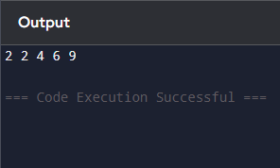

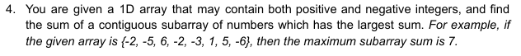
CODE:
#include <iostream>
using namespace std;

int main() {

int arr[] = {-2, -5, 6, -2, -3, 1, 5, -6};
int n = sizeof(arr) / sizeof(arr[0]);

int maxsum = arr[0];
int currsum = arr[0];

for(int i = 1; i < n; i++){
currsum = max(arr[i], currsum + arr[i]);
maxsum = max(maxsum, currsum);
}

cout << "the max contiguous subarray sum: " << maxsum << endl;

return 0;
}
OUTPUT:
